**Environment description.**

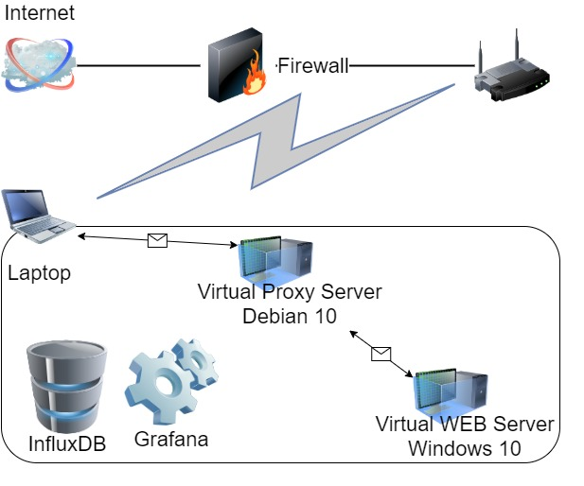

**Laptop** Windows 10**:**

Intel Core i7-8665U / 32 GB

**Virtual Proxy Server** Debian 10:

2 CPU (70%) / 4 GB

**Virtual WEB Server** Windows 10:

1-4 CPU / 2-5 GB

1. Regular load
   1. Script: Task 7
   2. Users: Editor – 2, Admin – 1, Anonymous – 35
   3. Rump-up: Editor – 120s, Admin – 60s, Anonymous – 1800s
   4. Test duration – 1h
2. KPI – avg response time, throughput, percentage of errors, CPU and Memory utilization, Get Home Page (First Page) samples results (avg, 90 pct, 95 pct)
3. Graphs

3.1 Number of text Posts – 100

3.2 Number of text Posts - 1000

3.3 Number of text Posts – 2000

3.4 Number of text Posts – 5000

3.5 Number of text Posts with attached photo 1 MB – 1000

1. Summary

1 CPU (4 GB RAM): Max avg response time – 8.45 s

Max 90pct response time – 12.51 s

Max throughput – 13.6 req/s

Percentage of errors – 0%

Max CPU utilization – 100 %

Average CPU utilization – 90 %

Min available Memory – 999 MB

Get Home Page: avg – 1.78 s, 90pct – 3.72 s, 95pct – 9.35 s.

2 CPU (4 GB RAM): Max avg response time – 5.47 s

Max 90pct response time – 11.33

Max throughput – 12.6 req/s

Percentage of errors – 0 %

Max CPU utilization – 100 %

Average CPU utilization – 70 %

Min available Memory – 893 MB

Get Home Page: avg – 995.2 ms, 90pct – 2.36 s, 95pct – 7.43 s.

3 CPU (4 GB RAM): Max avg response time – 5.23 s

Max 90pct response time – 9.94 s

Max throughput – 13.6 req/s

Percentage of errors – 0 %

Max CPU utilization – 84 %

Average CPU utilization – 50 %

Min available Memory – 1.199 GB

Get Home Page: avg – 785.09 ms, 90pct – 2.42 s, 95pct – 5.01 s.

4 CPU (4 GB RAM): Max avg response time – 5.64 s

Max 90pct response time – 9.08 s

Max throughput – 13.2 req/s

Percentage of errors – 0 %

Max CPU utilization – 61 %

Average CPU utilization – 35 %

Min available Memory – 1.158 GB

Get Home Page: avg – 834.64 ms, 90pct – 3.35 s, 95pct – 6.70 s.

4 CPU (3 GB RAM): Max avg response time – 7.47 s

Max 90pct response time – 12.27 s

Max throughput – 13.6

Percentage of errors – 0 %

Max CPU utilization – 85 %

Average CPU utilization – 35 %

Min available Memory – 417 MB

Get Home Page: avg – 1.02 s, 90pct – 4.70 s, 95pct – 7.31 s.

4 CPU (2 GB RAM): Max avg response time – 7.84 s

Max 90pct response time – 16.14 s

Max throughput – 14.2

Percentage of errors – 0.03 %

Max CPU utilization – 72

Average CPU utilization – 35 %

Min available Memory – 248.8 MB

Get Home Page: avg – 1.05 s, 90pct – 2.86 s, 95pct – 8.83 s.

4 CPU (5 GB RAM): Max avg response time – 6.01 s

Max 90pct response time – 9.73 s

Max throughput – 14.0 req/s

Percentage of errors – 0 %

Max CPU utilization – 62 %

Average CPU utilization – 35 %

Min available Memory – 1.855 GB

Get Home Page: avg – 743.6 ms, 90pct – 1.49 s, 95pct – 3.33 s.

Get Home Page (First Page) samples:

|  |  |  |  |  |  |
| --- | --- | --- | --- | --- | --- |
| CPU | 100 | 1000 | 2000 | 5000 | 1000+photo |
| avg |  |  |  |  |  |
| 90 pct |  |  |  |  |  |
| 95 pct |  |  |  |  |  |

Total throughput and response time directly depend on the number of processors and RAM. According to the results, there is not one multiplier. It is different for each case (for RAM approximately: 1,1 - 1,3; for CPU 1.3 - 1.79).

Bottleneck: network configuration (proxy server).