PP MESSAGE CENTER
AUTO-ANALYSIS
Technical Documentation
Power Automate | AI Builder | SharePoint
Field | Value
Document date | 16/06/2026
Authors | Sunneteam — Yehor Sakovtsev | Yauheniya Drozd | Yahor Andreichykau | Dmytro Zavhorodnii
Classification | General documentation
Environment | DEV / TEST / PROD

Table of Contents
1. Solution Overview 4
1.1 Description 4
1.2 Project Goal 4
1.3 Scope 4
2. Solution Components 6
2.1 Power Automate – Cloud Flow 6
2.2 Other Components 6
3. Flow Description – Details 7
3.1 General Information 7
3.2 Steps / Flow Logic 7
3.3 Activity Diagram 9
4. AI Prompts (AI Builder) 11
4.1 Prompt Description 11
4.2 Input Parameters 11
4.3 Expected Output 11
4.4 Classification Rules 11
4.5 Limitations and Notes 12
5. Data Sources 13
6. Tables (SharePoint Lists) 14
6.1 Source list – MessageCenter 14
6.2 Target list – Admin List 14
7. UML Architecture Diagrams 16
7.1 Component Diagram 16
7.2 Data Model Diagram 16
7.3 Sequence Diagram 17
8. Deployment and Packaging 19
9. Known Issues and Limitations 20
10. Appendix 21

1. Solution Overview
Field | Value
Solution name | PP Message Center Auto-Analysis
Environment | DEV / TEST / PROD
Owner | Sunneteam
Release date | June 2026
Technologies | Power Automate Cloud, AI Builder, SharePoint Online

1.1 Description
The system automatically monitors all Microsoft 365 Message Center announcements that relate to the Power Platform and its components (Power Apps, Power Automate, Dataverse, Copilot for Power Platform and others). When a new announcement arrives in the source SharePoint list, an automation flow is triggered — it analyses the content, classifies it with AI Builder, stores the result in a repository (SharePoint Admin List) and notifies administrators when required.

1.2 Project Goal
The project ensures proactive, consistent and efficient handling of all Microsoft Message Center announcements related to the Power Platform by:
- Reducing manual effort spent on monitoring MC announcements
- Earlier detection of impactful changes (breaking changes, planned maintenance)
- Timely communication with stakeholders
- Keeping an up-to-date knowledge repository
- Improving platform stability, compliance and operational readiness
The UML Use Case diagram below shows the actors and the main use cases of the PP MC Auto-Analysis solution:
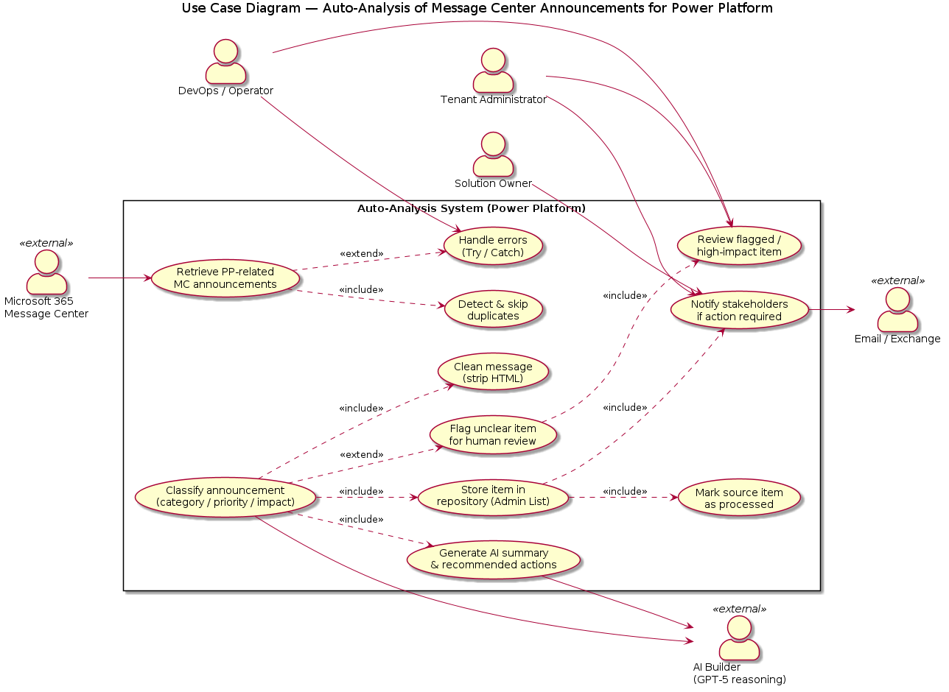
Figure 1. Use Case diagram — PP MC Auto-Analysis

1.3 Scope

In scope:
- Automatic retrieval and pre-processing of PP-related MC announcements
- Automatic classification by category (Maintenance / New Feature / Breaking Change / Other)
- Automatic priority and impact-level classification (High / Medium / Low)
- Automatic actions for planned maintenance, routine updates and unclear messages
- Creation and maintenance of a structured repository
- Automatic stakeholder communication (email)
- Monitoring: Power Apps, Power Automate, Microsoft Copilot, Dataverse, Power Platform overall

Out of scope:
- Manual deep investigation of complex or ambiguous MC messages
- Handling announcements unrelated to the Power Platform
- Full lifecycle management of business-critical changes
- Automatic remediation of issues caused by updates
- Monitoring of non-Microsoft services
The diagram below shows how the functional and non-functional requirements relate to each other:
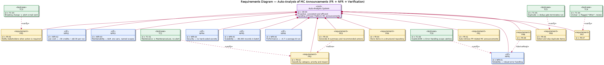
Figure 2. Requirements diagram — PP MC Auto-Analysis

2. Solution Components

2.1 Power Automate – Cloud Flow
Flow name | Type | Trigger | Purpose
PP MC Auto-Analysis | Cloud (Automated) | When item created / modified (SharePoint) | Analyse and classify MC announcements with AI

2.2 Other Components
Component | Type | Description
AI Builder Prompt | AI / GenAI | Classification of MC announcements: extracts title, category, priority, impact, status and summary as JSON
Environment Variables | Configuration | Environment variables: SharePoint list URL, credentials (Secret), source table name
Connection References | Connections | SharePoint (source and target), Office 365 Outlook (email notifications)
Error Handling Scope | Flow scope | Capture and log failures from the AI and SharePoint steps

3. Flow Description – Details

3.1 General Information
Attribute | Value
Name | PP MC Auto-Analysis Flow
Purpose | Automatic analysis and classification of Microsoft 365 Message Center announcements related to Power Platform
Trigger | When an item is created or modified – SharePoint (MessageCenter list)
Input | SharePoint list item: ID, Modified, Created, FullMessage (HTML)
Output | New item in SharePoint Admin List + optional email to administrators
Error handling | Error Handling scope with Compose (logs failure details)
Dependencies | AI Builder (Prompt), SharePoint (x2), Office 365 Outlook

3.2 Steps / Flow Logic
The flow consists of 9 steps grouped into Scopes. Each stage is described in detail below.

Step 1 – Trigger: when an item is created or modified
Type | SharePoint – Automated trigger
Source | SharePoint list: MessageCenter (86 000+ records)
Trigger condition | New or modified item
Input data | ID (Integer), Modified (DateTime), Created (DateTime), FullMessage (HTML Text)

Step 2 – Initialize Variables (x4)
Before the main logic runs, 4 working variables are initialised:
Variable name | Type | Description
varCleanMessage | String | Holds the plain-text announcement after HTML-to-text conversion
varTitle | String | Announcement title extracted by AI Builder
varCategory | String | Classification category (Maintenance / New Feature / Breaking Change / Other)
varStatus | String | Processing status (Open / Closed)

Step 3 – SCOPE: Check If Needs Processing
Condition that verifies whether the item needs to be processed by AI:
- If condition = True: continue to the next steps
- If condition = False: Terminate — the scope is skipped and the flow ends immediately
Prevents repeated processing of the same items.

Step 4 – SCOPE: Clean Message
Strips HTML to plain text before sending to AI:
Action | Type | Details
Html to Text | Data Operation | Converts FullMessage (HTML) into plain text — strips HTML tags, preserves the logical content structure
Set variable | Variable | Assigns the conversion result to varCleanMessage

Step 5 – SCOPE: AI Classification (The Brain)
Key stage — AI Builder integration for announcement classification:
Action | Type | Details
Run a Prompt | AI Builder | Sends varCleanMessage to the AI Builder model with the classification system prompt. Returns JSON containing: Title, Category, Priority, Impact, Summary, ActionsTaken, Status.
Parse JSON | Data Operation | Parses the AI Builder JSON response into dynamic fields available in subsequent steps.

Step 6 – SCOPE: Store in Admin List
Action | Type | Details
Create item | SharePoint | Creates a new item in the SharePoint Admin List with the AI classification results: Title, Category, Priority, Impact, Summary, ActionsTaken, Status, CreatedOn_Src, ModifiedOn_Src.

Step 7 – SCOPE: Notify if Action Required
Conditional notification based on the status assigned by AI:
- If Status = Open: an email is sent to Power Platform administrators with the announcement summary (V3 email connector)
- If Status = Closed (e.g. routine update): Terminate 1 — no notification, the item is stored and closed

Step 8 – SCOPE: Update Original Item
Action | Type | Details
Update item | SharePoint | Updates the original item on the source MessageCenter list — marks it as processed (prevents the trigger from re-firing for the same item).

Step 9 – SCOPE: Error Handling
Catches failures from any step of the flow:
- A Compose action captures error details (message, timestamp, item ID)
- Configured as: Configure run after → Has failed / Has timed out
- Possible extension: add a step to send an alert email to DevOps

3.3 Activity Diagram
The UML Activity diagram below shows the full control flow inside the cloud flow:
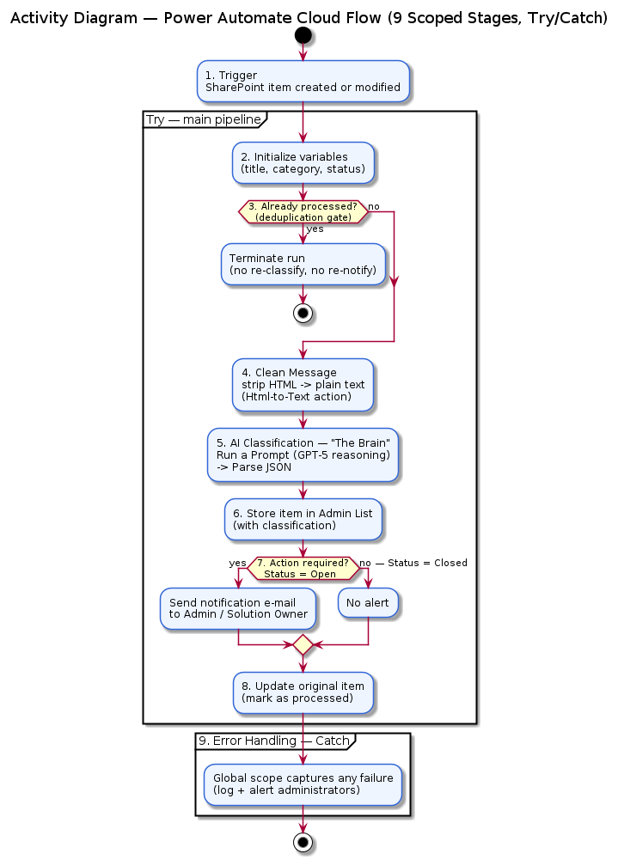
Figure 3. Activity diagram — PP MC Auto-Analysis Flow

4. AI Prompts (AI Builder)

4.1 Prompt Description
Attribute | Value
Prompt name | MC_ClassificationPrompt
Use case | Automatic classification of Microsoft 365 Message Center announcements related to Power Platform
Service / Model | AI Builder – Large Language Model (GPT-4 / Copilot foundation)
Action in Flow | Run a Prompt (Step 5 – AI Classification)

4.2 Input Parameters
Parameter | Type | Source
varCleanMessage | String (plain text) | Result of HTML → text conversion (Step 4)

4.3 Expected Output
The model returns a pure JSON object only — no surrounding text or Markdown formatting:
JSON Field | Type | Possible values / Description
Title | String | Announcement title extracted by the model
Category | String (Choice) | Maintenance | New Feature | Breaking Change | Other
Priority | String (Choice) | High | Medium | Low — based on keywords ('critical', 'immediately', 'ASAP' → High)
Impact | String (Choice) | High | Medium | Low — scope of impact on solutions and environments
Summary | String | AI summary (1-2 sentences, English)
ActionsTaken | String | Actions taken or recommendations for the administrator
Status | String (Choice) | Open (needs attention) | Closed (routine, auto-close)

4.4 Classification Rules
Announcement pattern | Category | Status | Action
Planned maintenance / service window | Maintenance | Closed | Auto-notify + close
New functionality / improvement | New Feature | Closed | Save to repository, no alert
Deprecation / breaking change | Breaking Change | Open | Email alert to administrators
Unclear content / high impact | Other | Open | Email alert + manual review
Not related to Power Platform | Other | Open | Save + optional review

4.5 Limitations and Notes
- The model may misclassify very short or ambiguous announcements — periodic reviews recommended.
- The JSON output must be parsed by a Parse JSON step — a parsing error triggers Error Handling.
- Data sent to AI Builder is plain text (after HTML → text conversion), which reduces semantic noise.
- The model response must not contain Markdown markers (e.g. ```json) — this is enforced in the prompt rules.

5. Data Sources
Name | Type | Role | Connection | Authentication
MessageCenter List | SharePoint Online | Source — trigger input | Connection Reference (SP) | OAuth 2.0 — Power Platform service account
Admin List | SharePoint Online | Target — results repository | Connection Reference (SP) | OAuth 2.0 — Power Platform service account
AI Builder | Microsoft AI Builder | Processing and classification of the content | AI Builder Connector | Built into Power Platform
Office 365 Outlook | Exchange Online | Sending email notifications | Office 365 Outlook Connector | OAuth 2.0 — service account

6. Tables (SharePoint Lists)

6.1 Source list – MessageCenter
SharePoint list with raw Message Center announcements imported from the Microsoft 365 Admin Portal. Holds 86 000+ historical and current records.
Column | Type | Required | Description
ID | Integer (PK) | YES | Unique MC announcement identifier (range 10000–100xxx). Deduplication key.
Modified | DateTime | YES | Last modification date and time.
Created | DateTime | YES | Record creation date and time.
FullMessage | Multiline text (HTML) | YES | Full announcement content in HTML. Contains change description, dates, instructions. Latin1 encoded.

6.2 Target list – Admin List
SharePoint list serving as the AI-classification results repository. One record = one processed MC announcement.
Column | Type | Required | Description
ID | Integer (Auto, PK) | YES (auto) | SharePoint-assigned identifier.
SourceID | Integer (FK) | YES | ID from the source MessageCenter list. Reference key.
Title | Single line text | YES | Announcement title extracted by AI Builder.
Category | Choice | YES | Classification result: Maintenance | New Feature | Breaking Change | Other
Priority | Choice | YES | Priority: High | Medium | Low
Impact | Choice | YES | Impact scope: High | Medium | Low
Summary | Multiline text | NO | AI summary (1-2 sentences, English).
ActionsTaken | Multiline text | NO | Description of system actions or recommendations to the administrator.
Status | Choice | YES | Processing status: Open (needs attention) | Closed (auto-closed).
CreatedOn_Src | DateTime | NO | Created date from the source list.
ModifiedOn_Src | DateTime | NO | Modified date from the source list.

7. UML Architecture Diagrams
The swimlane diagram below shows responsibility split between the components when the workflow runs:
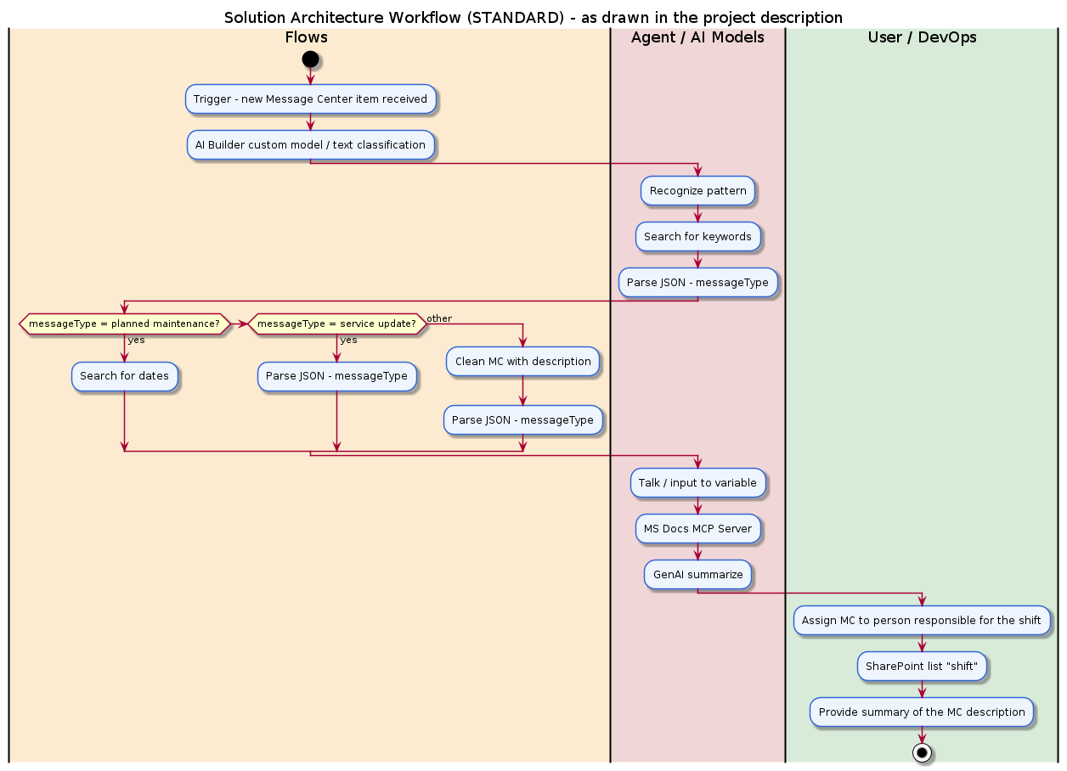
Figure 4. Swimlane diagram — solution architecture

7.1 Component Diagram
Shows the system layers and the data flow between them: source layer (SharePoint), processing layer (Power Automate), AI layer (AI Builder) and target layer (Admin List + Notifications).
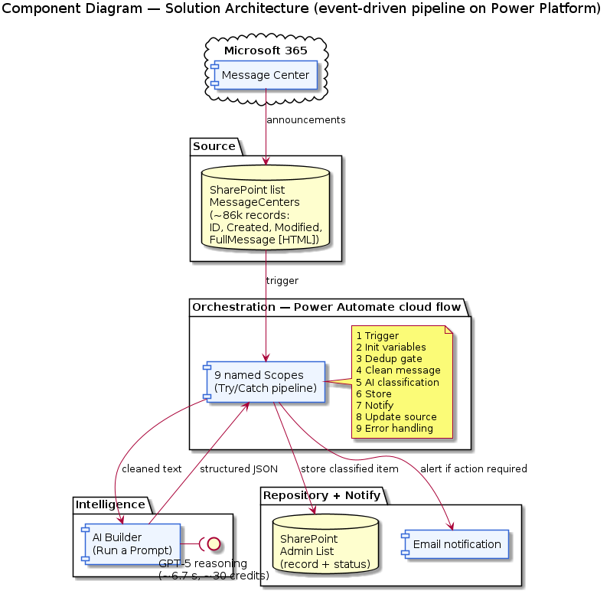
Figure 5. Component diagram — solution architecture

7.2 Data Model Diagram
UML class diagram showing the data structure — SharePoint list fields (source and target) and the JSON schema returned by AI Builder.
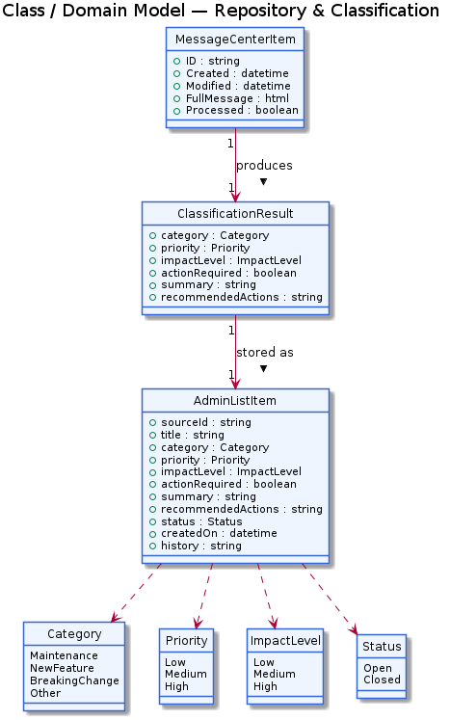
Figure 6. Data model — MessageCenter list, AI Output, Admin List

7.3 Sequence Diagram
The UML Sequence diagram shows the order of communication between participants: SharePoint (trigger), Power Automate (orchestration), AI Builder (classification), Admin List (persistence) and the administrator (recipient).
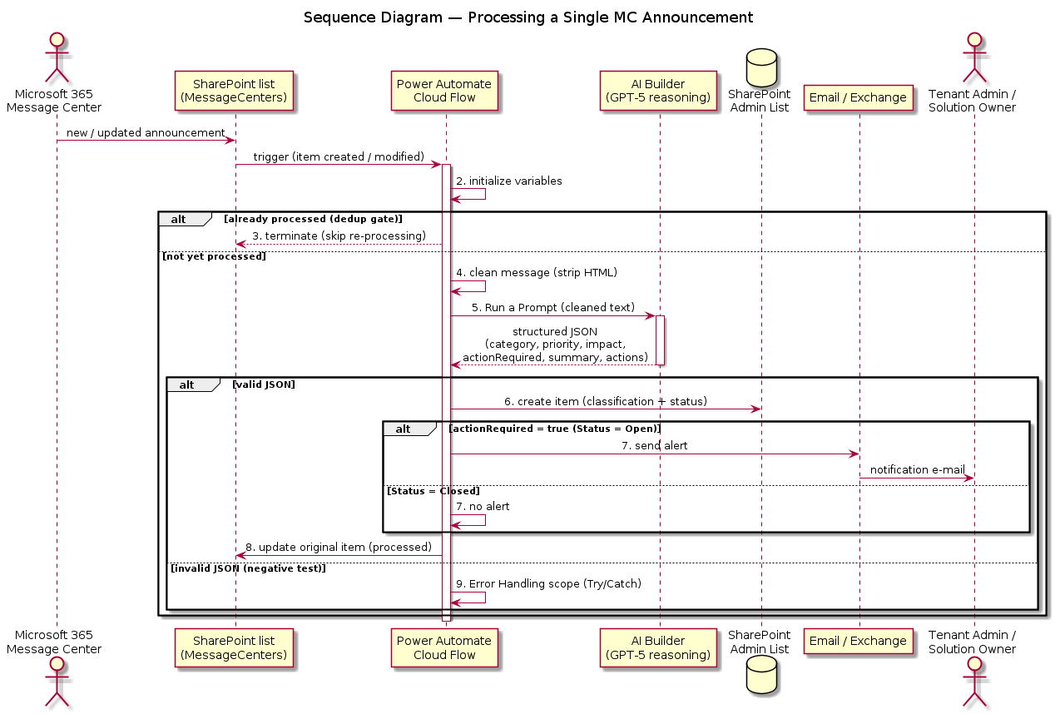
Figure 7. Sequence diagram — communication flow between components
The UML State diagram below shows the MC announcement lifecycle — from creation to closure or escalation:
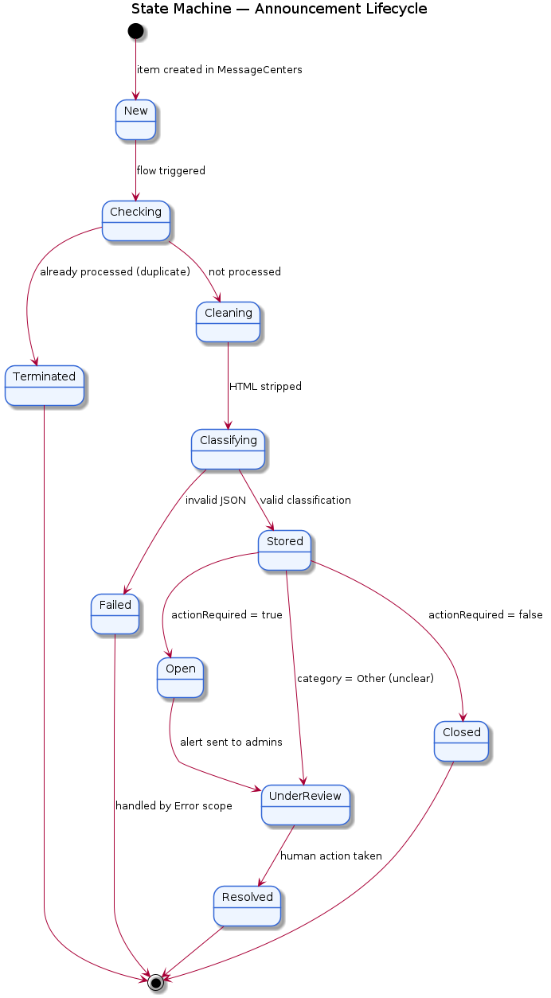
Figure 8. State diagram — announcement lifecycle

8. Deployment and Packaging

8.1 Solution Type
Package type | Managed (production) + Unmanaged (development)
Export format | Power Platform Solution (.zip)
Environments | DEV → TEST → PROD (per ALM best practices)

8.2 Deployment Steps
- Create the Admin List in SharePoint (structure from Section 6.2).
- Configure Connection References: SharePoint and Office 365 Outlook.
- Define Environment Variables (source list URL, target list URL, administrator email address).
- Import the Power Platform solution into the target environment (DEV → TEST → PROD).
- Activate the flow: PP MC Auto-Analysis Flow.
- Test on 5 representative items from the MessageCenter list (different categories).
- Run regression tests after every deployment.
The diagram below shows the deployment process per ALM best practices (DEV → TEST → PROD):
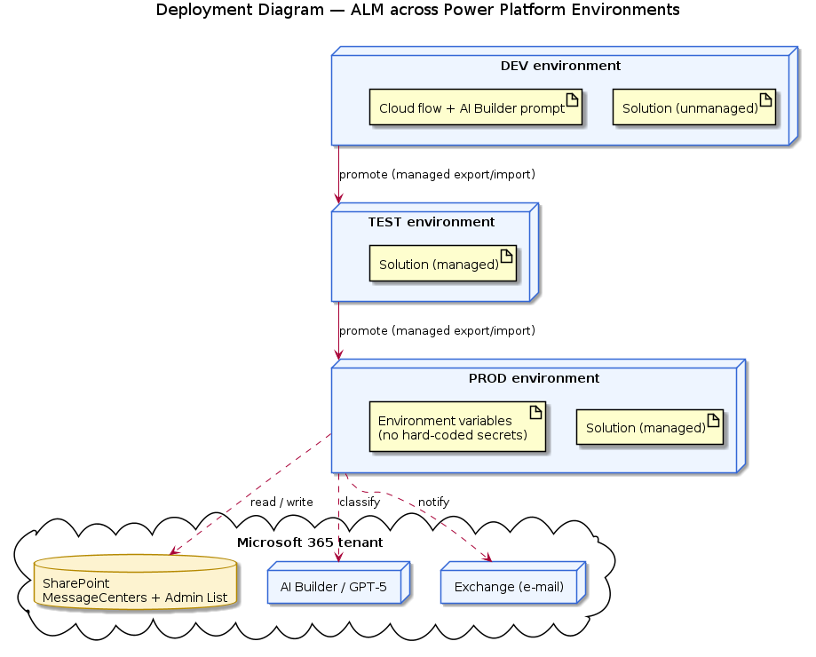
Figure 9. ALM deployment diagram — DEV / TEST / PROD

8.3 Required Configuration
Parameter | Value (DEV) | Description
SP_SourceSiteURL | https://[tenant].sharepoint.com/sites/[site] | URL of the SharePoint site hosting the MessageCenter list
SP_TargetSiteURL | https://[tenant].sharepoint.com/sites/[adminsite] | URL of the site hosting the Admin List
AdminEmailDL | powerplatform-admins@[tenant].com | Distribution list address for Power Platform administrators
AI_PromptName | MC_ClassificationPrompt | AI Builder prompt name

9. Known Issues and Limitations
# | Issue / Limitation | Environment | Workaround / Mitigation
1 | AI Builder may misclassify short or ambiguous messages | All | Periodic review of misclassifications; optional feedback loop
2 | The trigger may fire multiple times for the same item if it is modified concurrently | PROD | Check If Needs Processing + Update Original Item prevent duplicate entries
3 | The source list contains 86 000+ records — a large history can cause delays on first run | DEV/TEST | Filter by date during tests; incremental rollout
4 | HTML format in FullMessage is inconsistent — older announcements use different markup | All | Html to Text conversion absorbs most differences; legacy HTML may need extra cleanup
5 | No automatic remediation of issues caused by announced changes | All | Out of scope — the solution only identifies and notifies; remediation is performed by administrators
6 | AI Builder does not optimally handle announcements in languages other than English | All | Most MC announcements are in English; an optional translation step can be added

10. Appendix

10.1 Glossary
Term | Definition
MC / Message Center | Microsoft 365 Message Center — change-notification centre for M365 services
AI Builder | Microsoft Power Platform service that allows building and using AI models without writing code
Breaking Change | Change or deprecation of an API/feature that may break existing Power Platform solutions
Power Automate | Microsoft Low-Code/No-Code workflow automation service
Connection Reference | Connector abstraction inside a Power Platform solution — simplifies credential management across environments
Environment Variable | Power Platform configuration variable storing environment-dependent values (DEV/TEST/PROD)
Admin List | SharePoint list used as the MC announcement classification repository
Status: Open | Announcement requires administrator attention (breaking change, ambiguity, high impact)
Status: Closed | Announcement processed automatically without manual intervention (routine, planned)

10.2 Reference Links
- Power Automate documentation — https://learn.microsoft.com/power-automate
- AI Builder documentation — https://learn.microsoft.com/ai-builder
- SharePoint Online — https://learn.microsoft.com/sharepoint
- Microsoft 365 Message Center — https://admin.microsoft.com/adminportal/home
- Power Platform Best Practices — https://learn.microsoft.com/power-platform/guidance

10.3 Change History
Version | Date | Author | Change
1.0 | 16/06/2026 | Sunneteam | Initial document version
1.1 | 24/06/2026 | Sunneteam | English translation, structure preserved

