**Plan of Approach  
OpenGL Checkers Game**

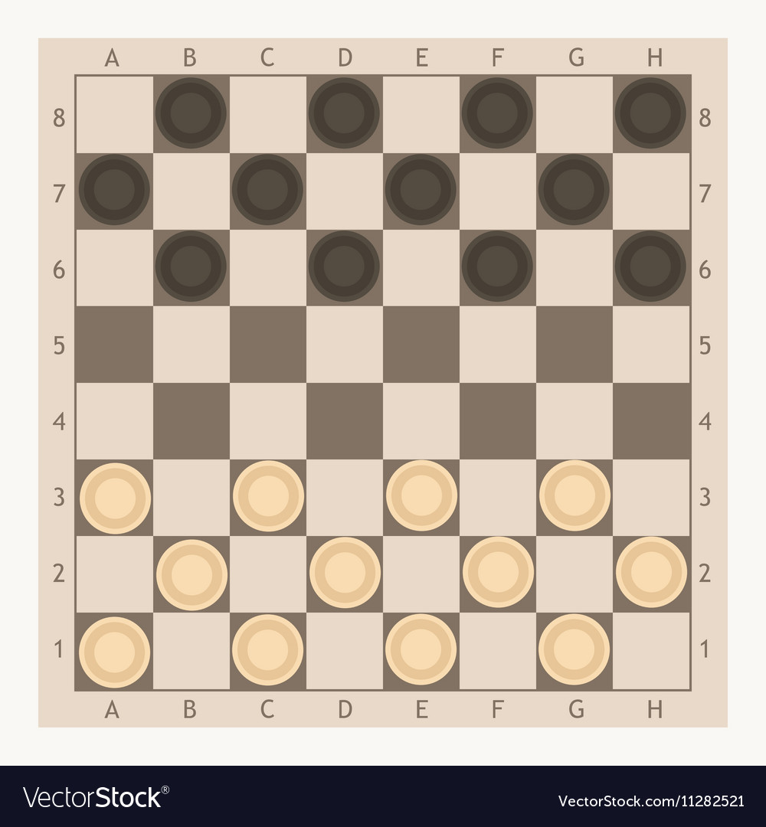

**Date: 01-05-2020  
Study: Technische Informatica  
Academy: Avans University of Applied Sciences – ‘s-Hertogenbosch  
Student: Max van den Biggelaar  
Student number: 2128574**

**Document history**

|  |  |  |
| --- | --- | --- |
| Rel. | Date | Changes |
| R01 | 01-05-2020 | First version |

**Distribution list**

|  |  |  |
| --- | --- | --- |
| Name | R01 | R02 |
| **Academic Institute Avans University of Applied Science – ‘s-Hertogenbosch** |  |  |
| Joan Schrasser |  |  |
|  | | |
| Max van den Biggelaar | x |  |

# Definitions and Abbreviations

## Definitions

|  |  |
| --- | --- |
| Marked Text | This text has changed from the previous session/release. |
|  |  |

## Abbreviations

|  |  |
| --- | --- |
| GPU | Graphical Processor Unit |
| WBD | Work Break Down |

**Table of Contents**

Definitions and Abbreviations 3

Definitions 3

Abbreviations 3

References 5

Introduction 6

Parties 6

Project result 7

Problem statement 7

Goal 7

Results 7

Project phases 8

Description of phases 8

Analyses 8

Research 8

Implementation 9

Finalization 9

Planning 10

# References

|  |  |  |
| --- | --- | --- |
| [1] | Title:  Author (Company):  ID, Version, Date:  File: |  |
| [2] | Title:  Author (Company):  ID, Version, Date:  File: |  |

# Introduction

**In the third year of the study Computer Science at Avans University of Applied Sciences ‘s-Hertogenbosch, all students have to follow a course in the last semester. This course is called “Individueel project”, Individual project in English. This document provides a short description of the plan of approach.**

## Parties

**The involved parties of this project are:**

* **The academic supervisor: Joan Schrasser**
* **The student: Max van den Biggelaar – 2128574**

# Project result

This chapter provides information about the project.

## Problem statement

The problem statement of the project is that in the study Computer Science the students get a lot of information about programming languages, databases, embedded systems, and a lot more software-based services, however, programming the software of GPU’s has never been explained or worked with.

## Goal

The goal of this project is to get acquainted with the software on GPU’s and work with the software OpenGL/OpenCL. At the end of this project, a demo with the well-founded knowledge of OpenGL/OpenCL is shown to the academic supervisor of this course.

## Results

**The expected end result is to show a demonstration of the knowledge of OpenGL based upon a game of Checkers. The focus will be set on the implementation of the game by using the programming language C/C++. The design of the game is documented in the design document.**

# Project phases

It is important to follow a structure within a project. Therefore, the structure that is used in this project is the waterfall structure. This structure consists of linear sequential phases and is used because of the inflexible nature of the project. The deadline for the project has already been set and the progress mainly flows in different phases. Every phase describes the activities and the results of the activities. The phases of the project are as follows:

* Analyses
* Research
* Implementation
* Finalization

Below are the phases described with their description.

## Description of phases

In every phase, one or more activities are described with their result. The planning is described further in this document.

### Analyses

The analyses phase is the first phase of the project. The purpose of this phase is outlining the activities per phase, getting acquainted with the project, setting up and analyzing the project, and schedule the planning.

* Activities:
  + Analyzation of the project
  + Setup the plan of approach
  + Setup the work break down (WBD)
  + Set up a Git repository.
  + Schedule the planning for the project
* Result:
  + Plan of Approach
  + Planning
  + WBD
  + GitHub

### Research

The research phase is the second phase of this project. The purpose of this phase is to get acquainted with the software OpenGL.

* Activities:
  + Research software OpenGL/OpenCL
  + Follow tutorials
  + Making examples with OpenGL/OpenCL
* Result:
  + Design document
  + Folder of tutorials and examples

### Implementation

The implementation phase is the third phase of this project. The purpose of this phase is to make an architecture of the project and a proof of concept. The demo is based upon a game of Checkers.

* Activities:
  + Implement OpenGL software
  + Realize a game of Checkers
* Result:
  + Design document
  + Proof of concept

### Finalization

The finalization phase is the last phase of this project. The project will be assessed at the end of this course. A final demonstration and all the documentation of the project is shown to the academic supervisor as a result of the project.

* Activities:
  + Final review on the documentation
  + Documentation handover
  + Demonstrate proof of concept
* Result:
  + Project management documentation
  + A proof of concept/demo

# Planning