Crop Recommendation

In this project we are combining crop dataset and crop production dataset to build crop recommendation model and to build this model we have used CNN and LSTM (RNN) algorithms. After training model we can use it to predict crop name and its production.

To implement this project we are using below two datasets

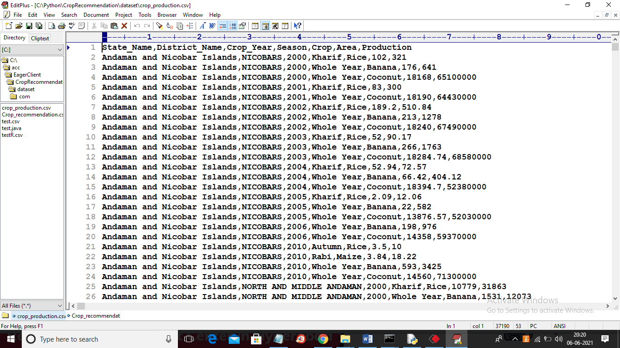

Above is the crop production dataset

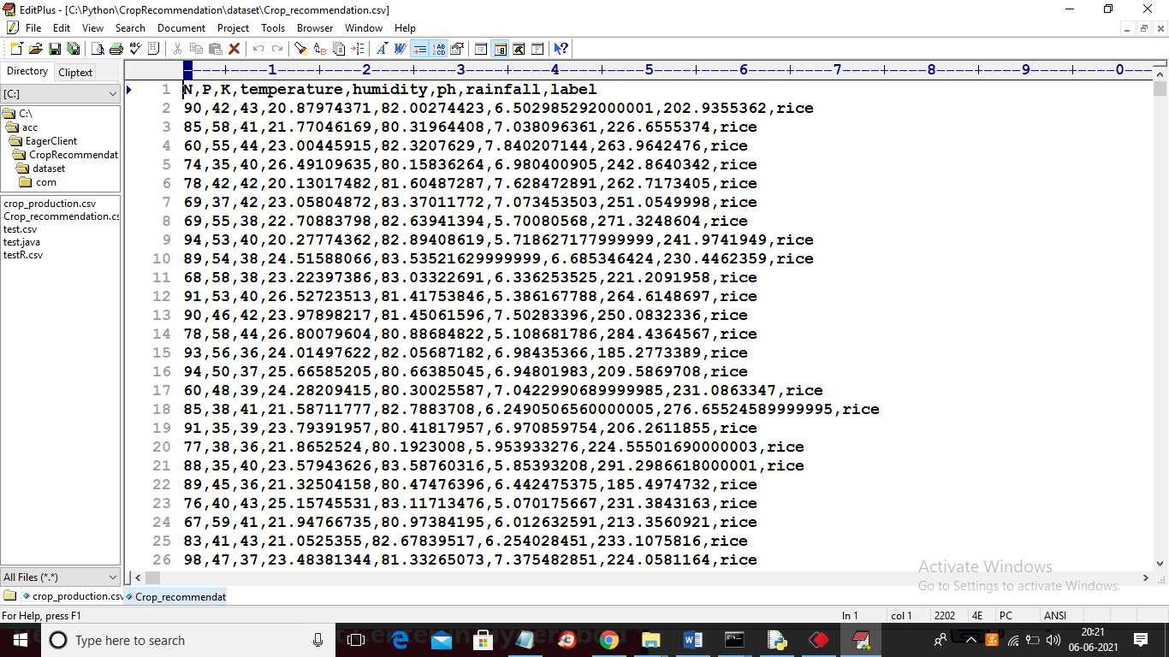

Above is the crop recommendation dataset.

To run project install python 3.7 and then install python DJANGO using below command

Pip install Django==2.1.7

Pip install pandas==0.25.3

Pip install sklearn

Pip install numpy==1.19.2

Pip install keras==2.1.3

Pip install tensorflow==1.14.0

Pip install h5py==2.10.0

After installing above packages then double click on ‘runserver.bat’ file to start DJANGO server

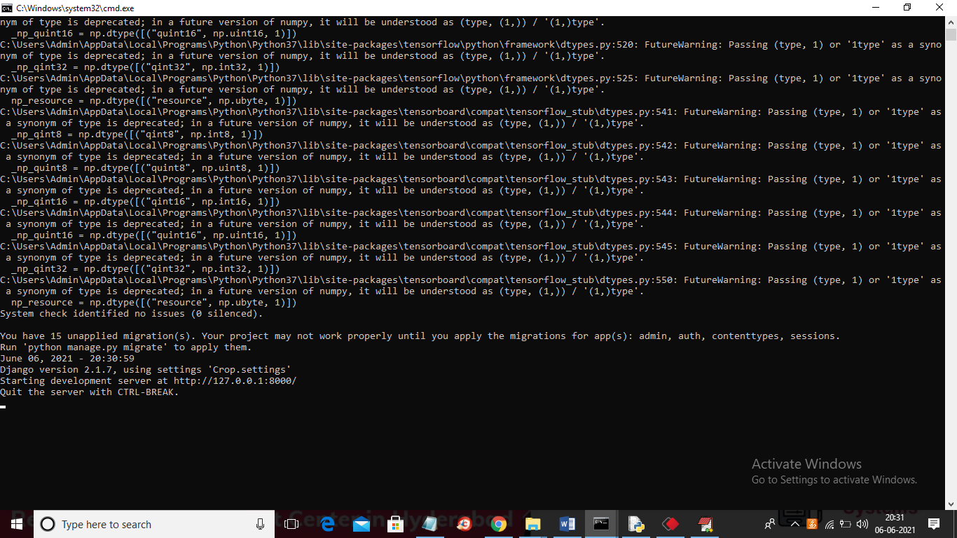

In above screen DJANGO server started and now open browser and enter URL as <http://127.0.0.1:8000/index.html> and press enter key to get below home page



In above screen click on ‘Generate & Load CNN & LSTM Model’ link to build CNN and LSTM model on both datasets and then calculate accuracy and confusion matrix

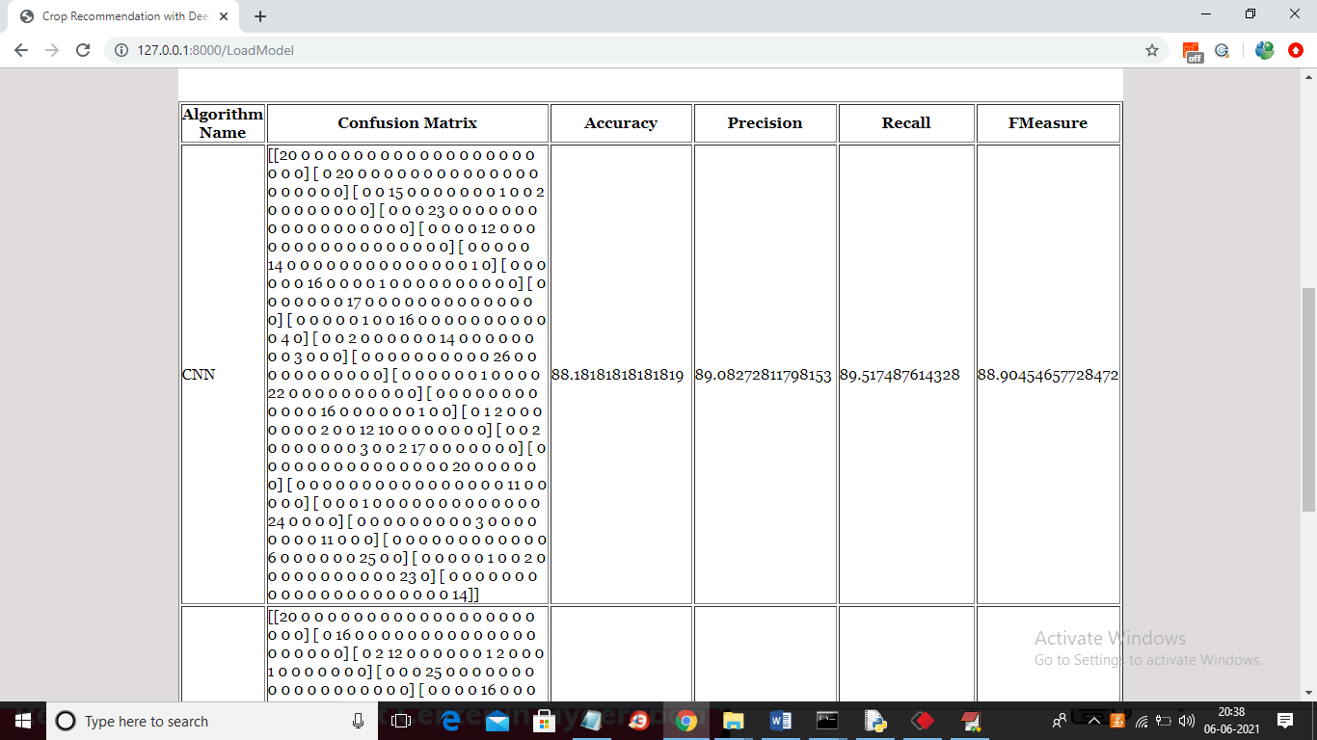

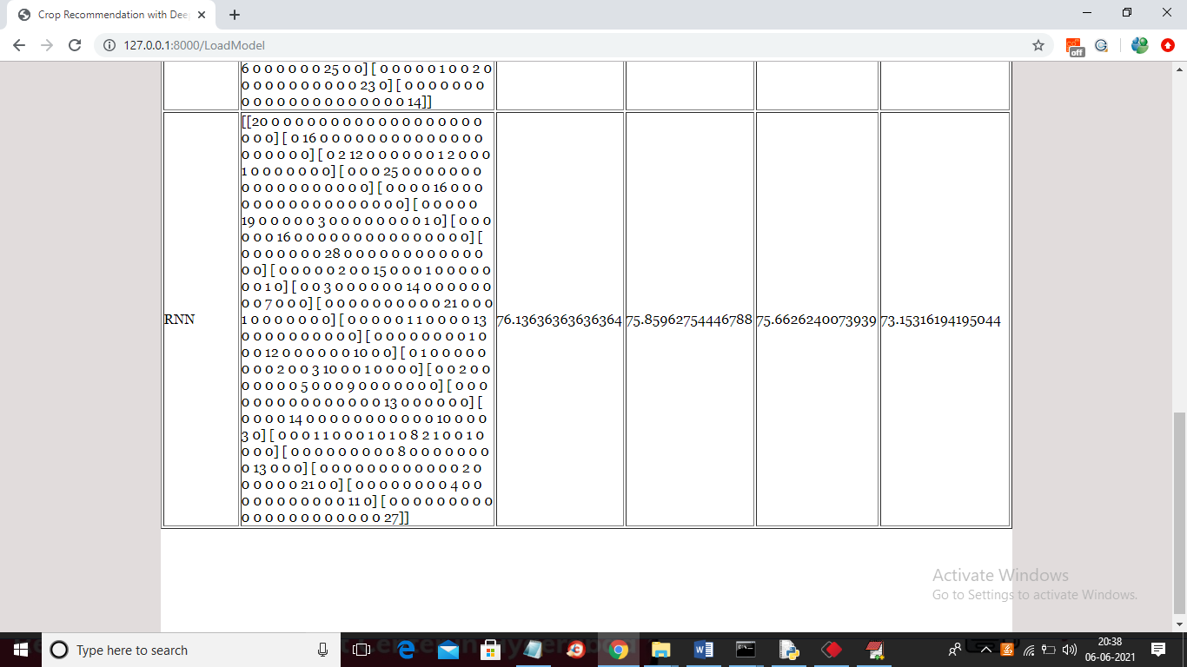

In above screen for CNN and LSTM we can see confusion matrix, accuracy, precision and recall and in dataset we have 20 different crop names or classes so we will get confusion matrix array for each class and now both models are ready and now click on ‘Crop Recommendation’ link to get below screen

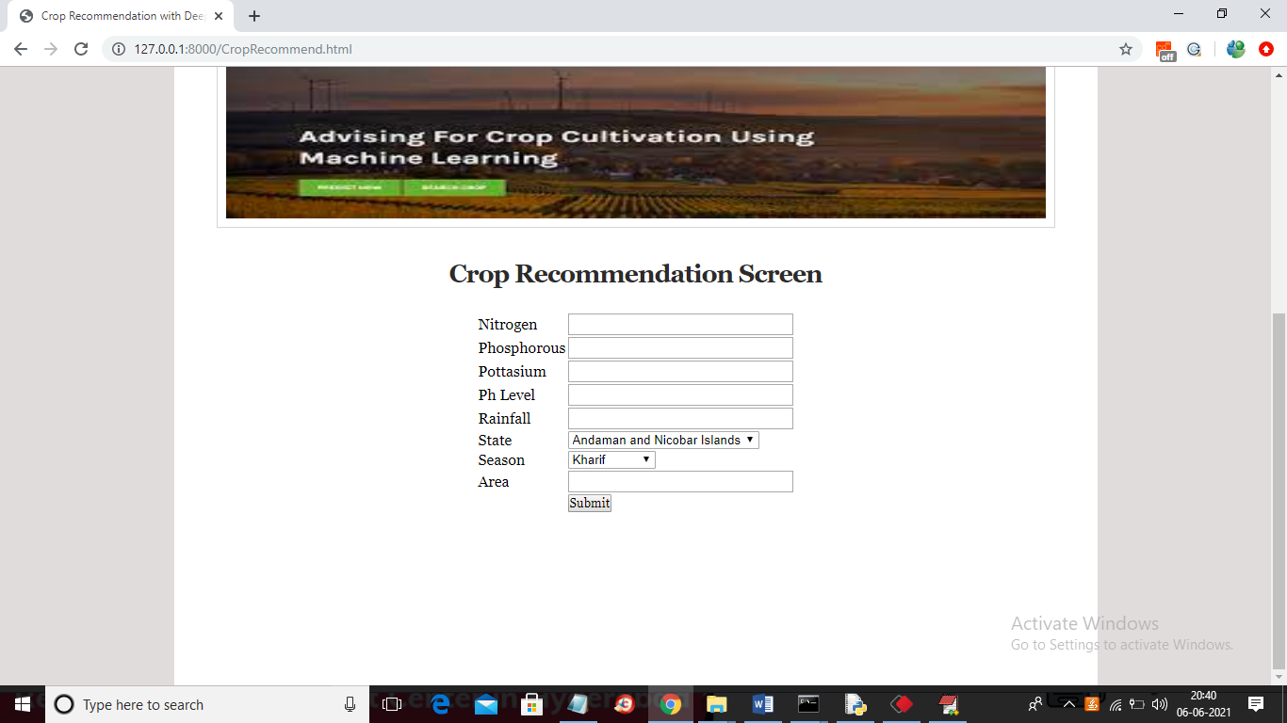

In above screen enter all values to recommend crop and production

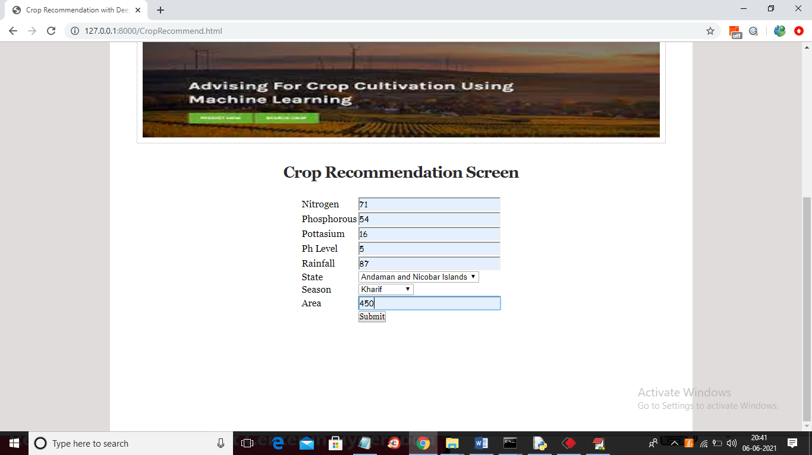

In above screen I entered some values and now click on ‘Submit’ button to get below screen

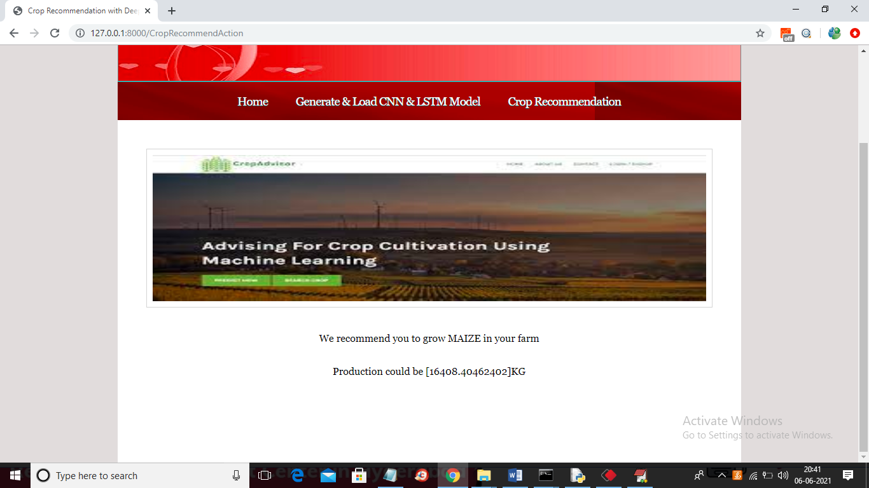

In above screen recommended crop is MAIZE and its predicted production is 16408 KG and now test with other values

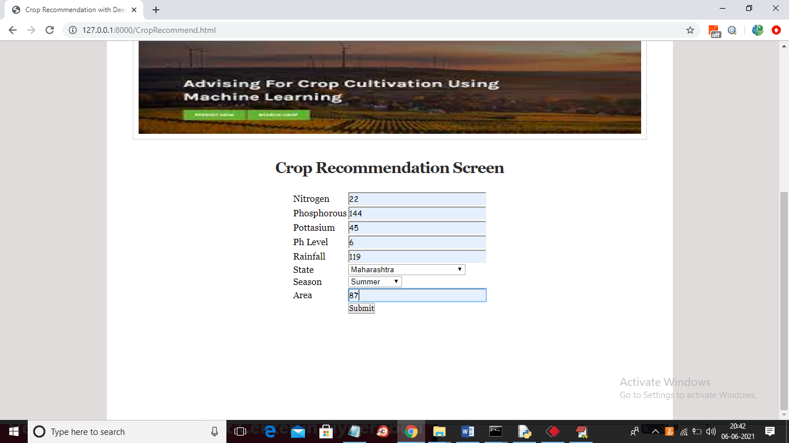

For above values below are the results

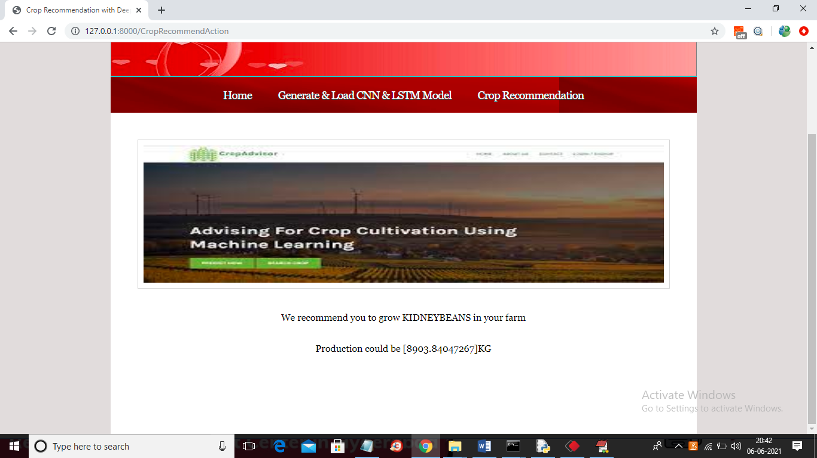

Similarly you can enter other values and get recommendation results