CHECKLIST FOR OVERTIME ADJUSTMENT PROCESSING

PAYROLL PERIOD Oct11 Oct25

* Arboleda, Josie Zausa – Aligned



* Asuncion, Mark Louie MITRA – Aligned



* Bacera, Romy MAYORDOMO - Aligned



* Biay, Jason Reyes - Aligned

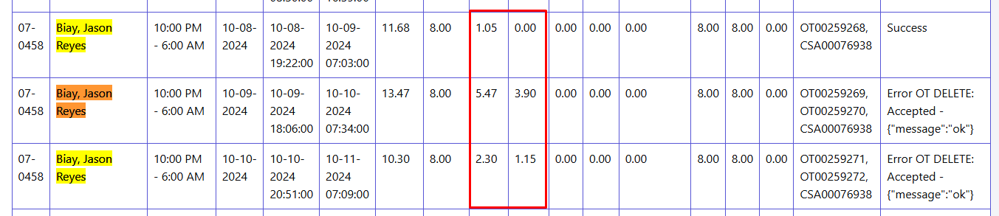

* Buenaobra, Jeffrey Gemao - Aligned



* Cabunoc, Melvin Moras - Aligned

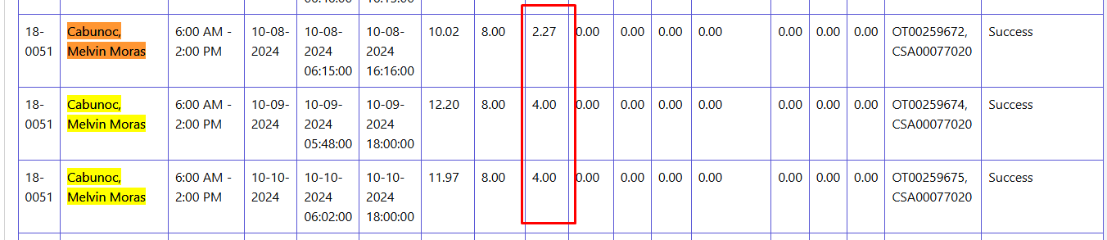

* Capati, Albert Ramos - Aligned

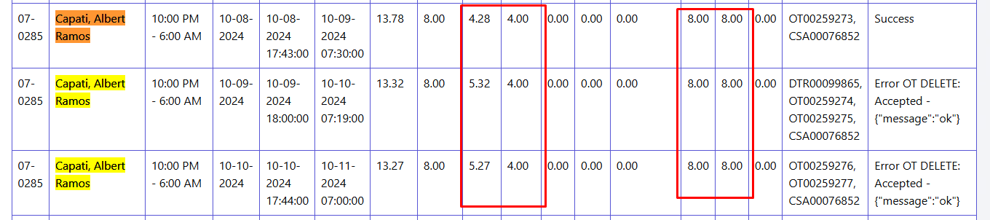

* Cay, Angella Pauline Constantino (No Value on Overtime) – A2 No OT

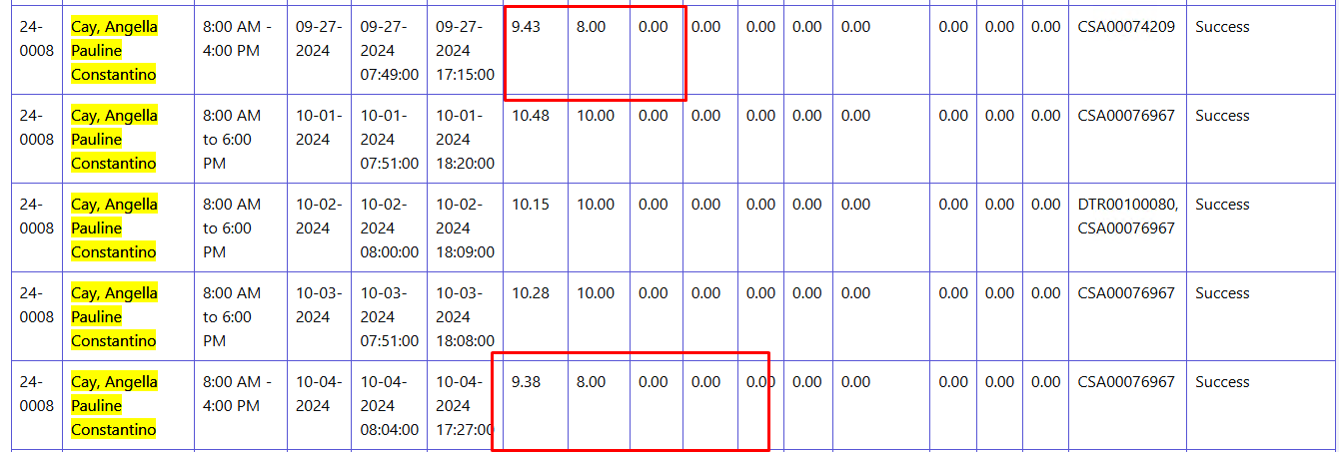

* Commandante, Ciara Galang - Aligned
* 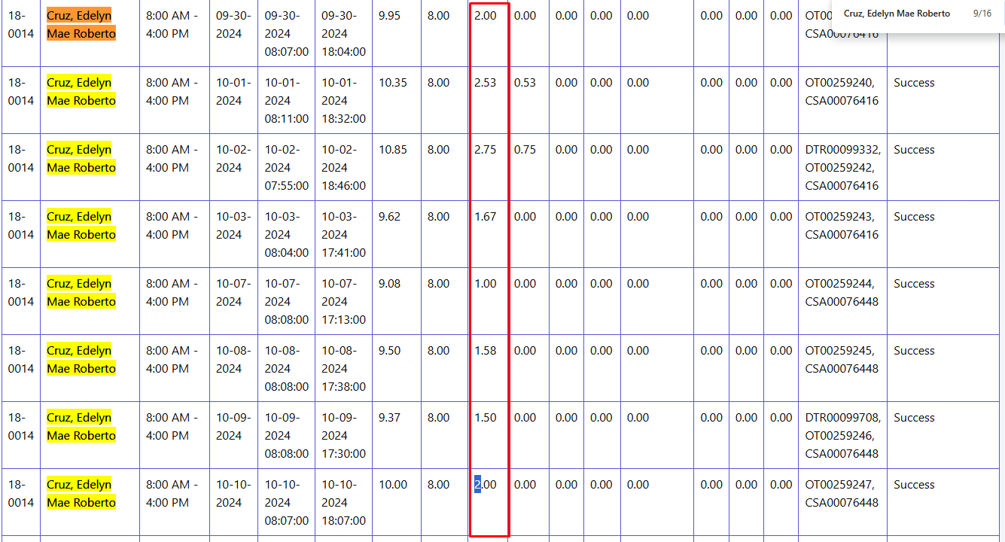Cruz, Edelyn Mae Roberto Aligned
* Cruz, Riza Del Ayre Aligned



* Erno, Marlon Estobo Aligned



* 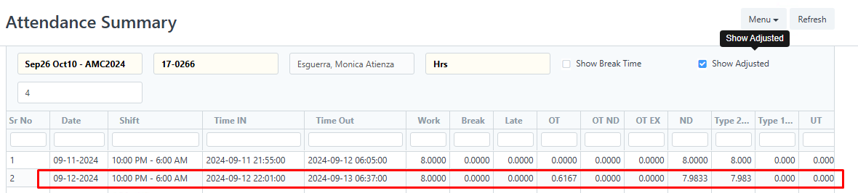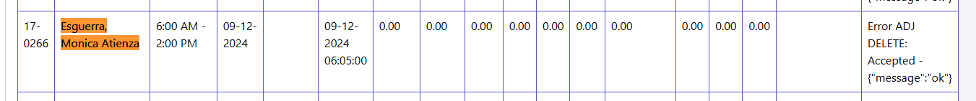 Esguerra, Monica Atienza Walang OT na nalabas



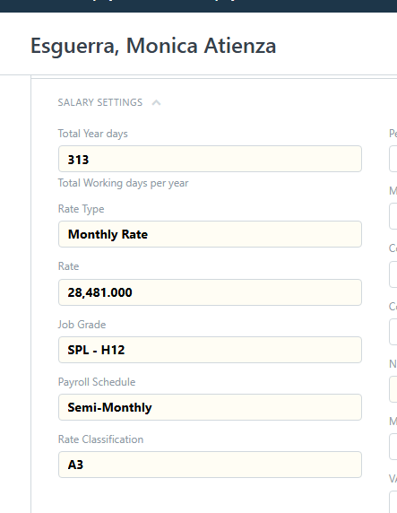

* Maranan, Jonh Paul Abila - May negative na nalabas

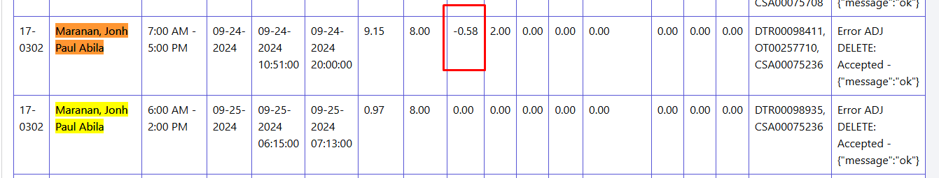



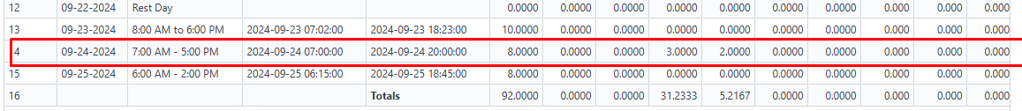

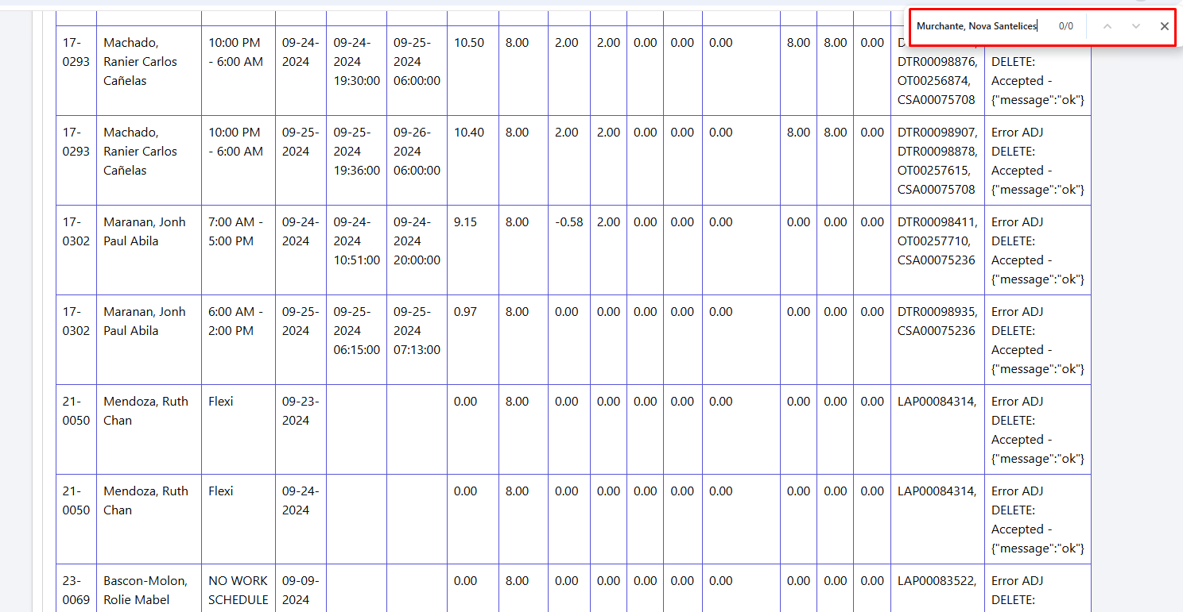Missing employee

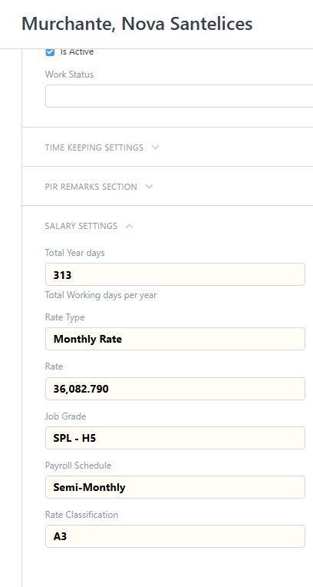



May negative yung OT nya kapag flexi

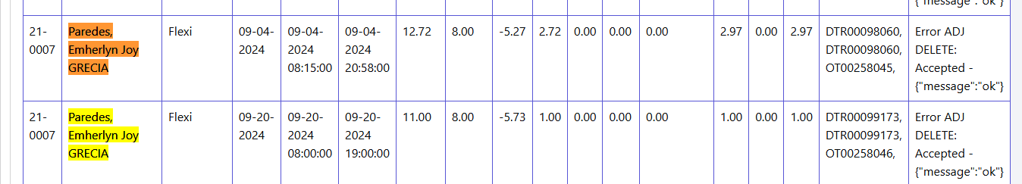

May negative yung OT nya kapag flexi

Tapos yung sep 22 nya walang value yung ot



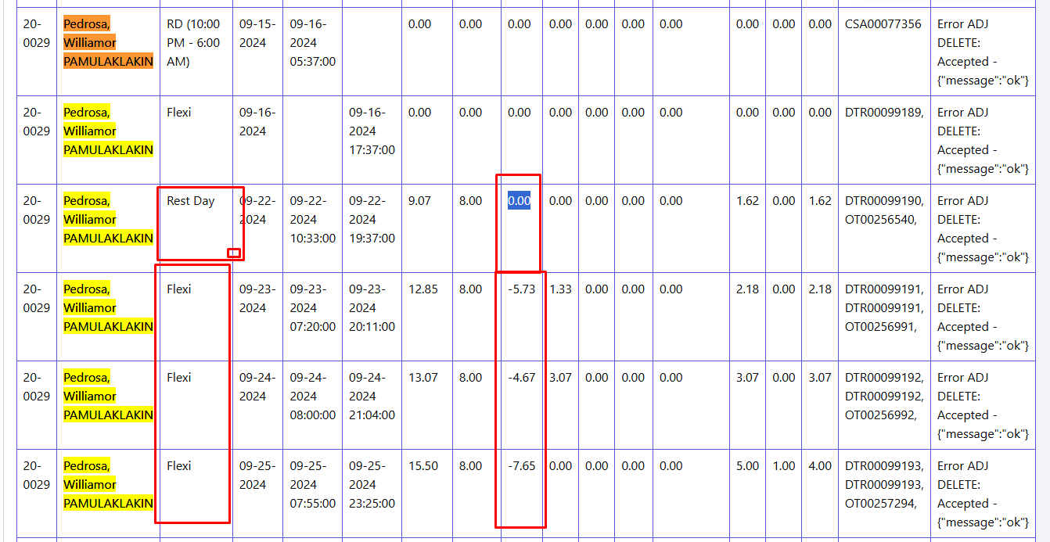

May DTRP at OT pero walang time out

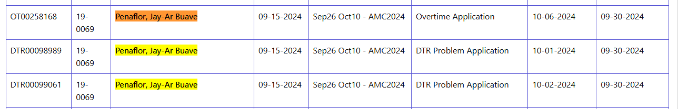

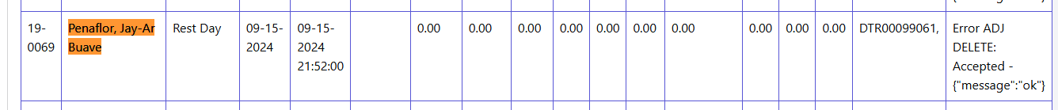

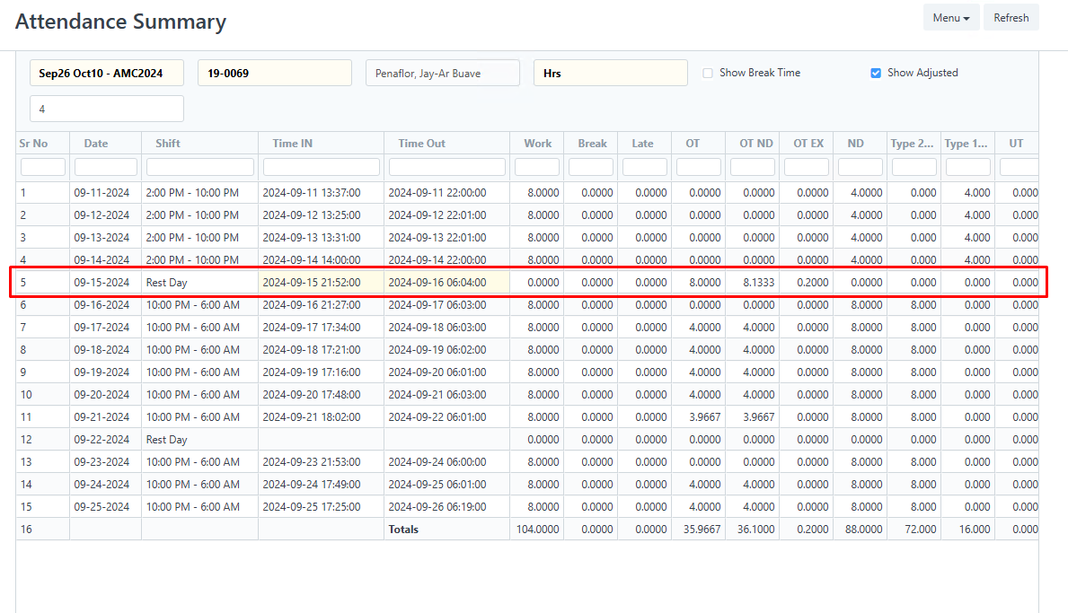

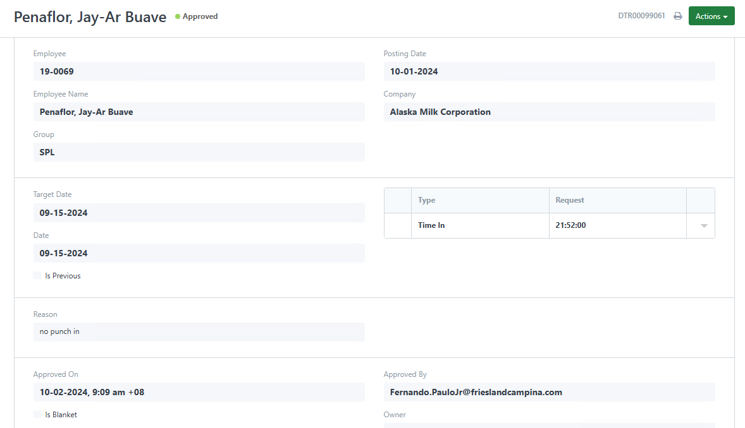

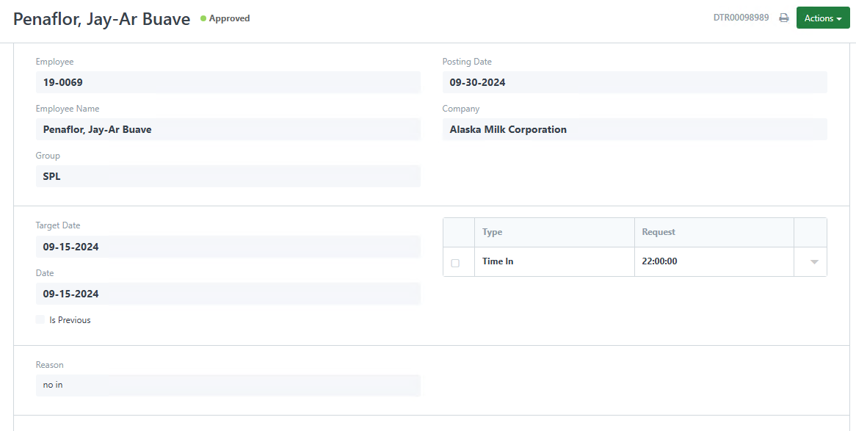



No records found

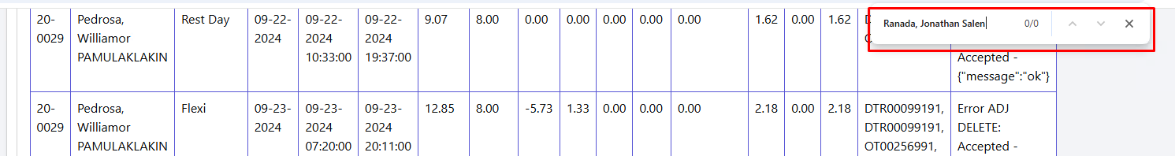

May OT sya dapat pero walang nag rereflec





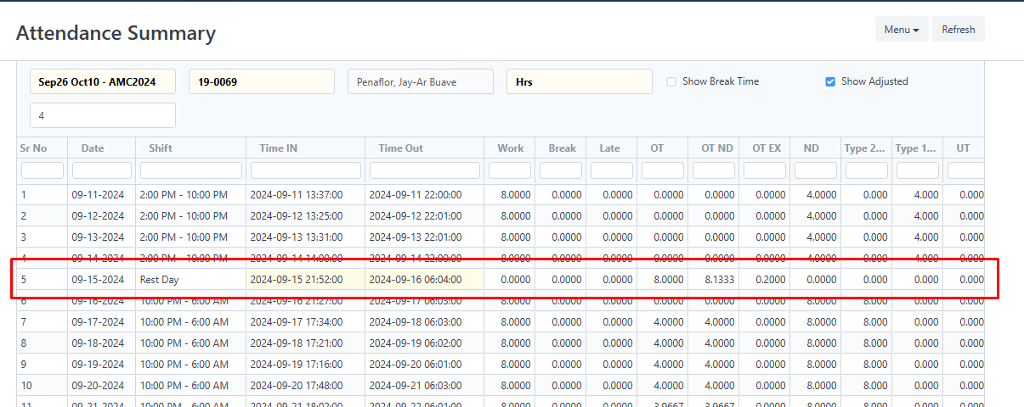

Walang Time out and OT na nacapure

