Comparison of Regression-Adjusted ABC and Neural Methods for Simulation-Based Inference

Stephen Dang
Supervised by Prof. Christopher Drovandi and Dr. David Warne
Queensland University of Technology

Abstract
This project implements and benchmarks regression-adjusted rejection ABC (REJ ABC RA) within a standardised simulation-based inference evaluation pipeline, comparing it against plain rejection ABC and neural posterior estimation (NPE) across seven benchmark tasks and three simulation budgets (10³–10⁵). Regression adjustment consistently improves posterior quality over plain rejection ABC on tasks where the relationship between parameters and data summaries is approximately linear, in some cases halving the error at low budgets with negligible additional runtime. However, on tasks with multimodal or strongly nonlinear posteriors, a single linear correction can actively hurt performance at small budgets by miscorrecting accepted samples. NPE remains the most accurate method overall, but requires orders of magnitude more computation. These results clarify when regression adjustment is a reliable and essentially free upgrade to classical ABC, and when its assumptions break down.
- Introduction
1.1 Motivation
Many problems in science and engineering involve models that are easy to simulate but hard to analyse mathematically. Given a set of parameters, such a model can generate synthetic data — but working backwards from data to parameters is difficult because the underlying probability of observing the data cannot be written down in a tractable form. Simulation-based inference (SBI) addresses this by using repeated simulations to approximate the answer instead.
A large family of SBI methods exists, ranging from classical Approximate Bayesian Computation (ABC) — which accepts or rejects simulated parameters based on how closely they reproduce the observed data — to modern neural approaches that learn a model of the posterior directly from simulations. Comparing these methods rigorously is challenging because results can depend heavily on the task, the simulation budget, and the choice of evaluation metric. Lueckmann et al. (2021) introduced SBIBM to address this, providing a standardised set of benchmark tasks, reference posteriors, and evaluation protocols that allow methods to be compared fairly.
Within classical ABC, a well-known issue is that accepted samples are rarely a perfect match to the observed data, introducing bias into the posterior approximation. Regression adjustment (RA) is a post-processing technique designed to correct for this, and Li and Fearnhead (2018) provide theoretical guarantees that it can improve posterior accuracy under appropriate conditions. This project implements regression-adjusted rejection ABC within the SBIBM framework and benchmarks it against plain rejection ABC and neural posterior estimation, with the goal of understanding when regression adjustment helps, when it fails, and how it compares to a neural alternative under matched simulation budgets.
  - Research Questions
This report addresses three research questions:
RQ1. Does regression adjustment consistently improve the posterior quality of rejection ABC across tasks and simulation budgets (10³–10⁵ simulations)?
RQ2. Which task characteristics predict when regression adjustment helps versus fails? In particular, how do properties such as local linearity of the parameter–summary relationship and multimodality of the posterior relate to RA performance?
RQ3. Under matched budgets, can regression adjustment make classical rejection ABC competitive with neural posterior estimation in accuracy and efficiency?

  - Contributions
The main contributions of this work are:
- Implementation: We implement regression-adjusted rejection ABC (REJ ABC RA) within the SBIBM-style evaluation pipeline, using the same protocol and budgets as baseline methods.
- Controlled benchmarking: We compare REJ ABC, REJ ABC RA, and NPE across multiple SBIBM tasks under matched simulation budgets (10³–10⁵) and repeated runs.
- Evaluation: We report posterior quality using two-sample metrics (MMD) and include runtime/efficiency summaries, aligning with SBIBM’s emphasis that metric choice affects conclusions.
- Interpretation via task geometry: We organise tasks into two groups based on posterior/summary geometry (smooth/locally linear vs complex/multimodal) and use this grouping to explain when RA behaves as a strong “default upgrade” and when it can fail.
- Documentation of scope: We clearly document any excluded tasks and the reasons for exclusion, to preserve reproducibility and interpretability.

  - Statement of Authorship
All experiments, code implementation, and analyses presented in this report are my own work under the supervision of Professor Christopher Drovandi and Dr David Warne, except where explicitly acknowledged. Benchmark software (SBIBM / sbi) and third-party libraries are cited in the references.

- Background and Related Work
2.1 Simulation-Based Inference (SBI)
In many scientific settings, the forward model is a stochastic simulator: given parameters $θ$, it generates synthetic data $x$, but the likelihood $p(x∣θ)$is often intractable, making standard Bayesian or frequentist likelihood-based inference difficult. Cranmer et al. (2020) describe such models as implicit and emphasize that the core challenge is precisely the inability to evaluate the likelihood, motivating simulation-based inference as a more appropriate umbrella term than “likelihood-free inference.”
SBI methods aim to approximate the posterior $p(θ∣x_{o})$using simulation. At a high level, the workflow is: specify a prior $p(θ)$, generate simulations $x∼p(⋅∣θ)$, optionally reduce data to summaries $s(x)$, and then use an inference procedure to approximate the posterior. Cranmer et al. (2020) distinguish “simulator-in-the-loop” approaches (e.g., ABC) from surrogate-based approaches that train models such as neural conditional density estimators to amortise inference across observations.
  - Approximate Bayesian Computation (ABC)
Approximate Bayesian Computation (ABC) is a classical SBI approach that bypasses likelihood evaluation by comparing simulated and observed data (or summaries). As described by Sunnåker et al. (2013), all ABC-based methods approximate the likelihood function through simulation, comparing synthetic outputs against observed data. In the basic rejection ABC algorithm, parameters are sampled from the prior, data are simulated under those parameters, and the parameter draw is accepted if the simulated data are sufficiently close to the observed data under a distance function and tolerance ε. Because exact matching is essentially impossible for nontrivial continuous data, a strictly positive tolerance is typically required, which introduces approximation error and a bias toward sampling from p(θ | r(D̂, D) ≤ ε) rather than the true posterior p(θ | D).
A key practical issue is the curse of dimensionality: as Sunnåker et al. (2013) note, acceptance probability typically decreases as the dimensionality of the data increases, which substantially reduces computational efficiency. A common remedy is to replace the full data with a set of lower-dimensional summary statistics s(x) and accept based on distance in summary space. If summaries are sufficient with respect to the model parameters, this compression preserves all information about θ without introducing additional error. However, as Sunnåker et al. (2013) observe, sufficient low-dimensional statistics are typically unattainable for the complex models where ABC is most relevant, and using poorly chosen summaries can lead to inflated credible intervals and additional posterior bias. The choice of summary statistics therefore becomes a major source of approximation error in practice.
  - Regression Adjustment (RA) for ABC
Regression adjustment (RA) is a widely used post-processing step designed to reduce ABC bias due to imperfect matching between simulated and observed summaries. Intuitively, even “accepted” simulations usually satisfy $s_{i}≈s_{\text{obs}}$rather than $s_{i}=s_{\text{obs}}$; RA attempts to correct accepted parameters $θ_{i}$toward what would be expected if the summaries exactly equaled the observation.
Li and Fearnhead (2018) formalize the commonly used local linear regression adjustment (introduced by Beaumont et al.) by fitting a linear model of $θ_{i}$ on $\left(s_{i} − s_{\text{obs}}\right)$and constructing adjusted samples $θ_{i}^{\text{*}}=θ_{i}-{\hat{β}}_{ε}(s_{i}-s_{\text{obs}})$.
Beyond this mechanism, Li and Fearnhead (2018) provide convergence results showing that, with appropriate bandwidth scaling, regression adjustment can yield a posterior that asymptotically correctly quantifies uncertainty, and they argue that the adjustment can be applied routinely when regression coefficients can be estimated accurately.
In practice, RA relies on assumptions that are often only approximately true: it is most effective when the parameter–summary relationship is locally close to linear and when the accepted sample cloud represents a single “local neighborhood” of the posterior. If the posterior is strongly nonlinear or multimodal, a single global linear correction can over- or under-correct.
2.4 Neural Posterior Estimation (NPE)
Neural Posterior Estimation (NPE) belongs to the class of SBI methods that learn a model of the posterior directly using a conditional density estimator. Greenberg et al. (2019) describe posterior density estimation approaches as training a neural network to map simulated data $x$to an estimated posterior density $q(θ∣x)$, enabling amortized inference without running a separate sampler at test time. A major motivation is that sampling $θ$from the prior can be wasteful when the posterior occupies only a small region of parameter space; sequential strategies adapt proposals toward regions that better explain the observation.
However, sequential proposals introduce a technical challenge: training on simulations generated from proposals other than the prior can require either post-hoc corrections or importance weighting, which can increase estimator variance and harm learning stability. Greenberg et al. (2019) present APT as one sequential NPE approach designed to support flexible proposals while avoiding some of these issues, and they highlight that neural approaches can scale to higher-dimensional observations and reduce reliance on hand-crafted summaries in some settings.
2.5 Benchmarks and metrics
Because SBI methods span many algorithmic families and are evaluated under different tasks, metrics, and budgets, comparing methods can be difficult. Lueckmann et al. (2021) argue that SBI comparisons have been fragmented—different studies use different tasks and metrics, comprehensive multi-task comparisons are rare, and metric choices can introduce bias—motivating the need for a shared benchmark framework. They introduce SBIBM, providing tasks, reference posteriors, metrics, plotting, and infrastructure tooling to enable rapid and reproducible comparisons. The framework is designed so that reference (“ground-truth”) posterior samples are available for evaluation, enabling consistent two-sample testing.
SBIBM evaluates algorithms under fixed observations and varying simulation budgets (e.g., 1k to 100k simulations), and reports performance via multiple metrics and runtime.
The central posterior-quality metrics are:
- Maximum Mean Discrepancy (MMD): a kernel-based two-sample test comparing samples from the inferred posterior to samples from the reference posterior. SBIBM notes that MMD can be sensitive to kernel hyperparameters, especially for complex or multimodal posteriors when using common heuristics such as the median heuristic for kernel length-scale selection.
Crucially, SBIBM emphasizes that metric choice can change conclusions: for example, trends visible under C2ST may not appear under MMD depending on hyperparameter settings, and some metrics can be “gamed” by good point estimates despite poor posterior quality.
In this project, SBIBM provides the standardized evaluation setting and metrics needed to compare classical ABC variants (with and without regression adjustment) and neural posterior estimation under matched simulation budgets.
- Methods
This section describes the methods compared and the exact implementation choices used to ensure a fair comparison under matched simulation budgets.
3.1 Methods compared
All methods are evaluated on the same benchmark tasks, fixed observations, and simulation budgets $N∈\{{10}^{3},{10}^{4},{10}^{5}\}$.
Rejection ABC (REJ ABC).
Sample $θ_{i}∼p(θ)$, simulate $x_{i}∼p(x∣θ_{i})$, compute a discrepancy $d_{i}$to the observed data $x_{\text{obs}}$, and retain the $k$smallest-distance particles. The accepted parameters approximate draws from the ABC posterior.
Rejection ABC with regression adjustment (REJ ABC RA).
Use the same accepted set as REJ ABC, then apply a local regression adjustment to reduce the bias induced by imperfect matching between simulated and observed outputs.
Neural Posterior Estimation (NPE).
Train a conditional density estimator $q_{ϕ}(θ∣x)$on simulated $\left(θ , x\right)$pairs using a sequential NPE procedure (SNPE-C/APT with normalising flows). Posterior samples are generated by sampling from $q_{ϕ}(θ∣x_{\text{obs}})$.
3.2 Regression adjustment for rejection ABC
Accepted set (top-$k$)
We use a top-$k$ acceptance rule (rather than an $ε$-threshold). For a given budget $N$, we generate $\left\{(θ_{i},x_{i})\}_{i=1}^{N}\right.$and compute distances
$$d_{i}=∥x_{i}-x_{\text{obs}}∥_{2},$$
where simulator outputs and the observation are flattened into vectors. Let $A$denote the indices of the $k$smallest distances. The baseline REJ ABC posterior sample is $\left\{θ_{i}\}_{i∈A}\right.$. We use $k=100$by default and also test $k=500$.
Local weighting
To emphasize locality around the observation, accepted particles are weighted using an Epanechnikov-style kernel based on their distance:
$$w_{i}=1-{\left(\frac{d_{i}}{d_{max}}\right)}^{2},d_{max}=\underset{i∈A}{max⁡}d_{i},i∈A.$$
Particles closer to $x_{\text{obs}}$receive higher weight.
Covariate preprocessing
We regress on the residual outputs $Δx_{i}=x_{i}-x_{\text{obs}}$. These residual vectors are standardised (z-scored) using the accepted set (with weighted mean and variance). To improve stability in high-dimensional outputs, we optionally apply PCA to obtain a reduced representation.
$${\tilde{x}}_{i}∈R^{m},m≤50,$$
with an additional cap on $m$ when $k$ is small to reduce overfitting risk.
Regression model and adjustment
We fit a local linear model on the accepted set:
$$θ_{i}=β_{0}+{\tilde{x}}_{i}^{⊤}B+ε_{i},i∈A,$$
using weights $w_{i}$. We use either ordinary least squares or ridge regression (with $l_{2}$penalty) to stabilise estimation when the covariates are high-dimensional.
The regression-adjusted parameters are then computed as
$$θ_{i}^{*}=θ_{i}-({\tilde{x}}_{i}-{\tilde{x}}_{\text{obs}})^{⊤}\hat{B},i∈A,$$
where ${\tilde{x}}_{\text{obs}}$is the transformed representation of $x_{\text{obs}}$under the same preprocessing, and $\hat{B}$is the fitted coefficient matrix. This subtracts the estimated local linear dependence of $θ$on the residual discrepancy, yielding parameters corresponding to the hypothetical case where the simulated output equals the observation. The output of REJ ABC RA is the set of $k$adjusted particles $\left\{θ_{i}^{*}\}_{i∈A}\right.$, returned directly.
3.3 Neural posterior estimation setup
NPE is trained on raw simulator outputs. Inputs $x$ and parameters $θ$ are standardised independently. The posterior model is a Neural Spline Flow conditional density estimator with fixed architecture across all tasks.
Training follows a sequential procedure with a fixed number of rounds $R=10$. For the total simulation budget $N$, the per-round budget is
$$N_{r}=\left\lfloor \frac{N}{R}\right\rfloor ,r=1,…,R.$$
After training, we draw $10,000$ posterior samples from the learned model:
$$θ^{\left(j\right)}∼q_{ϕ}(θ∣x_{\text{obs}}),j=1,…,10,000.$$
All neural hyperparameters are held constant across tasks and budgets; only the task, observation, budget, and random seed vary between runs.
3.4 Computational setup and reproducibility
Experiments use:
- Tasks: 7 benchmark tasks
- Budgets: ${10}^{3}$to ${10}^{5}$simulations
- Repeats: 10 independent runs (random seeds) per method–task–budget setting
- Hardware split: REJ ABC and REJ ABC RA run on CPU; NPE runs on GPU.
For each setting, we aggregate results across seeds using the mean of each evaluation metric.
Runtime is measured as end-to-end wall-clock time required to produce posterior samples under a given simulation budget: for ABC methods, this includes simulation and top-$k$ selection (and regression adjustment where applicable), and for NPE, this includes simulation, training across rounds, and posterior sampling.
- Experimental Design

4.1 Tasks and evaluation protocol
We evaluate methods on seven SBIBM benchmark tasks, using SBIBM’s standardised protocol: for each task, SBIBM defines multiple fixed observations and provides reference posterior samples for each observation; algorithms are run at simulation budgets from ${10}^{3}$ to ${10}^{5}$simulations and evaluated by comparing approximate posterior samples to the reference posterior samples.
To interpret when regression adjustment is expected to help, we group tasks by posterior / data–parameter geometry:
Group | Tasks | What to notice (task properties relevant to RA)
A — Smooth / locally near-linear | Gaussian linear; Gaussian linear uniform; Bernoulli GLM; Bernoulli GLM raw | Gaussian linear / uniform are simple 10-dimensional Gaussian models where $θ$is the mean and covariance is fixed; the uniform-prior variant introduces truncated support.  Bernoulli GLM has 10 parameters and is provided both with sufficient statistics (10-d) and raw data (100-d).  The “raw” version increases feature dimension and can make local linear adjustment less stable (more parameters to fit from a small accepted set).
B — Complex / multimodal | SLCP; Two moons; Gaussian mixture | SLCP is constructed to have a simple likelihood but a complex posterior: uniform prior over five parameters, data are four 2D points, and the posterior has four symmetric modes with additional structure.  Two moons is 2D with both global bimodality and local crescent-shaped structure, explicitly testing multimodality.  Gaussian mixture is a mixture of two 2D Gaussians (one much broader than the other) and is common in the ABC literature.  In these settings, accepted samples may come from multiple regions; a single local linear correction can over/under-correct when the accepted set spans distinct modes.
Across tasks, reference posterior samples are used as the evaluation target (SBIBM generates 10k reference posterior samples per observation in their setup).
4.2 Metrics
We evaluate posterior quality using two-sample tests between approximate posterior samples $\{θ_{i}\}_{i=1}^{n}∼q(θ∣x_{\text{obs}})$and reference posterior samples $\{θ_{j}^{'}\}_{j=1}^{m}∼p(θ∣x_{\text{obs}})$, and we also report the runtime.
Maximum Mean Discrepancy (MMD).
MMD measures the distance between distributions by comparing their mean embeddings in a reproducing kernel Hilbert space. With kernel $k(⋅,⋅)$, the population quantity is
$${MMD}^{2}(p,q)=E_{p,p}[k(θ,θ^{'})]+E_{q,q}[k(θ,θ^{'})]-2E_{p,q}[k(θ,θ^{'})].$$
In practice, this is estimated from posterior samples using the usual unbiased/biased sample estimators. In SBIBM, MMD is reported as ${MMD}^{2}$, where 0 is best. A key practical point is that MMD depends on kernel hyperparameters (e.g., RBF length-scale). SBIBM notes MMD can be sensitive to kernel choice, and that the commonly used median heuristic can struggle on multimodal posteriors such as Two Moons, making it harder to distinguish clearly different posteriors unless hyperparameters are adapted.
- Result
5.1 Overall summary
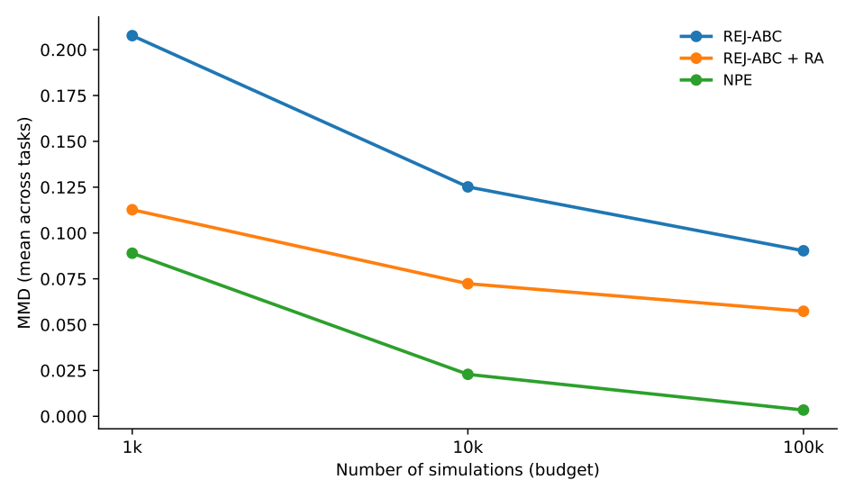
Figure 1: Overall performance: mean MMD across tasks and budget
The aggregate plot tells a clear story. At every simulation budget, the ranking is consistent: NPE < REJ ABC RA < REJ ABC, meaning NPE achieves the lowest (best) MMD, followed by regression-adjusted rejection, then plain rejection. Importantly, regression adjustment provides a meaningful and consistent improvement over plain rejection across all three budgets — at 10³ it roughly halves the MMD (≈0.21 → ≈0.11), and the gap is maintained through to 10⁵ (≈0.09 → ≈0.056). This directly answers RQ1: yes, RA consistently improves posterior quality across budgets.
However, NPE improves far more steeply with budget. By 10⁴ it pulls decisively ahead of both ABC variants, and by 10⁵ its mean MMD is near zero (~0.003) while REJ ABC RA sits at ~0.056. RA cannot make classical ABC competitive with NPE overall (RQ3 answer: no, at the aggregate level), though task-by-task nuance matters here.
5.2 Task-by-Task Breakdown
Group A — Smooth / Locally Near-Linear Tasks
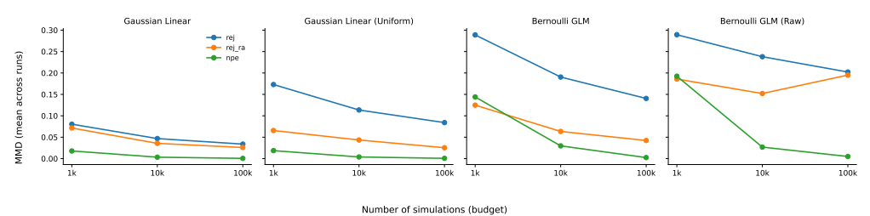
Figure 2: Group A performance: MMD vs Budget
Gaussian linear and Gaussian linear uniform are the clearest success cases for RA. On Gaussian linear, RA consistently sits below plain rejection across all budgets, and the ordering (NPE best, RA middle, REJ worst) holds cleanly throughout. The uniform variant shows an even larger relative gain from RA at 10³ — the gap between REJ and REJ RA is substantial (~0.17 vs ~0.065), and RA maintains this advantage all the way to 10⁵. These are precisely the tasks where RA theory predicts strong performance: the parameter–summary relationship is close to linear, so the local linear correction is well-specified.
Bernoulli GLM also shows RA as a clear improvement over plain rejection across all budgets. RA roughly halves the MMD relative to REJ at each budget point, and both converge toward NPE as budget grows. NPE eventually achieves near-zero MMD at 10⁵, while REJ ABC RA plateaus around 0.044.
Bernoulli GLM raw is the most instructive failure case within Group A. Here, RA starts similarly to plain rejection at 10³, improves modestly at 10⁴, but then increases back up at 10⁵, crossing close to or exceeding the plain rejection line. This is a direct demonstration of your predicted instability: the 100-dimensional raw output makes it much harder to fit a stable linear correction from a small accepted set, and at higher budgets where more simulations are available, the overfitting or ill-conditioning of the regression appears to worsen rather than improve. NPE, by contrast, handles the raw high-dimensional input cleanly and converges to near-zero MMD. This single task is strong evidence for a nuanced answer to RQ2: even within Group A, high-dimensional "raw" summaries can break RA.
Group B — Complex / Multimodal Tasks
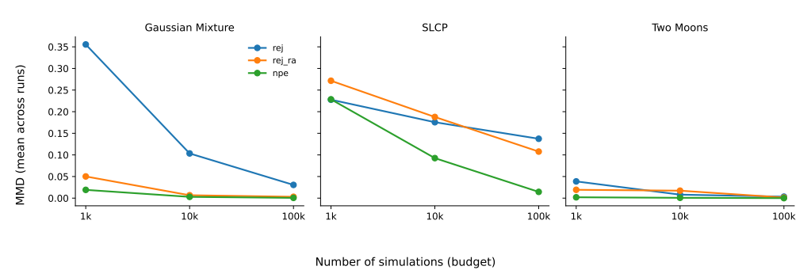
Figure 3: Group B performance: MMD vs budget
Gaussian mixture is a surprising result: RA performs dramatically better than plain rejection at 10³ (~0.05 vs ~0.36), and both RA and NPE converge to near-zero by 10⁴–10⁵. This is the one Group B task where RA is highly effective even at very low budget, likely because the mixture is only 2D and the accepted samples may often land within a single mode, making a local linear correction serviceable. Plain rejection is extremely poor here at small budget, so RA's gain is the largest of any task.
SLCP is the clearest case where RA actively hurts. At 10³, REJ ABC RA actually has a higher MMD than plain rejection (~0.273 vs ~0.229), meaning the linear adjustment is miscorrecting samples — consistent with the four-mode posterior structure causing accepted particles to span distinct regions. By 10⁴ RA recovers to roughly match REJ, and by 10⁵ it finally improves slightly. The damage at low budget is real and noteworthy. NPE dominates across all budgets and converges to ~0.015 by 10⁵.
Two moons also shows RA performing worse than plain rejection at 10³ and 10⁴ (~0.019 vs ~0.039 at 10³, but ~0.017 vs ~0.008 at 10⁴). The crescent-shaped bimodal structure causes the linear adjustment to misalign accepted samples. Interestingly, both methods converge closely by 10⁵, suggesting that at large budget the accepted set is dense enough that the correction becomes less harmful. NPE is far ahead throughout, essentially flat near zero from 10³ onwards.
5.3 Accuracy–Runtime Tradeoff
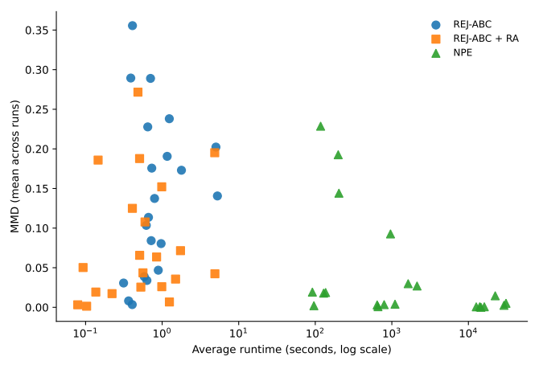
Figure 4: Accuracy-Runtime plot across task and budget
The scatter plot reinforces the aggregate story. REJ ABC and REJ ABC RA cluster tightly in the sub-10-second range (both run on CPU, sub-second to a few seconds per run), while NPE sits in the 10²–10⁴ second range depending on budget. This means REJ ABC RA achieves substantial accuracy improvements over plain rejection at essentially zero additional runtime cost — the regression step is computationally negligible. NPE's superior accuracy comes at 3–5 orders of magnitude greater computational cost. The practical implication: if compute is severely limited and the task geometry is smooth, REJ ABC RA is an efficient choice; if accuracy is the priority and compute is available, NPE is unambiguously better.
- Discussion and Conclusion
6.1 Summary of Findings
This project implemented and benchmarked regression-adjusted rejection ABC (REJ ABC RA) within the SBIBM evaluation framework, comparing it against plain rejection ABC and neural posterior estimation across seven tasks and three simulation budgets.
Three main findings emerge from the experiments.
First, regression adjustment is a consistent and essentially free upgrade over plain rejection ABC when the task geometry is suitable. On Group A tasks — Gaussian linear, Gaussian linear uniform, and Bernoulli GLM — RA reduces MMD substantially at every budget, in some cases halving the error at 10³ simulations, while adding negligible runtime overhead. This confirms the theoretical motivation of Li and Fearnhead (2018): when the parameter–summary relationship is locally well-approximated by a linear map, the correction is well-specified and reliable.
Second, the benefits of RA are not universal and task geometry is the key predictor of when it succeeds or fails. On multimodal tasks — SLCP and two moons — RA can actively hurt performance at low simulation budgets, producing higher MMD than plain rejection. This occurs because accepted particles span multiple posterior modes, making a single global linear correction ill-defined and capable of pushing samples further from the reference posterior rather than closer to it. On Bernoulli GLM raw, instability emerges even within Group A: the 100-dimensional output space makes the regression ill-conditioned, and RA's performance degrades at higher budgets rather than improving. Together, these cases illustrate that RA's assumptions — local linearity and a unimodal, well-concentrated accepted set — are genuine constraints, not just theoretical caveats.
Third, RA cannot close the gap to NPE under matched simulation budgets. NPE improves far more steeply with budget, and by 10⁴–10⁵ simulations it achieves near-zero MMD on most tasks while REJ ABC RA still carries meaningful error. However, NPE requires 3–5 orders of magnitude more computation. In resource-constrained settings where only a few hundred to a few thousand simulations are affordable and the task is smooth, REJ ABC RA represents a practical and well-motivated choice.
6.2 Limitations
Several limitations should be noted when interpreting these results.
Three SBIBM benchmark tasks — Lotka-Volterra (lv), SIR, and SLCP with distractors — were excluded from the evaluation due to compatibility issues with the experimental pipeline. These are among the more complex and higher-dimensional tasks in SBIBM, and their exclusion means the conclusions are drawn from a subset of the benchmark. In particular, the excluded tasks may be precisely the ones where RA would struggle most, potentially making the aggregate results more favourable to RA than a full benchmark would show.
The regression adjustment implemented here is restricted to local linear regression. While this is the most widely studied form of RA and is supported by the theoretical results of Li and Fearnhead (2018), the linear assumption is a genuine constraint. Nonlinear adjustments — such as those based on local polynomial regression, kernel methods, or neural network-based post-processing — may perform better in tasks where the parameter–summary relationship is smooth but not linear.
Finally, this work evaluates RA only in the context of rejection ABC. A natural extension would be to apply regression adjustment within sequential Monte Carlo ABC (SMC-ABC), where the accepted particles are already more concentrated around the posterior. In that setting, the local linearity assumption is more likely to hold even for complex tasks, potentially improving RA's performance in the multimodal regime.
6.3 Future Work
Three directions are most immediate. First, resolving the pipeline compatibility issues to include the three excluded tasks (lv, sir, and slcp distractors) would complete the SBIBM evaluation and provide a more comprehensive picture of RA's behaviour, particularly on high-dimensional and computationally expensive simulators.
Second, exploring richer regression adjustment strategies beyond local linear correction is a natural methodological extension. Non-linear adjustments — such as local polynomial, Gaussian process, or neural network-based post-processing — could better accommodate the curved parameter–summary relationships seen in multimodal tasks, potentially recovering performance in settings where linear RA currently fails.
Third, integrating regression adjustment into an SMC-ABC pipeline is a promising direction. Because SMC-ABC produces a more focused and localised accepted set through sequential tempering, the conditions under which linear RA is well-specified are more likely to be satisfied, even for complex posteriors. Benchmarking RA within SMC-ABC under the same SBIBM protocol would provide a more complete picture of how classical ABC can be strengthened.
6.4 Conclusion
This project demonstrates that regression-adjusted rejection ABC is a simple, computationally negligible enhancement that reliably improves posterior quality when the task geometry is smooth and locally linear. At the same time, the results clarify the conditions under which it fails: multimodal posteriors and high-dimensional raw summaries both break the linear correction assumption, and in these settings RA can be worse than doing nothing at small budgets. NPE remains the more robust and ultimately more accurate option across the full task suite, but at substantially greater computational cost. Regression adjustment occupies a clear and useful niche — as a low-cost default improvement for classical ABC in suitable problems — and the task grouping framework developed here provides a principled way to identify when that niche applies.

Referrences
Lueckmann, J.-M., Boelts, J., Greenberg, D. S., Gonçalves, P. J., & Macke, J. H. (2021). Benchmarking simulation-based inference. Proceedings of the 24th International Conference on Artificial Intelligence and Statistics (AISTATS), 130, 1578–1589
Cranmer, K., Brehmer, J., & Louppe, G. (2020). The frontier of simulation-based inference. Proceedings of the National Academy of Sciences, 117(48), 30055–30062. https://doi.org/10.1073/pnas.1912789117
Li, W., & Fearnhead, P. (2018). Convergence of regression-adjusted approximate Bayesian computation. Biometrika, 105(2), 301–318 . https://doi.org/10.1093/biomet/asx081
Greenberg, D. S., Nonnenmacher, M., & Macke, J. H. (2019). Automatic posterior transformation for likelihood-free inference. Proceedings of the 36th International Conference on Machine Learning, 97, 2404–2414. https://doi.org/10.48550/arXiv.1905.07488
Sunnåker, M., Busetto, A. G., Numminen, E., Corander, J., Foll, M., & Dessimoz, C. (2013). Approximate Bayesian Computation. PLOS Computational Biology, 9(1), e1002803. https://doi.org/10.1371/journal.pcbi.1002803

