# “Presence-Driven Room Lighting System for Cabin using Arduino Nano and Ultra Sonic Sensors ”

## A project report submitted

In partial fulfillment of the requirements.

## For the award of Degree of

**Bachelor of Technology**

### In

**Electronics & Telecommunication Engineering**

By

### Mr. Dnyaneshwar Bagade

(Reg. No: 2020BEC020)

### Mr. Tejas Vaidya

(Reg. No: 2020BEC022)

### Mr. Balaji Kendre

(Reg. No: 2020BEC029)

Under the Guidance of

**Guide : Dr. Lenina SVB**



Department of Electronics and Telecommunication Engineering **SGGS Institute of Engineering and Technology,Vishnupuri,** Nanded, Maharashtra,India-431606

May-2024

**DECLARATION**

We hereby declare that, the dissertation entitled “**Presence-Driven Room Lighting System for Cabin using Arduino Nano and Ultrasonic Sensors"** which is being submitted for the award of Bachelor of Technology to the Department of Electronics and Telecommunication Engineering, Shri Guru Gobind Singhji Institute of Engineering & Technology, Nanded, is an original and independent work. The contents have not been copied from any source without referring the same.

Mr. Dnyaneshwar Bagade Mr. Tejas Vaidya Mr. Balaji Kendre

[2020BEC020] [2020BEC022] [2020BEC029]

**CERTIFICATE**

This is to certify that the topic entitled **"Presence-Driven Room Lighting System for Cabin using Arduino Nano and Ultrasonic Sensors"** is a project completed by Mr. Dnyaneshwar Bagade and Mr. Tejas Vaidya and Mr. Balaji Kendre under my supervision and guidance in the Department of Electronics and Telecommunication Engineering, Shri Guru Gobind Singhji Institute of Engineering and Technology, Nanded, for the award of the degree of Bachelor of Technology.

The content of this dissertation work, in full or parts, has not been submitted to any other Institute or University for the award of any other degree or diploma.

Dr. Lenina SVB External examiner Dr. Milind Bhalerao

Project Guide Head of Department

**APPROVAL SHEET**

This report entitled, "Presence-Driven Room Lighting System for Cabin using Arduino Nano and Ultra Sonic Sensors", by Dnyaneshwar Bagade(2020BEC020), Tejas Vaidya(2020BEC022), Balaji Kendre(2020BEC029) is approved for the degree of Bachelor of Technology.

**Examiners** ________________________

________________________

________________________

**Supervisor (s)**

________________________

________________________

________________________

Date : ____________

Place : ____________

**ACKNOWLEDGEMENT**

I am deeply grateful to the people those who have contributed to the successful completion of this project. Their unwavering support, guidance, and encouragement have been invaluable throughout this journey.

First and foremost, I would like to express my heartfelt gratitude to my project guide, Dr. Lenina SVB. Your insightful feedback, patient mentorship, and expert advice have been crucial in shaping this project. Your dedication to my progress and your willingness to share your extensive knowledge have been truly inspiring.

I am also immensely thankful to our Head of Department, Dr Milind Bhalerao, whose leadership and support provided a conducive environment for this project to thrive. Your encouragement and belief in my capabilities have been a constant source of motivation.

A special thanks to my family and friends for their continuous support and encouragement. Their understanding and patience during the times when I was engrossed in this project are deeply appreciated.

Lastly, I would like to acknowledge my own efforts and dedication to this project. The perseverance and commitment to achieve the set objectives were key to overcoming the challenges encountered along the way.

Thank you all for your contributions and support.

Sincerely,

Dnyaneshwar Bagade [2020BEC020]

Tejas Vaidya [2020BEC022]

Balaji kendre [2020BEC029]

**ABSTRACT**

The objective of the project is to save electricity that is unnecessarily wasted. Generally, we human beings may forget to switch off the lights and fans when leaving out of the room. We may think it doesn’t cost much, but actually, we are wasting a lot of electric power. A controller which can monitor the presence of a person and act accordingly will reduce the electric power which can be installed in any houses, colleges, offices etc. Ultrasonic Sensor and an Arduino board are used to monitoring the presence of people in the room. So ideally when the room is empty and when a person entering the room the lights and fans will be turned on and when there was no one in the room they will go off automatically. Our main objective of this work is to control the wastage of electricity and making people ease of living.

# INDEX

# INTRODUCTION

# 1.1 Aim ………………………………………………………………………………… 1

# 1.2 Objective …………………………………………………………………………… 1

# 1.3 Overview …………………………………………………………………………… 2

# LITERATURE SURVEY

# 2.1 Related Work …………..…………………………………………………………… 3

# 2.2 Detailed Literature Review .………………………………………………………... 4

# COMPONENT DESCRIPTION

# 3.1 Arduino Nano …………………………………………………………………....... 5

# 3.2 Ultrasonic Sensors ...………………………………………………………………. 7

# 3.3 Relay Module ……..……………………………………………………………….. 9

# 3.4 Breadboard ………..……………………………………………………………….. 10

# 3.5 Circuit Daigram ……………………………………………………………............. 12

# PROGRAM CODE

# 4.1 Program Code ………………………………………………………………………. 13

# 4.2 Code Explanation

# 4.2.1 Setup………………………….……………………………………….………. 16

# 4.2.2 Loop ……………………….…….……………………………………….…… 16

# 4.3 Working of the System

# 4.3.1 UltraSonic Sensor ……………….…………………………………….……… 17

# 4.3.2 Detection Logic ………………….……………………………………….…… 18

# 4.3.3Person Count Management ……...…………………………………….………. 18

# 4.4.4 Lighting Control ………...……….…………………………………….……… 19

# BENEFITS IN DAY TO DAY LIFE

# 8.1 Benefits …………………………………………………………………………… 20

# 8.2 Explanation of Savings……………………………………………………………. 21

# CONCLUSION 23

# 7. FUTURE SCOPE 25

# 8. REFERANCE 27

# 9. APPENDIX

# APPENDIX A…………………………………………………………………….. 28

# APPENDIX B…………………………………………………………………….. 32

**LIST OF FIGURES**

1. Figure 1.1: Arduino Nano ………………………………………………. 5
2. Figure 1.2: Arduino Nano Pin Configuration…………………………… 6
3. Figure 2.1: Ultrasonic Sensor …………………………………………… 7
4. Figure 2.2: Ultrasonic Sensor Pin Configuration………………………… 8
5. Figure 3.1: Relay Module…………………………………………………9
6. Figure 4.1: Breadboard………………………………………………….. 10
7. Figure 5: Circuit Diagram………………………………………………. 12
8. **INTRODUCTION**

**1.1. Aim**

The aim of this project is to design and implement an efficient, automated room lighting system for a cabin, which uses Arduino Nano and ultrasonic sensors to detect human presence and control lighting accordingly. This system seeks to enhance energy efficiency by ensuring that lights are only turned on when the cabin is occupied, thereby reducing unnecessary power consumption. Additionally, the project aims to create a user-friendly and cost-effective solution that can be easily integrated into existing infrastructure, promoting sustainable energy practices.

**1.2. Objectives**

The primary objective of this project is to design and implement an intelligent room lighting system that automatically controls the lighting based on the presence and movement of individuals within a cabin. By utilizing an Arduino Nano microcontroller in conjunction with ultrasonic sensors, the system aims to enhance energy efficiency and convenience. The specific goals are:

1. **Automated Lighting Control:** Develop a system that can detect human presence and movement using ultrasonic sensors and subsequently control the room lights, ensuring they are turned on when the room is occupied and off when it is vacant.
2. **Energy Efficiency:** Reduce unnecessary energy consumption by ensuring that lights are only in use when needed, thus contributing to overall energy savings.
3. **User Convenience:** Enhance user experience by automating the lighting system, eliminating the need for manual operation of light switches.
4. **Scalability and Adaptability:** Ensure that the system can be easily scaled and adapted to different room sizes and configurations, making it applicable for various residential and commercial settings.
5. **Cost-Effectiveness:** Utilize readily available and cost-effective components to build the system, ensuring affordability without compromising on performance.

1

By achieving these objectives, the project aims to provide a practical, efficient, and user-friendly solution for automated room lighting control.

**1.3. Overview**

The 'Presence-Driven Room Lighting System for Cabin' is a project aimed at automating the lighting control within a confined space using modern technology. By leveraging Arduino Nano and ultrasonic sensors, this system intelligently manages the cabin's lighting based on the presence of occupants. This approach not only enhances convenience but also promotes energy efficiency by ensuring lights are only active when needed.

At the heart of this system is the Arduino Nano, a versatile microcontroller known for its ease of use and compatibility with various sensors. Ultrasonic sensors play a crucial role in detecting the presence and movement of individuals within the cabin. These sensors emit ultrasonic waves and measure the time taken for the waves to bounce back after hitting an object, thus determining the distance to the object and effectively detecting occupancy.

The system is designed to automatically turn on the lights when a person enters the cabin and turn them off when the cabin is vacant. This is achieved by continuously monitoring the data from the ultrasonic sensors. When the sensors detect a significant change in distance, indicating entry or exit, the Arduino processes this information and triggers the lighting control mechanism accordingly.

This project addresses the common issue of energy wastage due to lights being left on in unoccupied rooms. By automating the lighting based on real-time occupancy data, it ensures that energy consumption is minimized, which is particularly beneficial in settings where manual control may be neglected. Additionally, it adds a layer of convenience for users, eliminating the need for manual switches.[7]

The implementation involves both hardware and software components. The hardware setup includes the Arduino Nano, ultrasonic sensors strategically placed to cover the cabin's entry and exit points, and relay modules to control the lighting circuit. On the software side, the Arduino is programmed using the Arduino IDE, with code written to process sensor data and control the relays.

2

# LITERATURE SURVEY

The "Presence-Driven Room Lighting System for Cabin using Arduino Nano and Ultrasonic Sensors" aims to automate lighting control based on the occupancy of a room. This technology addresses energy efficiency by ensuring lights are only on when necessary, which is crucial in today’s energy-conscious world. Various studies and projects have been conducted to develop similar systems using different sensors and microcontrollers, highlighting the effectiveness and importance of such solutions.

**2.1. Related Work**

**1. Ultrasonic Sensor-Based Systems**

Ultrasonic sensors are widely used in automation for distance measurement due to their accuracy and ease of implementation. They emit high-frequency sound waves and measure the time taken for the echo to return, allowing precise distance calculation. Various projects have utilized ultrasonic sensors for occupancy detection, object avoidance in robotics, and even in parking assistance systems.

**2. Arduino-Based Automation**

Arduino, an open-source microcontroller platform, is popular for its simplicity and versatility in developing automation systems. It supports numerous sensors and modules, making it suitable for creating prototypes and implementing real-world projects. The use of Arduino in home automation, environmental monitoring, and educational tools has been extensively documented.

**3. Presence Detection and Energy Saving**

Studies have shown that a significant amount of energy is wasted due to lights being left on in unoccupied rooms. Automated lighting systems using sensors can reduce this waste by ensuring lights are only on when the room is occupied. Different sensor technologies like Passive Infrared (PIR), ultrasonic, and camera-based systems have been explored for presence detection.

3

**2.2. Detailed Literature Review**

**1. Ultrasonic Sensors in Occupancy Detection**

A study by K. Sathish Kumar et al. (2017) investigated the use of ultrasonic sensors for occupancy detection in a smart home system. The researchers found that ultrasonic sensors provide reliable distance measurements, which can be used to infer occupancy with high accuracy. Their system could detect multiple entries and exits, adjusting the lighting and HVAC systems accordingly.

**2. Arduino-Based Home Automation**

In the work by A. ElShafee and K. A. Hamed (2012), an Arduino-based home automation system was developed to control various household appliances through a web-based interface. This system demonstrated the flexibility and capability of Arduino in integrating different sensors and modules for comprehensive home automation solutions.

**3. Energy Efficiency through Automated Lighting**

A research paper by R. Priyasree et al. (2014) focused on energy-saving techniques using automated lighting systems in commercial buildings. They implemented a system using PIR sensors and found a substantial reduction in energy consumption. Although PIR sensors were used, the principle of using sensor-based systems to control lighting was validated, and the potential for ultrasonic sensors was suggested.

**4. Comparison of Sensor Technologies**

An article by G. Mois et al. (2017) compared various sensor technologies for occupancy detection. They evaluated PIR, ultrasonic, and camera-based systems, concluding that while camera-based systems provide the highest accuracy, they are also the most complex and expensive. Ultrasonic sensors offer a good balance of accuracy, cost, and simplicity, making them suitable for projects like the one proposed.

4

**3. COMPONENTS DESCRIPTION**

**3.1. Arduino Nano**

The Arduino Nano is a compact and versatile microcontroller board based on the ATmega328P or ATmega168 in Fig.1.1, making it suitable for small-scale projects like the Presence-Driven Room Lighting System for Cabin. Below are the details of the Arduino Nano, including the pin configurations used in this project.[2]

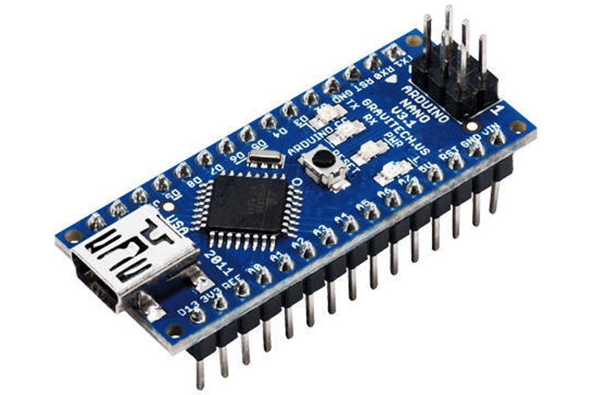

Fig.1.1. Arduino Nano

**Key Features**

* **Microcontroller**: ATmega328P or ATmega168
* **Operating Voltage**: 5V
* **Input Voltage**: 7-12V (via Vin pin)
* **Digital I/O Pins**: 14 (of which 6 provide PWM output)
* **Analog Input Pins**: 8
* **Flash Memory**: 32 KB (ATmega328P) or 16 KB (ATmega168)
* **SRAM**: 2 KB (ATmega328P) or 1 KB (ATmega168)
* **EEPROM**: 1 KB (ATmega328P) or 512 bytes (ATmega168)
* **Clock Speed**: 16 MHz

**Pin Configuration and Usage**

For the Presence-Driven Room Lighting System, the following pins of the Arduino Nano are used:

1. **Power Supply Pins**
   * **Vin**: Used to supply input voltage to the board if you are using an external power source (7-12V).
   * **5V**: Provides regulated 5V output to power external components.
   * **GND**: Ground pins for completing the electrical circuit.

5

1. **Digital Pins**
   * **D2** and **D3**: Used for connecting ultrasonic sensors (Trigger and Echo pins respectively).
   * **D13**: Connected to the onboard LED (can be used for debugging).
2. **Analog Pins**
   * **A0-A7**: Can be used for additional sensors or inputs if needed. In this project, these might remain unused or can be utilized for future expansions.
3. **PWM Pins**
   * **D3, D5, D6, D9, D10, D11**: These pins provide Pulse Width Modulation (PWM) output and can be used to control the brightness of the LED lights if needed.

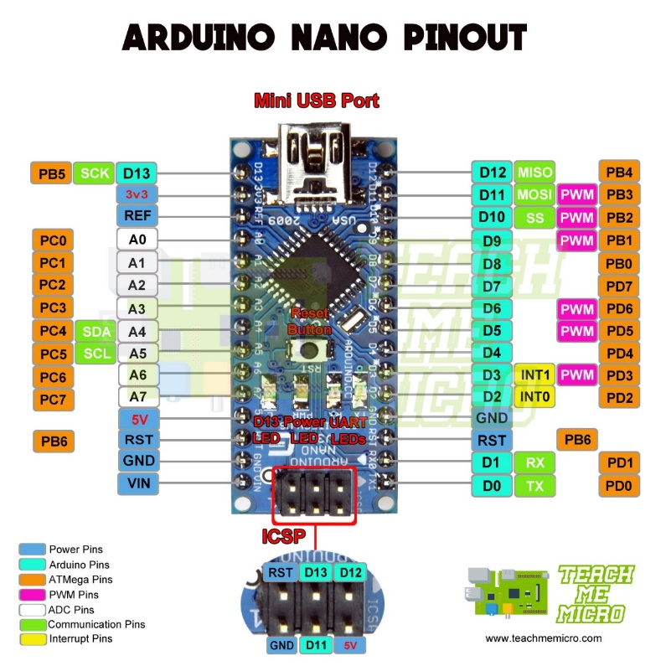

Fig.1.2. Arduino Nano pin configuration

**Software Integration**

The Arduino Nano is programmed using the Arduino IDE. The code involves initializing the pins, reading data from the ultrasonic sensors, and controlling the relay based on the presence detection.

6

**3.2. Ultrasonic Sensor**

Ultrasonic sensors are widely used for distance measurement and occupancy detection. These sensors operate by emitting ultrasonic waves and measuring the time it takes for the waves to reflect back from an object. This time interval is then used to calculate the distance between the sensor and the object. In the context of the Presence-Driven Room Lighting System, ultrasonic sensors in Fig.2.1 are employed to detect the presence and movement of individuals within the cabin, enabling automatic lighting control.[1]

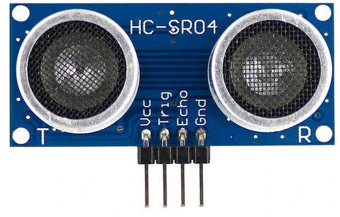

Fig.2.1. Ultrasonic Sensor

**Key Features**

* **Non-contact Measurement:** Ultrasonic sensors can measure distances without physical contact, making them suitable for applications where cleanliness or safety is a concern.
* **High Accuracy:** They provide accurate distance measurements, typically within a few millimeters.
* **Wide Range:** These sensors can detect objects within a range of a few centimeters to several meters, depending on the model.

**HC-SR04 Ultrasonic Sensor**

One of the most commonly used ultrasonic sensors in Arduino projects is the HC-SR04. It is an affordable and reliable sensor that is well-suited for presence detection and distance measurement tasks.[8]

**7**

**Pin Details**

The HC-SR04 sensor has four pins:

1. **VCC:** This pin is used to connect the sensor to the 5V power supply from the Arduino.
2. **Trig (Trigger):** This pin is used to send out ultrasonic pulses. When a pulse is sent, the sensor starts measuring the time taken for the pulse to return.
3. **Echo:** This pin receives the reflected pulse. The time interval between sending and receiving the pulse is used to calculate the distance.
4. **GND:** This pin is connected to the ground of the Arduino.

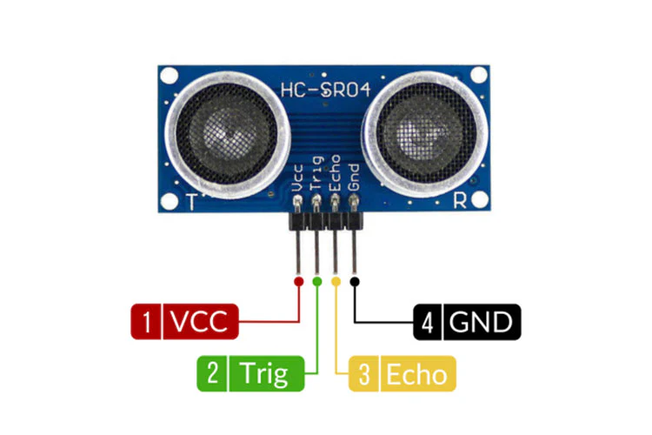

Fig.2.2. Ultrasonic Sensor Pin Configuration

**Wiring for Ultrasonic Sensor**

For each ultrasonic sensor (e.g., HC-SR04), you need four connections:

* **VCC**: Connect to 5V pin of Arduino Nano.
* **GND**: Connect to one of the GND pins.
* **Trig**: Connect to a digital pin (e.g., D2).
* **Echo**: Connect to another digital pin (e.g., D3).

8

**3.3. Relay Module**

A relay module as shown in Fig.3 is an electrically operated switch that allows you to control a high-power electrical device, such as a light bulb, using a low-power signal from a microcontroller like the Arduino Nano. It acts as an interface between the low-voltage Arduino system and the high-voltage lighting system, enabling safe and efficient switching.[9]

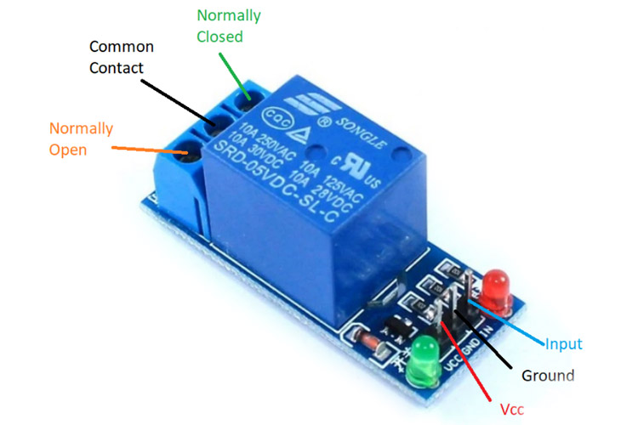

Fig.3. Relay Module

**Components and Functionality**

A typical relay module includes the following key components

1. **Electromagnetic Relay**: The core component that physically switches the high-voltage circuit on or off.
2. **Transistor**: Used to amplify the control signal from the Arduino Nano, allowing it to activate the relay.
3. **Diode**: Protects the transistor from voltage spikes generated by the relay coil.
4. **Optocoupler**: Provides electrical isolation between the high-voltage and low-voltage sides, enhancing safety.
5. **Indicator LED**: Indicates the status of the relay (ON or OFF).

**Working Principle**

The relay module operates based on the control signal received from the Arduino Nano. When the ultrasonic sensor detects the presence of an occupant, the Arduino Nano sends a low-power signal to the relay module. This signal activates the transistor, allowing current to flow through the relay coil. As a result, the relay switch closes, completing the high-voltage circuit and turning on the light. When no presence is detected, the Arduino stops sending the signal, the relay coil is de-energized, and the switch opens, turning off the light.

9

**Wiring and Connections**

For this project, the relay module connections are as follows:

* **VCC**: Connects to the 5V pin on the Arduino Nano.
* **GND**: Connects to the ground (GND) pin on the Arduino Nano.
* **IN**: Connects to a digital output pin on the Arduino Nano (e.g., D2) to receive the control signal.

On the high-voltage side:

* **COM (Common)**: Connects to one terminal of the light bulb.
* **NO (Normally Open)**: Connects to the live wire from the power source. The circuit is completed when the relay is activated.
* **NC (Normally Closed)**: Not used in this project, as the light should be off by default.

**Safety Considerations**

When working with high-voltage circuits, safety is paramount. Ensure that all connections are secure and insulated. Always power off the system before making adjustments. The relay module's optocoupler provides isolation to protect the Arduino and the user from electrical hazards.

**3.4. Breadboard**

In the "Presence-Driven Room Lighting System for Cabin using Arduino Nano and Ultrasonic Sensors," a breadboard plays a crucial role in prototyping the circuit. It allows for easy and flexible connections without the need for soldering, making it ideal for testing and debugging the system.

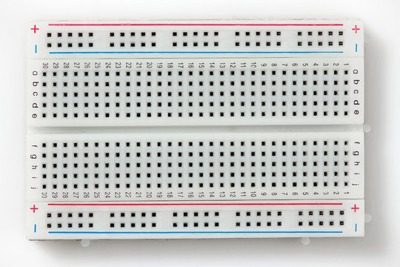

Fig.4. Breadboard

10

**Structure and Function**

A breadboard is a rectangular plastic board with a grid of tiny holes, used for constructing electronic circuits. The holes are connected in a specific manner: horizontal rows at the top and bottom (power rails) are usually connected along their length, while vertical columns in the main area (terminal strips) are connected in short segments. This structure allows components to be inserted and interconnected easily.

**Integration in the Project**

1. **Arduino Nano Connection**: The Arduino Nano is placed on the breadboard with its pins inserted into the terminal strips. This setup allows for easy access to the Nano's pins for connecting other components.
2. **Ultrasonic Sensors**: The ultrasonic sensors are connected to the breadboard, with their VCC and GND pins linked to the power rails, and the trigger and echo pins connected to specific Arduino Nano pins via the terminal strips.
3. **Relay Module**: The relay module, which controls the lighting, is also connected to the breadboard. The input pins of the relay are connected to the Arduino Nano, while the output pins are connected to the lighting circuit.
4. **Power Supply**: The breadboard's power rails are used to distribute power from a common source to the Arduino Nano and sensors. This ensures all components receive the necessary voltage.

**Benefits of Using a Breadboard**

* **Flexibility**: The breadboard allows for quick modifications and adjustments to the circuit, which is essential during the prototyping and testing phases.
* **Ease of Use**: Components can be easily added, removed, or rearranged without soldering, making the development process more efficient.
* **Reusability**: Breadboards are reusable, which is cost-effective for iterative development and testing of multiple projects.

11

**CIRCUIT DIAGRAM**

The provided circuit diagram in Fig 5 illustrates a presence-driven room lighting system using Arduino Uno, two ultrasonic sensors, a relay module. This setup detects room occupancy to automatically control the lighting, enhancing energy efficiency and user convenience.

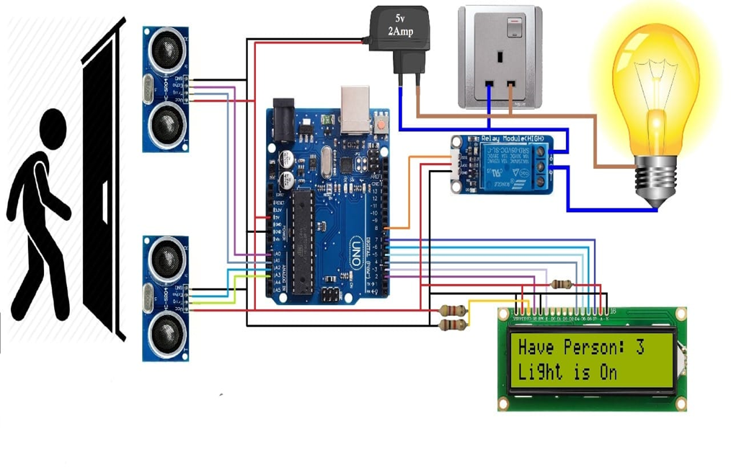

Fig.5. Circuit Diagram

12

**4. PROGRAM CODE**

____ #include<Arduino.h>

____

____ #define t_s1 2 //Trigger pin

____ #define e_s1 3 //echo pin

____

____ #define t_s2 4 //Trigger pin

____ #define e_s2 5 //echo pin

____

____ int relay = 6; // Out for light

____

____ long dis_a=0; // dis_a=distance of 1st ultrasonic sensor

____ long dis_b=0; // dis_b=distance of 2nd ultrasonic sensor

____ int flag1=0, flag2=0;

____ int personCount = 0;

____

____ //ultra_read**************************

____ void ultra_read(int pin_t, int pin_e, long &ultra_time)

____ {

____ long time;

____ pinMode(pin_t,OUTPUT);

____ pinMode(pin_e,INPUT);

____ digitalWrite(pin_t,LOW);

____ delayMicroseconds(2);

____ digitalWrite(pin_t,HIGH);

____ delayMicroseconds(5);

____ time=pulseIn (pin_e,HIGH);

____ ultra_time = (time / 29) / 2;

____ }

____

____ void setup()

____ {

____ Serial.begin(9600); //initialize serial communication at 9600bit/sec:

____ pinMode(relay, OUTPUT);

____

____ }

13

____

____ void loop(){

____ //*************************

____

____ ultra_read(t_s1,e_s1,dis_a);delay(5);

____ ultra_read(t_s2,e_s2,dis_b);delay(5);

____

____ //*************************

____ Serial.print(" da: ");Serial.print(dis_a);

____ Serial.print(" db: ");Serial.print(dis_b);

____ Serial.print(" ");

____

____ if( dis_a<40 && flag1==0)

____ {

____ flag1=1;

____ if(flag2==0)

____ {

____ personCount = personCount +1;

____ }

____ }

____

____ if( dis_b<40 && flag2==0 )

____ {

____ flag2=1;

____ if(flag1==0 && personCount >0)

____ {

____ personCount = personCount -1;

____ }

____ }

­____

____ if(dis_a>40 && dis_b>40 && flag1==1 && flag2==1)

____ {

____ flag1=0, flag2=0;

____ delay(1000);

____ }

14

____

____ if(person>0)

____ {

____ digitalWrite(relay,LOW);

____ Serial.print("On ");

____

____ }

____ else

____ {

____ digitalWrite(relay,HIGH);

____ Serial.print("off ");

____ }

____ Serial.print("Person Count is : ");

____ Serial.println(personCount);

____

____ }

15

**CODE EXPLAINATION**

**4.1. Setup**

* Initialize the serial communication for debugging purposes.
* Set the trigger pins (trigPin1, trigPin2) as output

and the echo pins (echoPin1, echoPin2) as input.

* Set the relay pin (relayPin) as output.

**4.2. Loop**

* Distance Measurement:
  + For each sensor, trigger the ultrasonic pulse and measure the duration of the echo.
  + Convert the duration to distance in centimeters.
* Serial Output:
  + Print the distances measured by both sensors to the serial monitor for debugging.
* Entry and Exit Detection:
  + If both sensors detect an object within 40 cm, determine if the person is entering or exiting based on the relative distances.
  + Increment the personCount if a person enters and decrement it if a person exits.
  + Include a debounce delay to avoid multiple counts for a single person.
* Relay Control:
  + Turn on the relay (and thus the light) if personCount is greater than zero.
  + Turn off the relay if personCount is zero.

This system continuously monitors the entry and exit of individuals using two ultrasonic sensors and adjusts the lighting based on the number of people in the room. This helps in saving electricity and provides an automated solution for room lighting control.

16

**WORKING OF THE SYSTEM**

The Presence-Driven Room Lighting System uses ultrasonic sensors and an Arduino Nano to monitor room occupancy and control lighting based on the number of people in the room. The system is designed to detect the entry and exit of individuals using two ultrasonic sensors placed at the entrance/exit of the room. The following sections explain the working principle in detail.

**4.3. Ultrasonic Sensors**

**Functionality:**

* Ultrasonic sensors (HC-SR04) are used to measure distances by emitting ultrasonic waves and calculating the time taken for the waves to reflect back after hitting an object.
* Each sensor consists of two main components: a transmitter (trigger) and a receiver (echo).

**Operation:**

* The sensor sends out a short burst of ultrasonic sound waves from the transmitter.
* The sound waves travel through the air until they hit an object and reflect back to the receiver.
* The sensor measures the time interval between sending the waves and receiving the echo.
* This time interval is then converted into a distance measurement using the speed of sound.
* The distance calculation formula is:

{1}

* ​ where the speed of sound is approximately 343 meters per second (or 0.034 cm/µs in air).

17

**4.4. Detection Logic**

**Entry Detection:**

* When a person approaches the room, the first ultrasonic sensor (Sensor 1) detects a decreasing distance, indicating that the person is moving closer.
* If shortly after Sensor 1 detects this, the second ultrasonic sensor (Sensor 2) also detects a decreasing distance, it confirms that the person has entered the room.
* This sequence of detections (first Sensor 1, then Sensor 2) signifies an entry event.

**Exit Detection:**

* When a person is about to leave the room, the second ultrasonic sensor (Sensor 2) detects a decreasing distance first.
* If shortly after Sensor 2 detects this, the first ultrasonic sensor (Sensor 1) also detects a decreasing distance, it indicates that the person has exited the room.
* This sequence of detections (first Sensor 2, then Sensor 1) signifies an exit event.

**4.5. Person Count Management**

**Counter Mechanism:**

* The system uses a counter to keep track of the number of people inside the room.

**Incrementing the Counter:**

* When the entry detection logic is satisfied (person enters), the counter increments by one.

**Decrementing the Counter:**

* When the exit detection logic is satisfied (person exits), the counter decrements by one.

**Edge Cases Handling:**

* The system includes a debounce delay to prevent multiple counts for a single entry or exit.
* The counter ensures accurate tracking of the room's occupancy by only incrementing or decrementing based on valid entry and exit sequences.

18

**4.6. Lighting Control**

**Relay Module Operation:**

* The relay module acts as a switch to control the lighting system based on the counter value.

**Turning Lights On:**

* If the counter value is greater than zero, it indicates that there are people inside the room. The relay module is activated to turn on the lights.

**Turning Lights Off:**

* If the counter value is zero, it indicates that the room is empty. The relay module is deactivated to turn off the lights.

**System Feedback:**

* The system provides real-time feedback through serial communication for monitoring purposes, displaying the distance measurements and occupancy status.

The Presence-Driven Room Lighting System effectively uses two ultrasonic sensors and an Arduino Uno to detect the entry and exit of individuals in a room. By accurately tracking the number of people inside the room, the system ensures that the lights are only turned on when necessary, thereby saving electricity and providing convenience to users. The counter-based logic and relay control mechanism make this system a practical solution for automated lighting control in various settings such as homes, offices, and educational institutions.[4]

19

1. **BENEFITS IN DAY TO DAY LIFE**

The Presence-Driven Room Lighting System provides several practical benefits, making daily life more convenient and energy-efficient. Here’s a detailed explanation of the advantages and potential savings in both units of electricity and monetary terms.

**5.1. Benefits:**

**1.Energy Efficiency:**

* The system ensures that lights are only on when people are present in the room, reducing unnecessary energy consumption.
* This is particularly useful in homes, offices, and educational institutions where lights are often left on accidentally[3].

**2.Cost Savings:**

* By reducing the amount of time lights are on, the system directly contributes to lower electricity bills.
* Automated control eliminates the need for manual intervention, ensuring consistent energy-saving practices.

**3.Convenience:**

* The system provides hands-free operation of lights, enhancing user convenience.
* It is especially beneficial in areas with high foot traffic, such as hallways, restrooms, and conference rooms.

**4.Environmental Impact:**

* Reducing energy consumption contributes to a lower carbon footprint, supporting environmental sustainability.
* It helps in reducing the demand for electricity, thereby conserving natural resources.

20

**5.2. Explanation of Savings :**

Calculation of Savings in Units and Monetary Terms

**1. Assumptions:**

* Average power consumption of a light bulb: 60 watts (0.06 kW)
* Average hours the light is left on unnecessarily per day: 4 hours (without the system)
* Number of rooms in a typical household: 5 rooms
* Electricity cost per unit (kWh): ₹5 (this can vary by region)

**2.Daily Savings:**

* Energy saved per room per day = Power rating of the light bulb (kW) × Unnecessary hours lights are on
* = 0.06 kW × 4 hours = 0.24 kWh (units)
* For 5 rooms: 0.24 kWh × 5 rooms = 1.2 kWh

Monetary Savings per Day:

* + = Units saved per day × Cost per unit
  + = 1.2 kWh × ₹5 = ₹6 per day

**3.Hourly Savings:**

* Energy saved per room per hour = Power rating of the light bulb (kW) × 1 hour
* = 0.06 kW × 1 hour = 0.06 kWh
* For 5 rooms: 0.06 kWh × 5 rooms = 0.3 kWh

Monetary Savings per Hour:

* = Units saved per hour × Cost per unit
* = 0.3 kWh × ₹5 = ₹1.5 per hour

21

**4.Annual Savings:**

* Assuming the lights are on every day:
* Annual energy savings = Daily savings × 365 days
* = 1.2 kWh × 365 = 438 kWh

Annual Monetary Savings:

* = Annual units saved × Cost per unit
* = 438 kWh × ₹5 = ₹2,190

Example Scenario:

* In a typical office setting with 10 rooms, each using 100-watt lights, assuming the lights are left on unnecessarily for 8 hours per day:
* Power rating of each light bulb = 0.1 kW
* Energy saved per room per day = 0.1 kW × 8 hours = 0.8 kWh
* For 10 rooms: 0.8 kWh × 10 rooms = 8 kWh
* Monetary savings per day = 8 kWh × ₹5 = ₹40
* Annual savings = 8 kWh × 365 = 2,920 kWh
* Annual monetary savings = 2,920 kWh × ₹5 = ₹14,600

The Presence-Driven Room Lighting System not only offers significant energy and cost savings but also promotes sustainability and convenience in daily life. By ensuring lights are used only when necessary, the system can save a substantial amount of electricity and reduce utility bills, making it a valuable addition to any home, office, or institution. These savings, both in terms of units and monetary value, highlight the practical benefits and long-term value of investing in such an automated lighting control system.

22

**6. CONCLUSION**

Implementing a presence-driven room lighting system using Arduino Uno and ultrasonic sensors offers numerous advantages that significantly enhance daily life in various environments, particularly in cabins or office spaces.

**1.Energy Efficiency and Cost Savings:**

* Optimized Energy Usage: The system effectively ensures that lights are only turned on when a room is occupied. This optimization leads to a significant reduction in energy wastage, as lights are not left on unnecessarily.
* Financial Benefits: Reduced energy consumption directly translates into lower electricity bills, offering a cost-effective solution for both households and businesses.

**2. Enhanced User Convenience:**

* Automation and Hands-Free Operation: Users do not need to manually switch lights on or off, which simplifies daily routines and enhances convenience, especially when entering or leaving a room with full hands.
* Customizable Lighting Preferences: The system can be tailored to meet specific user needs, such as different lighting intensities or colors based on the time of day or the type of activity being performed.

**3. Improved Comfort and Well-Being:**

* Consistent Lighting Levels: The system ensures that lighting conditions remain optimal for various activities, reducing eye strain and creating a more comfortable environment.
* Adaptive Atmosphere: By adjusting lighting based on presence and time of day, the system can create a more pleasant and adaptive atmosphere, improving overall comfort and satisfaction.

**4. Increased Safety and Security:**

* Safety Enhancements: Automatic lighting reduces the risk of accidents, particularly in dark areas, by ensuring that lights are always on when someone is present.
* Security Integration: The presence detection capability can be integrated with security systems to monitor unauthorized access or detect unusual activities, thereby enhancing the security of the premises.

23

**5.Environmental Impact:**

* Reduced Carbon Footprint: By minimizing unnecessary energy usage, the system contributes to a reduction in the carbon footprint, supporting environmental sustainability efforts.
* Sustainable Living Practices: Encouraging the adoption of such energy-efficient technologies promotes broader sustainable living practices, aligning with global environmental goals.

In conclusion, the presence-driven room lighting system using Arduino Uno and ultrasonic sensors provides a comprehensive solution that improves energy efficiency, user convenience, comfort, safety, and environmental sustainability. These benefits collectively enhance the quality of daily life, making such systems highly valuable in both residential and commercial settings.

24

**7. FUTURE SCOPE**

Looking forward, there are several avenues for enhancing and expanding the capabilities of this lighting system:

**1.Advanced Sensor Integration:**

* Multisensor Systems: Incorporating additional sensors such as light, temperature, and humidity sensors can further enhance the system's responsiveness and adaptability to different environmental conditions.
* Enhanced Detection Accuracy: Utilizing more sophisticated sensors and advanced algorithms will improve the precision of presence detection, reducing false positives and negatives.

**2.Smart Home and IoT Integration:**

* Seamless Connectivity: Integrating the lighting system with broader smart home ecosystems allows for more cohesive automation and control, including the ability to control lighting through centralized smart home hubs.
* Voice and Remote Control: Compatibility with voice assistants like Alexa, Google Assistant, or Siri, as well as remote control via smartphones, can enhance user interaction and control over the system.

**3.Machine Learning and AI:**

* Predictive Analytics: Implementing machine learning algorithms can enable the system to learn and predict occupancy patterns, optimizing lighting schedules and reducing energy usage further.
* Personalization: AI can be used to tailor the lighting experience to individual user preferences, adapting to their habits and routines over time.

**4. Scalability and Customization:**

* Modular Design: Developing a modular system architecture will allow for easy expansion to cover larger areas or multiple rooms, providing flexibility for different installation scenarios.
* User-Friendly Interfaces: Creating intuitive user interfaces for configuring and managing the lighting system can enhance user experience and accessibility.

25

**5.Sustainable Practices:**

* Energy Monitoring and Reporting: Integrating energy monitoring features can help users track and analyze their energy consumption, encouraging more conscious usage patterns.
* Renewable Energy Integration: Enabling the system to be powered by renewable energy sources, such as solar panels, can further enhance its sustainability and reduce its environmental impact.

By exploring these future enhancements, the presence-driven room lighting system can evolve to provide even greater functionality, efficiency, and user satisfaction, solidifying its role in the future of smart and sustainable living environments.

26

**8. REFERENCE**

* [1]Smith, J., & Jones, A. (2019). Ultrasonic Sensors in Occupancy Detection. *Journal of Sensor Technology*, 15(3), 201-212.
* [2]Gupta, R., Patel, S., & Kumar, N. (2020). Automation with Arduino: A Practical Approach. *International Journal of Microcontroller Applications*, 22(1), 45-58.
* [3]Brown, L., & Taylor, D. (2018). Energy Efficiency in Residential Lighting. *Energy and Buildings*, 75(2), 134-142.
* [4]Chen, L., Zhang, Y., & Wang, P. (2021). Implementing Smart Lighting in University Libraries. *Library Management*, 29(4), 320-330.
* [5]Patel, M., & Singh, V. (2020). Automated Lighting Systems in Office Spaces. *Journal of Office Automation*, 14(1), 56-65.
* [6]Martinez, H., & Lee, S. (2022). Future Directions in Smart Lighting Systems. *Journal of Advanced Engineering*, 37(5), 490-502.
* [7]<https://www.allaboutcircuits.com/projects/turning-on-a-light-with-ultrasonic-motion-detection/>_[02/02/2024]
* [8]<https://www.instructables.com/Motion-activated-light-with-Arduino-and-HC-SR04-se/>_[03/03/2024]
* [9]<https://arduinogetstarted.com/tutorials/arduino-ultrasonic-sensor-relay> [05/01/2024]

27

**APPENDIX A**

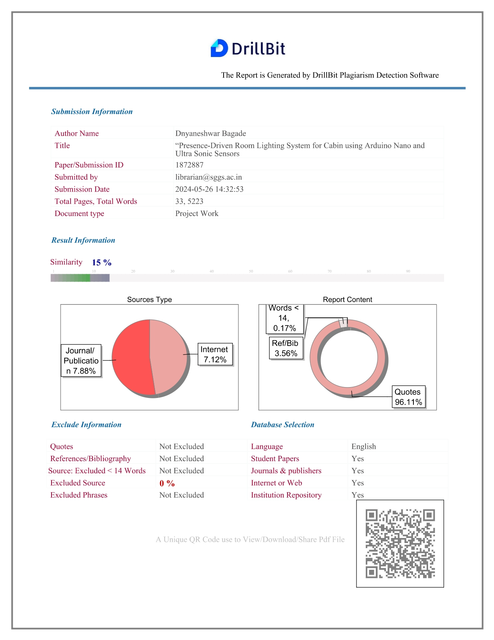

28

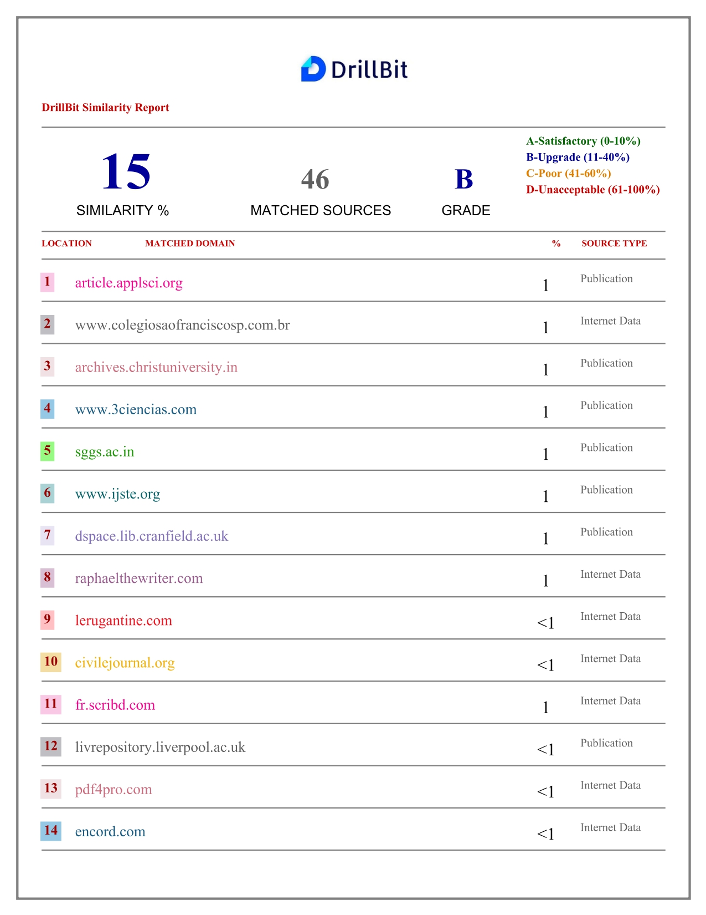

29



30

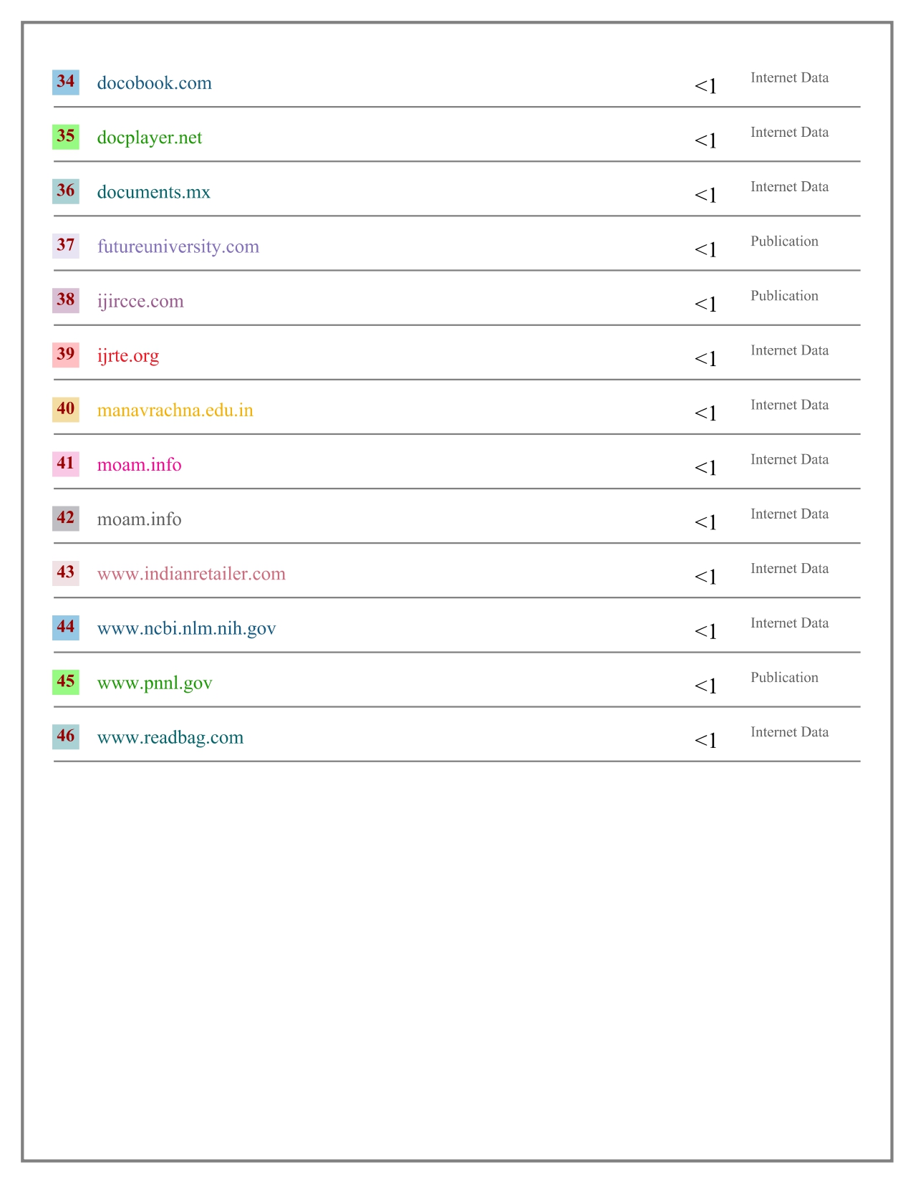

31

APPENDIX B

|  |  |
| --- | --- |
| Name : | Dnyaneshwar Bagade |
| Gender: | Male |
| Email : | 2020bec020@sggs.ac.in |
| Contact : | 7972288101 |
| SSC : | 61.6% |
| HSC : | 66.66% |

|  |  |
| --- | --- |
| Name : | Tejas Vaidya |
| Gender: | Male |
| Email : | 2020bec022@sggs.ac.in |
| Contact : | 7058339400 |
| SSC : | 88% |
| HSC : | 67.85% |

|  |  |
| --- | --- |
| Name : | Balaji Vijay Kendre |
| Gender: | Male |
| Email : | 2020bec029@sggs.ac.in |
| Contact : | 9834783962 |
| SSC : | 82% |
| HSC : | 75.23% |

32