Windows Autopilot Complete Device Enrollment
Practical Windows Autopilot deployment workflow for IT admins. The goal is simple: get a Windows device from OOBE to a fully managed corporate endpoint with minimal manual configuration.
🔹 STEP 1: GET DEVICE READY
Start with a supported device on Windows 10/11 and connect it to the Internet.
🔹 STEP 2 GATHER THE HARDWARE HASH
Run PowerShell as an administrator and get the Autopilot hardware hash of the device.
This hardware information uniquely identifies the device within the Autopilot Service.
🔹 STEP 3 INSERT THE DEVICE
In the Microsoft Intune admin center, navigate to:
Devices > Windows > Windows Enrollment > Windows Autopilot
Import the hardware hash and wait for the device to be registered.
🔹 STEP 4 CREATE AN AUTOPILOT DEPLOYMENT PROFILE.
Create a deployment profile and configure the Windows OOBE experience to include:
• Microsoft Entra ID Join • Automatic Intune enrollment • User-driven deployment
• Privacy settings • Account type • OOBE configuration
🔹 STEP 5 ASSIGN THE DEPLOYMENT PROFILE
Assign the Autopilot profile to the target device.
Once assigned, verify that the device shows the correct deployment profile.
🔹 STEP 6 CONFIGURE APPLICATIONS & POLICIES
Before deployment, configure the required Intune policies and applications, such as:
• Microsoft 365 Apps • Microsoft Edge • Security policies • Device restrictions
• Compliance policies • Required business applications
🔹 STEP 7 START THE WINDOWS DEVICE
Reset or start the Windows device and connect it to the internet.
During OOBE, Windows communicates with the Windows Autopilot service and identifies the device.
🔹 STEP 8 COMPANY SIGN-IN
The user signs in using their organization’s Microsoft 365 account.
🔹 STEP 9 AUTOMATIC ENROLLMENT & CONFIGURATION
The device automatically enrolls into Microsoft Intune and receives the assigned configuration, applications, and security policies.
🔹 STEP 10 VERIFY THE DEPLOYMENT
Finally, verify:
✅ Device appears in Intune ✅ Entra ID Join is successful
✅ Applications are installed ✅ Policies are applied
✅ Device is compliant ✅ User can access required company resources
🎯 FINAL RESULT
The device is now centrally managed, secured, and ready for business use without manually configuring every laptop.
This is where Windows Autopilot + Microsoft Intune + Microsoft Entra ID become extremely powerful for modern endpoint management.
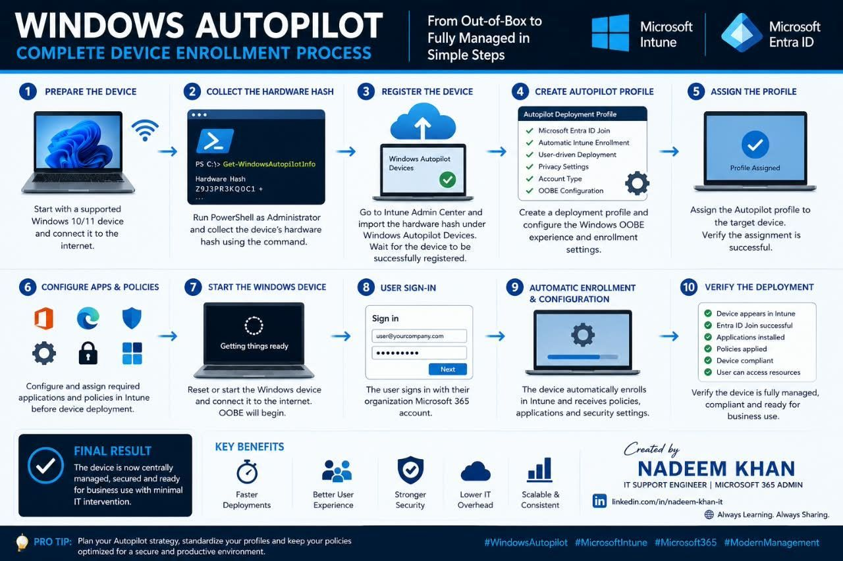
5 Powerful Windows Repair Commands
Windows running slow, showing corrupted files, experiencing disk errors, DNS problems, or having trouble booting? These essential Windows repair commands can help diagnose and fix many common Windows 10 and Windows 11 problems.
🔹 DISM /Online /Cleanup-Image /RestoreHealth
Repairs corruption in the Windows system image and component store.
🔹 CHKDSK C: /F /R
Checks your drive for file-system errors& bad sectors & attempts recovery of readable data.
🔹 SFC /SCANNOW
Scans protected Windows system files and repairs corrupted or missing files.
🔹 IPCONFIG /FLUSHDNS
Clears the Windows DNS resolver cache—useful when troubleshooting certain website, DNS, and connectivity problems.
🔹 BOOTREC /FIXMBR
Repairs the Master Boot Record in supported recovery scenarios when troubleshooting Windows boot problems.
💡 PRO TIP: Run repair commands from an elevated Command Prompt (Run as Administrator) when required. Boot repair commands may need to be executed from the Windows Recovery Environment (WinRE).
⚠️ Always understand what a repair command does before running it, especially CHKDSK and boot-repair commands. Back up important data whenever possible.
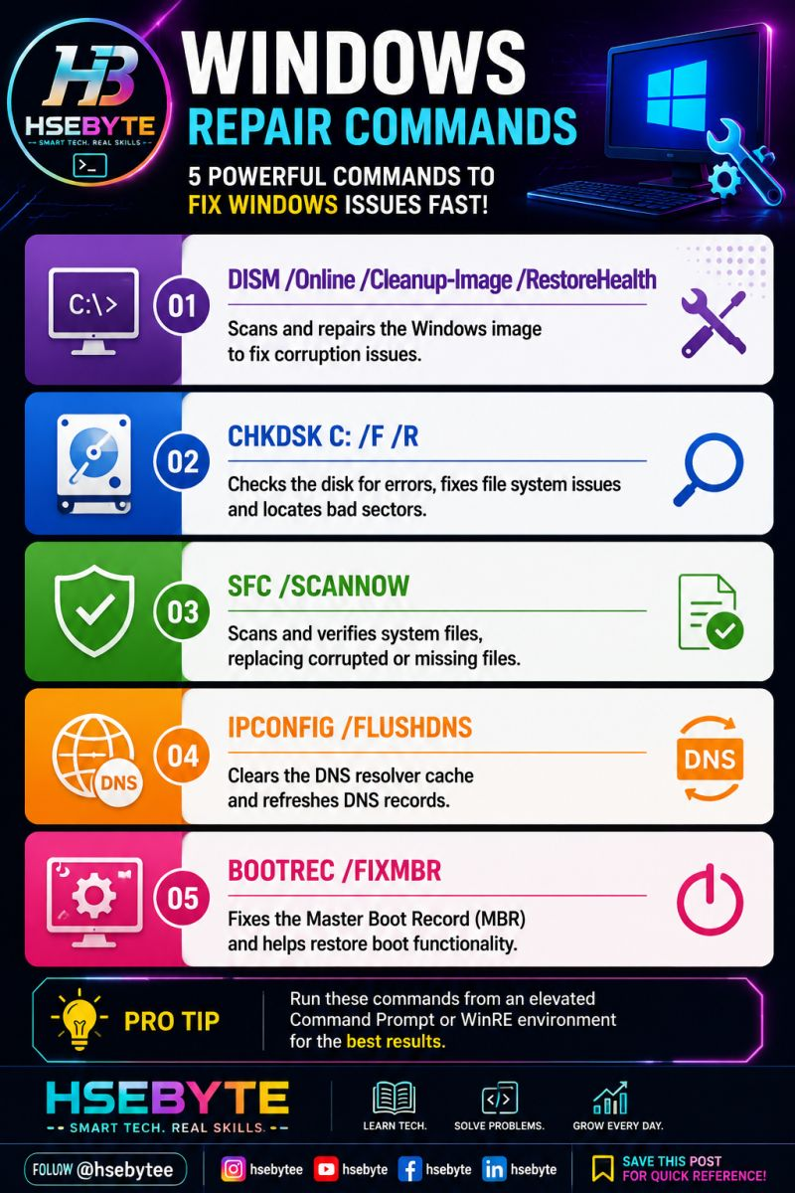
RDP Troubleshooting
A user says: “I can ping the server, but Remote Desktop is not connecting.”
A successful ping does not always mean RDP will work.
Troubleshooting Checklist
1️⃣ Check RDP is enabled : Make sure Remote Desktop is allowed on the target machine.
2️⃣ Check TCP port 3389, Use: "Test-NetConnection <IP> -Port 3389"
3️⃣ Check Windows Firewall : Verify that the RDP inbound rule is enabled.
4️⃣ Check Remote Desktop Services : Make sure the required service is running.
5️⃣ Check user permissions : Verify the user is allowed to log in through Remote Desktop.
6️⃣ Check Network/VPN connectivity : Confirm client can reach correct server network.
7️⃣ Check NLA / authentication issues : Network Level Authentication can also cause login failures.
💡 Key Takeaway: Ping works ≠ RDP works.
Always troubleshoot layer by layer:
Network → Port → Firewall → Service → Permission → Authentication
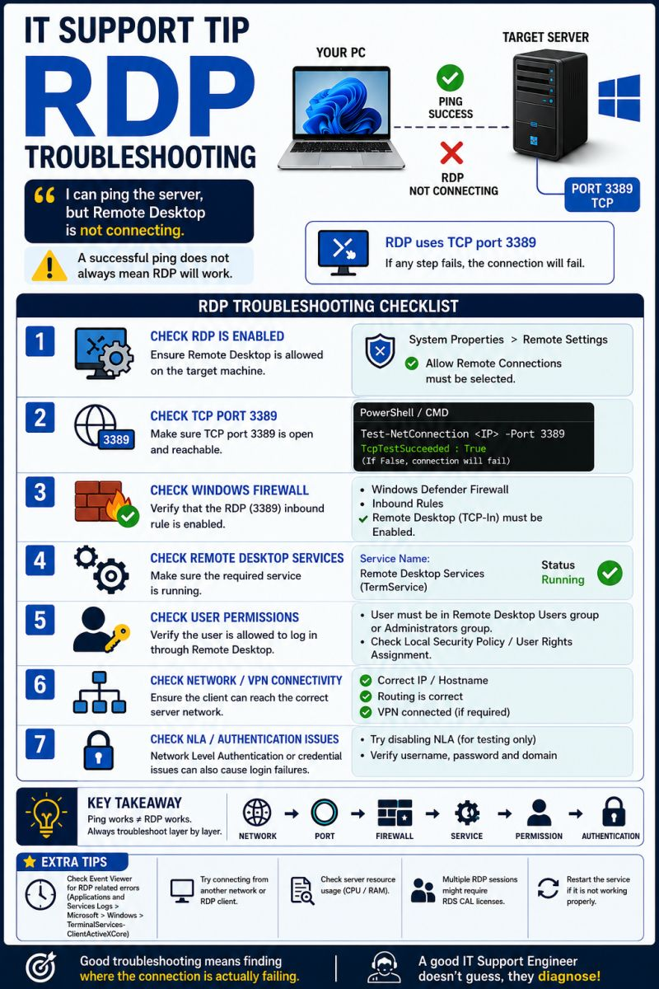
𝗛𝗼𝘄 𝗪𝗶𝗻𝗱𝗼𝘄𝘀 𝗔𝘂𝘁𝗼𝗽𝗶𝗹𝗼𝘁 V2 𝗗𝗲𝘃𝗶𝗰𝗲 𝗣𝗿𝗲𝗽𝗮𝗿𝗮𝘁𝗶𝗼𝗻 𝗪𝗼𝗿𝗸𝘀
Windows Autopilot device preparation is a modern Windows deployment experience designed to simplify device provisioning and reduce the amount of IT intervention required.
🔹1. Device Starts : The user powers on a new or reset Windows 11 device and begins the Out-of-Box Experience (OOBE).
🔹 2. Connect to the Internet : The device connects to an available internet connection such as Wi-Fi or Ethernet.
🔹 3. Device Preparation Starts : Windows uses the organization's cloud-based configuration to determine how the device should be prepared.
🔹 4. Microsoft Intune Applies Configuration : Intune delivers the required policies, applications, security settings, and configuration defined by the organization.
🔹 5. User Authentication: The user signs in using their organizational Microsoft Entra ID account.
🔹 6. Device Becomes Ready : The required configurations and applications are applied, allowing the user to start working with a corporate-managed Windows device.
🔐 Key Benefits : ✅ Cloud-based Windows provisioning ✅ Reduced IT involvement ✅ Microsoft Entra ID integration ✅ Microsoft Intune management ✅ Application and policy deployment ✅ Security configuration during setup ✅ Simplified out-of-box experience ✅ Scalable deployment for modern workplaces
Key Microsoft Technologies : 💻 Windows 11, ☁️ Windows Autopilot / Device Preparation, 🛡️ Microsoft Intune, 🔐 Microsoft Entra ID,📦 Win32 & Microsoft Store applications, ⚙️ Configuration profiles and security policies
The goal:
👉 A secure, standardized and cloud-managed Windows device with minimal hands-on IT effort.
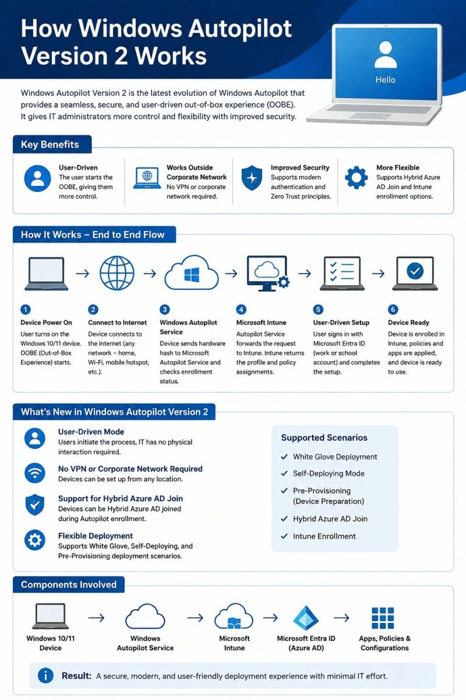
Change Boot Order in BIOS
Need to boot from USB, install Windows, or fix startup problems? How to change BIOS/UEFI boot order step-by-step.
✅ Enter BIOS/UEFI Setup
✅ Change Boot Priority
✅ Select USB / SSD / HDD
✅ Save Changes with F10
✅ Fix Common Boot Issues
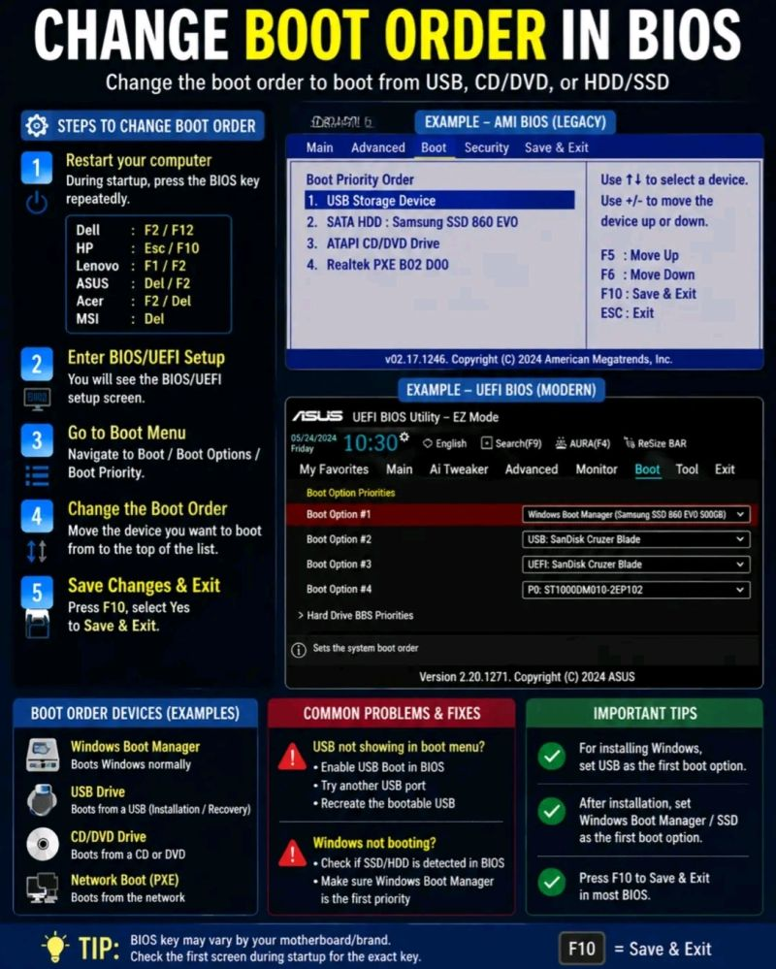
WINDOWS 11 ➔ MICROSOFT INTUNE
Simple Device Enrollment : Microsoft Intune | Windows 11 | Endpoint Management
1. Prepare: Windows 11 device, internet, and Entra ID connection.
2. Enroll: Initiate modern device enrollment into Intune.
3. Sign In: Authenticate using corporate work credentials.
4. Register: Device connects and registers inside Intune.
5. Apply Policies: Deploy profiles, security compliance, and apps.
6. Ready: Fully managed, secured, and ready for work.
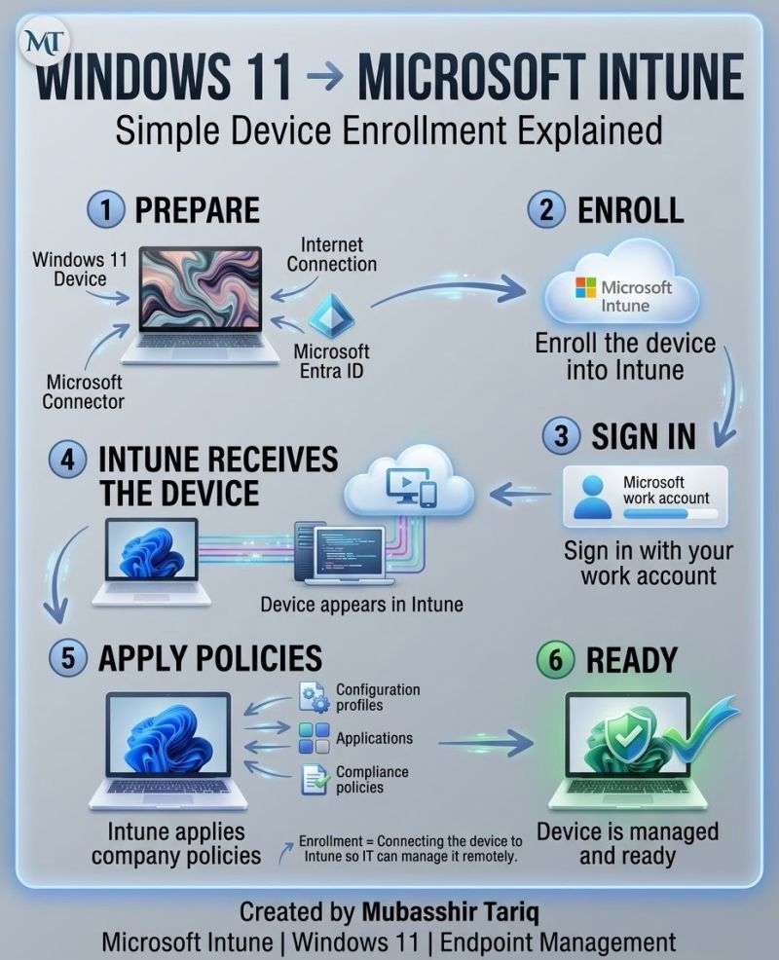
Essential CMD & PowerShell Commands
From checking system information to diagnosing network issues, managing services, investigating processes, and troubleshooting Windows.
Here are some areas I regularly find useful:
🔹 System Information
systeminfo • Get-ComputerInfo
🔹 Networking
ipconfig /all • ping • tracert • nslookup
Test-Connection • Resolve-DnsName
🔹 Processes & Performance
tasklist • taskkill
Get-Process • Stop-Process
🔹 Windows Services
sc query • net start
Get-Service • Start-Service • Stop-Service
🔹 User & System Management
whoami • net user
Get-LocalUser • Get-LocalGroupMember
🔹 Files & Disk Management
dir • chkdsk • robocopy
Get-ChildItem • Get-Volume
🔹 Windows Troubleshooting
sfc /scannow • DISM • eventvwr.msc
Get-WinEvent • Get-WindowsUpdateLog
🔹 Active Directory
nltest • net user /domain
Get-ADUser • Get-ADGroupMember
It's about understanding which tool to use, what information to collect, and how that information helps you identify the root cause.
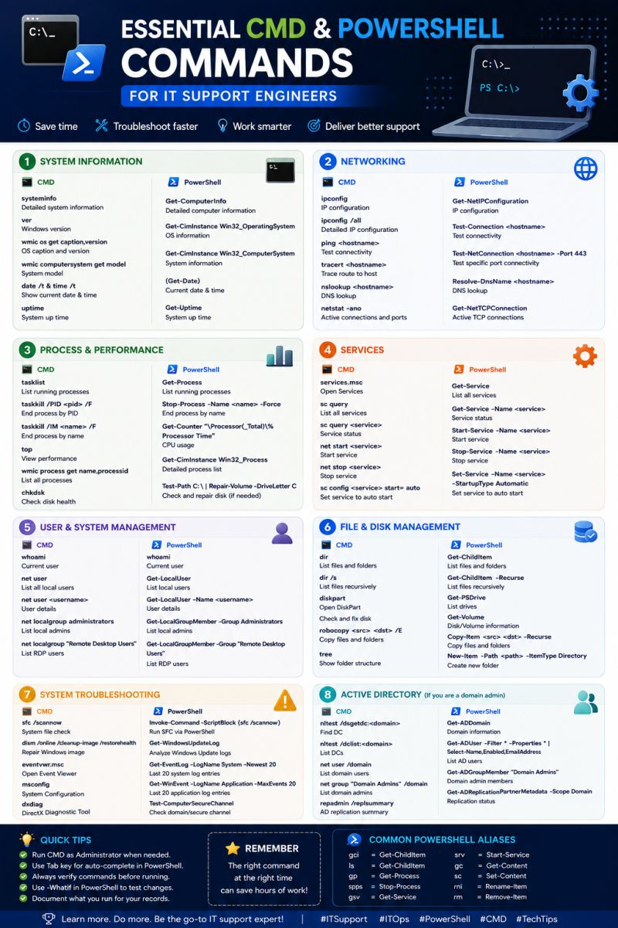
System Restore vs Reset This PC: Know the Difference.
Choosing the right Windows recovery option can save time and prevent unnecessary data loss. Understanding when to use **System Restore** and when to use **Reset This PC** is an essential part of effective IT troubleshooting.
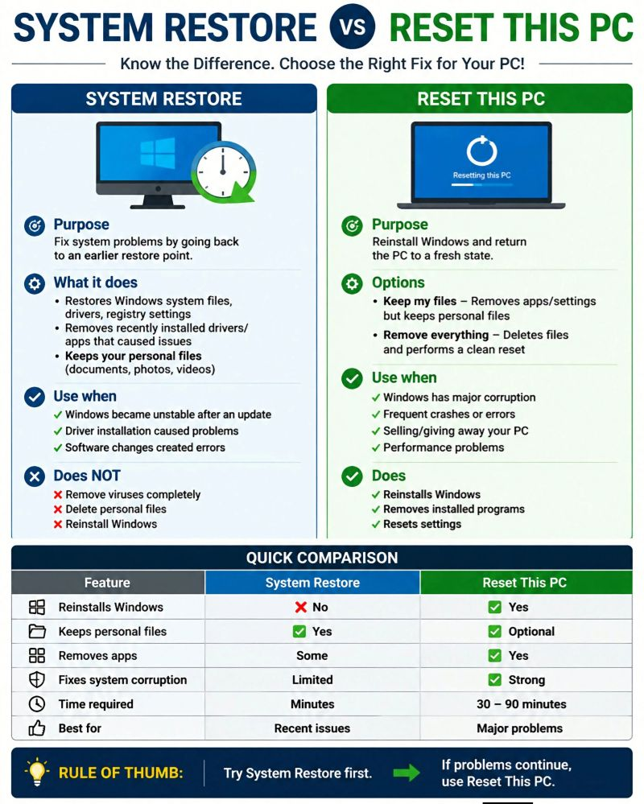
𝗪𝗶𝗻𝗱𝗼𝘄𝘀 𝗔𝘂𝘁𝗼𝗽𝗶𝗹𝗼𝘁 | 𝗧𝗿𝗼𝘂𝗯𝗹𝗲𝘀𝗵𝗼𝗼𝘁𝗶𝗻𝗴 𝗗𝗲𝘃𝗶𝗰𝗲 𝗦𝗲𝘁𝘂𝗽 𝗘𝗿𝗿𝗼𝗿 – 𝟬𝘅𝟴𝟬𝟬𝟳𝟬𝟬𝟬𝟮
While provisioning a Windows device using Windows Autopilot + Microsoft Intune, I encountered an Enrollment Status Page (ESP) failure:
❌ 𝗗𝗲𝘃𝗶𝗰𝗲 𝗦𝗲𝘁𝘂𝗽 → 𝗔𝗽𝗽𝘀 (𝟬𝘅𝟴𝟬𝟬𝟳𝟬𝟬𝟬𝟮):
1️⃣ 𝙄𝙙𝙚𝙣𝙩𝙞𝙛𝙮 𝙩𝙝𝙚 𝙁𝙖𝙞𝙡𝙚𝙙 𝘼𝙥𝙥𝙡𝙞𝙘𝙖𝙩𝙞𝙤𝙣 : First, identify which application is failing during the ESP Device Setup phase.
2️⃣ 𝘾𝙝𝙚𝙘𝙠 𝙄𝙣𝙨𝙩𝙖𝙡𝙡 & 𝙐𝙣𝙞𝙣𝙨𝙩𝙖𝙡𝙡 𝘾𝙤𝙢𝙢𝙖𝙣𝙙𝙨 : Verify the commands configured in Intune.
For an MSI application:
𝙄𝙣𝙨𝙩𝙖𝙡𝙡: msiexec /i "Application.msi" /qn /norestart
𝙐𝙣𝙞𝙣𝙨𝙩𝙖𝙡𝙡: msiexec /x {PRODUCT-CODE} /qn /norestart
For EXE applications, use the silent-install switches supported by the application vendor.
3️⃣ 𝙑𝙚𝙧𝙞𝙛𝙮 𝘿𝙚𝙩𝙚𝙘𝙩𝙞𝙤𝙣 𝙍𝙪𝙡𝙚𝙨 : Make sure the detection rule matches the file, folder, registry key, or other condition created after installation.
4️⃣ 𝘾𝙝𝙚𝙘𝙠 𝘿𝙚𝙥𝙚𝙣𝙙𝙚𝙣𝙘𝙞𝙚𝙨 : Verify that required applications are installing successfully before the dependent application.
5️⃣ 𝘾𝙝𝙚𝙘𝙠 𝘼𝙥𝙥𝙡𝙞𝙘𝙖𝙩𝙞𝙤𝙣 𝘼𝙨𝙨𝙞𝙜𝙣𝙢𝙚𝙣𝙩𝙨 : Confirm application is assigned to correct device.
6️⃣ 𝘼𝙘𝙘𝙚𝙨𝙨 𝘾: 𝘿𝙧𝙞𝙫𝙚 & 𝙍𝙚𝙫𝙞𝙚𝙬 𝙇𝙤𝙜𝙨 : Even while the device is still on the Windows Autopilot/OOBE “Setting up for work or school” screen, you can inspect the file system. Because standard shortcuts like Windows + E do not work here, use this method:
1) Press Shift + F10 to open the Command Prompt.
2) Type explorer.exe and press Enter to open File Explorer.
3) Navigate to the Intune Management Extension logs: C:\ProgramData\Microsoft\IntuneManagementExtension\Logs
4) Open IntuneManagementExtension.log and search for: 0x80070002, failed, or error.
⚠️ If IME logs aren't available yet, collect full Autopilot/MDM diagnostics using quotes so the semicolon parses correctly:
mdmdiagnosticstool.exe -area "Autopilot;DeviceEnrollment" -cab C:\AutopilotLogs.cab
7️⃣ 𝙏𝙚𝙨𝙩 𝙩𝙝𝙚 𝙄𝙣𝙨𝙩𝙖𝙡𝙡𝙚𝙧 𝙈𝙖𝙣𝙪𝙖𝙡𝙡𝙮 : Run the same installation command locally to determine whether the issue is with the application package or the Intune deployment.
8️⃣ 𝙍𝙚𝙩𝙧𝙮 𝙩𝙝𝙚 𝘿𝙚𝙥𝙡𝙤𝙮𝙢𝙚𝙣𝙩 : After correcting the application configuration, retry the Autopilot deployment and verify that Device Setup completes successfully.
💡 𝙆𝙚𝙮 𝙏𝙖𝙠𝙚𝙖𝙬𝙖𝙮: When an Autopilot ESP app fails, don't immediately reset the device.
Press Shift + F10 during OOBE to access C: and check logs. Verify the app's commands, detection rule, dependencies, assignment, and IME logs before retrying. Always follow your organization's Intune, Autopilot, security, and deployment policies.
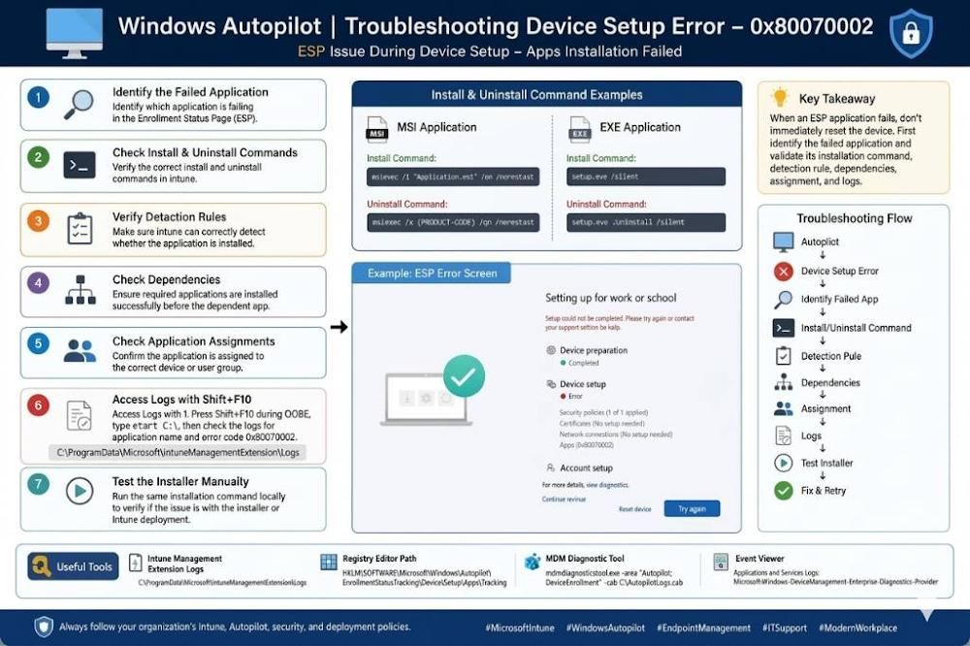

Windows Troubleshooting Cheat Sheet (CMD + PowerShell)
After years of handling escalations, I’ve compiled the most useful commands I actually use in real L2/L3 Windows support work.
This one-page reference covers:
• System File & Image Repair (SFC + DISM) • Disk & File System
• Network (IP, DNS, Stack & Firewall) • Identity & Group Policy
• Services, Processes & Tasks • Event Logs
• Boot, Recovery & BCD • System Info & Drivers
• Performance, Power & Memory
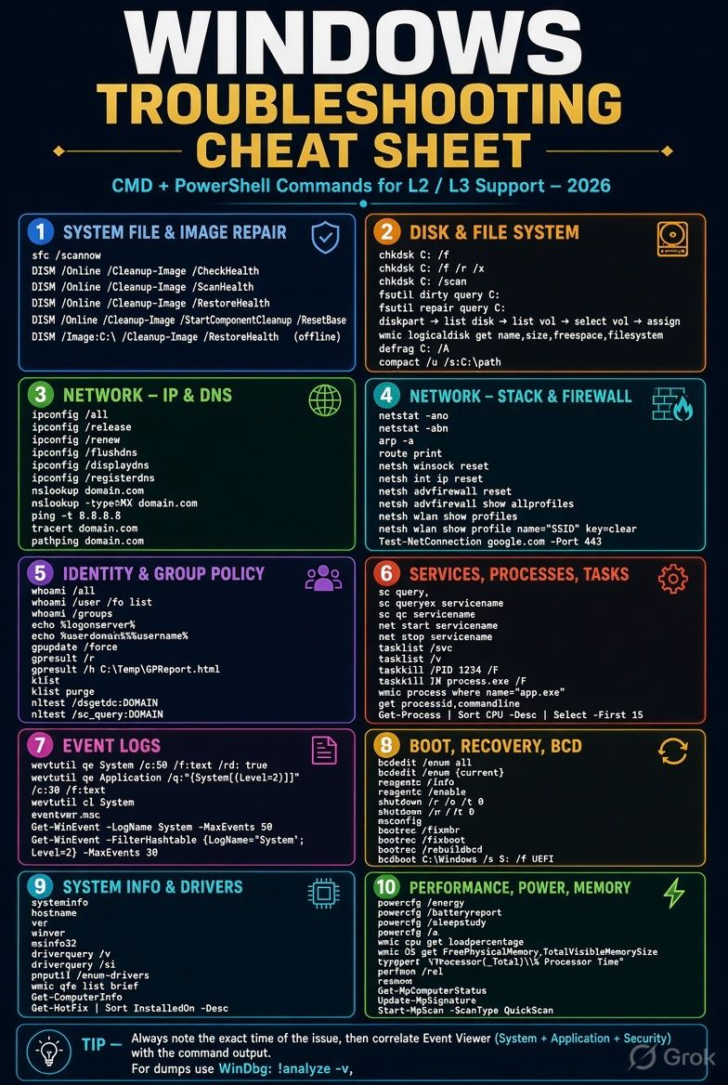
Citrix WEM vs UPM vs GPO — When to Use Each?
In a Citrix CVAD environment, UPM, WEM and Microsoft GPO have different responsibilities. Using them correctly helps create a scalable, secure and easy-to-troubleshoot environment.
🔹 1. Citrix UPM — “Where is my Profile?”
UPM = User Profile Management
UPM helps keep the user's profile consistent when they move between VDAs.
✅ Profile persistence ✅ Profile Containers ✅ Profile synchronization
✅ Profile exclusions ✅ Profile streaming ✅ User settings & application preferences
👉 UPM = Preserve the User Profile
🔹 2. Citrix WEM — “How should the User Environment behave?”
WEM = Workspace Environment Management
WEM manages the Windows user environment and helps optimize VDA resources.
✅ Applications & shortcuts ✅ Network drives ✅ Printers ✅ Privilege elevation
✅ Registry & environment variables ✅ CPU optimization ✅ Memory optimization
✅ I/O optimization ✅ Logon/logoff optimization ✅ Citrix Optimizer
👉 WEM = Manage & Optimize the User Environment
🔹 3. Microsoft GPO — “How should Windows behave?”
Group Policy is ideal for enterprise Windows and Active Directory configuration.
✅ Security policies ✅ Windows Defender ✅ Windows Firewall ✅ Windows Update
✅ Administrative Templates✅User & Computer configuration ✅ Enterprise security baselines
👉 GPO = Secure & Configure Windows
🏗️ How They Work Together:
Active Directory → GPO → Windows Configuration
UPM → User Profile → Profile Store
WEM → User Environment → Apps / Drives / Printers / Optimization
Citrix Policies → HDX / Session / Citrix-specific behavior
🧠 Easy Interview Formula:
> 🔐 GPO = Secure & Configure Windows
👤 UPM = Preserve the User Profile
⚙️ WEM = Configure & Optimize the Environment
🖥️ Citrix Policies = Control the Citrix Session Experience
💡 Best Practice: Don't try to make one technology do everything.
✔ Use GPO for Windows & security configuration
✔ Use UPM for profile management
✔ Use WEM for environment management & optimization
✔ Use Citrix Policies for Citrix/HDX-specific requirements
Also avoid overlapping configurations—for example, mapping the same network drive through both GPO and WEM without a clear design.
A clean separation of responsibilities = easier administration + easier troubleshooting + better user experience.
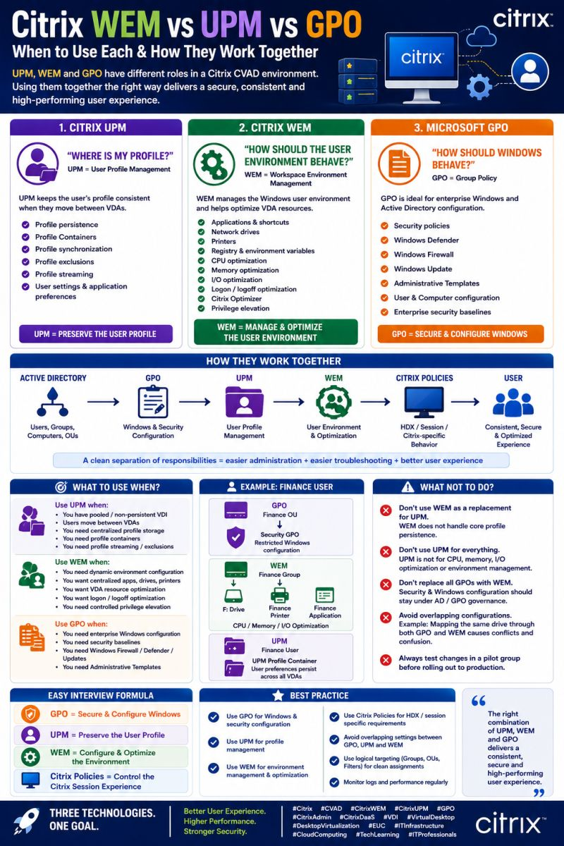
Windows Autopilot Device Association – What Actually Happens?
One of the most important concepts in Windows Autopilot is understanding how a device becomes associated with the correct user, tenant, Autopilot profile, and Intune policies.
Many Autopilot issues are caused by misunderstanding this association process.
🔹 1️⃣ Device → Windows Autopilot: The device’s hardware hash is registered in Windows Autopilot. The hardware identity allows Microsoft to recognize the device during OOBE and associate it with the organization’s tenant.
🔹 2️⃣ Device → Autopilot Profile: After the device is registered, an Autopilot deployment profile can be assigned using: • Static device groups • Dynamic device groups • Group tags • Assignment filters
The profile determines how OOBE behaves—for example:
✅ User-driven vs Self-deploying✅ Azure/Entra join type✅ Privacy settings
✅ User account creation✅ Device naming configuration
🔹 3️⃣ Device → Entra ID: During Autopilot, the device is joined to Microsoft Entra ID according to the deployment configuration.
This creates the device identity that is subsequently used for authentication, Conditional Access, and management.
🔹 4️⃣ Device → Intune: The device enrolls into Microsoft Intune through the MDM enrollment process. Once enrolled, Intune can deliver:
📌 Configuration profiles 📌 Compliance policies 📌 Security policies 📌 Applications
📌 PowerShell scripts 📌 Remediations 📌 Windows Update policies
🔹 5️⃣ Device → Primary User: For user-driven deployments, the user who completes the Autopilot process generally becomes associated with the device as the Primary User.
This association is important for: • Company Portal experience • User-targeted applications • User-targeted policies • Device ownership visibility • Troubleshooting
🔄 Simplified Association Flow:
Hardware Hash⬇️Windows Autopilot Registration⬇️Autopilot Profile Assignment⬇️ Windows OOBE ⬇️ Entra ID Join ⬇️ Intune Enrollment ⬇️ Primary User Association ⬇️
Policies + Apps + Compliance
⚠️ Common Troubleshooting Scenarios: If something goes wrong, don’t immediately blame Intune. Check the association at each layer:
🔍 Is the hardware hash registered? 🔍 Is device correctly assigned to Autopilot profile?
🔍 Is the device in the expected Entra ID group? 🔍 Did Entra ID join complete successfully? 🔍 Did Intune enrollment complete? 🔍 Is the expected Primary User assigned? 🔍 Are the applications/policies targeted to the correct user or device group?
💡 Key Takeaway: Autopilot is not simply “install Windows and apply Intune policies.”
It is an association and orchestration process involving: Device Identity → Autopilot → Entra ID → Intune → User → Policies & Applications
Understanding these relationships makes Autopilot troubleshooting significantly easier.
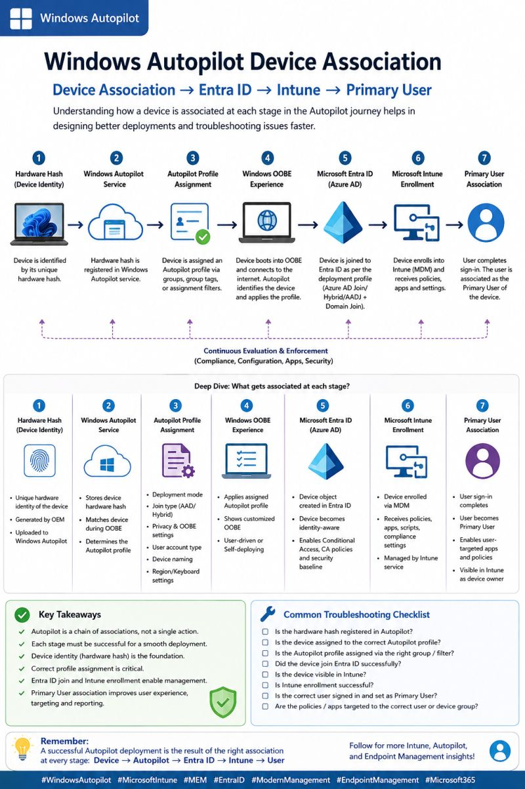
Microsoft Intune – New Mobile Device Registration in Service Management
When a new mobile device is enrolled in Microsoft Intune, it officially becomes part of an organization’s managed environment. This process is not just about connecting a device it’s about ensuring security, control, and seamless access to business resources.
💡 Key Learning Points:
✅ The journey begins with installing the Intune Company Portal app
✅ Users authenticate using their work or school credentials
✅ The device gets registered with Azure Active Directory, establishing identity and trust
✅ Configuration and security policies are automatically applied
✅ A compliance check validates whether the device meets organizational standards
✅ Only compliant devices are allowed to access corporate apps and data
✅ IT teams retain the ability to monitor, manage, and secure devices remotely
🔐 Understanding Compliance Check: Before granting access, Intune evaluates the device against predefined policies. This may include password requirements, encryption status, OS version, security updates, and threat protection. It ensures that only secure and trustworthy devices interact with organizational resources.
🚀 Why these matters: A well-defined device registration and compliance process helps organizations maintain strong security, reduce risks, and simplify device management especially in today’s hybrid and remote work environments.
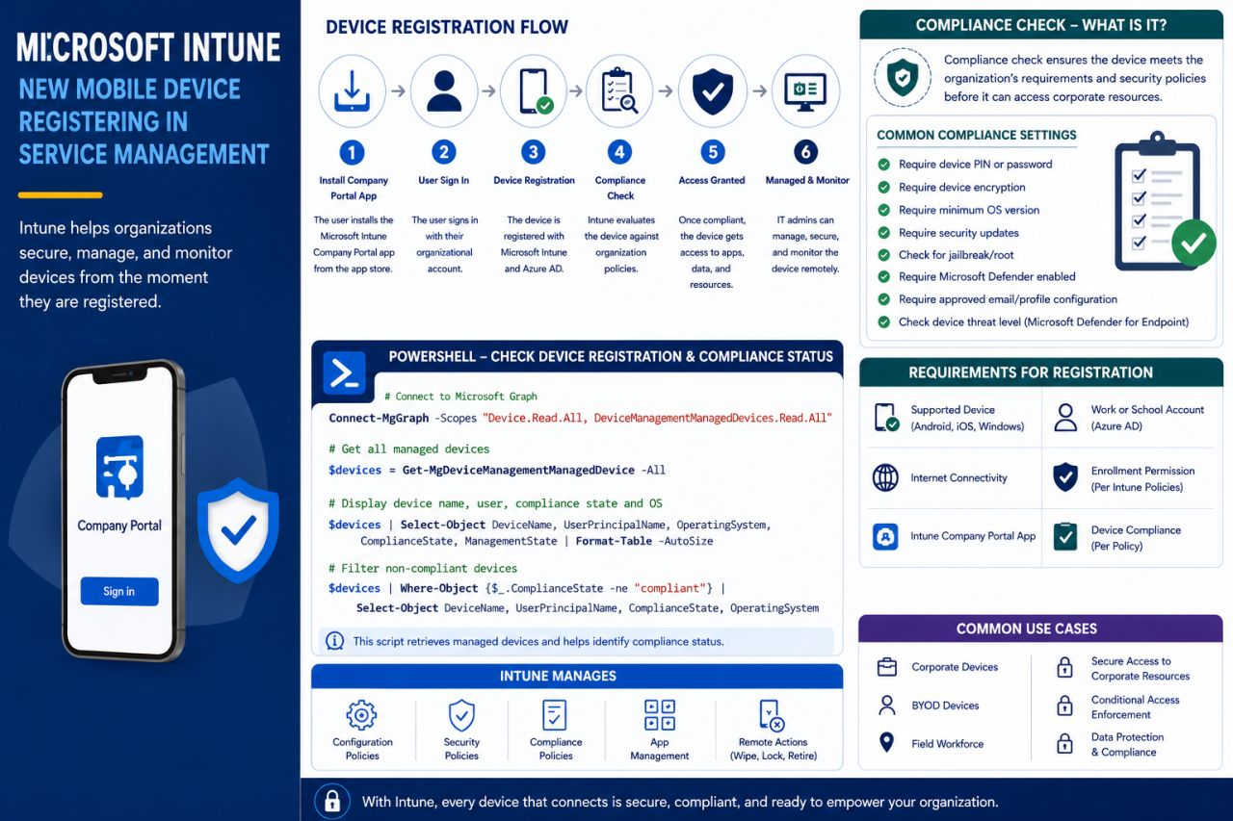
SPF, DKIM & DMARC: The 3 Pillars of Email Authentication
Email security is not just about having a strong password or antivirus.
Every organization should also protect its domain from email spoofing, phishing, and unauthorized senders.
That’s where SPF, DKIM, and DMARC come in:
🔹 SPF — Sender Policy Framework: Verifies whether the sending server is authorized to send emails on behalf of your domain.
🔹 DKIM — DomainKeys Identified Mail: Adds a digital signature to emails, helping recipients verify that the message is authentic and hasn’t been tampered with.
🔹 DMARC — Domain-based Message Authentication, Reporting & Conformance: Uses SPF and DKIM results to determine what should happen when an email fails authentication—and provides reporting visibility.
📩 Simple flow: Sender → SPF Check → DKIM Check → DMARC Policy → Inbox / Action
✅ Reduces email spoofing ✅ Helps prevent phishing ✅ Protects your domain reputation ✅ Improves email trust & security ✅ Provides visibility through DMARC reporting
💡 IT Admin Tip: Don't treat SPF, DKIM, and DMARC as separate technologies. They work together as a layered email authentication strategy.
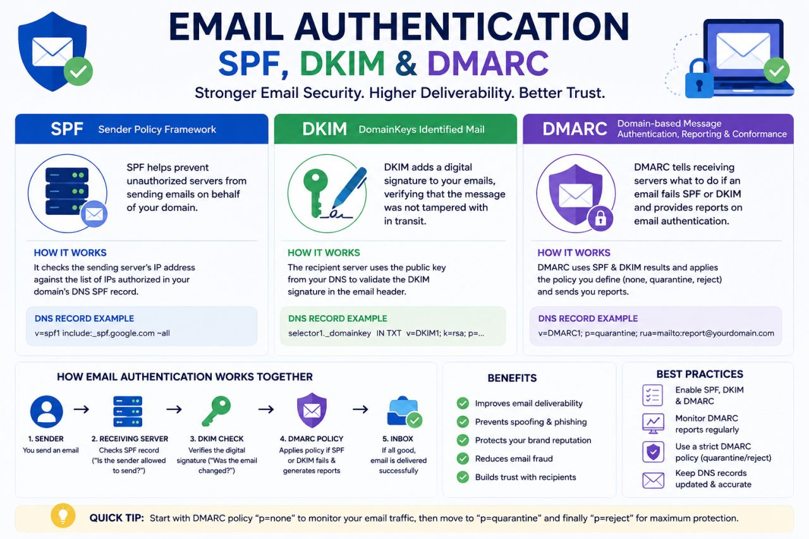
Windows 11 → Microsoft Intune: Device Enrollment Process
How does a brand-new Windows 11 device become a secure, compliant, and fully managed corporate device?
Here’s the simplified flow:
1. PREPARE: Windows 11 device , Internet connectivity, Microsoft Entra ID, Intune licensing
2. ENROLL: The Windows device is enrolled into Microsoft Intune, allowing IT administrators to manage the device remotely.
3. SIGN IN: The user signs in using their corporate Microsoft Entra ID account.
MFA and Conditional Access can evaluate the authentication and device access.
4. INTUNE RECEIVES THE DEVICE: Once enrollment is successful, the device appears in the Microsoft Intune admin center, where IT can monitor device information, management status, and compliance.
5. APPLY POLICIES: Intune can deliver:
⚙️ Configuration Profiles
📦 Applications
🛡️ Security Policies
🔒 BitLocker & Endpoint Security
🌐 Wi-Fi / VPN settings
🔄 Windows Update policies
✅ Compliance requirements
🔐 The Result
Windows 11 + Entra ID + Intune + Policies + Security + Compliance = Fully Managed Device
The combination of Microsoft Entra ID, Intune, Conditional Access, and endpoint security helps organizations implement a modern device-management and Zero Trust approach.
💡 In simple words:
User signs in → Entra ID authenticates → Device enrolls into Intune → Policies & apps are applied → Compliance is evaluated → Secure managed device.
This is one of the fundamental concepts every Microsoft 365 / Intune / Endpoint Administrator should understand.
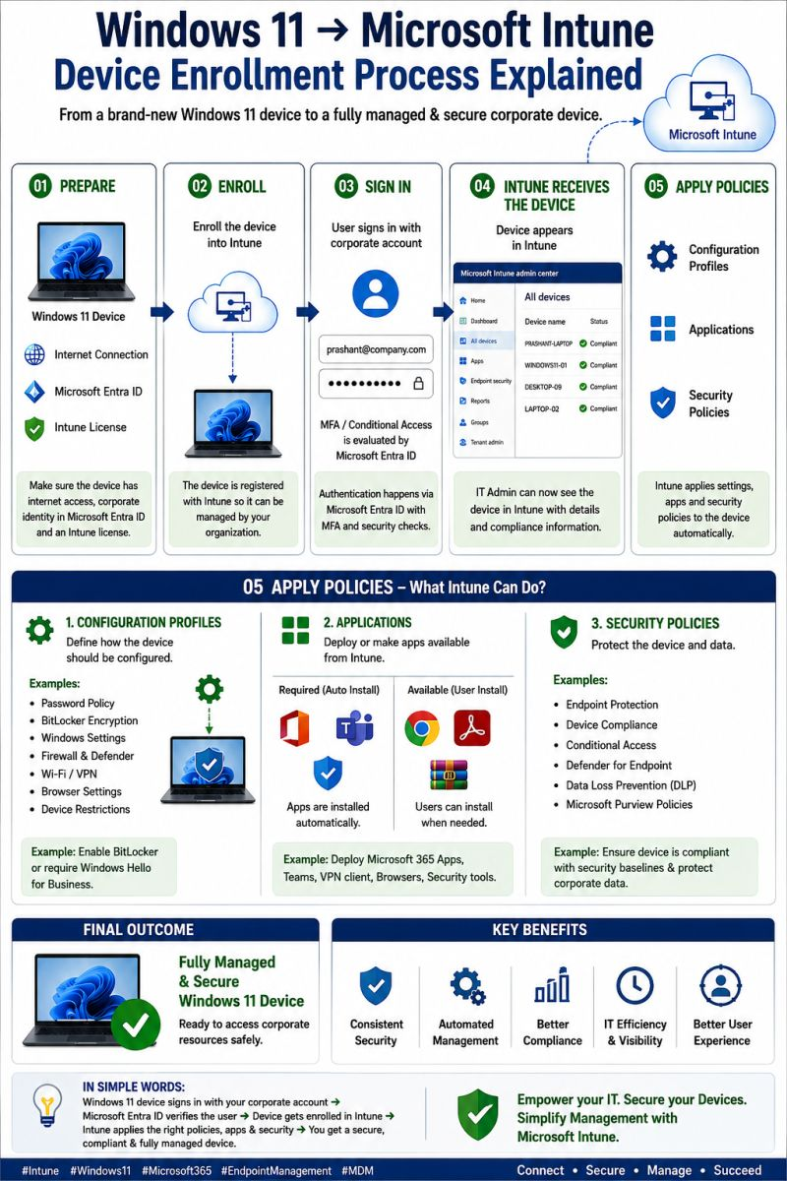
Windows Server Admin : Task Manager
As a Windows Server Administrator, Task Manager is one of the simplest and most useful tools for monitoring server performance and troubleshooting issues.
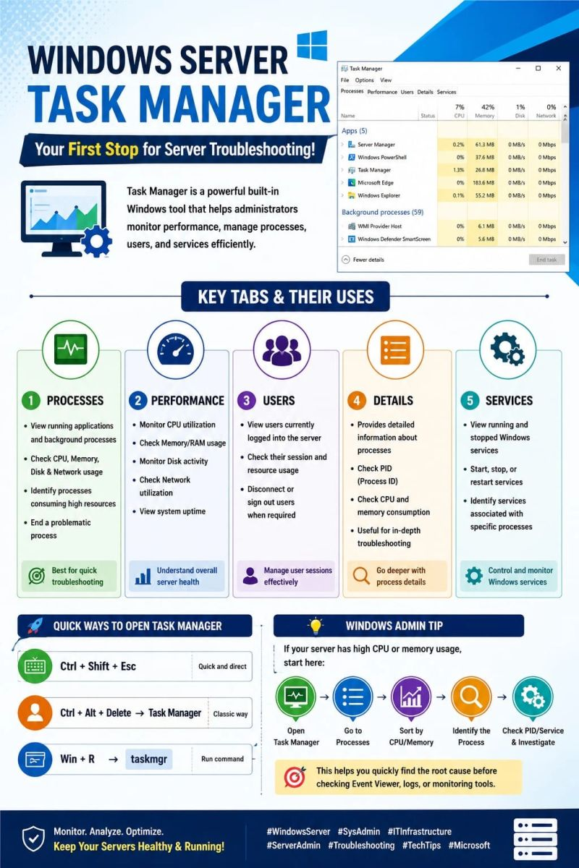
10 Windows Commands Every IT Support Engineer
1️⃣ ipconfig: Quickly checks your IP configuration. Useful when troubleshooting network connectivity.
2️⃣ ipconfig /all: Shows detailed network information including: IP address, DNS, DHCP, MAC address and more.
3️⃣ ipconfig /flushdns: Clears the DNS resolver cache. Helpful when websites or internal systems aren't resolving correctly.
4️⃣ ping: Checks whether a device or server is reachable over the network.
Example: ping 8.8.8.8
5️⃣ tracert: Shows the path packets take to reach a destination. Useful for identifying where network delays or failures may occur.
6️⃣ nslookup: Checks DNS resolution and helps identify DNS-related problems.
7️⃣ hostname: Quickly displays the computer's hostname. Simple, but useful when identifying systems remotely.
8️⃣ systeminfo: Provides detailed information about the Windows system, including OS version, hardware and system configuration.
9️⃣ tasklist: Displays currently running processes. Useful when investigating applications consuming resources or behaving unexpectedly.
🔟 sfc /scannow: Scans Windows system files and attempts to repair corrupted files.
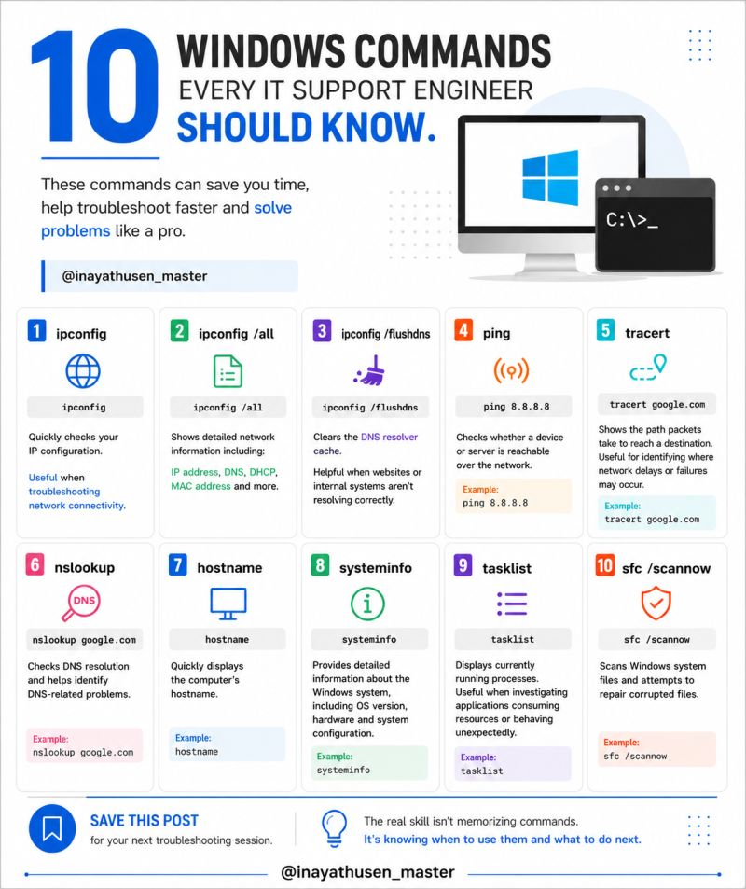
IT Support Tip: Printer Not Printing? 🖨️🔧
“Other computers can print, but mine can’t.” Don’t immediately reinstall the printer. Troubleshoot step-by-step:👇
🔹 Check printer power & physical connection 🔹 Check network connectivity
🔹 Verify printer is Online 🔹 Check printer driver 🔹 Clear stuck print jobs
🔹 Verify correct default printer 🔹 Check firewall/security settings 🔹 Print a test page
💡 Quick Fix: If the print queue is stuck, restart the Print Spooler service. "services.msc" → Print Spooler → Restart
Key Takeaway: Identify → Check → Diagnose → Fix → Verify
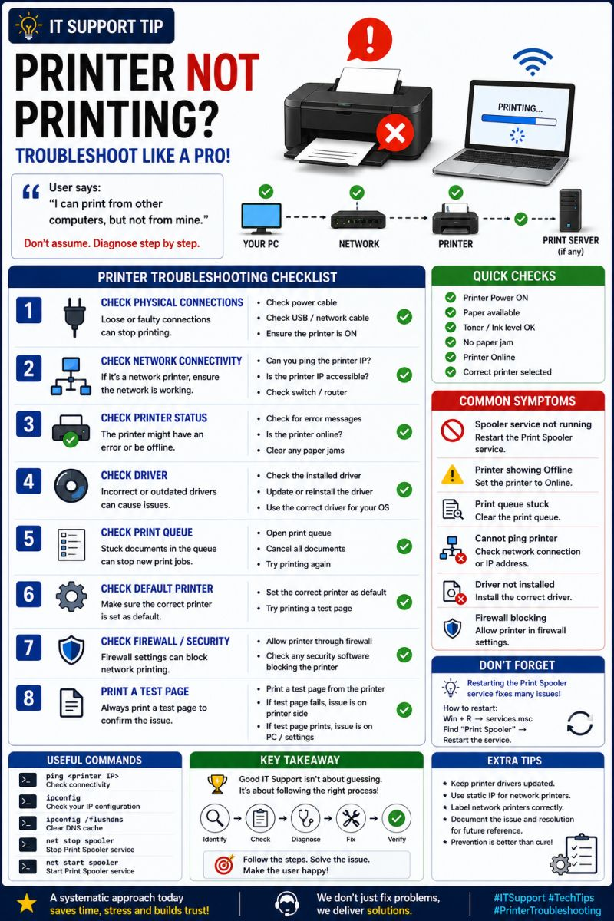
🖥️ Workstation & Domain – IT Infrastructure Basics
A workstation is an end-user computer connected to the organization’s network. When it is joined to a Windows Domain, IT teams can centrally manage users, computers, security policies, and shared resources.
🔹 Workstation:
• Windows 10/11 • IP Address, DNS & Gateway • User login & permissions
• Applications & antivirus • Network printers and shared resources
🔹 Domain Environment:
• Active Directory (AD) – User & computer management
• Domain Controller (DC) – Authentication
• DNS – Name resolution
• Group Policy (GPO) – Security & configuration
• OU – Organizing users and computers
• File/Print Servers – Centralized resources
🔗 Basic Network Flow: Workstation → Switch → Firewall/Router → Domain Controller
🔐 Joining a Workstation to Domain:
1️⃣ Configure IP address
2️⃣ Configure DNS pointing to the Domain Controller
3️⃣ Test connectivity
4️⃣ Verify DNS resolution
5️⃣ Open System Properties
6️⃣ Select Change → Domain
7️⃣ Enter the domain name
8️⃣ Provide authorized domain credentials
9️⃣ Restart the workstation
🔟 Login using the domain account
✅ Benefits:
• Centralized user management • Better security and access control
• Centralized Group Policy • Easy resource sharing
• Simplified IT administration • Scalable enterprise environment
💡 Interview Tip:
“A workstation is an end-user computer, while a domain provides centralized authentication and management through Active Directory. Domain-joined computers can be centrally managed using AD, DNS and Group Policy.”

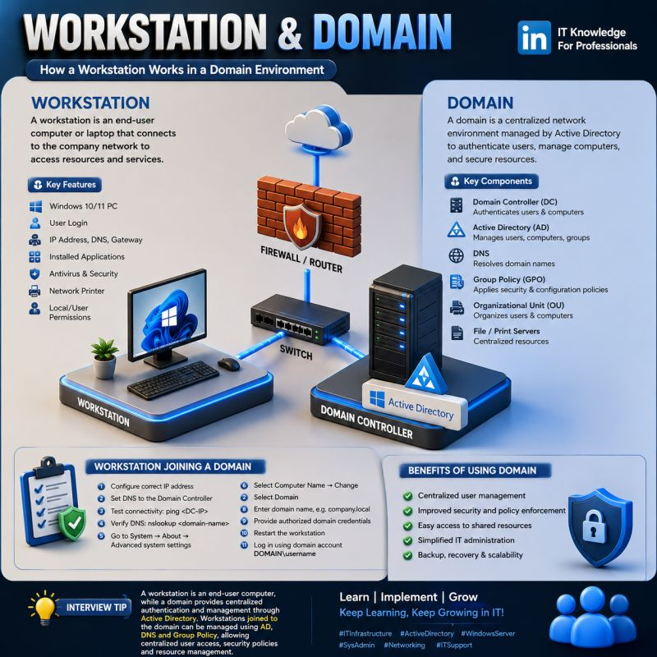
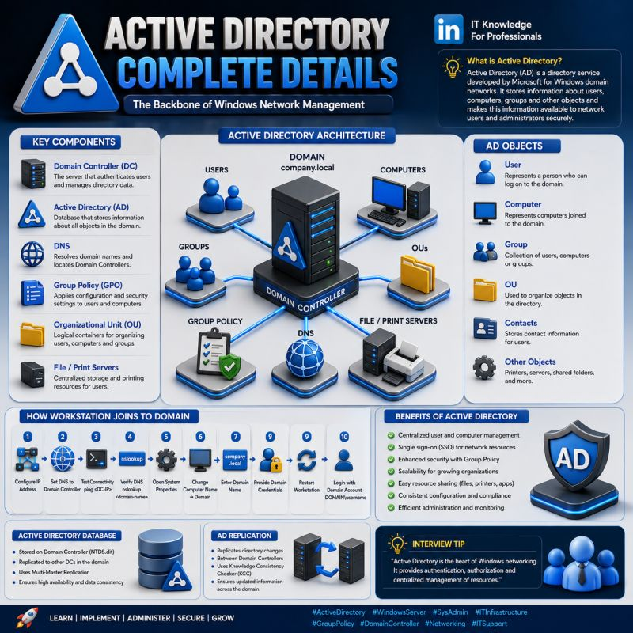
1. IT Help Desk Series
✅ What an IT Help Desk. ✅ Key responsibilities
✅ Essential tools ✅ Core skills every IT Support Engineer should know
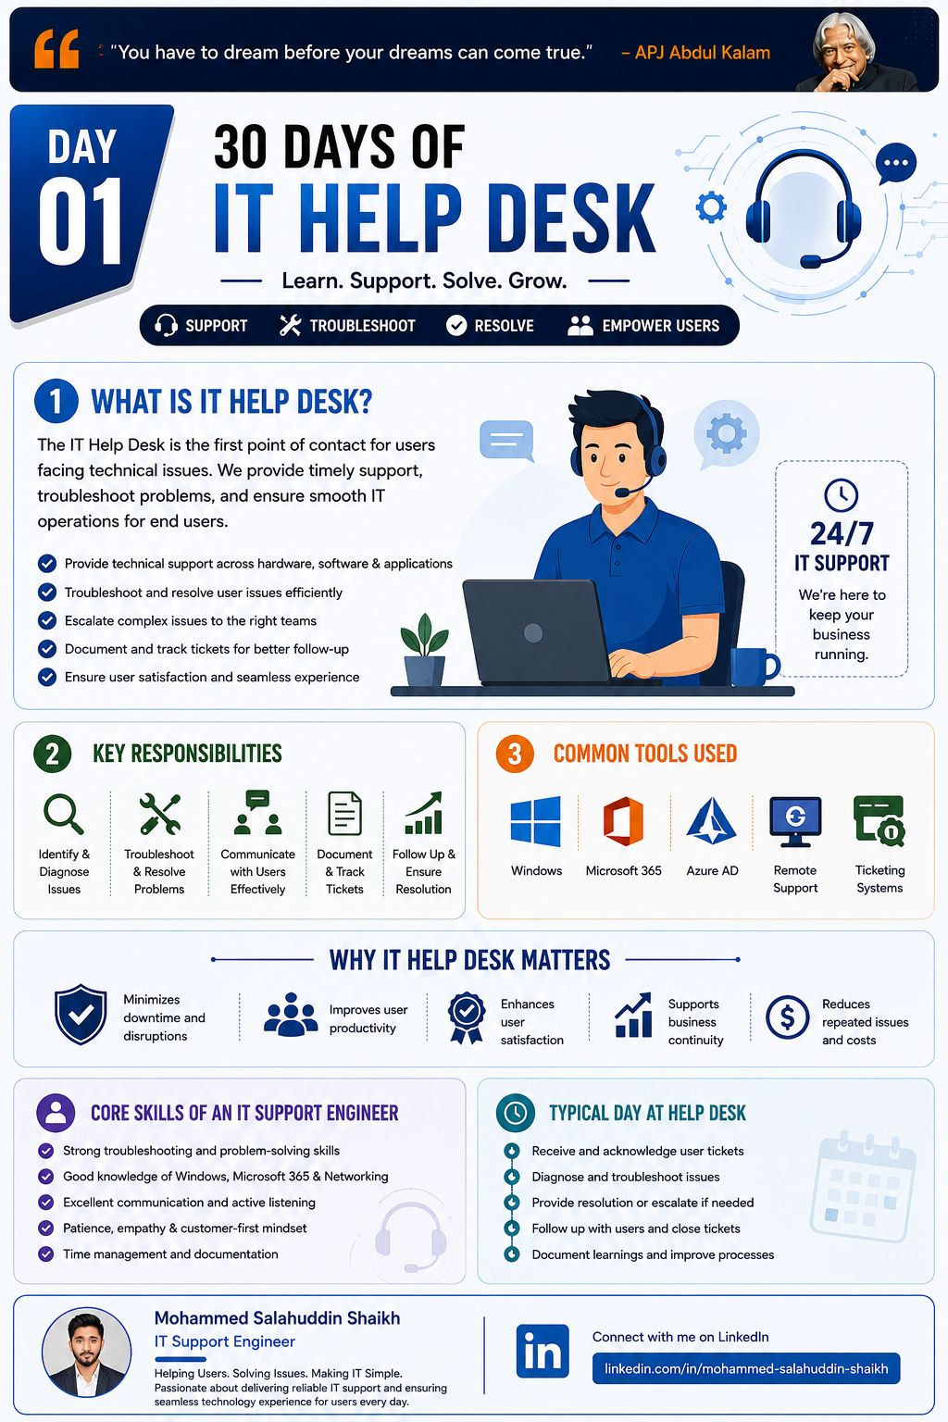
2. IT Help Desk Series : IT Ticketing Systems 🎫
✅ What an IT ticket is✅ Ticket lifecycle
✅ Priority levels ✅ Best practices for handling tickets
Understanding ticket management helps improve response time, user satisfaction, and overall IT operations.
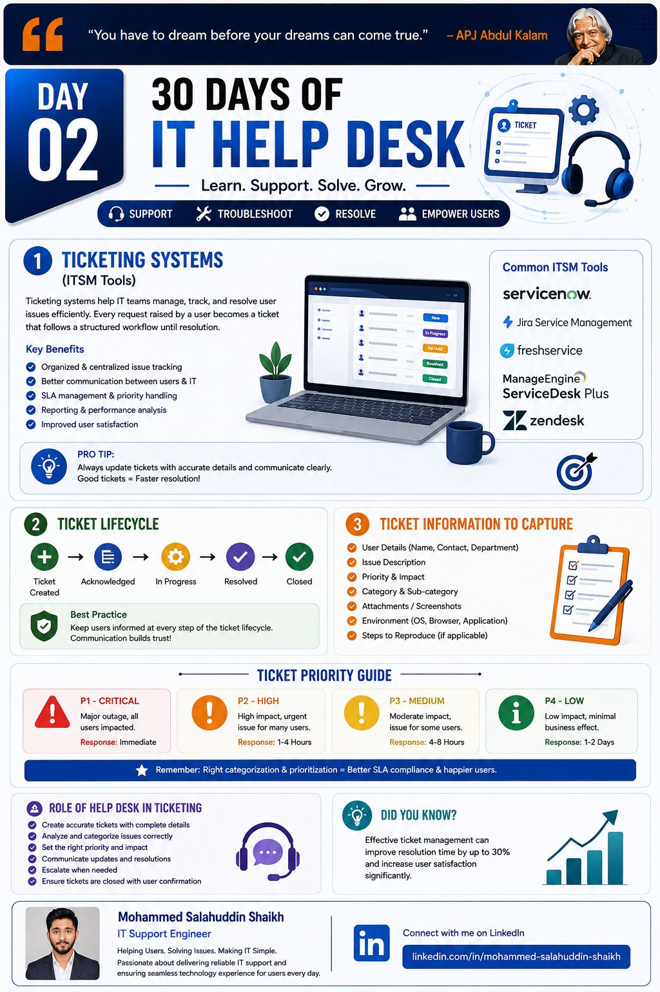
3. IT Help Desk Series: Troubleshooting Basics 🛠️
A structured approach helps identify the root cause, resolve issues faster, and improve user satisfaction.
✅ Troubleshooting process ✅ Common IT issues
✅ Best practices ✅ Essential troubleshooting tools
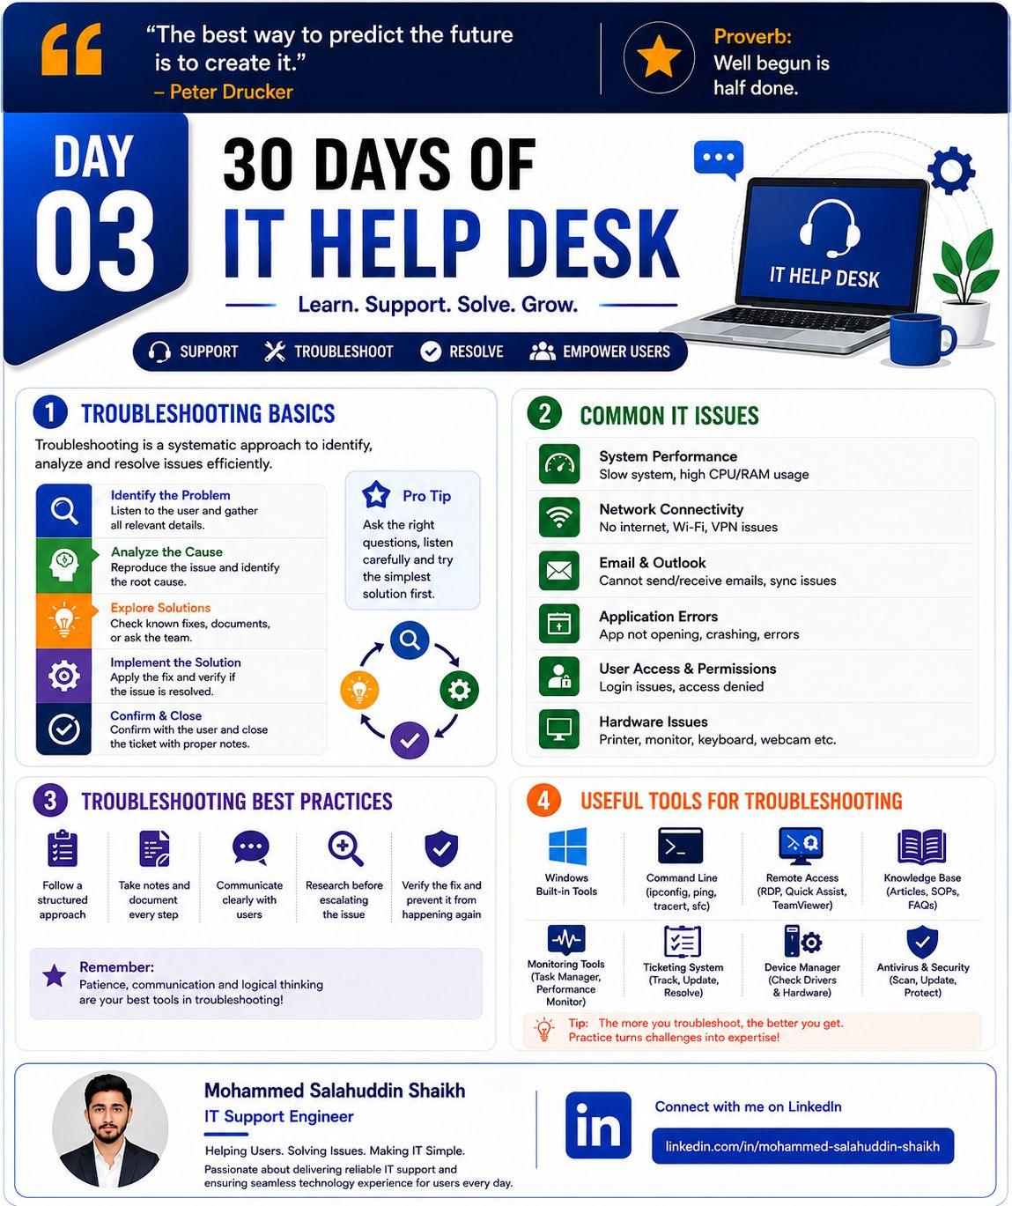
4. IT Help Desk Series: IT Ticket Priority Levels (P1, P2, P3 & P4)
Understanding ticket priorities is essential for every IT Support Engineer.
Proper prioritization helps resolve critical issues faster, minimize downtime, and improve user satisfaction.
✅ How ticket priorities are assigned ✅ Real-world examples ✅ Best practices for prioritization
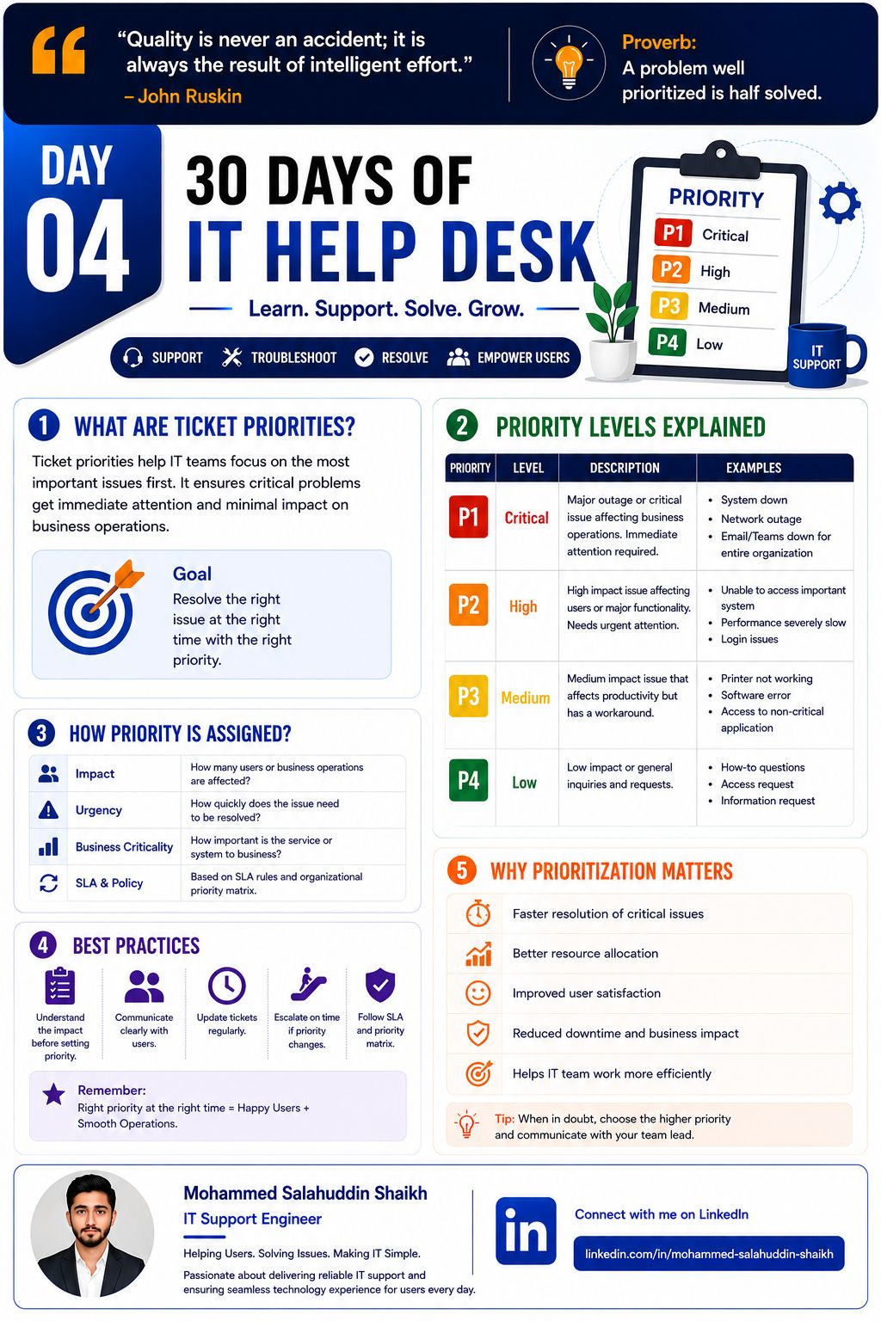
5. IT Help Desk Series: Incident Management
Incident Management is all about restoring normal IT services as quickly as possible while minimizing the impact on users and business operations.
✅ What Incident Management is ✅ Incident Lifecycle ✅ Key Principles
✅ Common Incident Examples ✅ Best Practices
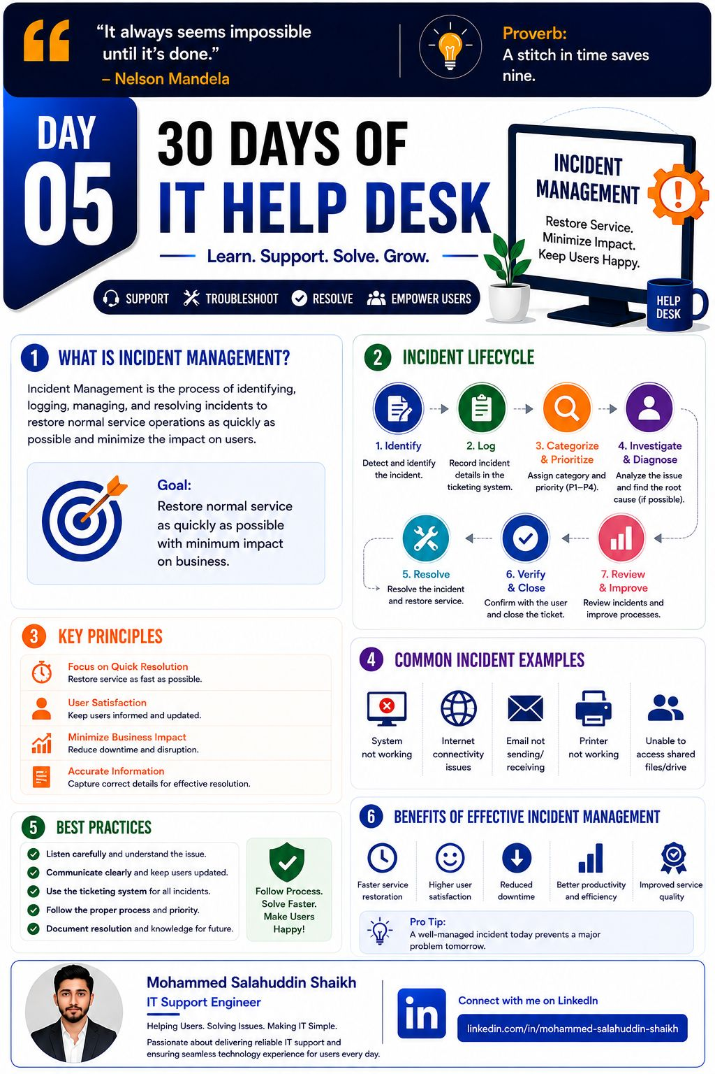
6. IT Help Desk Series: Service Request vs Incident vs Problem
Understanding the difference helps IT Support teams categorize, prioritize, and resolve issues more effectively.
✅ Service Request ✅ Incident ✅ Problem ✅ Key differences & examples
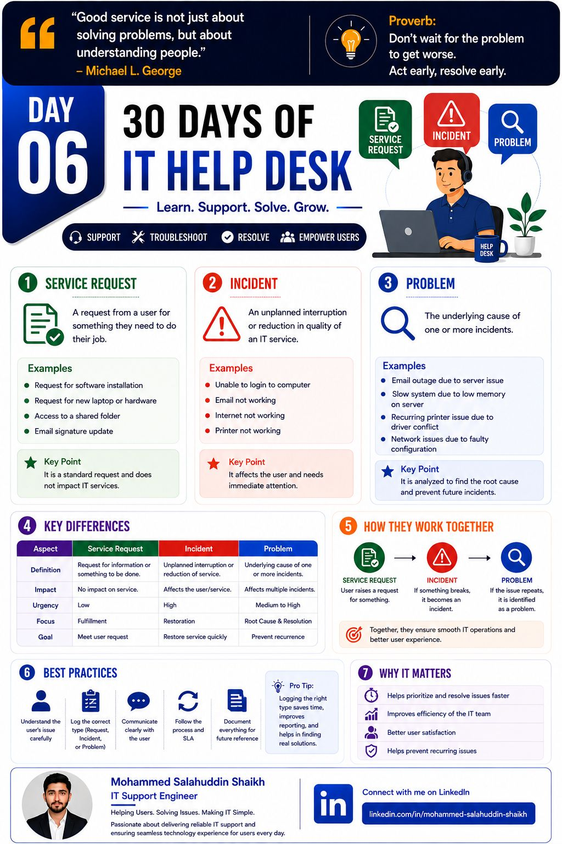
7. IT Help Desk Series: Problem Management & Root Cause Analysis (RCA)
Finding the root cause helps IT teams prevent recurring incidents instead of only fixing the symptoms.
✅ Problem Management✅ RCA process ✅ Common RCA techniques ✅ Real-world examples
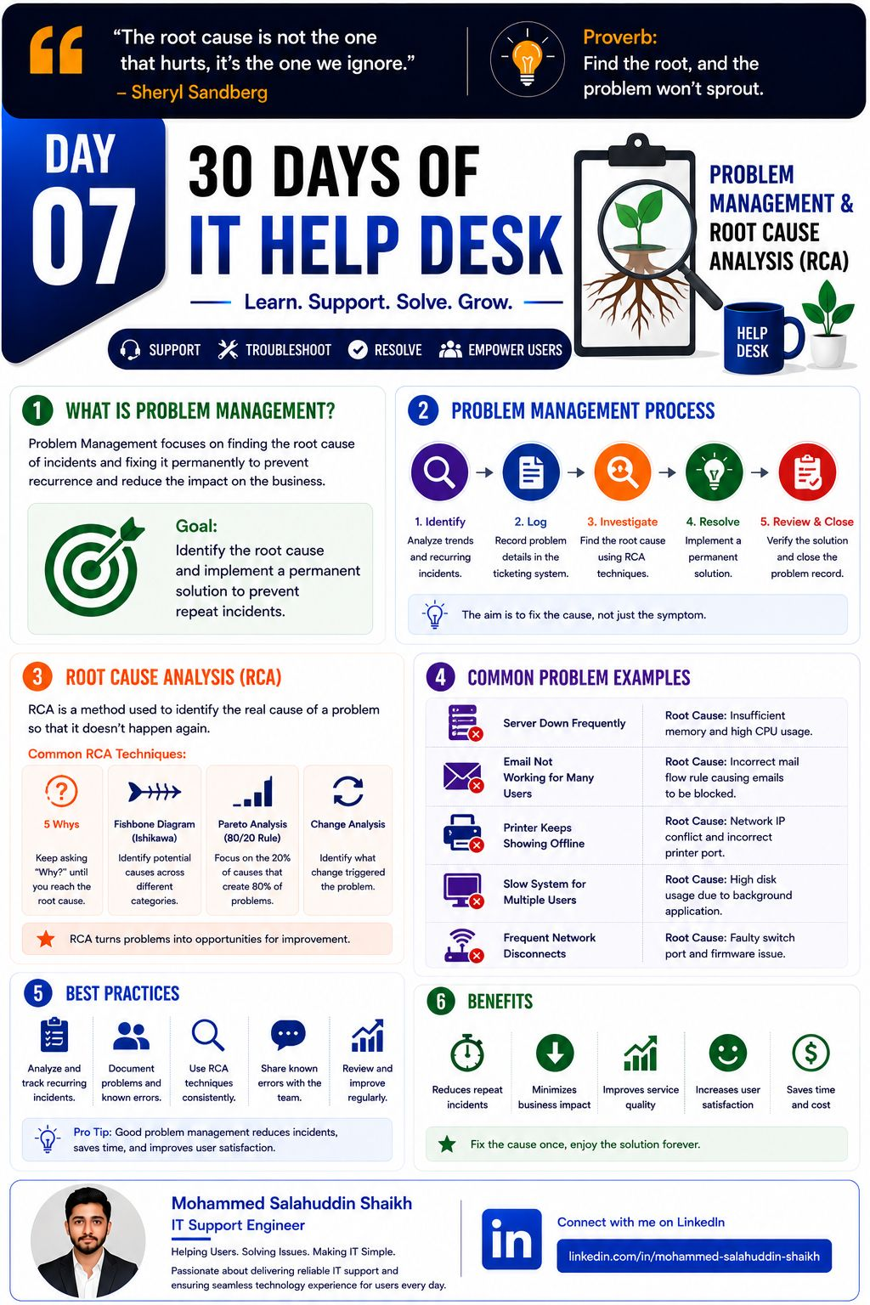
8. IT Help Desk Series: Active Directory Basics
Active Directory helps IT teams centrally manage users, computers, groups, and access across an organization.
✅ What Active Directory is ✅ Key components ✅ AD structure ✅ Common Help Desk tasks
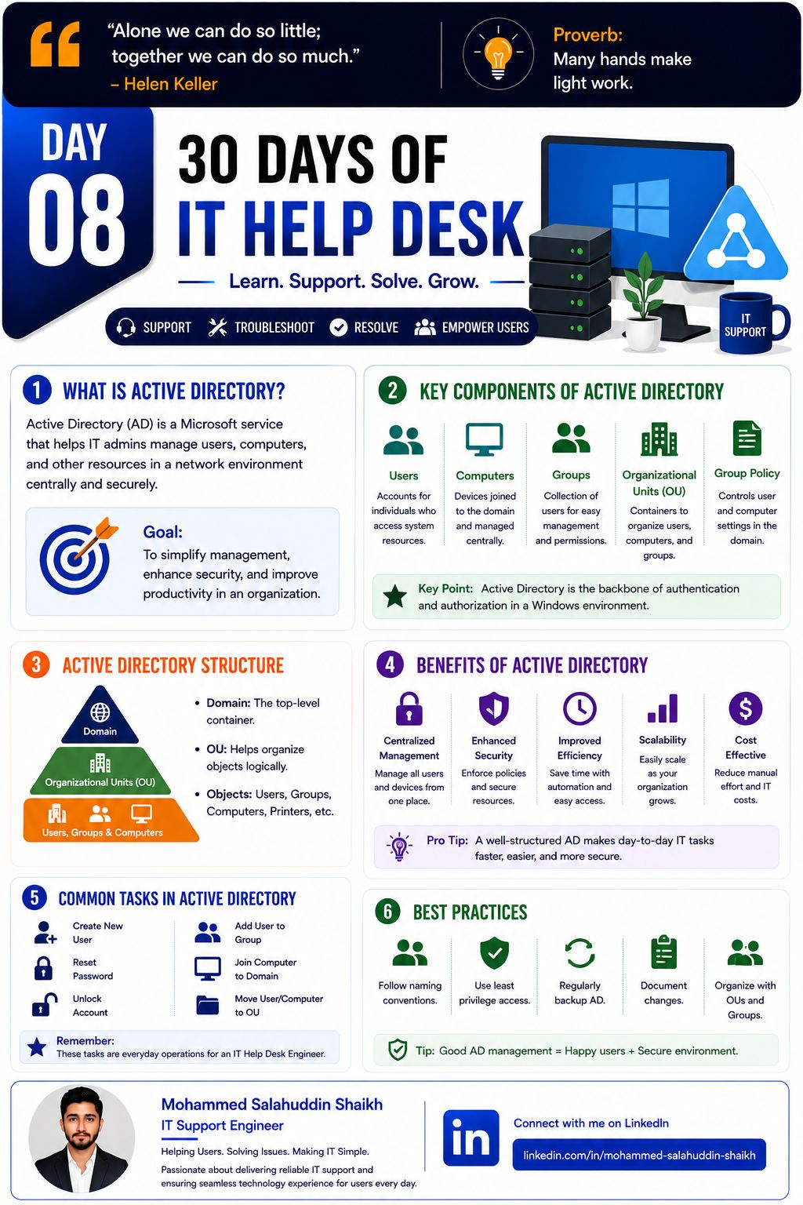
9. IT Help Desk Series: Password Reset & Account Unlock
Password and account issues are some of the most common Help Desk requests. Following the right process helps restore access quickly while keeping user accounts secure.
✅ Password reset process ✅ Account unlock process
✅ Identity verification ✅ Common causes
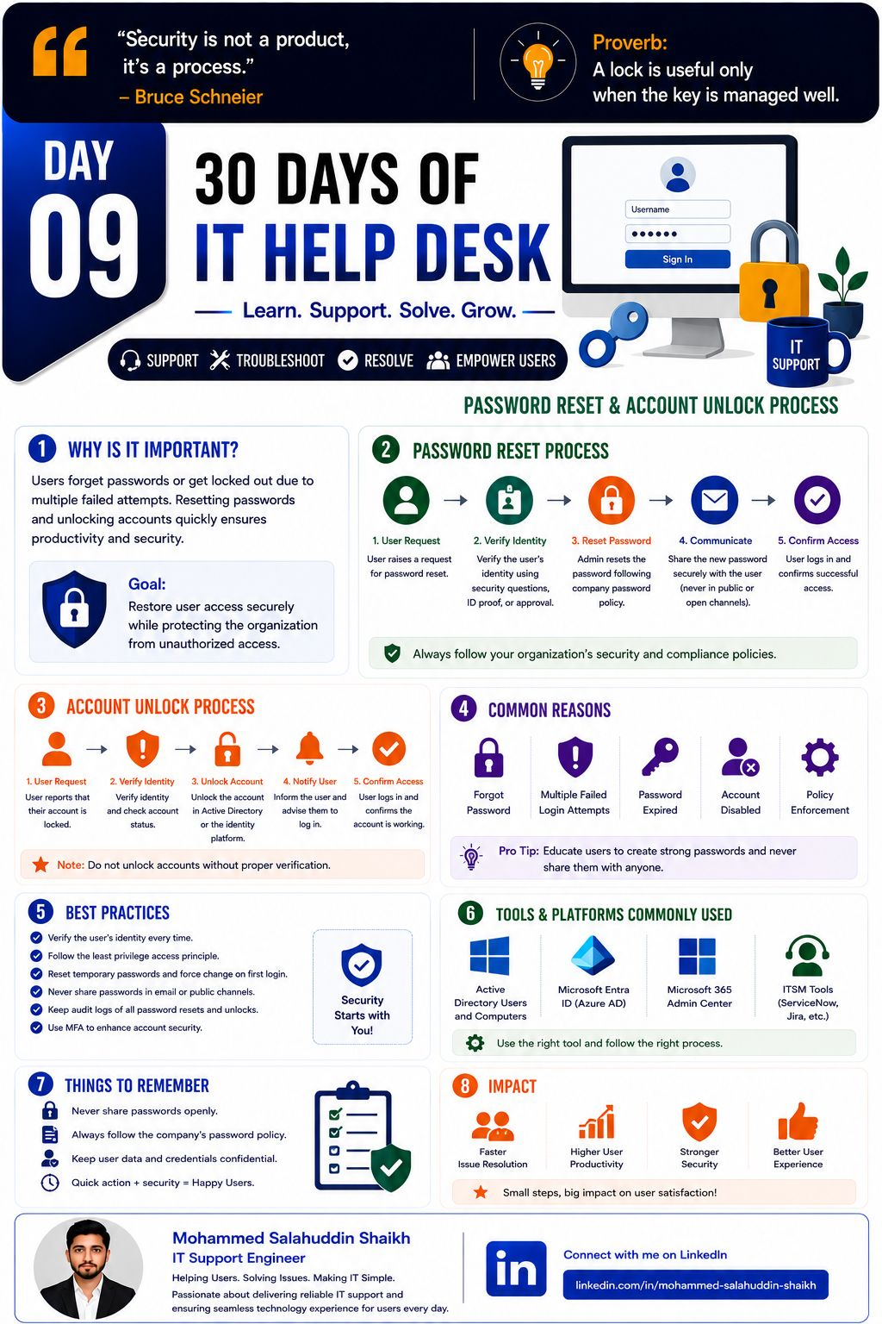
10. IT Help Desk Series: Microsoft 365 Overview
Microsoft 365 is an essential platform for modern workplaces, combining productivity, collaboration, security, and cloud services.
✅ Core Microsoft 365 apps ✅ Exchange Online & Teams
✅ OneDrive & SharePoint ✅ Intune & Entra ID
✅ Common Help Desk tasks ✅ Security & support best practices
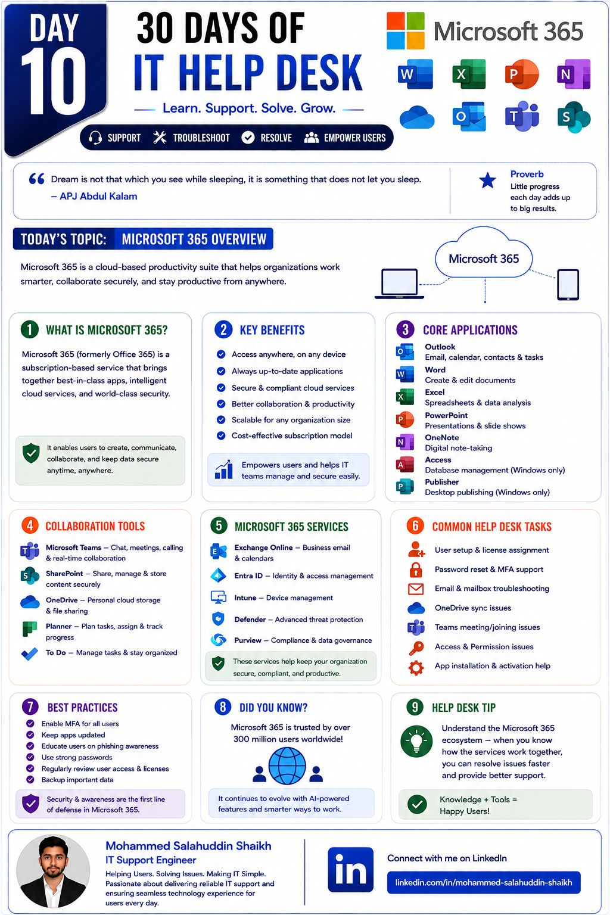
11. IT Help Desk Series: Outlook Troubleshooting
How to identify common Outlook issues, perform initial checks, and apply quick troubleshooting steps.
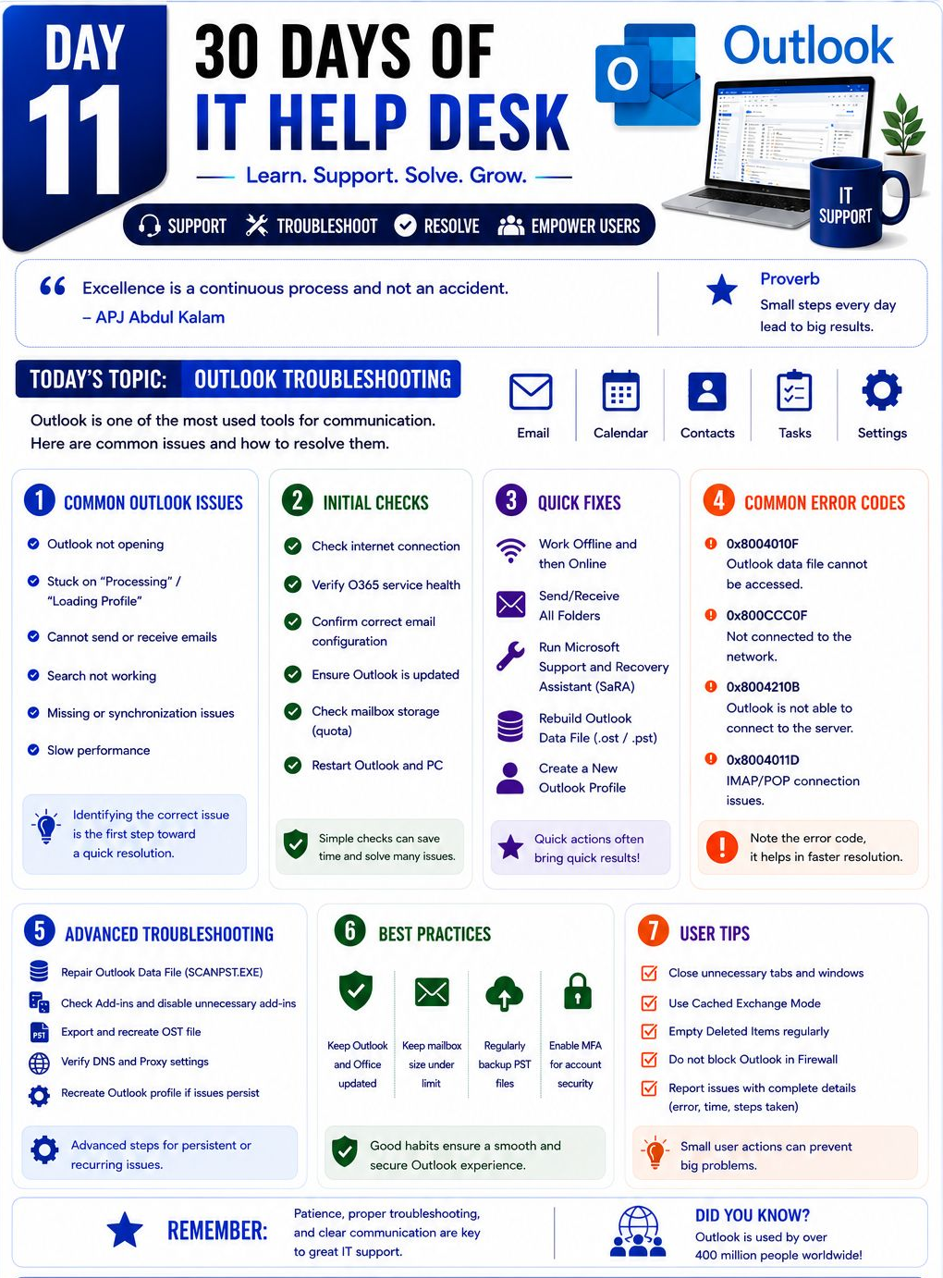
12. IT Help Desk Series: Microsoft Teams Troubleshooting
How to troubleshoot common Teams issues like login problems, meeting errors, audio/video issues, connectivity, and chat synchronization.
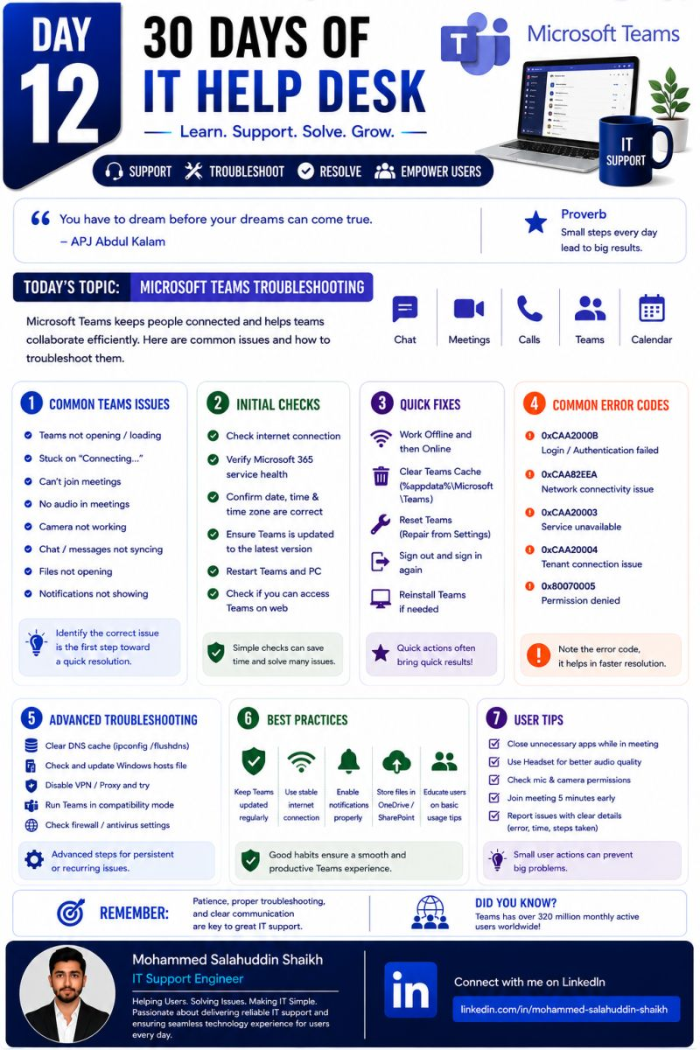
13. IT Help Desk Series: SharePoint Troubleshooting
SharePoint issues can affect file access, syncing, permissions, and collaboration.
Knowing the right troubleshooting steps helps IT Support resolve these issues quickly and keep users productive.
✅ Common SharePoint issues ✅ Initial checks ✅ Quick fixes ✅ Error troubleshooting
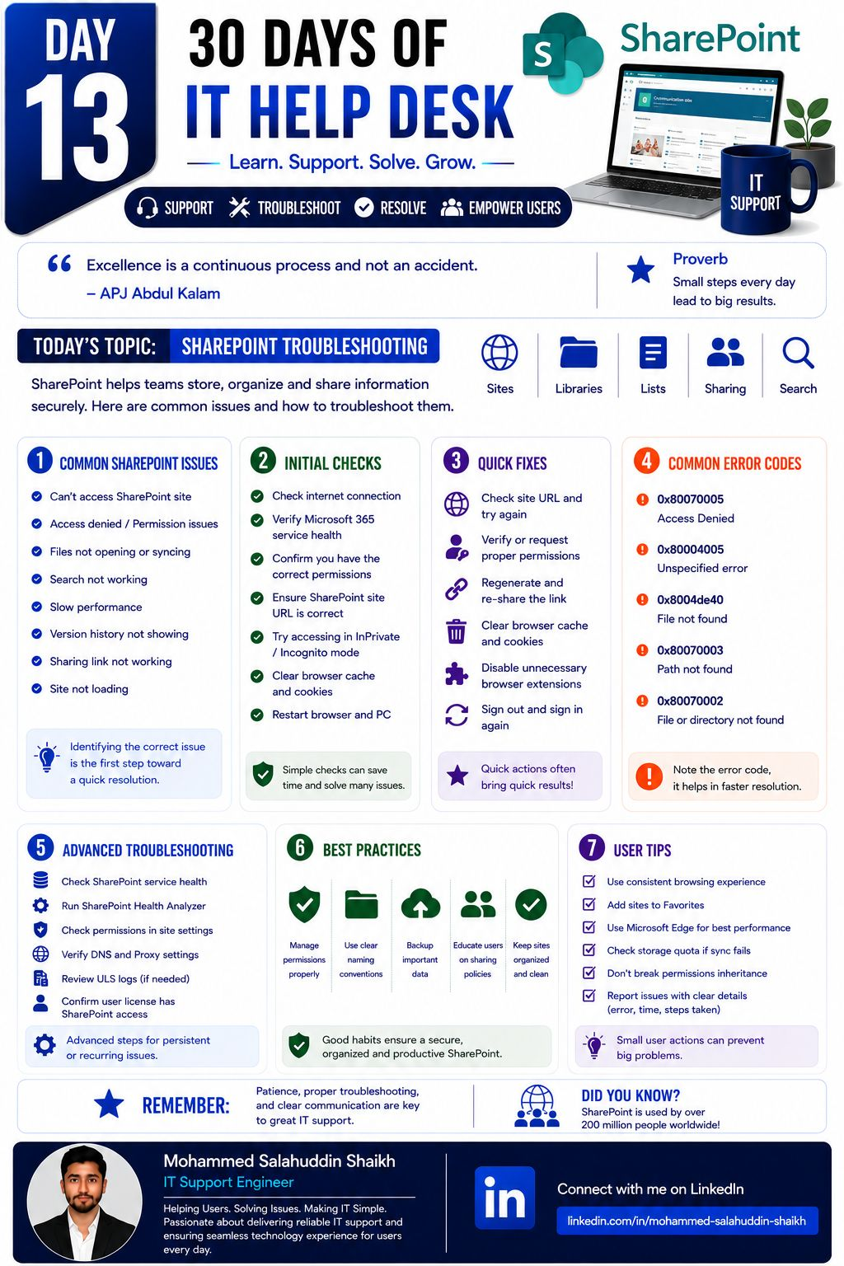
14. IT Help Desk Series: Blue Screen of Death (BSOD) Troubleshooting
How to identify common BSOD causes, check error codes, troubleshoot drivers and hardware, and apply practical steps to resolve Windows crashes.
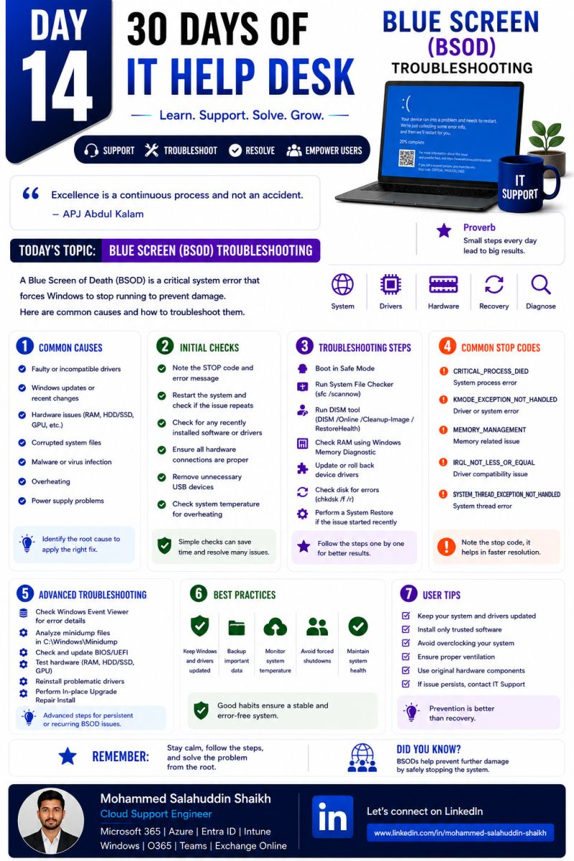
15. IT Help Desk Series: Printer Troubleshooting 🖨️
How to troubleshoot common printer issues such as offline status, print queue errors, driver problems, connectivity issues, paper jams, and print quality problems.
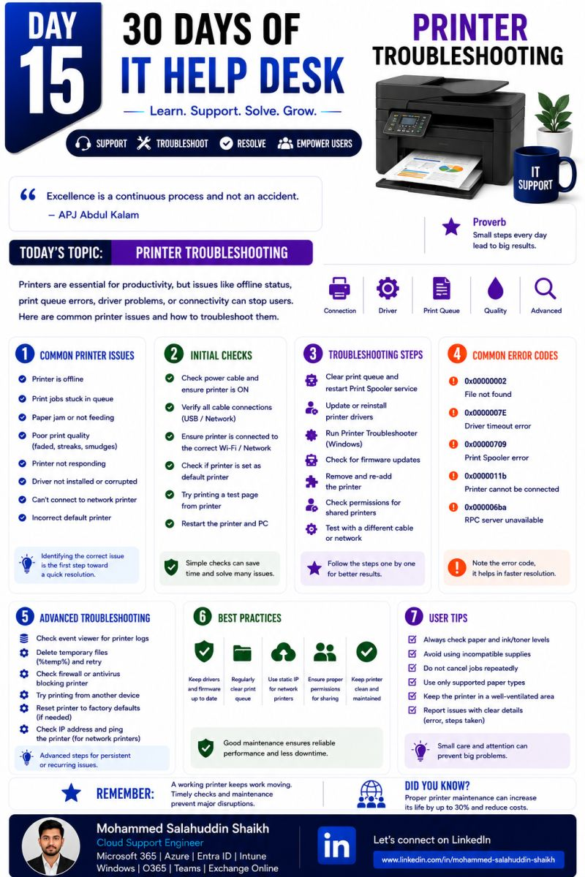
16. IT Help Desk Series: BIOS, UEFI & Boot Menu Explained
Basics of BIOS and UEFI, how to access the BIOS/UEFI settings, understand the Boot Menu, and troubleshoot common boot and startup issues.
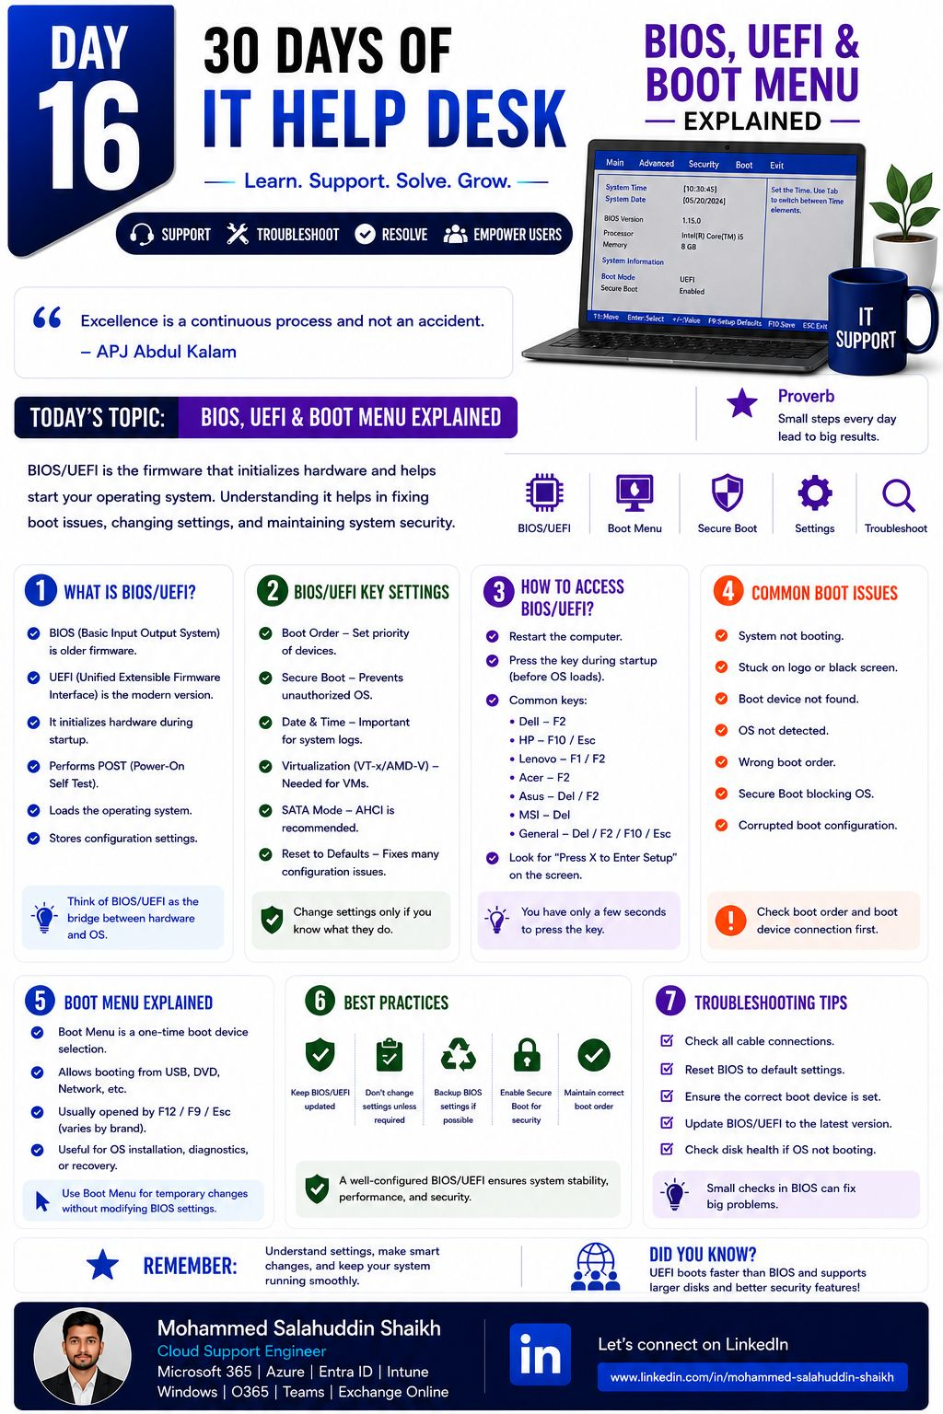
17. IT Help Desk Series: Laptop & Desktop Hardware Troubleshooting
How to troubleshoot common hardware issues such as power failures, display problems, overheating, RAM errors, storage issues, keyboard/mouse problems, and boot failures.
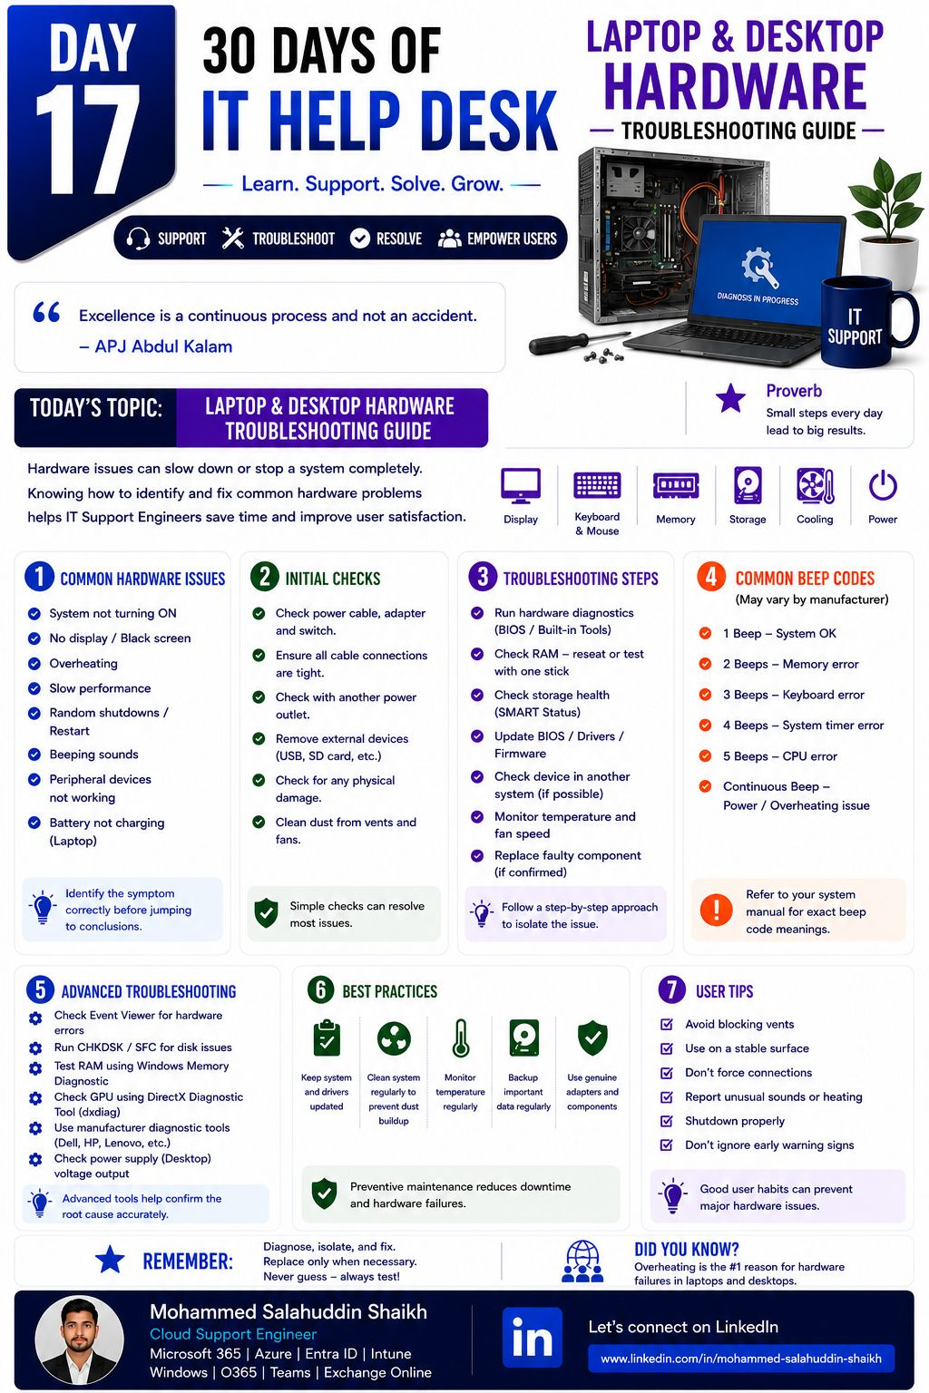
18. IT Help Desk Series: Networking
Fundamentals of IP addresses, DNS, DHCP, gateways, subnetting, Wi-Fi, and basic network troubleshooting—essential skills for every IT Support Engineer.
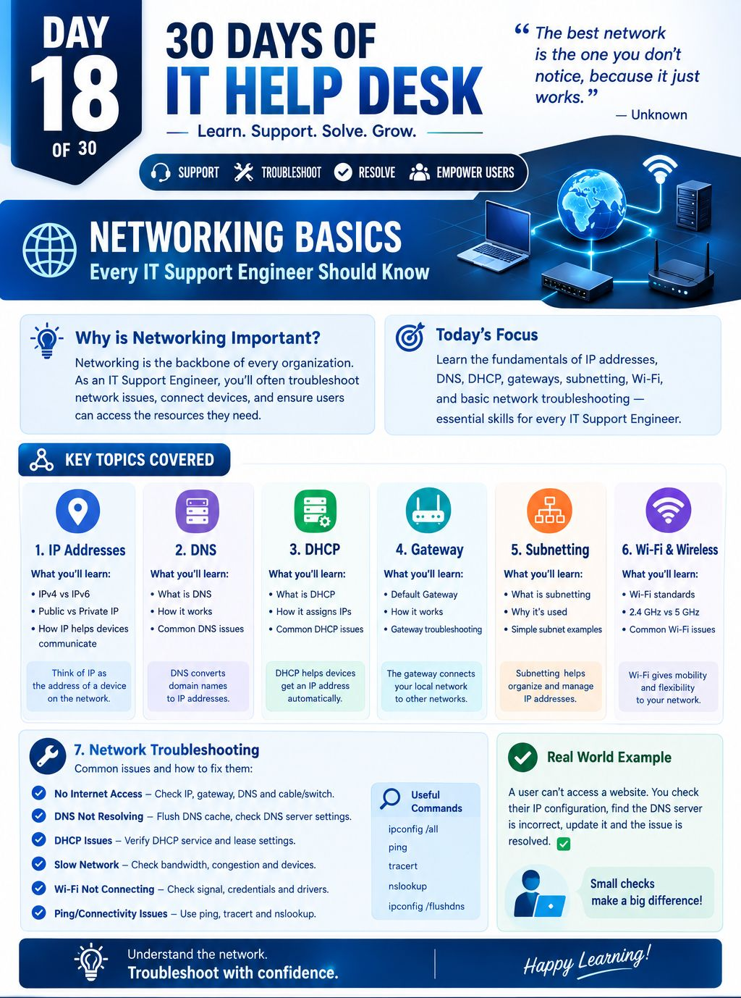
19. IT Help Desk Series: DNS & DHCP Explained
How DNS translates domain names into IP addresses and how DHCP automatically assigns IP addresses to devices on a network. Also understand common issues and basic troubleshooting steps.
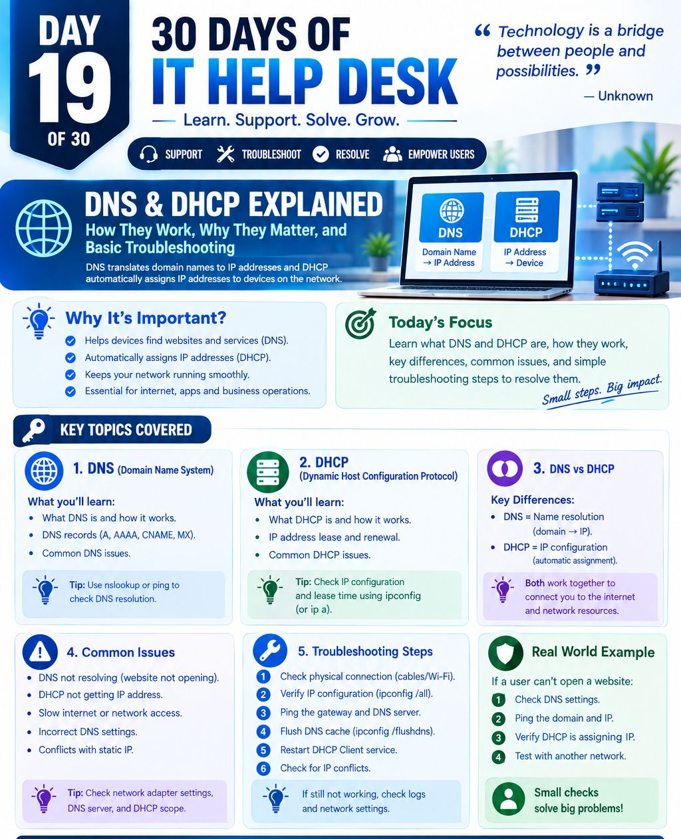
20. IT Help Desk Serie: VPN Issues & Troubleshooting Tips
How to troubleshoot common VPN issues such as connection failures, authentication errors, slow performance, VPN client problems, and access issues with practical step-by-step checks.
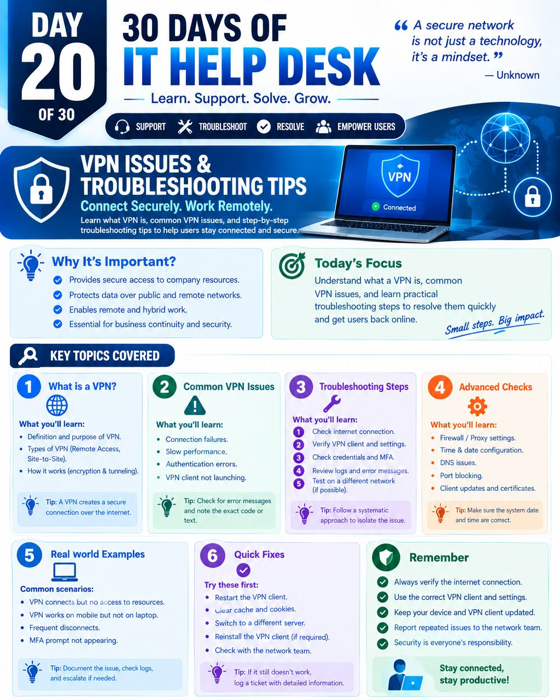
21. IT Help Desk Series: Remote Desktop (RDP) & Remote Assistance
How to use RDP and remote assistance to support users remotely, troubleshoot connectivity and login issues, and resolve problems efficiently without being physically present.
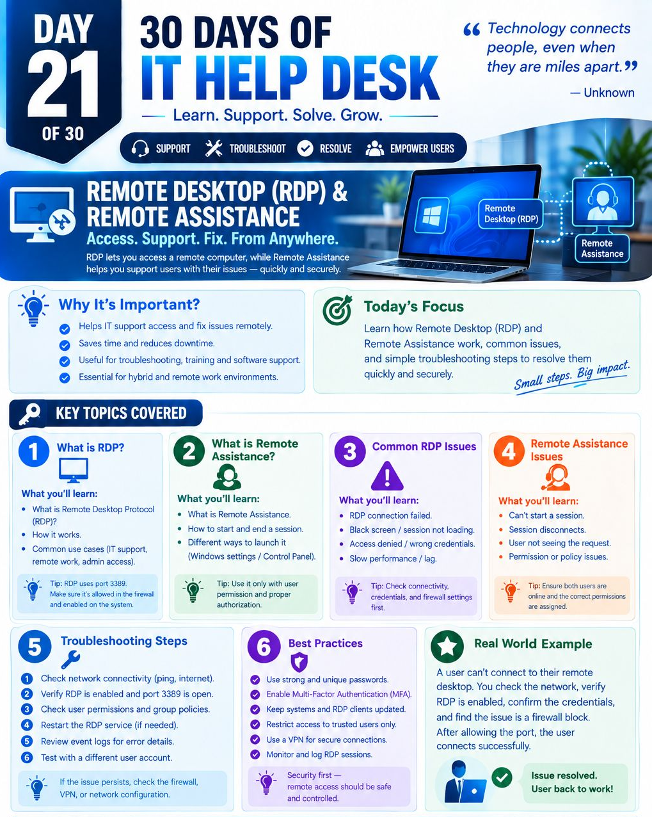
Computer Management Models.
An organisation can manage its computers using three common models: Workgroup, Domain-Client, and Microsoft Intune.
Workgroup Model: Each computer operates independently and is managed locally. It is simple and inexpensive, making it suitable for home users and very small organisations, but it becomes difficult to manage and secure as the number of computers increases.
Domain-Client Model: Computers are joined to a central Active Directory Domain Controller. IT administrators can centrally manage users, computers, Group Policies, software, security settings, printers, and shared resources. It provides strong centralised control but requires on-premises infrastructure, maintenance, and IT expertise.
Microsoft Intune Model: Intune provides cloud-based device management, allowing administrators to manage Windows, macOS, iOS/iPadOS, and Android devices from anywhere. It supports device enrollment, application deployment, security policies, compliance, remote management, and integration with Microsoft Entra ID and Microsoft 365. It is particularly suitable for modern, remote, and hybrid organisations.
In simple terms:
Workgroup = Individual Management, Domain = Centralised On-Premises Management, Intune = Centralised Cloud Management.
The choice depends on the organisation's size, infrastructure, security requirements, workforce location, budget, and cloud strategy.
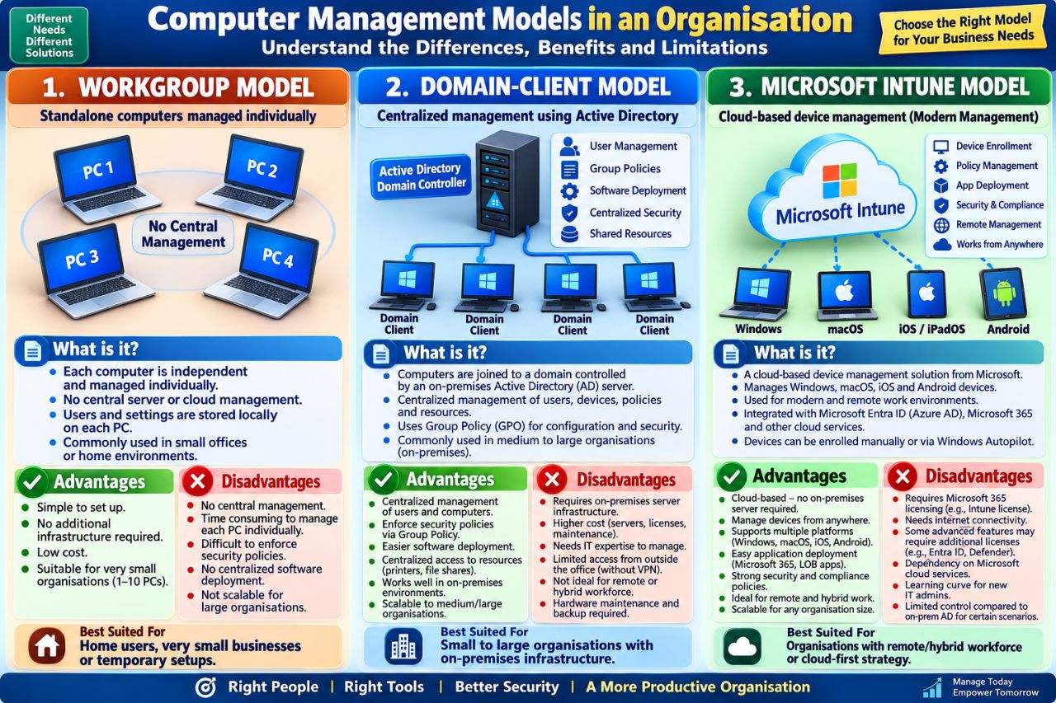
Microsoft 365 Troubleshooting:
When Microsoft 365 stops working, don’t start with “What should I restart?”
Start with: 👉 Is it a user issue, device issue, configuration issue, or service issue?
🛠️ Quick M365 Troubleshooting Checklist:
🔐 Can't Sign In? : Check account status → MFA → Conditional Access → Entra sign-in logs
📧 Email Not Sending/Receiving?: Check Service Health → mailbox → mail flow → message trace → DNS"
🔄 Outlook/OneDrive Not Syncing?: Check connectivity → Service Health → storage → sync errors → client health
💬Teams Not Working?: Check Service Health → licensing → network → sign-in → client version
🗂️ SharePoint Access Denied?: Check permissions → group membership → sharing policies → identity → Conditional Access
Professional Formula: Service Health → Scope → User → Configuration → Logs → Fix → Test
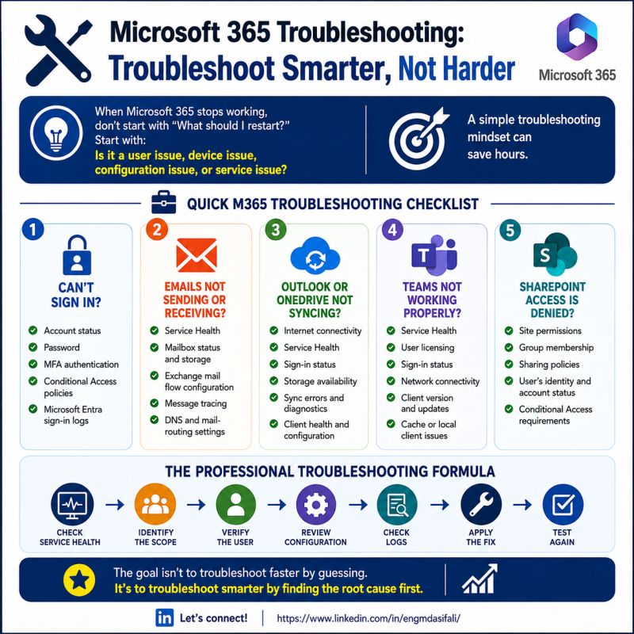
Mailbox vs Alias vs Shared Mailbox — What’s Difference?
👤USER MAILBOX = Your personal email home
A mailbox belongs to one user. You get your own inbox, calendar, contacts, storage and other Microsoft 365 services.
🏷️ ALIAS = Another name for the same mailbox
An alias is simply an additional email address pointing to the **same mailbox**.
For example: john.smith@company.com`, `jsmith@company.com`
➡️ All can deliver mail to the **same inbox**.
👥 SHARED MAILBOX = One inbox for a team
A shared mailbox is designed for multiple users.
Think of: `support@company.com`, `info@company.com`, `sales@company.com`
➡️ Multiple authorized users can access and work from the same mailbox.
💡 The easiest way to remember: Mailbox → One person, Alias → Another address,
Shared Mailbox → Multiple people
👉 **Do I need a new mailbox, another address for the same mailbox, or an inbox that a team can share?**
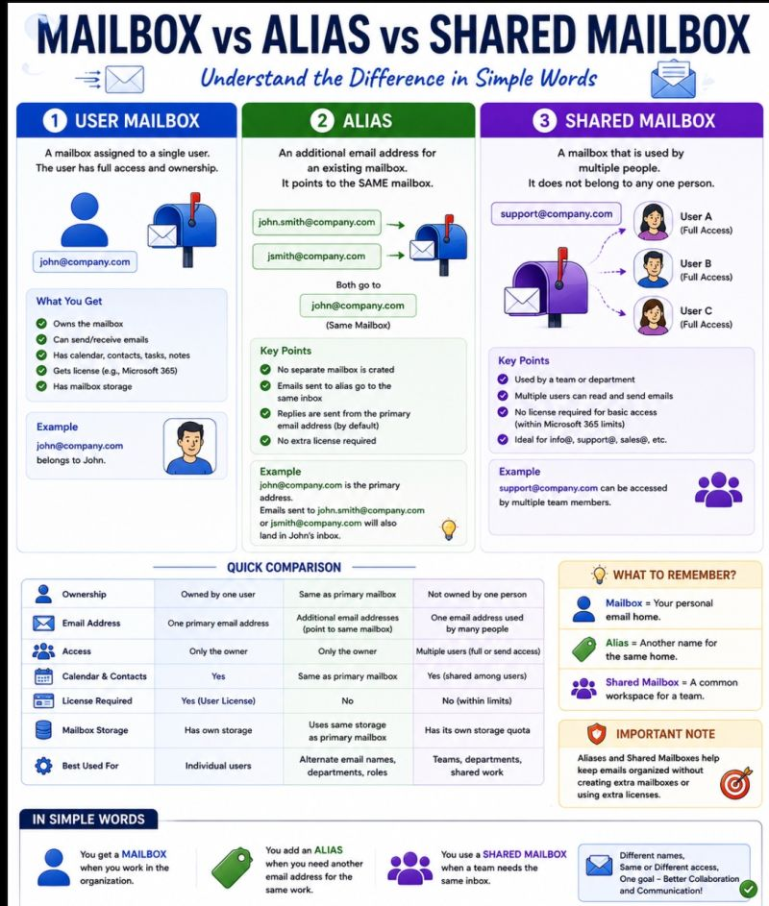
Windows Server: How to Allocate a Storage Quota to a
File Server Folder
Managing storage on a Windows File Server becomes much easier with FSRM (File Server Resource Manager). Instead of allowing a shared folder to consume the entire disk, we can define a specific storage limit for that folder.
🔹Step 1 - Install FSRM: On Windows Server: Server Manager → Add Roles and Features → File and Storage Services → File and iSCSI Services → File Server Resource Manager
Or using PowerShell:
"Install-WindowsFeature FS-Resource-Manager
-IncludeManagementTools"
🔹Step 2 - Open FSRM: Go to: Server Manager → Tools → File Server Resource Manager Then navigate to: Quota Management → Quota Templates
🔹Step 3 - Create a Quota Template: Right-click Quota Templates → Create Quota Template
Example: Template Name: "100 GB File Share"→ Space Limit: "100 GB" → Type: Hard Quota
You can also configure notification thresholds such as: 80% → Warning, 90% → Critical Warning, 100% → Quota Reached
A Hard Quota prevents additional files from being saved after the configured limit is reached, while a Soft Quota only monitors/report usage without enforcing the limit.
🔹Step 4 - Apply the Quota to a Folder: Go to: Quota Mgmt → Quotas → Create Quota
Example: "D:\FileShare\Finance", Select: Create quota on path
Then select the previously created quota template and click Create. → The quota will apply to that folder and its contents.
🔹Bonus - Auto Apply Quota: If you have multiple department folders, you can use
an Auto Apply Quota so that the quota is automatically applied to existing and newly created subfolders.
This is especially useful for large file-server environments with many department/user folders.
💡Real-World Example: Suppose: "D:\Shares\HR" needs a maximum of 100 GB.
Configure: 📁 Folder → HR, 💾 Quota → 100 GB, ⚠️ Warning → 80%, 🚨 Critical → 90%, 🛑 Hard Limit → 100%
This gives the infrastructure team better control over file-server capacity and prevents a single share from unexpectedly consuming all available storage.
FSRM is a simple but powerful Windows Server feature for storage governance.
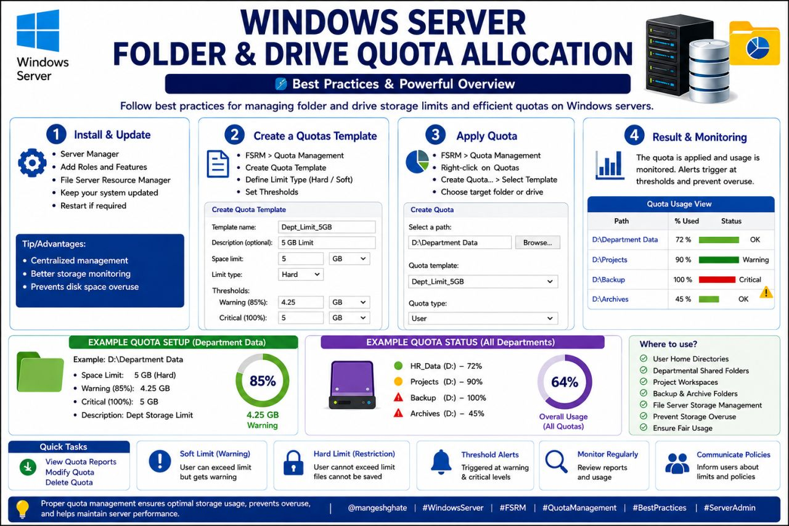

Windows Network Folder Sharing - Complete Guide
A Windows Network Folder makes file sharing & collaboration easier. Here’s a practical quick guide: Create Folder: Create folder → Properties → Sharing.
Set Permissions: Set Share & NTFS permissions., Check Network: Keep both PCs on the same network., Enable Sharing: Turn on Network Discovery & File Sharing. Check Firewall: Allow File & Printer Sharing., Access Folder: \ComputerName\Shared or \IP_Address\Shared , Use CMD: net share , Use PowerShell: New-SmbShare
Keep It Secure: Use specific users/groups instead of Everyone where possible.
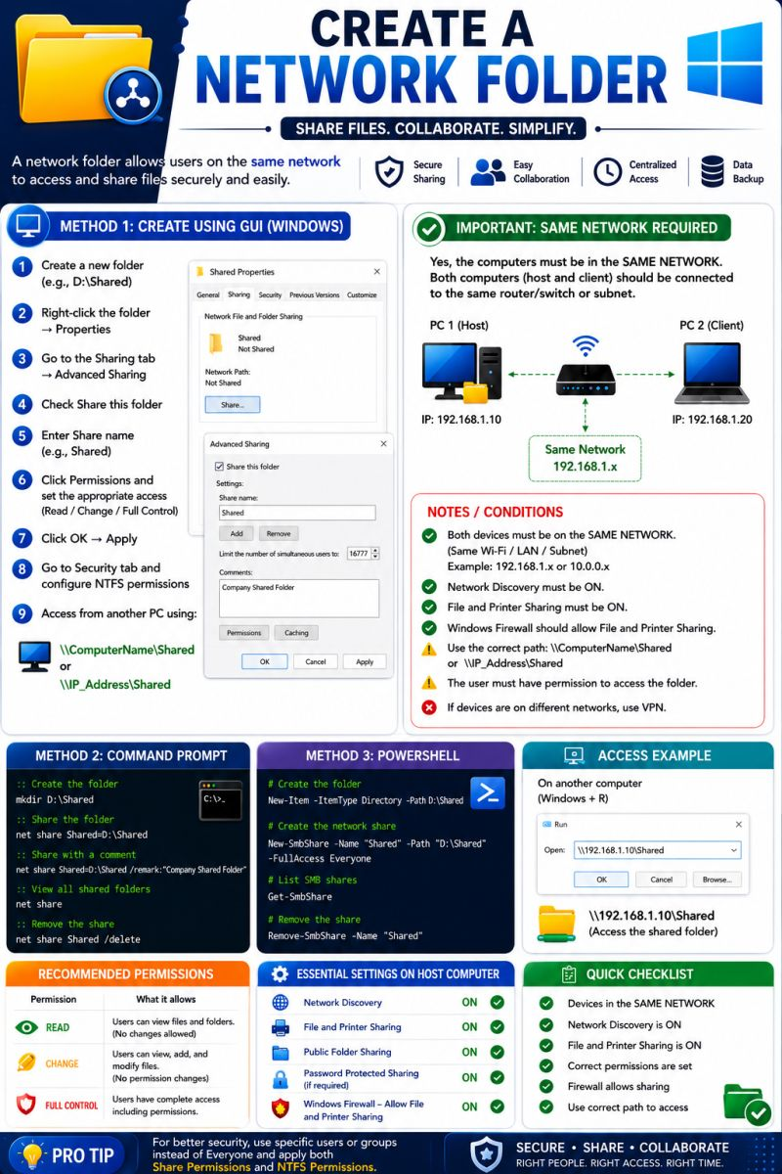
Blue Screen of Death (BSOD)
A user says: “My computer keeps showing a blue screen and restarting.”
Don’t just restart and wait for it to happen again. Find the root cause. 🔧
🔹Note the Stop Code🔹Check RAM / Memory🔹Check HDD/SSD health
🔹Update device drivers🔹Install Windows Updates 🔹Run "sfc /scannow"
🔹Check disk errors with "chkdsk /f /r"🔹Check CPU/GPU temperature
🔹Review recently installed software/hardware🔹Check Event Viewer for related errors
Useful Commands:
🔹"mdsched.exe" → Windows Memory Diagnostic 🔹"sfc /scannow" → Scan system files
🔹"chkdsk /f /r" → Check disk errors🔹"eventvwr.msc" → Check Windows Event Logs
💡 Key Takeaway: A BSOD is not just an error screen — the Stop Code can give you a valuable clue. Identify → Check → Diagnose → Fix → Verify
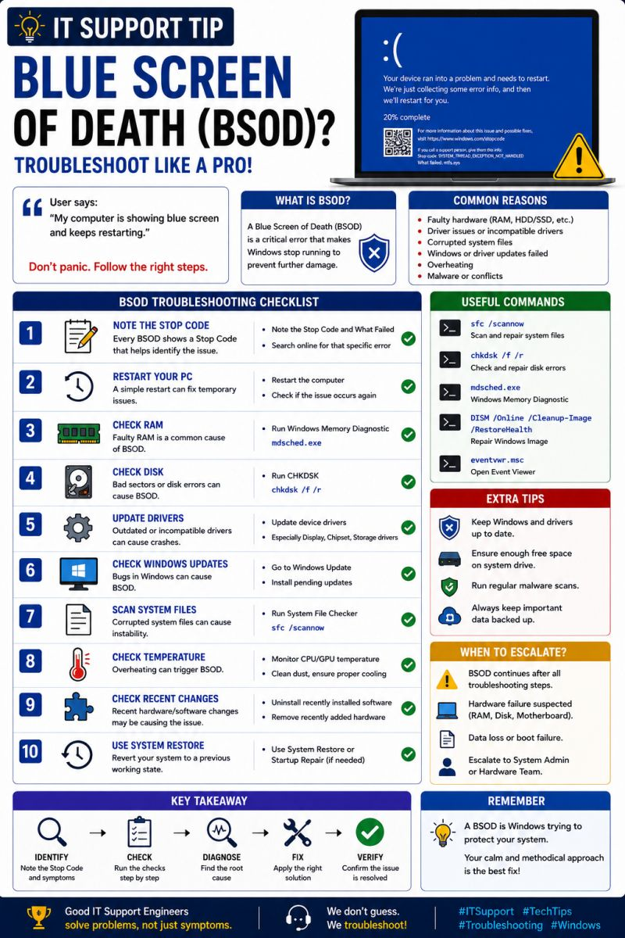
𝗜𝗺𝗽𝗹𝗲𝗺𝗲𝗻𝘁𝗶𝗻𝗴 𝗢𝗸𝘁𝗮–𝗗𝘂𝗼 𝗦𝗦𝗢 𝗜𝗻𝘁𝗲𝗴𝗿𝗮𝘁𝗶𝗼𝗻 𝘄𝗶𝘁𝗵 𝗦𝗔𝗠𝗟 𝟮.𝟬
I worked on an Okta–Duo SSO integration, implementing a federated authentication flow using SAML 2.0, Active Directory, Duo MFA, and Okta Identity Engine.
🏗️ 𝗔𝗿𝗰𝗵𝗶𝘁𝗲𝗰𝘁𝘂𝗿𝗲: AD→ Duo SSO → Duo MFA → SAML → Okta → Role-Based Access
In this architecture, Duo acts as the SAML Identity Provider (IdP), while Okta acts as the Service Provider (SP).
⚙️ 𝗪𝗵𝗮𝘁 𝗜 𝗪𝗼𝗿𝗸𝗲𝗱 𝗢𝗻:
🔹 Configured a Duo Generic SAML application and established the SAML trust between Duo and Okta.
🔹 Configured Duo as an external SAML IdP in Okta, including SSO endpoints and the signing certificate.
🔹 Used Terraform to automate the Okta-side SAML IdP configuration.
🔹 Implemented Okta IdP routing rules to route selected internal users through Duo SSO while maintaining a separate authentication path for other users.
🔹 Integrated Active Directory groups with Duo Directory Sync to support centralized user and group management.
🔹 Configured and validated Duo Push MFA as part of the authentication flow.
🔹 Validated SAML assertions and group claims using SAML tracing to confirm that the correct identity and authorization information was passed to Okta.
🧪 𝗩𝗮𝗹𝗶𝗱𝗮𝘁𝗶𝗼𝗻 & 𝗧𝗲𝘀𝘁𝗶𝗻𝗴:
✅ Internal users successfully redirected from Okta to Duo SSO
✅ Duo Push MFA successfully completed
✅ Successful SAML response from Duo back to Okta
✅ Admin and Read-Only access validated based on group membership
✅ AD group membership changes correctly reflected in SAML assertions and resulting Okta permissions
✅ Separate authentication flow validated for users who should not be routed through Duo
✅ JIT and user-profile behavior validated
💡 𝗞𝗲𝘆 𝗧𝗮𝗸𝗲𝗮𝘄𝗮𝘆:
This implementation gave me valuable hands-on experience with the complete federation lifecycle — from directory synchronization and IdP routing to SAML assertions, MFA, JIT provisioning, and group-based authorization.
It was especially valuable to see how Active Directory, Duo, Okta, Terraform, and SAML 2.0 work together to build a secure and scalable identity architecture.

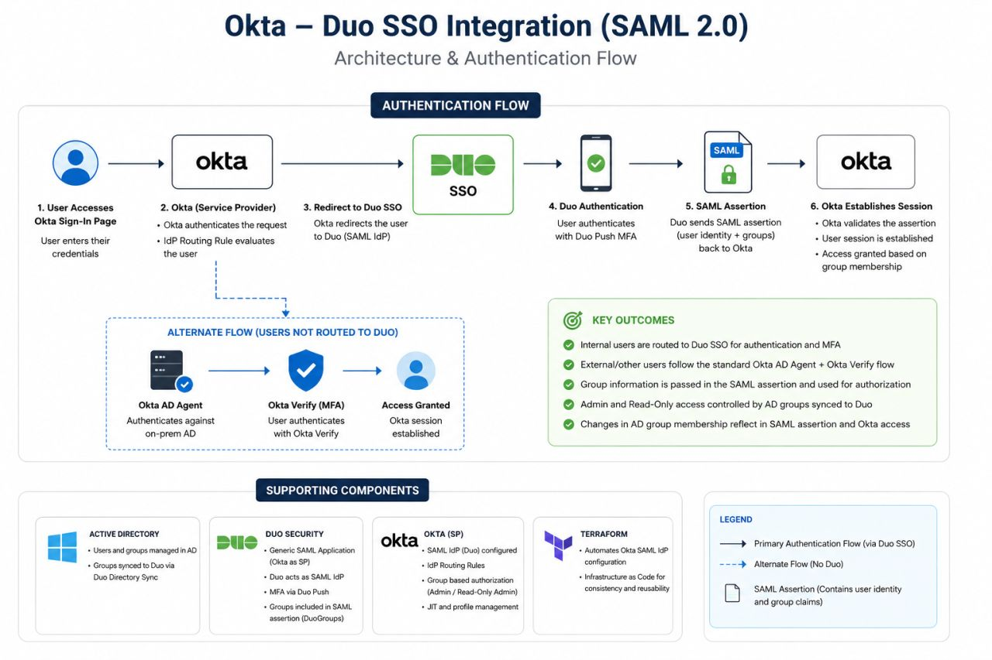

Active Directory: Active Directory (AD) is a Microsoft directory service used by organizations to centrally manage users, computers, permissions, and security policies.
🔹 Key Components:
👤 User Accounts: Create and manage employee accounts and access.
💻 Computer Accounts: Manage company computers connected to the domain.
🏢Organizational Units: Organize users&computers based on department, locations, etc.
Group Policy (GPO): Centrally apply security & system settings to domain-joined devices.
👥 Security Groups: Assign permissions and access to multiple users efficiently.
Common IT Support Tasks:
✅ Password reset & account unlock ✅ Domain joining a computer
✅ Managing user/group permissions ✅ Troubleshooting login issues
✅ Applying and troubleshooting GPOs ✅ Checking account status and access
💡 IT Tip: Instead of giving permissions to individual users, use Security Groups wherever possible. It makes access management easier, more consistent, and scalable.
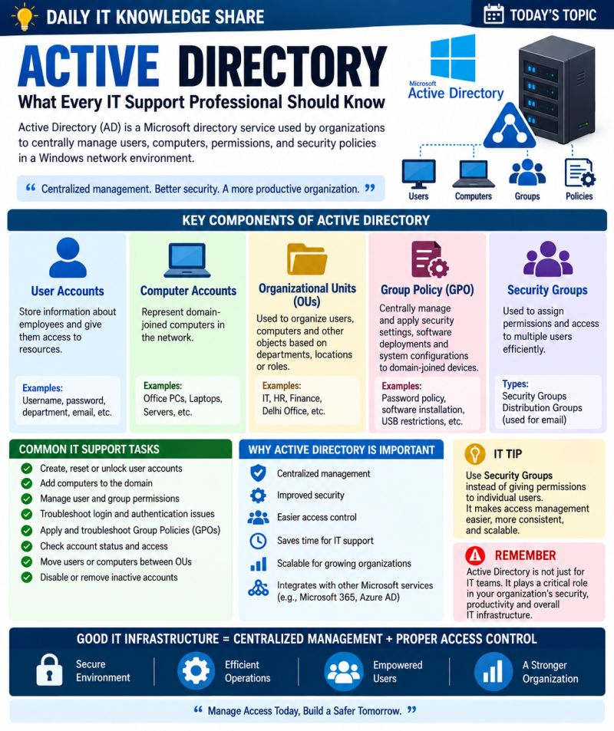
New Employee IT Onboarding: From HR Request to First-Day Readiness
A new employee joining the company is not just an HR process. It must ensure that the employee has the right device, software, access, security and connectivity before starting work.
🔹1. Receive the Joining Requirement: HR / Department should provide:
👤 Employee Name 🆔 Employee ID 🏢 Department 💼 Designation 📅 Joining Date 📍 Location 💻 Required Device 📦 Required Software
🔹2. Prepare the IT Asset: Before handover, IT should verify:
💻 Laptop / Workstation 🔢 Serial Number 🏷️ Asset Tag ⚙️ Configuration 🖥️ Operating System 🔄 Updates & Patches
🔹3. Configure Software: Install or assign required:
📦 Business Applications 📐 CAD / Engineering Software 🟨 Adobe 🪟 Microsoft 365
✉️ Email 🖨️ Printer / Other Applications
🔹4. Configure Security: Before giving the device to the employee:
🛡️ Antivirus / EDR 🔐 DLP 🔒 Encryption 🛡️ Security Updates 🛡️ Security Policies
🔹5. Configure User Access: Provide only the access required for the job:
👤 AD / Entra ID✉️Email 📁Shared Folders 🌐Network / VPN 🔗Applications 🖨️ Printers
🔹6. Test Everything: Before handover, verify:
✅ Login✅ Internet✅ DNS✅ Network Drives✅ Applications✅ Email✅ VPN ✅ Security Policies
🔹7. Asset Handover: Document the handover:
🏷️ Asset Tag🔢 Serial Number👤 Employee📅 Handover Date💻 Device Details
🎒 Accessories✍️ User Acknowledgement🪟 Update the IT Asset Register after handover.
💚 IT Onboarding Flow:👥 HR / Department Request⬇️📋 Requirement Validation⬇️ 🖥️ Asset Allocation⬇️⚙️ OS & Software Configuration⬇️🛡️ Security Configuration⬇️
👤 User & Access Setup⬇️📶 Network Testing⬇️🤝 User Handover⬇️🗄️ Asset Register Update
⭐ Key Takeaway: A successful IT onboarding means the employee can start work securely and productively from Day 1.
Right Device → Right Software → Right Access → Right Security → Ready to Work
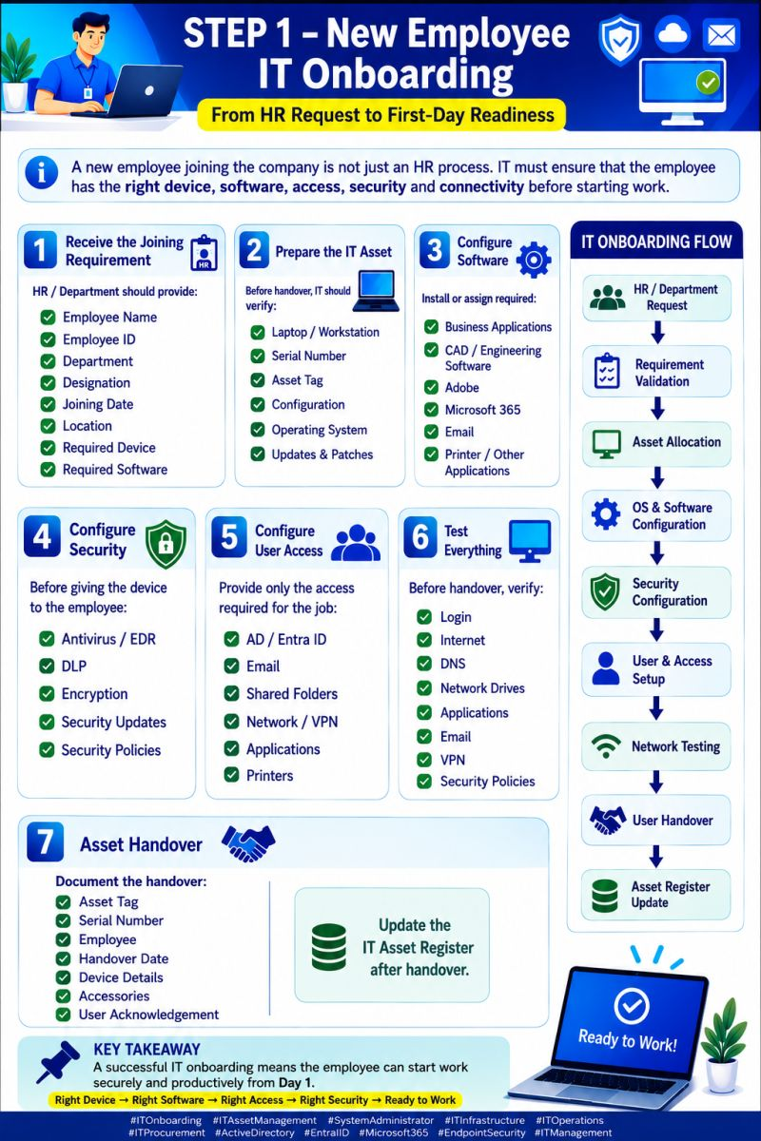
IT Onboarding Is More Than Just Giving a Laptop
A new employee’s first day should start with productivity—not IT issues.
A well-structured IT onboarding process ensures that every employee receives the right device, software, access, security controls, and connectivity before they start working.
Here’s a simple 7-step IT onboarding framework:
1️⃣ Receive Joining Requirements – Employee, department, role, location, device & software needs
2️⃣ Prepare IT Asset – Laptop, asset tag, configuration, OS, patches
3️⃣ Configure Software – Business apps, Microsoft 365, Adobe, engineering tools, email
4️⃣ Configure Security – EDR/Antivirus, DLP, encryption & security policies
5️⃣ Configure User Access – AD/Entra ID, folders, VPN, applications & printers
6️⃣ Test Everything – Login, internet, DNS, network drives, applications, email & VPN
7️⃣ Asset Handover & Register Update – Documentation, acknowledgement & asset tracking
💡 The goal: HR Request → IT Preparation → Secure Configuration → Testing → First-Day Readiness.
When onboarding is standardized, IT teams can reduce delays, improve security, maintain accurate asset records, and deliver a better employee experience.
IT onboarding is not an operational task. It's the first step in building a secure and productive digital workplace.
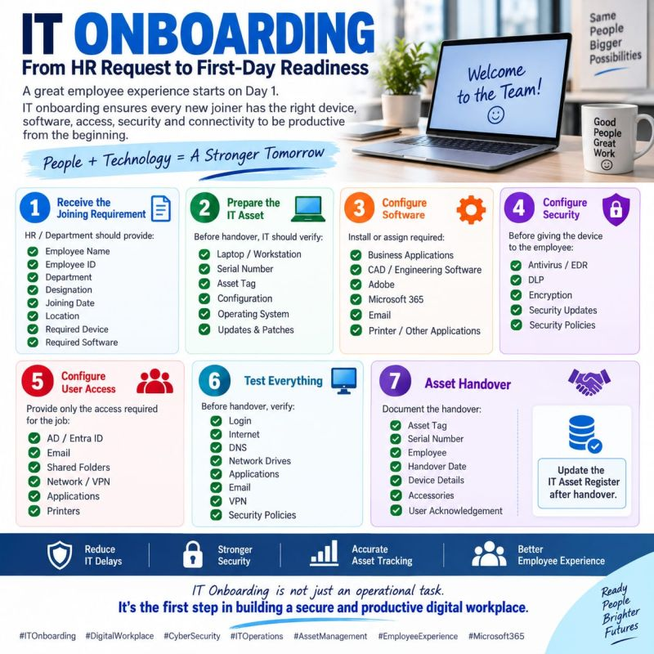
🔹 Intune vs Tanium vs SCCM
In endpoint management, there’s no single tool that does everything.
Microsoft Intune, Tanium, and SCCM each solve different problems—and understanding where they fit can make a big difference in your endpoint strategy.
📌 Microsoft Intune
Best for modern, cloud-first endpoint management:
• MDM/MAM capabilities
• Windows, macOS, iOS, Android & more
• Compliance and Conditional Access
• Modern application deployment
• Ideal for remote & hybrid workforces
📌 Tanium
Best for real-time endpoint visibility and action:
• Real-time endpoint data
• Large-scale remediation
• Security and vulnerability operations
• Fast querying across endpoints
• Strong fit for complex enterprise environments
📌 Microsoft SCCM / Configuration Manager
Best for traditional, controlled endpoint management:
• Windows OS deployment
• Application deployment
• Software updates
• Detailed administrative control
• Strong on-premises infrastructure
👉 The key takeaway:
Don’t ask “Which tool is better?” Ask: “Which tool is best for this requirement?”
In many enterprise environments, these technologies can complement each other rather than simply compete.
💡 If you work in Endpoint Engineering, what’s your preferred combination—Intune, Tanium, SCCM, or a mix?
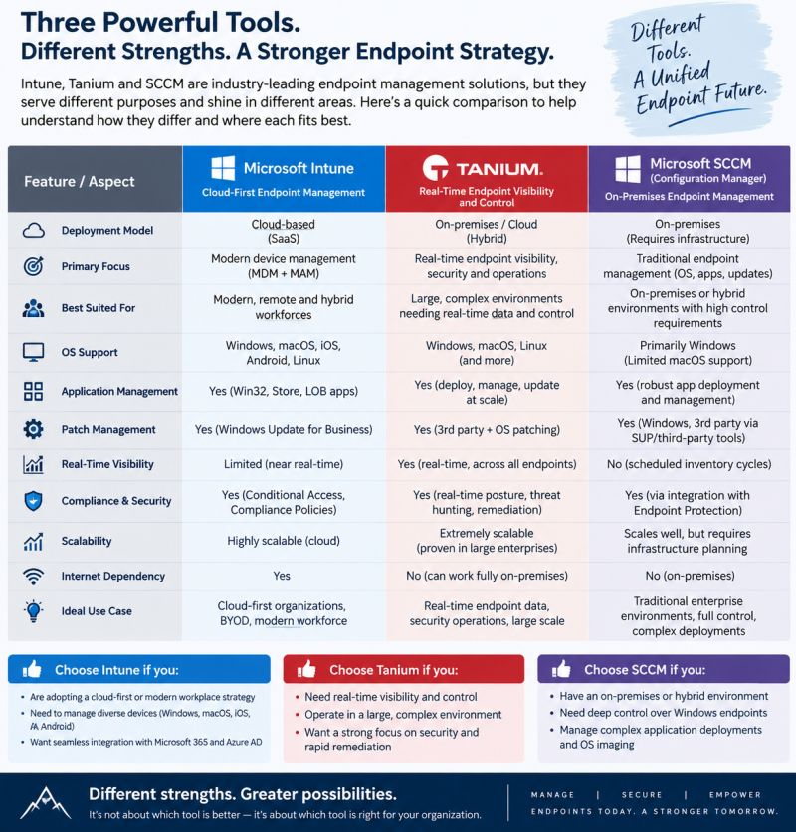

🔐 Microsoft Purview Data Loss Prevention (DLP)
Sensitive data can be shared through emails, Teams, SharePoint, OneDrive, devices, cloud applications, and even AI applications.
Microsoft Purview DLP helps organizations identify, monitor, and protect sensitive information from being accidentally or intentionally shared with the wrong people🛡️
🔎 DLP is more than simple keyword matching. It can detect sensitive information using:
• Sensitive information types and patterns
• Keyword matching
• Regular expressions
• Context and proximity analysis
• Machine learning and advanced detection methods 🤖
🌐 Beyond Microsoft 365: Inline Web Traffic DLP
One interesting capability is protecting sensitive information when users interact with web applications.
Using Microsoft Edge for Business and Network Data Security, organizations can help protect sensitive data across:
🤖 AI applications such as ChatGPT, Google Gemini, and DeepSeek
☁️ Supported cloud applications
🌐 Other web applications and services
This helps extend data protection beyond traditional Microsoft 365 services such as Exchange, SharePoint, and OneDrive.
🛡️ When sensitive data is detected, DLP can:
⚠️ Notify users
🚫 Block risky actions
🔒 Restrict data sharing
📝 Monitor activities
🔓 Allow overrides with business justification
💡 The key takeaway: DLP is not just about blocking users. It helps organizations protect sensitive information while allowing employees to work securely.
⚠️ Note: Some AI-related and Inline Web Traffic DLP capabilities mentioned above are currently in Preview and may have different availability or requirements.
📚 Reference:https://lnkd.in/gSampYFn

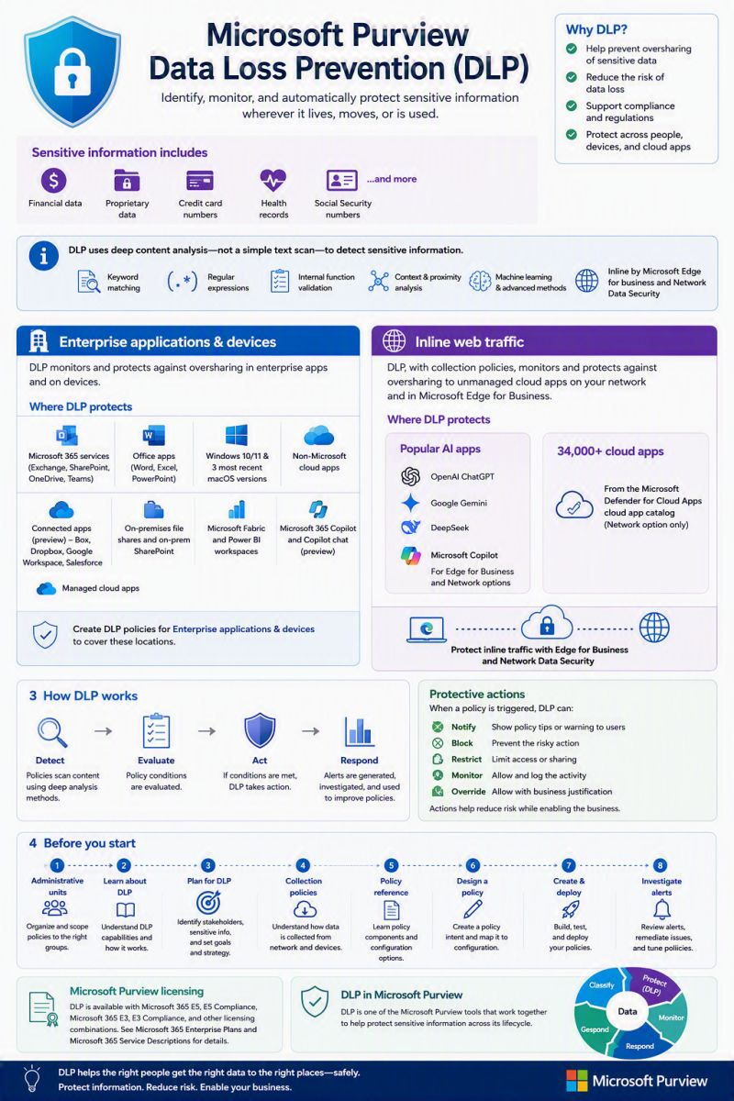
Windows Update Failed?
A user says: “Windows Update keeps failing.” Before repeatedly clicking Retry, troubleshoot the root cause. 👇
🔹Check available disk space🔹Verify internet connectivity
🔹Check Windows Update services🔹Restart the Windows Update service
🔹Clear the Windows Update cache🔹Run Windows Update Troubleshooter
🔹Check Event Viewer for errors🔹Run system file checks if required
Useful Commands:🔹"services.msc": Check Windows Update service 🔹"eventvwr.msc": Review update-related errors🔹"sfc /scannow": Check Windows system files🔹"DISM /Online /Cleanup-Image /RestoreHealth": Repair the Windows component store
💡 Key Takeaway: When an update fails, the error message is a clue, not just an error.
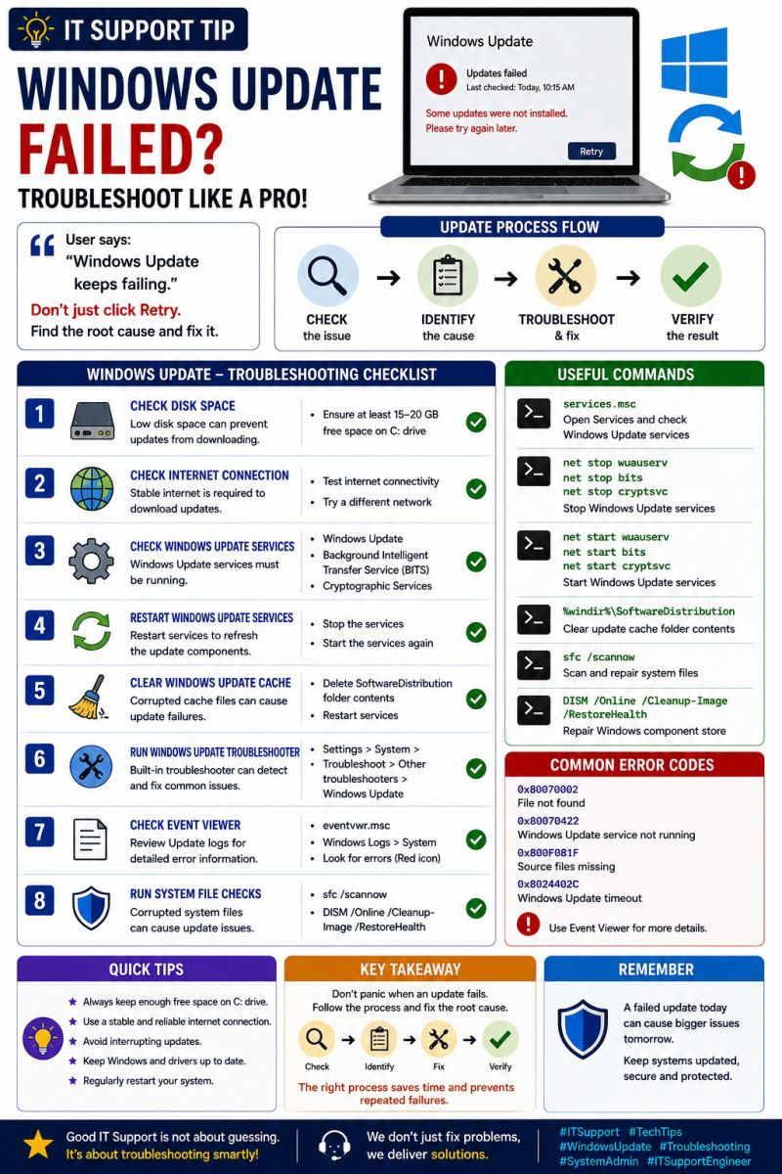
Slow Computer
User says: “My computer is very slow.” Don’t immediately reinstall Windows. Diagnose first.
🔹Check CPU usage🔹Check RAM / Memory usage🔹Check Disk usage
🔹Check free space in C: drive🔹Check system temperature🔹Review Startup apps.
🔹Scan for malware🔹Check Windows & driver updates
Useful Commands:🔹"perfmon /report" → Generate performance report🔹"cleanmgr" → Disk Cleanup🔹"sfc /scannow" → Check system files🔹"chkdsk /f" → Check disk errors
💡 Key Takeaway: A slow computer is usually caused by a resource bottleneck.
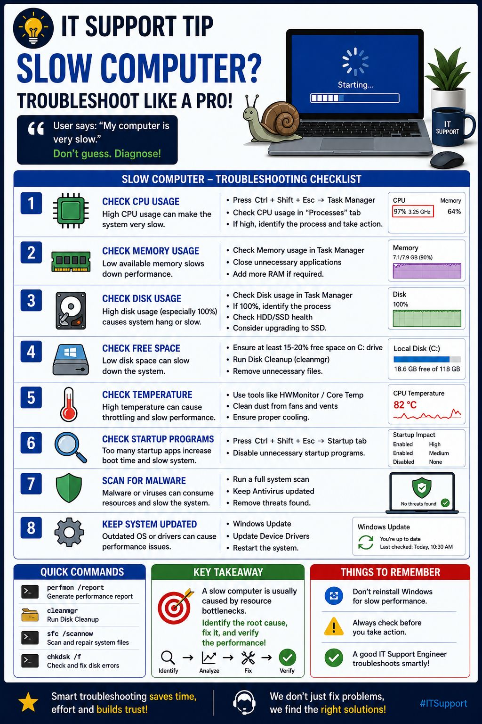
Low Disk Space?
A user says: “My C: drive is almost full and the system is getting slow.”
🔹 Check which drive is running low 🔹 Find large files & folders
🔹 Empty Recycle Bin🔹 Clean temporary files🔹 Review Downloads folder
🔹 Uninstall unused applications🔹 Move personal files to another drive/cloud
🔹 Check disk health🔹 Enable Storage Sense
Useful Commands:
🔹 "cleanmgr" → Disk Cleanup🔹 "chkdsk C: /f" → Check disk errors
🔹 "powercfg /h off" → Disable hibernation and free space
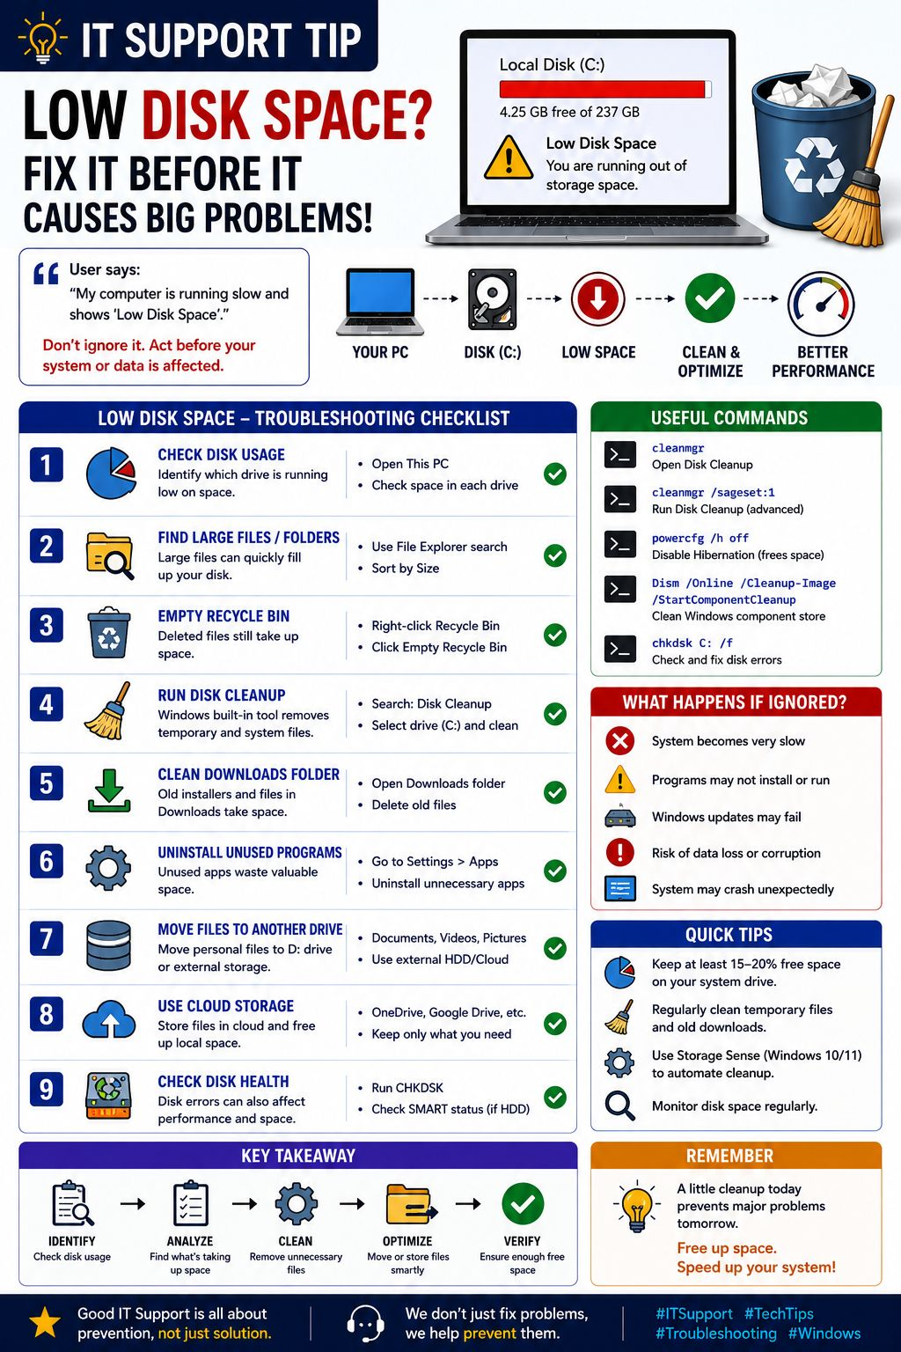
“Outlook is open, but my emails are stuck in the Outbox.”
Instead of immediately recreating the Outlook profile, I’d troubleshoot step-by-step:
🔹Check internet connectivity🔹Check Outlook connection status
🔹Verify mailbox storage/quota🔹Check if email is stuck because of a large attachment
🔹 Test Outlook Web Access🔹 Start Outlook in Safe Mode
🔹 Check add-ins🔹 Repair the Outlook profile if required
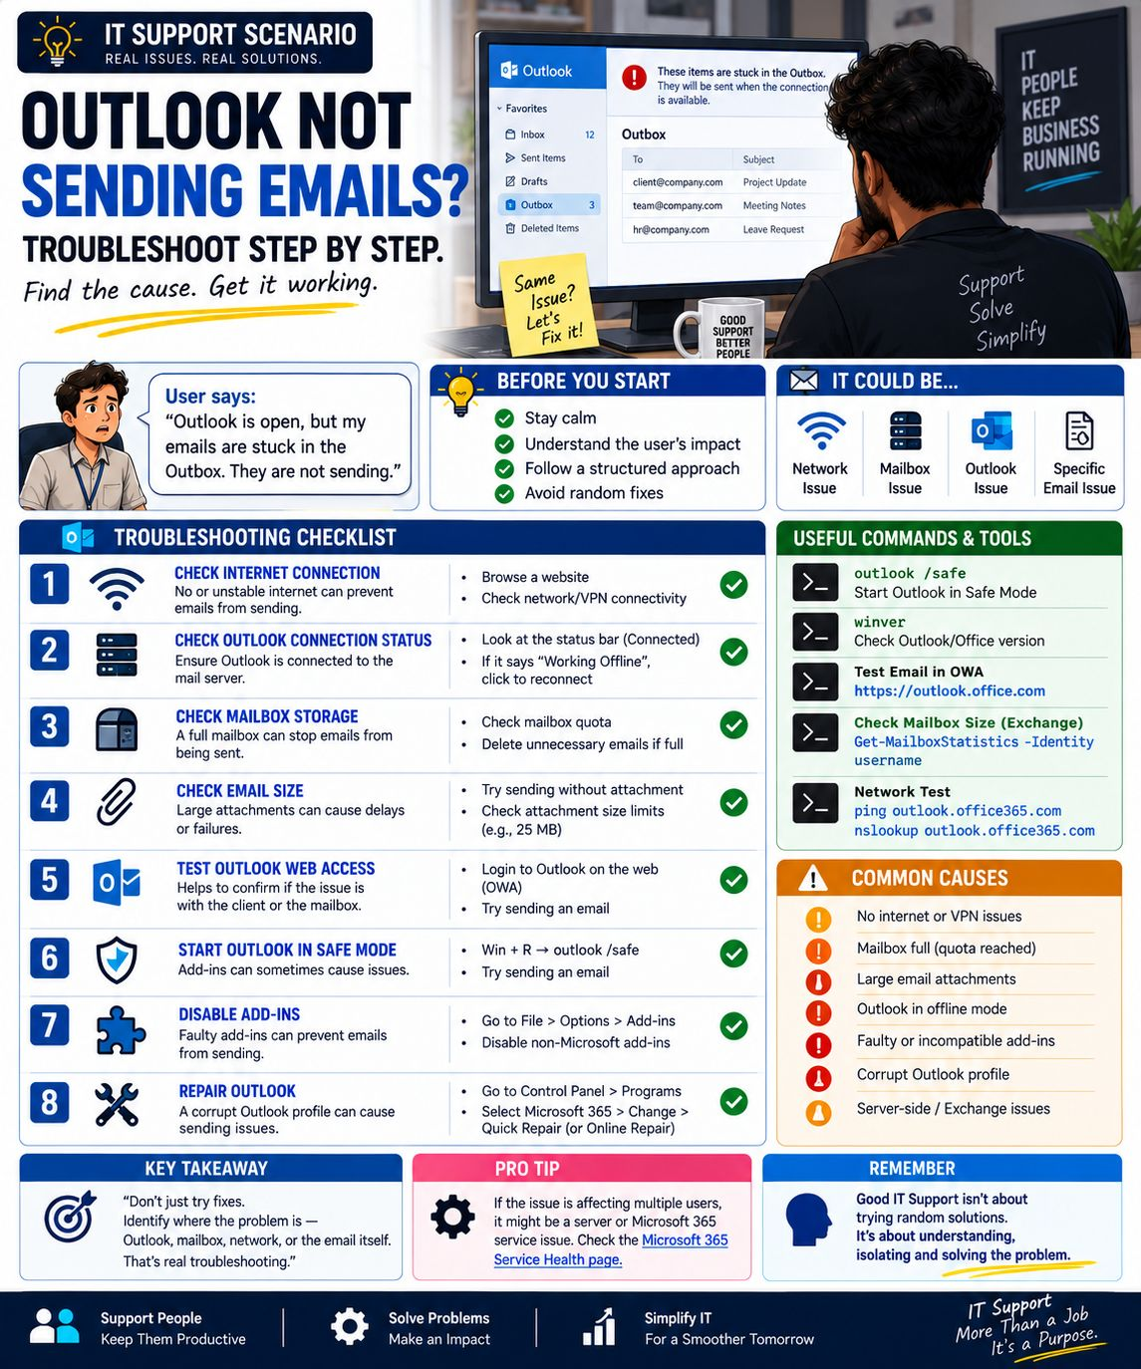
SCCM vs Microsoft Intune
Both SCCM/MECM and Microsoft Intune help IT teams manage devices, applications, updates, and security — but they follow very different approaches.
🔹 SCCM / MECM
✅ On-premises device management ✅ Software & application deployment
✅ OS imaging and task sequences ✅ Patch management
✅ Hardware & software inventory ✅ Ideal for traditional enterprise environments
☁️ Microsoft Intune
✅ Cloud-based device management✅ Windows, macOS, iOS & Android support
✅ Microsoft 365 application deployment✅ Security & compliance policies
✅ BitLocker & Defender management✅ Windows Autopilot
✅ Ideal for modern & hybrid workplaces
🚀 Co-management: Many organizations don't need to choose one immediately.
SCCM + Intune + Autopilot + Entra ID + Defender can provide a powerful transition from traditional device management to a modern, cloud-based workplace.
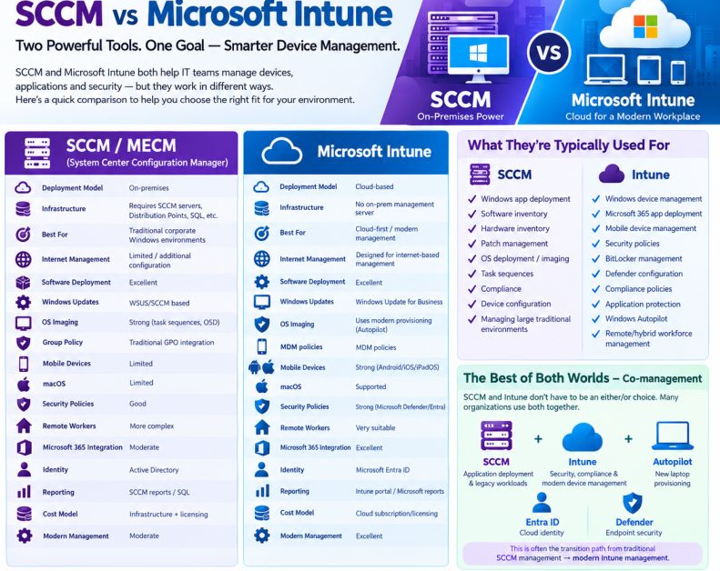
Microsoft Purview DLP Policy-Protecting Sensitive Business Data
Data Loss Prevention (DLP) is not simply about blocking users from sharing information. A well-designed DLP strategy should identify sensitive data, understand the context, and apply the right level of protection without disrupting business operations.
• 🔎 Identifying and classifying sensitive business information
• 🛡️ Preventing unauthorized sharing and data leakage
• 📧 Applying protection across Exchange Online and Microsoft 365 workloads
• 👥 Controlling actions based on users, groups, locations, and sensitivity
• ⚠️ Using policy tips and alerts to increase user awareness
• 📊 Monitoring DLP events and continuously tuning policies
• ✅ Balancing security requirements with business productivity
The key is to avoid creating a policy that simply blocks everything.
A mature DLP implementation should follow a phased approach:
Identify → Classify → Monitor → Warn → Restrict → Optimize
This allows organizations to strengthen data protection while minimizing false positives and unnecessary business disruption.
💡 DLP is most effective when security controls are designed around how the business actually uses its data.
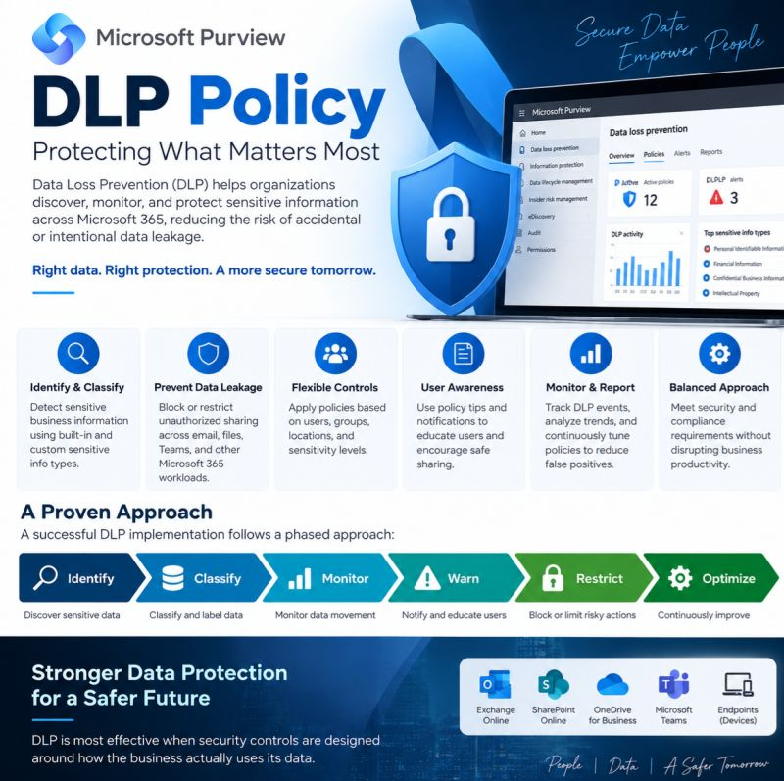
Identity & Access Management (IAM)-The Foundation of Modern Security
Who has access to what and why?
Identity & Access Management (IAM) helps organizations ensure that the right person gets the right access to the right resource at the right time.
A simple way to understand IAM: 👤 Identity → Who is the user?🔑 Authentication → Can they prove who they are?🛡️ Authorization→ What are they allowed to access?
📊 Auditing → Is their access being monitored and reviewed?
💡 Real-world example: New Employee
When an employee joins an organization, IAM helps manage the entire access lifecycle:
1️⃣ Create the user's identity2️⃣ Provide access based on their role
3️⃣ Secure authentication with MFA4️⃣ Review & manage access throughout their journey
As organizations increasingly adopt cloud applications, SaaS platforms, and hybrid environments, managing identities securely has become more important than ever.
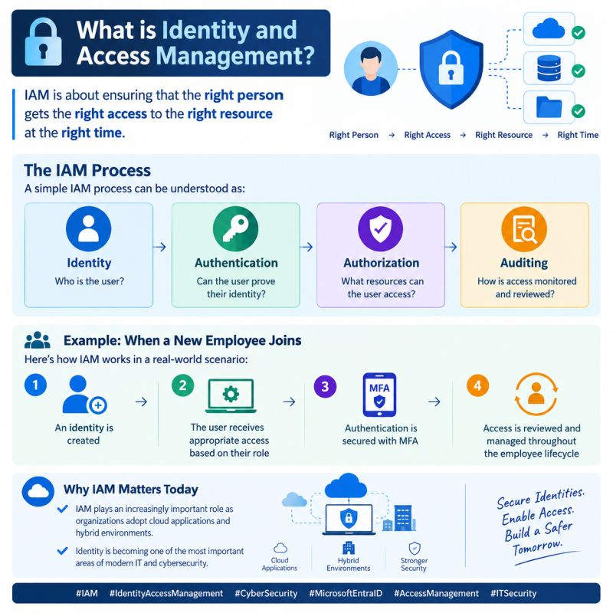
Why is Multi-Factor Authentication Important?
Passwords alone are no longer enough to protect user accounts. Even a strong password can be compromised through phishing, credential leaks, or other attacks.
Multi-Factor Authentication adds an additional layer of security.
For example:
🔑 Something you know — Password
📱 Something you have — Authentication application or device
👤 Something you are — Biometric authentication
MFA helps reduce the risk of unauthorized access even if a password is compromised.
From an IAM perspective, securing authentication is one of the most important parts of protecting identities.
Security is not only about protecting systems. It starts with protecting identities. 🔐
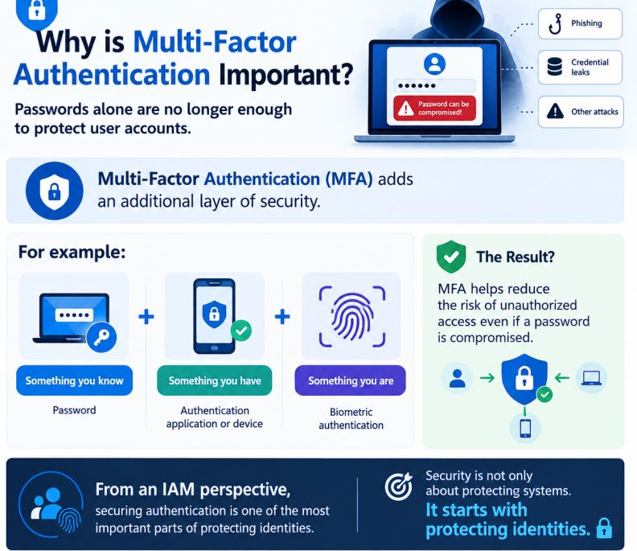
We Have Microsoft 365. So Why Do We Need Backup?
Imagine this: An employee accidentally deletes an important folder from OneDrive. A few days later, the team realizes they need those files back. The first question is:👉 “Can we recover them?”
This is where many organizations assume that Microsoft 365 automatically means they have a complete backup strategy. But Microsoft 365 and Backup are not the same thing.
Microsoft 365 provides several built-in capabilities that can help recover data, depending on the service and configuration:
🔹 Recycle Bin🔹 Deleted Items / Recoverable Items
🔹 Retention Policies🔹 Version History🔹 Microsoft Purview
But what happens when you need to:
🔸 Recover data from a specific point in time?
🔸 Restore a large amount of deleted or modified data?
🔸 Recover after a ransomware incident?
🔸 Restore data after an accidental or malicious deletion?
🔸 Have an independent copy of your business data?
This is where a dedicated backup strategy becomes important.
⚠️ Retention is not the same as Backup. Retention is mainly about keeping data according to defined policies.
Backup is about having recoverable copies of your data and being able to restore them when needed.
So before saying:“Don’t worry, everything is in Microsoft 365.” ☁️
Ask yourself: 👉 If someone deleted your critical business data today, how would you recover it?
And more importantly: **How far back could you actually restore?**
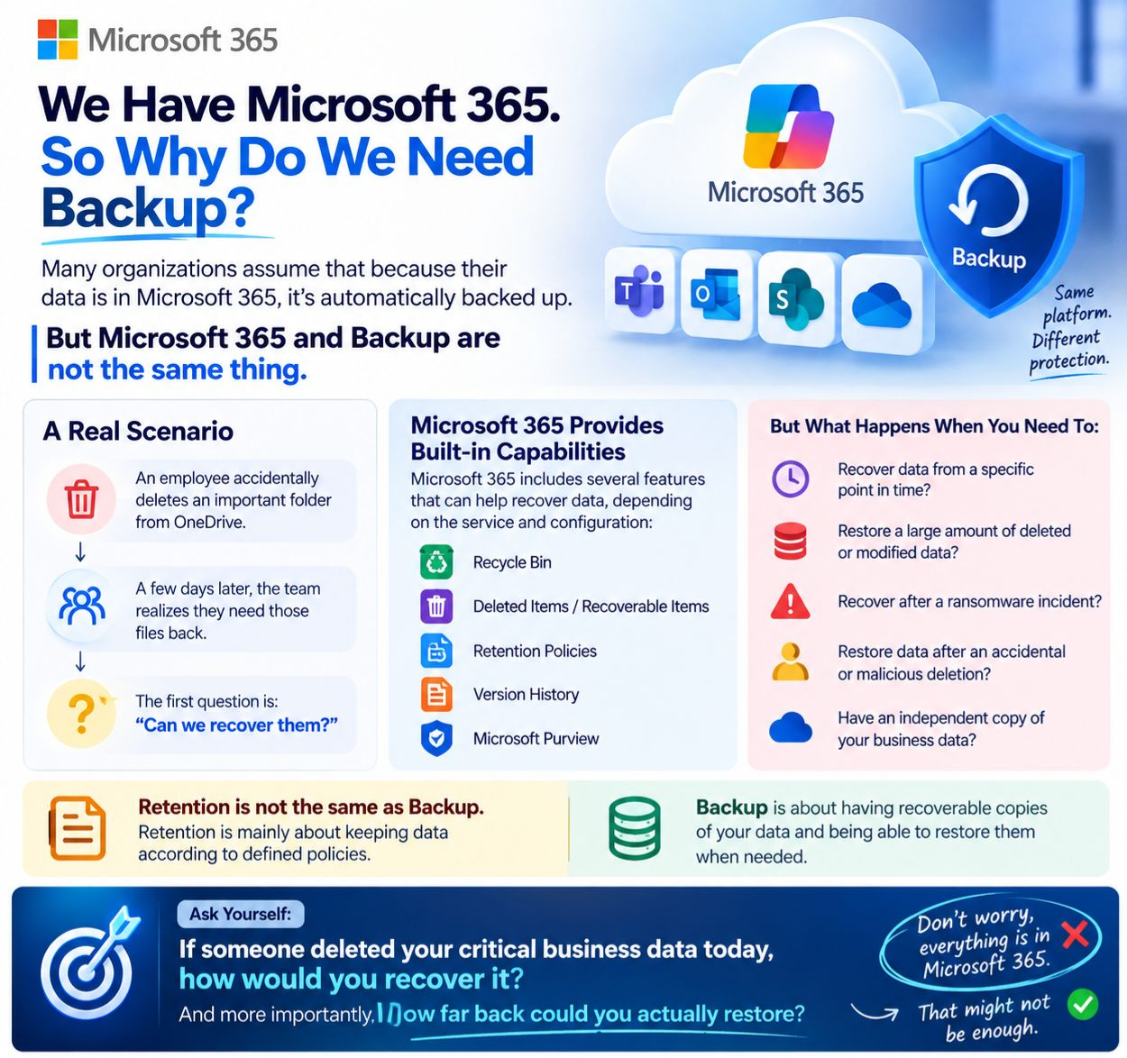

Microsoft 365 Copilot — Is Your Sensitive Data Protected?
Microsoft 365 Copilot can work with a huge amount of info. across your organization.
But here's question: What happens when users enter sensitive information into Copilot?
One important control to look at is your DLP (Data Loss Prevention) configuration.
In the Excel assessment, one of the policies listed is:👉“Protect sensitive M365 Copilot interactions”
The purpose is to help control how sensitive information is handled when users interact with Microsoft 365 Copilot.
A proper DLP review should consider:
🔹 What sensitive information is being detected?🔹 Which users or groups are covered?
🔹 What happens when sensitive data is detected?🔹 Are users warned or blocked?
🔹 Which Microsoft 365 Copilot interactions are in scope?🔹 Are the rules aligned with your organization's data classification?
⚠️Having a DLP policy doesn't automatically mean your Copilot environment is fully protected.
The real question is: Is the policy actually configured to protect the data that matters to your organization?
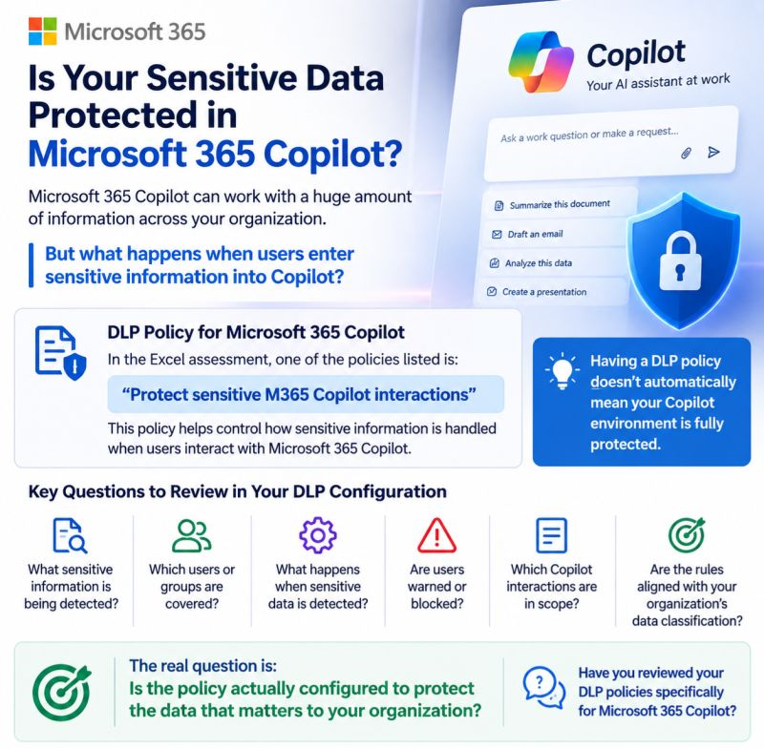
A User Deleted the Email. Can an Admin Still Find It?
A user deletes an email from their Microsoft 365 mailbox. Is it gone forever?
Not necessarily.
Depending on the mailbox state, retention configuration, and available compliance features, an administrator may still be able to investigate or recover relevant content.
🔹 Deleted Items: The first place to check after a normal deletion.
🔹 Recoverable Items: Messages removed from Deleted Items may still exist in the mailbox’s recoverable storage, depending on the situation.
🔹 Microsoft Purview eDiscovery: Can help authorized investigators search for relevant mailbox content during an investigation.
🔹 Retention & Legal Hold: Retention policies or holds can affect how long content is preserved and whether users can permanently remove it.
🔹 Audit Logs: Can help determine who performed an action and when which is different from simply finding the email itself.
💡 The important part: “Deleted” does not always mean “irretrievably gone.”
But it also doesn’t mean that every deleted email can always be recovered.
The result depends on where the message is, what retention controls are configured, and what happened before the investigation started.
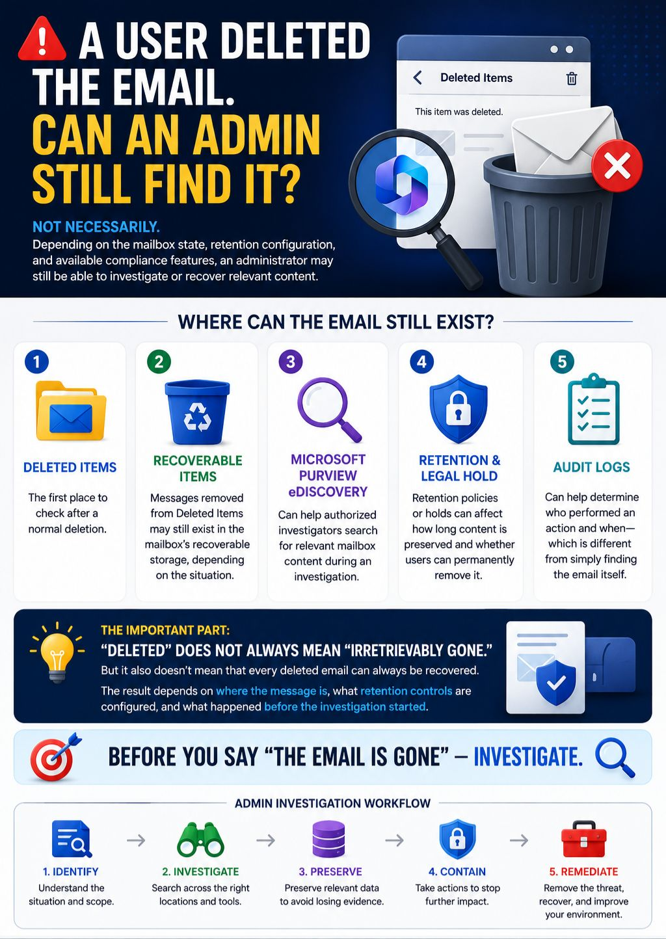
Don’t Delete the Evidence: The Biggest Mistake During a Microsoft 365 Investigation
A compromised Microsoft 365 account can turn into a much bigger incident than expected.
Imagine this scenario:
🔹A user reports suspicious emails.🔹An attacker may have accessed the mailbox.
🔹Inbox rule was created to hide or redirect msgs🔹Suspicious sign-ins appear in EntraID.
The first instinct might be to delete emails, disable the account, and clean everything up.
But there’s one problem:
You might be deleting the evidence you need to understand what actually happened.
Before remediation, investigate and preserve the relevant data:
🔍 Microsoft Purview eDiscovery: Search and preserve relevant mailbox content.
📋 Microsoft 365 Audit Logs: Investigate user and administrative activities.
🔐 Microsoft Entra ID: Review sign-ins, authentication activity, and suspicious access.
💻 Microsoft Defender for Endpoint: Investigate endpoint activity and correlate device-related events.
📧 Exchange Online:Check mailbox rules, forwarding, sent messages, and other indicators of compromise.
The goal isn't simply to delete the evidence. The goal is to understand the attack, preserve the evidence, contain the incident, and then remediate it.
Contain first. Investigate. Preserve the evidence. Then clean up.
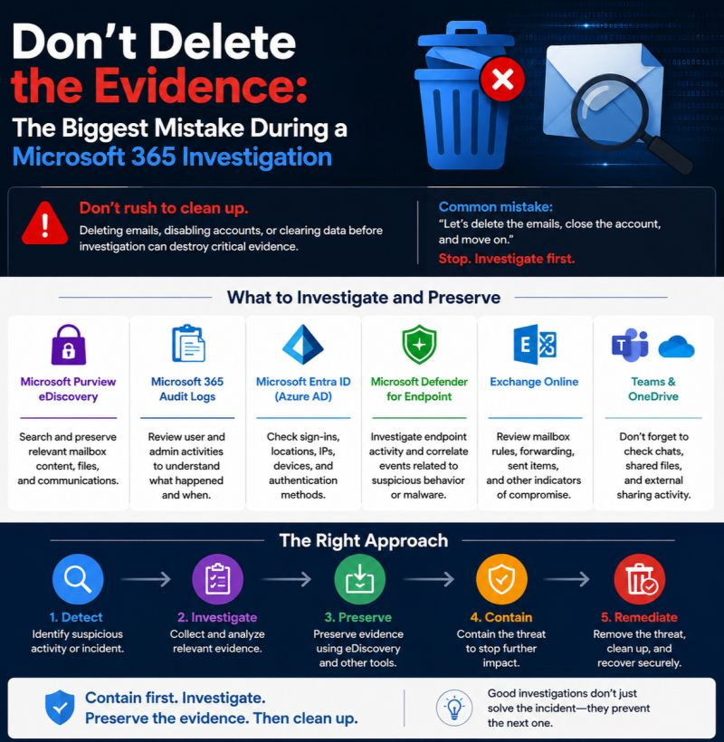
eDiscovery vs Defender — Which Is Better for Email Deletion?
Imagine this scenario: An employee has been sending emails to a large number of internal employees over a period of time.
Suddenly, due to an organizational decision, the company requires that emails sent by this employee to specific internal recipients be removed from the recipients’ mailboxes.
This is where I see a strong and specific use case for Microsoft Purview eDiscovery / Search & Purge.
The requirement is not necessarily that the email is malicious.
The requirement is: “Find the messages matching this specific scope across the affected mailboxes, validate the results, and perform a controlled purge.”
That is fundamentally a data discovery and controlled removal scenario.
Microsoft documentation specifically describes eDiscovery Search & Purge as an incident-response capability for situations such as data spillage, for example when sensitive information is accidentally shared with a large group of users.
So where does Defender for Office 365 fit?
Defender for Office 365 → Security threat / email remediation
If the email is malicious, phishing, malware, or another security threat, Threat Explorer is the natural choice for investigation and rapid remediation.
Purview eDiscovery → Data discovery / investigation / controlled purge
If the requirement is driven by data governance, an organizational decision, investigation, or data-spillage response, and you need to define the exact search scope before performing the purge, eDiscovery becomes a very relevant option.
So the question isn't simply: “Can Defender delete the email?”
Yes, it can in the appropriate security-remediation scenario.
The better question is: “Why are we deleting the email, and what exactly is the scope of the action?”
That distinction can determine whether I reach for Defender for Office 365 or Microsoft Purview eDiscovery.
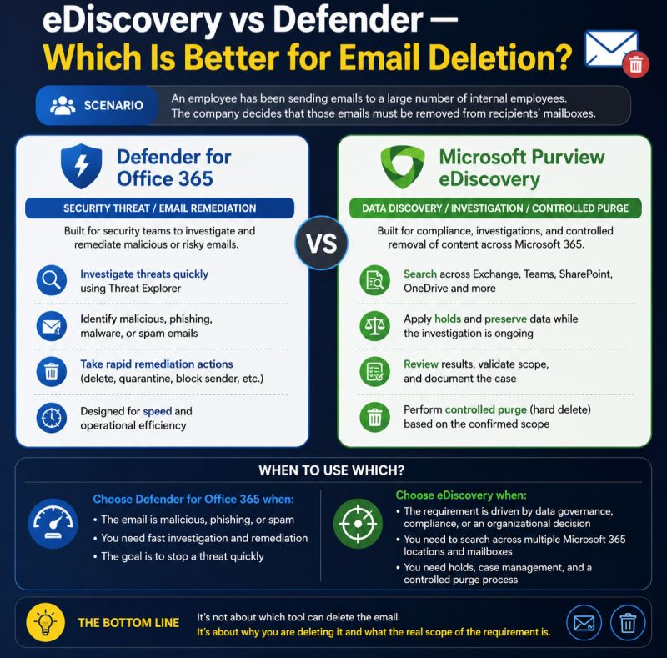

Microsoft 365: eDiscovery & Email Removal‼️
One important Microsoft 365 concept that is often misunderstood: eDiscovery can help administrators locate specific emails across mailboxes within their organization.
For example, if an employee accidentally sends a sensitive email internally, an authorized administrator can use Microsoft Purview eDiscovery to search for the message and, where the appropriate permissions and process are in place, use Search & Purge to remove copies from organizational mailboxes.
But there is an important limitation: If the email was sent to an external recipient, eDiscovery in your tenant cannot delete the copy from the external recipient’s mailbox.
So the key distinction is:
Internal recipient → Your organization can potentially locate and remove the message.
External recipient → You don't control their mailbox.
This is a great example of why understanding the difference between eDiscovery, mailbox delegation, and Exchange Online administration matters in Microsoft 365.
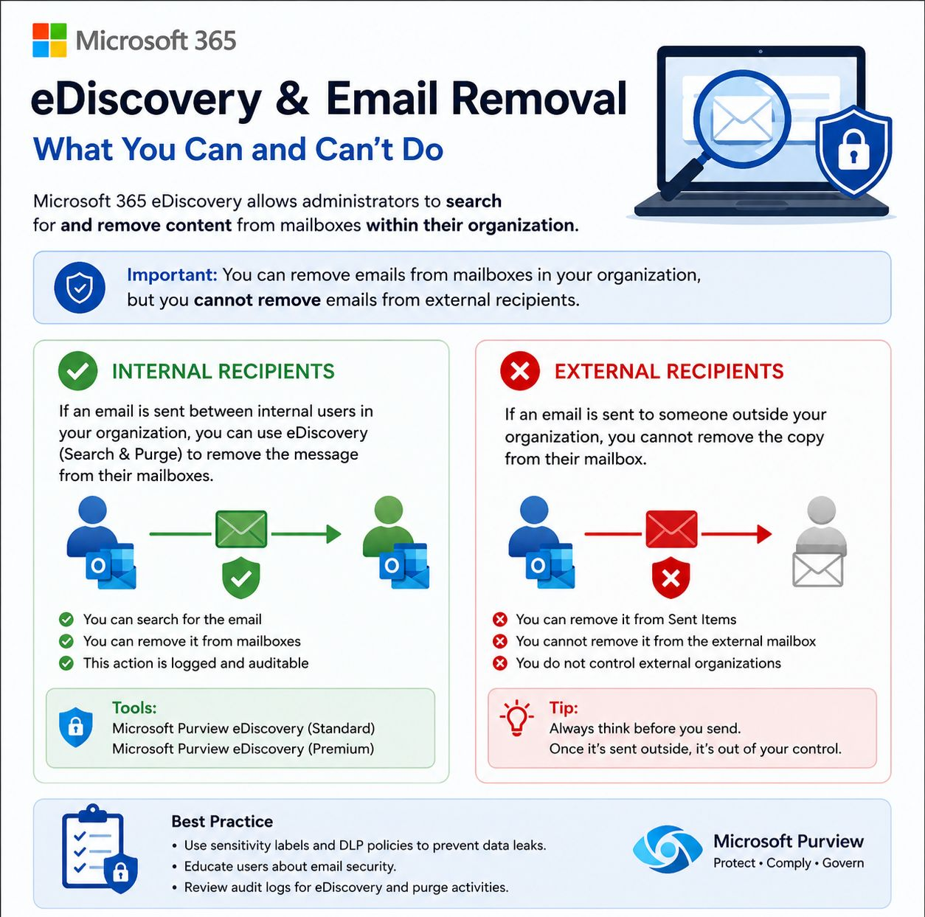
Conditional Access Policy: MFA – Internal vs Guest 🔐
Should you really use the same MFA policy for your internal users and guest users?
In many environments, separating them can provide better control and a more predictable security model.
🔵 MFA Policy – Internal Users:
🔹Who? All users🔹Exclude: Guest / External users
🔹Grant: Require MFA🔹Mode: Report-only → On
This policy focuses on protecting your internal workforce and company data.
🟢 MFA Policy – Guest Users:
🔹Who? Guest and external users🔹Grant: Require MFA
🔹Option: Use Authentication Strength when stronger authntin requirements are needed.
This gives you a dedicated policy for controlling authentication requirements for external identities.
Why separate the policies?
✅ Different security requirements for different user types ✅ Easier troubleshooting and monitoring ✅ More granular Conditional Access control ✅ Lower risk of accidentally impacting guest access ✅ Easier to introduce stronger MFA requirements over time
💡 Best Practice: Don’t simply ask: “Do we have MFA enabled?”
Ask: “Do we have the right Conditional Access policy for each type of identity?”
Conditional Access becomes much more powerful when policies are designed around identity, risk, and business requirements.
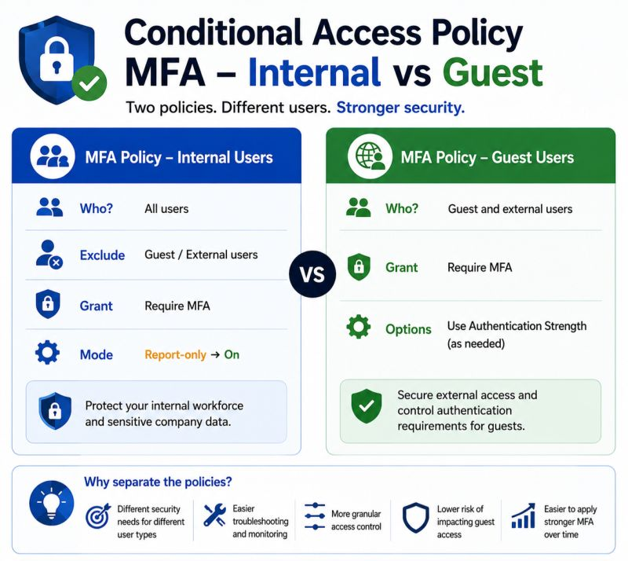
Why Can Two Users with the Same Microsoft 365 License Have Different Features? 🤔
You check both users: 👤 User A: Microsoft 365 E3 ✅ 👤 User B: Microsoft 365 E3 ✅
Same license… but one user has access to a specific feature while the other doesn’t.
Why? The license name is only part of the story.
You also need to check:
🔹 Service Plans — Which services are actually enabled within the license?
🔹 License Assignment — Is the license assigned directly or through a group?
🔹 Group-Based Licensing — Is the user receiving additional or different service plans through another group?
🔹 Configuration & Eligibility — Is the feature enabled and available for that specific user or environment?
🔹 Additional Licenses — Could another license or add-on be providing the feature?
💡 The takeaway: When troubleshooting Microsoft 365 feature access, don't just ask:
“Does the user have an E3 license?”
Ask: “Which Service Plans does the user actually have, and where are they coming from?”
Same license ≠ always the same experience.
Have you ever seen two users with the same license but different feature access? 👇
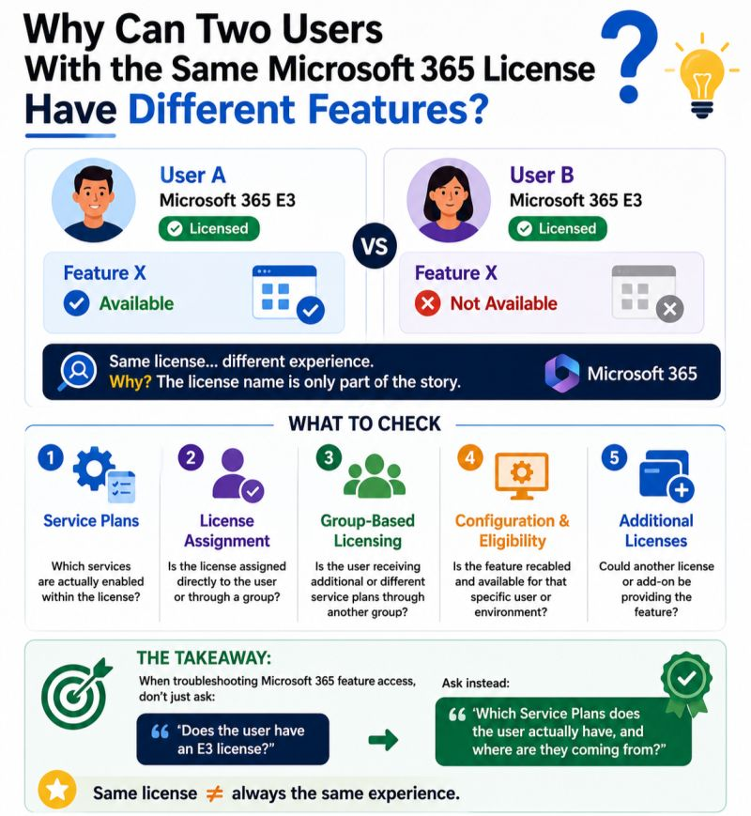
⭕️ Removing a Microsoft 365 License ≠ Immediately Losing Everything ⚠️
One of the common misconceptions I see in Microsoft 365 licensing is: “If I remove the license, the user’s data is gone.”
Not necessarily. For example:
📧 Exchange Online: Removing the Exchange Online license can immediately disconnect the mailbox from the user, but the mailbox data is generally retained for 30 days before permanent deletion in the standard scenario.
☁️ OneDrive: Removing the license alone does not automatically delete the user's OneDrive files if the user account remains active.
🛡️ Retention / Holds: Retention policies and holds can change what happens to data and may preserve content for compliance or discovery requirements.
So before removing a license, always ask:
🔹What service is being unlicensed?🔹Does the user still need access?
🔹Does the data need to be retained?🔹Are there retention policies or legal holds?
Licensing changes are not just a cost decision — they can have data, access, and compliance implications.
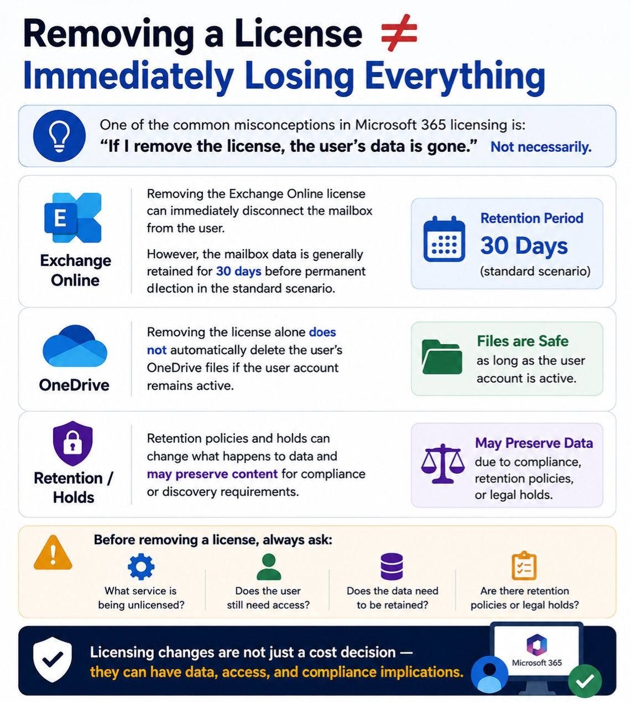
What’s the Best Option When a Mailbox Is Full?
A user with a Microsoft 365 Standard license, and the user’s Exchange Online mailbox has reached its maximum storage capacity.
There are several possible options, but each one has different licensing and technical considerations:
🔹Upgrade the license: Move the user to a license that provides a larger primary mailbox, such as a plan that supports a 100 GB mailbox.
🔹Online Archive: Enable the user’s Online Archive and move older emails from the primary mailbox to archive. This can help keep the primary mailbox under the storage limit.
🔹Auto-Expanding Archive: For users with a large amount of historical email, Auto-Expanding Archive can provide additional archive capacity when the supported licensing requirements are met.
🔹Retention Policies: Use Microsoft Purview retention policies to manage older emails and automaticly move eligible content to archive, depending on the organize requirements.
🔹Mailbox cleanup: Before changing license, another option is to identify large emails, attachments, deleted items, and other unnecessary content and reduce the mailbox size.
The important point is that Online Archive and Auto-Expanding Archive do not simply increase the size of the primary mailbox. They provide additional archive capacity, while upgrading the appropriate license can increase the primary mailbox limit.
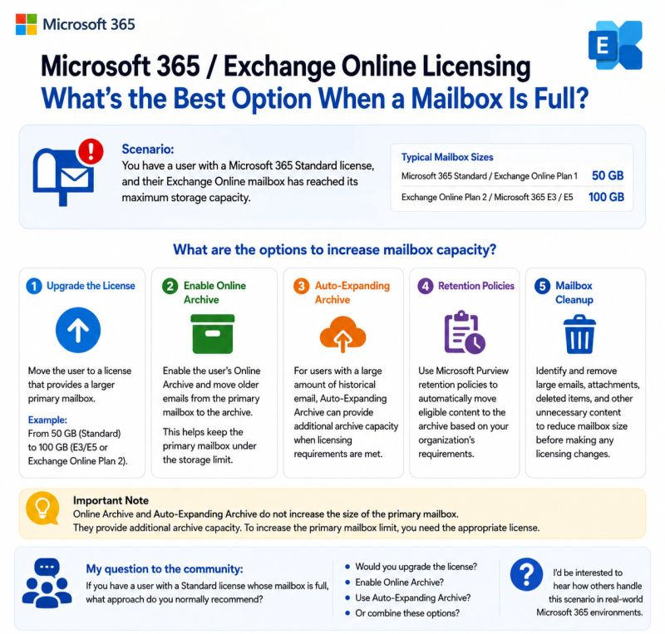
🔍 5 Advanced Microsoft 365 Features That Every IT Administrator Should Be Using..
These features can significantly improve security, compliance, and operational efficiency.
🔹1. Conditional Access Policies: Go beyond MFA. Apply risk-based access controls based on user identity, device compliance, location, and application sensitivity.
🔹2. Microsoft Entra ID Identity Protection: Automatically detect risky sign-ins and compromised accounts, then trigger remediation actions before attackers gain access.
🔹3. Microsoft Purview Data Loss Prevention (DLP): Prevent sensitive information such as financial data or personal information from leaving your organization through email, Teams, SharePoint, or OneDrive.
🔹4. Microsoft Defender for Office 365: Protect users against phishing, Business Email Compromise (BEC), malicious links&zero-day email threat with advanced threat detection.
🔹5. Privileged Identity Management (PIM): Eliminate permanent Global Administrators by enabling Just-in-Time (JIT) privileged access with approval workflows and auditing.
Microsoft 365 is no longer just an email and collaboration platform—it's a comprehensive security, identity, compliance, and productivity ecosystem.
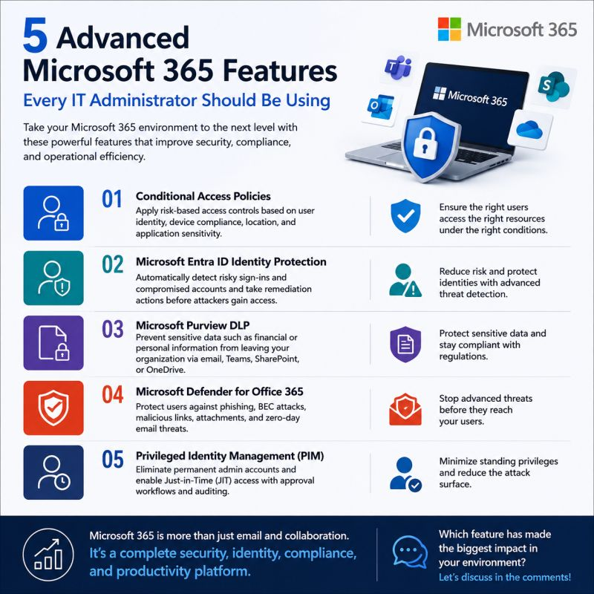
🚀 Microsoft 365 vs Office 365 – What's the Difference?
Many people still use the name Office 365, but Microsoft has evolved it into Microsoft 365.
✅ Office 365 focuses on productivity with apps like Word, Excel, Outlook, Teams, Exchange, OneDrive, and SharePoint.
✅ Microsoft 365 includes everything in Office 365 plus advanced security, device management, identity protection, compliance features, and AI capabilities such as Microsoft Copilot (available with eligible licenses).
Bottom Line: Microsoft 365 = Office 365 + Security + Device Management + AI + More
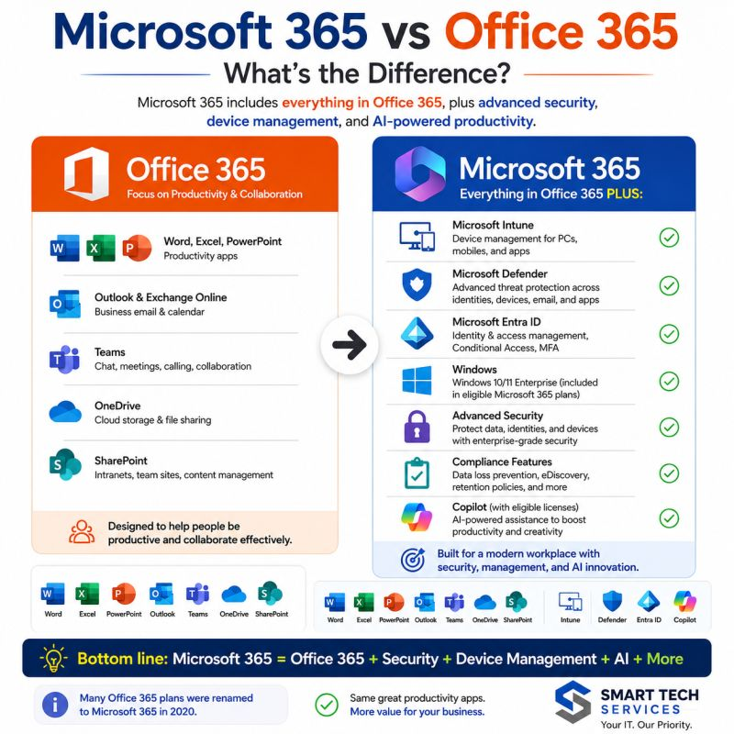
🚨 What Happens If Your Domain Gets Hijacked?
Most organizations invest in endpoint security, firewalls, and email protection... but often overlook one of their most critical assets: their domain.
If attackers gain control of your domain, the impact can be severe:
🔹 Website redirection to malicious pages🔹 Business email compromise (BEC)
🔹Credential theft through fake login portals🔹Brand impersonation and reputational damage🔹 Service disruption affecting customers and employees
How can you reduce the risk?
✅ Enable Multi-Factor Authentication (MFA) on your domain registrar account.
✅ Use Registry Lock if your registrar supports it.
✅ Protect your DNS with DNSSEC where available.
✅ Regularly monitor DNS records and domain changes.
✅ Restrict registrar account access using the principle of least privilege.
Cybersecurity isn't only about protecting your infrastructure—it's also about protecting your digital identity.
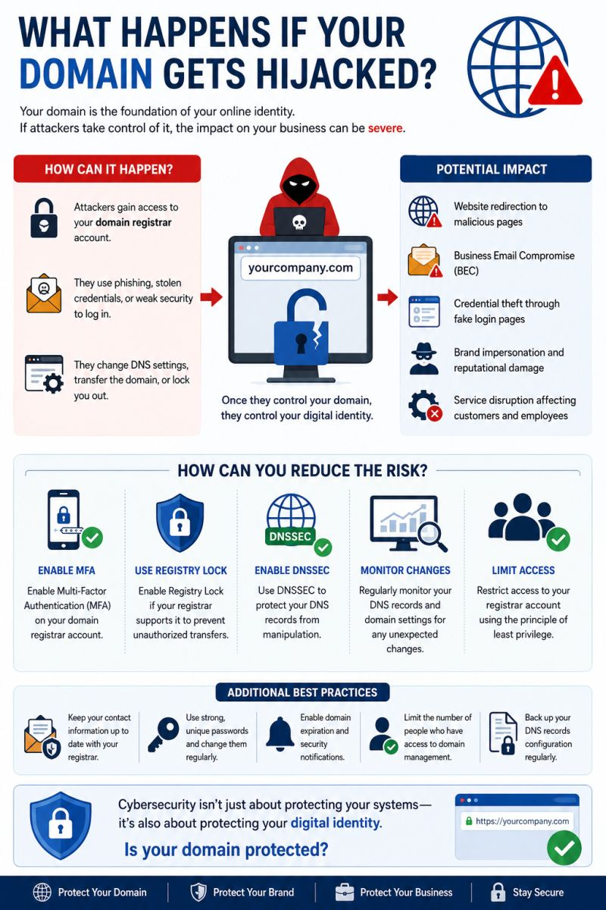
🔄 Hybrid Microsoft Entra Join vs Microsoft Entra Join
Choosing the right device identity model is essential for a secure and modern workplace.
🔹Hybrid Microsoft Entra Join: Best for organizations that still rely on on-premises Active Directory while gradually adopting cloud services.
🔹Microsoft Entra Join: Designed for cloud-first organizations using Microsoft 365 and Microsoft Intune, with no dependency on on-premises Active Directory.
💡 Key takeaway: If your organization is moving toward a cloud-native environment, Microsoft Entra Join is the recommended long-term approach. If you still depend on on-premises infrastructure, Hybrid Microsoft Entra Join provides a smooth transition.
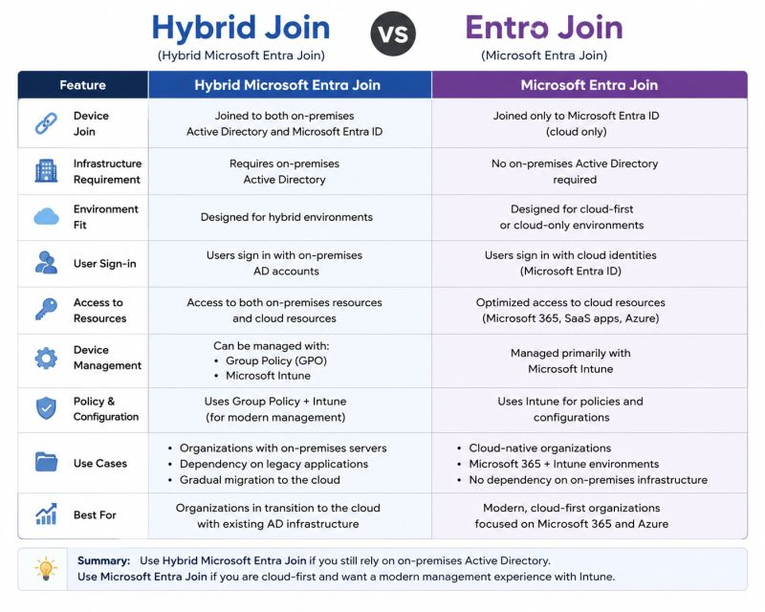
Keep Personal Files in OneDrive. Store Shared Files in SharePoint.
One of the best ways to improve collaboration and centralize your organization's data.
Instead of keeping important files in a personal OneDrive, move them to a SharePoint document library where your team can securely access and collaborate on same content.
Benefits of moving OneDrive data to SharePoint:
✅ Centralized document management
✅ Better collaboration with Microsoft Teams integration
✅ Granular permissions and access control
✅ Version history and file recovery
✅ Reduced dependency on individual user accounts
💡 Pro Tip: For large-scale migrations, use the SharePoint Migration Tool (SPMT) to preserve folder structures and simplify the migration process.
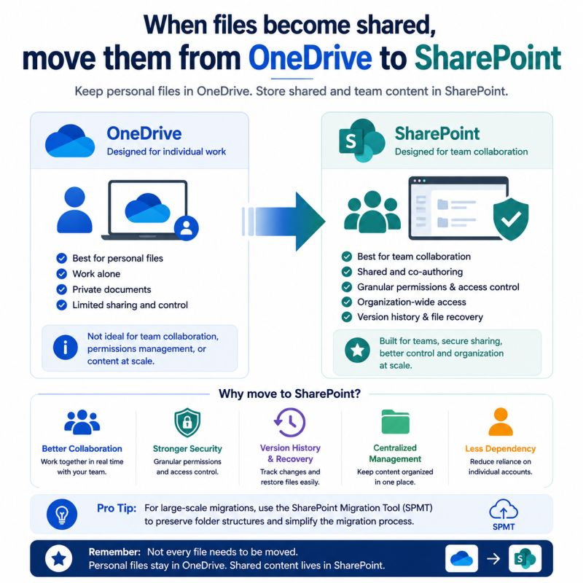
🚀 Everything Included in Microsoft 365 Business Premium!!
If someone asked me: "What's the best Microsoft 365 license for small and medium-sized businesses?"
My answer would almost always be Microsoft 365 Business Premium.
Here's what you get in a single license:
📧 Exchange Online (50 GB Mailbox) 💬 Microsoft Teams 📁 SharePoint Online
☁️ OneDrive for Business (1 TB) 📝 Microsoft 365 Apps (Word, Excel, PowerPoint, Outlook...) 🔐 Microsoft Intune (Endpoint Management) 🛡️ Microsoft Entra ID P1
🔒 Conditional Access 🚫 Multi-Factor Authentication (MFA) 🛡️ Microsoft Defender for Business 🏷️ Microsoft Purview Information Protection
💻 Windows Business Premium Features:
✅ All in one license designed to improve productivity, security, and device management.
💡 Best for: Organizations with up to 300 users that want enterprise-grade security without enterprise complexity.
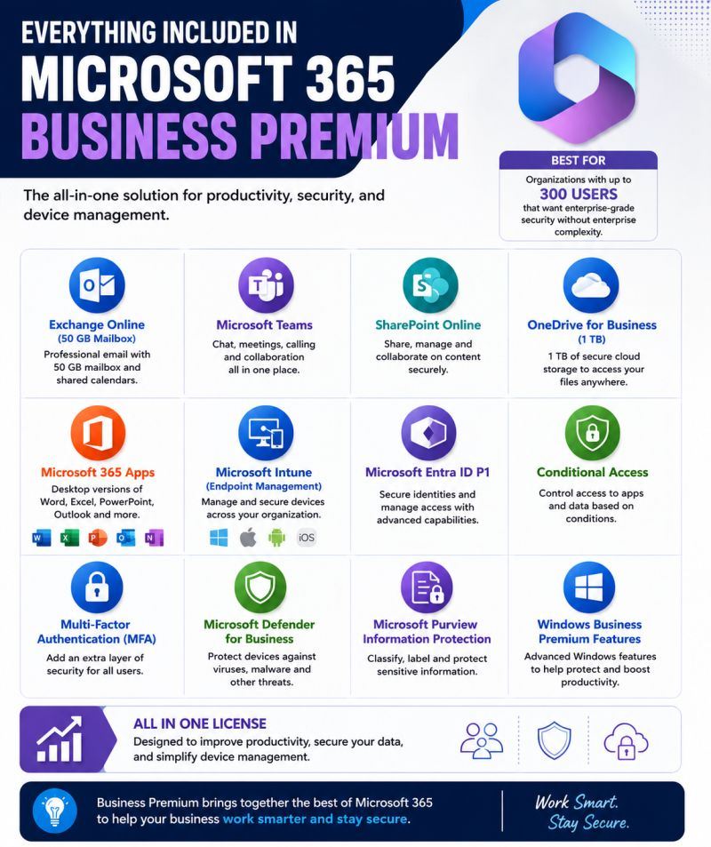
🔥 How to Secure a Microsoft 365 Tenant in 10 Minutes
Take 10 minutes and verify these essential security settings:
✅ Enable Multi-Factor Authentication (MFA) ✅ Block Legacy Authentication
✅ Configure Conditional Access Policies ✅ Protect Global Administrator accounts
✅ Review Risky Users & Risky Sign-ins ✅ Enable Microsoft Defender (if available)
✅ Turn on Audit Logs ✅ Secure SharePoint & OneDrive sharing
✅ Review Admin Roles & Permissions ✅ Check your Microsoft Secure Score
💡 Cybersecurity isn't about reacting to attacks-it's about preventing them before they happen.
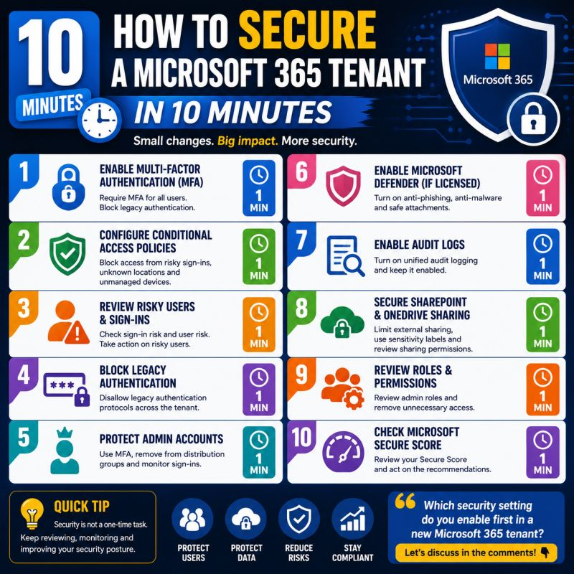
📌 Shared Mailbox vs Distribution List vs Microsoft 365 Group
Here's a simple breakdown:
📧 Shared Mailbox:
✅ Best for shared email management (e.g., support@, sales@)
✅ Multiple users can read and reply from the same mailbox.
✅ Great for customer support and shared departments.
📨 Distribution List :
✅ Sends one email to multiple recipients. ✅ No shared inbox.
✅ Best for announcements and mass communication.
👥 Microsoft 365 Group:
✅ Shared mailbox + Calendar + SharePoint + Planner + Teams integration. ✅ Designed for collaboration, not just email.
✅ Perfect for teams working on projects together.
💡 Quick Tip:
👉 If your team only needs to receive emails together → Shared Mailbox.
👉 If you only need to send emails to many people → Distribution List.
👉 If your team needs to collaborate, share files, meetings & tasks → Microsoft 365 Group.
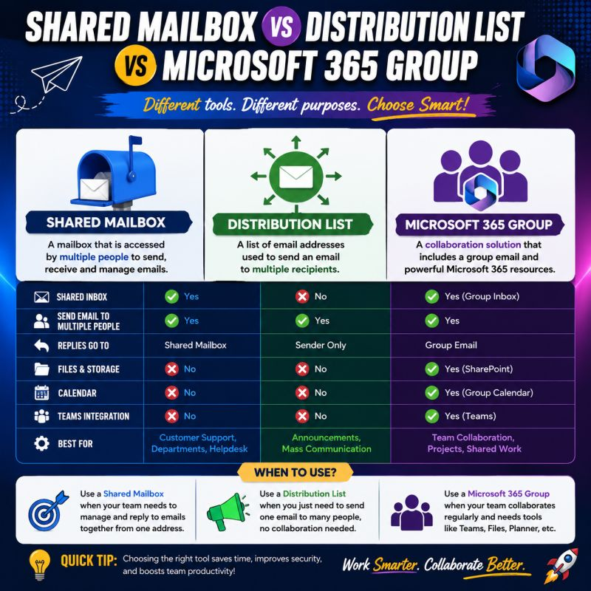
Collaborating with External Users in Microsoft Power Platform
You can securely collaborate with external users in Microsoft Power Platform without creating a full internal account?
Here are the key steps:
✅ Invite the external user as a Guest through Microsoft Entra ID (Azure AD B2B). ✅ The user accepts the invitation using their existing email address. ✅ Assign the appropriate Power Automate Premium license. ✅ The user signs in with their original email and can access the resources they have been granted.
Using Guest (B2B) access helps organizations collaborate securely with partners, consultants, and vendors while maintaining governance and control.
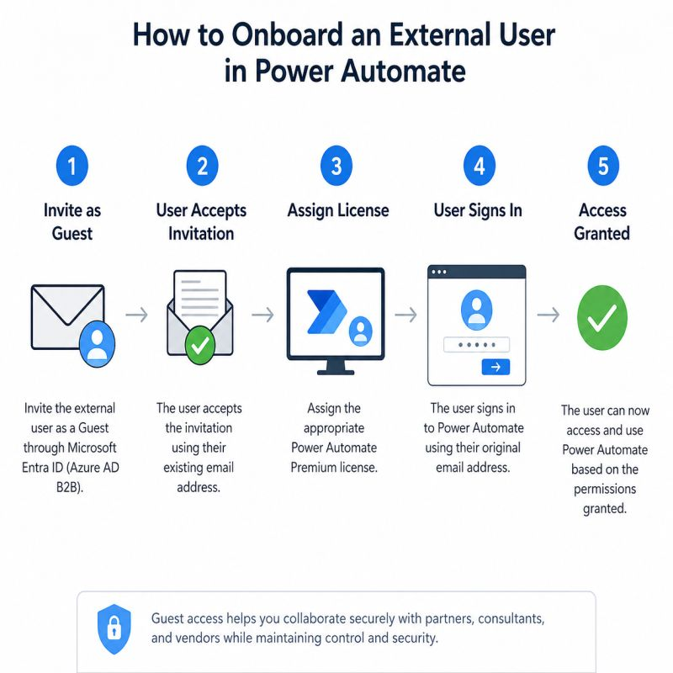
OneDrive vs. SharePoint: Know When to Use Each.
Many people think OneDrive and SharePoint do the same thing—but they serve different purposes.
🔹OneDrive is your personal workspace.
✅Store your own files ✅Work on drafts ✅Share files when needed
🔹SharePoint is your team's collaborative workspace.
✅Centralized document management ✅Version history and permission management
✅Team collaboration & co-authoring ✅Files remain with organization, not an individual
Simple rule:
📁 OneDrive = My Files
🤝 SharePoint = Our Files
Using the right tool improves collaboration, security, and document governance across Microsoft 365.
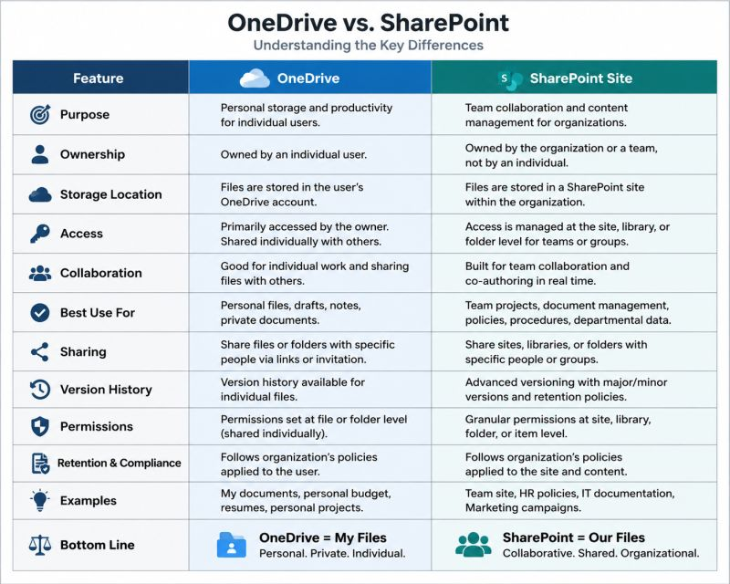
🚨 Entra ID Join ≠ Intune Enrollment
Think they're the same? Think again. Here's why everyone should know the difference.
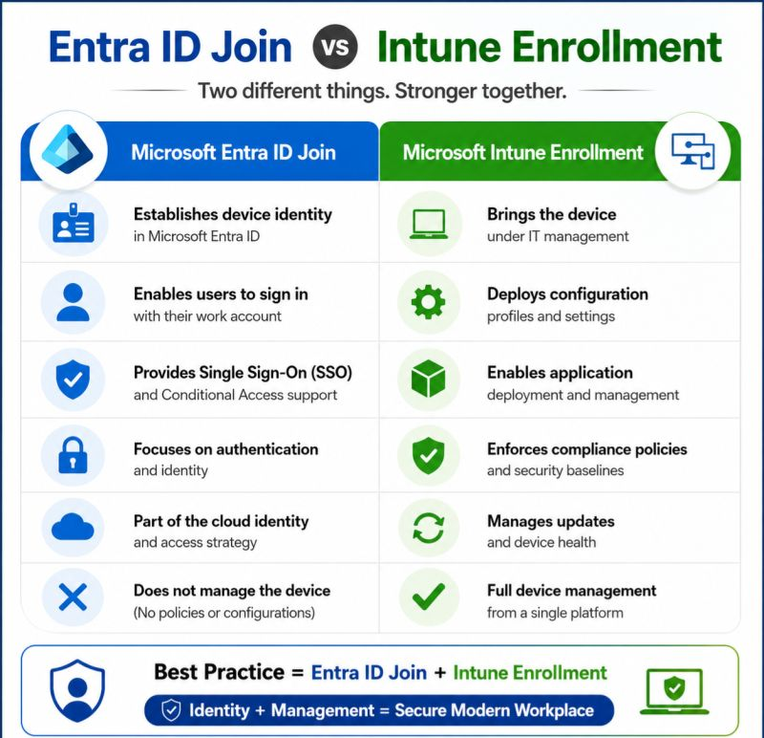

When Microsoft 365 Licenses Disappear Automatically...
I worked on a case where several Microsoft 365 licenses appeared to be removed automatically after a synchronization event.
After investigating: ✅ Reviewed Microsoft Entra audit logs. ✅ Checked Microsoft Graph activity. ✅ Verified Azure AD Connect synchronization. ✅ Confirmed licensing wasn't group-based. ✅ Analyzed license assignment history to identify the root cause.
Key takeaway:
Before reassigning licenses, always investigate the audit logs and synchronization events. The root cause is often different from what it first appears to be.
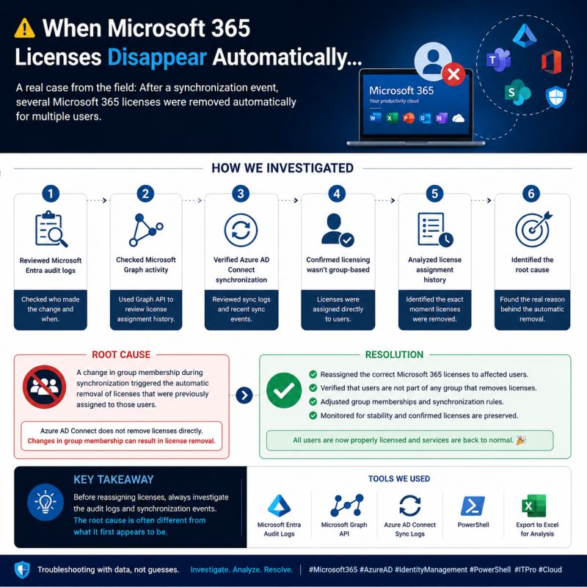
🔑 𝗜𝗔𝗠 𝗧𝗢𝗢𝗟𝗦 - 𝗪𝗛𝗢 𝗨𝗦𝗘𝗦 𝗪𝗛𝗔𝗧 & 𝗙𝗢𝗥 𝗪𝗛𝗜𝗖𝗛 𝗗𝗢𝗠𝗔𝗜𝗡
Choosing the right Identity & Access Management (IAM) platform isn't about finding a single tool that does everything—it's about deploying the right tool for the right identity challenge.
Here is a breakdown of the leading IAM tools, their core target users, primary domains, and how they work together to secure the modern enterprise:
𝟭. 𝗔𝗰𝗰𝗲𝘀𝘀 𝗠𝗮𝗻𝗮𝗴𝗲𝗺𝗲𝗻𝘁, 𝗔𝘂𝘁𝗵𝗲𝗻𝘁𝗶𝗰𝗮𝘁𝗶𝗼𝗻 & 𝗖𝗜𝗔𝗠
* 𝗢𝗸𝘁𝗮: Designed for Enterprises, IT Teams, App Owners, and Security Teams. Used for Employee SSO, Customer Identity (Auth0), MFA, Access Policies, and Lifecycle Management. Primary Domains: Access Management, Authentication, and CIAM.
* 𝗣𝗶𝗻𝗴 𝗜𝗱𝗲𝗻𝘁𝗶𝘁𝘆: Built for Enterprises, IAM Teams, Developers, and Security Architects. Used for CIAM, SSO & Federation, API Security, and Risk-Based Auth via PingOne AIC, PingFederate, PingAccess, PingDirectory, and PingID.
* 𝗙𝗼𝗿𝗴𝗲𝗥𝗼𝗰𝗸: Ideal for Enterprises, Developers, and Identity Architects handling complex CIAM Platforms, Identity Orchestration, Identity APIs, and Access Management across AM, IDM, and IG components.
* 𝗠𝗶𝗰𝗿𝗼𝘀𝗼𝗳𝘁 𝗘𝗻𝘁𝗿𝗮 𝗜𝗗: Core for IT Admins, Security Teams, and Employees. Delivers SSO to Microsoft 365, Conditional Access, MFA, Risk-Based Access, PIM, and Hybrid Identity built on Zero Trust principles.
𝟮. 𝗜𝗱𝗲𝗻𝘁𝗶𝘁𝘆 𝗚𝗼𝘃𝗲𝗿𝗻𝗮𝗻𝗰𝗲 & 𝗔𝗱𝗺𝗶𝗻𝗶𝘀𝘁𝗿𝗮𝘁𝗶𝗼𝗻 (𝗜𝗚𝗔)
* 𝗦𝗮𝗶𝗹𝗣𝗼𝗶𝗻𝘁: Utilized by IAM Teams, Compliance Teams, and Business Owners for Identity Governance, Access Certifications, Role Management, Access Requests, and SoD Compliance.
* 𝗦𝗮𝘃𝗶𝘆𝗻𝘁: Deployed by Large Enterprises, Security Teams, and IT Leaders for IGA, Privileged Access, Access Certification, and Cloud Native IGAaaS.
𝟯. 𝗣𝗿𝗶𝘃𝗶𝗹𝗲𝗴𝗲𝗱 𝗔𝗰𝗰𝗲𝘀𝘀 𝗠𝗮𝗻𝗮𝗴𝗲𝗺𝗲𝗻𝘁 (𝗣𝗔𝗠)
* 𝗖𝘆𝗯𝗲𝗿𝗔𝗿𝗸: Essential for Security Teams, Privileged Users, and IT Operations. Manages Privileged Access, Secrets Management, Session Monitoring, Vaulting (PSM/PVWA), and Endpoint Privilege Enforcement.
𝟰. 𝗛𝗼𝘄 𝗧𝗵𝗲𝘆 𝗪𝗼𝗿𝗸 𝗧𝗼𝗴𝗲𝘁𝗵𝗲𝗿
A resilient security posture relies on an integrated identity lifecycle:
* 𝗔𝘂𝘁𝗵𝗲𝗻𝘁𝗶𝗰𝗮𝘁𝗲: Verify users securely via Okta, Ping, or Entra ID.
* 𝗔𝘂𝘁𝗵𝗼𝗿𝗶𝘇𝗲: Apply access policies and conditional checks at the application level.
* 𝗚𝗼𝘃𝗲𝗿𝗻: Control identities, roles, and access rights using SailPoint or Saviynt.
* 𝗣𝗿𝗼𝘁𝗲𝗰𝘁: Secure high-risk administrative access and secrets with CyberArk or Saviynt.
* 𝗠𝗼𝗻𝗶𝘁𝗼𝗿 & 𝗜𝗺𝗽𝗿𝗼𝘃𝗲: Continuously analyze and audit identity signals across SIEM and security tools.
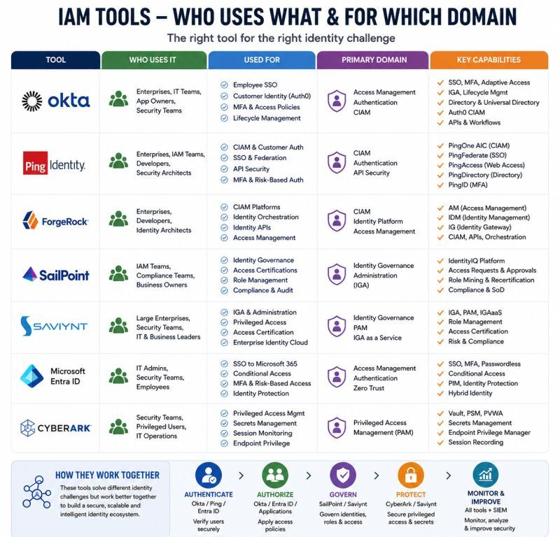

SMART / Drive Health Checks — Check the Drive Before It Fails
A slow Windows system, unexpected freezes, boot failures, or file corruption can sometimes be early signs of a storage device problem.
Before replacing or reinstalling Windows, I always consider checking health of HDD/SSD.
🔍 What I check:
✅ SMART / drive health status ✅ SSD/HDD temperature ✅ Reallocated or bad sectors
✅Pending & uncorrectable sectors✅Read/write errors✅Power-on hrs and drive usage
✅ SSD/NVMe health information✅ Disk performance and response time
🛠️ Useful Windows commands:
🔹 “Get-PhysicalDisk | Format-Table -AutoSize”🔹 “Get-Volume”
🔹 “Get-Partition”🔹 “chkdsk C: /scan”
For deeper SMART analysis, tools such as smartctl or a vendor diagnostic utility can provide additional drive attributes.
⚠️ Warning signs:
🔴 Predictive failure / unhealthy status🔴 Increasing bad or reallocated sectors
🔴 Uncorrectable errors🔴 Frequent freezes or disk-related BSODs
🔴 Files becoming corrupted🔴 Unusual drive noises on HDDs
🎯Troubleshooting principle:Detect early → Backup data → Diagnose → Replace when necessary
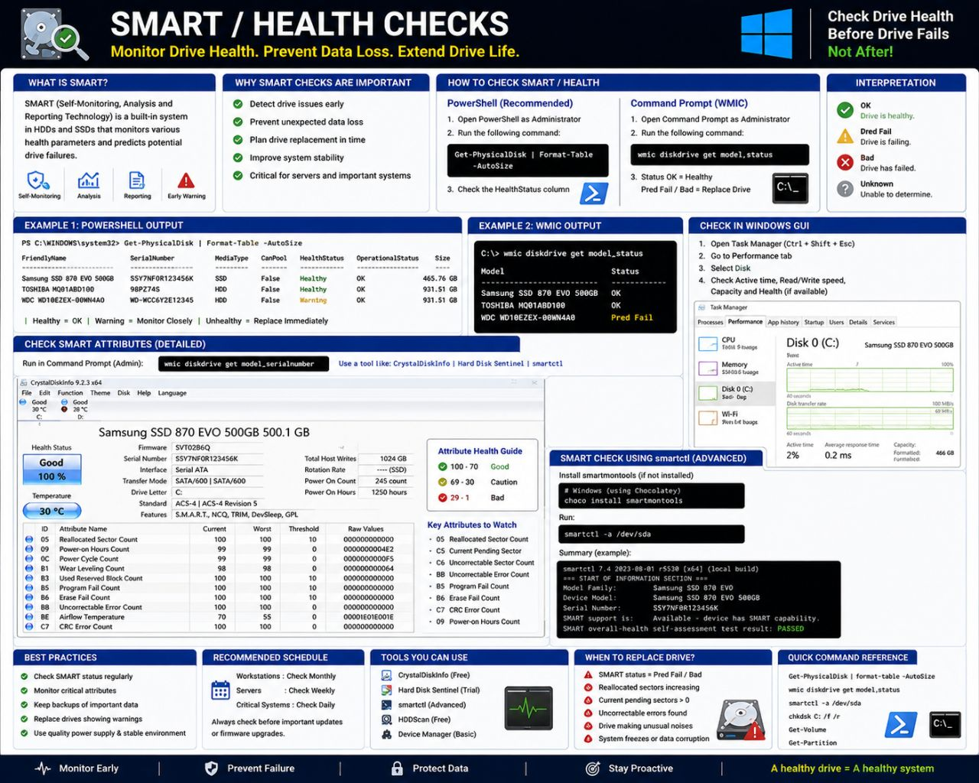
Application & Production Support – Log Analysis
In a production environment, logs are one of the first sources of evidence during incident troubleshooting.
Whether the issue is:
❌ Application failure❌ Transaction failure❌ API error
❌ Unexpected application behavior❌ Performance degradation
A structured log investigation can help identify where the failure occurred and what happened before it.
🔍 Essential Linux commands for log analysis:
🔹 tail -f app.log → Monitor logs in real time
🔹 tail -n 100 app.log → Review recent log entries
🔹 grep "ERROR" app.log → Search application errors
🔹 grep -i "exception" app.log → Search exceptions
🔹 less app.log → Analyze large log files
🔹 find / -name "*.log" → Locate log files
🔹 zgrep "ERROR" app.log.gz → Search compressed logs
🛠️ Production Log Investigation Approach:
Incident → Identify log source → Check timestamp → Analyze ERROR/EXCEPTION → Correlate Request/Transaction ID → Check dependent services → Identify RCA → Implement fix → Validate
💡 Key Support Practice: Finding an ERROR is only the starting point.
A proper investigation should correlate:
📌 Timestamp 📌 Request/Transaction ID 📌 Application component
📌 Error/Exception details 📌 API/Database dependencies
📌 Events immediately before and after the failure
For example, a database connection error in the application log may be a symptom of a database, network, connection-pool, or infrastructure issue.
The objective is to identify the actual failure point, not simply the first error that appears in the log.
📊 Application Support = Evidence + Troubleshooting + RCA + Service Restoration
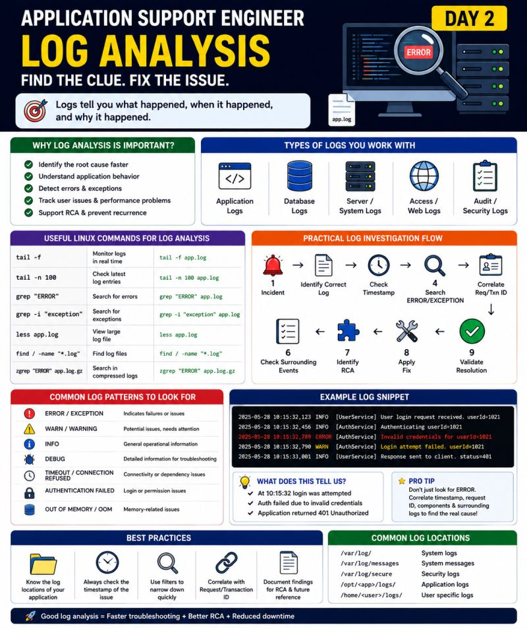

API Failure Troubleshooting - Production Support
APIs are the backbone of modern applications, and troubleshooting API failures is a critical skill for Production Support Engineers.
When an API fails in production, I follow a structured approach instead of immediately escalating the issue.
🔍 My troubleshooting checklist:
1️⃣ Identify the API:
🔹Endpoint🔹HTTP method🔹Timestamp
🔹Request/Transaction ID🔹Affected users/transactions
2️⃣ Check the HTTP status code:
🔹400 → Bad Request🔹401 → Authentication issue
🔹403 → Authorization/permission issue 🔹404 → Resource/endpoint not found
🔹408 → Request Timeout🔹429 → Too many requests
🔹500 → Internal Server Error🔹502 → Bad Gateway
🔹503 → Service Unavailable🔹504 → Gateway Timeout
3️⃣ Check application logs:
Look for:🔹Exceptions🔹Timeout🔹Connection errors
🔹Authentication failures🔹Downstream service failures
4️⃣ Validate connectivity:
Check whether the application can reach the API/server and whether the required port is accessible.
5️⃣ Check dependent services:
An API may be healthy itself but fail because of:
API → Database → External Service → Another API
6️⃣ Check recent changes:
Look for recent:🔹Deployments🔹Configuration changes🔹Certificates
🔹Firewall/network changes🔹API version changes
7️⃣ Validate the response:
Compare:🔹Request🔹Response🔹Headers🔹Status code🔹Response time
8️⃣ Mitigate and resolve:
If there's a known safe workaround, follow the approved process. Otherwise, escalate to the appropriate development/infrastructure/API team with complete evidence.
9️⃣ Validate after resolution:
Retry the transaction and confirm the business functionality- not just that the API returns 200.
💡 Production Support mindset:
An API error code tells you what happened. Logs, timestamps, dependencies and request/transaction details help you understand why it happened.
Effective API troubleshooting = API + Logs + Linux + Network + Database + Monitoring + RCA
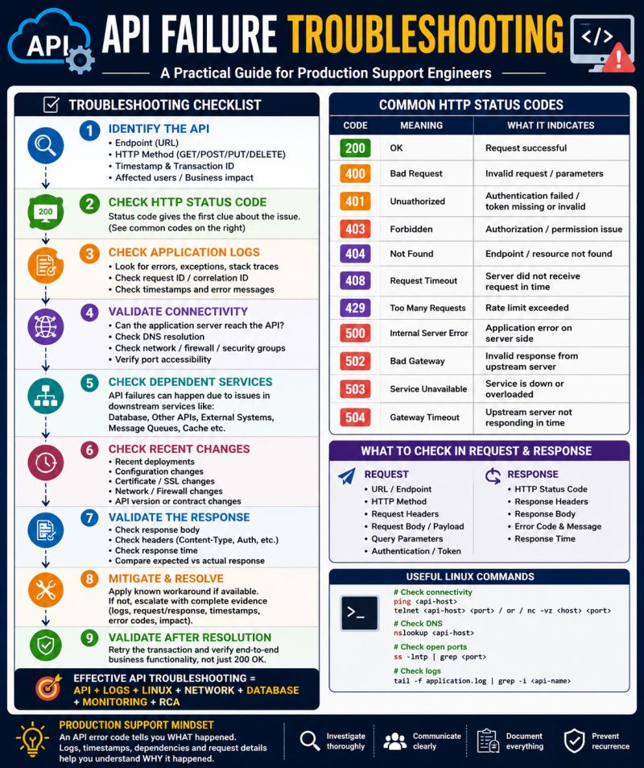
💾 SAN vs. NAS: What’s the Real Difference?
Both SAN and NAS provide networked storage — but they are designed for different workloads.
As an IT professional, choosing the wrong storage architecture can affect performance, cost, scalability, and management complexity.
Here is the simplest way to understand the difference:
🔵 SAN — Storage Area Network:
A SAN typically provides block-level storage to servers. The operating system sees the storage more like a disk or volume, making SAN a common choice for workloads that require high performance and low latency.
SAN environments commonly use technologies such as Fibre Channel or iSCSI.
🚀 Best suited for:
🔹 VMware and virtualized environments🔹 Databases🔹 Enterprise applications
🔹 Mission-critical workloads🔹 High-performance infrastructure
Think: Performance + Low Latency + Enterprise Scale
🟢 NAS — Network Attached Storage:
NAS provides file-level storage over a standard network. Users and systems access files through shared folders using common protocols such as SMB and NFS. NAS is generally easier to deploy and manage for file sharing and collaborative workloads.
📁 Best suited for:
🔹 File sharing🔹 Shared folders🔹 User home directories
🔹 Document repositories🔹 Backups and general file storage
Think: Simplicity + File Sharing + Cost Efficiency
The choice is not about which technology is universally better—it depends on the workload. High-performance applications may benefit from block storage and SAN architectures, while shared file workloads are often a natural fit for NAS.
💡 The Practical IT Rule:
Need high-performance storage for critical servers and applications? Think SAN.
Need simple, centralized file sharing? Think NAS.
🎯 The Real Question: Don't ask: Which storage is better?
Ask: What does my workload actually need?
The best storage solution is the one that delivers the right balance of:
Performance → Availability → Scalability → Cost → Simplicity
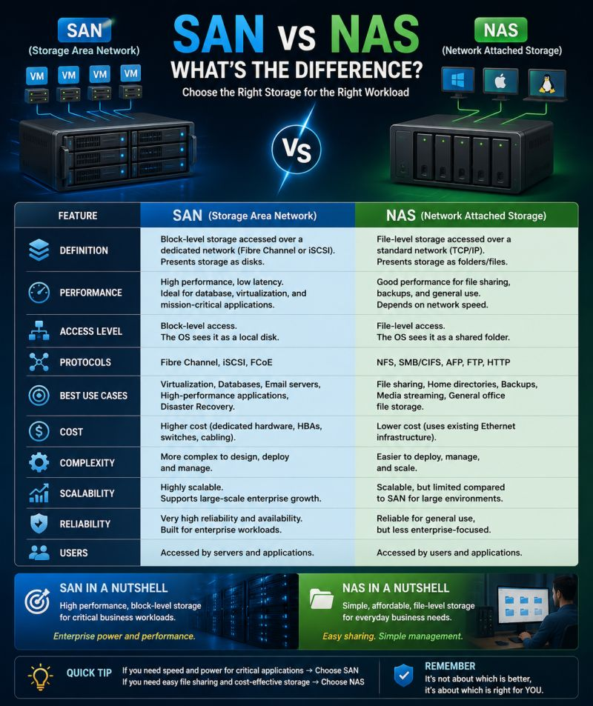

Azure Entra Connect with AD FS – Enterprise Architecture
A practical enterprise reference architecture for integrating on-premises Active Directory with Microsoft Entra ID using Entra Connect and AD FS.
The architecture covers the complete identity flow—from users and domain controllers to Entra Connect, AD FS/WAP, and Microsoft Entra ID.
🔹 Active Directory – Multiple Domain Controllers with replication, DNS and Global Catalog
🔹 Entra Connect – Primary and Staging servers for synchronization and high availability
🔹 AD FS Farm – Provides federated authentication for applications and users
🔹 WAP – Provides secure external access to AD FS
🔹 Firewall – Segmentation between internal infrastructure and Internet-facing services
🔹 Microsoft Entra ID – Cloud identity, applications, Conditional Access and authentication
🔹 Network requirements – TCP/UDP ports mapped to their respective communication flows and purposes
🛡️ Key Enterprise Considerations:
A reliable hybrid identity deployment should focus on:
✅ High availability across Domain Controllers and AD FS
✅ Entra Connect Staging Server for recovery
✅ Least-privilege firewall rules
✅ Secure communication using TLS
✅ Proper DNS and time synchronization
✅ Monitoring with Entra Connect Health
✅ Clear separation between internal AD FS services and Internet-facing WAP
The goal is to build a secure, resilient and well-segmented hybrid identity platform, rather than simply establishing connectivity.
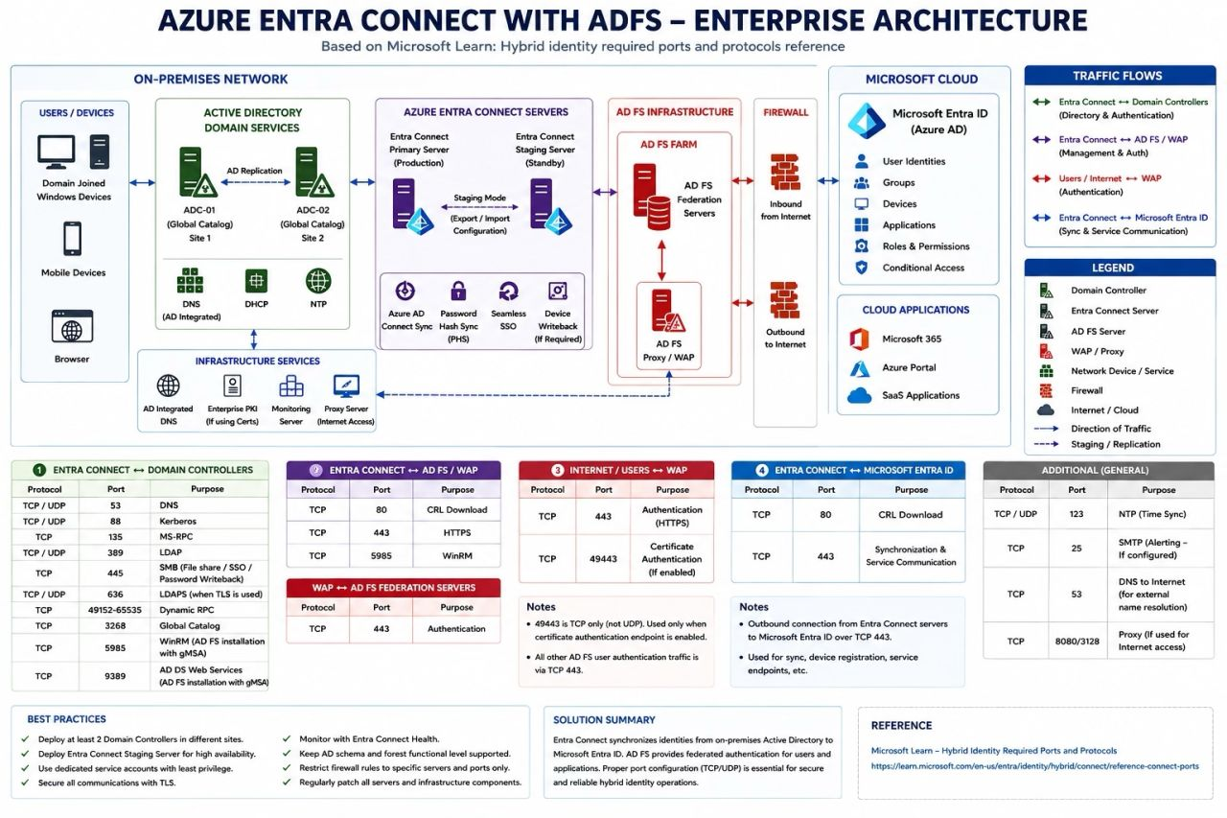

𝗣𝗖 𝗻𝗼𝘁 𝗷𝗼𝗶𝗻𝗶𝗻𝗴 𝘁𝗵𝗲 𝗗𝗼𝗺𝗮𝗶𝗻? 💻🌐
A Domain Join failure doesn't always mean there is an issue with Active Directory. In most cases, the root cause can be DNS, network connectivity, time synchronization, credentials, permissions, or an existing computer account.
𝗛𝗲𝗿𝗲’𝘀 𝗮 𝘀𝗶𝗺𝗽𝗹𝗲 𝘁𝗿𝗼𝘂𝗯𝗹𝗲𝘀𝗵𝗼𝗼𝘁𝗶𝗻𝗴 𝗮𝗽𝗽𝗿𝗼𝗮𝗰𝗵 𝗜 𝗳𝗼𝗹𝗹𝗼𝘄:
🔹1. Check Network Connectivity Can the client reach the Domain Controller?
🔹2. Verify DNS Configuration Make sure the client is using the Domain Controller as its DNS server.
🔹3. Check Time Synchronization Even a small time difference can cause Kerberos authentication issues.
🔹4. Verify Domain Credentials Check username, password, account status, and domain permissions.
🔹5. Check Existing Computer Object An old/stale computer account in Active Directory can sometimes prevent a successful join.
🔹6. Check Permissions & GPO Make sure the account has the required permissions and that no policy is blocking the domain join.
🔹7. Retry & Verify After fixing the root cause, join the PC again and verify authentication with a domain account.
💡 𝗨𝘀𝗲𝗳𝘂𝗹 𝗰𝗼𝗺𝗺𝗮𝗻𝗱𝘀:
ipconfig /all
nslookup <domain>
nltest /dsgetdc:<domain>
w32tm /query /status
whoami /upn
👉 𝗠𝘆 𝘁𝗿𝗼𝘂𝗯𝗹𝗲𝘀𝗵𝗼𝗼𝘁𝗶𝗻𝗴 𝗿𝘂𝗹𝗲: 𝘋𝘰𝘯'𝘵 𝘫𝘶𝘴𝘵 𝘧𝘪𝘹 𝘵𝘩𝘦 𝘦𝘳𝘳𝘰𝘳 — 𝘪𝘥𝘦𝘯𝘵𝘪𝘧𝘺 𝘵𝘩𝘦 𝘳𝘰𝘰𝘵 𝘤𝘢𝘶𝘴𝘦.
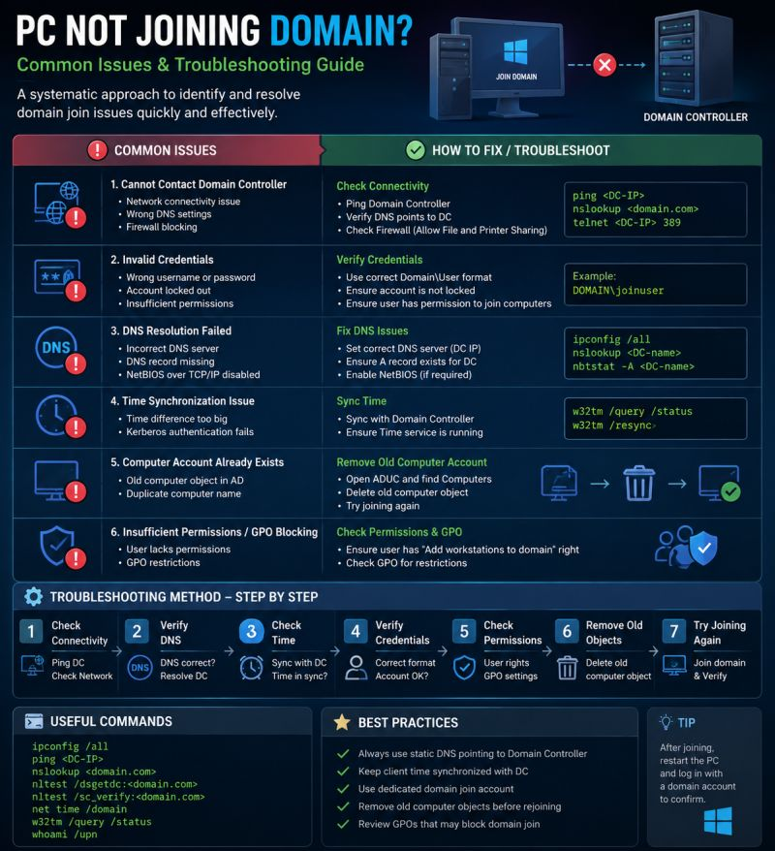

🛡️ How to View Firewall Rules on Windows
Check what your Windows Firewall is allowing or blocking?
Here are 3 simple ways:
1️⃣ PowerShell – Use "Get-NetFirewallRule" for detailed filtering and troubleshooting.
2️⃣ Command Prompt – Use "netsh advfirewall firewall show rule name=all" for a quick rule listing.
3️⃣ Firewall GUI – Press Win + R → "wf.msc" to visually inspect inbound & outbound rules.
💡 Tip: Firewall rules are extremely useful when troubleshooting connectivity issues, verifying application access, and auditing security settings.!
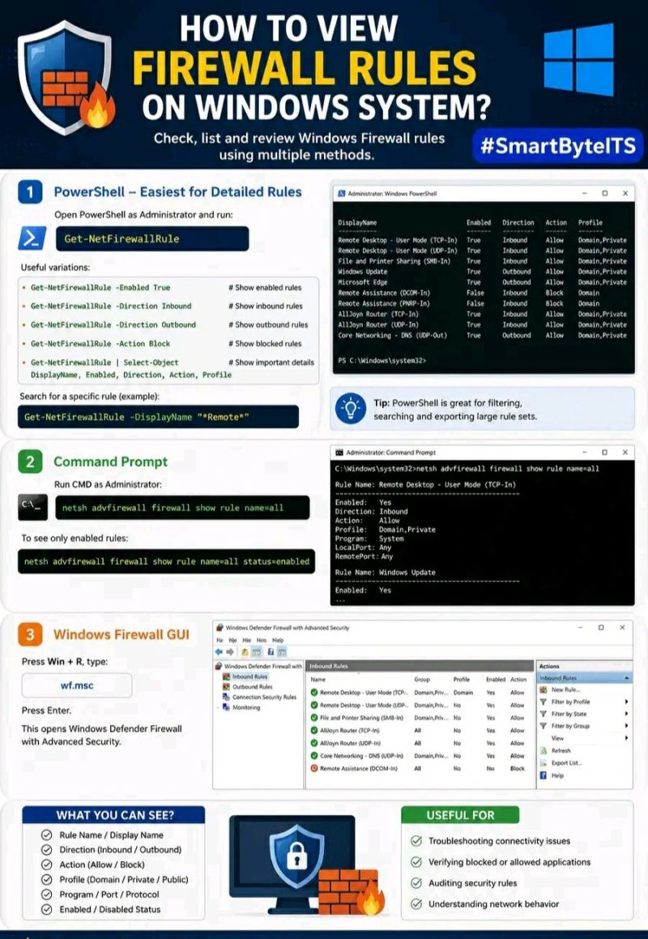
What Is Microsoft Entra ID? ☁️
Microsoft Entra ID is Microsoft's cloud-based identity and access management service.
In simple terms: Who are you? → Authentication
What can you access? → Authorization
Under what conditions can you access it? → Conditional Access
🏗️ MICROSOFT ENTRA ID ARCHITECTURE:
🌐 INTERNET→👤 USERS & DEVICES→🔐 MICROSOFT ENTRA ID→ 🔑 AUTHENTICATION→ 🛡️ CONDITIONAL ACCESS→ 🔑 AUTHORIZATION→ ☁️ APPLICATIONS & RESOURCES
1. USERS & DEVICES:
The process begins when a user attempts to access an organizational resource.
* Employees * Administrators * Guests * Windows devices * Mobile devices
* macOS devices
2. MICROSOFT ENTRA ID:
Entra ID provides the central identity layer.
* Users * Groups * Devices * Applications * Enterprise applications * Roles
* Identity information
3. AUTHENTICATION:
* Passwords * Multi-Factor Authentication (MFA) * Passwordless authentication
* Microsoft Authenticator * Biometrics
4. CONDITIONAL ACCESS:
Conditional Access evaluates the context of an access request.
* User * Application * Device * Location * Risk * Device platform
* Authentication requirements
✅ Allowed 🔐 Allowed with additional requirements🚫 Blocked
5. AUTHORIZATION:
* Application permissions * Roles * Group-based access * Resource permissions
* Least-privilege access
6. APPLICATIONS & RESOURCES:
After identity and access policies are satisfied, the user can access authorized resources.
☁️ Microsoft 365 ☁️ Azure 📧 Exchange Online 💬 Microsoft Teams
📁 SharePoint 💾 OneDrive 🏢 Enterprise applications🔗 Custom applications
🔄 ACCESS FLOW:
User requests access → Microsoft Entra ID identifies the user → Authentication takes place → Conditional Access evaluates policies → Additional security requirements are enforced → Authorization determines permissions → Access is granted or blocked → User reaches the authorized application/resource
🛡️ ZERO TRUST CONNECTION:
Microsoft Entra ID plays an important role in a Zero Trust security model.
* Verify explicitly * Use least privilege * Assume breach
WHY ENTRA ID MATTERS:
Modern organizations have users, devices, cloud services, SaaS applications and resources distributed across different environments.
A strong identity platform helps organizations:
✅ Secure identities ✅ Control access ✅ Enforce security policies
✅ Support Single Sign-On (SSO) ✅ Apply least privilege
✅ Protect cloud resources ✅ Improve visibility and governance
SIMPLE ARCHITECTURE:
USERS & DEVICES → MICROSOFT ENTRA ID → AUTHENTICATION → CONDITIONAL ACCESS → AUTHORIZATION → APPLICATIONS & RESOURCES
Identity is the foundation of modern cloud security.
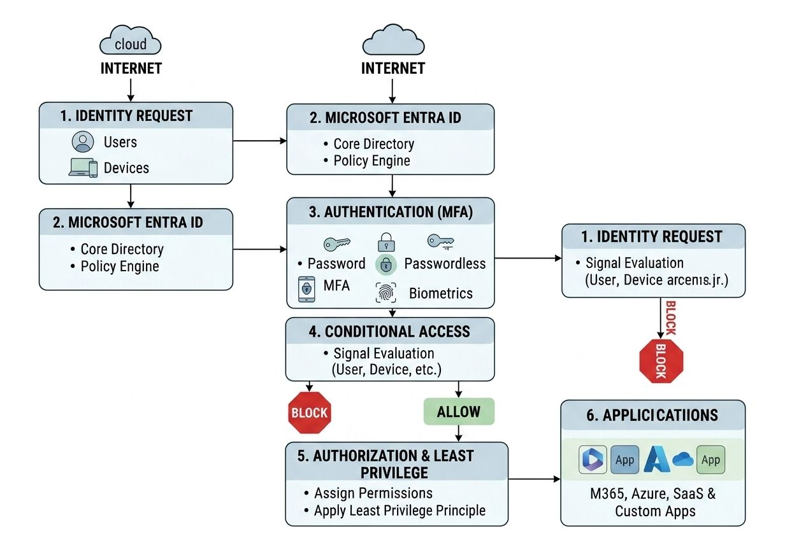
System Engineer | Day 24
⚡ PowerShell Commands: Windows Servers
Instead of performing every task through a GUI, PowerShell helps you manage, troubleshoot, monitor, and automate Windows systems.
💻 BASIC SYSTEM COMMANDS:
🔹Get-ComputerInfo → View detailed system information.🔹Get-Process → View running processes.🔹Get-Service → Check Windows services.🔹Get-WinEvent → Review Windows event logs.
👤 USER & ADMINISTRATION:
🔹Get-LocalUser → List local users🔹Get-LocalGroup → List local groups
🔹Get-LocalGroupMember → Check group members 🔹Add-LocalGroupMember → Add users to groups
🌐 NETWORKING COMMANDS:
🔹Get-NetIPConfiguration → View IP configuration.
🔹Test-NetConnection → Test connectivity and ports.
Example: Test-NetConnection google.com -Port 443
🔹Get-NetTCPConnection → View active TCP connections.
📁 FILE & FOLDER MANAGEMENT:
🔹Get-ChildItem → List files/folders🔹Copy-Item → Copy files🔹Move-Item → Move files 🔹Remove-Item → Remove files🔹Get-Content → Read file contents
⚙️ SERVICE MANAGEMENT:
Get-Service
Find running services: Get-Service | Where-Object {$_.Status -eq "Running"}
Start a service: Start-Service ServiceName
Stop a service: Stop-Service ServiceName
⚠️ Always verify the service before making production changes.
🔍 TROUBLESHOOTING COMMANDS
🔹Get-WinEvent → Event logs🔹Get-Process → Processes🔹Get-Service → Services
🔹Get-Disk → Disk information🔹Get-Volume → Volume information🔹Get-NetAdapter → Network adapters
These commands can help troubleshoot issues quickly without opening multiple GUI tools.
🤖 WHY POWERSHELL MATTERS:
PowerShell helps System Engineers:
✅ Automate repetitive tasks ✅ Manage multiple servers ✅ Troubleshoot faster ✅ Collect system information✅ Create administrative scripts✅ Reduce manual work
✅ Standardize operations
💡 One command is useful. A script that automates 100 repetitive tasks is powerful.
🧠 SYSTEM ENGINEER TIP: Don't try to memorize hundreds of PowerShell commands.
Start with: Get → Find → Filter → Change → Verify
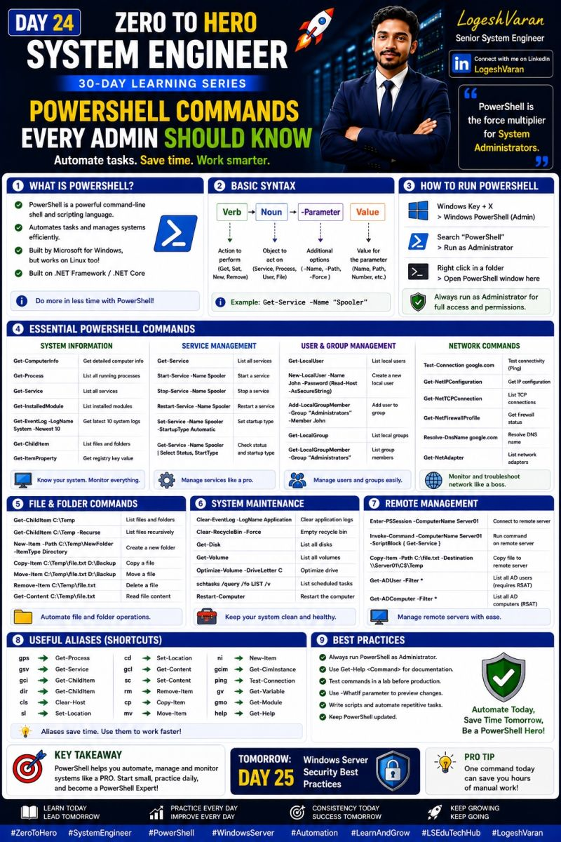
𝗦𝗔𝗠𝗟: 𝗜𝗗𝗘𝗡𝗧𝗜𝗧𝗬 𝗣𝗥𝗢𝗩𝗜𝗗𝗘𝗥 𝘃𝘀. 𝗦𝗘𝗥𝗩𝗜𝗖𝗘 𝗣𝗥𝗢𝗩𝗜𝗗𝗘𝗥
Ever wondered what actually happens when you click “Sign in with your company account” and suddenly get access to an application?
A big part of that experience can be SAML-based Single Sign-On (SSO).
To understand SAML, you first need to understand two important players:
🆔 Identity Provider (IdP): The IdP is responsible for verifying your identity.
It handles authentication, applies security controls such as MFA, and sends trusted information about your identity to the application.
Examples include: • Okta • Microsoft Entra ID • Ping Identity
Think of the IdP as the trusted source that says, “Yes, this is who this person is.”
🌐 Service Provider (SP): The SP is the application you're trying to access.
Instead of maintaining a separate authentication system for every user, the application can rely on the IdP to authenticate them.
Examples include: • Salesforce • ServiceNow • Workday • Slack
The SP essentially says: “I trust this Identity Provider to verify the user.”
So what happens during a SAML SSO login?
1️⃣ You request access to an application.
2️⃣ The application acts as the Service Provider and redirects you to the IdP.
3️⃣ You authenticate with the IdP and complete MFA if required.
4️⃣ The IdP generates a SAML Assertion containing trusted information about your identity.
5️⃣ The assertion is sent back to the Service Provider.
6️⃣ The SP validates the assertion.
7️⃣ Access is granted.
And the best part?
From the user's perspective, it can feel almost effortless.
But behind that simple login is a trust relationship between two systems.
That relationship is one of the foundations of federated identity and enterprise SSO.
The key takeaway:
IdP → Verifies your identity.
SP → Provides the application/resource.
SAML → Helps securely communicate the authentication result between them.
Understanding this flow is essential for anyone working with IAM, SSO, or enterprise identity platforms.
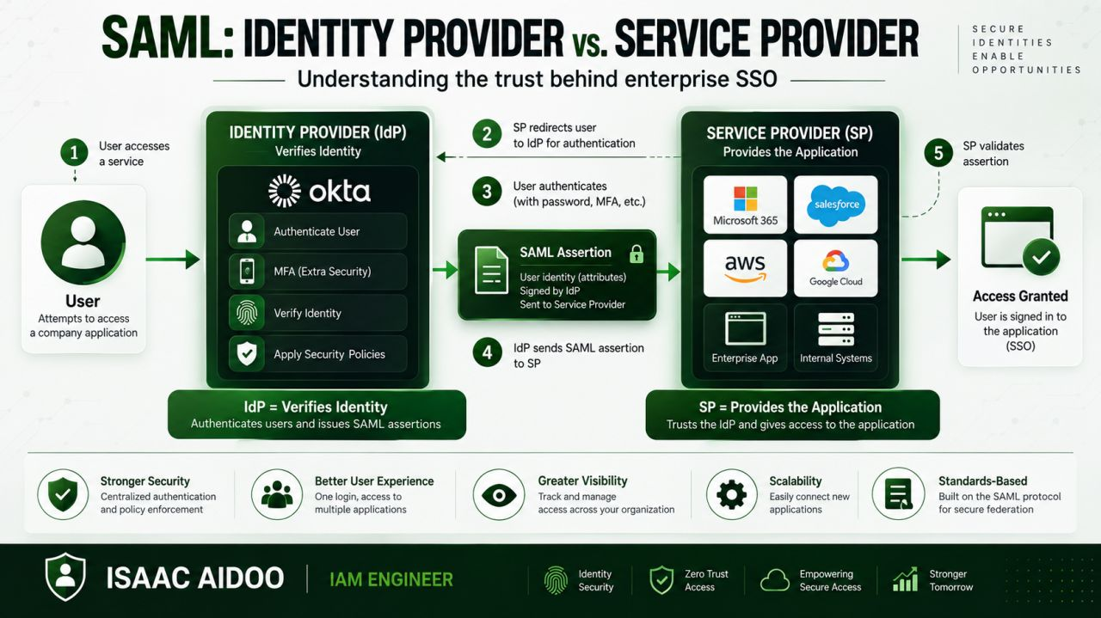

𝗪𝗛𝗔𝗧 𝗜𝗦 𝗢𝗣𝗘𝗡𝗜𝗗 𝗖𝗢𝗡𝗡𝗘𝗖𝗧 (𝗢𝗜𝗗𝗖)?
You’ve probably heard of OAuth 2.0 and OpenID Connect (OIDC) being used together.
But they aren’t the same thing.
Here’s the simplest way to remember it:
🔹🔐 OAuth 2.0 → What can you access? 🔹👤 OIDC → Who are you?
OAuth is primarily an authorization framework.
OIDC builds on OAuth 2.0 and adds an identity layer, allowing an application to verify the identity of the person signing in.
So, what does an OIDC login look like?
1️⃣ You try to sign in to an application.
2️⃣ The application redirects you to an Identity Provider (IdP), such as Okta.
3️⃣ You authenticate and complete MFA if required.
4️⃣ The IdP returns an ID Token and an Access Token.
5️⃣ The application validates the ID Token and uses the identity information to establish your session.
From the user's perspective, it can feel like a simple “Sign in” button.
Behind that button, there’s a trusted exchange happening between the application and the Identity Provider.
Why is OIDC so important?
✅ Designed for modern web and mobile applications
✅ Works with OAuth 2.0
✅ Supports SSO experiences
✅ Uses JSON Web Tokens (JWTs)
✅ Makes identity information easier for applications to consume
For IAM professionals, understanding OIDC is becoming increasingly important as organizations move toward cloud-native applications and modern identity architectures.
And while SAML is still widely used, especially across enterprise environments, OIDC is increasingly common in modern application development.
The key takeaway:
🔹OAuth helps control access. 🔹OIDC helps establish identity.
🔹Once you understand that distinction, OIDC becomes much easier to understand.
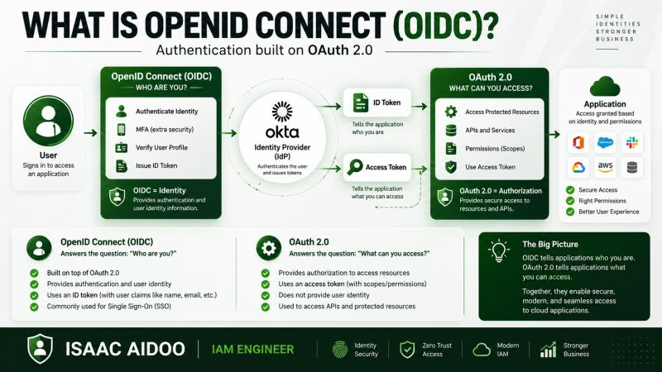

RBAC: The Foundation of Effective Identity & Access Management
Role-Based Access Control (RBAC) is one of the most effective ways to manage access at enterprise scale — but implementing RBAC successfully is about much more than simply creating roles.
At its core, RBAC answers a simple question: “What access should a user have based on their job responsibilities?”
A well-designed RBAC model typically includes:
🔹Users → Roles → Permissions: Users are assigned roles, and roles are mapped to the permissions required to perform specific job functions.
🔹Least Privilege: Users should receive only the access necessary to perform their responsibilities, reducing the attack surface and potential impact of compromised accounts.
🔹Role Engineering: Roles should be designed around actual business functions rather than individual applications or organizational structures.
🔹Joiner / Mover / Leaver Automation: Integrating RBAC with HR-driven identity lifecycle processes helps automatically provision, modify, and revoke access as employees change roles.
🔹Segregation of Duties (SoD): RBAC should prevent conflicting access combinations — especially in financial, healthcare, and other regulated environments.
🔹Access Reviews & Governance: Roles need continuous monitoring and periodic certification to ensure permissions remain appropriate over time.
💡 One important lesson:
A role that gives everyone “everything they might need” isn't really RBAC — it's excessive privilege packaged as a role.
The goal is to create well-defined, business-aligned roles that provide the right access to the right people at the right time.
Modern IAM programs can take this further by combining RBAC + ABAC + Identity Governance + Zero Trust + automation to make access decisions more dynamic and risk-aware.
For IAM professionals, understanding how to design, govern, and automate RBAC is a critical skill across platforms such as SailPoint, Saviynt, Microsoft Entra ID, Okta, and other IGA/IAM solutions.
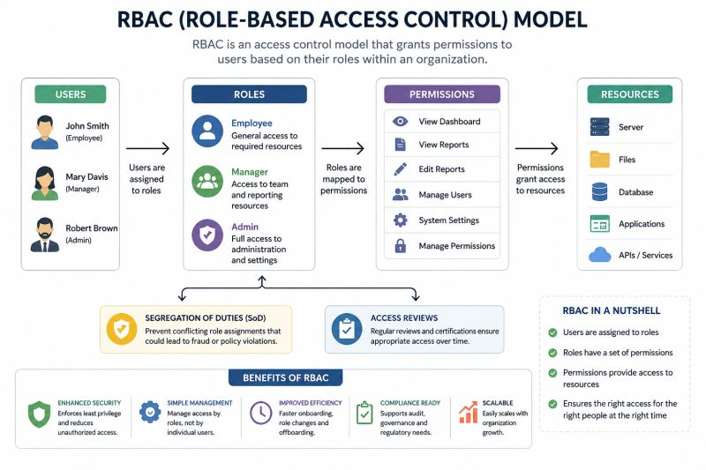

𝗦𝗶𝗻𝗴𝗹𝗲 𝗦𝗶𝗴𝗻-𝗢𝗻 (𝗦𝗦𝗢)
You log in once. Then you open your email, CRM, HR portal, cloud apps, and other company tools — without entering your password again.
Ever wondered how that works?......-That’s Single Sign-On (SSO).
But SSO is more than just making life easier for employees.
It gives organizations a more centralized way to manage identity and access.
Here’s a simple look at what happens behind the scenes 👇
1️⃣ You try to access an application.
2️⃣ The application sends you to the organization’s Identity Provider (IdP).
3️⃣ You authenticate — often using a password, MFA, or passwordless method.
4️⃣ The IdP verifies your identity.
5️⃣ The IdP sends a trusted authentication response or token to the application.
6️⃣ The application validates that trust.
7️⃣ You’re in — without having to log in again.
Simple from the user’s perspective. A lot is happening behind the scenes.
So why do organizations use SSO?
🔹 Better user experience — fewer passwords to remember.
🔹 Centralized identity management — access can be managed from a central point.
🔹 Stronger security — authentication controls such as MFA can be applied consistently.
🔹 Better visibility and governance — organizations have greater control over how users access applications.
🔹 Scalable access — one identity can securely connect users to many enterprise applications.
But there’s an important point: SSO doesn’t mean “one login = unlimited access.”
Authentication proves who you are. Authorization determines what you can access.
That distinction is at the heart of IAM. When implemented properly, SSO can make access simpler for users and easier to govern for security teams.
In a world where employees use dozens of applications every day, having one trusted identity layer can make a huge difference.
🔹One identity🔹One authentication experience.🔹Controlled access across many apps.
That’s the power of SSO.
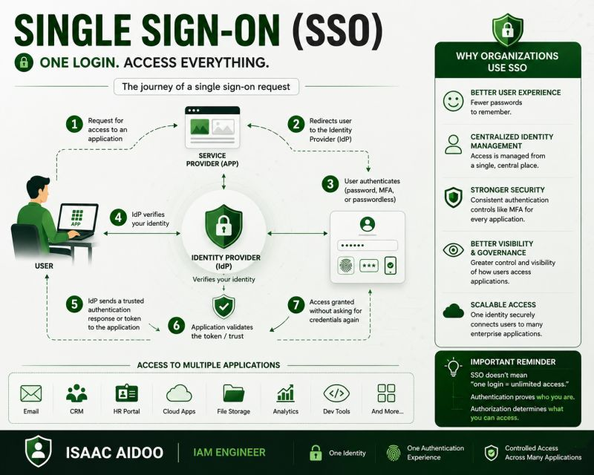

IAM vs PAM — Understanding the Difference 🔐
Identity security is not just about logging in securely. It is also about making sure the right users get the right access, while privileged access is controlled much more tightly.
🔵 IAM – Identity & Access Management: IAM manages identities and regular access across applications and resources.
It focuses on:✅Authentication & Authorization ✅SSO & MFA ✅Identity Lifecycle Mgmt✅RBAC & ABAC ✅Federation & Provisioning ✅SAML, OAuth 2.0, OIDC & SCIM
Examples include Microsoft Entra ID, Okta, PingFederate and ForgeRock.
🟣 PAM – Privileged Access Management: PAM protects high-risk and privileged accounts such as administrators, DBAs, root accounts and service accounts.
It focuses on: ✅ Least Privilege ✅ Just-in-Time (JIT) Access ✅ Credential Vaulting
✅ Password Rotation ✅ Approval Workflows ✅ Session Monitoring & Recording
Examples include CyberArk, BeyondTrust, Delinea and HashiCorp Vault.
💡 Simple way to remember:
IAM → Who are you and what can you access?
PAM → How do we securely control privileged access?
Both IAM and PAM work together to strengthen an organization’s overall Identity Security and Zero Trust strategy.
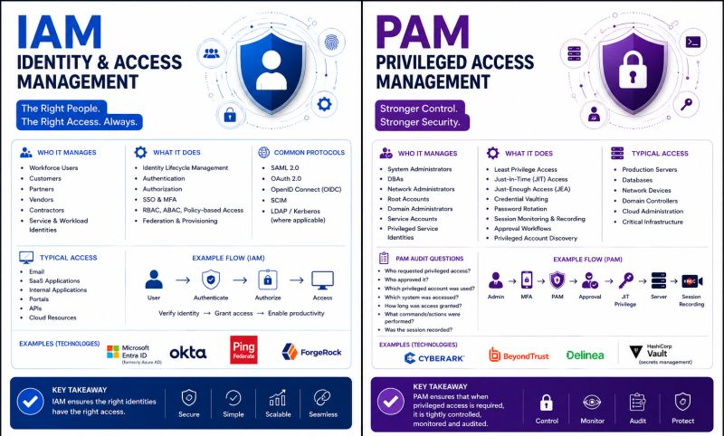
Authentication vs. Authorization: Why the Difference Matters
One of the most common concepts in Identity & Access Management is also one of the easiest to confuse: Authentication and Authorization.
They work together, but they answer two very different questions.
🔐 Authentication: “Who are you?”
🛡️ Authorization: “What are you allowed to access or do?”
Think about logging into an enterprise application.When you enter your credentials and complete MFA, the system is verifying your identity. That is authentication.
But successfully signing in doesn't mean you should automatically have access to every application, database, or administrative function. Determining what you can access based on your role, permissions, policies, and context is authorization.
For example:
👤 An employee authenticates successfully.
➡️ They can access the applications required for their job.
➡️ A manager may have additional permissions.
➡️ An administrator may have privileged access.
The identity is the same person, but the level of access is different. This distinction is fundamental to effective IAM.
Authentication commonly involves technologies such as:
• Multi-Factor Authentication (MFA)
• Single Sign-On (SSO)
• Passwordless authentication
• Biometrics
• Identity providers
Authorization can involve:
• Role-Based Access Control (RBAC)
• Attribute-Based Access Control (ABAC)
• Least privilege
• Access policies
• Privileged access controls
And this is where cybersecurity becomes especially important.
Strong authentication without proper authorization can still lead to excessive access.
Likewise, well-designed authorization policies don't help much if the organization cannot reliably verify who is requesting access.
A mature IAM strategy therefore needs both:
Authenticate the identity.
Authorize the access.
Continuously govern the permissions.
Understanding this difference is one of the foundations of building secure identity environments.
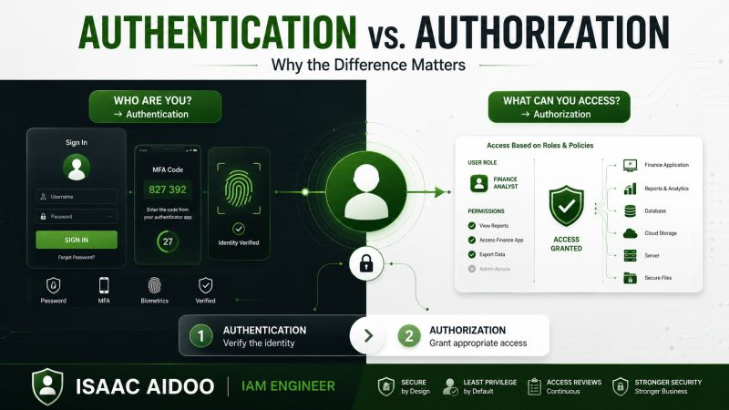

Identity and Access Management (IAM) is often treated as an IT function.
I think that view is outdated. In modern organizations, identity is the new security perimeter.
Employees work remotely. Applications live across SaaS, cloud, and on-prem environments. Service accounts, APIs, and other non-human identities are accessing sensitive resources every day.
So the real question is no longer: “Can this user log in?”
It is: “Should this identity have access to this resource, under these conditions, right now?”
That is where a mature IAM program makes a difference.
A strong IAM strategy brings several capabilities together:
• Identity Governance (IGA): Managing the identity lifecycle — Joiner, Mover, Leaver — and ensuring access changes when someone's role changes.
• Authentication: Using MFA, SSO, passwordless authentication, and phishing-resistant methods to verify that an identity is really who it claims to be.
• Authorization: Determining what an authenticated identity can actually do through models such as RBAC and ABAC.
• Privileged Access Management (PAM): Protecting high-risk administrative access through least privilege, credential vaulting, session monitoring, and Just-in-Time access.
• Non-Human Identity Management: Managing service accounts, API keys, workloads, and other machine identities with the same discipline we apply to human users.
• Access Reviews & Governance: Continuously asking whether people still need the access they currently have , instead of allowing permissions to accumulate indefinitely.
One of the biggest IAM challenges I see is that access is easy to grant but surprisingly difficult to govern over time.
Someone joins a company.→ They receive access. → They change teams. → They receive more access. → They get promoted. → More access.
Eventually, nobody is quite sure what they still need. That is how privilege accumulation happens.
Good IAM reverses that pattern by making identity lifecycle, least privilege, access reviews, and automated deprovisioning part of the process, not an afterthought.
And this is why IAM is becoming increasingly important to cybersecurity.
It is not simply about managing accounts.
It is about answering one of the most important security questions an organization can ask:
Who has access to what — and why?
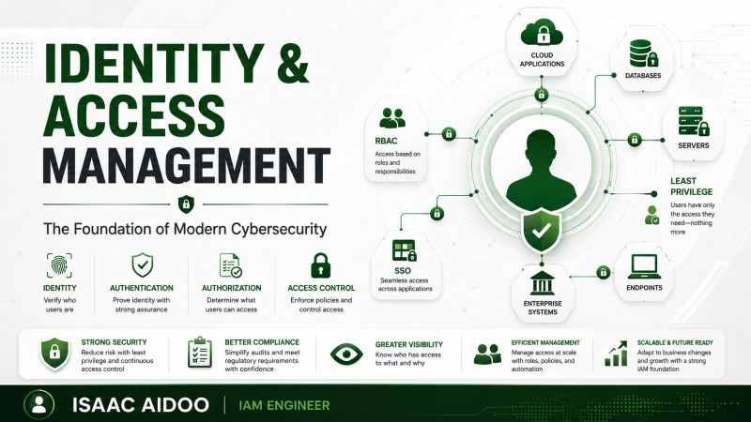

Application Support vs Production Support - What’s the Difference?
These two roles are closely related, but their focus, responsibilities, and day-to-day activities can be quite different.
🔵 Application Support:
🎯 Focus: Keeping the application functional and helping users resolve application-related issues.
🔹 Troubleshoot application errors and bugs
🔹 Handle user access and login issues
🔹 Investigate data and functional issues
🔹 Analyze application logs
🔹 Support application releases and deployments
🔹 Work with Development, QA, Business, and Product teams
🛠️ Common Tools:
SQL | Jira | ServiceNow | Splunk | Dynatrace | Application Monitoring Tools
📌 Example:
A user reports that a report is not loading → check the application logs → validate the database using SQL → identify the issue → coordinate with the development team if required.
🟢 Production Support:
🎯 Focus: Keeping the live/production environment stable, available, and performing well.
🔹 Monitor production applications and services
🔹 Handle P1/P2 incidents and outages
🔹 Monitor CPU, memory, disk, database, and network issues
🔹 Analyze logs and system alerts
🔹 Troubleshoot performance degradation
🔹 Coordinate with Infrastructure, DBA, Network, DevOps, and Development teams
🔹 Perform RCA and ensure incidents are resolved within SLA
🛠️ Common Tools:
Dynatrace | Splunk | ServiceNow | Datadog | Linux/Unix | Cloud & Monitoring Tools
📌 Example:
A production application becomes unavailable → check monitoring alerts → analyze logs → identify the failed service → coordinate with the relevant team → restore service → perform RCA.
🎯 Quick Interview Summary
Application Support = Application + User + Functional Issues
Production Support = Live Environment + Availability + Performance + Incidents
👉 In simple words:
Application Support keeps the application working correctly for users.
Production Support keeps the entire live environment stable and available.
💬 Interview Tip:
If asked, “What is the difference between Application Support and Production Support?”, explain the focus, type of incidents, tools, and teams involved, and give one practical example.
📈 Both roles require strong troubleshooting, SQL, Linux, log analysis, monitoring, incident management, RCA, and communication skills.
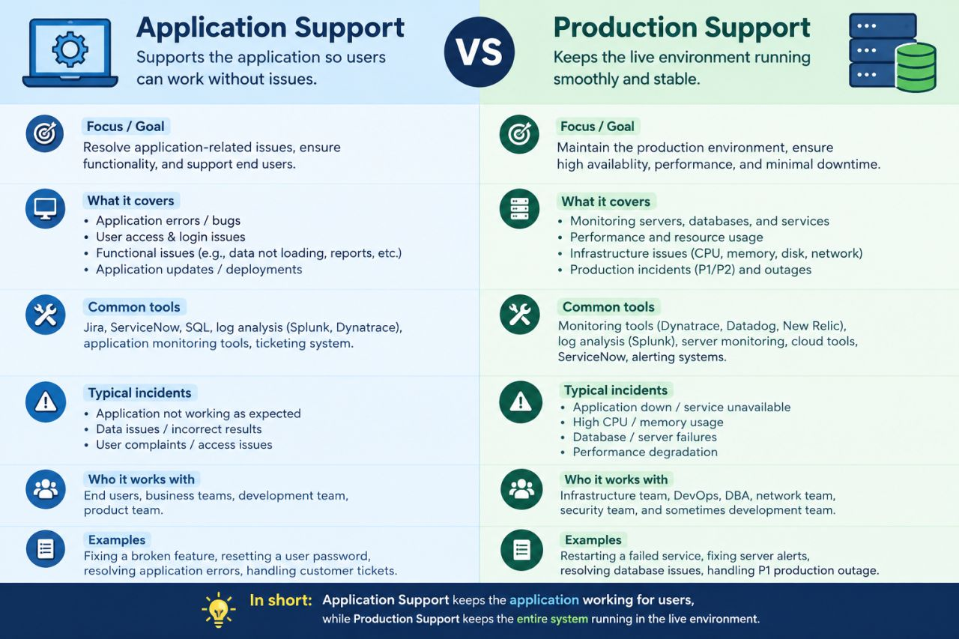
Application Support Engineer – Production Deployment Checklist
A successful deployment isn't just about pushing code — it's about preparation, validation, monitoring, and a safe rollback plan.
🔹Before Deployment:
✅ Review change ticket & approvals
✅ Check deployment window
✅ Validate dependencies
✅ Take required backups
✅ Confirm rollback plan
✅ Notify stakeholders
🚀 During Deployment:
🔸 Monitor deployment steps
🔸 Check application/server logs
🔸 Validate database changes
🔸 Monitor CPU, memory & errors
🔸 Communicate status updates
🔍 After Deployment:
✅ Perform smoke testing
✅ Validate APIs & key transactions
✅ Check application logs
✅ Monitor alerts & performance
✅ Confirm business functionality
✅ Update the change ticket
↩️ If Something Goes Wrong:
Stop → Assess → Communicate → Rollback/Restore → Validate → Document
💡 Pro Tip:
Never consider a deployment complete just because the deployment tool says “SUCCESS.” Always validate the application from both a technical and business perspective.
🎯 Goal: Zero-surprise deployments + Faster recovery + Stable production
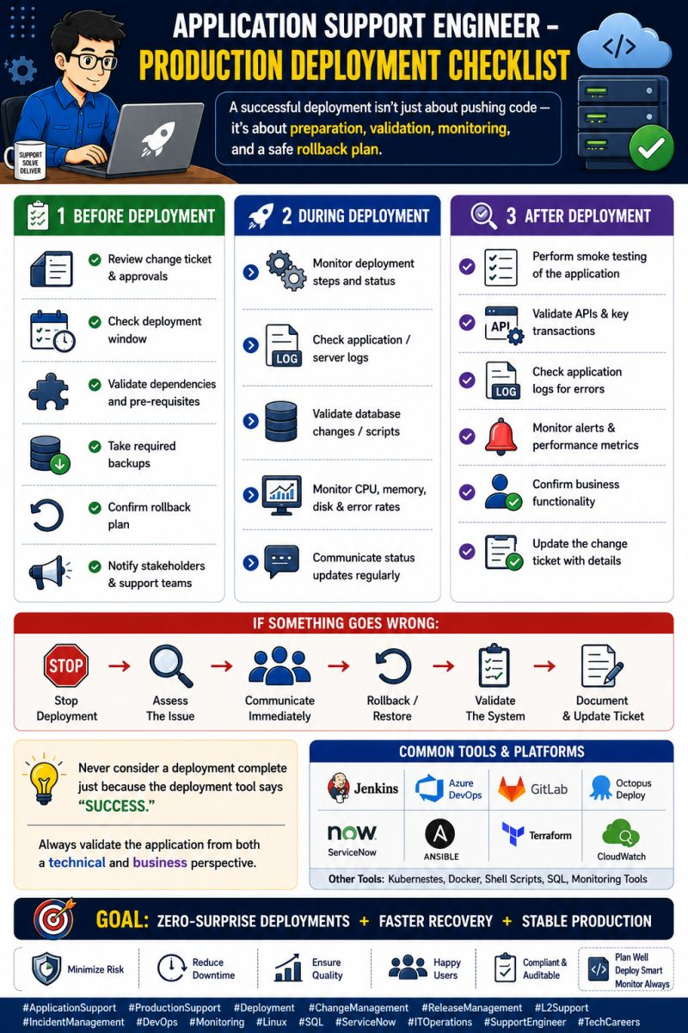
Application Support Engineer – Cloud Troubleshooting Basics
Modern applications often depend on cloud services, so understanding the basics of cloud troubleshooting is a valuable support skill.
🔍 What should you check first?
1️⃣ Application Health:
✔ Is the application responding?
✔ Check health checks and service status
2️⃣ Compute & Resources:
🖥️ CPU usage 💾 Memory utilization
💽 Disk space 📈 Resource spikes
3️⃣ Logs & Monitoring:
🔎 Check application logs
🚨 Review alerts
📊 Analyze metrics
⏱️ Investigate latency
4️⃣ Network & Connectivity:
🌐 DNS resolution
🔗 Security groups / firewall rules
⚡ Load balancer health
🔌 Port connectivity
5️⃣ Database & Dependencies:
🗄️ Verify database connectivity
🔗 Check dependent services
⏳ Investigate timeouts
6️⃣ Recent Changes:
🚀 Deployment
⚙️ Configuration change
🔐 Permission/IAM change
🛠️ Infrastructure update
☁️ Common Cloud Services to Know:
✅ AWS EC2✅ AWS Lambda✅ API Gateway✅ CloudWatch✅ S3✅ RDS
✅ Azure VMs✅ Azure Monitor
💡 Pro Tip: Follow the flow:
User → DNS → Load Balancer → Application → Database → External Service
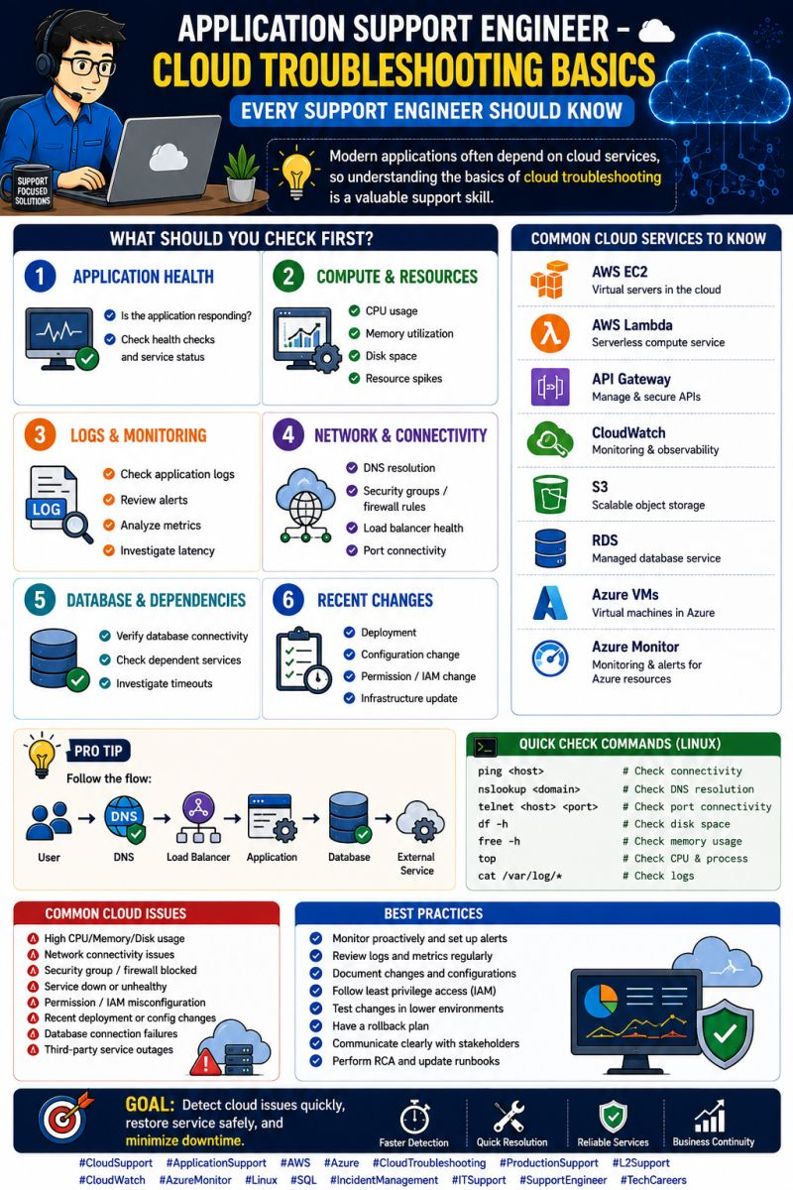
Application Support Engineer – Authentication & Authorization Troubleshooting Basics 👨‍💻
When users suddenly cannot log in or access an application feature, authentication and authorization should be checked systematically.
🔍 Troubleshooting Checklist:
1️⃣ Authentication – Can the user successfully log in?
2️⃣ Authorization – Does the user have the required permissions?
3️⃣ User Account – Check account status, password expiry & lockout
4️⃣ Tokens/Sessions – Validate session, token expiry & authentication flow
5️⃣ Application Logs – Search for 401, 403, authentication errors & exceptions
6️⃣ SSO/Identity Provider – Check SSO, LDAP, Active Directory or OAuth flow
7️⃣ API Access – Validate credentials, headers, tokens & permissions
8️⃣ Recent Changes – Check deployments, configuration or access-policy changes
📊 Common HTTP Codes:
✅ 200 – Successful request
🔐 401 – Authentication required/failed
🚫 403 – Access forbidden
❌ 404 – Resource not found
🚨 500 – Internal server error
💡 Pro Tip:
401 usually points to authentication. 403 usually points to authorization. Always confirm with logs and monitoring before making changes.
🎯 Goal: Restore user access quickly while maintaining security and auditability.
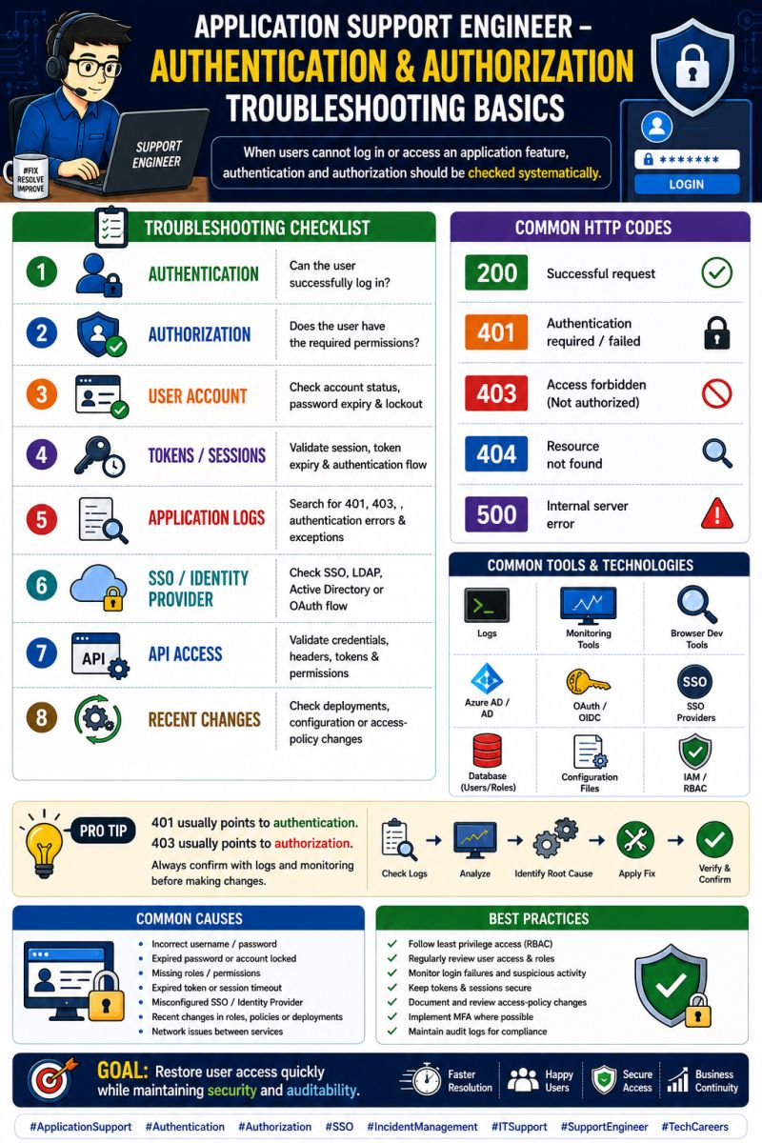
Application Support Engineer – Incident Management Lifecycle
Handling an incident is not just about fixing the error — it’s about restoring service, communicating clearly, and preventing the same issue from happening again.
📌 Incident Management Lifecycle:
1️⃣ Detection – Monitoring alert or user-reported issue
2️⃣ Logging – Create and record the incident ticket
3️⃣ Categorization – Identify application/service affected
4️⃣ Prioritization – Determine impact & urgency
5️⃣ Investigation – Check logs, SQL, monitoring & infrastructure
6️⃣ Resolution – Apply fix or approved workaround
7️⃣ Validation – Confirm service is working correctly
8️⃣ Closure – Document resolution and close the ticket
📊 For Critical/P1 Incidents:
🚨 Immediate acknowledgement
📢 Stakeholder communication
👨‍💻 Engage resolver teams
🔍 Continuous investigation
📝 RCA & preventive actions
🛠️ Common Tools: ServiceNow • Jira • Splunk • Dynatrace • Grafana • SQL • Linux
💡 Pro Tip:
Always maintain a clear timeline of what happened → what was checked → what was changed → how the issue was resolved.
🎯 Goal: Faster resolution + Better communication + Reduced downtime
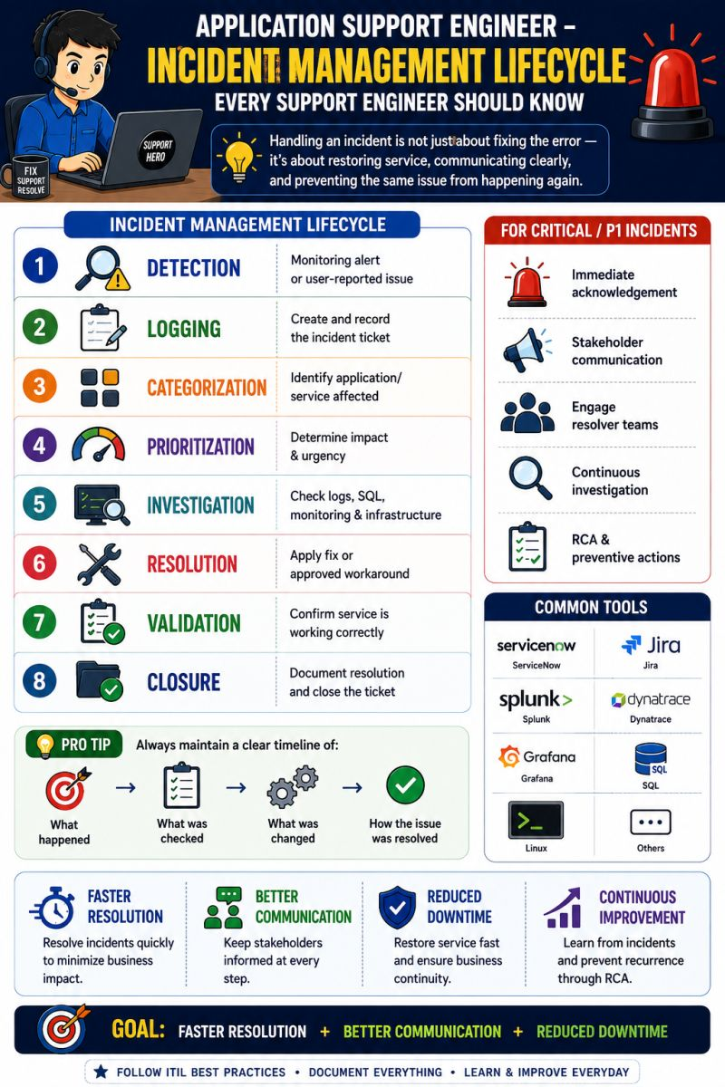
Application Support Engineer – Database Troubleshooting Basics
When an application is slow, failing, or showing incorrect data, the database is one of the first areas to investigate.
🔍 What should you check?
1️⃣ Database Connectivity:
✔ Is the database reachable?
✔ Are connections available?
2️⃣ SQL Queries:
✔ Check slow-running queries
✔ Validate joins and filters
✔ Look for incorrect or missing data
3️⃣ Performance:
📊 Check CPU, memory & disk
⏱️ Investigate query response time
🔎 Identify blocking or long-running sessions
4️⃣ Errors & Logs:
🚨 Review database errors
🔗 Check connection failures
📋 Correlate timestamps with application logs
5️⃣ Data Validation:
✅ Verify transactions
✅ Compare expected vs actual data
✅ Check duplicate or missing records
🛠️ Common Tools:
SQL • MySQL • Oracle • SQL Server • PostgreSQL • Database Logs • Monitoring Tools
💡 Pro Tip:
Don't immediately restart the application or database. Understand the issue → Collect evidence → Identify root cause → Apply a safe fix → Validate.
🎯 Goal: Faster database troubleshooting, accurate RCA, and minimal application downtime.
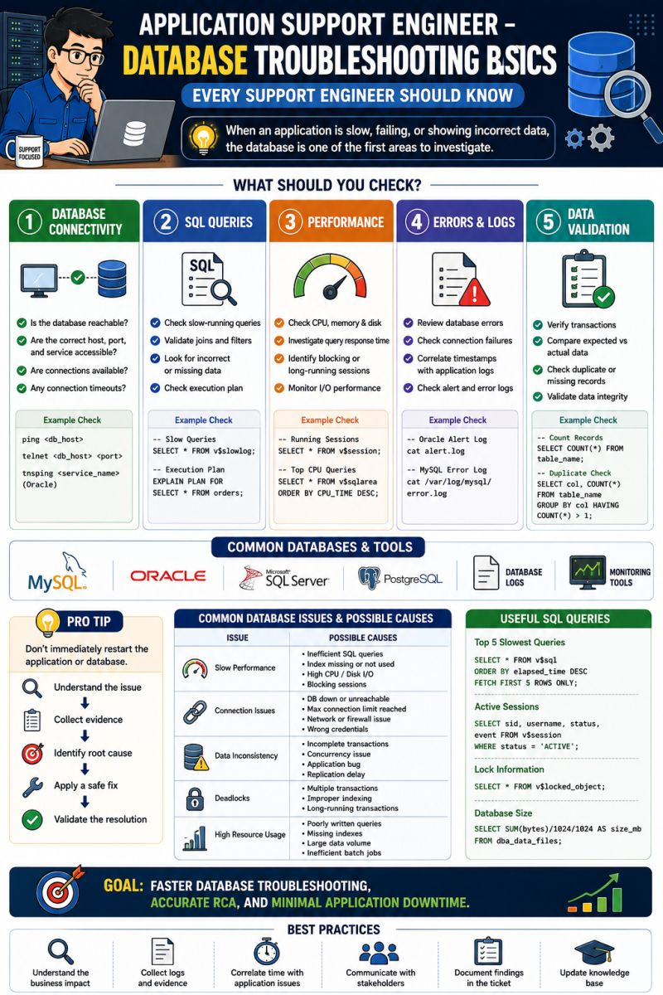
Application Support Engineer – API Troubleshooting Basics 🔍
APIs are a critical part of modern applications. When an API fails, the impact can quickly reach users and business processes.
🔎 What should you check first?
1️⃣ HTTP Status Code:
✅ 200 – Success
⚠️ 400 – Bad Request
🔐 401/403 – Authentication/Authorization
❌ 404 – Not Found
🚨 500 – Server Error
2️⃣ Request & Response:
✔ Check request parameters
✔ Validate headers
✔ Review response body
✔ Check response time
3️⃣ Application Logs:
🔹 Search for exceptions
🔹 Check timestamps
🔹 Correlate request/transaction IDs
🔹 Identify downstream failures
4️⃣ Database & Dependencies:
🗄️ Check database connectivity
🔗 Verify dependent services
⏱️ Investigate timeout issues
5️⃣ Monitoring:
📊 Check API latency
🚨 Review alerts
📈 Compare error rates
🔍 Identify unusual traffic patterns
💡 Pro Tip:
Don't immediately blame the API. Check the complete flow:
Client → API → Application → Database → External Services
🎯 Goal: Identify the failure point quickly, restore service, and prevent recurrence.
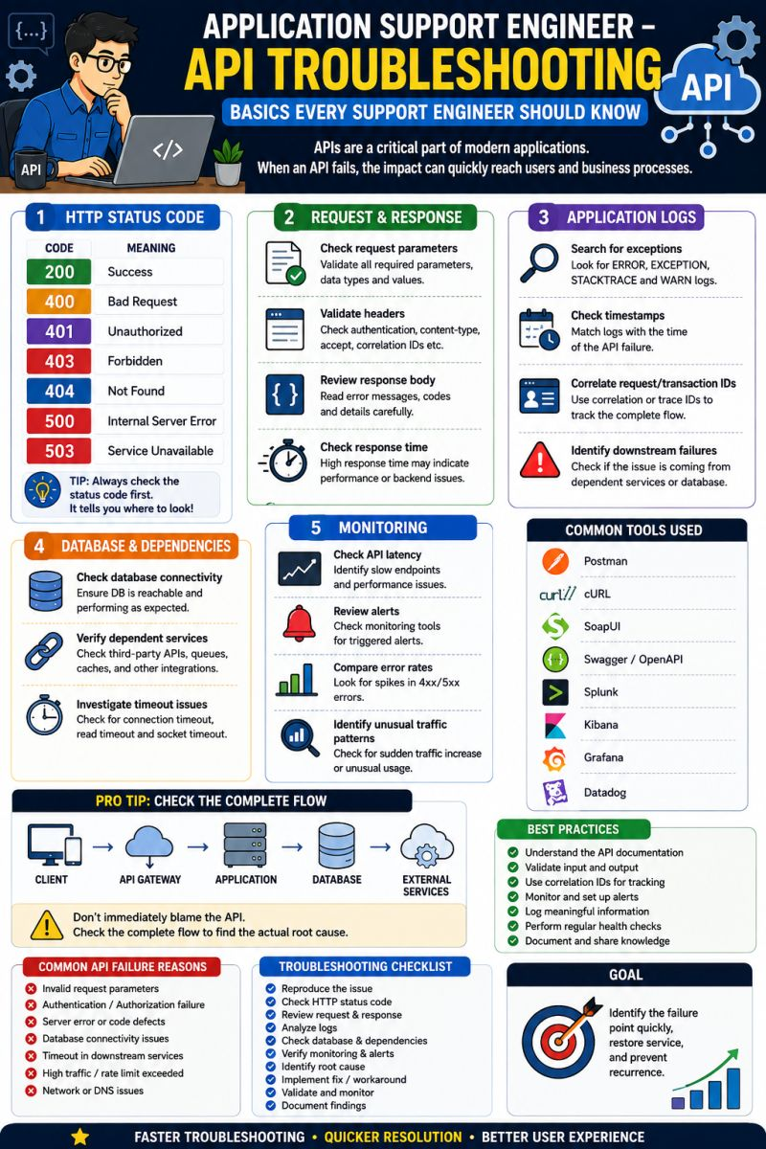
Application Support Engineer – Top Linux Commands Used Daily
Linux is a core skill for Application & Production Support Engineers.
1️⃣ top – Check CPU & memory usage2️⃣ ps -ef – Check running processes
3️⃣ df -h – Check disk space4️⃣ free -m – Check memory usage
5️⃣ tail -f – Monitor logs in real time6️⃣ grep – Search errors and keywords in logs
7️⃣ find – Locate files and directories8️⃣ netstat / ss – Check network connections
9️⃣ chmod – Manage file permissions🔟 kill – Stop or terminate processes
🔍 Common Support Use Cases:
✅ Application troubleshooting✅ Log analysis✅ Disk & memory investigation
✅ Server health checks✅ Process troubleshooting ✅ Production incident resolution
💡 Pro Tip:
Before restarting a production service, always check logs, processes, resources, dependencies, and recent changes.
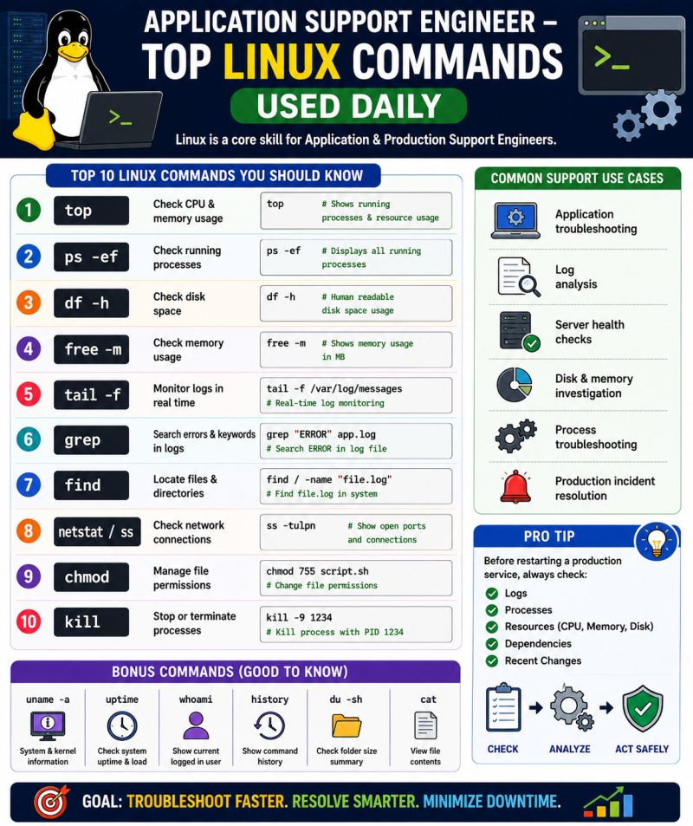
Application Support Engineer – How to Handle a P1 Production Incident
A P1 incident means critical business impact — and every minute matters.
🔥 P1 Incident Response Process:
1️⃣ Acknowledge – Accept the incident immediately
2️⃣ Assess – Understand business and user impact
3️⃣ Communicate – Notify stakeholders and support teams
4️⃣ Investigate – Check monitoring, logs, SQL and infrastructure
5️⃣ Mitigate – Apply a workaround or restore service quickly
6️⃣ Validate – Confirm the application is stable
7️⃣ Monitor – Watch the system after recovery
8️⃣ RCA – Identify the root cause
9️⃣ Prevent – Implement corrective & preventive actions
🔟 Document – Update the incident and knowledge base
💡 Golden Rule:⚡ Restore Service First → Find Root Cause → Prevent Recurrence
🛠️ Key Skills:✅Incident Management✅Log Analysis✅SQL Troubleshooting✅ Linux/Unix✅Monitoring & Alerts✅RCA & Problem Mgmt✅Stakeholder Communication
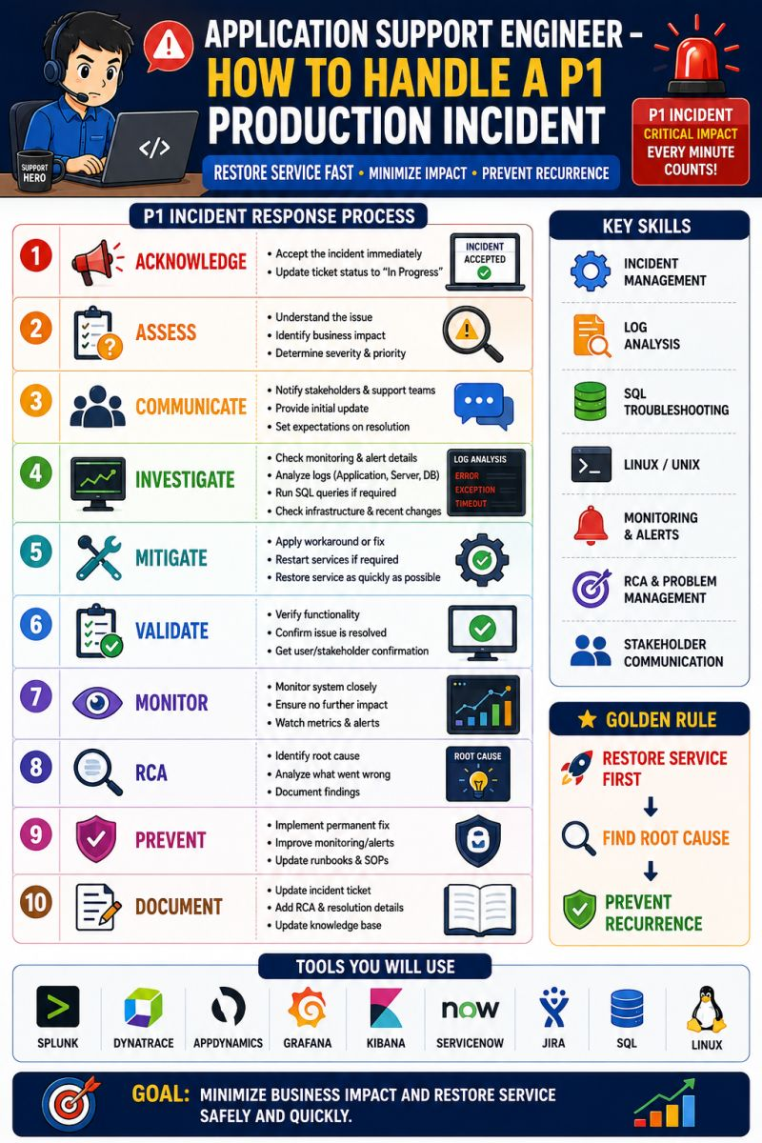
Application Support Engineer – Log Analysis Basics
Logs are the first place to look when an application issue occurs.
💡 Why Log Analysis Matters?
🔹 Identify application errors 🔹 Track failed transactions
🔹 Investigate performance issues 🔹 Find root causes faster
🔹 Monitor system behavior 🔹 Validate application fixes
🛠 Common Logs Checked Daily:
✅ Application Logs✅ Server Logs✅ Database Logs
✅ API Logs✅ Error Logs✅ Audit Logs
🔍 What Support Engineers Look For?
✔ ERROR messages ✔ Exceptions & Stack Traces ✔ Failed API Calls
✔ Timeout Errors ✔ Database Connection Issues ✔ Memory & CPU Warnings
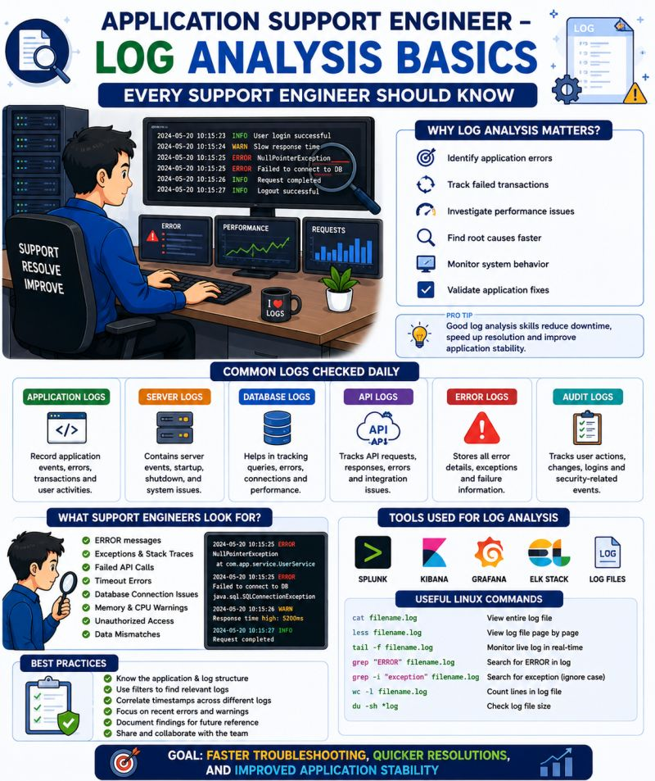
Application Support Engineer – Monitoring Tools
A good support engineer doesn't wait for users to report issues. They identify problems before business is impacted.
🔹 Monitor application health🔹 Track server performance
🔹 Detect slow transactions🔹 Analyze logs and errors
🔹 Monitor database performance🔹 Receive real-time alerts🔹 Reduce downtime
🛠 Popular Monitoring Tools:
✅ Splunk✅ Dynatrace✅ AppDynamics✅ Grafana✅ Kibana
✅ Prometheus✅ AWS CloudWatch✅ ELK Stack
💡 Monitoring + Troubleshooting = Faster Incident Resolution
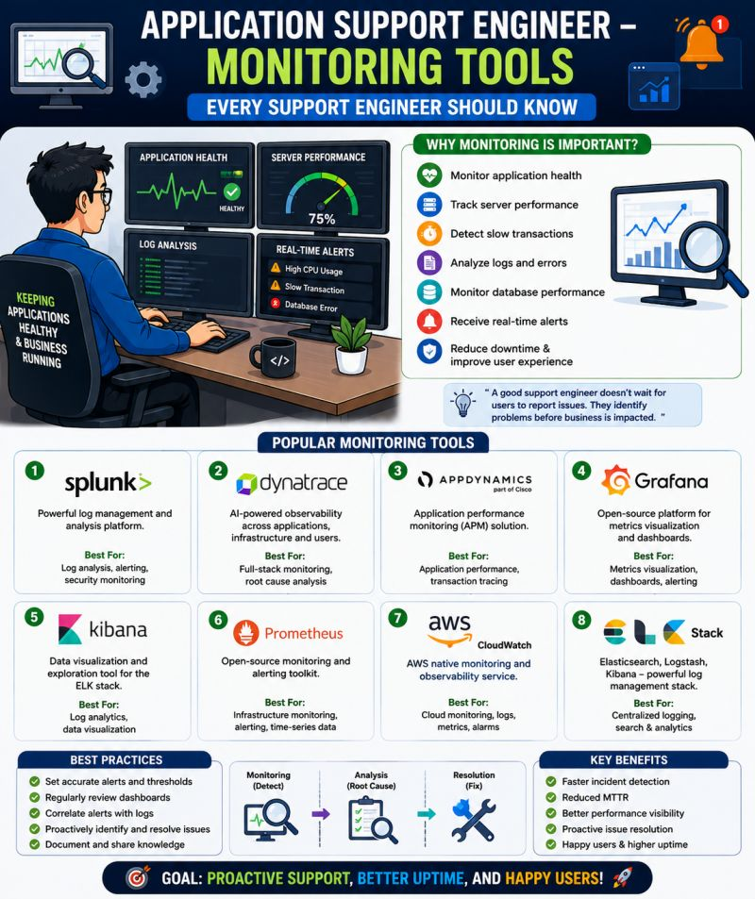
Application Support Engineer – Top 10 SQL Queries Used Daily
SQL is one of the most important skills for every Application Support Engineer.
🔹 Check application data 🔹 Validate transactions
🔹 Investigate production issues 🔹 Find failed records
🔹 Verify user activity 🔹 Generate support reports
🔹 Analyze database performance 🔹 Troubleshoot missing data
🔹 Monitor business processes 🔹 Support RCA activities
💡 Common Queries:
✅ SELECT ✅ WHERE ✅ ORDER BY ✅ GROUP BY ✅ INNER JOIN
✅ LEFT JOIN ✅ COUNT() ✅ SUM() ✅ UPDATE ✅ DELETE
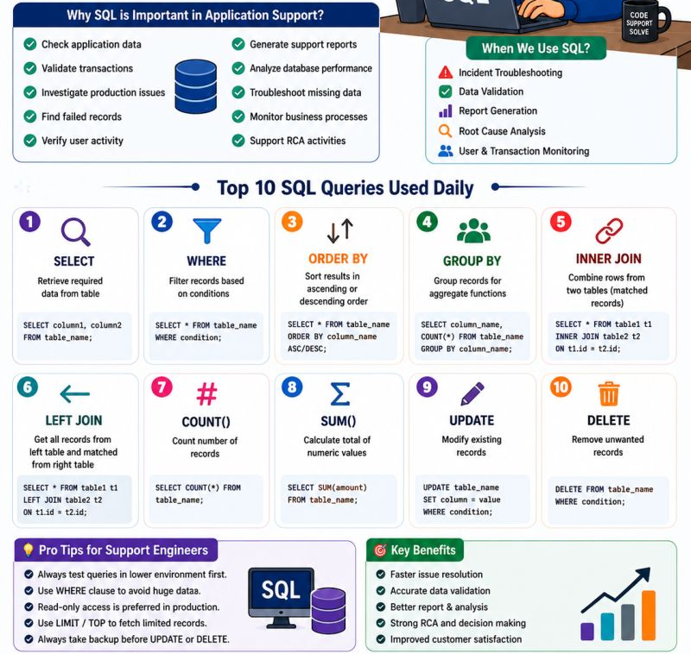
🚀 Application Support Engineer – Daily Routine 👨‍💻
Ever wondered what an Application Support Engineer does every day? 🤔
🔹 Monitor application health & alerts🔹 Review and prioritize support tickets
🔹 Investigate incidents using SQL & logs🔹 Perform root cause analysis (RCA)
🔹 Coordinate with Dev, DBA & Infra teams🔹 Resolve issues and validate fixes
🔹 Document solutions & update knowledge base🔹 Ensure smooth business operations with minimal downtime
💡 Key Skills:
✅ SQL✅ Linux/Unix✅ Incident Management✅ Troubleshooting
✅ Monitoring Tools (Splunk, Dynatrace, Grafana)✅ ServiceNow / Jira
