Microsoft Intune Compliance Policies
Screenshot-Based Zero-to-Advanced Master SOP
Design | Create | Notify | Remediate | Conditional Access | Custom Compliance | Monitor | Troubleshoot | Govern
Purpose
A complete operational guide to Microsoft Intune device compliance. It explains concepts, exact portal paths, Windows policy creation, actions for noncompliance, notification templates, tenant compliance settings, custom compliance scripts, monitoring, Conditional Access integration, BitLocker/security dependencies, troubleshooting, governance, and the screenshots supplied in Compliance Policies.docx.

Document field | Value
Owner | Endpoint Management / IT Operations
Platform | Microsoft Intune and Microsoft Entra ID
Worked example | Windows Compliance policy
Source screenshots | Compliance Policies.docx
Version | 1.0
Prepared date | 25 September 2026
Classification | Internal use

1. Compliance Fundamentals

1.1 What compliance does
A compliance policy evaluates whether an enrolled device meets defined requirements. Examples include minimum operating system version, encryption, firewall, antivirus, Secure Boot, TPM, password, and threat level. Compliance evaluates state; configuration profiles and security policies are used to apply settings.

1.2 Decision flow
- Intune assigns compliance policy.
- Device evaluates built-in and custom settings.
- Device reports results.
- Intune calculates overall compliance state.
- Actions for noncompliance run according to schedule.
- Conditional Access can use the compliant-device signal to allow or block access.

1.3 Status meanings
State | Meaning | Administrator action
Compliant | All applicable required settings passed | Continue monitoring
Noncompliant | At least one applicable requirement failed | Open per-setting details and remediate
In grace period | Device failed but scheduled action delay remains | Notify and remediate before deadline
Not evaluated | Policy has not evaluated or device lacks required conditions | Check enrollment, assignment, check-in, user, and licensing
Error | Evaluation/script/platform error | Review setting, custom script, logs, and platform support
Conflict | Competing policies define incompatible requirements | Identify overlapping policies
Key distinction
Compliance does not automatically configure BitLocker, antivirus, firewall, or password settings. Deploy configuration or endpoint security policies first, then use compliance to verify the resulting state.

2. Navigate to Device Compliance
Exact portal path
Microsoft Intune admin center > Devices > Compliance

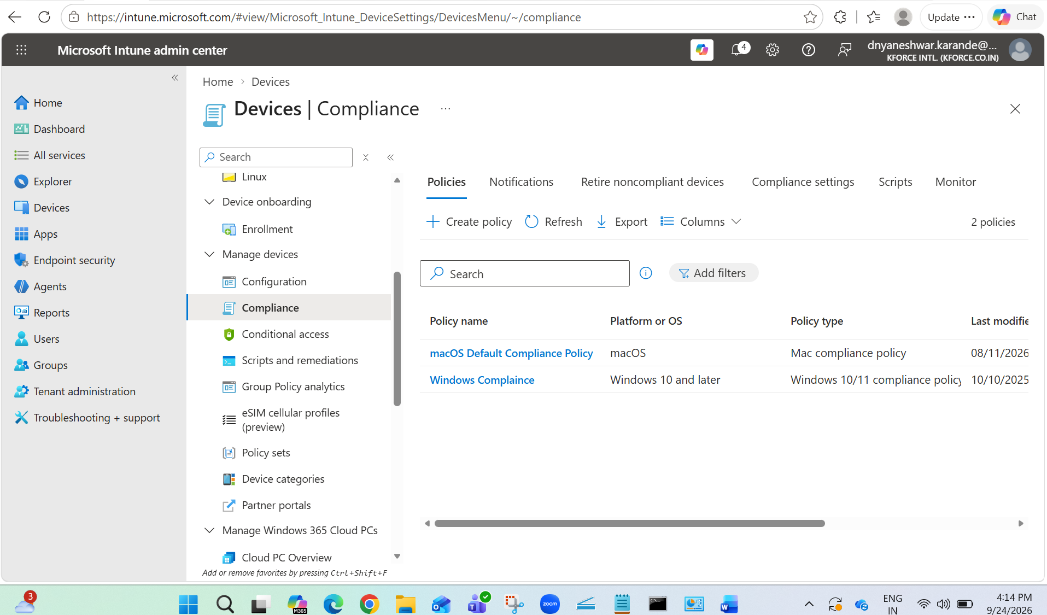
Figure 1. Devices > Compliance overview with Policies, Notifications, Retire noncompliant devices, Compliance settings, Scripts, and Monitor.
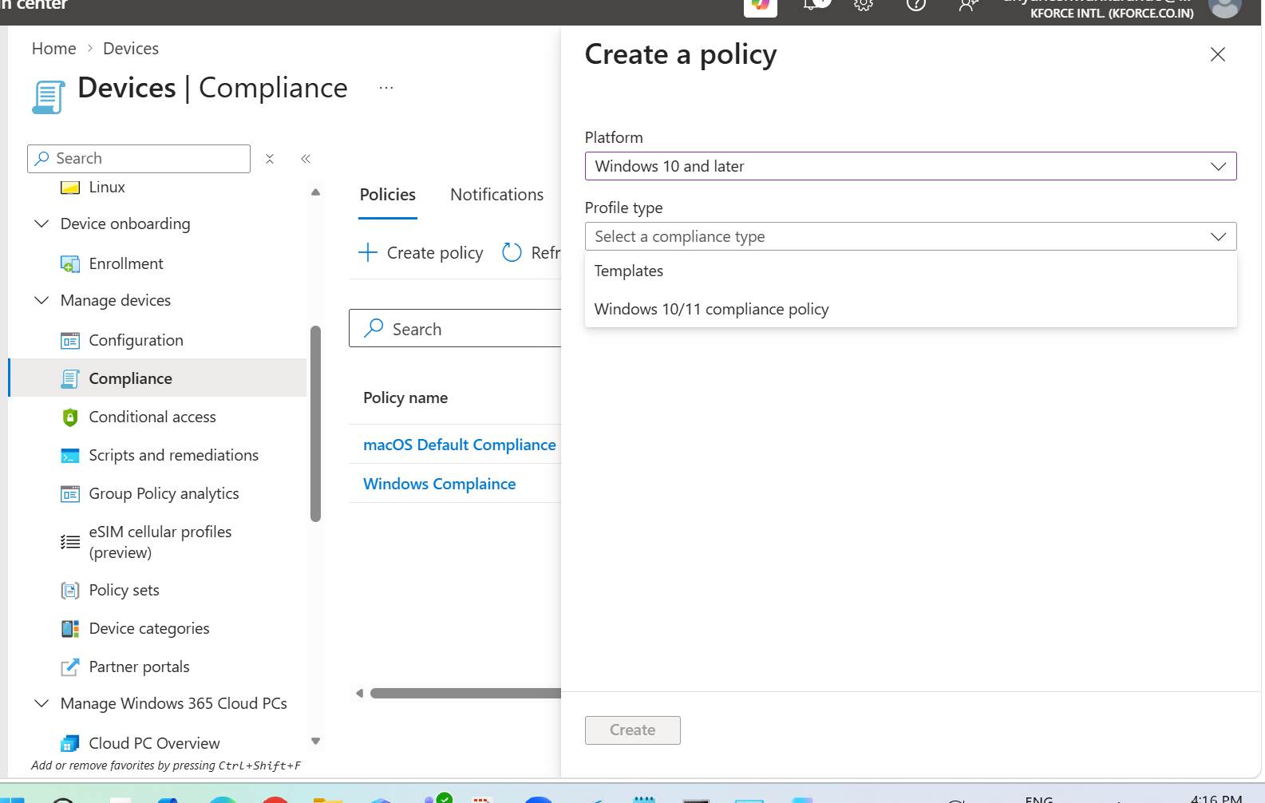
Figure 2. Device onboarding and compliance navigation context.

2.1 Prerequisites
- Active Intune subscription.
- Devices enrolled in Intune to report compliance.
- Target users/devices and groups identified.
- Microsoft Entra ID P1 or P2 when Conditional Access is used.
- Supported platform and enrollment method.
- Configuration/security policies ready to remediate the required state.

3. Create a Windows Compliance Policy
Exact portal path
Microsoft Intune admin center > Devices > Compliance > Policies > Create Policy

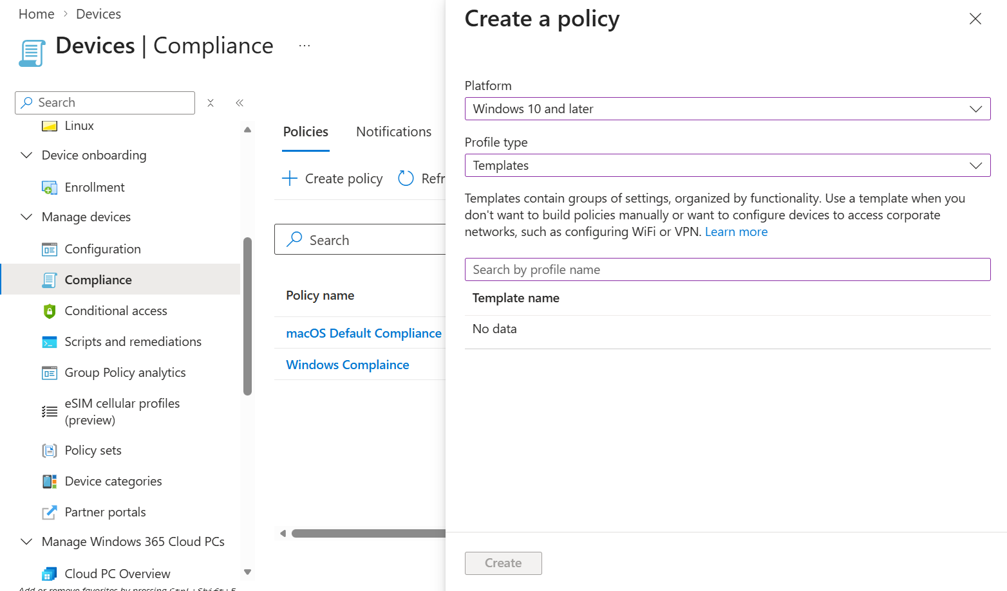
Figure 3. Compliance Policies list and Create Policy entry point.

3.1 Select platform
- Select Windows 10/11 as the platform.
- Select the available compliance policy profile.
- Select Create.
- On Basics, enter a unique Name and Description.
- Include owner, business purpose, target group, policy version, and change ticket.
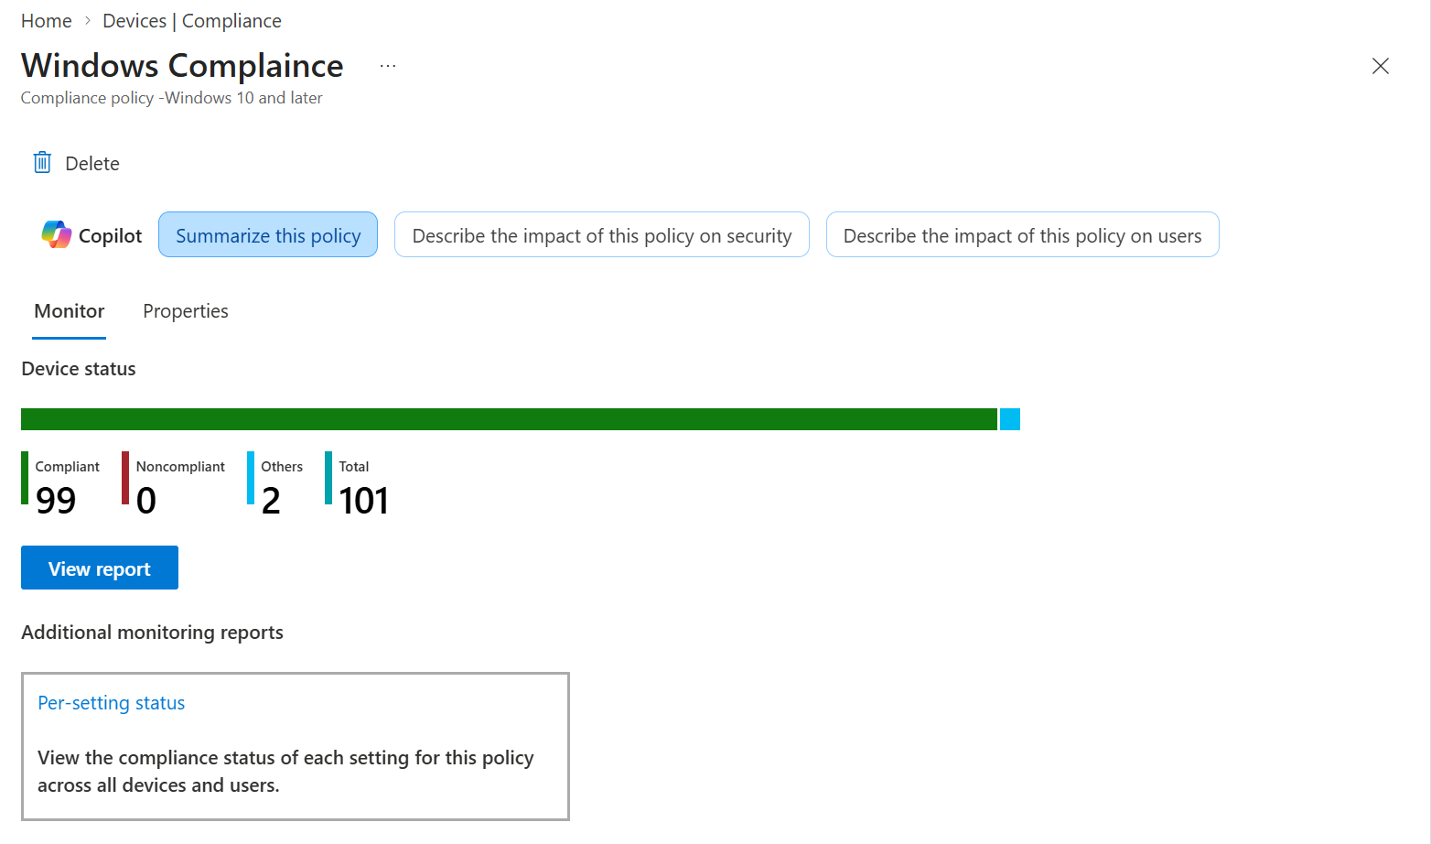
Figure 4. Windows Compliance policy overview and device/user status.
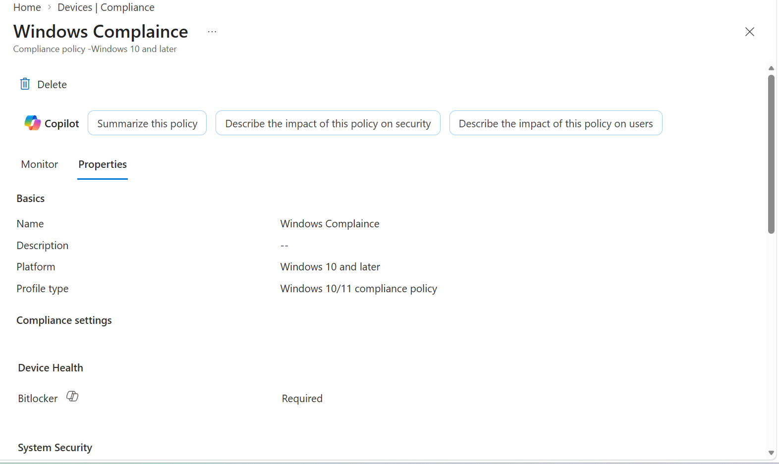
Figure 5. Policy properties and compliance settings summary.

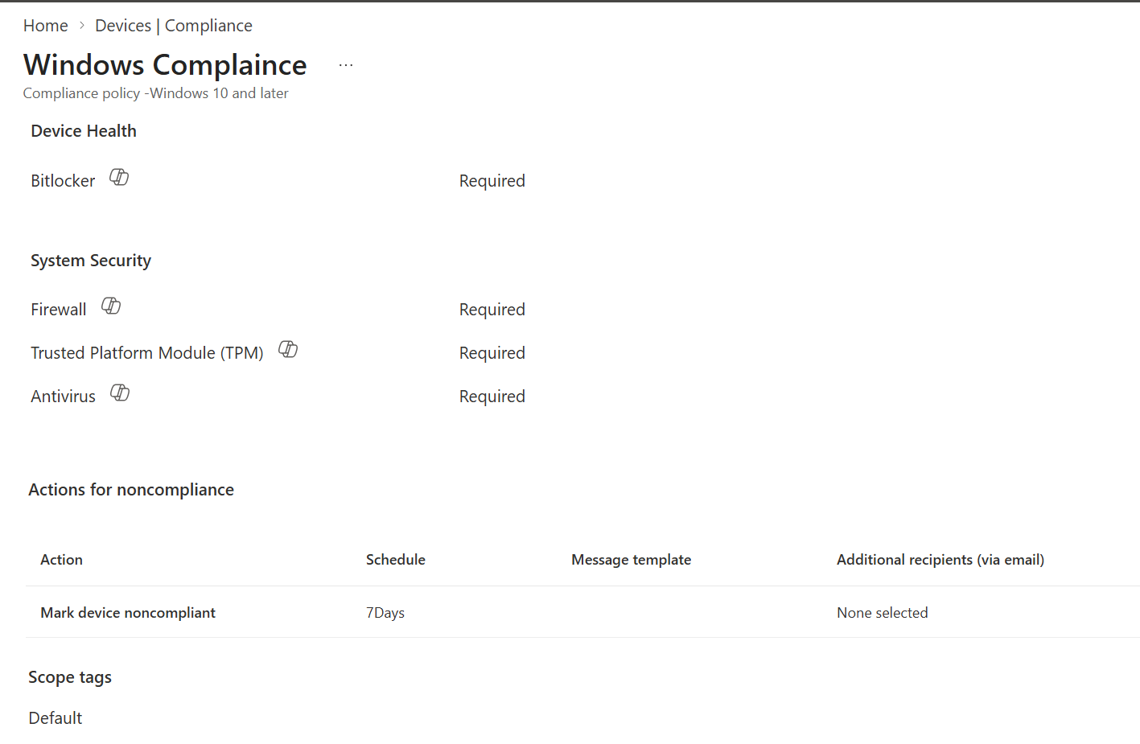
Figure 6. Device Health settings including BitLocker and security checks.

3.2 Recommended setting categories
Category | Examples | Design note
Device Health | BitLocker, Secure Boot, code integrity | Validate hardware/edition support
Device Properties | Minimum and maximum OS versions | Avoid sudden lockout during feature rollouts
Configuration Manager compliance | Co-management compliance signal | Use only in supported co-managed design
System Security | Firewall, TPM, antivirus, antispyware | Ensure remediation policy exists
Microsoft Defender for Endpoint | Machine risk score | Requires MDE integration and licensing
Windows Hello / password | Password and simple password requirements where applicable | Modern authentication design may reduce password-policy relevance

3.3 Actions for noncompliance
- Keep the default Mark device noncompliant action.
- Set schedule based on risk and rollout plan.
- Add Send email to end user after creating the notification template.
- Add remotely lock or retire actions only where supported and formally approved.
- Use a grace period for production rollout when users need time to remediate.

3.4 Assignments
- Apply Scope tags if RBAC requires them.
- Assign first to a small pilot user/device group.
- Use exclusions for emergency access or documented technical exceptions.
- Review and Create.
- Monitor policy evaluation before connecting enforcement.
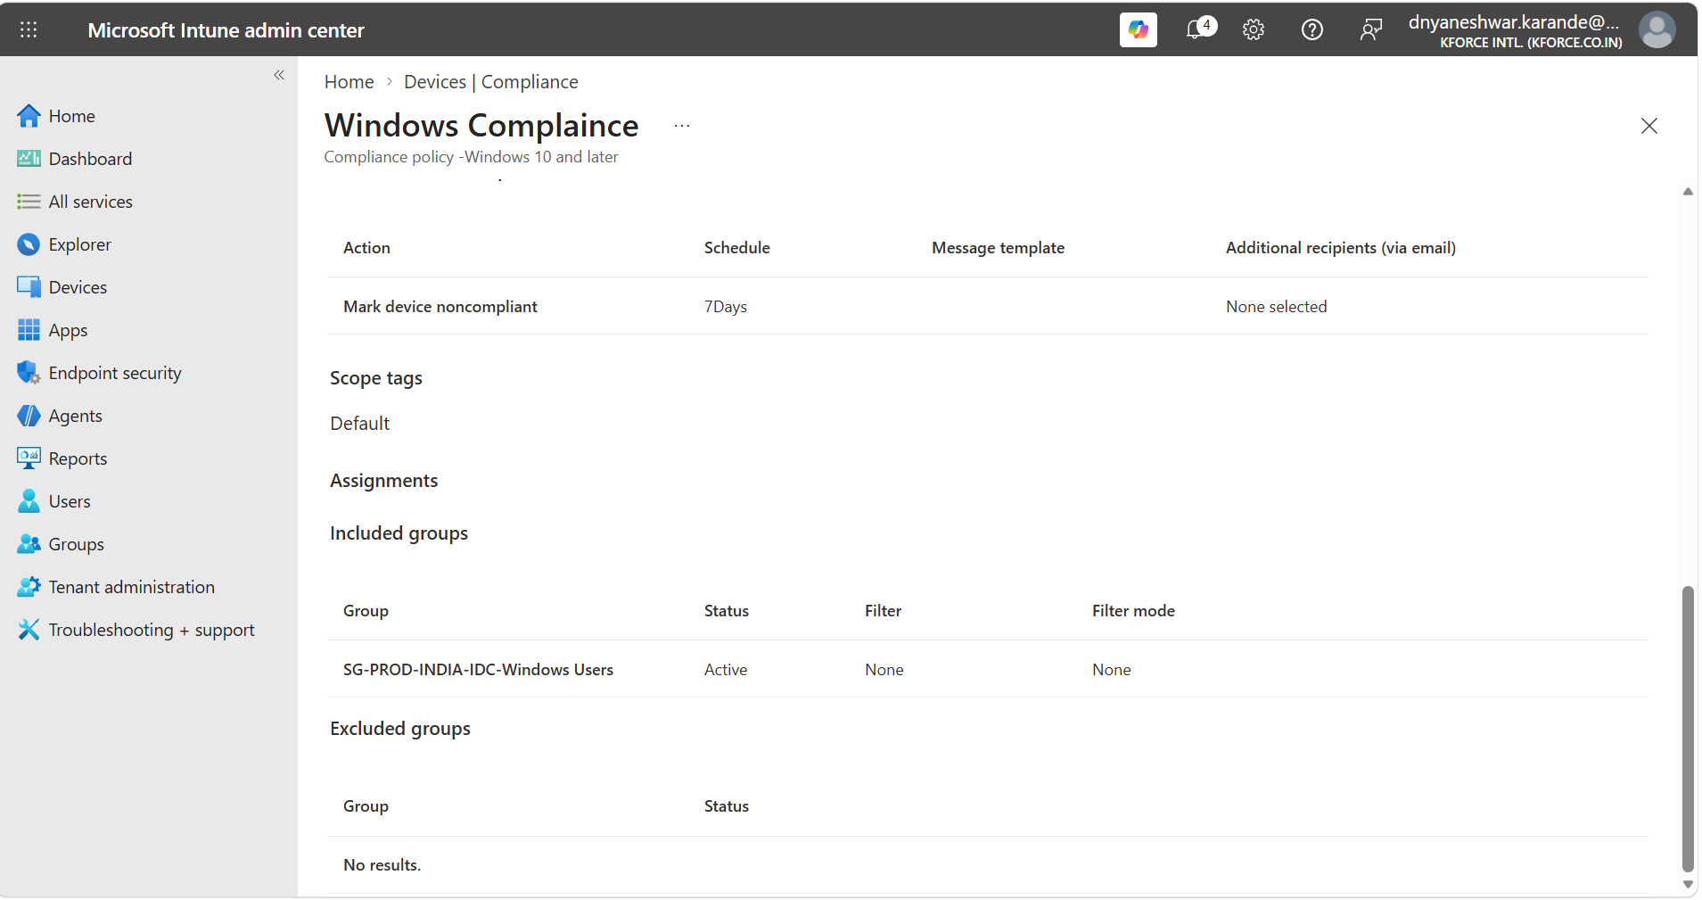
Figure 7. Device policy status and compliance reporting navigation.

4. Create Noncompliance Notification Template
Exact portal path
Microsoft Intune admin center > Devices > Compliance > Notifications > Create Notification

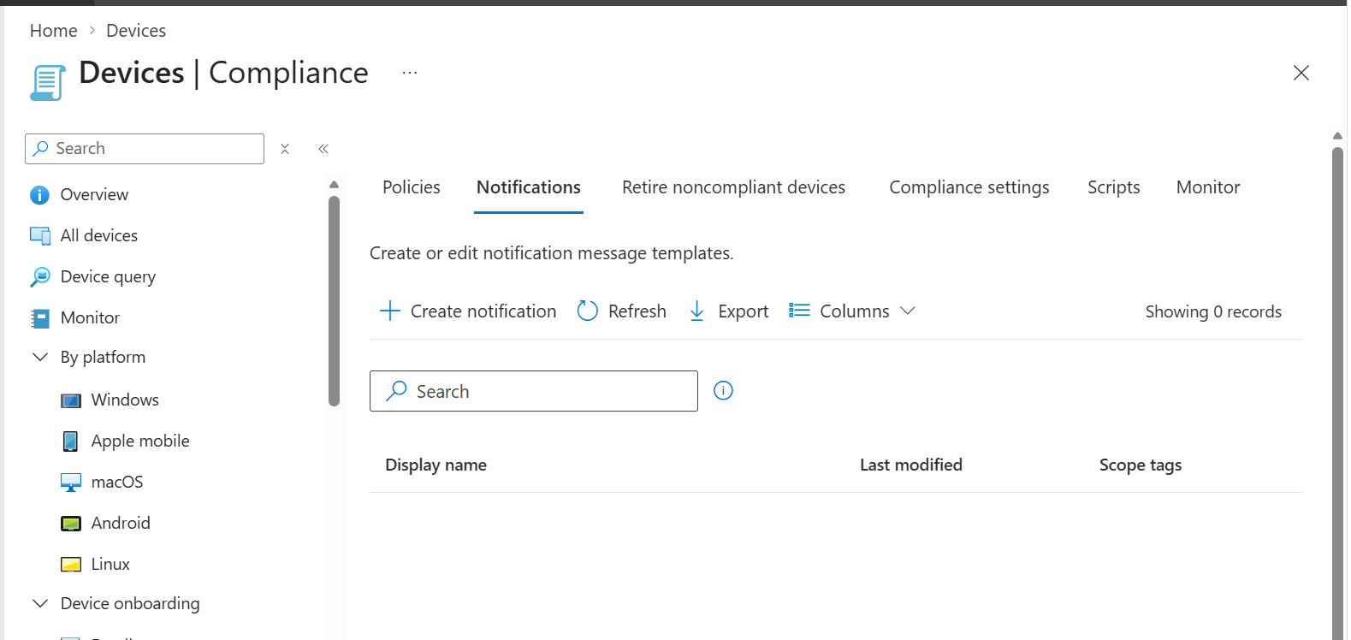
Figure 8. Notifications list and Create notification entry point.
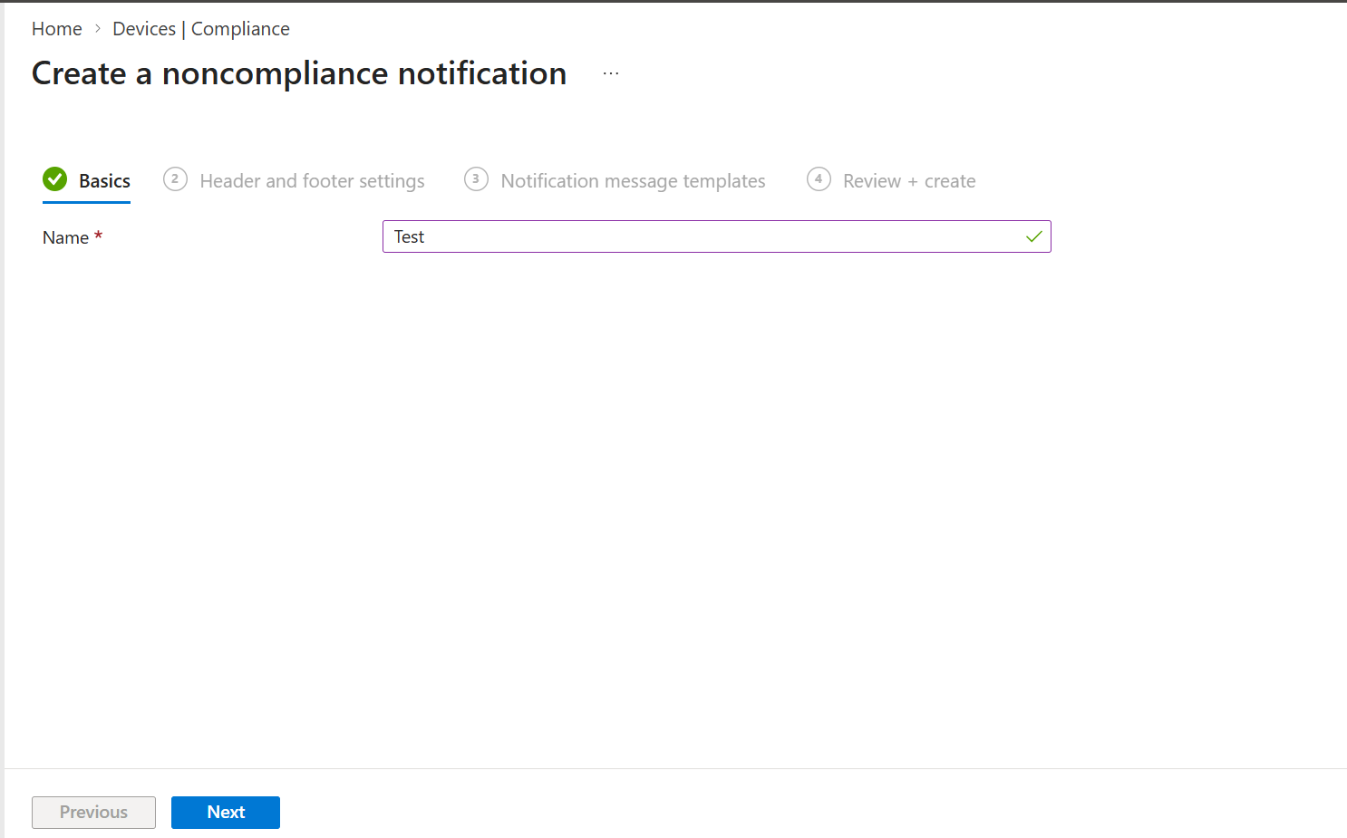
Figure 9. Notification Basics with template name.
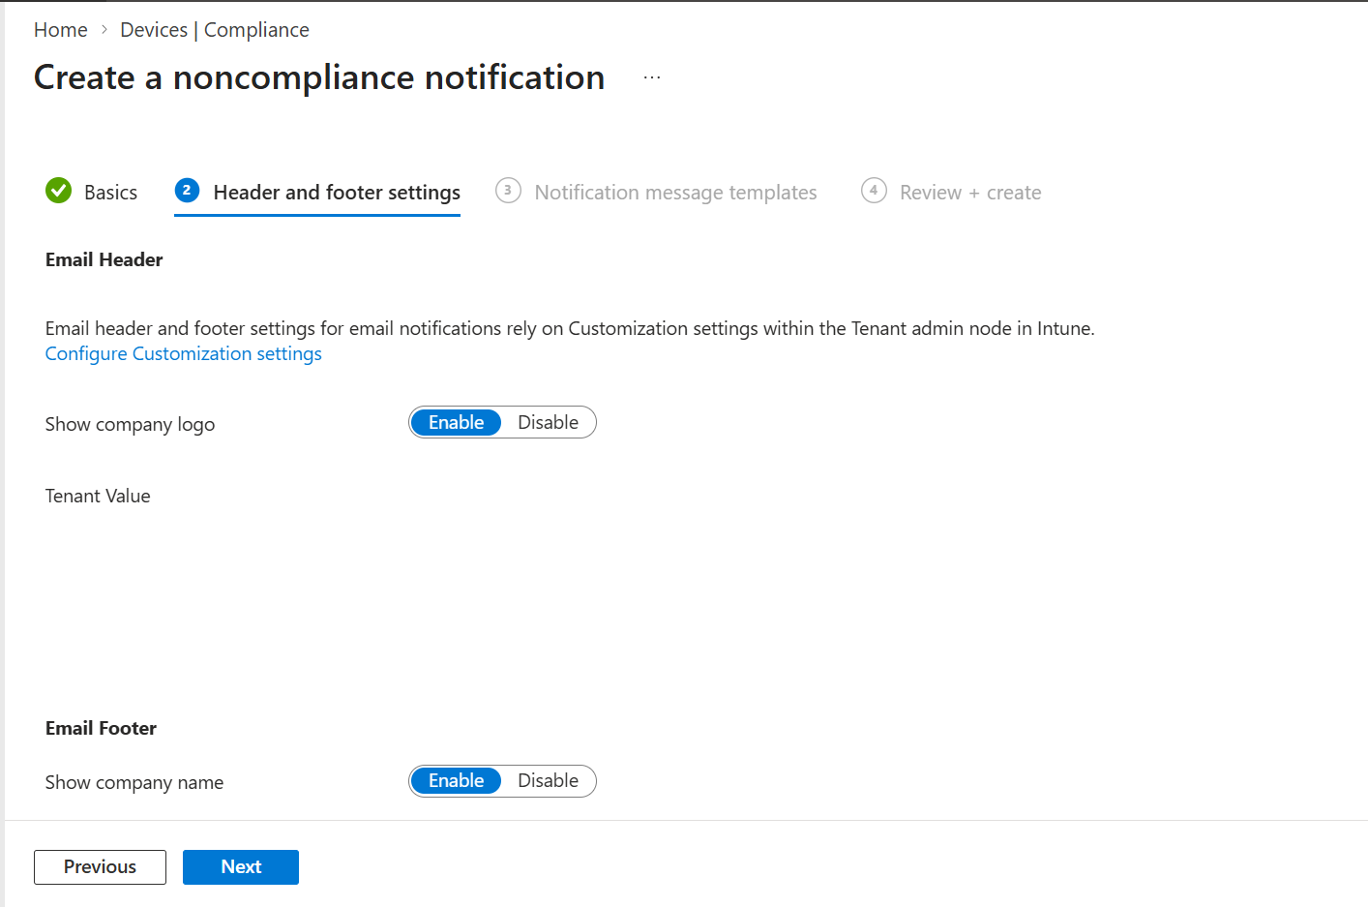
Figure 10. Email header settings and tenant customization dependency.
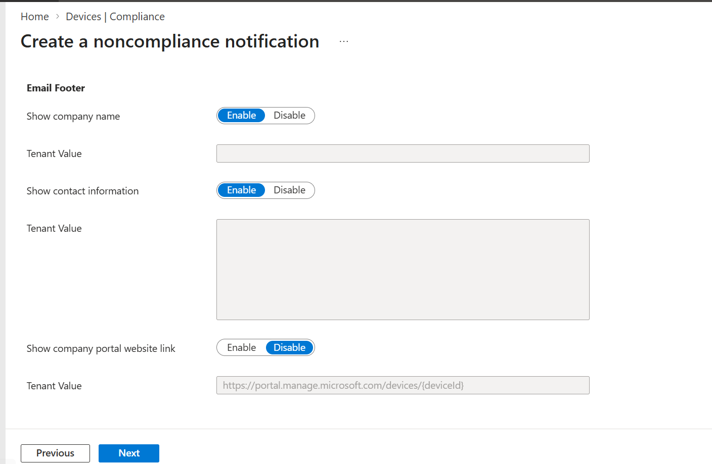
Figure 11. Email footer settings, company name, contact information, and portal link.

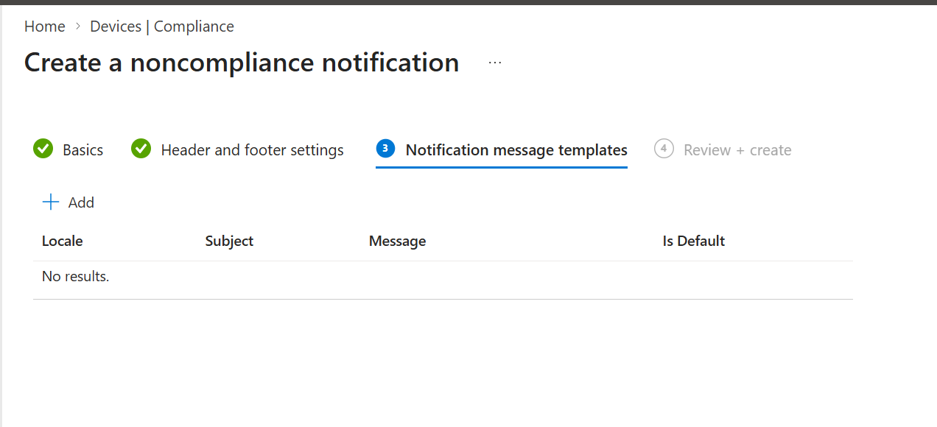
Figure 12. Notification message templates page with locale, subject, message, and default option.
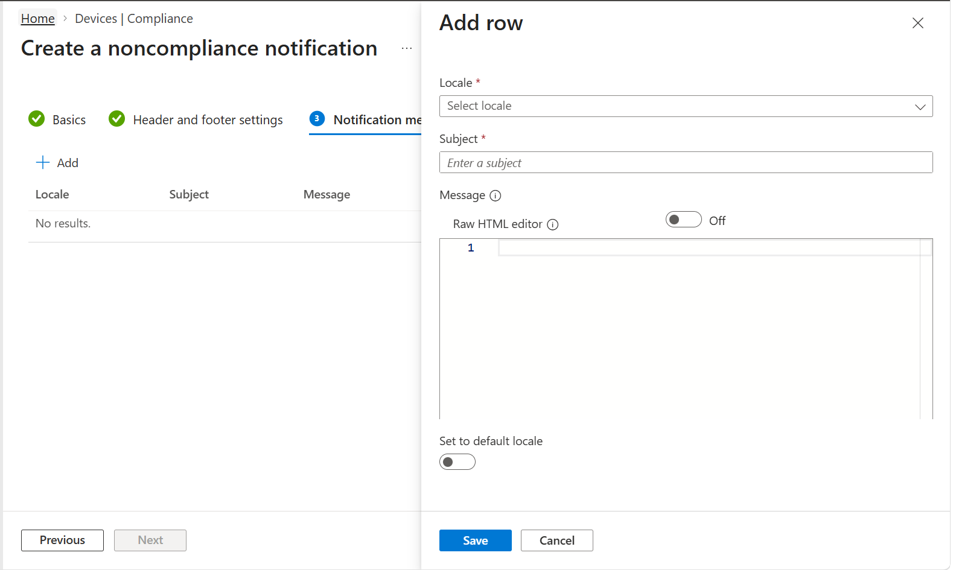
Figure 13. Add localized notification message.

4.1 Notification process
- Enter a unique notification name.
- Configure header and footer behavior.
- Add at least one locale.
- Enter a clear subject and message.
- Explain why the device is noncompliant, what the user should do, the deadline, and support contact.
- Set the default locale.
- Review and Create.
- Return to the compliance policy actions and select this template for Send email to end user.

4.2 Communication standard
Element | Recommended content
Subject | Action required: Device does not meet security requirements
Reason | Use Intune noncompliance details; do not guess
User action | Sync device, connect to internet, enable required security, restart, or contact support
Deadline | Use policy grace deadline
Support | Service desk channel and ticket information
Security | Never request password or sensitive authentication data

5. Review Existing Policy, Tenant Settings, and Retire Rules
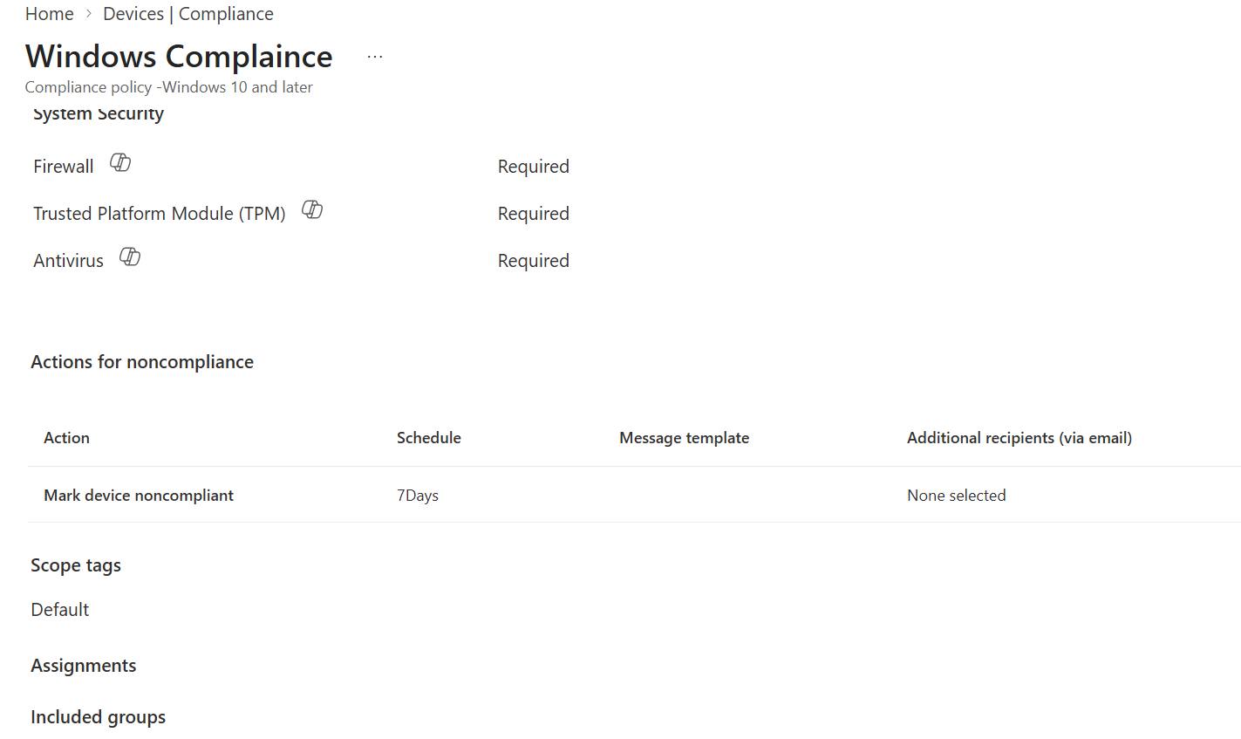
Figure 14. Windows Compliance System Security settings including Firewall and TPM.
Exact portal path
Microsoft Intune admin center > Devices > Compliance > Compliance settings

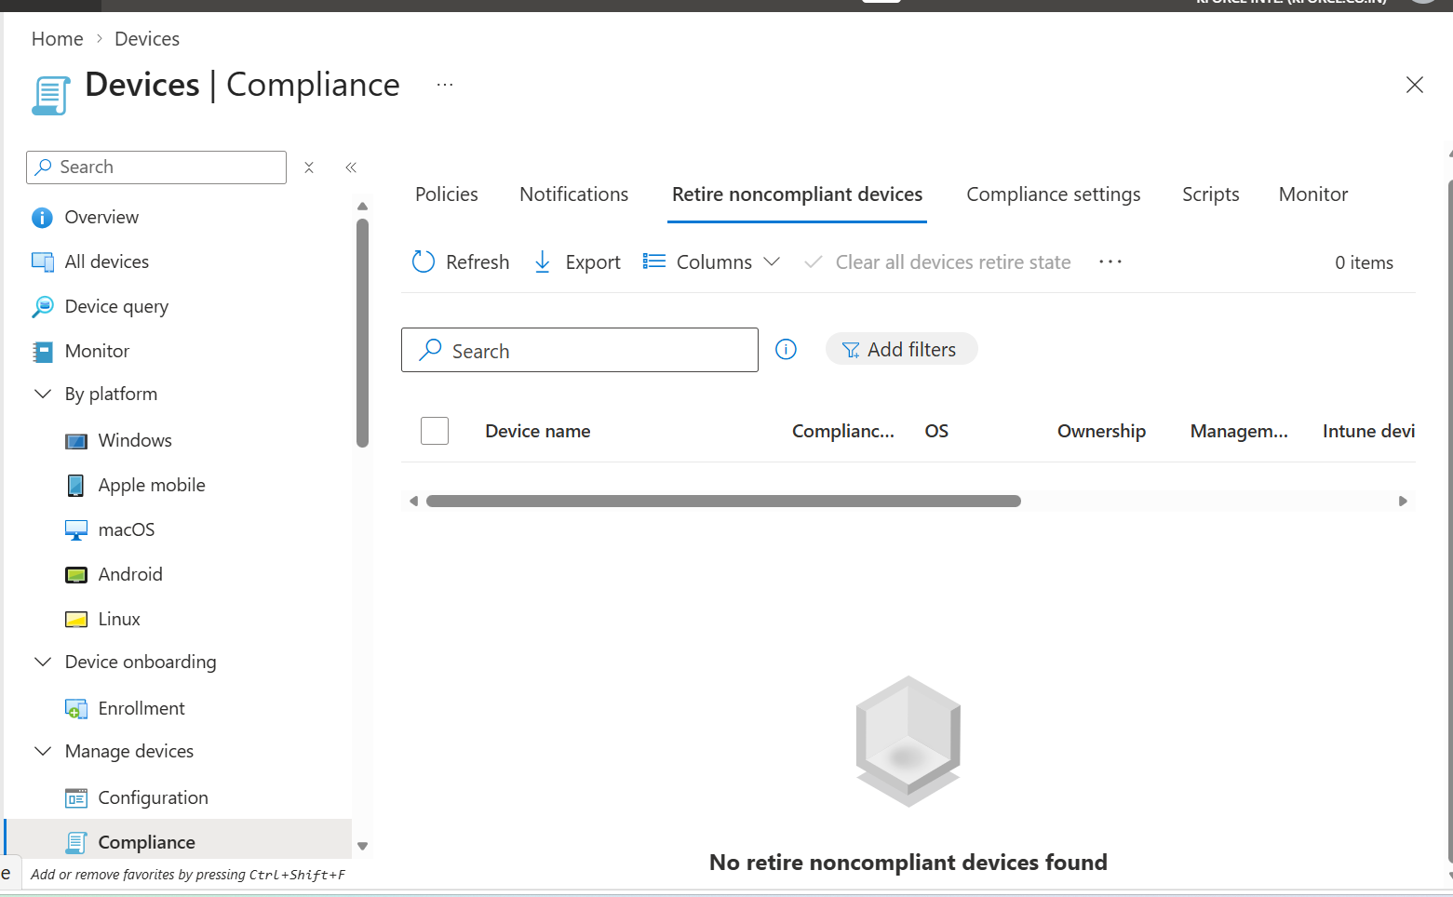
Figure 15. Compliance settings area.
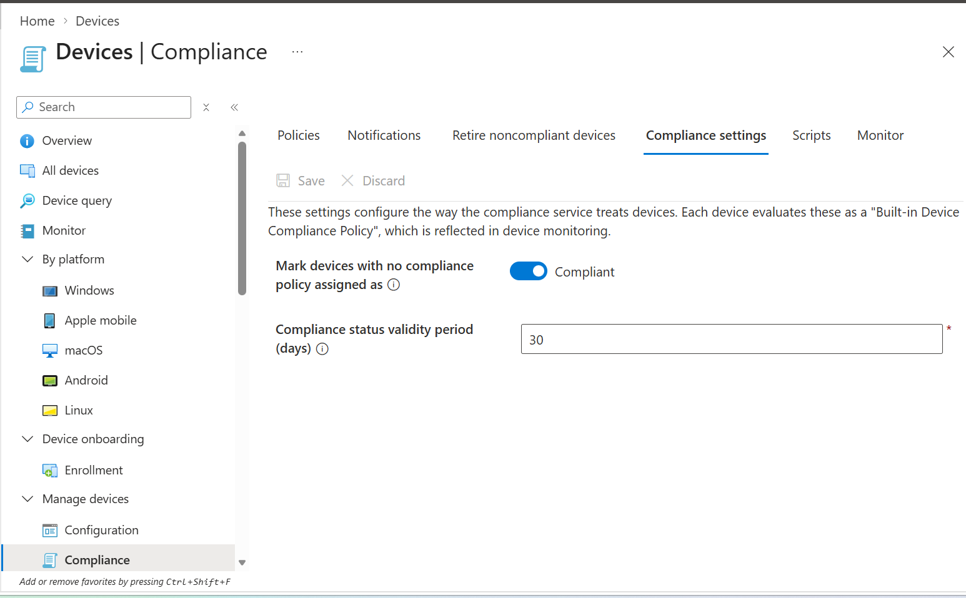
Figure 16. Compliance settings configuration and device query view.

5.1 Mark devices with no policy assigned
- Review this tenant-wide compliance setting.
- During production enforcement, consider marking devices without a compliance policy as noncompliant after validating assignment coverage.
- Before changing, report devices without policies and correct gaps.
- Use change control because this can affect Conditional Access.

5.2 Enhanced jailbreak/root and validity settings
- Review each platform-specific tenant setting.
- Apply only after confirming platform support and operational impact.
- Document owner and rationale.
Exact portal path
Microsoft Intune admin center > Devices > Compliance > Retire noncompliant devices

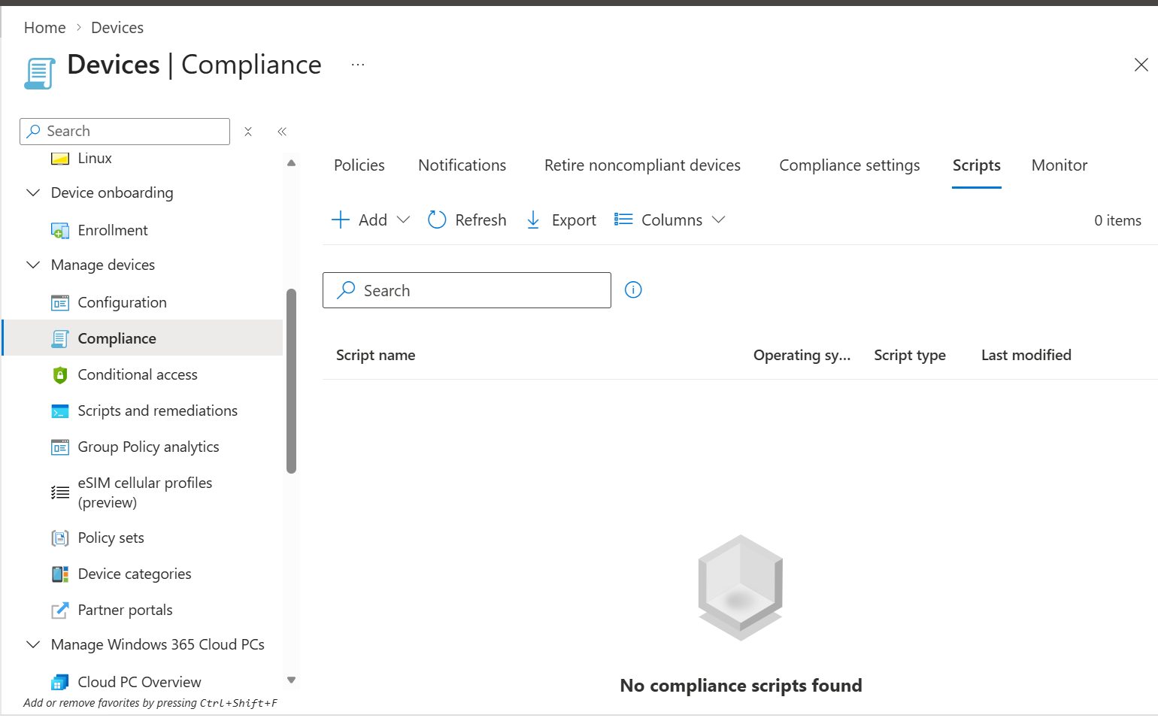
Figure 17. Retire noncompliant devices workflow.
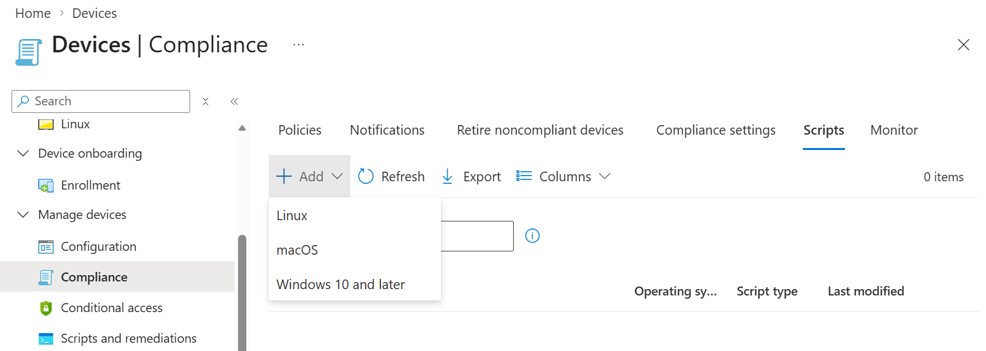
Figure 18. Retire noncompliant devices configuration reference.
High-impact action
Automatic retirement can remove organizational access and data. Use only after legal, security, HR, service desk, device ownership, and user communication requirements are approved.

6. Custom Compliance: PowerShell Discovery and JSON Rules
Exact portal path
Microsoft Intune admin center > Devices > Compliance > Scripts > Create

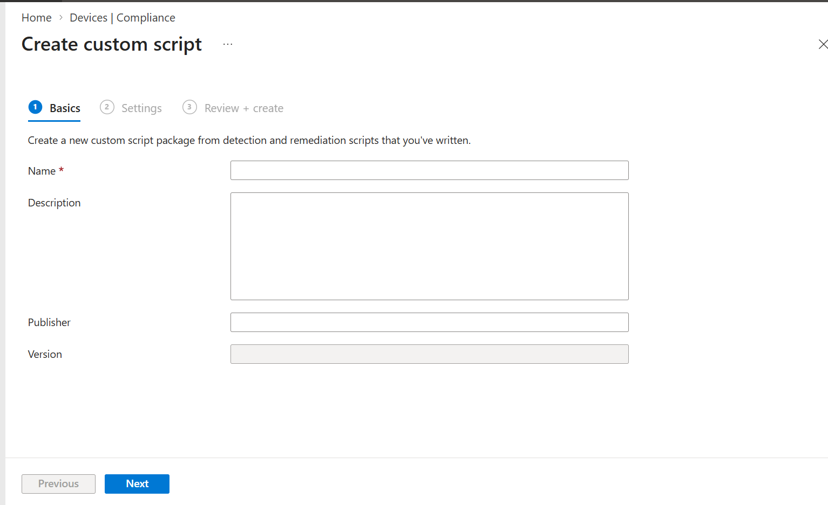
Figure 19. Create custom script Basics page.
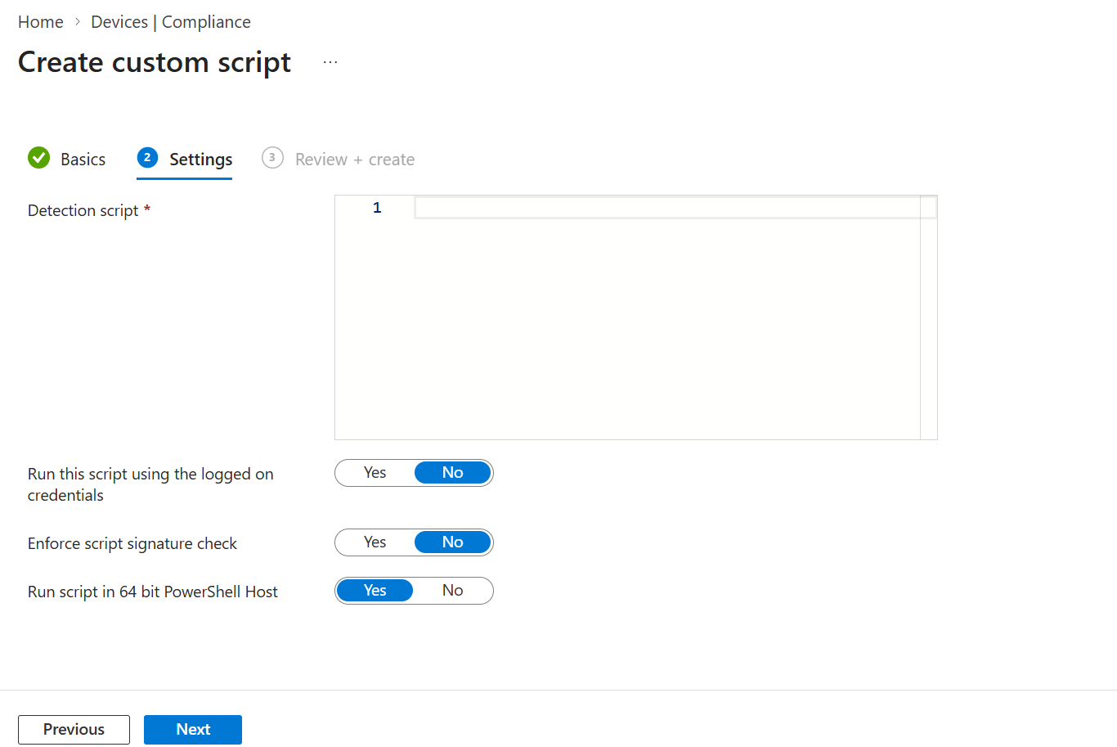
Figure 20. Upload detection script and configure execution settings.

6.1 How custom compliance works
- A PowerShell discovery script runs on Windows.
- The script outputs discovered settings as compressed JSON.
- A JSON rules file defines expected values, operators, data types, and user remediation messages.
- Intune compares discovery output with rules.
- Custom and built-in settings contribute to the final device compliance state.

6.2 Example discovery script
$result = @{
BitLockerProtected = ((Get-BitLockerVolume -MountPoint $env:SystemDrive).ProtectionStatus -eq "On")
FirewallEnabled = ((Get-NetFirewallProfile | Where-Object {$_.Enabled -eq $false}).Count -eq 0)
}
return $result | ConvertTo-Json -Compress

6.3 Safe deployment
- Test PowerShell locally as SYSTEM where applicable.
- Return valid compressed JSON only.
- Use matching SettingName values in the JSON rules file.
- Provide accurate remediation strings.
- Upload the script before building the custom settings category in the policy.
- Pilot without Conditional Access enforcement.
- Monitor Error and Not evaluated states.
Current Microsoft model
Microsoft documentation states that Windows custom compliance uses a PowerShell discovery script and a JSON definition file; each compliance policy supports one script that can discover multiple settings.

7. Monitor Compliance and Investigate Devices
Exact portal path
Microsoft Intune admin center > Devices > Compliance > Monitor

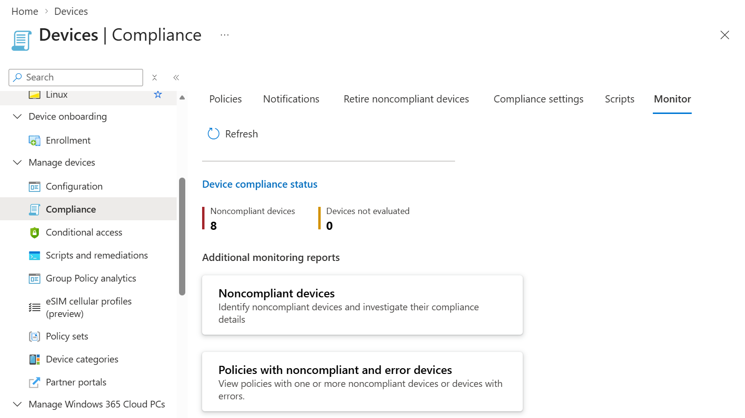
Figure 21. Compliance Monitor dashboard with compliant/noncompliant devices, Conditional Access, scripts, and reports.
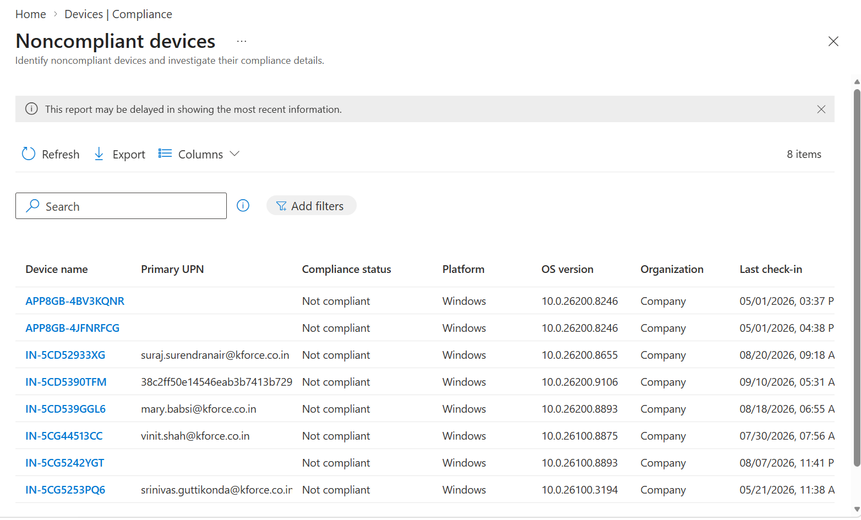
Figure 22. Noncompliant devices report.
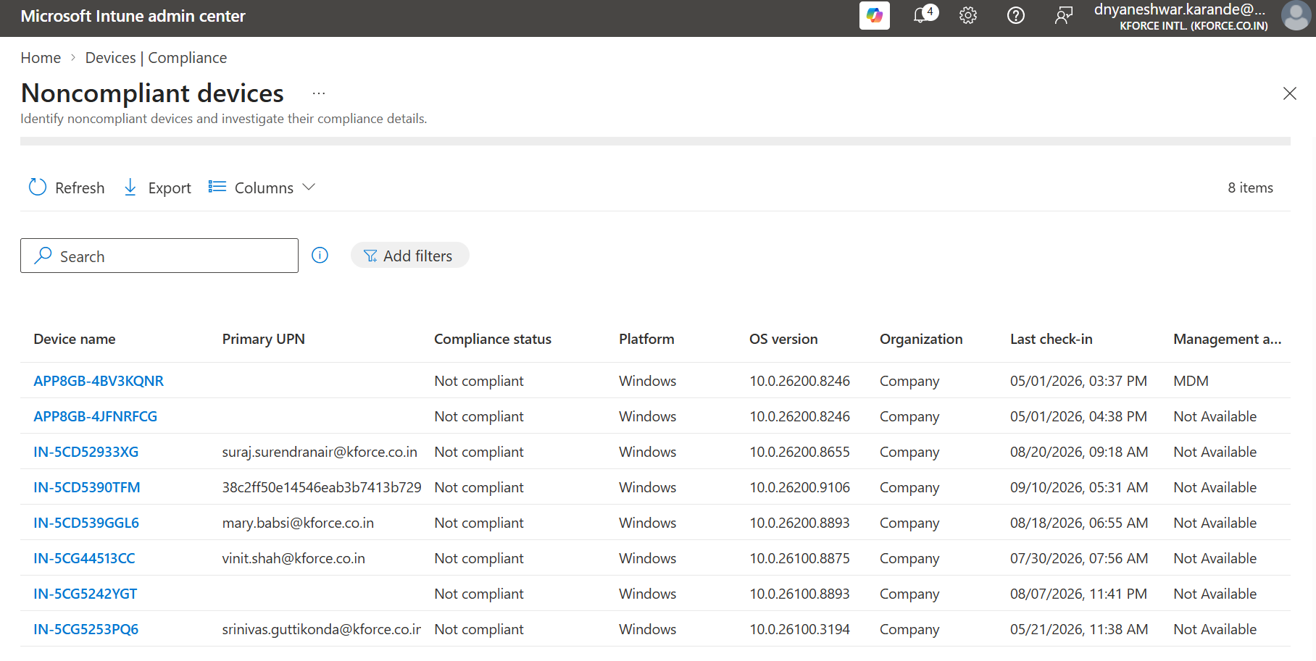
Figure 23. Noncompliant devices list with primary UPN, platform, OS version, and last check-in.
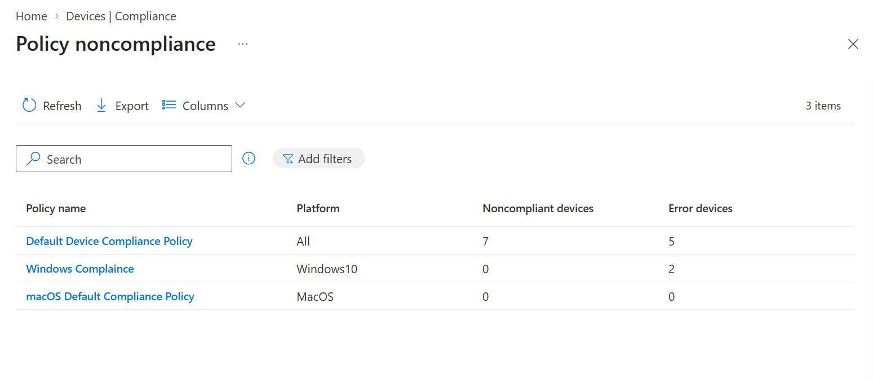
Figure 24. Policy noncompliance report showing policies and affected/error devices.

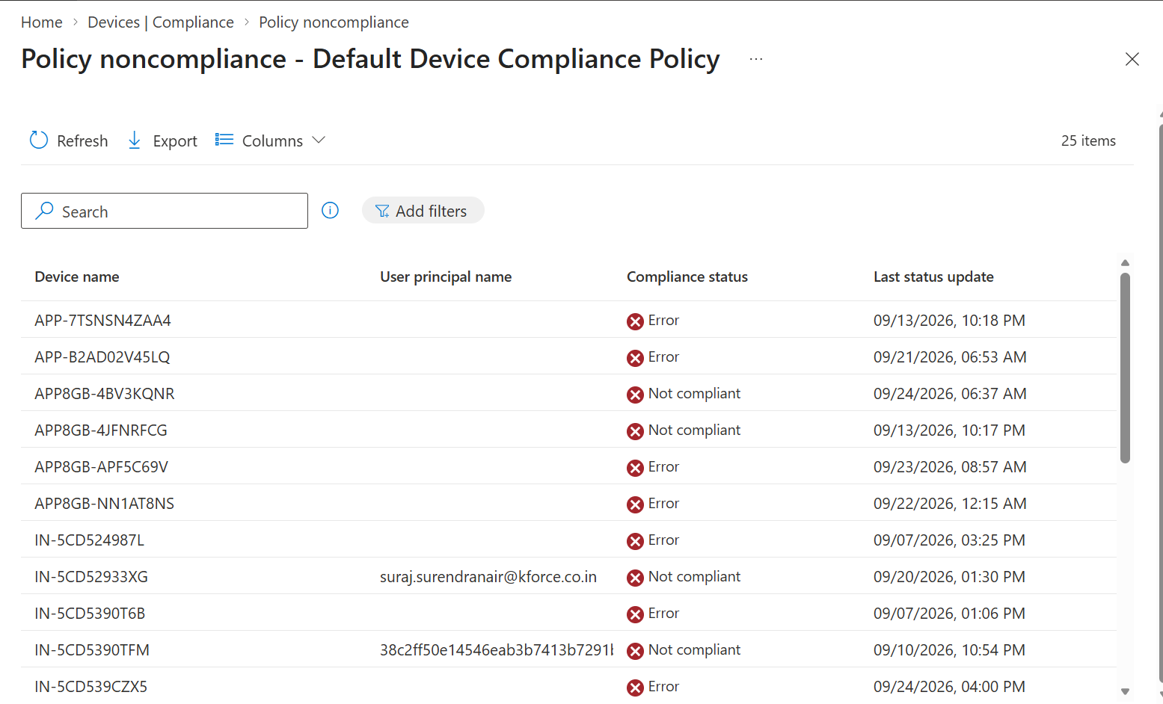
Figure 25. Default Device Compliance Policy status details.
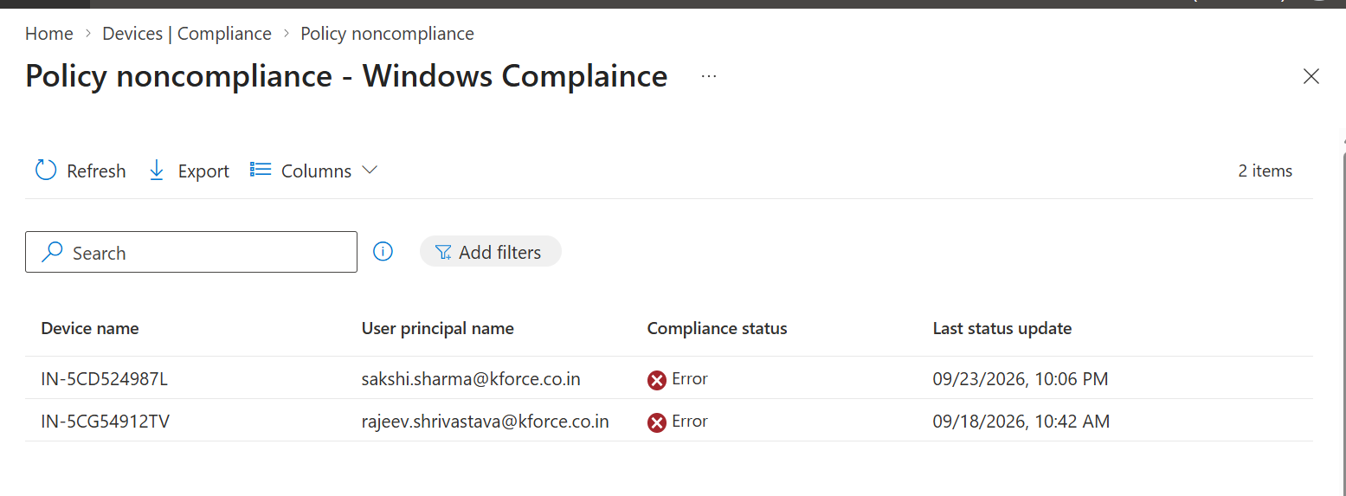
Figure 26. Windows Compliance policy noncompliant device list.
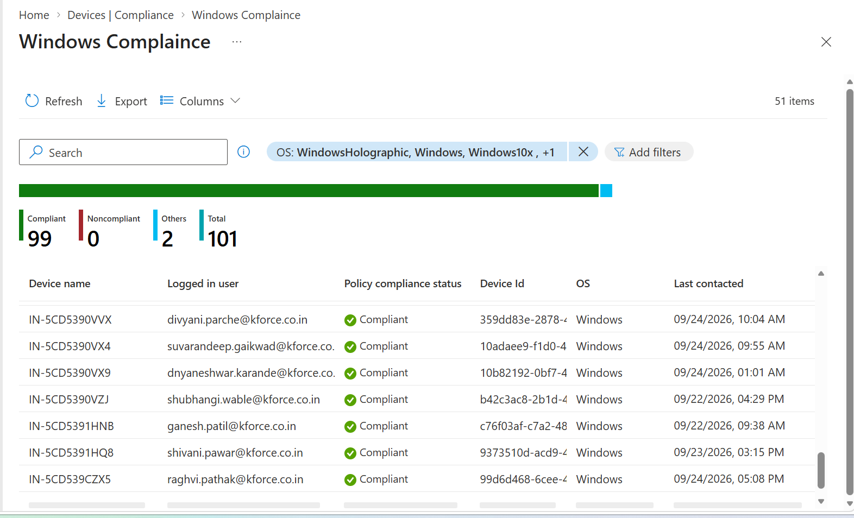
Figure 27. Policy compliance status chart.
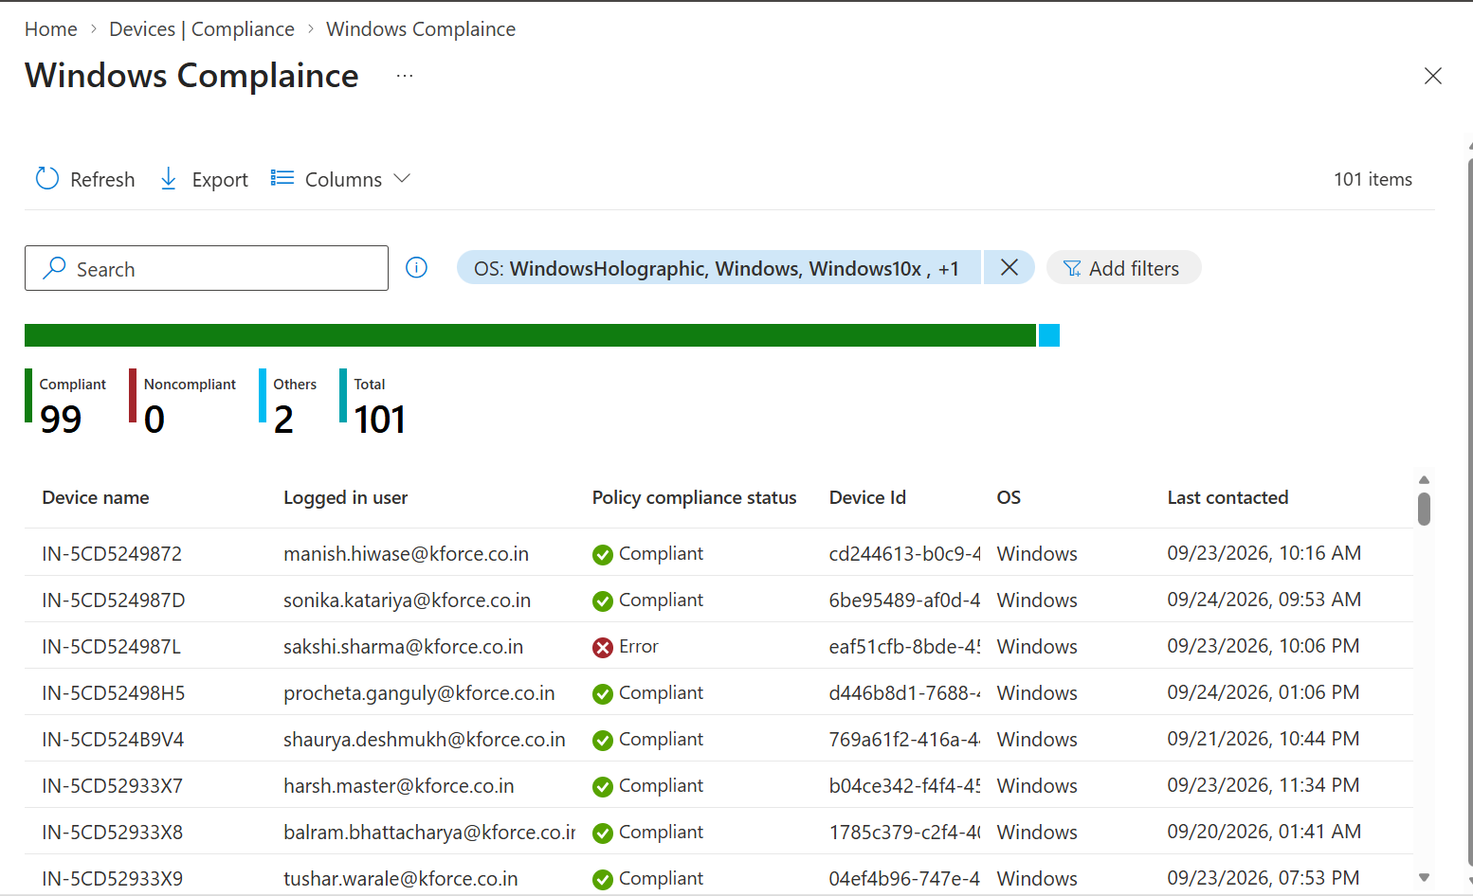
Figure 28. Policy compliance status and per-setting monitoring.

7.1 Investigation order
- Confirm last check-in.
- Confirm the expected policy assignment.
- Open device compliance status.
- Open policy and per-setting status.
- Identify exact failed setting.
- Confirm a remediation policy exists and applied.
- Sync device and re-evaluate.
- Check Conditional Access sign-in impact.
- Document root cause, remediation, and final state.

8. Device-Level Compliance Investigation
Exact portal path
Microsoft Intune admin center > Devices > All devices > select device

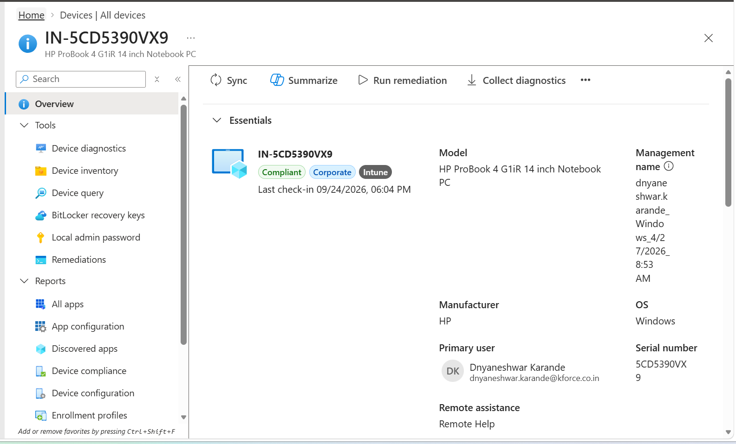
Figure 29. All devices list with compliance status.
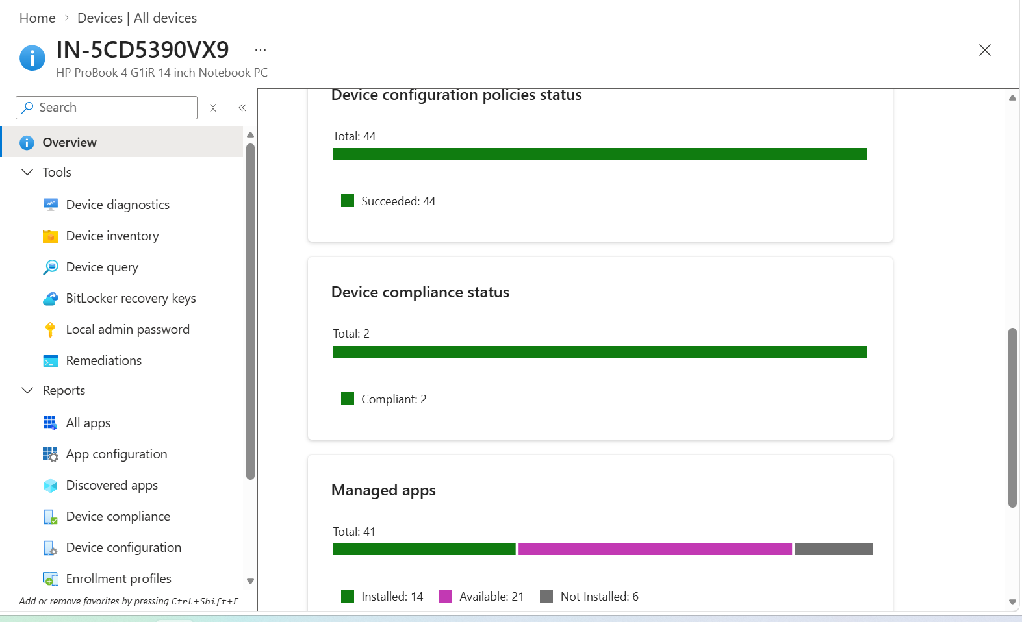
Figure 30. Device compliance status across enrolled devices.
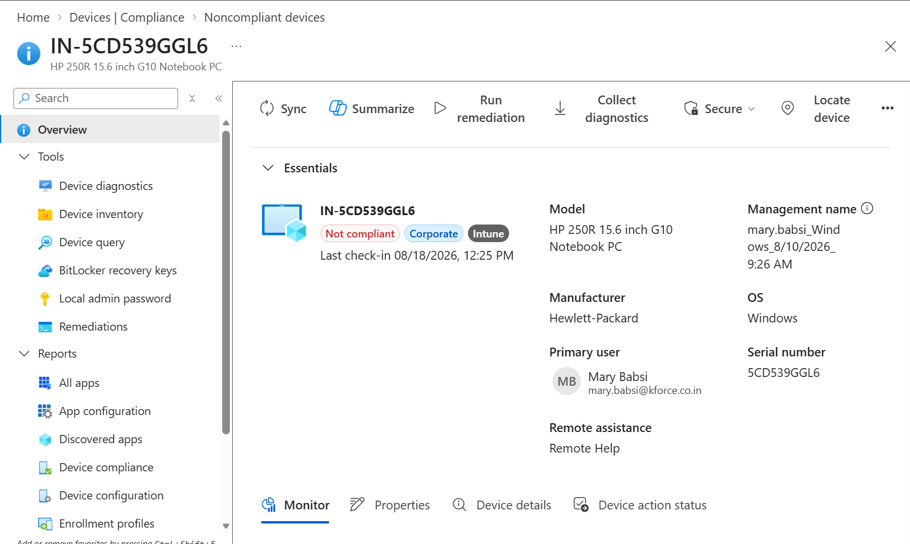
Figure 31. Noncompliant device overview and monitor navigation.
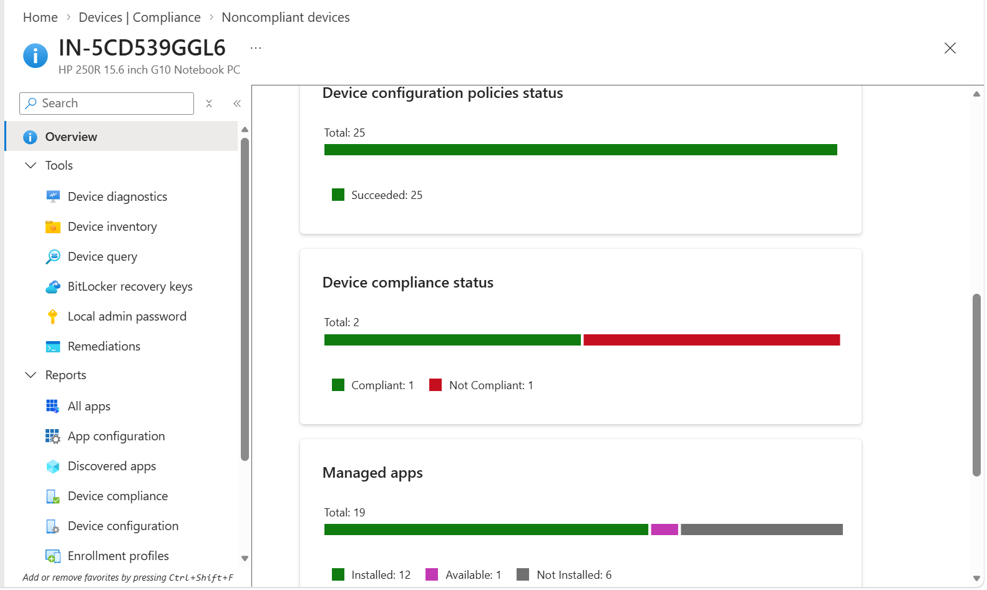
Figure 32. Noncompliant device properties, OS, ownership, primary user, and last check-in.

8.1 Device validation checklist
Check | Expected evidence
Identity | Correct device ID, serial, user, tenant
Management | Intune managed and recent check-in
Ownership | Corporate or expected personal ownership
Policy | Correct compliance policy assigned
Setting | Exact failed requirement identified
Remediation | Configuration/security policy assigned and successful
Conditional Access | Sign-in logs show intended result
Resolution | Device re-evaluates as compliant

9. Conditional Access Integration
Exact portal path
Microsoft Entra admin center > Protection > Conditional Access > Policies

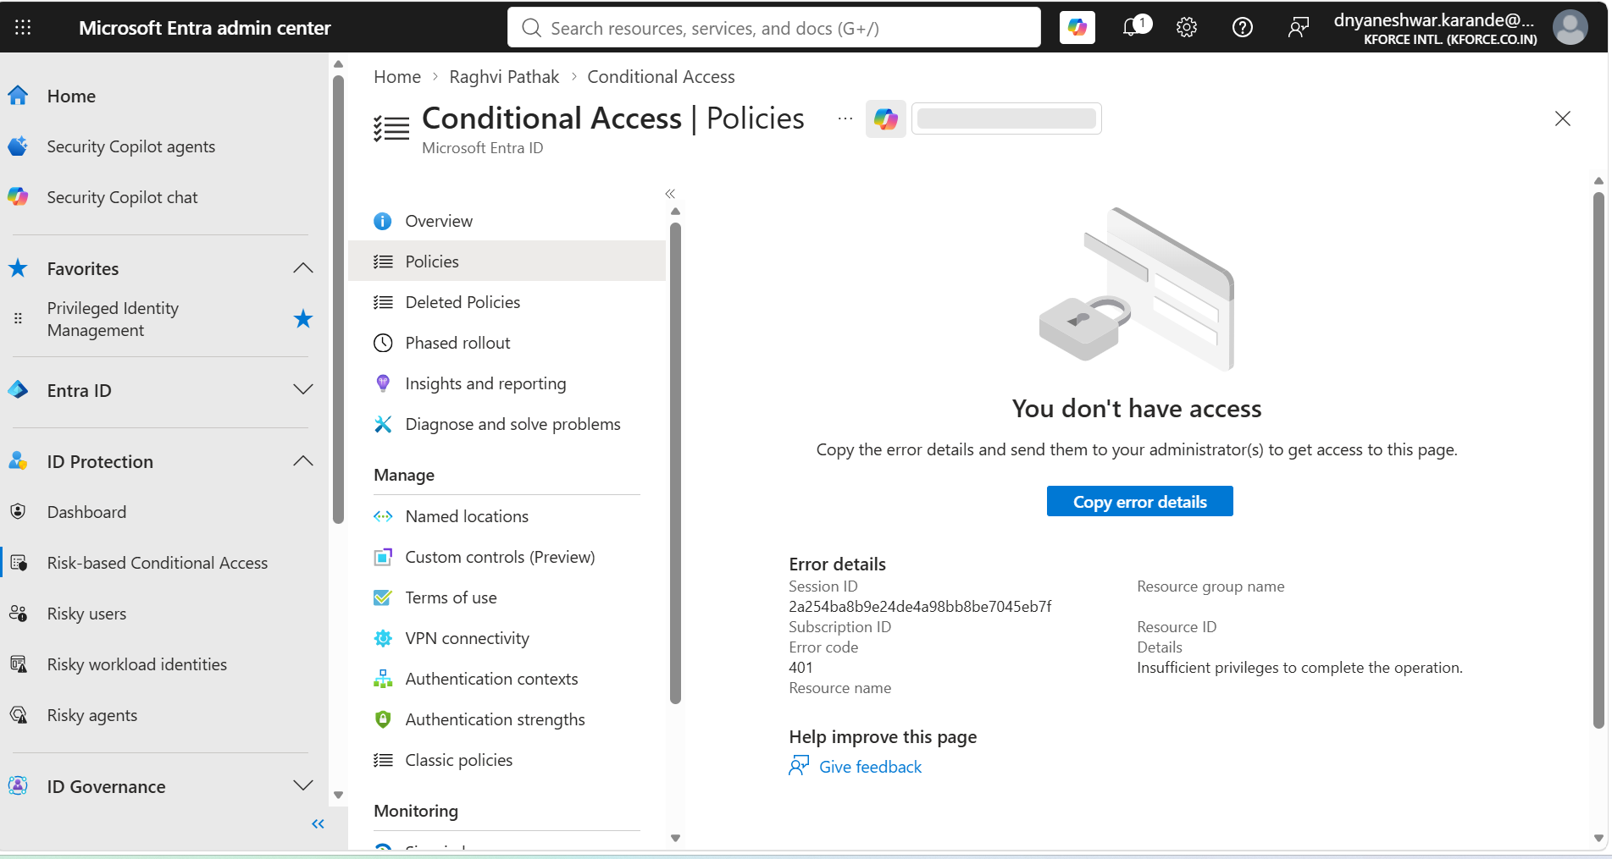
Figure 33. Risk-based Conditional Access policy area.
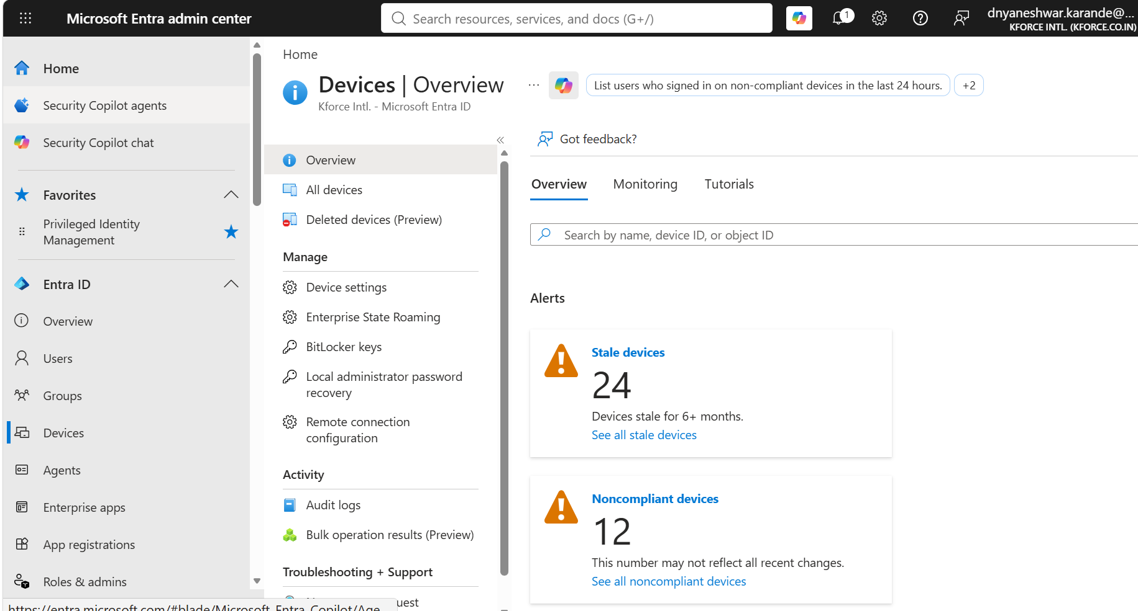
Figure 34. Device overview and compliance-related reporting.
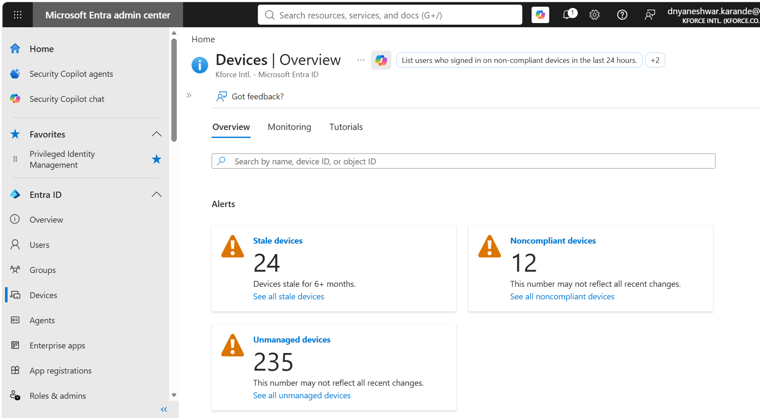
Figure 35. Entra device overview with stale and noncompliant device counts.
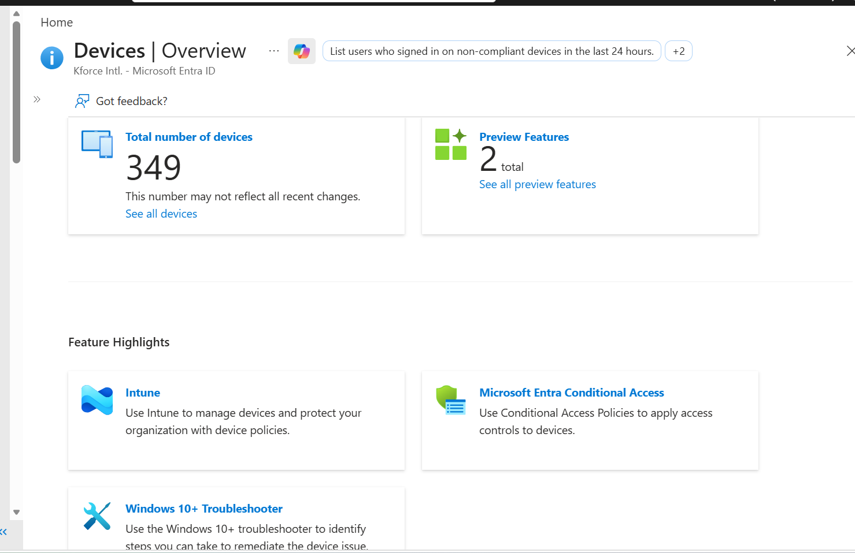
Figure 36. Intune and Microsoft Entra Conditional Access integration overview.

9.1 Safe enforcement sequence
- Create and assign compliance policy first.
- Monitor evaluation without blocking access.
- Resolve unknown, not evaluated, and widespread noncompliance.
- Create Conditional Access policy in report-only mode.
- Review sign-in logs and impact.
- Exclude emergency access accounts according to security policy.
- Pilot enforcement with a controlled group.
- Expand only after approval and support readiness.

9.2 Common CA mistakes
- Requiring compliance before devices can enroll.
- No emergency access exclusion.
- Targeting unsupported device types.
- Using overly short grace periods.
- Treating stale devices as current failures.
- Assuming compliance remediates settings.

10. BitLocker, Endpoint Security, and Security Baselines
Exact portal path
Microsoft Intune admin center > Devices > BitLocker keys

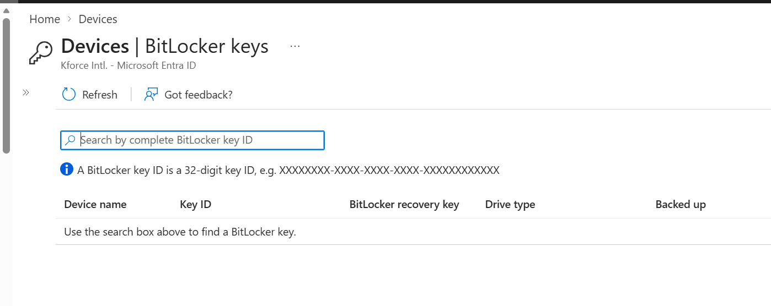
Figure 37. BitLocker recovery key search by full key ID.
Exact portal path
Microsoft Intune admin center > Endpoint security > Overview

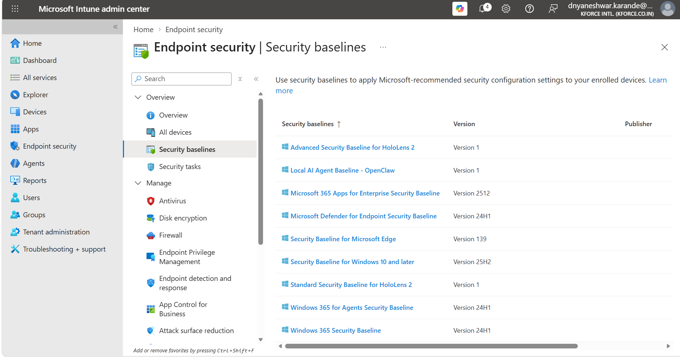
Figure 38. Endpoint security overview.
Exact portal path
Microsoft Intune admin center > Endpoint security > Security baselines > Create Profile

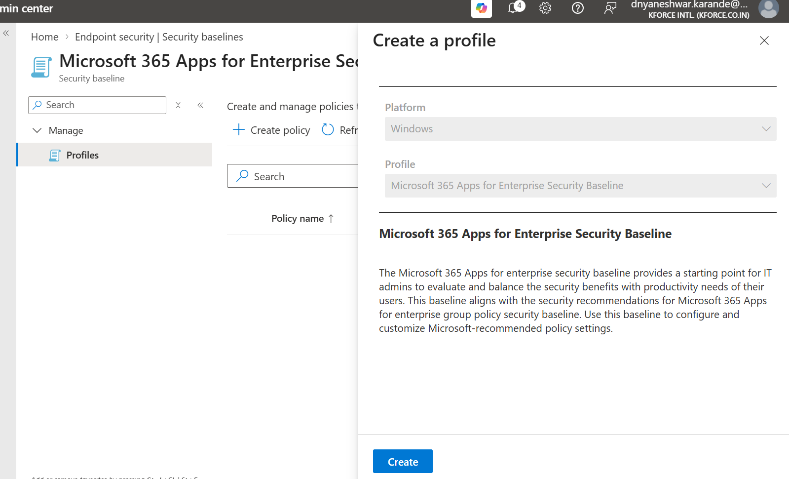
Figure 39. Security baseline creation for Windows and Microsoft products.
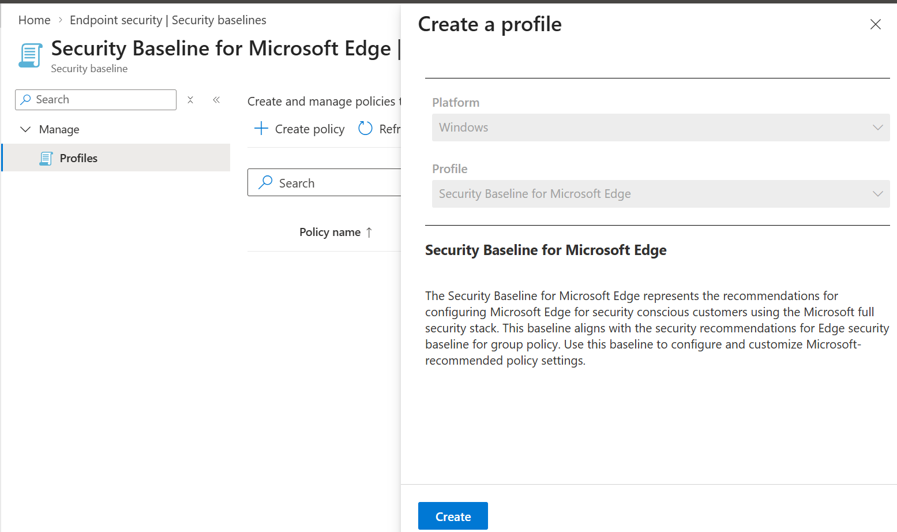
Figure 40. Security Baseline for Microsoft Edge profile list.

10.1 Relationship
Control | Purpose
Endpoint security/configuration profile | Applies BitLocker, firewall, Defender, or baseline settings
Compliance policy | Checks whether the required security state exists
Conditional Access | Uses compliance state for access decision
Recovery key portal | Supports approved recovery process
Avoid conflicts
Do not configure the same setting with incompatible values across Security baselines, Settings catalog, Endpoint security, and older templates. Use per-setting status to find conflicts.

11. Platform and Assignment Design
Platform | Typical compliance areas
Windows | Health, OS, encryption, firewall, antivirus, Defender risk, custom compliance
macOS | OS, password, encryption, firewall, Gatekeeper, system integrity/custom compliance where supported
iOS/iPadOS | OS, passcode, device threat/jailbreak, restricted apps
Android Enterprise | OS, encryption, root/threat, password, device integrity
Linux | Supported distribution/version and custom compliance capabilities

11.1 User vs device assignment
- User assignment follows the user across enrolled devices and aligns naturally with Conditional Access.
- Device assignment suits shared, kiosk, or device-specific control where supported.
- Test enrollment-without-user and primary-user scenarios.
- Avoid overlapping policies that create incompatible requirements.

12. Troubleshooting Matrix
Symptom | Likely cause | Action
Not evaluated | No check-in, enrollment/assignment gap, unsupported state | Confirm enrollment, last check-in, assignment, platform, and primary user.
Noncompliant after remediation | Device has not re-evaluated or setting still fails | Sync, restart if needed, inspect per-setting state and local configuration.
Error | Custom script/JSON, MDE integration, platform evaluation error | Review script output, rule names/types, licensing, and logs.
Conflict | Overlapping compliance/configuration requirements | Identify every policy targeting the setting and resolve design overlap.
No email received | Template/action/schedule/UPN issue | Confirm notification template, action, locale, user email, and timing.
Conditional Access not blocking | CA scope, mode, grant control, stale sign-in | Review What If and sign-in logs; confirm Require compliant device.
Unexpected lockout | Broad CA scope, no grace/exclusion, unknown state | Use approved emergency process; review report-only evidence and exclusions.
BitLocker noncompliant | Encryption incomplete, policy failed, unsupported state | Review disk encryption policy, local protection status, recovery-key escrow.
Firewall/AV noncompliant | Service disabled or security product reporting issue | Validate local security provider and Endpoint security policy.
Stale device remains noncompliant | Device no longer active | Use stale-device and lifecycle process; do not treat as an active endpoint.

12.1 Useful client checks
dsregcmd /status
Get-BitLockerVolume
Get-NetFirewallProfile
Get-MpComputerStatus
Get-ScheduledTask | Where-Object {$_.TaskPath -like "*EnterpriseMgmt*"}

12.2 Event Viewer
- Applications and Services Logs > Microsoft > Windows > DeviceManagement-Enterprise-Diagnostics-Provider > Admin.
- Applications and Services Logs > Microsoft > Windows > User Device Registration > Admin.
- Intune Management Extension logs for Windows custom compliance scripts.

13. Production Rollout and Governance

13.1 Rollout rings
Phase | Scope | Exit criteria
Lab | Endpoint engineers | Evaluation, remediation, reporting pass
IT pilot | IT users/devices | Notifications and support process pass
Business pilot | Representative users and hardware | Low false-positive and acceptable support volume
Report-only CA | Wider population | Sign-in impact reviewed
Enforced production | Approved groups | Security owner approval and rollback ready

13.2 Governance checklist
- Policy owner and purpose.
- Included/excluded groups.
- Required remediation policies.
- Noncompliance actions and grace period.
- Notification template and support route.
- Conditional Access dependency.
- Emergency access exclusions.
- Custom script code review.
- Pilot evidence and rollback.
- Review cadence and exception expiry.

14. Interview and Expert Reference
Question | Strong answer
Compliance vs configuration? | Configuration applies settings; compliance evaluates whether requirements are met.
What does Conditional Access do? | It can use the compliant-device signal as a grant requirement for access.
What is grace period? | Time between initial failure and scheduled noncompliance enforcement/action.
Why Not evaluated? | Device has not evaluated because of check-in, assignment, enrollment, user, or support conditions.
How does custom compliance work? | Discovery script outputs values; JSON rules define compliant values and remediation messages.
Why start report-only? | To understand real impact and reduce unintended user lockout before CA enforcement.
How do you troubleshoot? | Check identity, enrollment, assignment, check-in, per-setting status, remediation, then CA sign-in logs.
What is default compliance policy? | A built-in status policy that reports core management states and should not replace platform compliance policies.
What is MDE risk integration? | Defender risk can be used as a compliance requirement when integration and licensing are configured.
Can compliance enable BitLocker? | No. Use disk encryption/configuration policy to enable it; compliance verifies state.

15. Reusable Policy and Incident Records

15.1 Policy record
Field | Record
Policy name/version
Platform
Owner
Settings
Assignments/exclusions
Actions/grace
Notification template
Remediation profiles
Conditional Access
Pilot evidence
Rollback
Ticket/approval

15.2 Noncompliance incident
Field | Record
Device/user
Policy/setting
Status/error
Last check-in
Business impact
Remediation
CA impact
Final state
Owner/date

16. Official References and Maintenance
- Microsoft Learn: Create device compliance policies - https://learn.microsoft.com/intune/device-security/compliance/create-policy
- Microsoft Learn: Custom compliance settings - https://learn.microsoft.com/intune/device-security/compliance/custom-settings
Review trigger
Review this SOP when Microsoft changes supported platforms, compliance settings, custom compliance schema, portal navigation, Conditional Access behavior, Defender integration, licensing, or organizational security requirements.

