Windows Update Rings & Patch Management
Zero-to-Advanced Master SOP with Tenant Screenshots
Plan | Create Rings | Feature Updates | Quality Updates | Drivers | Autopatch | Monitor | Troubleshoot | Report
Purpose
A complete operational guide for managing Windows updates from Microsoft Intune. It combines exact portal paths, ring design, policy creation, assignments, feature/quality/driver update management, Windows Autopatch concepts, monitoring, troubleshooting, governance, and the screenshots supplied in Windows Update Rings.docx.

Document field | Value
Owner | Endpoint Management / IT Operations
Platform | Microsoft Intune and Windows Update for Business
Scope | Update rings, feature, quality, driver updates, Windows Autopatch, compliance
Source screenshots | Windows Update Rings.docx
Version | 1.0
Prepared date | 25 September 2026
Classification | Internal use

1. Windows Update Management Fundamentals

1.1 What update rings control
Update ring policies configure Windows Update client behavior, including deferrals, restart experience, deadlines, active hours, and notifications. They are commonly used to create staged deployments such as test, pilot, and production.

1.2 Policy types
Policy type | Purpose | What it does not replace
Update rings | Client behavior, deferrals, deadlines, restart, notifications | Feature target version and dedicated quality/driver approval
Feature updates | Hold or deploy a specific Windows feature version | Restart/user experience policy
Quality updates | Target or expedite quality updates; eligible hotpatch scenarios | Update ring restart experience
Driver updates | Review/approve/defer Windows drivers | OEM firmware governance outside the selected channel
Windows Autopatch | Service-managed update orchestration and rings | Organizational testing, application readiness, and incident ownership

1.3 Update flow
- Device enrolls in Intune and is assigned a policy.
- Intune delivers Windows Update policy through MDM.
- The Windows Update client scans Microsoft update services.
- Applicable approved content downloads directly to the device.
- Windows installs according to policy.
- The device reports state back to Microsoft services and Intune.
- Administrators monitor deployment, investigate errors, and pause or remediate when required.
Avoid policy conflict
Do not assign multiple update rings with competing settings to the same device. When Windows Autopatch manages a device, avoid adding custom rings unless the design explicitly calls for it.

2. Navigate to Windows Updates
Exact portal path
Microsoft Intune admin center > Devices > Windows > Manage updates > Windows updates

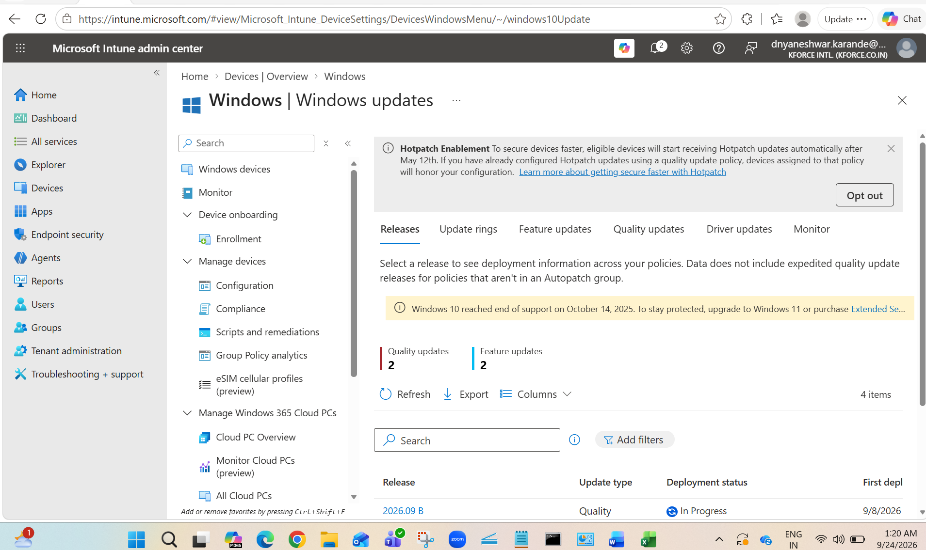
Figure 1. Windows updates overview with Releases, Update rings, Feature updates, Quality updates, Driver updates, and Monitor tabs.
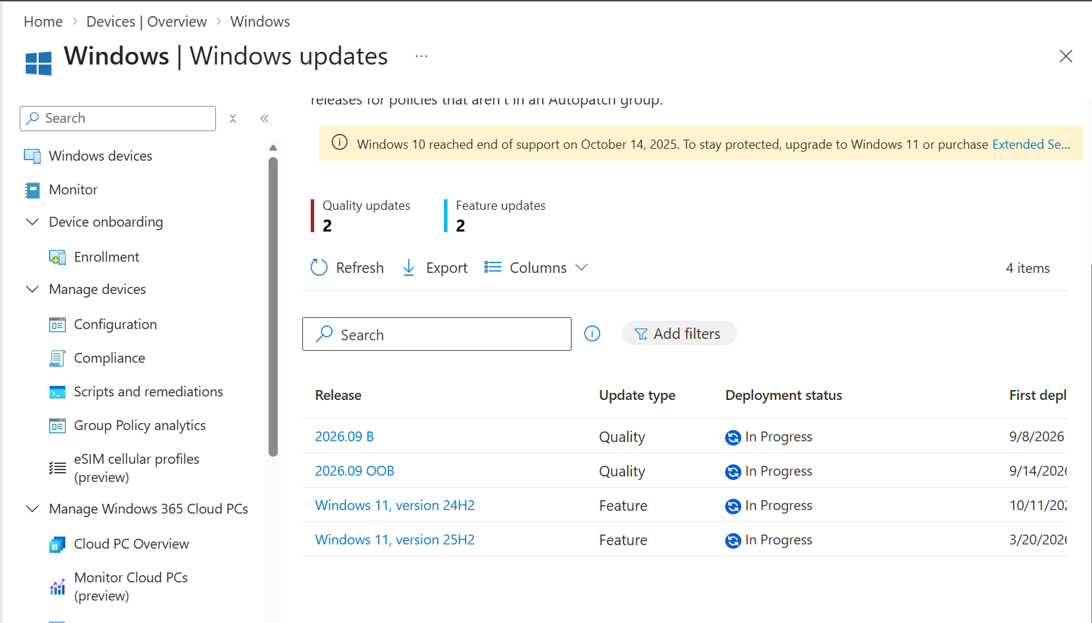
Figure 2. Releases view shows quality and feature update deployment status.

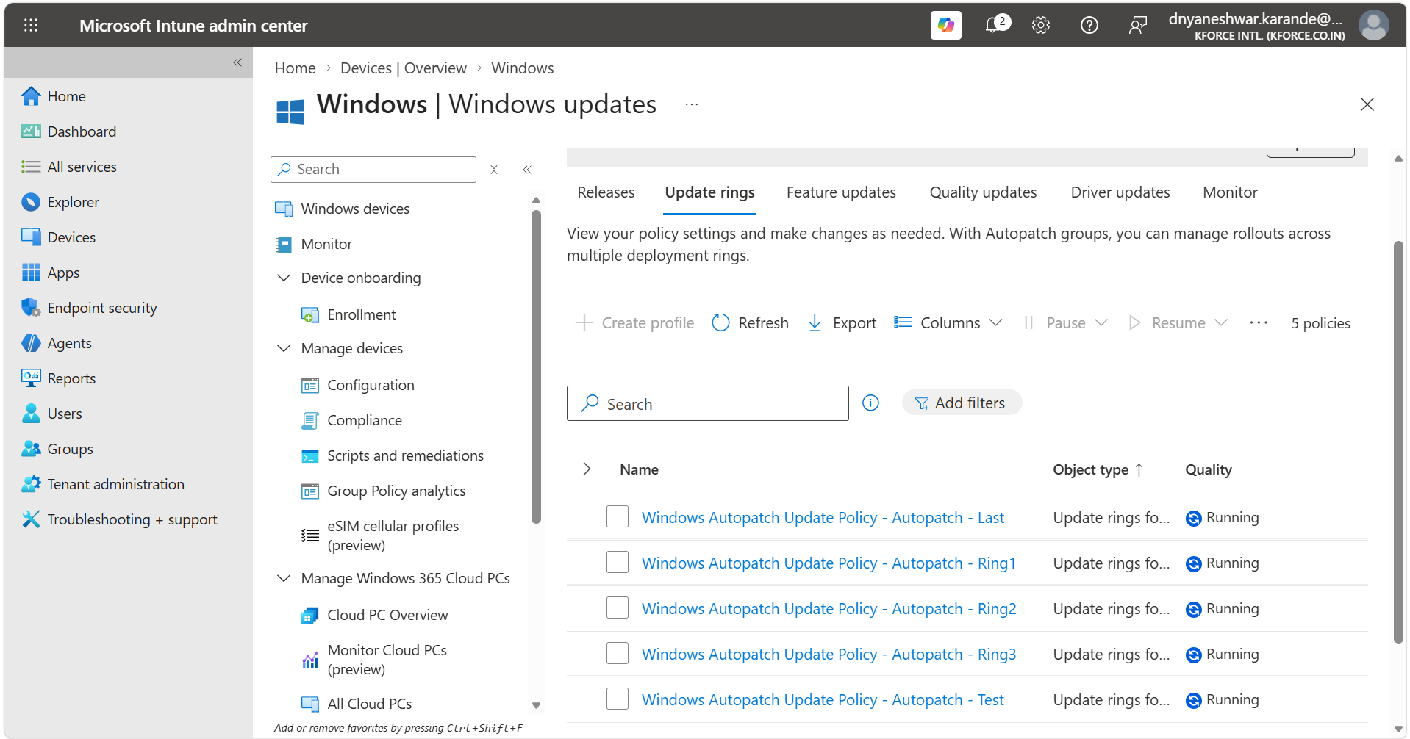
Figure 3. Update rings list showing service-managed Windows Autopatch policies.
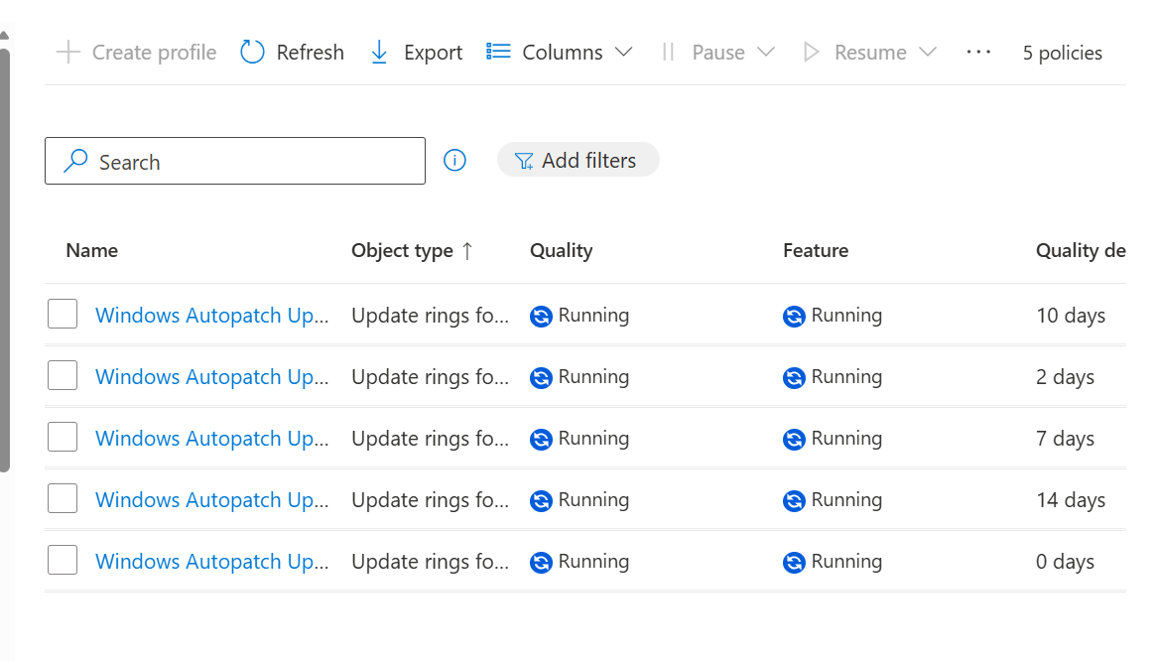
Figure 4. Ring list status, quality/feature state, and quality deferral values.

2.1 What to verify before creating a policy
- The device is Intune enrolled and supported.
- The device can reach Intune, Windows Update, and Autopatch endpoints where applicable.
- Required licensing is assigned.
- Device groups for Test, Ring1, Ring2, Ring3, or Production exist.
- There is no conflicting Configuration Manager, Group Policy, WSUS, or third-party update authority.
- Maintenance, reboot, and user-notification requirements are approved.

3. Design Deployment Rings

3.1 Recommended rollout model
Ring | Typical membership | Purpose | Suggested behavior
Test | Endpoint engineers and lab devices | Catch packaging, policy, and hardware issues first | Earliest release, shortest deferral
Ring 1 / First | IT and selected technical users | Validate production-like use | Short deferral and enforced deadlines
Ring 2 / Fast | Representative business pilot | Broader application and hardware coverage | Moderate deferral
Ring 3 / Broad | Most production devices | Broad deployment after validation | Longer deferral
VIP / Critical | Business-critical devices | Controlled restart experience | Separate windows and explicit support

3.2 Group design
Exact portal path
Microsoft Entra admin center > Identity > Groups > All groups > New group

- Create Security groups.
- Use assigned membership for Test and small pilot rings.
- Use well-governed dynamic membership for broad groups only after validation.
- Ensure every device belongs to exactly one intended ring unless the update design explicitly requires otherwise.
- Maintain exclusions for break-fix and emergency investigation.

3.3 Naming standard
Windows Update Ring - Test
Windows Update Ring - Ring1
Windows Update Ring - Ring2
Windows Update Ring - Ring3
Windows Feature Update - Windows 11 24H2
Windows Driver Update - Ring1

4. Create a Windows Update Ring
Exact portal path
Microsoft Intune admin center > Devices > Windows > Manage updates > Windows updates > Update rings > Create profile

4.1 Basics
- Select Create profile.
- Enter a unique Name using the naming standard.
- Enter Description with owner, ring purpose, target group, ticket, and version.
- Select Next.

4.2 Update settings explained
Setting | Function | Design guidance
Microsoft product updates | Allows updates for Microsoft products beyond Windows | Enable if the enterprise update model requires it
Windows drivers | Allows drivers through Windows Update | Coordinate with dedicated Driver update policies and OEM tools
Quality update deferral | Days before monthly/cumulative quality update is offered | Lower for early rings, higher for broad ring
Feature update deferral | Days before feature update is offered | Use carefully; dedicated Feature update policy may provide clearer version control
Upgrade Windows 10 to latest Windows 11 release | Controls eligible upgrade behavior | Enable only after hardware/app readiness approval
Feature update uninstall period | Days rollback files remain available within supported boundaries | Set according to support policy
Servicing channel | Generally available or approved pre-release channel | Use pre-release only in an isolated test ring

4.3 User experience settings
Setting | Purpose | Best-practice decision
Automatic update behavior | Download/install behavior and active hours | Align with user working hours
Restart checks | Controls restart handling | Avoid unexpected reboot during critical operations
Notifications | User update notification level | Keep communication clear; do not hide all notices without support plan
Deadline for feature updates | Maximum time before enforcement | Use after pilot validation
Deadline for quality updates | Maximum time before enforcement | Shorter than feature deadline in most environments
Grace period | Time after deadline before forced restart | Balance security and active user work
Auto reboot before deadline | Allows restart sooner when conditions permit | Choose per ring and support model

4.4 Assignments
- Select Next until Assignments.
- Under Included groups, add the intended ring group only.
- Review Excluded groups.
- Do not add the same device group to multiple ring policies.
- Select Next, review all settings, and Create.

5. Review Existing Ring Policies
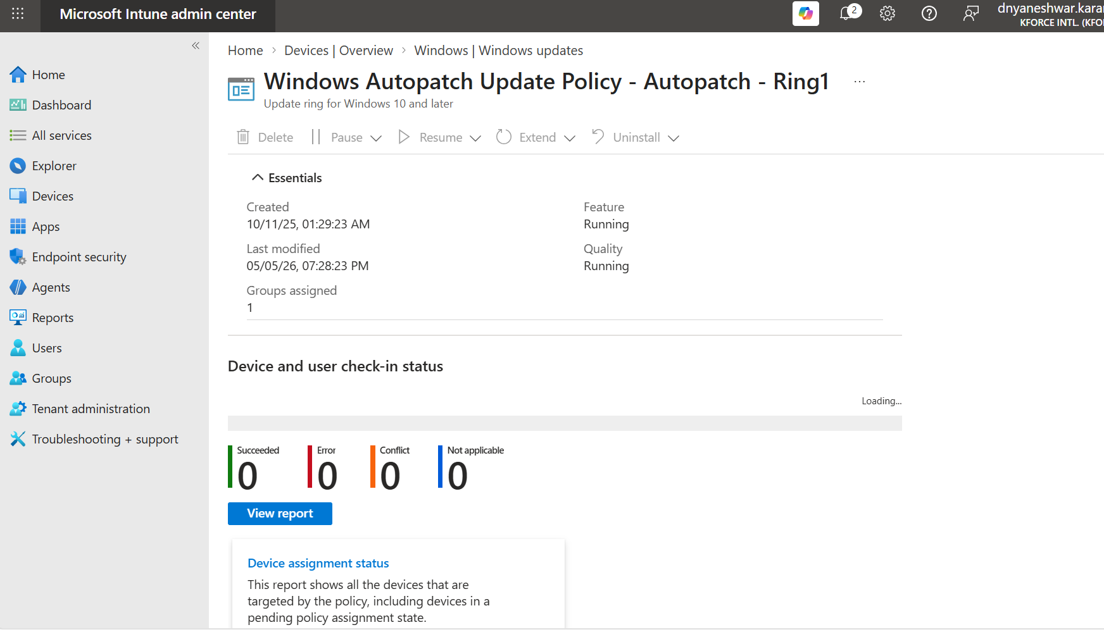
Figure 5. Ring1 overview with device and user check-in status.
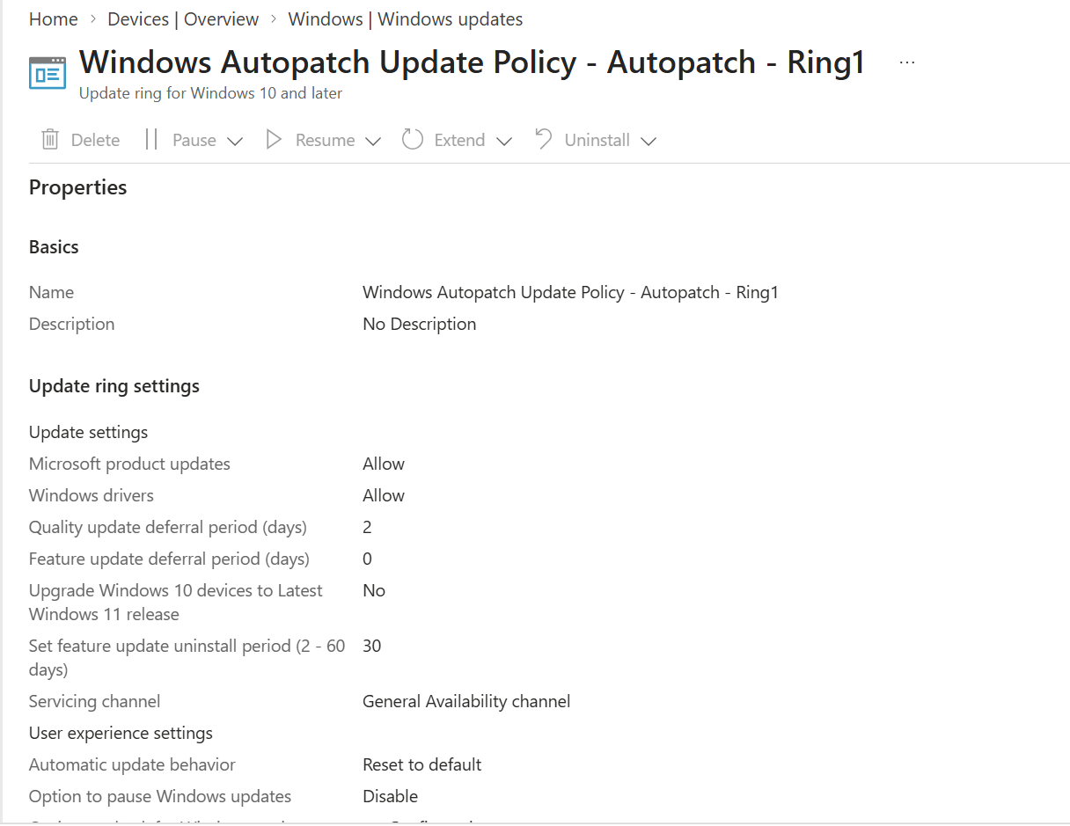
Figure 6. Ring1 update settings, including product updates, drivers, deferrals, servicing channel, and user experience.
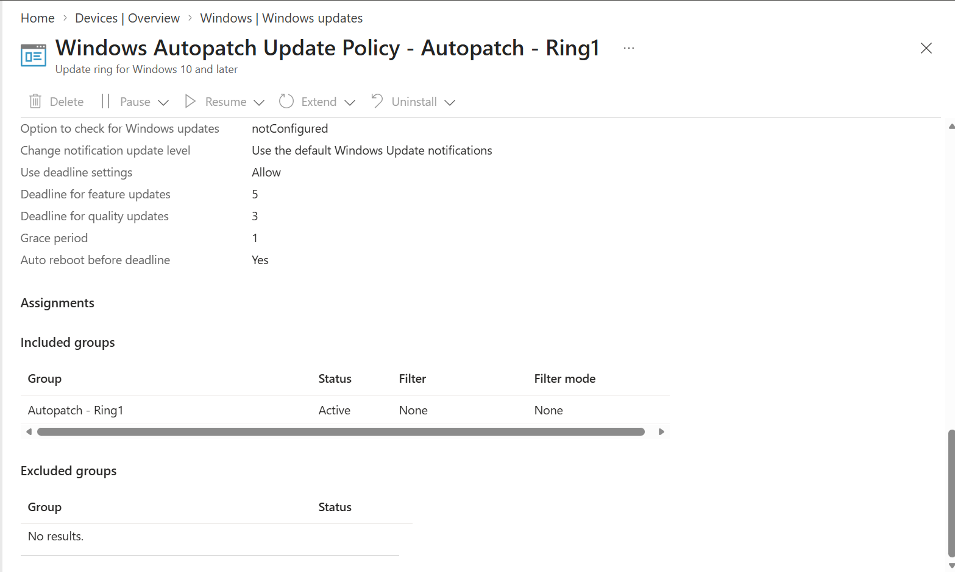
Figure 7. Ring1 deadlines, grace period, restart behavior, and assignment.

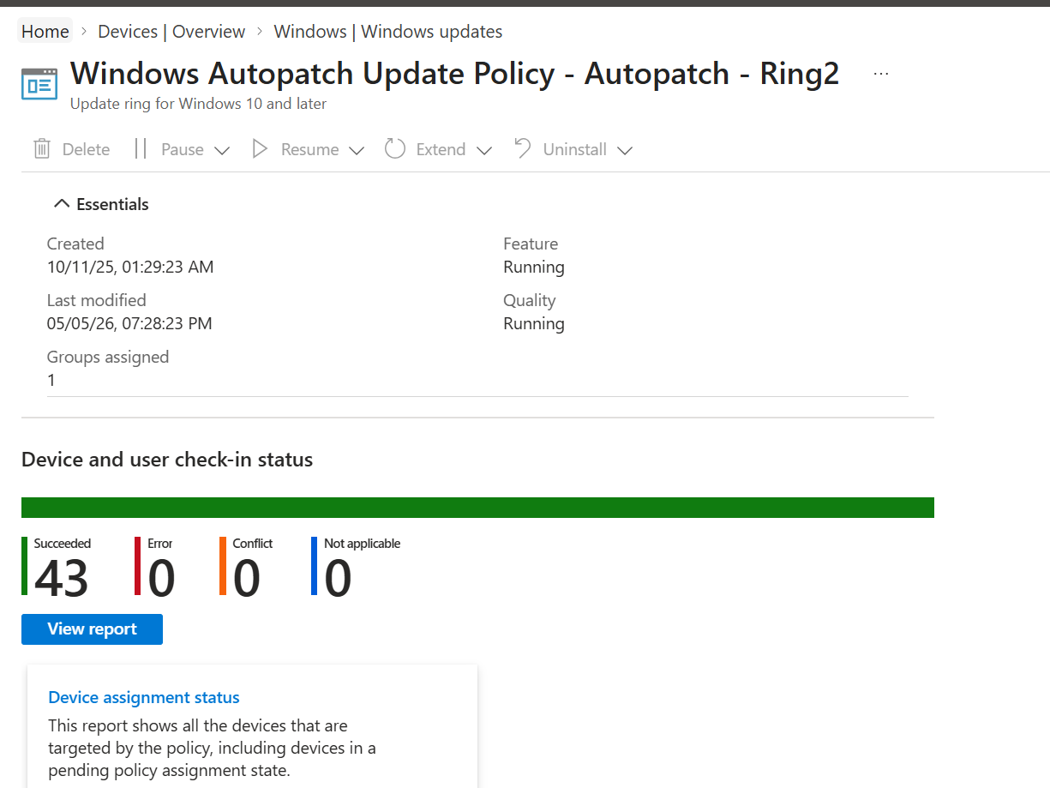
Figure 8. Ring2 overview and successful device count.
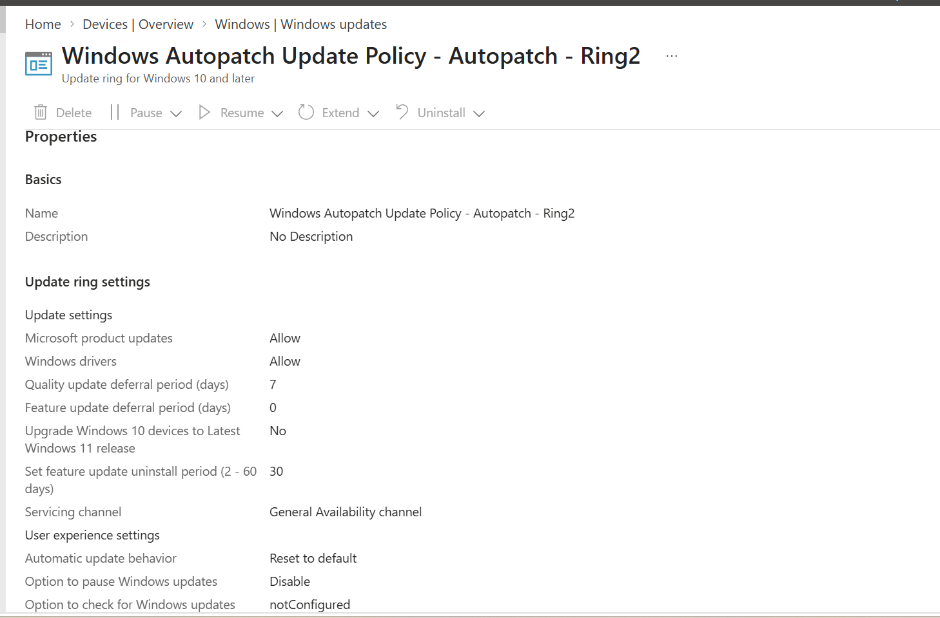
Figure 9. Ring2 properties and update settings.
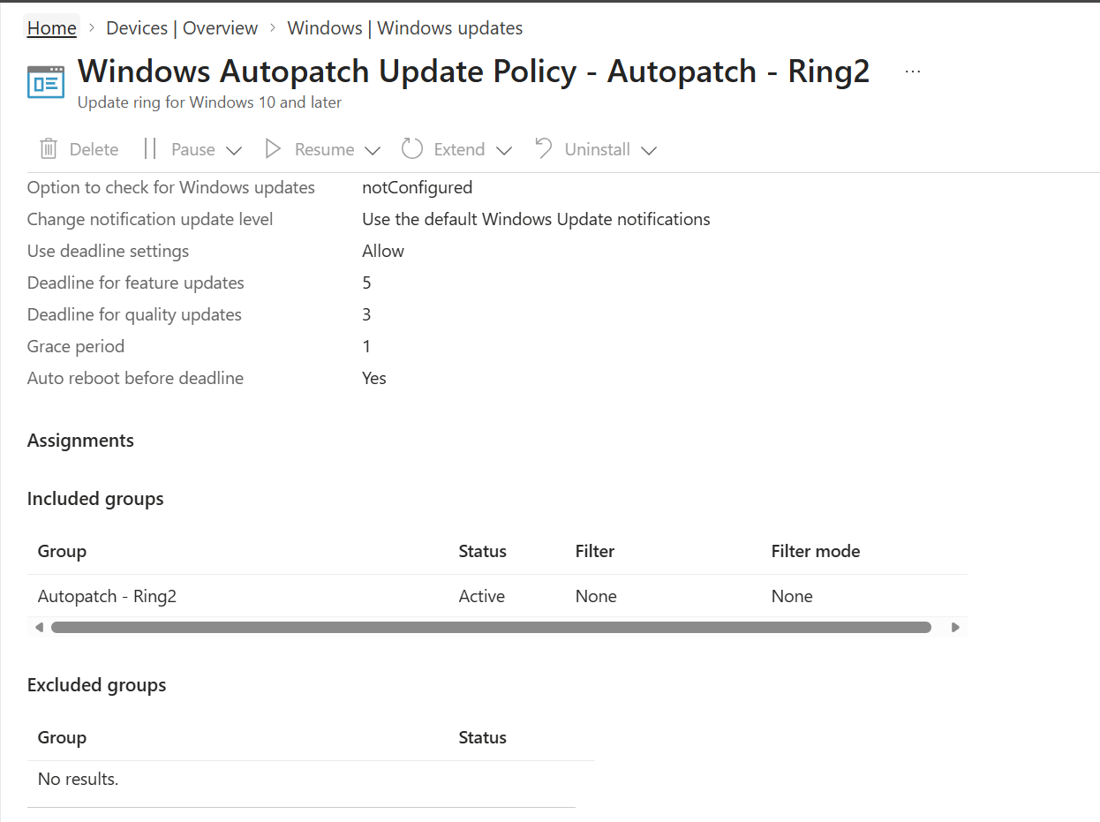
Figure 10. Ring2 deadline and assignment configuration.

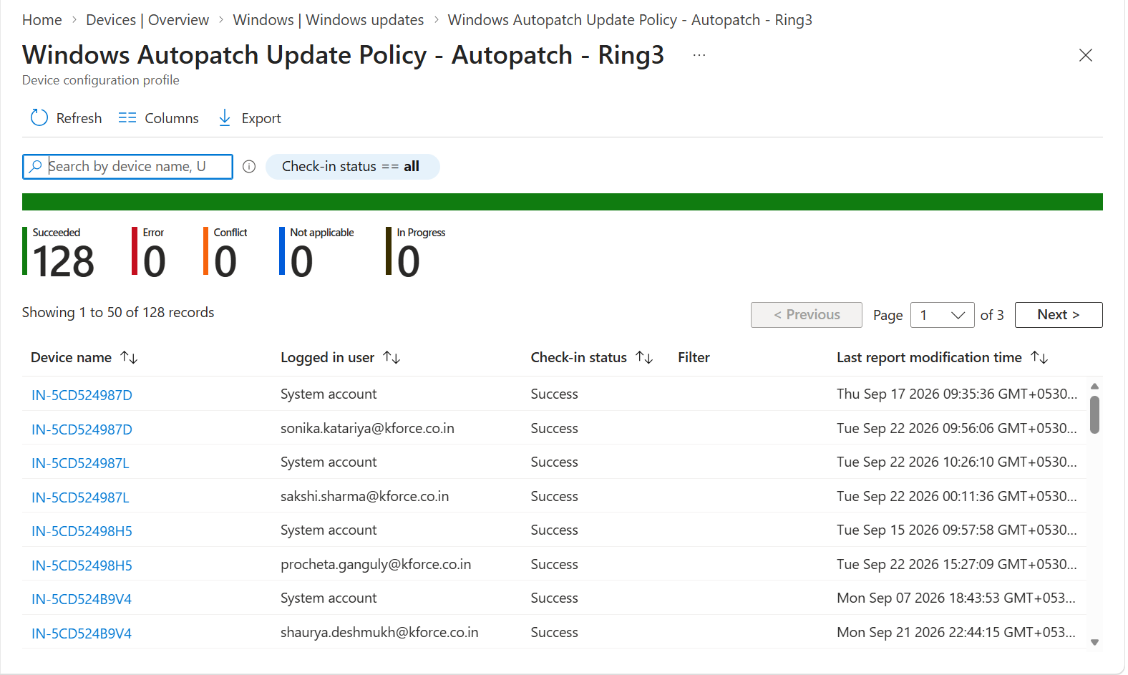
Figure 11. Ring3 device status report with successful check-ins.
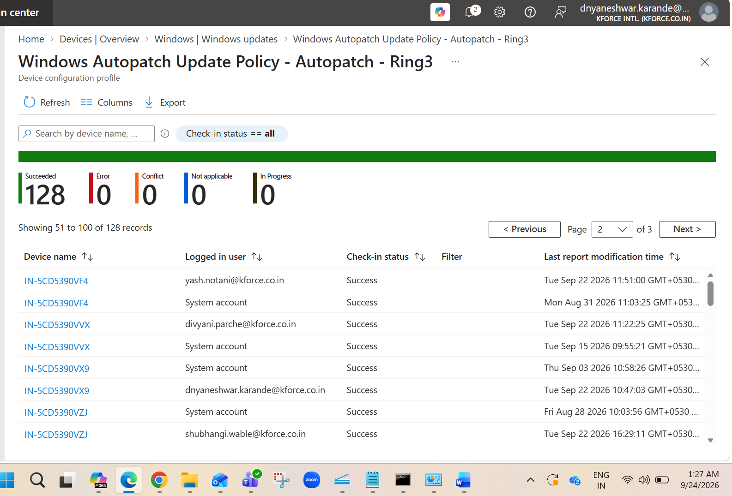
Figure 12. Ring3 report continuation with user and device records.
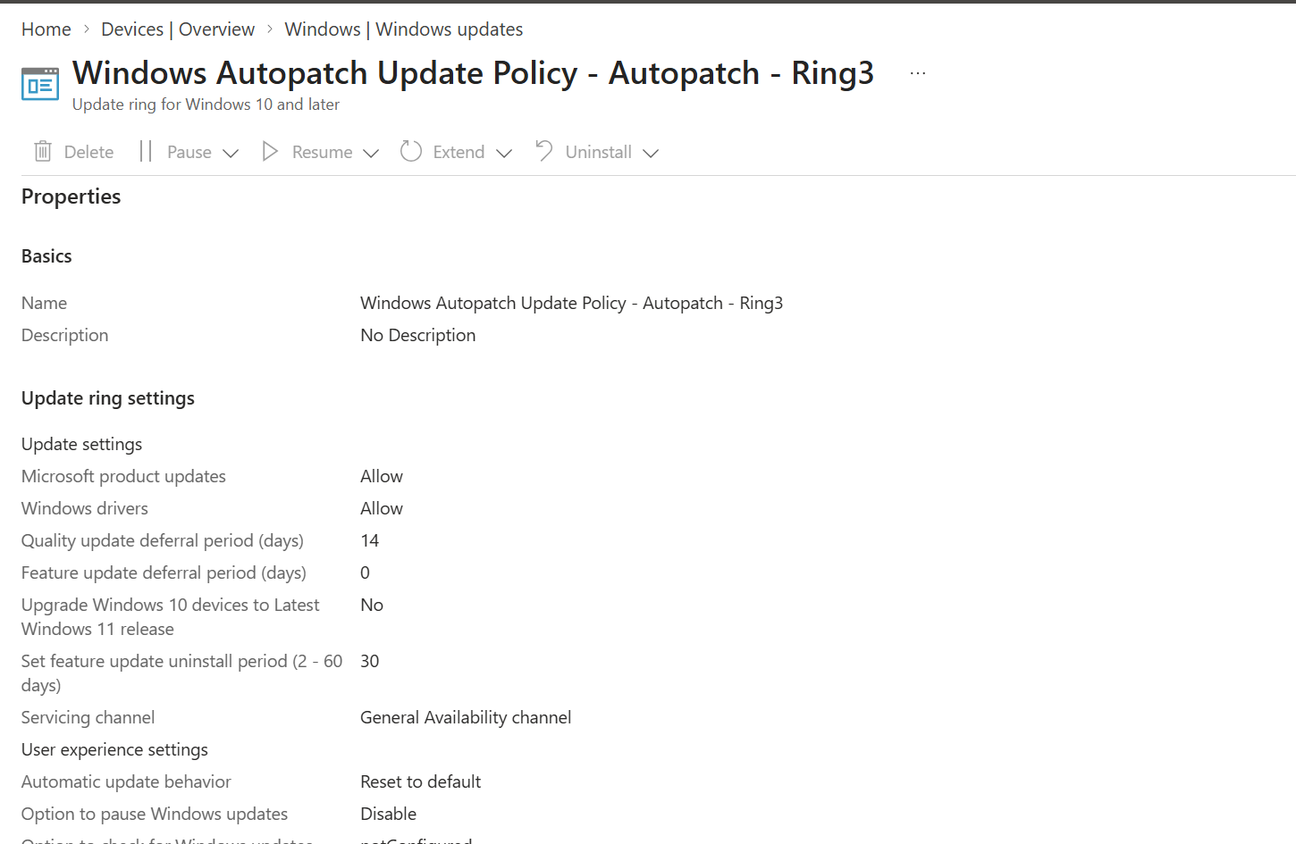
Figure 13. Ring3 update settings and longer quality deferral.
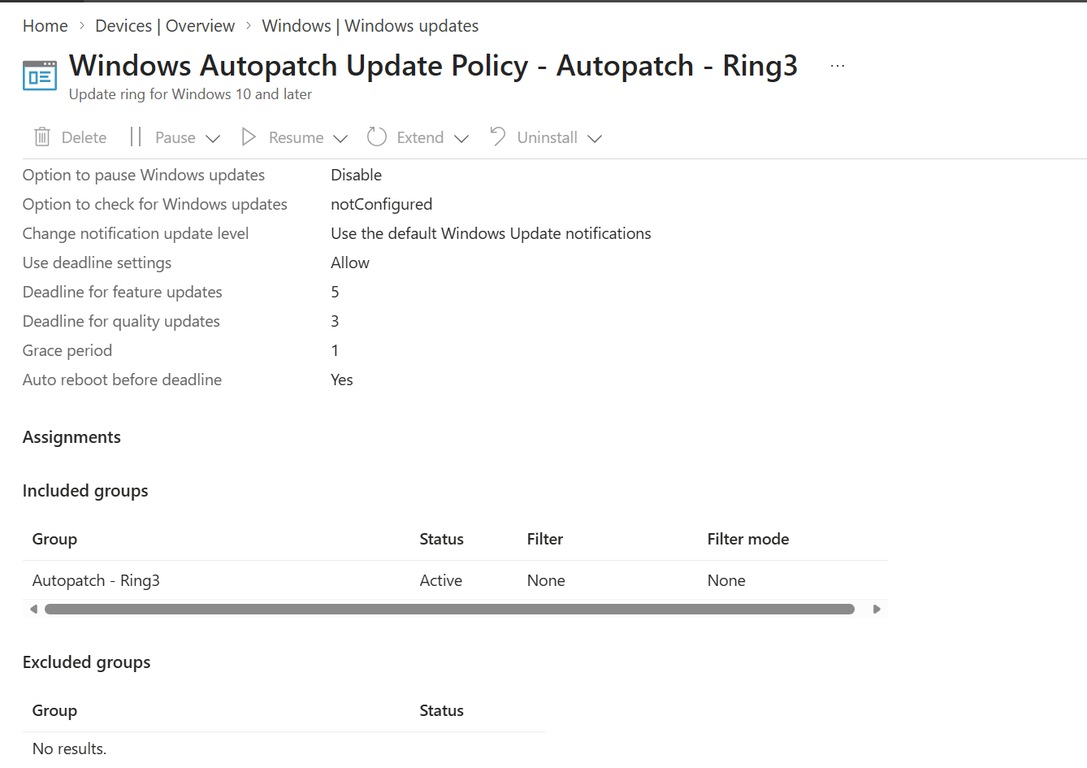
Figure 14. Ring3 deadline, notifications, restart behavior, and assignment.

5.1 Screenshot interpretation
- Ring1, Ring2, and Ring3 use distinct groups.
- Quality deferral increases as deployment moves to broader rings.
- Feature deferral shown in the source tenant is zero, indicating feature version control is handled separately.
- Device status and assignment must be reviewed together before changing a ring.

6. Manage, Pause, Resume, Extend, and Delete Rings
Exact portal path
Microsoft Intune admin center > Devices > Windows > Manage updates > Windows updates > Update rings > select policy

- Use Pause only after confirming an active update risk or approved change hold.
- Record whether quality updates, feature updates, or both are affected.
- Use Resume after mitigation and approval.
- Use Extend only when the portal provides a supported extension and the risk is documented.
- Before Delete, remove/replace assignments and confirm devices receive another approved update policy.
- Use Uninstall only where the selected update and Windows support it, and only after compatibility/risk review.

6.1 Emergency pause record
Field | Record
Incident/change
Policy/ring
Update type/KB/version
Reason
Affected devices
Pause time
Owner
Validation plan
Resume approval

7. Feature Update Policies
Exact portal path
Microsoft Intune admin center > Devices > Windows > Manage updates > Windows updates > Feature updates

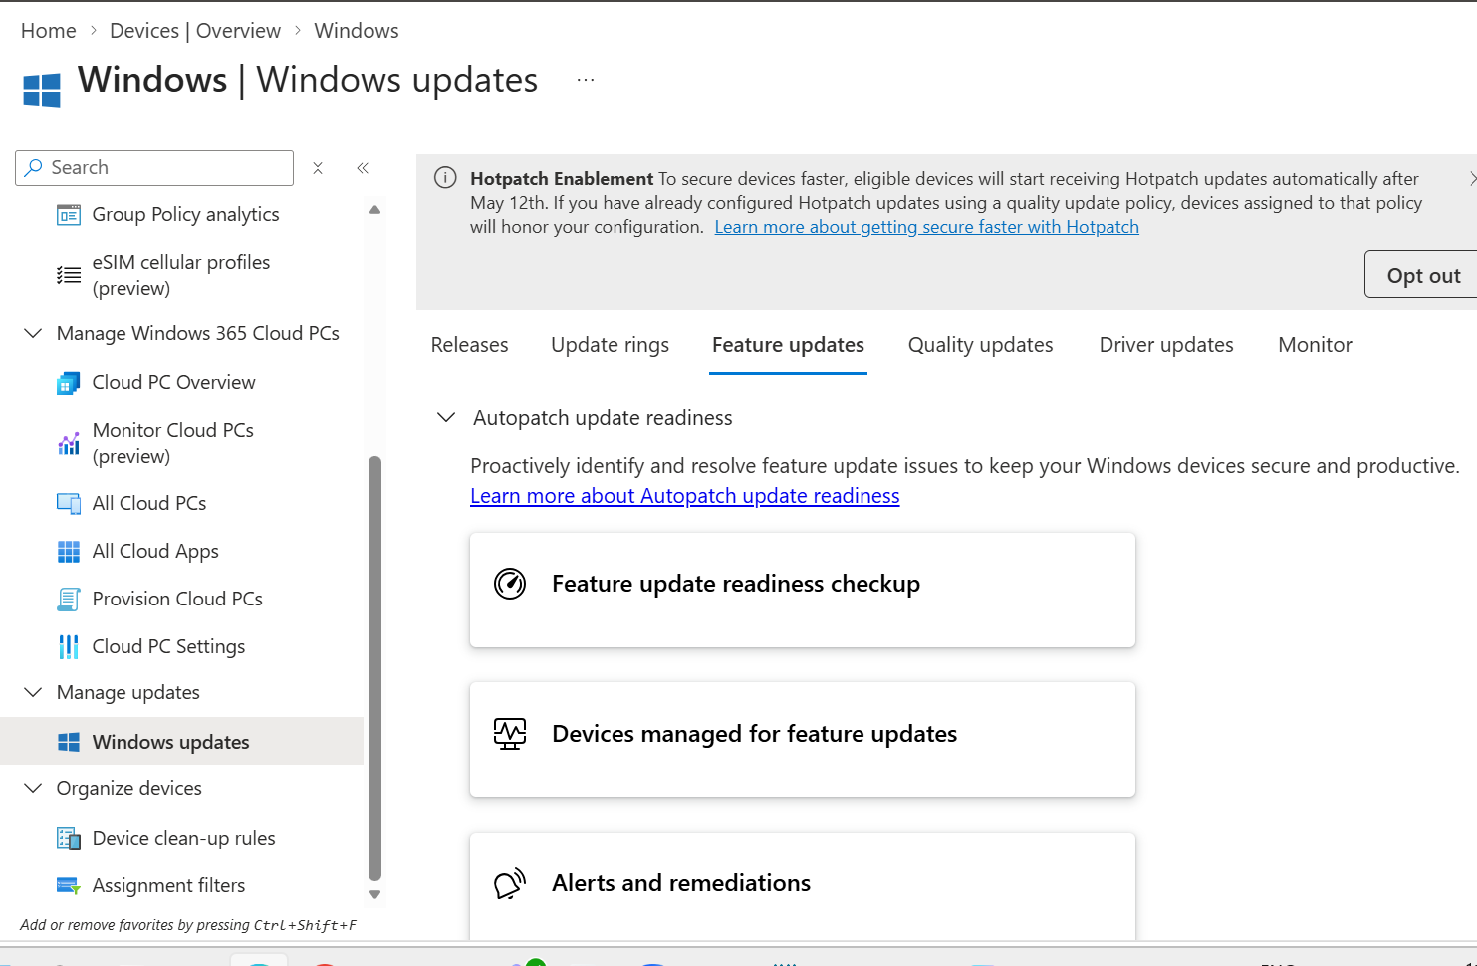
Figure 15. Feature update readiness and alerts/remediations entry points.
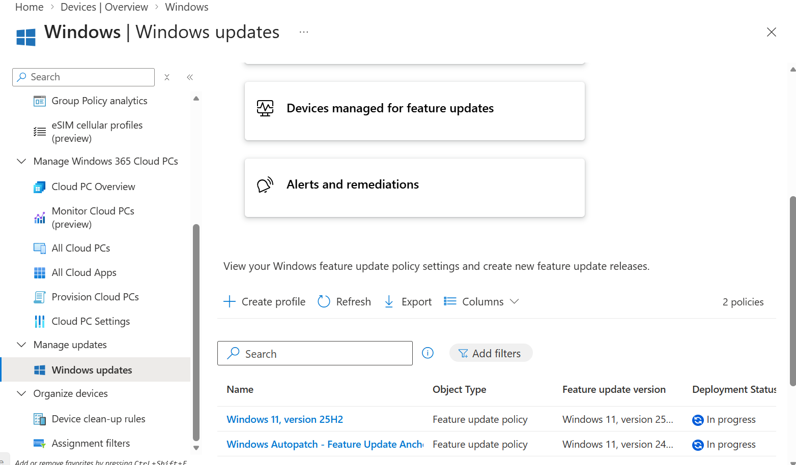
Figure 16. Existing feature update policies and deployment status.
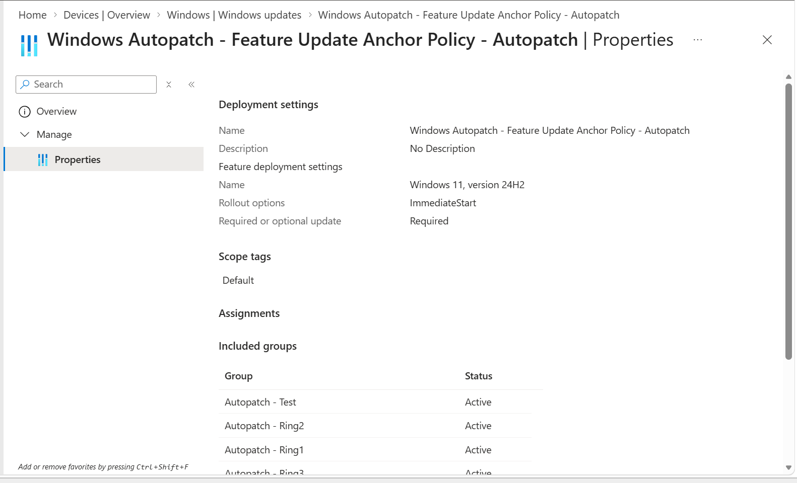
Figure 17. Windows Autopatch feature update anchor policy properties and assignments.

7.1 Create feature update policy
- Select Create profile.
- Enter Name and Description.
- Select the target Windows feature update version.
- Choose rollout option available in the current portal, such as immediate or scheduled/phased behavior.
- Decide how optional updates are handled.
- Assign to a pilot device group.
- Review and Create.
- Monitor deployment status and safeguard holds.

7.2 Readiness checks
- Application compatibility.
- Hardware and driver compatibility.
- Free disk space.
- Encryption and recovery-key status.
- VPN/security agent compatibility.
- Known issue and safeguard hold review.
- Rollback support and user communication.
Important interaction
Use one clear feature-version strategy. If a dedicated feature update policy is used, keep update-ring feature deferral settings consistent with that design.

8. Quality Updates, Expedite, and Hotpatch
Exact portal path
Microsoft Intune admin center > Devices > Windows > Manage updates > Windows updates > Quality updates

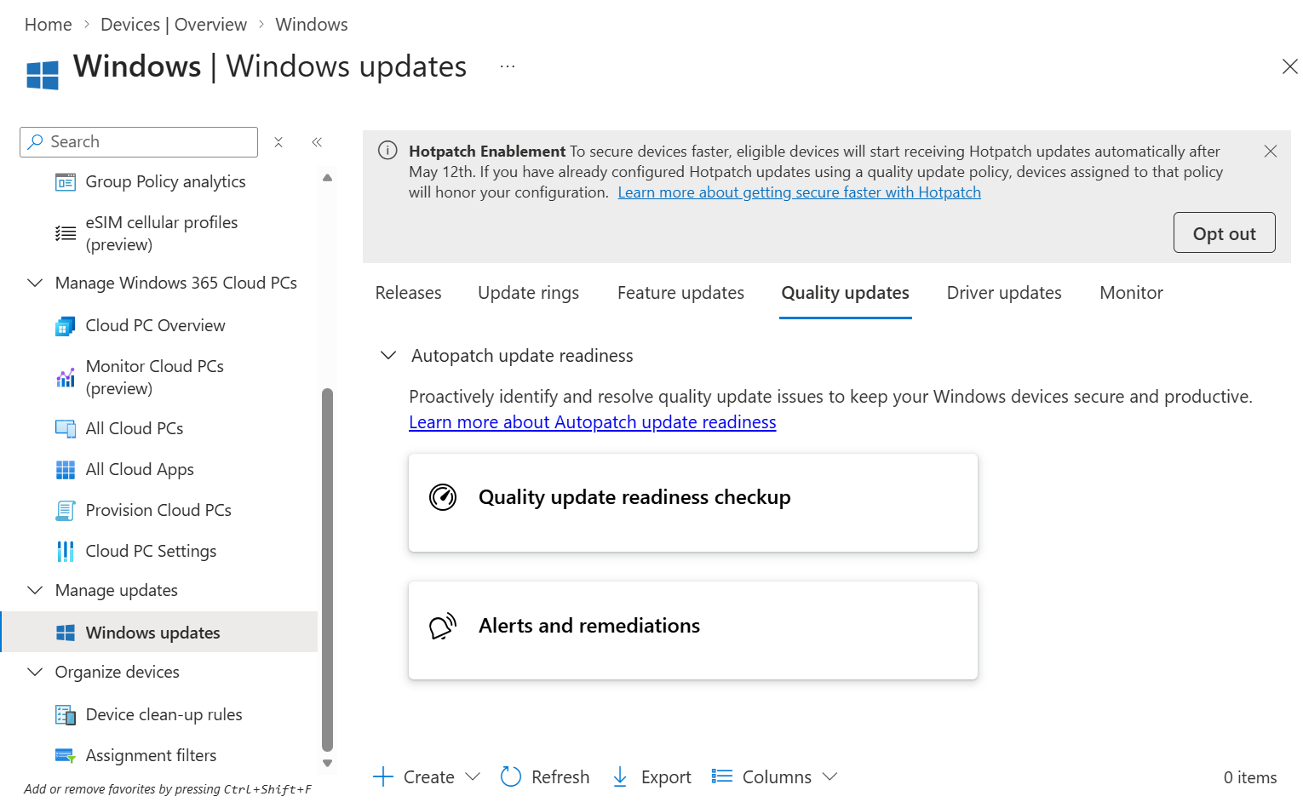
Figure 18. Quality update readiness and alerts/remediations.

8.1 Standard monthly updates
- Manage restart, deadline, deferral, and notification behavior through update rings.
- Monitor release and deployment status.
- Validate Test and early rings before broad production reaches its deadline.

8.2 Expedite a critical update
- Open Quality updates.
- Select Create or the expedite action available in the current portal.
- Select the applicable quality/security update.
- Configure restart enforcement if presented.
- Assign to the targeted emergency group.
- Review and create.
- Monitor success, errors, and restart completion.
- Remove or close the temporary emergency assignment after completion according to change policy.

8.3 Hotpatch
- Use only on eligible Windows editions and configurations.
- Review Hotpatch enablement and licensing requirements.
- Understand that not every monthly update is a hotpatch release.
- Maintain update rings for client-side behavior and deadlines.
- Monitor Hotpatch eligibility and deployment status separately.

9. Driver Update Policies
Exact portal path
Microsoft Intune admin center > Devices > Windows > Manage updates > Windows updates > Driver updates

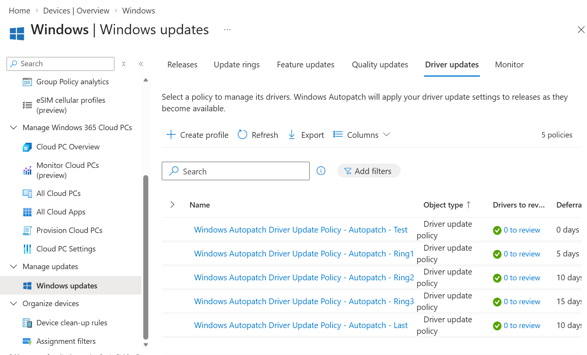
Figure 19. Driver update policies for Test, Ring1, Ring2, Ring3, and Last/Broad with different deferrals.

9.1 Create driver policy
- Select Create profile.
- Enter Name and Description.
- Choose the approval model offered by the current portal, such as automatic or manual approval.
- Configure deferral behavior.
- Assign to the intended ring group.
- Create the policy.
- Open the policy to review recommended drivers and other drivers.
- Approve only after testing when manual approval is used.
- Monitor installation and rollback incidents.

9.2 Driver governance
- Pilot BIOS, firmware, storage, network, graphics, and audio drivers on representative models.
- Do not run overlapping driver-control tools without clear precedence.
- Record driver version, release date, hardware model, test results, and rollback.
- Treat firmware and BIOS changes as higher-risk updates.

10. Monitoring and Reporting
Exact portal path
Microsoft Intune admin center > Devices > Windows > Manage updates > Windows updates > Monitor

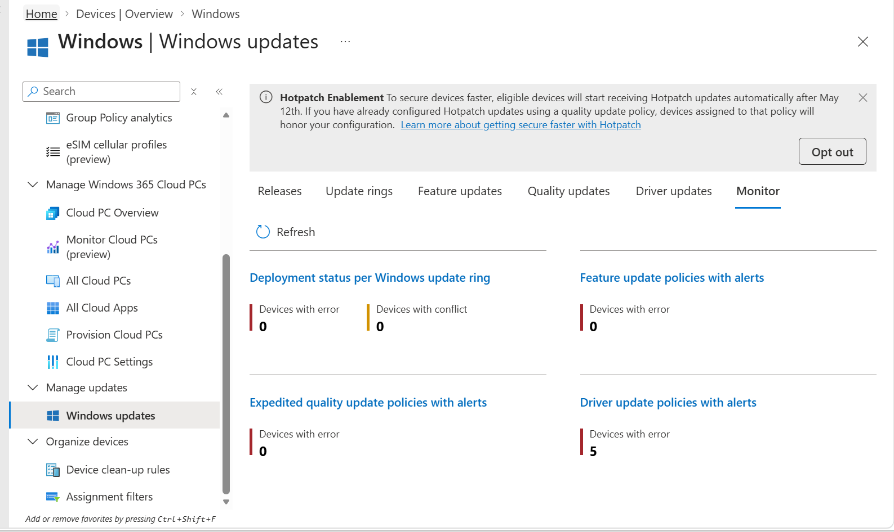
Figure 20. Monitor dashboard with deployment status and policy alerts.

10.1 Key views
View | Use
Releases | Overall quality and feature release deployment
Update ring device status | Succeeded, error, conflict, not applicable, in progress
Feature update report | Version rollout and readiness
Quality update report | Update state, expedited deployment, Hotpatch where applicable
Driver report | Driver approval and install state
Monitor alerts | Policies with errors or conflicts

10.2 Device-level validation
Exact portal path
Microsoft Intune admin center > Devices > Windows > select device > Monitor / Device configuration / Device compliance / Managed apps

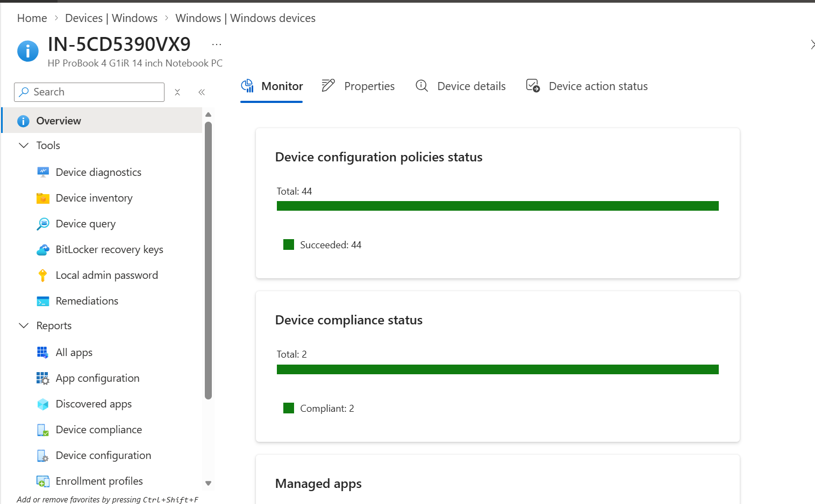
Figure 21. Device overview showing configuration and compliance status.
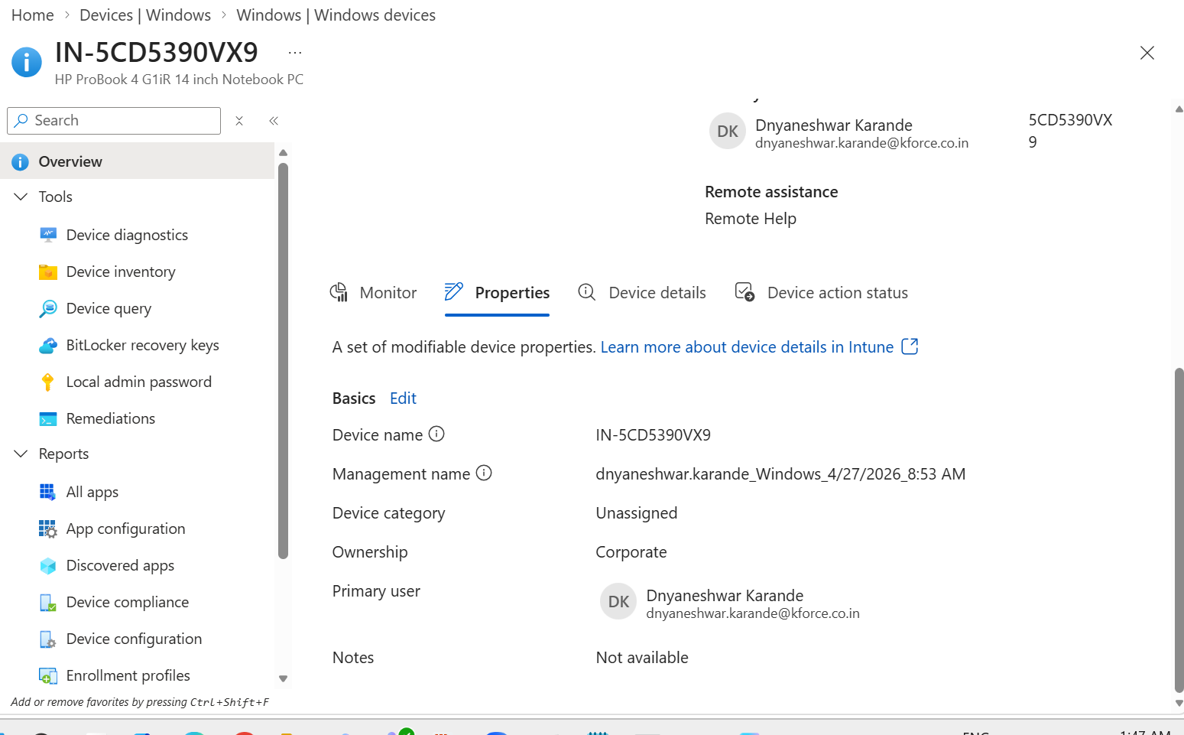
Figure 22. Device properties, corporate ownership, and primary user.
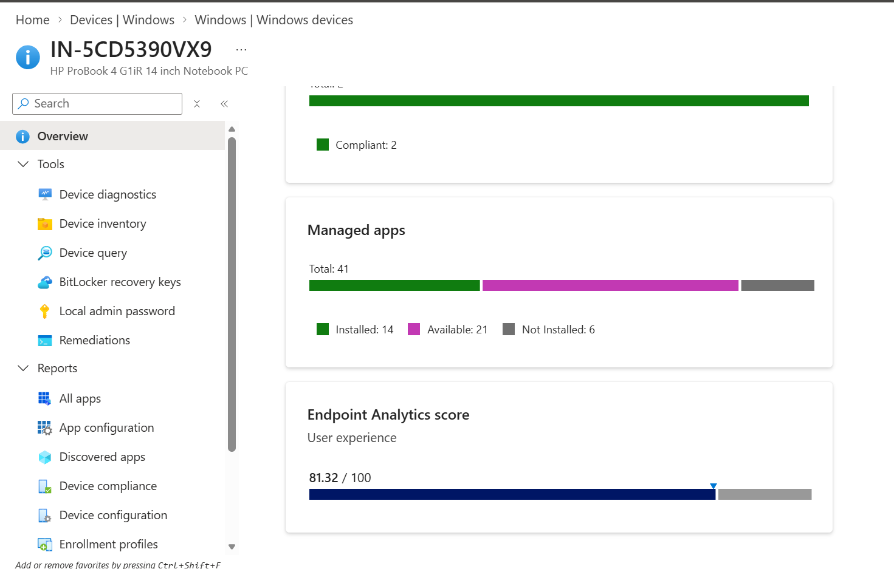
Figure 23. Managed apps and Endpoint Analytics user experience score.

10.3 Interpretation
- Succeeded means the policy check-in or setting application succeeded, not necessarily that every future patch is already installed.
- Error requires error-code and device-log investigation.
- Conflict usually indicates competing policies.
- Not applicable can indicate unsupported OS/edition or a condition that does not apply.
- In progress must be evaluated with last check-in, deadline, restart state, and release status.

11. Patch Compliance and Security Reporting
Exact portal path
Microsoft Intune admin center > Devices > Compliance > Policies

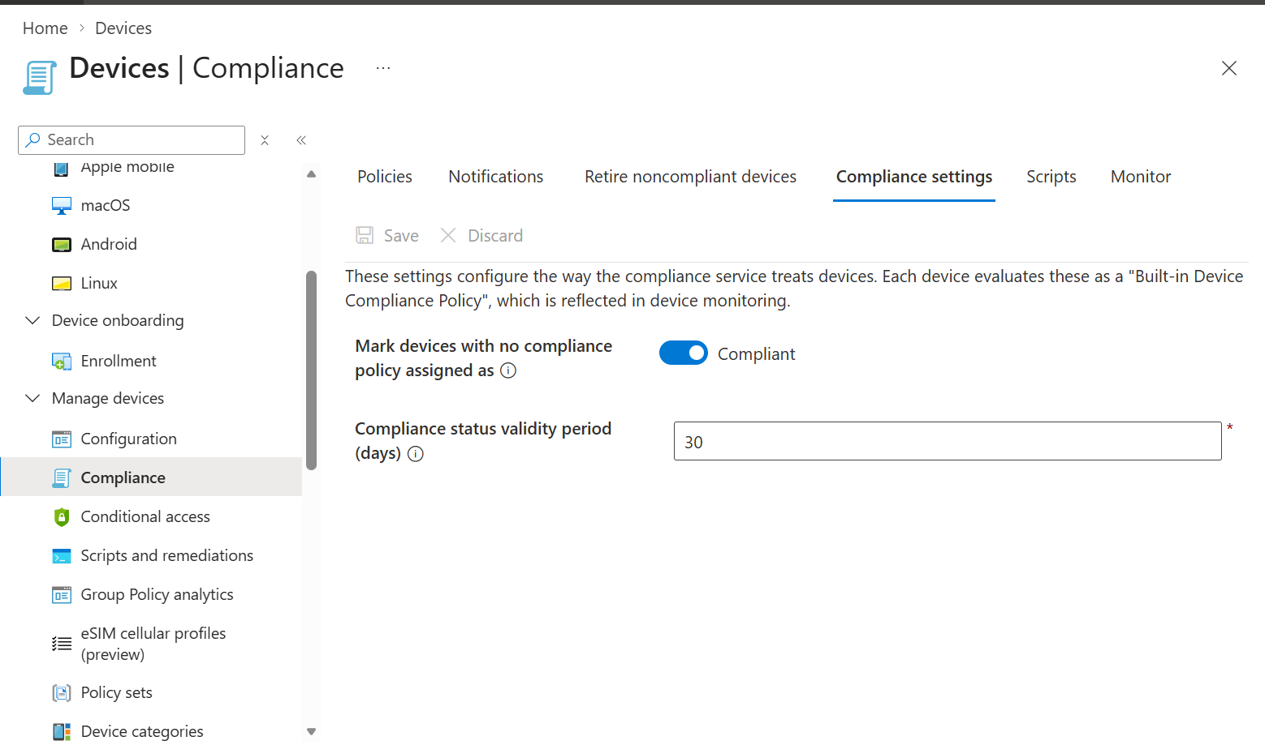
Figure 24. Compliance policy list with Windows and macOS policies.
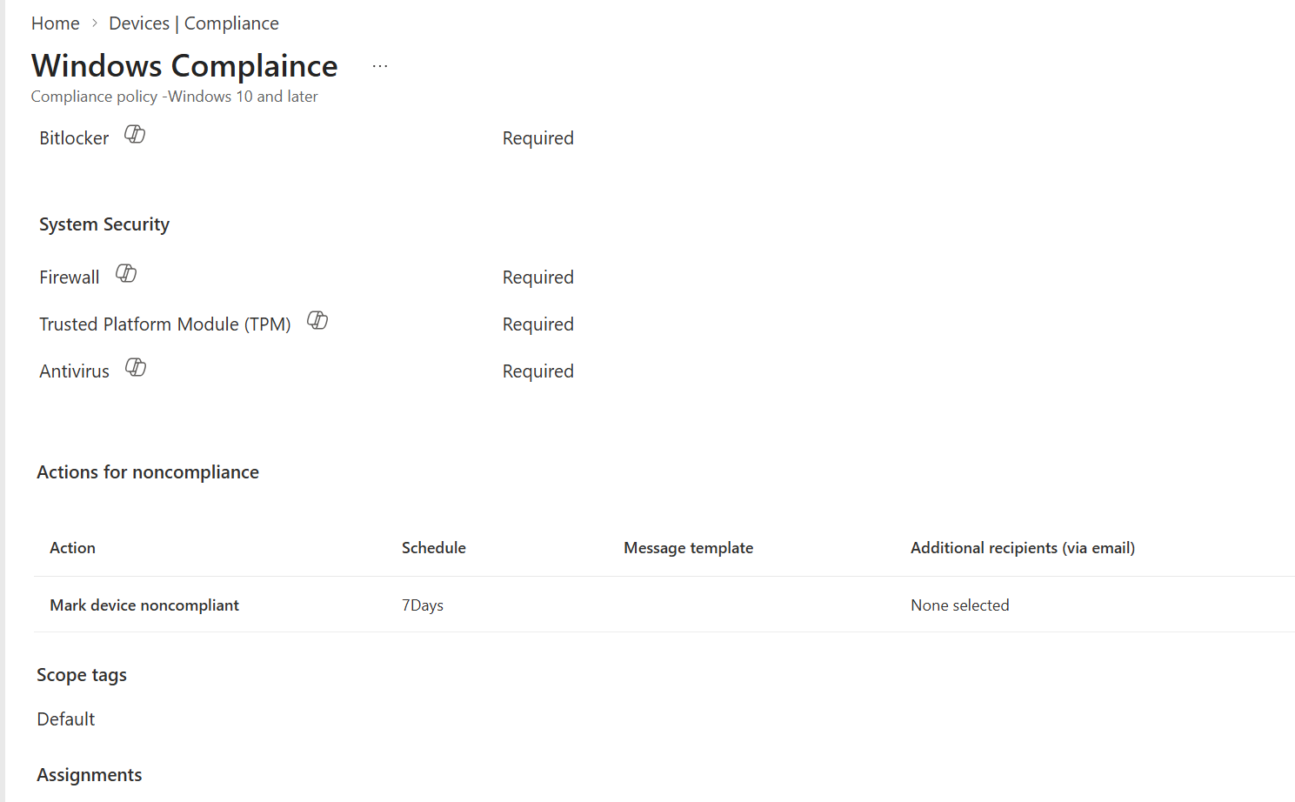
Figure 25. Windows Compliance policy device status and per-setting status.

11.1 Recommended compliance linkage
- Use a supported minimum OS/version requirement when approved.
- Require encryption, firewall, antivirus, antispyware, Secure Boot, and code integrity according to security policy.
- Configure actions for noncompliance and grace periods.
- Coordinate Conditional Access to avoid unintended lockout.
- Use update reports for patch state and compliance policies for access/security posture.

12. Additional Device and Compliance Reference Screens
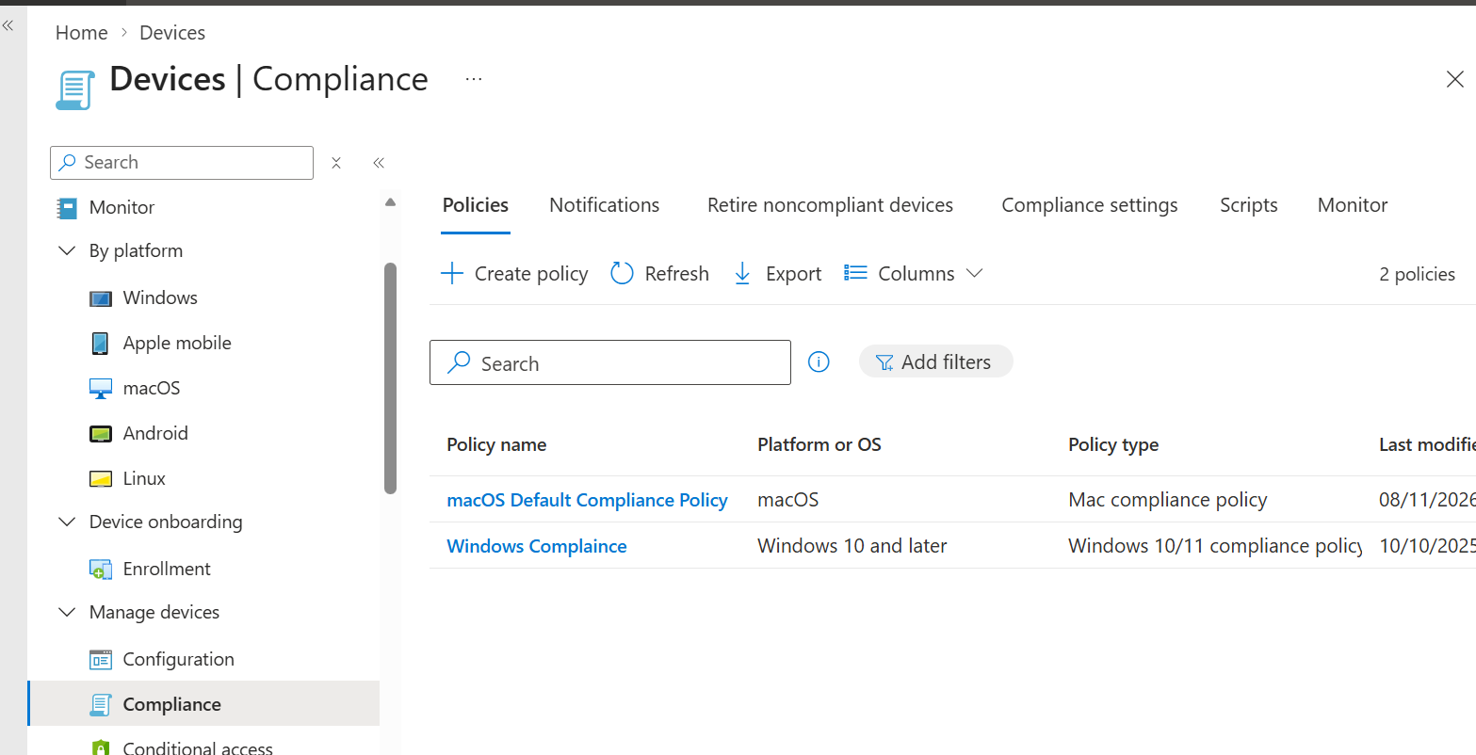
Figure 26. Device overview and monitoring reference.
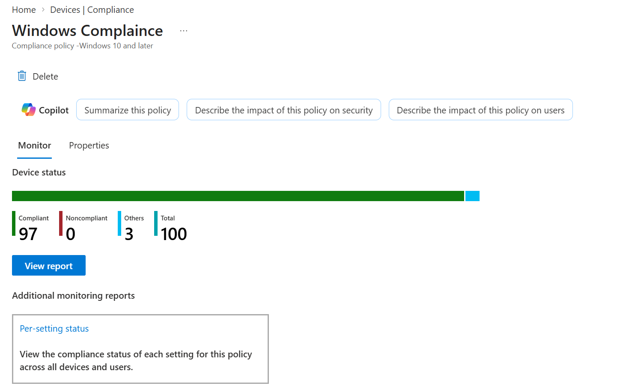
Figure 27. Device properties reference.
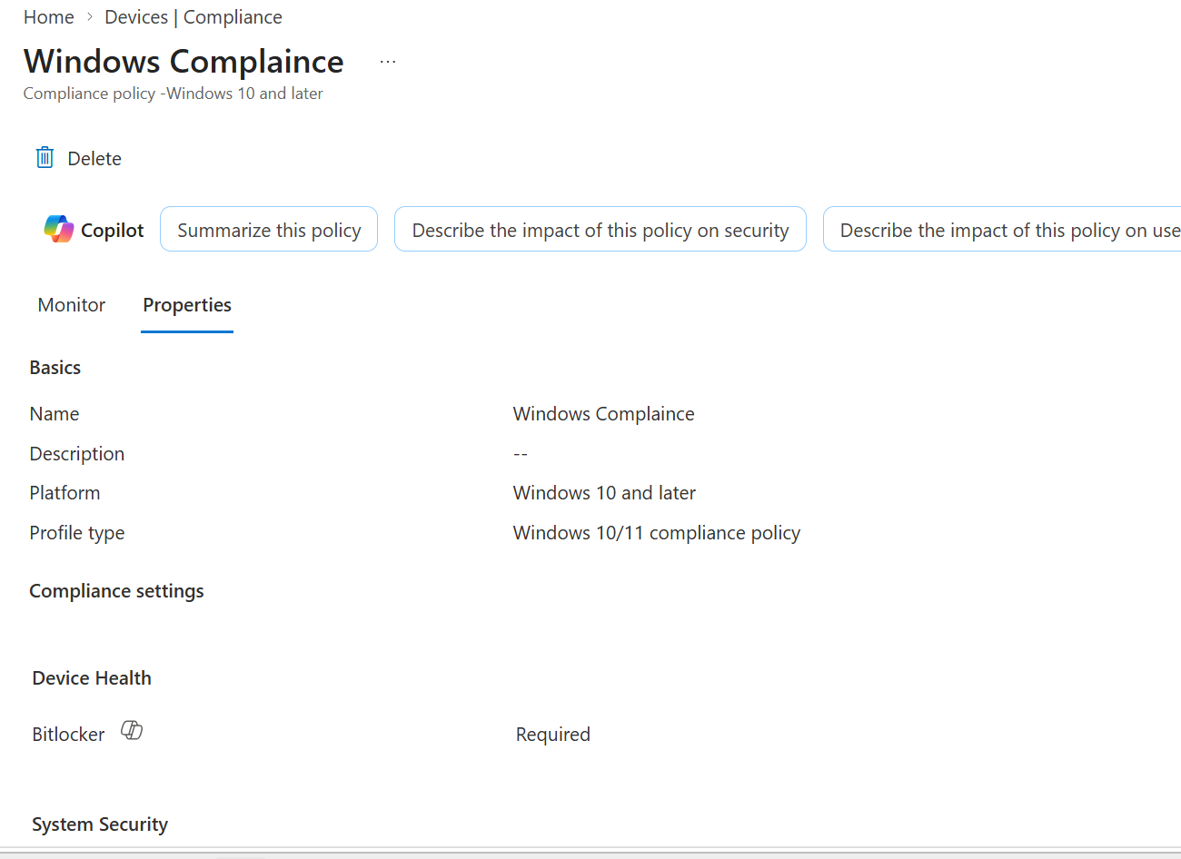
Figure 28. Managed apps and Endpoint Analytics reference.
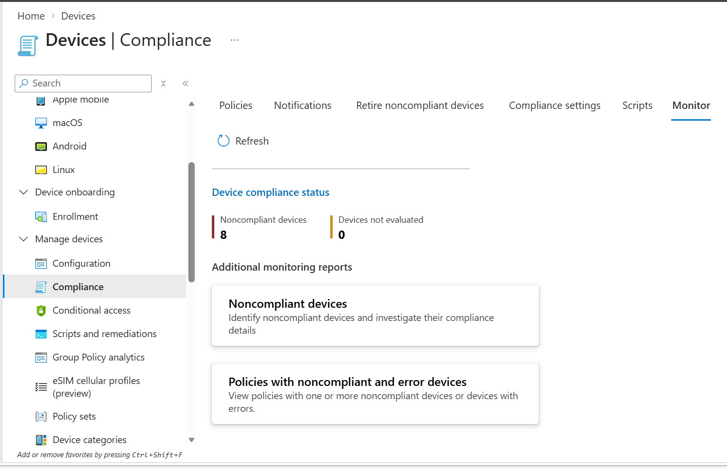
Figure 29. Additional compliance policy view retained from the source document.

13. Troubleshooting Matrix
Symptom | Likely cause | Actions
Policy not applied | Wrong group, stale check-in, unsupported edition, MDM issue | Confirm assignment, exclusions, edition, last check-in, and Windows Update policy status.
Conflict | Overlapping update rings or settings catalog/GPO | Identify every source configuring the same Windows Update setting and remove overlap.
Feature update not offered | Safeguard hold, service disabled, policy conflict, hardware readiness | Review feature readiness, safeguards, wlidsvc, hardware, storage, and policy.
Quality update delayed | Deferral/deadline, pause, device offline | Review ring settings, pause state, last scan, active hours, and restart state.
Driver not offered | Policy, applicability, approval, OEM supersedence | Review driver policy, hardware ID, approval state, and vendor tool.
Device needs restart | Deadline/grace period or user postponement | Review restart settings, active hours, deadline, and notification.
Reporting stale | Device offline or insufficient diagnostics/telemetry | Check last check-in, connectivity, diagnostics permissions, and Windows Update logs.
Autopatch ring unexpected | Service-managed policy and device registration | Review Autopatch device membership and service-managed policy assignments.
Update repeatedly fails | Servicing stack, disk, corruption, driver/app issue | Capture exact error, review Windows Update logs, free space, DISM/SFC, and known issues.

13.1 Client commands
# Update policy/result and join state
dsregcmd /status
gpresult /h C:\Temp\gpresult.html

# Windows Update log
Get-WindowsUpdateLog -LogPath C:\Temp\WindowsUpdate.log

# Repair checks after approval
DISM.exe /Online /Cleanup-Image /ScanHealth
sfc /scannow

13.2 Event Viewer
- Applications and Services Logs > Microsoft > Windows > WindowsUpdateClient > Operational.
- Applications and Services Logs > Microsoft > Windows > DeviceManagement-Enterprise-Diagnostics-Provider > Admin.
- Applications and Services Logs > Microsoft > Windows > UpdateOrchestrator > Operational where available.

14. Monthly Patch Management Runbook
- Review Microsoft release information and known issues.
- Confirm Test ring devices and owners are active.
- Validate ring, feature, quality, and driver policies have no conflicts.
- Monitor the earliest ring after release.
- Record application, driver, VPN, boot, BitLocker, and user-experience issues.
- Approve progression to Ring1/Ring2 according to policy.
- Monitor errors, restarts, compliance, and support tickets.
- Pause only with incident/change approval.
- Progress broad deployment after exit criteria are met.
- Review noncompliant and stale devices.
- Create management summary with success, failures, risks, and actions.
- Close the cycle with lessons learned and policy updates.

14.1 Emergency patch runbook
- Validate update applicability and urgency.
- Create a small emergency test assignment.
- Use quality-update expedite where supported.
- Communicate restart and support expectations.
- Monitor success/error in near real time.
- Expand in approved phases.
- Close emergency policy/assignment and document final state.

15. Governance, Change Control, and Production Standards
- Each policy has owner, purpose, version, target, exclusions, and ticket.
- Every device belongs to one intended update ring.
- Feature version control is documented.
- Driver approval approach is documented.
- Windows Autopatch-managed devices are identified clearly.
- Pause, resume, extend, and uninstall actions require recorded approval.
- Report access and RBAC use least privilege.
- Pilot devices represent hardware models, locations, users, and applications.
- Policy changes are reviewed by a second administrator.
- User communications explain restart and deadline behavior.

15.1 Recommended evidence pack
PatchManagement/
YYYY-MM/
ReleaseReview/
RingStatus/
FeatureUpdate/
QualityUpdate/
DriverUpdate/
Incidents/
Compliance/
ManagementSummary/

16. Interview and Expert Reference
Question | Strong answer
What does an update ring control? | Windows Update client behavior: deferrals, deadlines, restart, active hours, and notifications.
Update ring vs feature update policy? | The ring controls experience and timing behavior; feature policy targets a specific Windows feature version.
Why use multiple rings? | To validate updates on smaller representative groups before broad rollout.
What is a safeguard hold? | A Microsoft compatibility protection that can delay feature updates on affected devices.
What does quality update expedite do? | Accelerates a selected critical/security quality update to targeted eligible devices.
How are drivers managed? | Through driver update policies with approval and deferral controls, coordinated with OEM tools.
What is Windows Autopatch? | A cloud service that manages update orchestration and service-managed policies for eligible devices.
Why can status be conflict? | Multiple management sources or Intune policies configure incompatible values.
How do you troubleshoot? | Check assignment, applicability, authority, policy conflict, scan, download, install, restart, and reporting in order.
Pause vs deferral? | Deferral is planned delay by policy; pause is an operational stop typically used for risk or incident response.

17. Reusable Policy and Monthly Reporting Templates

17.1 Policy record
Field | Record
Policy name/type
Owner
Purpose
Included/excluded groups
Deferrals
Deadlines/grace
Restart behavior
Feature target
Driver model
Pilot evidence
Rollback/pause plan
Change ticket

17.2 Monthly status
Metric | Status / detail
Release month
Test ring
Ring1
Ring2
Ring3/Broad
Feature update
Quality update
Driver updates
Errors/conflicts
Noncompliant devices
Incidents
Next actions / owner

18. Official References and Maintenance
- Microsoft Learn: Manage Windows Update ring policies - https://learn.microsoft.com/intune/device-updates/windows/manage-update-rings
- Microsoft Learn: Manage Windows quality updates - https://learn.microsoft.com/intune/device-updates/windows/manage-quality-updates
- Microsoft Learn: Windows Autopatch documentation - https://learn.microsoft.com/windows/deployment/windows-autopatch/
Review trigger
Review this SOP whenever Microsoft changes Intune Windows update navigation, update ring settings, feature/quality/driver policy behavior, Windows Autopatch service behavior, supported Windows versions, licensing, or reporting.

