# Hive Assignment 1 Facebook_analysis

# Create table facebook

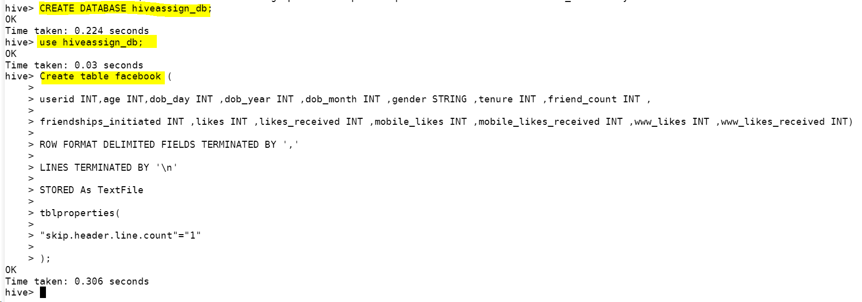

Q1:Find out the total no of users in the dataset



### Records inserted into Facebook table.

LOAD DATA LOCAL INPATH '/home/mavricbdhnov017/Assignmnet1_FacebookDataAnalysis/pseudo_facebook.csv' INTO TABLE facebook;

Herader is skipped so the records are 99003 in the facebook table.

### Q2: Find out the no of users above the age of 25

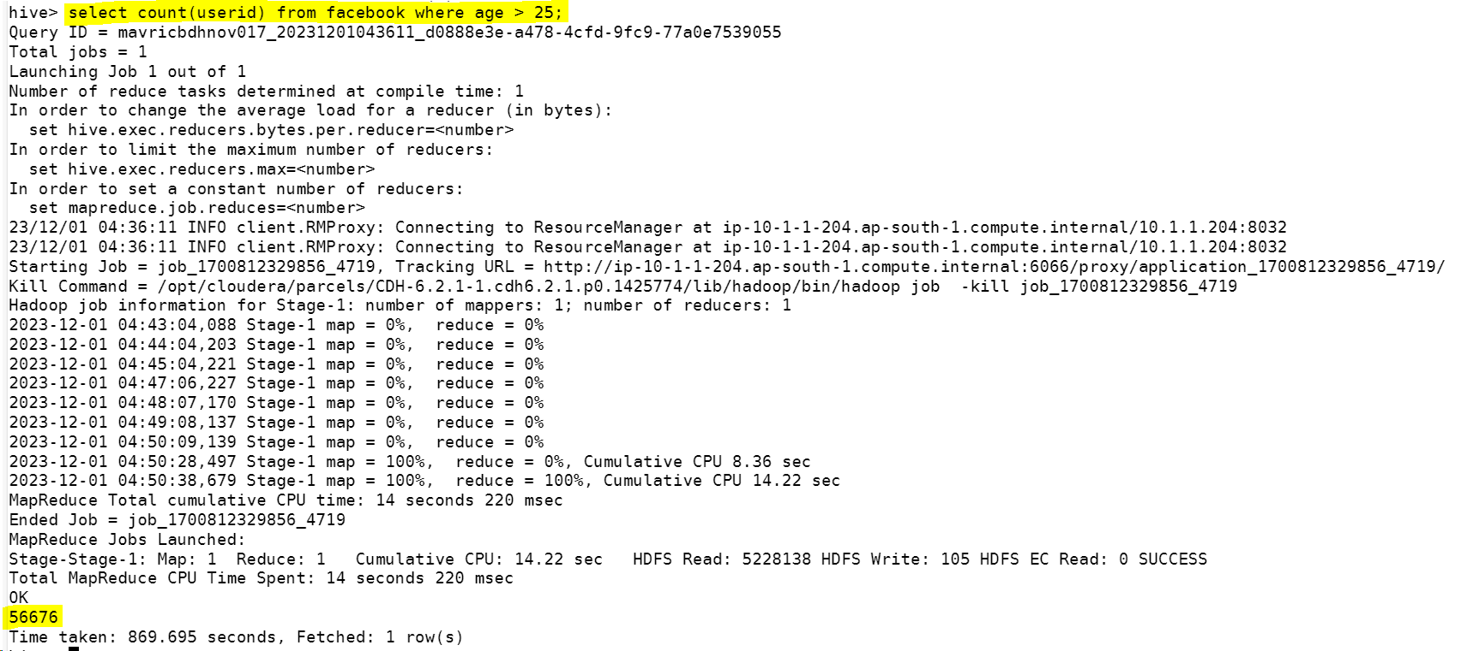

### Q3: Do male face book users tend to have more friends or female users

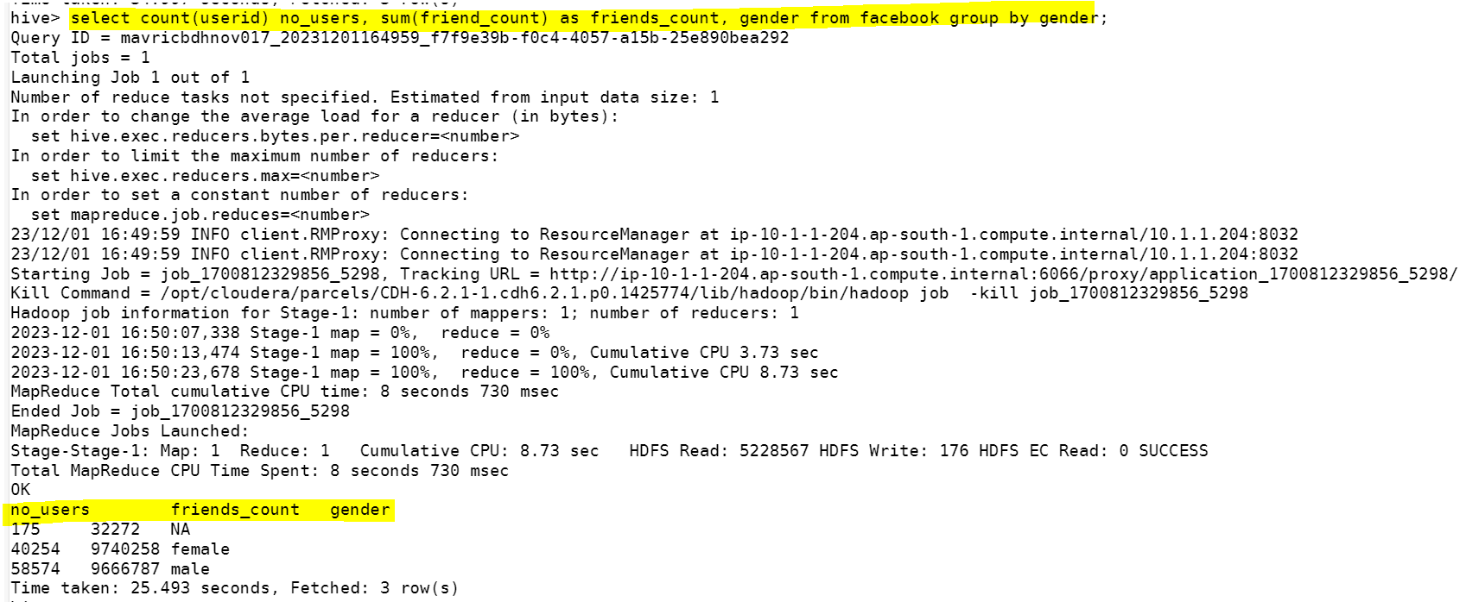

### Q4: How many likes do young people receive on facebook as opposed to old people

### Q5: Find out the count of facebook users for each birthday month

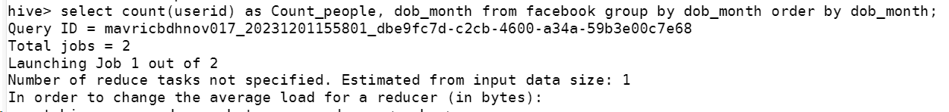

### Q6: Do young members use mobile phones or computers for facebook browsing

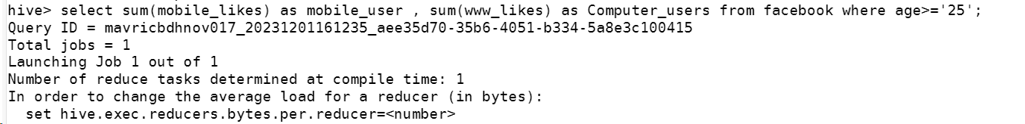

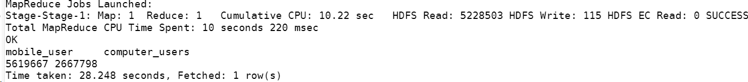

### Q7: Do adult members use mobile phones or computers for facebook browsing

