# Hive_assignment_pb3

## Data Setup in HDFS

### **Step 1:** Copy the provided csv files in a directory named AirlinesOntimeAnalysis

## **Step 2:** Unzip the contents for the bz2 files.

## Step 3: Create the directories in hdfs where your data will reside

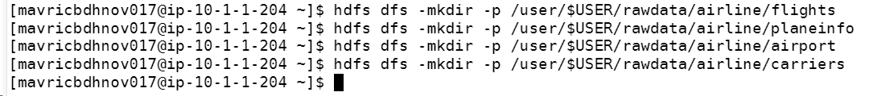

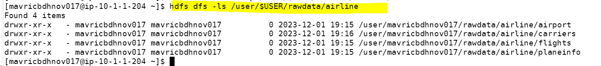

## Step 4: copy the respective files to the above created hdfs structure





## Create tables using Hive

### Create all the tables in a different database in Hive(airline_db)

Create database dn_airline_db;

### Create tables for flights , plane_info, carriers and airports in the staging area.

#### Airports

CREATE EXTERNAL TABLE airports_stg

(IATA String COMMENT '3-letter IATA code. Null if not assigned/unknown',

Name String COMMENT 'Name of airport. May or may not contain the City name',

City String COMMENT 'Main city served by airport. May be spelled differently from Name',

State String COMMENT 'Main state served by airport. May be spelled differently from Name',

Country String COMMENT 'Country or territory where airport is located. See countries.dat to cross-reference ISO 3166-1 codes',

Lat Decimal COMMENT 'degreesCOMMENT usually to six significant digits. Negative is SouthCOMMENT positive is North',

Long Decimal COMMENT 'degreesCOMMENT usually to six significant digits. Negative is WestCOMMENT positive is East')

ROW FORMAT DELIMITED FIELDS TERMINATED BY ','

LINES TERMINATED BY '\n'

STORED As TextFile

LOCATION '/user/mavricbdhnov017/rawdata/airline/airport'

tblproperties(

"skip.header.line.count"="1"

);

#### Carrier

CREATE EXTERNAL TABLE carrier_stg

(Code String COMMENT 'Unique OpenFlights identifier for this airline',

Description String COMMENT 'Name of the airline')

ROW FORMAT DELIMITED FIELDS TERMINATED BY ','

LINES TERMINATED BY '\n'

STORED As TextFile

LOCATION '/user/mavricbdhnov017/rawdata/airline/carriers'

tblproperties(

"skip.header.line.count"="1"

);

#### Plane Info

CREATE EXTERNAL TABLE plane_info_stg

(tailNum String COMMENT 'Tail number painted on the tail of a plane',

type String COMMENT 'manufacturer String, Manufacturer of plane like Airbus BOEING',

issue_date String,

model String COMMENT 'Model number of the plane',

status String ,

aircraft_type String COMMENT 'Type of aircraft',

engine_type String COMMENT 'Type of engine',

year Int COMMENT 'Year of manufacture')

ROW FORMAT DELIMITED FIELDS TERMINATED BY ','

LINES TERMINATED BY '\n'

STORED As TextFile

LOCATION '/user/mavricbdhnov017/rawdata/airline/planeinfo'

tblproperties(

"skip.header.line.count"="1"

);

#### Flights

CREATE EXTERNAL TABLE flights_stg

(Year Int COMMENT '2003-2005',

Month Int COMMENT '1-12',

DayofMonth Int COMMENT '1-31',

DayOfWeek Int COMMENT '1 (Monday) - 7 (Sunday)',

DepTime Int COMMENT 'actual departure time (local, hhmm)',

CRSDepTime Int COMMENT 'scheduled departure time (local, hhmm)',

ArrTime Int COMMENT 'actual arrival time (local, hhmm)',

CRSArrTime Int COMMENT 'scheduled arrival time (local, hhmm)',

UniqueCarrier String COMMENT 'unique carrier code',

FlightNum String COMMENT 'flight number',

TailNum String COMMENT 'plane tail number',

ActualElapsedTime Int COMMENT 'in minutes',

CRSElapsedTime Int COMMENT 'in minutes',

AirTime Int COMMENT 'in minutes',

ArrDelay Int COMMENT 'arrival delay, in minutes',

DepDelay Int COMMENT 'departure delay, in minutes',

Origin String COMMENT 'origin IATA airport code',

Dest String COMMENT 'destination IATA airport code',

Distance Int COMMENT 'in miles',

TaxiIn String COMMENT 'taxi in time, in minutes',

TaxiOut String COMMENT 'taxi out time in minutes',

Cancelled String COMMENT 'was the flight cancelled?',

CancellationCode String COMMENT 'reason for cancellation (A = carrier,B = weather, C = NAS, D = security)',

Diverted String COMMENT '1 = yes, 0 = no',

CarrierDelay Int COMMENT 'in minutes',

WeatherDelay Int COMMENT 'in minutes',

NASDelay Int COMMENT 'in minutes',

SecurityDelay Int COMMENT 'in minutes',

LateAircraftDelay Int COMMENT 'in minutes')

ROW FORMAT DELIMITED FIELDS TERMINATED BY ','

LINES TERMINATED BY '\n'

STORED As TextFile

LOCATION '/user/mavricbdhnov017/rawdata/airline/flights'

tblproperties(

"skip.header.line.count"="1"

);

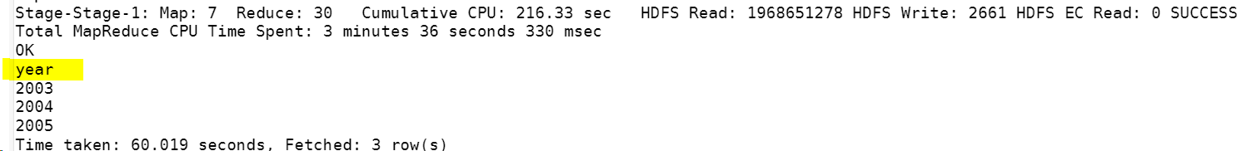

### What is the average arrival delay and average departure delay in each month of the year 2004?

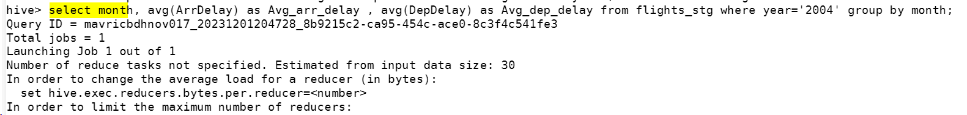

## Improving the performance of Hive tables - Parquet format

Create the parquet table as external tables for flights from the above staging table.

Name the new table with _pq as a suffix: Ex : flights_pq

Point all the table location output/airline/pq_flights

CREATE EXTERNAL TABLE flights_pq

(Year Int COMMENT '2003-2005',

Month Int COMMENT '1-12',

DayofMonth Int COMMENT '1-31',

DayOfWeek Int COMMENT '1 (Monday) - 7 (Sunday)',

DepTime Int COMMENT 'actual departure time (local, hhmm)',

CRSDepTime Int COMMENT 'scheduled departure time (local, hhmm)',

ArrTime Int COMMENT 'actual arrival time (local, hhmm)',

CRSArrTime Int COMMENT 'scheduled arrival time (local, hhmm)',

UniqueCarrier String COMMENT 'unique carrier code',

FlightNum String COMMENT 'flight number',

TailNum String COMMENT 'plane tail number',

ActualElapsedTime Int COMMENT 'in minutes',

CRSElapsedTime Int COMMENT 'in minutes',

AirTime Int COMMENT 'in minutes',

ArrDelay Int COMMENT 'arrival delay, in minutes',

DepDelay Int COMMENT 'departure delay, in minutes',

Origin String COMMENT 'origin IATA airport code',

Dest String COMMENT 'destination IATA airport code',

Distance Int COMMENT 'in miles',

TaxiIn String COMMENT 'taxi in time, in minutes',

TaxiOut String COMMENT 'taxi out time in minutes',

Cancelled String COMMENT 'was the flight cancelled?',

CancellationCode String COMMENT 'reason for cancellation (A = carrier,B = weather, C = NAS, D = security)',

Diverted String COMMENT '1 = yes, 0 = no',

CarrierDelay Int COMMENT 'in minutes',

WeatherDelay Int COMMENT 'in minutes',

NASDelay Int COMMENT 'in minutes',

SecurityDelay Int COMMENT 'in minutes',

LateAircraftDelay Int COMMENT 'in minutes')

STORED AS PARQUET

LOCATION '/user/mavricbdhnov017/rawdata/airline/flights_pq'

tblproperties(

"skip.header.line.count"="1"

);

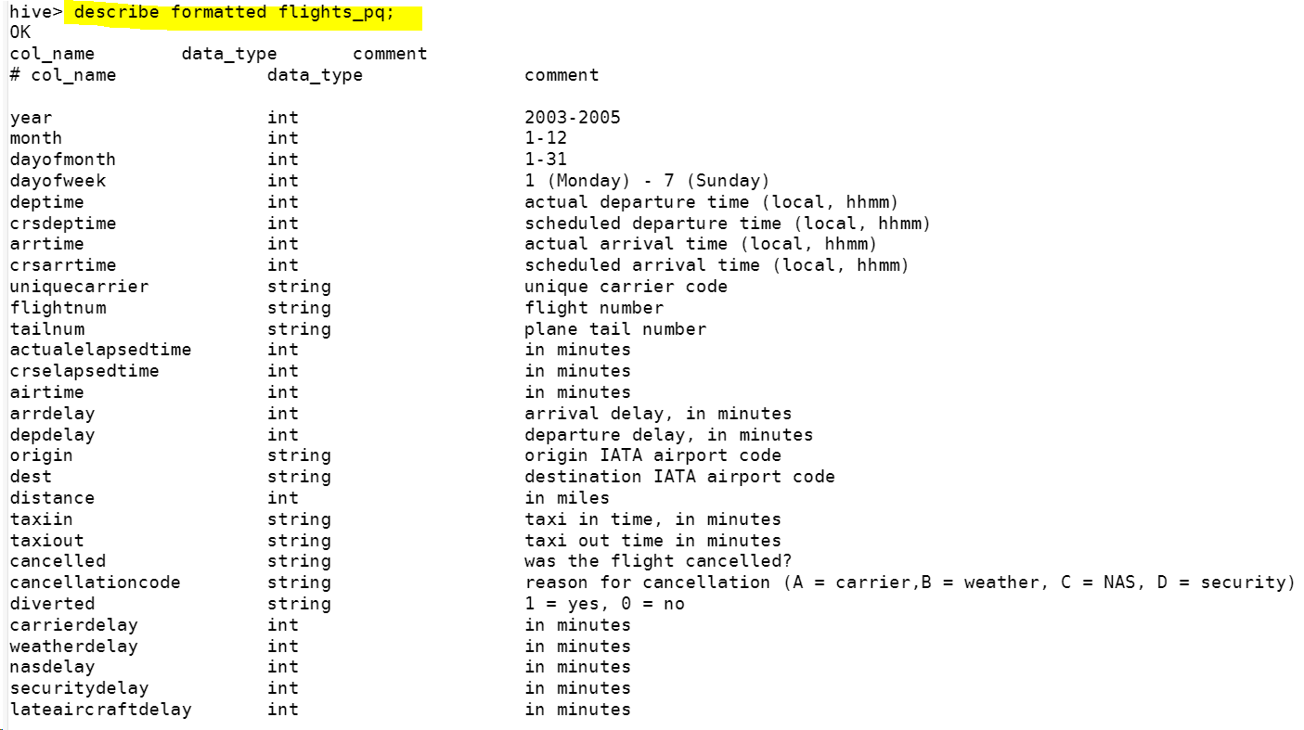

### Run the same query as above to check if data is loaded properly

#### Is there a difference between the response times for the queries(2 and 3)

##### Query-2

##### Query-3

###### Avg calculation

Staging table

parquet table

