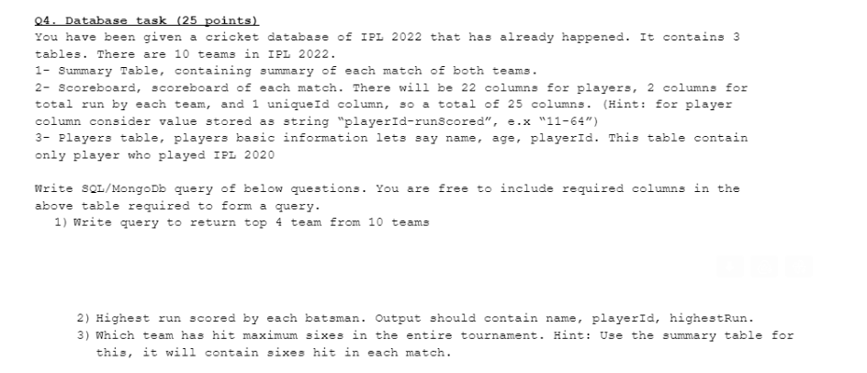

1. Write query to return top 4 team from 10 teams

In Scoreboard table there is 2(two) columns for total run by each team and teamName

**SELECT teamName, SUM(run) AS TotalRun FROM SCOREBOARD GROUP BY teamName ORDER BY TotalRun DESC LIMIT 4;**

1. Highest run scored by each batsman

In scoreboard table there is 22 columns for players which contain player name, playerId-runScored and many more. From that above column name we can select name playerid and runscore by batsman. We can separate the **“playerId-runScored”** the column name using **SUBSTRING_INDEX** function for query.

**SELECT name, SUBSTRING_INDEX(playerId-runScored,”-“,1) AS playerId, MAX(SUBSTRING_INDEX(playerId-runScored,”-“,-1) FROM SCOREBOARD GROUP BY SUBSTRING_INDEX(playerId-runScored,”-“,1);**

1. Which team has hit maximum sixes

In Summary table it contains columns like teamName, sixes of each team.

**SELECT teamName, SUM(sixes) as totalSixes FROM SUMMARY GROUP BY teamName ORDER BY totalSixes DESC LIMIT 1;**