Pimpri Chinchwad Education Trust’s

Pimpri Chinchwad College of Engineering
Sector No. 26, Pradhikaran, Nigdi, Pune 411044
An Autonomous Institute Approved By AICTE and Affiliated To SPPU, Pune

DEPARTMENT OF INFORMATION TECHNOLOGY

Software Project Management Laboratory Mini Project Report
of

T. Y. B. Tech
Academic Year: 2026-27
Semester - I on

MediLocker — Secure Cloud-Based Digital Medical Record Management Platform
By
PRN | Name of the Student
124B1F032  123B1F034  124B1F047 | Dnyaneshwari Ghorpade  Aastha Chaudhari  Soham Sapkal

CERTIFICATE

This is to certify that the project report entitled MediLocker — Secure Cloud-Based Digital Medical Record Management Platform submitted by Dnyaneshwari Ghorpade , in partial fulfillment of the requirements for the award of the degree Bachelor of Technology in Information Technology, is a record of original work carried out under the supervision of Mrs.Sandhya Sandeep Waghere. This project report has not been previously submitted to any other institute or university for the award of any degree or diploma.

Dr. Sandhya Sandeep Waghere  Project Guide | Prof. Dr. Jayashree Katti  HOD IT

INDEX
Sr. No. | Chapters | Page No
1. | Introduction  1.1 Project Background, Purpose, and Relevance  1.2 Problem Addressed and Domain  1.3 Mapping to Sustainable Development Goals (SDGs)  1.4 Objectives | 5
2. | System Study  2.1 Currently Available System / Process  2.2 Disadvantages or Inefficiencies  2.3 Proposed Solution and Advantages  2.4 Problem Statement and Project Title  2.5 Key Tasks, User Intervention, and Performance Parameters | 6
3. | System Requirements Specification (SRS)  3.1 Functional Requirements  3.2 Non-Functional Requirements | 8
4. | System Design  4.1 Existing System  4.2 Limitations of Existing System  4.3 Problem Definition / Title  4.4 Proposed System — Current Implementation Architecture | 10
5. | System Implementation  5.1 Functional Modules of the System  5.2 Algorithm: AES-256-GCM Envelope Encryption  5.3 Key Code Snippet — Audit Log Immutability Trigger | 12
6. | Testing and Deployment  6.1 Manual Test Cases  6.2 Output / Deployment Screens | 14
7. | Result and Discussion | 16
8. | References | 17

Chapter 1 : Introduction
1.1 Project Background, Purpose, and Relevance
In the modern healthcare landscape, patient medical records are fragmented across hospitals, clinics, and diagnostic centers. This fragmentation causes redundant testing, care discontinuity, and life-threatening delays during emergencies. The shift towards digitization has introduced severe privacy risks, as Personal Health Information (PHI) is stored in insecure, siloed systems. MediLocker is a secure, cloud-based, patient-owned digital medical record management platform. It empowers patients with absolute data control through granular consent while providing healthcare providers with immediate, verified access to medical histories in critical situations.
1.2 Problem Addressed and Domain
MediLocker addresses health data fragmentation and privacy vulnerability in the Healthcare domain. It mitigates unauthorized data sharing, data loss, and emergency access delays by implementing a zero-trust architecture, ECDSA P-256 cryptographic signatures for prescriptions, and a SHA-256 hash-chained tamper-evident integrity ledger backed by an immutable database trigger.
1.3 Mapping to Sustainable Development Goals (SDGs)
SDG 3 — Good Health and Well-being: Immediate access to verified medical history reduces medical errors and improves emergency response outcomes.
SDG 9 — Industry, Innovation and Infrastructure: A cloud-native, cryptographically secure digital infrastructure for healthcare, aligned with India's Ayushman Bharat Digital Mission (ABDM).
1.4 Objectives
1. To develop a cloud-native patient medical vault with AES-256-GCM envelope encryption and category-level, time-bounded consent controls for all five user roles.
2. To implement a 'Break-Glass' emergency access protocol with dual-party OTP approval and automatic 4-hour expiry, enabling life-saving data access when a patient is incapacitated.
3. To ensure data integrity through a SHA-256 hash-chained PostgreSQL ledger with an immutability trigger and ECDSA P-256 prescription signing verified server-side against the doctor's registered public key.
Chapter 2 : System Study
2.1 Currently Available System / Process
The existing ecosystem relies on isolated Hospital Management Systems (HMS) and physical paper records. A patient's medical history stays locked in the previous institution's database. Inter-hospital data exchange occurs via unencrypted email or physical paper handoffs, with no patient consent layer or cryptographic authenticity mechanism.
2.2 Disadvantages or Inefficiencies
1. Data Fragmentation: Patients lose reports, leading to repeated diagnostic tests and disjointed care.
2. Emergency Access Delays: Attending physicians have zero access to a critical patient's allergy or chronic disease history during trauma, risking fatal drug interactions.
3. No Consent Control: Doctors and staff can view a patient's complete medical file without explicit patient permission, violating the DPDP Act 2023.
4. No Prescription Authenticity: PDF prescriptions are easily altered using basic software, enabling pharmaceutical fraud with no cryptographic detection.
2.3 Proposed Solution and Advantages
MediLocker centralizes records in a zero-trust encrypted vault. Patients grant time-bound, category-specific access (e.g., allowing Blood Reports, blocking HIV Reports). The Break-Glass module provides dual-verified emergency access within a strictly enforced 4-hour window. Prescriptions are signed with ECDSA P-256 keys; the server verifies every signature before storing the prescription. All document SHA-256 hashes are anchored to a hash-chained immutable ledger — any tampering is instantly detectable.
2.4 Problem Statement and Project Title
Title: MediLocker — Secure Cloud-Based Digital Medical Record Management Platform.
Problem Statement: To design and implement a patient-centric digital healthcare platform that addresses medical record fragmentation, supports privacy through granular consent, and facilitates verified access during emergencies, while allowing for further legal and regulatory assessment before claiming full compliance with the India DPDP Act 2023 or formal integration with the ABDM framework.
2.5 Key Tasks, User Intervention, and Performance Parameters
Key Tasks: Salted Aadhaar hash registration (DPDP-compliant), MRN-verified doctor onboarding, AES-256-GCM file upload, category-level consent management, ECDSA P-256 prescription signing, SHA-256 hash-chain integrity sweeping via scheduled jobs.
User Intervention: Minimal once consent is granted. Emergency access requires hospital admin OTP approval.
Performance Parameters — Speed: <10ms consent evaluation on Redis cache hit; ~90ms on cold cache. Accuracy: 100% ECDSA signature and SHA-256 hash verification accuracy. Accessibility: 78/78 API routes verified non-5xx; deployed on Vercel (frontend) and Render (backend).

Chapter 3: System Requirement Specification (SRS)
3.1 Functional Requirements
FR01 — Role-Based Portals: Distinct authenticated portals for Patient, Doctor, Hospital Admin, Platform Admin, Emergency Physician, and a public verifier (no login).
FR02 — Medical Vault and Encryption: Doctors upload files (PDF, JPEG, PNG) encrypted with AES-256-GCM using a unique per-file DEK wrapped by a master key (local or AWS KMS).
FR03 — Granular Consent Engine: Patients grant time-bounded, category-specific access per doctor. A block always overrides a grant. Revocation takes effect within 1 second via Redis key deletion.
FR04 — TOTP MFA: All users complete time-based OTP authentication after password entry. Backup codes are issued at enrolment.
FR05 — Digital Prescriptions: Doctors sign prescriptions with ECDSA P-256 (browser-generated, non-extractable key). Server verifies signature before storage. Public verifier portal at /verify.
FR06 — Break-Glass Emergency Access: Dual-party OTP approval required. Hard 4-hour expiry enforced by scheduled job. Patient and emergency contact notified immediately.
FR07 — Integrity Ledger: SHA-256 hash of every uploaded file anchored to an append-only, hash-chained PostgreSQL ledger. Scheduled integrity sweep re-hashes stored files and alerts on mismatch.
FR08 — Audit Log: Every state-changing request and every record access is logged with a chained SHA-256 hash. No row may be modified or deleted (enforced by database trigger).
3.2 Non-Functional Requirements
NFR01 — Security: PHI encrypted at rest (AES-256-GCM) and in transit (TLS 1.3). Passwords hashed with Bcrypt. JWT secrets ≥ 32 characters; system refuses to start without them.
NFR02 — Performance: Consent evaluation <10ms on Redis cache hit. Current remote DB round-trip: ~1300ms (Supabase ap-northeast-1).
NFR03 — DPDP Compliance: Aadhaar stored as salted SHA-256 hash only. Audit logs immutable (7-year retention). Soft deletes preserve audit hashes.
NFR04 — Account Security: Account locked after 10 failed login attempts for 15 minutes. Auth endpoints rate-limited to 10 requests per 15-minute window.
NFR05 — Scalability: Docker + docker-compose brings up full stack (PostgreSQL, Redis, API, nginx frontend). GitHub Actions CI runs typecheck, 77 integration tests, and build on every PR.

Chapter 4 : System Design
SDLC Model and Justification
Agile SDLC was adopted across six sequential delivery phases. Justification: Integrating cryptography, a tamper-evident ledger, and healthcare compliance required correctness to precede capability. Each phase had verifiable acceptance criteria (tests passing, not merely assertions). Phases: (1) Foundation and Defect Repair, (2) Backend Hardening and Audit Integrity, (3) Encrypted File Pipeline, (4) Cryptographic Identity, (5) Platform Services and Automation, (6) Frontend Completion and Delivery. All six phases were delivered.
4.1 Existing System
Isolated Hospital Management Systems store patient records in plaintext relational databases or paper filing cabinets. Data exchange occurs through unencrypted email or physical handoffs. No patient consent layer, no cryptographic signature, and no immutable audit trail exists.
4.2 Limitations of Existing System
1. Plaintext storage is vulnerable to ransomware and internal theft.
2. Patients have no visibility or control over who views their data.
3. PDF prescriptions can be forged or altered without detection.
4. Emergency physicians have no access to patient history for unconscious or unresponsive patients.
5. No cryptographic audit trail exists to prove unauthorized access or data modification.
4.3 Problem Definition / Title
Title: MediLocker — Secure Cloud-Based Digital Medical Record Management Platform.
Definition: To develop a patient-centric digital healthcare platform that addresses medical record fragmentation, supports patient-controlled access through granular consent, and facilitates verified emergency access. Further legal and regulatory assessment is required before claiming full compliance with the DPDP Act 2023 or formal integration with the ABDM framework.

4.4 Proposed System — Current Implementation Architecture
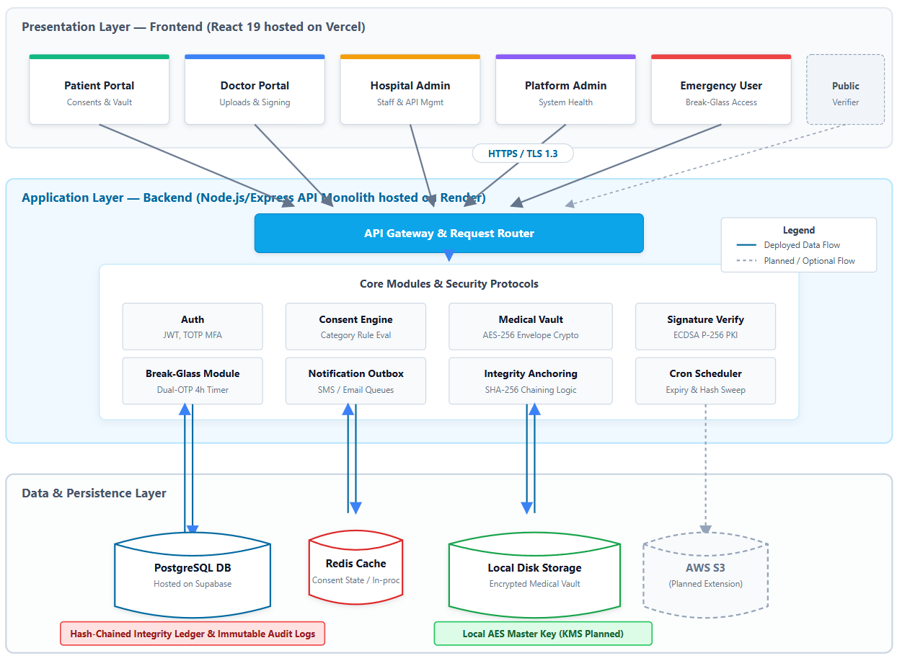
Figure 4.1: MediLocker System Architecture

The MediLocker system follows a centralized, cloud-based architecture in which the React frontend communicates with the Node.js/Express backend through secure HTTPS requests. The backend manages authentication, role-based access control, patient consent, medical record operations and prescription verification. PostgreSQL stores application data, while the hash-chained integrity ledger and audit logs support the detection of unauthorized modifications. Medical documents are protected using AES-256-GCM envelope encryption before storage. Redis provides consent caching when configured, with an in-process fallback available in the current implementation. Scheduled jobs and notification processing support background operations. Cloud object storage and external key-management services remain potential extensions where they have not yet been integrated.

Chapter 5 : System Implementation
5.1 Functional Modules of the System
The system is organized into 12 domain modules backed by 20 PostgreSQL tables:
1. Identity, Authentication & RBAC — users, user_sessions, mfa_backup_codes. TOTP MFA, Bcrypt passwords, JWT session management across 5 roles.
2. Medical Vault & Records — patient_vaults, medical_records. AES-256-GCM file encryption, SHA-256 hash computation, per-file DEK.
3. Prescriptions — prescriptions (JSONB medications array, ECDSA P-256 signature, QR link).
4. Consent Management — consents. Redis-cached category-level grants/blocks with instant revocation.
5. Break-Glass Emergency — break_glass_access_sessions, break_glass_record_accesses. Dual OTP approval, 4-hour expiry, patient notification.
6. Integrity Ledger — ledger_entries. Append-only, SHA-256 hash-chained. Scheduled integrity sweep.
7. Record Flagging — record_flags. Four-state dispute lifecycle (FLAGGED → UNDER_REVIEW → RESOLVED).
8. Patient Vitals — patient_vitals. Time-series readings (BP, blood sugar, SpO2, weight) for dashboard charts.
9. Consultations — consultations. Doctor visit history with follow-up reminders via scheduled job.
10. HMS API Management — hms_api_clients. SHA-256 API key hashing, IP whitelisting, rate limiting.
11. Notifications — notifications. Outbox pattern for 6 event types via email/SMS; rows marked SIMULATED if no provider is configured.
12. Audit Log — audit_logs (BIGSERIAL). Every request logged with chained SHA-256. BEFORE UPDATE OR DELETE trigger enforces immutability. Verifiable at GET /api/v1/admin/audit-logs/verify-chain.
5.2 Algorithm: AES-256-GCM Envelope Encryption
Step 1: Generate a unique 32-byte DEK (crypto.randomBytes(32)) per file.
Step 2: Generate a 12-byte IV (crypto.randomBytes(12)).
Step 3: Encrypt the file buffer using AES-256-GCM with the DEK and IV; extract GCM auth tag.
Step 4: Encrypt the DEK with the master key (local env or AWS KMS); wipe plaintext DEK from memory.
Step 5: Store ciphertext to disk/S3; store Encrypted DEK + IV + auth tag + SHA-256 hash in PostgreSQL.
Decryption: Fetch Encrypted DEK → decrypt with master key → decrypt file in memory → stream to client → log in audit chain.
5.3 Key Code Snippet — Audit Log Immutability Trigger
CREATE OR REPLACE FUNCTION trg_enforce_audit_immutability()
RETURNS TRIGGER AS $$
BEGIN
RAISE EXCEPTION 'Audit logs are immutable. UPDATE and DELETE are forbidden.';
RETURN NULL;
END;
$$ LANGUAGE plpgsql;
CREATE TRIGGER trg_audit_logs_immutable
BEFORE UPDATE OR DELETE ON audit_logs
FOR EACH ROW EXECUTE FUNCTION trg_enforce_audit_immutability();

Chapter 6 : Testing and Deployment
6.1 Manual Test Cases
TC ID | Test Condition | Data Input | User Action | Expected Output | Actual Output | Result
TC-01 | Patient login with TOTP MFA | Correct email, password, valid 6-digit TOTP | Click Sign In | Redirect to /patient/dashboard | Redirected to dashboard | PASS
TC-02 | Doctor views consent-blocked category (HIV_REPORT) | record_id of HIV_REPORT; consent blocks category | GET /api/v1/vault/records/:id/download | HTTP 403 — category blocked | HTTP 403 as expected | PASS
TC-03 | File encryption integrity | Upload test_xray.jpg | POST /api/v1/vault/records | Stored file is AES-256-GCM ciphertext | Raw stored object is unreadable ciphertext | PASS
TC-04 | Audit log immutability | SQL: DELETE FROM audit_logs WHERE log_id=1 | Run query directly on DB | Transaction aborted by trigger | ERROR: Audit logs are immutable | PASS
TC-05 | Break-glass session auto-expiry | Session token past 4-hour expiry | GET /api/v1/emergency/session/:id/records | HTTP 401 — session expired | HTTP 401 as expected | PASS
TC-06 | Prescription tampering detection | Altered prescription (dosage changed) | POST /api/v1/public/verify-prescription | Signature verification failed | Tamper detected — invalid signature | PASS
TC-07 | Account lockout after 10 failed logins | 10 × wrong password attempts | POST /api/v1/auth/login ×10 | HTTP 423 — account locked 15 min | HTTP 423 returned on 11th attempt | PASS
TC-08 | Consent revocation takes immediate effect | Active consent revoked by patient | PATCH /api/v1/consent/:id/revoke then doctor accesses record | HTTP 403 within 1 second | HTTP 403 < 1s after revocation | PASS
6.2 Output / Deployment Screens
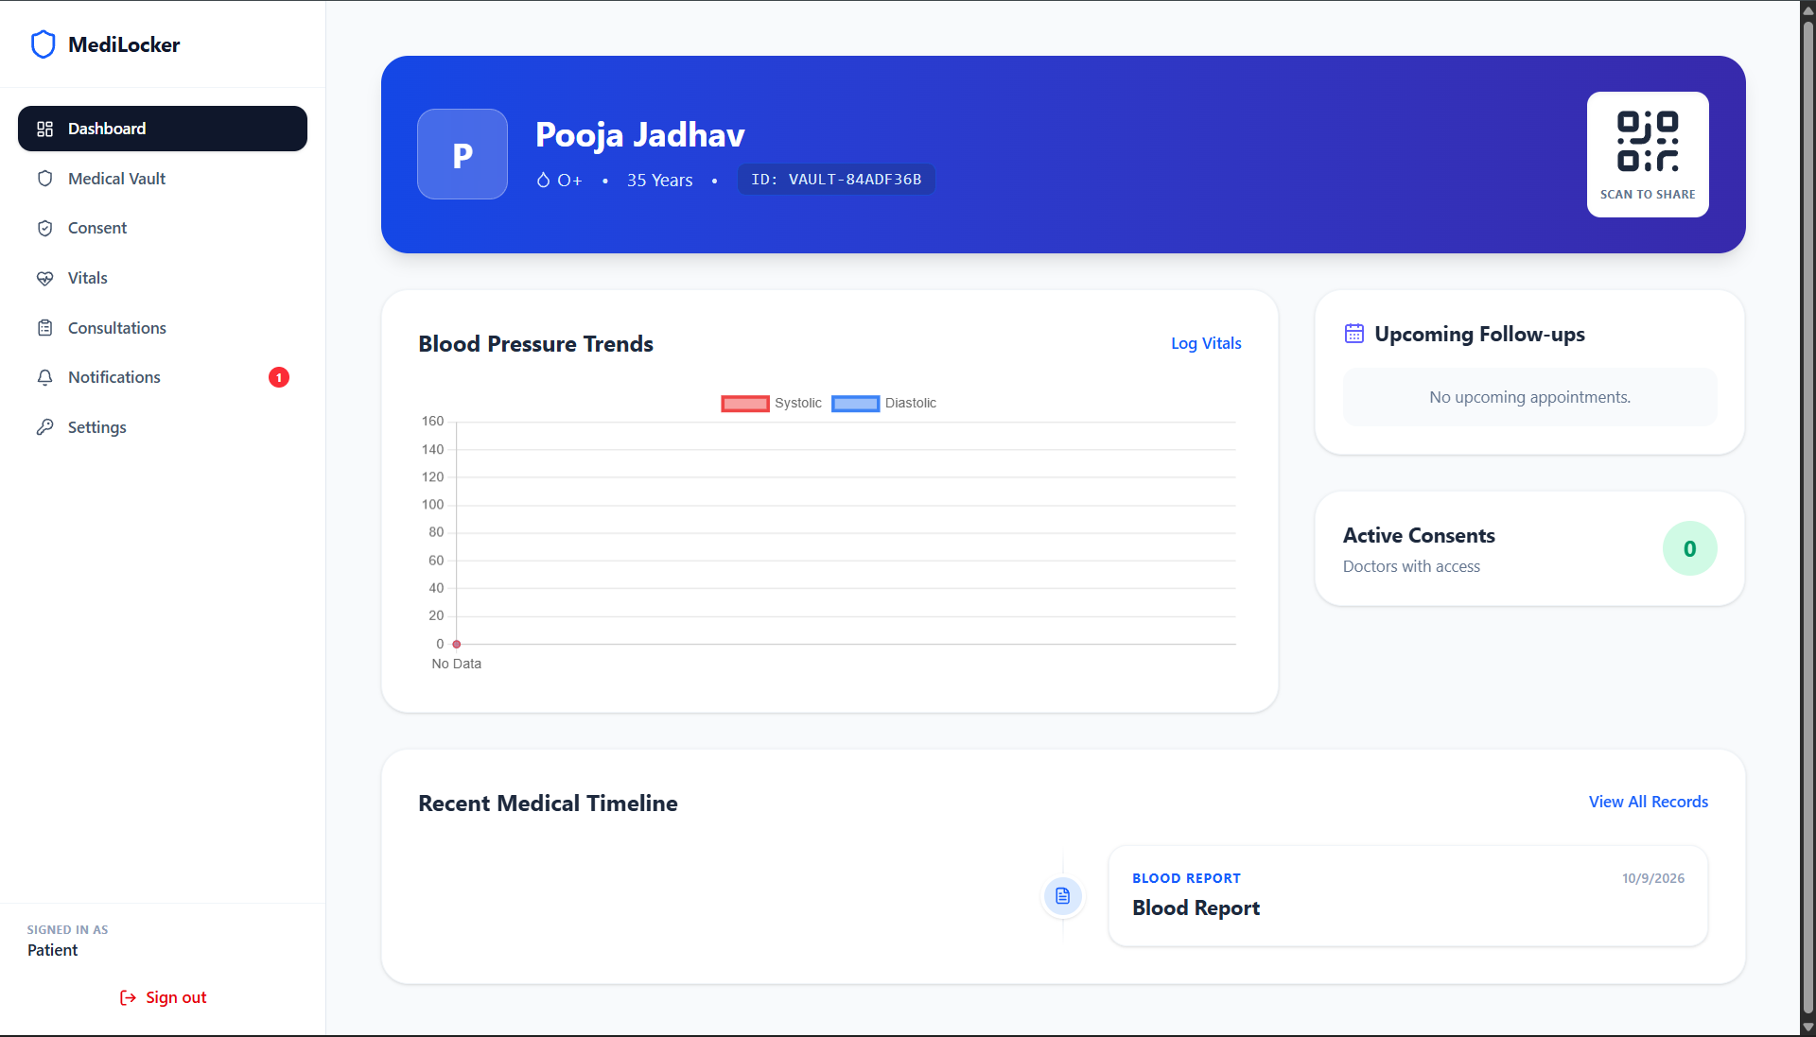Figure 6.1: Patient Dashboard of the MediLocker Platform
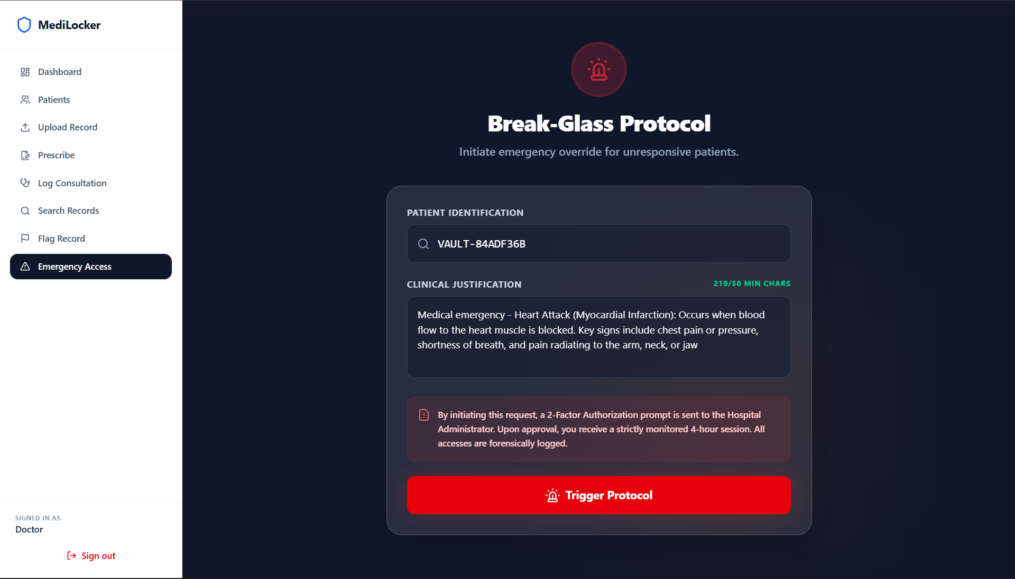Figure 6.2: Break-Glass Emergency Access Interface
Deployment URLs:
Frontend(Vercel) : https://medi-locker-khaki.vercel.app
Backend API (Render) : https://medilocker-backend-5vpd.onrender.com
Database : Supabase PostgreSQL 16, ap-northeast-1 (20 tables)
Local: docker compose up --build → API:3000, Frontend:8080, Redis:6379, PostgreSQL:5432
Chapter 7 : Result and Discussion
7.1 Achievements Summary
All six delivery phases were completed. Key verifiable outcomes: AES-256-GCM encryption is real — stored objects are unreadable without the master key. ECDSA P-256 prescription signing is verified server-side — an altered dosage field causes failure. Audit log chain is INTACT over all entries — immutability trigger confirmed. Break-Glass auto-expiry confirmed — sessions become unusable at 4 hours. Consent revocation takes effect in <1 second via Redis cache deletion. 77 integration tests pass; 78/78 smoke checks confirm zero 500 errors.
7.2 Performance Evaluation (Measured, Not Asserted)
Database round-trip (Supabase, ap-northeast-1): ~1300ms. Consent evaluation — cache hit (Redis): <1ms ✓ meets NFR02 <10ms target. Consent evaluation — cold cache: ~90ms ✗ does not meet <10ms on uncached path with remote DB. A co-located database with a provisioned Redis instance would be required to meet NFR02 generally.
7.3 Future Extensions
1. AWS KMS + S3: Substitute local key/disk drivers to deliver the full cryptographic trust boundary.
2. UIDAI/ABDM Integration: Live Aadhaar OTP and ABHA health ID resolution (requires accreditation).
3. PostgreSQL Row-Level Security: Database-layer enforcement of per-patient data isolation.
4. Apache Kafka: Replace node-cron outbox with event streaming for multi-institution scale-out.
5. Hyperledger Fabric Ledger: Distributed consensus for cross-institution tamper-proof anchoring.

Chapter 8 : References
1.Digital Personal Data Protection (DPDP) Act, 2023. Ministry of Law and Justice, Government of India.
2.Ayushman Bharat Digital Mission (ABDM) Architecture Framework. National Health Authority, India. abdm.gov.in.
3.IEEE Std 830-1998 — IEEE Recommended Practice for Software Requirements Specifications. IEEE, 1998.
4.NIST FIPS PUB 197 — Advanced Encryption Standard (AES). U.S. Department of Commerce, 2001.
5.NIST FIPS PUB 186-4 — Digital Signature Standard (DSS), ECDSA. U.S. Department of Commerce, 2009.
6.AWS Key Management Service Cryptographic Details. Amazon Web Services. docs.aws.amazon.com/kms.
7.Supabase Platform Documentation. supabase.com/docs.
8.Prisma ORM Documentation v7. prisma.io/docs.
9.Redis Commands Reference. redis.io/docs.
10.React 19 Documentation. Meta Platforms, Inc. react.dev.
11.IETF RFC 6238 — TOTP: Time-Based One-Time Password Algorithm. IETF, 2011.

