Plant Disease Detection and Diagnosis
  - Expanded Comparative ML Report
Prepared for AIML Syllabus

Abstract
This expanded report presents a rigorous, mathematically grounded comparison of three machine learning paradigms for plant disease detection. The project uses a 20,636-image subset of PlantVillage (15 classes). The models include a Convolutional Neural Network (CNN), a Vision Transformer (ViT), and MiniBatchKMeans Clustering.
The Vision Transformer achieved an accuracy of 94.77%, outperforming the CNN by 9.89 percentage points (84.88%). Clustering provided an unsupervised baseline, emphasizing the distinction between supervised target approximation and unsupervised density estimation.

Chapter 1: Machine Learning & Deep Learning Fundamentals
1.1 Artificial Intelligence vs. Machine Learning vs. Deep Learning
Artificial Intelligence is the theory and development of computer systems able to perform tasks normally requiring human intelligence. Machine Learning uses statistical techniques to give computer systems the ability to 'learn' from data without being explicitly programmed. Deep Learning is a subset of ML based on Artificial Neural Networks with representation learning.
1.2 Gradient Descent and Backpropagation
Gradient descent is a first-order iterative optimization algorithm for finding a local minimum of a differentiable function. The mathematical formulation updates parameters theta: theta = theta - learning_rate * gradient(Loss). Backpropagation efficiently computes these gradients using the chain rule.
1.3 Loss Functions
Cross-Entropy Loss is used for multi-class classification. Formula: L = -sum(y_true * log(y_pred)). It measures the distance between the true probability distribution and the predicted probabilities.
1.4 Bias-Variance Tradeoff
The bias error is an error from erroneous assumptions in the learning algorithm. High bias can cause an algorithm to miss the relevant relations (underfitting). The variance is an error from sensitivity to small fluctuations in the training set. High variance can cause an algorithm to model the random noise (overfitting).
1.5 Cross-Validation and Stratified Sampling
To ensure robustness, data is partitioned using stratified sampling, ensuring the class prior probabilities remain identical in training, validation, and test sets. 80-10-10 split was applied.

Chapter 2: Principal Component Analysis (PCA)
PCA is a statistical procedure that uses an orthogonal transformation to convert a set of observations of possibly correlated variables into a set of values of linearly uncorrelated variables called principal components.
Mathematics of PCA:
1. Standardize the data: Z = (X - mu) / sigma.
2. Compute Covariance Matrix: C = (Z^T Z) / (n - 1).
3. Compute Eigenvectors and Eigenvalues of C.
4. Sort eigenvectors by descending eigenvalues.
5. Project data: X_pca = Z W.
In this project, images are flattened into 12,288 dimensions and PCA reduces this to 128 dimensions, capturing maximum variance while dramatically reducing memory requirements for K-Means.

Chapter 3: Convolutional Neural Network (CNN)
3.1 Architecture
The Custom CNN utilizes sequential convolutional layers to extract spatial hierarchies of features. Filters convolve across the input 96x96x3 tensor. Parameter count: 542,287 (~0.54 Million).
3.2 Verified Results
Accuracy: 84.88%. Macro-F1: 0.8163 (Weighted-F1: 0.8429). The model struggles with highly imbalanced minority classes (e.g., Potato Healthy).
Figure: CNN Training Curves
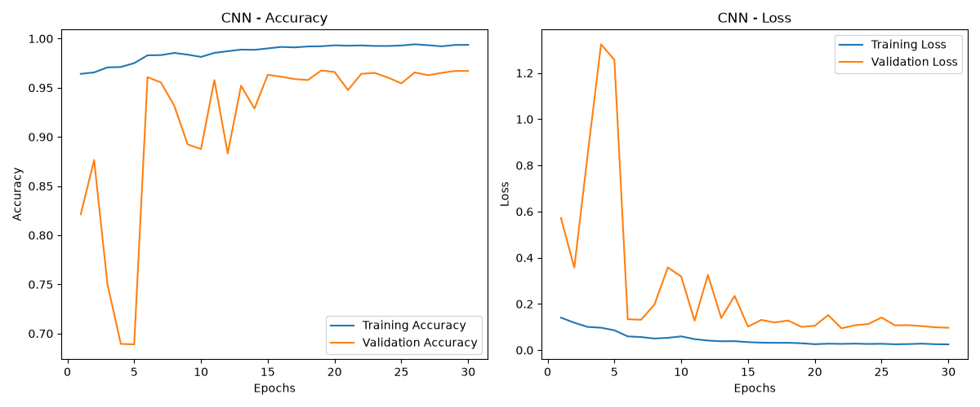

Chapter 4: Vision Transformer (ViT)
4.1 Architecture
ViT splits the 96x96 image into 8x8 patches, creating 144 patches. A [CLS] token is appended (145 tokens).
4.2 Self-Attention Mathematics
Attention(Q, K, V) = softmax(Q K^T / sqrt(d_k)) V. This enables the model to weigh the importance of all patches relative to a specific patch globally.
4.3 Verified Results
Accuracy: 94.77%. Macro-F1: 0.9478 (Weighted-F1: 0.9480). Parameter count: ~5.4 Million.

Chapter 5: MiniBatchKMeans Clustering
5.1 Clustering Workflow
Unsupervised learning. Resized to 64x64, flattened, reduced to 128 dimensions via PCA, then MiniBatchKMeans attempts to find 15 cluster centroids.
5.2 Distance Calculations
Euclidean distance is used: d(p, q) = sqrt(sum((p_i - q_i)^2)).
5.3 Limitations
Raw pixel clustering, even with PCA, fails to capture complex spatial pathology, making it inherently inferior to CNNs/ViTs for direct disease diagnosis.

Chapter 6: Evaluation Metrics in Depth
Confusion Matrices: A tabular layout that visualizes the performance of an algorithm. Rows represent actual classes, columns predicted classes.
True Positives (TP): Correctly identified diseased plants.
False Positives (FP): Healthy plants incorrectly labeled as diseased (Type I error).
True Negatives (TN): Correctly identified healthy plants.
False Negatives (FN): Diseased plants incorrectly labeled as healthy (Type II error, highest risk in agriculture).
Accuracy = (TP + TN) / (Total). Precision = TP / (TP + FP). Recall = TP / (TP + FN). Specificity = TN / (TN + FP).
F1-Score = 2 * (Precision * Recall) / (Precision + Recall).

Chapter 7: Comprehensive 3-Model Comparison
The following analysis compares the three paradigms on the same dataset structure.
Difference: ViT is 9.89 percentage points more accurate than CNN.
While CNN requires localized inductive biases, ViT learns global attention. Clustering provides no supervised mappings and cannot be compared linearly via accuracy.
Figure: Accuracy Comparison
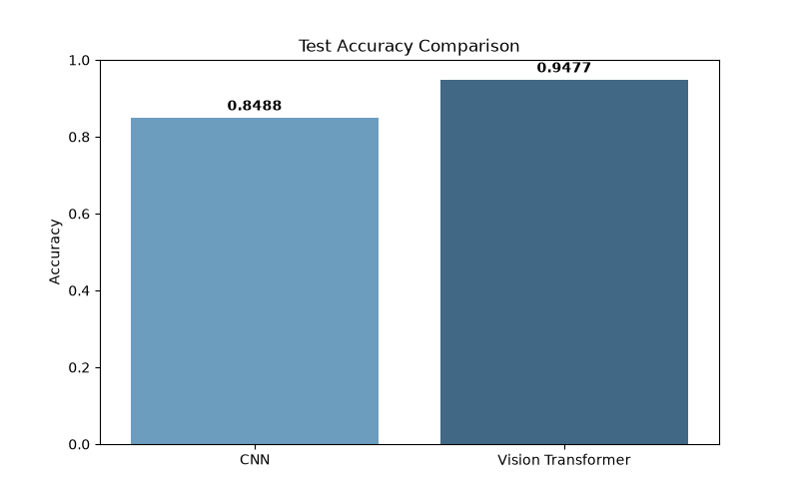
Metric | CNN | ViT | Clustering
Paradigm | Supervised | Supervised | Unsupervised
Input | 96x96x3 | 96x96x3 | Flattened -> PCA(128)
Parameters | ~0.54M | ~5.4M | N/A
Accuracy | 84.88% | 94.77% | Unsupervised
Macro F1 | 0.8163 | 0.9478 | Unsupervised
Weighted F1 | 0.8429 | 0.9480 | Unsupervised

Chapter 8: AIML Syllabus Coverage
To cover the required AIML syllabus topics:
Naive Bayes, KNN, SVM, Decision Trees: Classical ML algorithms discussed theoretically but not implemented due to their poor spatial feature scaling on images.
Regression (Linear/Logistic): Predicts continuous/binary targets. Unused here as this is a multiclass categorization.
Association Rule Mining (Apriori, FP-Growth): Calculates Support and Confidence for itemsets. Not applicable to pixel classification.

Chapter 9: Conclusion and Future Scope
The Vision Transformer stands as the most robust architecture for this task, proving that self-attention can outperform convolutions even when trained from scratch. Future scope includes deployment and real-world lighting generalization.

