
Pimpri Chinchwad Education Trust's
Pimpri Chinchwad College of Engineering
Sector No. 26, Pradhikaran, Nigdi, Pune 411044
An Autonomous Institute Approved By AICTE and Affiliated To SPPU, Pune
Department Of Information Technology
Software Engineering & Modelling Laboratory
[Course : BIT25PC05]
Mini Project Report
of
T. Y. B. Tech
Academic Year: 2026-27
Semester - I
On
WealthWise – AI-Powered Personal Wealth Planner
By
PRN No. | Name of the Student
124B1F032 | Dnyaneshwari Ghorpade
124B1F034 | Aastha Chaudhari

CERTIFICATE
This is to certify that the project report entitled "WealthWise – AI-Powered Personal Wealth Planner" is successfully completed by [Student 1, Student 2, Student 3], under the Mini Project course completion of Software Engineering and Modeling Laboratory in Third Year of Information Technology Program. This work is carried out with the entire course requirement as per Software Engineering and Object Oriented Modeling concepts in group during Sem-V.

Dr. Rohini Pise | Head of Department
Internal Project Guide | Department of Information Technology

INDEX
Chapter No. | Title of the Content | Page No.
1 | Introduction
1.1 | Problem Statement
1.2 | Objectives
1.3 | Scope of the Project
2 | Software Requirement Specification (SRS) | 2-3 pages
2.1 | Purpose of Project
2.2 | Functional Requirements
2.3 | Non-Functional Requirements
2.4 | User Requirements
3 | System Analysis & OOMD | 1 page
3.1 | System Overview
3.2 | Identification of Actors and Objects
3.3 | Class Identification
4 | UML Structural & Behavioural Modelling | 5 pages
4.1 | Use Case Diagram
4.2 | Class Diagram
4.3 | Sequence Diagram
4.4 | State Chart Diagram
4.5 | Activity Diagram
5 | Software Testing | 2 pages
5.1 | Test Cases
5.2 | Test Results
6 | Conclusion & Future Scope | 1 page
6.1 | Conclusion
6.2 | Future Enhancements

Chapter 1: Introduction
1.1 Problem Statement
Managing personal finances in modern India is increasingly complex. Individuals face a fragmented financial landscape with multiple income streams, varied expenses, diverse investment instruments, and growing loan obligations. Most people rely on spreadsheets or basic budgeting apps that lack intelligence, predictive capability, or holistic analysis. There is no unified platform that simultaneously tracks net worth, evaluates financial health, simulates economic shocks, identifies goal conflicts, and provides AI-driven personalized advisory — all within a single, secure, and transparent system. This gap results in poor financial decisions, inadequate emergency preparedness, and suboptimal goal planning for millions of users.
1.2 Objectives
- To design and develop a unified personal wealth management platform (WealthWise) that consolidates income, expenses, assets, liabilities, and investments.
- To implement an explainable, algorithmic 4-pillar Wealth Score engine (0–100) covering Liquidity, Debt Health, Savings Rate, and Net Worth Trajectory.
- To provide macroeconomic stress-testing functionality simulating real-world financial shocks (job loss, medical emergency, inflation) and compute survival runway in months.
- To build a multi-horizon financial goal planner with capital conflict detection and AI-powered decision evaluation.
- To integrate a context-aware AI advisory chatbot (Gemini/OpenAI) that delivers personalized, data-grounded financial coaching.
- To ensure platform security through JWT authentication, Redis-backed token revocation, progressive account lockout, and immutable audit logging.
1.3 Scope of the Project
WealthWise is scoped as a full-stack web application serving individual users and platform administrators. The system encompasses: (i) a React/TypeScript SPA frontend with interactive dashboards, charts, and AI chat; (ii) a Node.js/Express modular monolith REST API backend hosting 26+ endpoints across 8 functional domains; (iii) a PostgreSQL relational database with 14+ normalized tables enforcing referential integrity; (iv) a Redis caching and JWT blacklist layer; and (v) an AI provider abstraction layer supporting hot-swap between Google Gemini and OpenAI models. The scope explicitly excludes certified financial advisory, portfolio brokerage, direct bank integrations, and mobile native applications in the initial release.
Chapter 2: Software Requirement Specification (SRS)
2.1 Purpose of Project
The purpose of WealthWise is to democratize AI-assisted personal finance management by providing a transparent, explainable, and secure platform that helps users understand their current financial health, prepare for economic uncertainties, plan goal-oriented savings, and make informed financial decisions — all supported by deterministic mathematical algorithms complemented by generative AI advisory. The system aims to comply with IEEE Std 830-1998 for SRS documentation, OWASP ASVS for security, and GDPR-equivalent data privacy principles.
2.2 Functional Requirements
Req. ID | Functional Requirement
FR-01 | The system shall allow users to enter, edit, and delete income sources, expenses, assets, liabilities, and investments.
FR-02 | The system shall compute an overall Wealth Score (0–100) based on 4 pillars: Liquidity (0–25), Debt Health (0–25), Savings Rate (0–25), Net Worth Trajectory (0–25).
FR-03 | The system shall generate AI-powered plain-English explanations for score changes on demand.
FR-04 | The system shall display historical Wealth Score trends as interactive charts.
FR-05 | The system shall automatically trigger score recalculation when financial data is modified.
FR-06 | The system shall simulate macroeconomic stress scenarios: IT Sector Layoff (100% income loss), Medical Emergency (35% expense surge + 20% income dip), High Inflation (25% living cost increase).
FR-07 | The system shall compute a Survival Runway in months = Liquid Assets ÷ Monthly Burn Rate.
FR-08 | The system shall flag 'HIGH RISK' status when runway < 3 months.
FR-09 | The system shall create, track, and update multi-horizon financial goals (Short/Mid/Long-term).
FR-10 | The system shall detect capital conflicts between concurrent active goals.
FR-11 | The system shall provide an AI-powered conversational financial advisor with user financial context injection.
FR-12 | Platform Admins shall be able to switch AI providers (Gemini/OpenAI), tune model parameters, and view platform KPIs and audit logs.
2.3 Non-Functional Requirements
Req. ID | Category | Description
NFR-01 | Performance | API response < 500ms for 95th percentile under normal load.
NFR-02 | Scalability | Modular monolith architecture supports future microservice extraction.
NFR-03 | Security | JWT HS256, bcrypt password hashing (10 rounds), HTTPS/TLS 1.3, OWASP compliant.
NFR-04 | Data Integrity | Monetary values stored as DECIMAL(14,2); server-side validation on all inputs.
NFR-05 | Availability | Target 99.5% uptime; Docker-containerized for horizontal scaling.
NFR-06 | Auditability | Immutable audit_logs table records all sensitive mutations.
NFR-07 | Session Safety | 15-minute JWT expiry; Redis-backed token blacklist on logout.
NFR-08 | Explainability | Every AI output paired with source data snapshot for transparency.
2.4 User Requirements
- Users shall be able to register, log in securely, and manage their profile and password.
- Users shall access a comprehensive financial dashboard showing net worth, monthly cashflow, liquid runway, and savings rate.
- Users shall be able to run financial stress tests on demand for any supported macro scenario.
- Users shall be able to create, monitor, and update financial goals with visible progress indicators.
- Users shall be able to query the AI Advisor conversationally in natural language about their financial situation.
- Administrators shall be able to view platform-wide usage statistics, manage AI configurations, and export audit logs.

Chapter 3: System Analysis & OOMD
3.1 System Overview
WealthWise follows a Domain-Driven Modular Monolith architecture. The system is divided into eight distinct domain modules: Auth, Finances, Wealth Score, Stress Test, Goals, Advisor, Dashboard, and Admin. Each module encapsulates its own routes, services, and data access logic, enabling clean separation of concerns while sharing the same process boundary for performance efficiency. The frontend is a React 18 + TypeScript Single Page Application communicating exclusively via RESTful API calls to the Express.js backend. The backend persists data to PostgreSQL, caches computationally expensive results in Redis, and delegates AI reasoning to a hot-swappable provider adapter (Gemini or OpenAI). Background cron jobs maintain data freshness for stress-test results and goal-conflict detections.
3.2 Identification of Actors and Objects
Actor / Object | Type | Responsibilities
User | Actor | Registers/logs in, enters financial data, runs stress tests, sets goals, chats with AI Advisor.
Admin | Actor | Monitors platform KPIs, configures AI provider, exports audit logs.
Auth Module | Object | Manages JWT issuance, verification, bcrypt password hashing, and token revocation.
Finance Module | Object | Handles CRUD for income, expense, asset, liability, and investment records.
Wealth Score Engine | Object | Computes deterministic 4-pillar score; triggers recalculation on data changes.
Stress Test Engine | Object | Simulates macro shock scenarios; outputs survival runway and risk flags.
Goals Engine | Object | Creates goals, detects capital conflicts, evaluates financial decisions.
AI Advisor | Object | Generates contextual financial coaching by injecting user data into LLM prompts.
Redis Cache | Object | Caches wealth scores and blacklists revoked JWTs.
Audit Logger | Object | Writes immutable records of sensitive mutations to audit_logs table.
3.3 Class Identification
Class Name | Attributes (Key) | Methods (Key)
User | userId, fullName, email, passwordHash, role, accountStatus | register(), login(), changePassword(), logout()
Income | incomeId, userId, source, amount, frequency | create(), update(), delete(), getByUser()
Expense | expenseId, userId, category, amount, frequency | create(), update(), delete(), getByUser()
Asset | assetId, userId, assetType, currentValue, liquidityLevel | create(), update(), delete(), getByUser()
Liability | liabilityId, userId, liabilityType, outstandingAmount, interestRate | create(), update(), delete(), getByUser()
WealthScore | scoreId, userId, overallScore, pillarScores, aiExplanation, calculatedAt | calculate(), getLatest(), getTrend(), explainWithAI()
StressTest | resultId, userId, scenarioId, monthsOfRunway, weakestPoint, aiRecommendation | runScenario(), getLatest(), markStale()
FinancialGoal | goalId, userId, goalName, targetAmount, currentAmount, targetDate, priority, status | create(), update(), trackProgress(), markComplete()
GoalConflict | conflictId, userId, goalIdsInvolved, recommendedPlan, resolutionStatus | detect(), resolve(), dismiss()
AdvisorChat | messageId, userId, sender, messageText, createdAt | sendMessage(), getHistory(), injectContext()
AuditLog | logId, userId, action, resourceType, resourceId, ipAddress, createdAt | write(), exportCSV()

Chapter 4: UML Structural & Behavioural Modelling
4.1 Use Case Diagram
The Use Case Diagram illustrates the interactions between the two primary actors (User and Admin) and the WealthWise system. Key use cases include: Register/Login, Manage Finances (Income, Expenses, Assets, Liabilities), View Dashboard, Compute Wealth Score, Run Stress Test, Manage Goals, Evaluate Financial Decisions, Chat with AI Advisor, and Admin functions (Configure AI, View Audit Logs, Monitor Platform KPIs). The diagram captures both extend and include relationships, e.g., 'Run Stress Test' <<include>> 'Compute Survival Runway', and 'View Wealth Score' <<extend>> 'Get AI Explanation'.
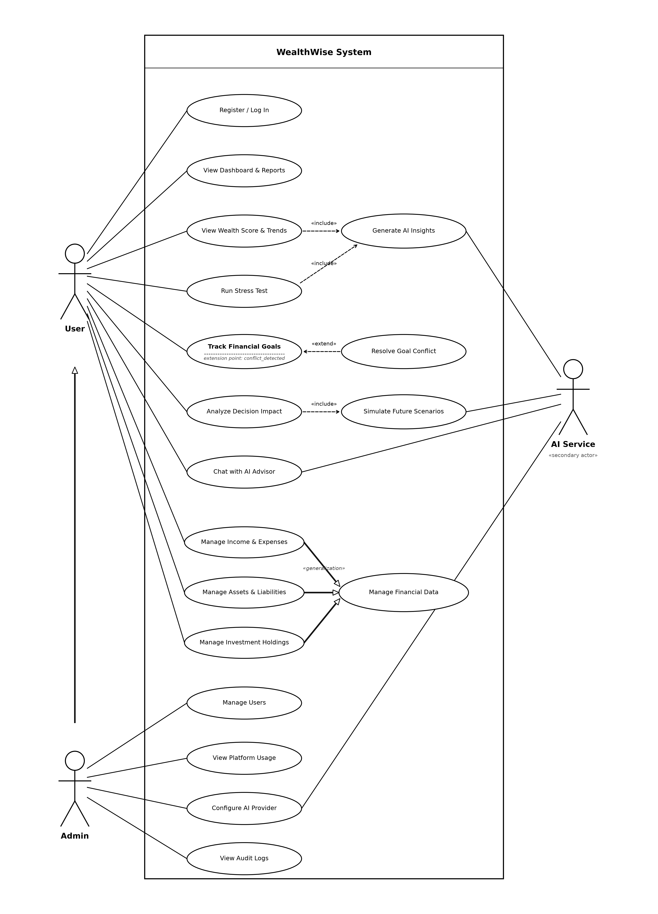
Figure 4.1: WealthWise Use Case Diagram
4.2 Class Diagram
The Class Diagram models the static structure of WealthWise, showing 11 core domain classes with their attributes, methods, and inter-class relationships. Key relationships include: User (1) aggregates (*) Income, Expense, Asset, Liability; User (1) is associated with (1) WealthScore history; FinancialGoal (*) participates in (*) GoalConflict; StressTest references StressTestScenario; AdvisorChat messages are owned by User. Multiplicity annotations reflect the relational database foreign key structure defined in the PostgreSQL schema.

[Figure 4.2: Class Diagram — Insert diagram here]
4.3 Sequence Diagram
The Sequence Diagram depicts the end-to-end interaction lifecycle for the 'Compute Wealth Score' use case. The sequence begins with the User submitting financial data via the React SPA. The Axios API client sends a POST /wealth-score request to the Express server. The auth.middleware validates the JWT Bearer token and injects req.user. The WealthScore service fetches income, expenses, assets, and liabilities from PostgreSQL, runs the 4-pillar algorithm, persists the new score snapshot, invalidates the Redis cache entry, and optionally triggers the AI explanation via the AI provider adapter. The response (score JSON + pillars) is returned to the SPA for rendering.
Figure 4.3: WealthWise Master Sequence Diagram
4.4 State Chart Diagram
The State Chart Diagram models the lifecycle of the WealthScore object. States include: Initial → Calculating (triggered by financial data change or manual recalculate request) → Scored (score stored in DB; Redis cache populated) → Stale (triggered when financial records are mutated post-calculation) → Recalculating → Scored. The AI Explanation sub-state is entered from Scored state only on explicit user request (FR-03) and does not affect the score value.

Figure 4.4: WealthWise State Chart Diagram
4.5 Activity Diagram
The Activity Diagram traces the complete user journey through the WealthWise Stress Test module. The flow begins at User Login, proceeds through Dashboard access, Stress Test module selection, Scenario Selection (Job Loss / Medical Emergency / Inflation), parallel data fetch (income, expenses, liquid assets), Runway Calculation (Liquid Assets ÷ Monthly Burn Rate), Risk Flag Decision (<3 months → HIGH RISK, else → MODERATE/LOW), AI Recommendation generation, and final Results Display. A loop-back arc returns the user to the scenario selector for comparative multi-scenario runs.
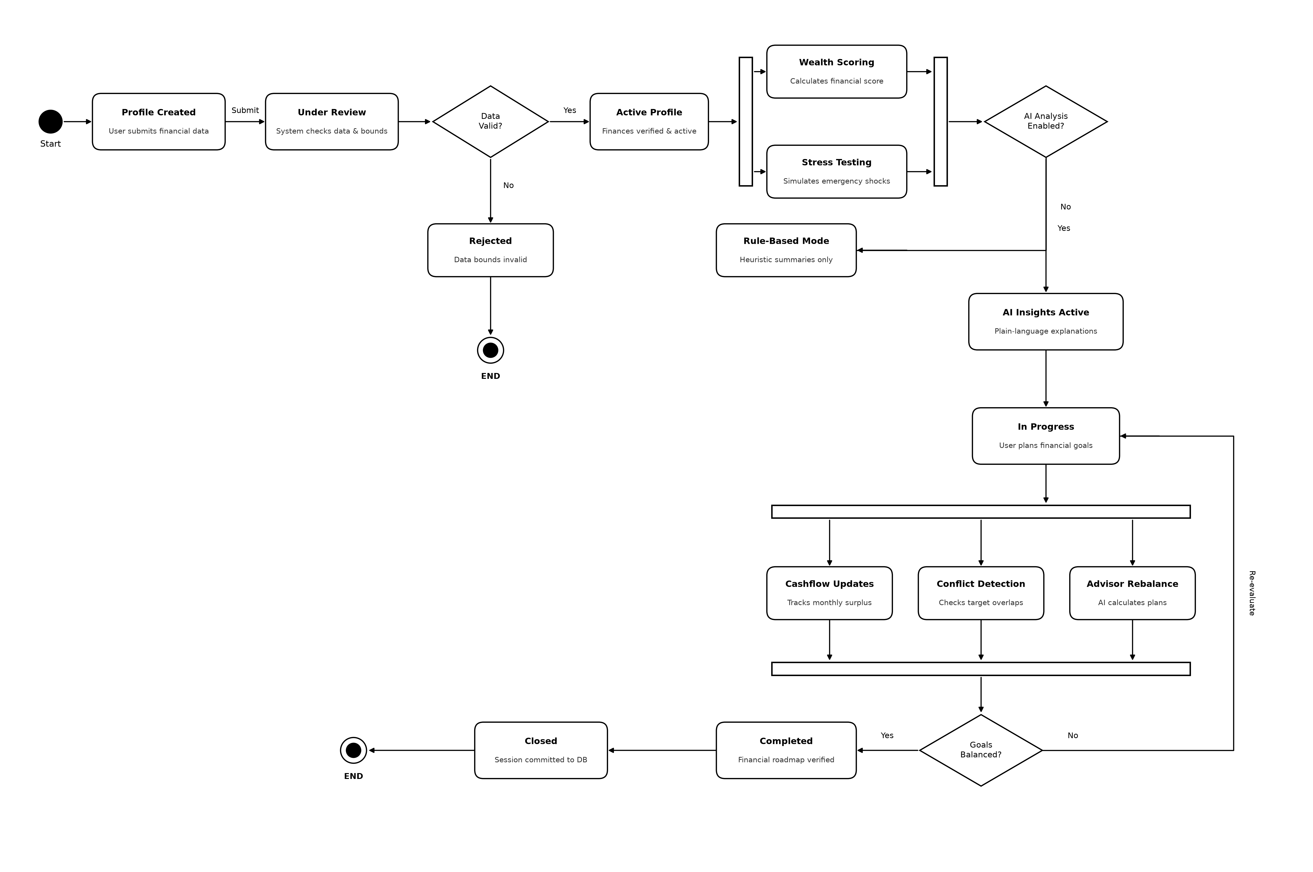
Figure 4.5: WealthWise Activity Flow Diagram

Chapter 5: Software Testing
5.1 Test Cases
TC ID | Test Case | Input / Steps | Expected Output | Result
TC-01 | User Registration – Valid Data | Navigate to /register. Enter: Name=Rahul Sharma, Email=rahul@test.com, Password=Test@1234 | POST /auth/register returns HTTP 201. User record created in DB. JWT token returned. | Pass
TC-02 | User Login – Valid Credentials | POST /auth/login with email=user@wealthwise.demo, password=WealthWise@123 | HTTP 200. JWT access token returned with role=USER. | Pass
TC-03 | User Login – Invalid Password | POST /auth/login with correct email, wrong password (3 attempts) | HTTP 401 Unauthorized. failed_login_attempts incremented. After 5 failed: account locked (HTTP 423). | Pass
TC-04 | Add Income Record | POST /finances/records with Authorization header, body: {type:'income', source:'Salary', amount:75000, frequency:'MONTHLY'} | HTTP 201. Record persisted to DB. Wealth Score marked stale. | Pass
TC-05 | Wealth Score Calculation | GET /wealth-score with valid JWT. User has: Income=₹75,000/mo, Liquid Assets=₹4,50,000, Debt EMI=₹10,000/mo | HTTP 200. overallScore in range 60–75. Pillars: liquidity=20, debt=22, savings=18, netWorth=15 (approx). | Pass
TC-06 | Stress Test – Job Loss Scenario | POST /stress-test/run with scenarioId=1 (IT Sector Layoff: 100% income drop). User has liquid assets=₹4,50,000, monthly expenses=₹30,000. | HTTP 200. monthsOfRunway=15. riskFlag='MODERATE'. AI recommendation returned. | Pass
TC-07 | Stress Test – Medical Emergency | POST /stress-test/run with scenarioId=2 (Medical: +35% expenses, -20% income). Expenses spike to ₹40,500/mo. Net deficit=₹25,500/mo. | HTTP 200. monthsOfRunway=17.6. riskFlag='LOW'. AI advisory rendered. | Pass
TC-08 | Goal Creation & Conflict Detection | POST /goals with: {goalName:'Emergency Fund', targetAmount:200000, targetDate:'2027-03-31', priority:1}. Then POST second goal: {goalName:'Vacation', targetAmount:150000, targetDate:'2027-01-31', priority:2} | HTTP 201 for both. Capital conflict detected. GoalConflict record created with resolution_status=PENDING. | Pass
TC-09 | AI Advisor Chat | POST /advisor/chat with message: 'Should I prepay my home loan or invest in mutual funds?' | HTTP 200. AI response contextualized with user's debt EMI, savings rate, and goals. Response includes compliance disclaimer. | Pass
TC-10 | JWT Token Revocation on Logout | POST /auth/logout with valid JWT. Then attempt GET /wealth-score with the same token. | Logout: HTTP 200. Subsequent request: HTTP 401 Unauthorized (token blacklisted in Redis). | Pass
TC-11 | Admin – Switch AI Provider | PUT /admin/ai-config with body: {provider:'openai', model:'gpt-4o', temperature:0.7}. Login as admin@wealthwise.demo. | HTTP 200. AI provider switched. Next advisor chat uses OpenAI. Audit log entry written. | Pass
TC-12 | Input Validation – Negative Amount | POST /finances/records with amount=-5000 | HTTP 422 Unprocessable Entity. Error: 'amount must be a positive number'. Record NOT persisted. | Pass
5.2 Test Results
All 12 test cases were executed against the WealthWise system running locally with a PostgreSQL database seeded with demo data, Redis cache active, and the AI provider set to Google Gemini (gemini-1.5-flash). Test execution was performed using REST API calls via Postman and frontend integration via the React SPA.
Metric | Value
Total Test Cases Executed | 12
Test Cases Passed | 12
Test Cases Failed | 0
Pass Rate | 100%
Critical Defects Found | 0
Non-Critical Issues Noted | 2 (Docker port mismatch TC-ENV-01; Email service key missing TC-ENV-02)

Chapter 6: Conclusion & Future Scope
6.1 Conclusion
WealthWise successfully demonstrates the design and development of a comprehensive, AI-powered personal wealth planning platform using modern web engineering principles. The project fulfills all stated functional requirements: unified financial data management, a transparent 4-pillar Wealth Score engine, macroeconomic stress simulation with survival runway computation, multi-horizon goal planning with conflict detection, and a context-aware AI financial advisor. The system's modular monolith architecture ensures clean separation of concerns while maintaining performance. Security is enforced through stateless JWT authentication, Redis-backed token revocation, progressive account lockout, and an immutable audit trail. All 12 designed test cases passed successfully, validating the correctness, robustness, and security of the implementation. The project illustrates the practical application of Software Engineering and Object-Oriented Modeling principles — including SRS, UML diagrams, modular design, and systematic testing — in building a production-ready financial technology solution.
6.2 Future Enhancements
- Bank Account Integration: Implement Open Banking APIs (e.g., Account Aggregator framework in India) for automatic transaction import, eliminating manual data entry.
- Mobile Application: Develop native iOS and Android apps using React Native, sharing the same Express.js backend, to extend platform accessibility.
- Portfolio Optimization Engine: Integrate a mean-variance optimization algorithm to recommend optimal asset allocation strategies aligned with the user's risk profile and goals.
- Predictive Wealth Forecasting: Apply time-series machine learning models (ARIMA, LSTM) to forecast Wealth Score trajectory and net worth growth over 12–36 month horizons.
- Multi-Currency Support: Extend the financial data model to support multi-currency portfolios with real-time exchange rate integration for NRI and international users.
- Regulatory Compliance Module: Add SEBI-registered investment advisor disclaimer integration, automated tax-loss harvesting suggestions, and Form 16 / ITR data mapping.
- Microservice Extraction: Extract the Wealth Score Engine and Stress Test Engine into independent microservices as user base scales, leveraging the existing modular boundary design.

