BFS_DFS
Breadth First Search (BFS) is a fundamental graph traversal algorithm that explores all neighbors of a node before moving to their neighbors. BFS guarantees finding the shortest path in unweighted graphs, making it widely used in network analysis, shortest path algorithms, and AI search problems.
Logic Behind BFS:
- Uses a queue (FIFO) for traversal.
- Starts at a given node, visits all adjacent nodes first before proceeding to the next level.
- Keeps track of visited nodes to avoid cycles.
Algorithm:
- Start from the given node, mark it as visited, and enqueue it.
- While the queue is not empty:
  - Dequeue a node.
  - Process the node.
  - Enqueue all its unvisited adjacent nodes.
- Repeat until all nodes are visited.
Time Complexity: O(V+E)O(V + E)
Space Complexity: O(V)
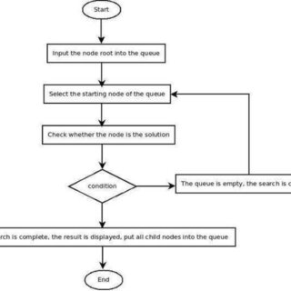

DFS
Depth First Search (DFS) is a graph traversal algorithm that explores as far as possible along each branch before backtracking. It follows a depthward motion, meaning it goes deep into a node’s neighbors before moving to another branch.
Logic Behind DFS:
- Uses a stack (either explicit or recursion) for traversal.
- Starts at a given node, visits one neighbor deeply before moving to another.
- Keeps track of visited nodes to avoid cycles.
Algorithm:
- Start from the given node, mark it as visited.
- Recursively visit all unvisited adjacent nodes.
- If all adjacent nodes are visited, backtrack.
- Repeat until all nodes are visited.
Time Complexity: O(V+E)O(V + E)
Space Complexity: O(V)O(V) (due to recursion stack)
