**Documentation**

**Web Development Task 1**

Hello and welcome to our restaurant's Table Booking Form documentation!

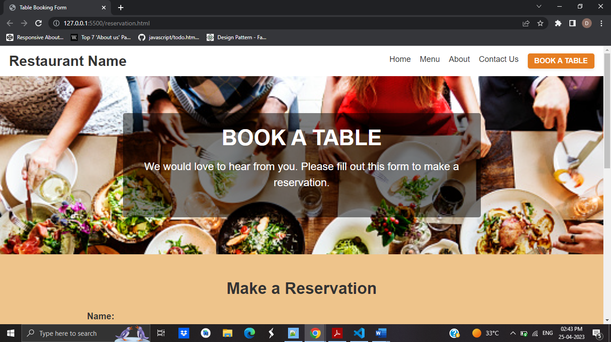

This is a form for guests who want to make a reservation at our restaurant. It asks for the user's name, email address, phone number, the date and time they want to make the reservation, and the number of guests they intend to bring. In addition, users can provide any particular demands they have in the "Special Requests" area.

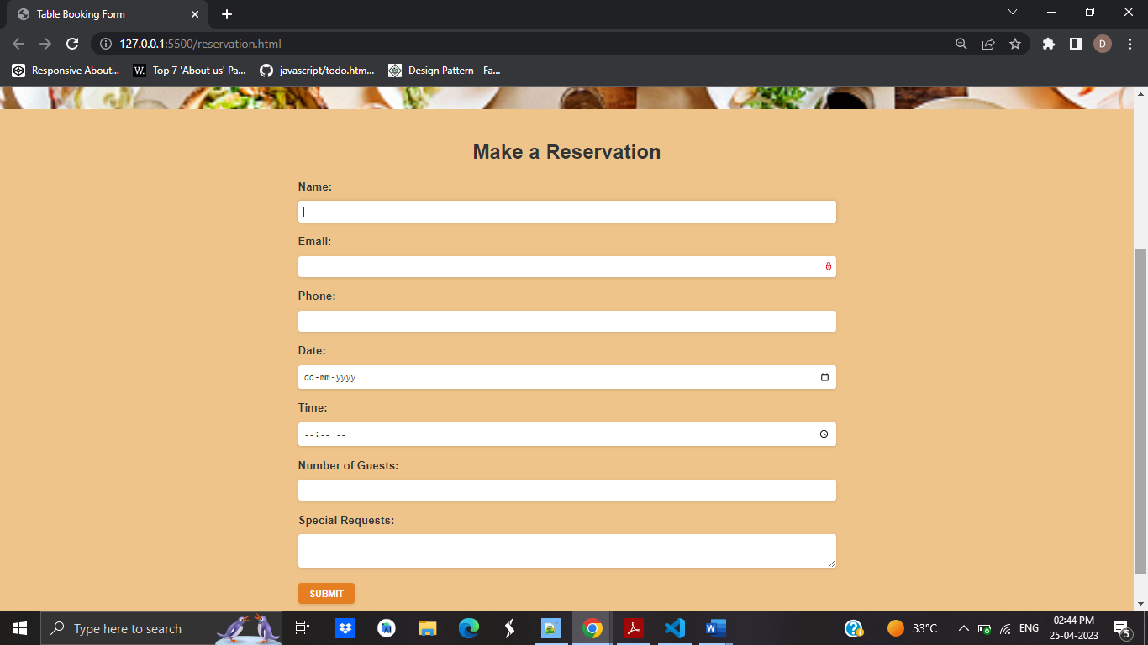

To utilise the form, simply follow these steps:

Navigate to the page where the form is hosted.

You may get to the form by clicking the "Book A Table" button in the navigation bar.

Fill out the form with the following information:

**Name:** Please provide your full name.

**Email**: Please enter a valid email address.

**Phone**: Please enter a valid phone number.

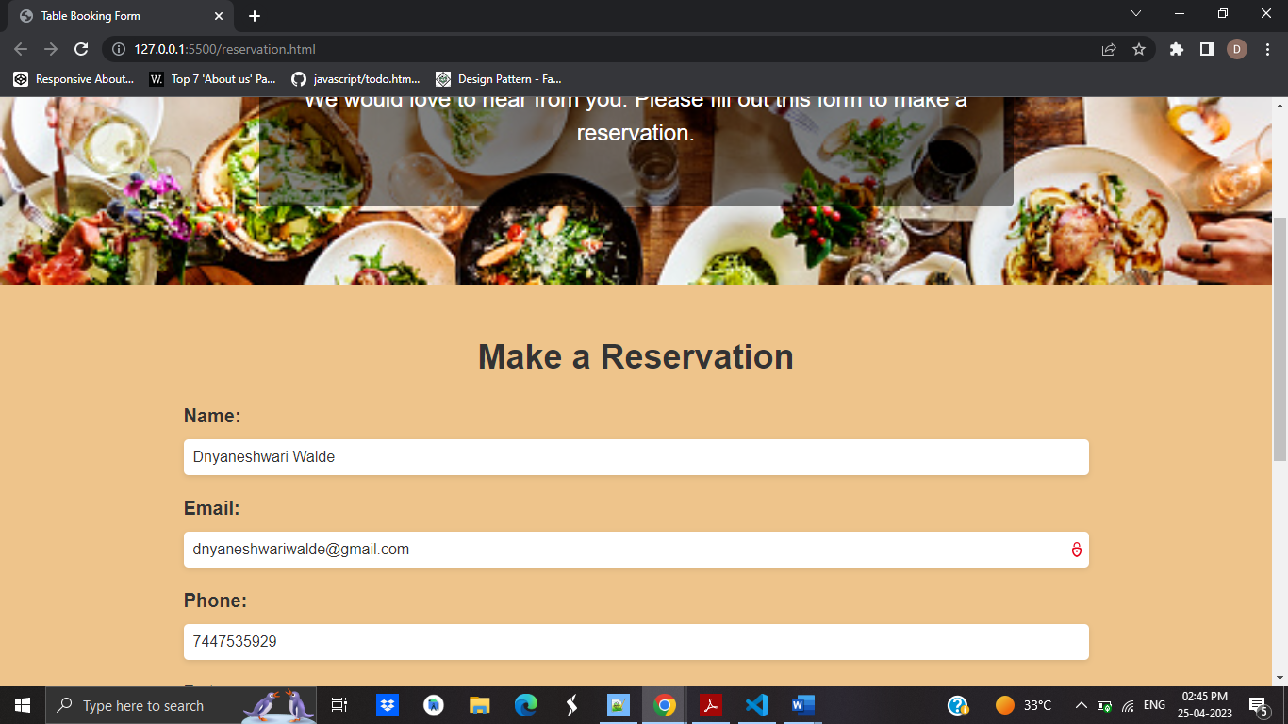

**Date**: Please select the date for which you want to make the reservation.

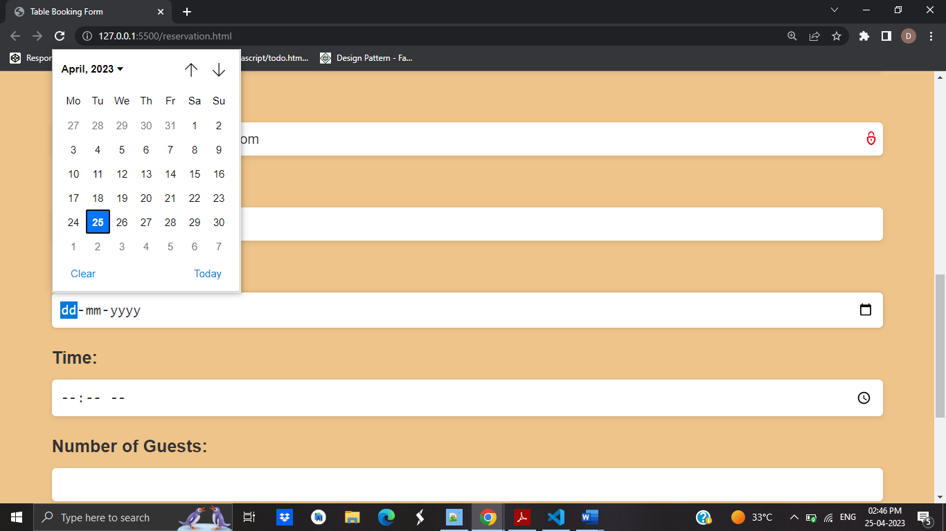

Time: Please select the time you want to make the reservation.

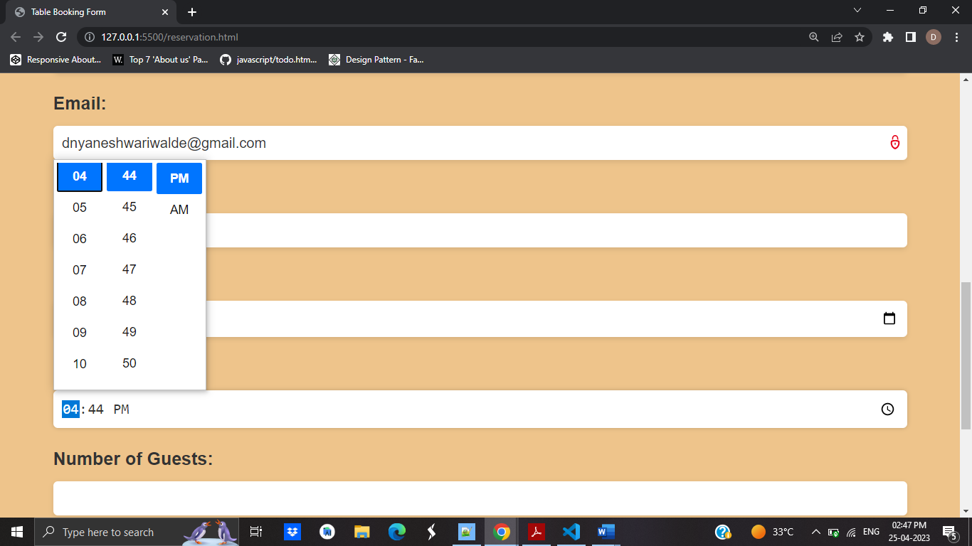

Please specify the number of visitors you want to invite.

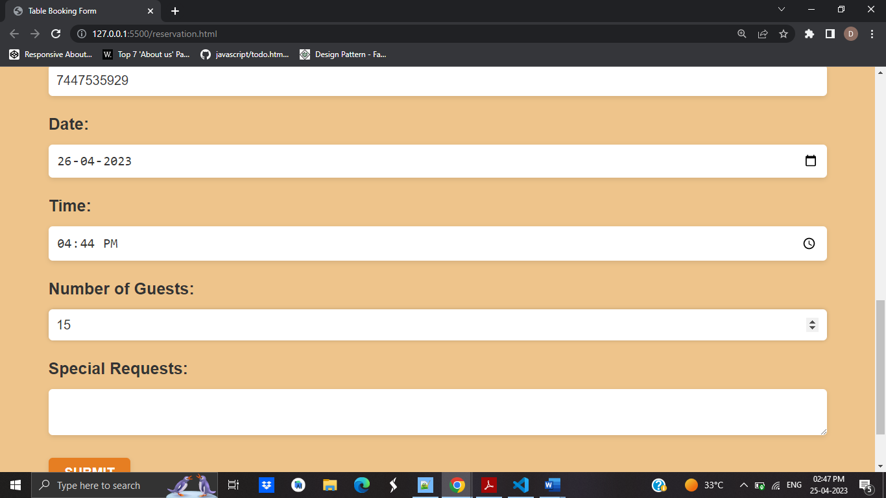

Fill in the "Special Requests" area if you have any particular demands.

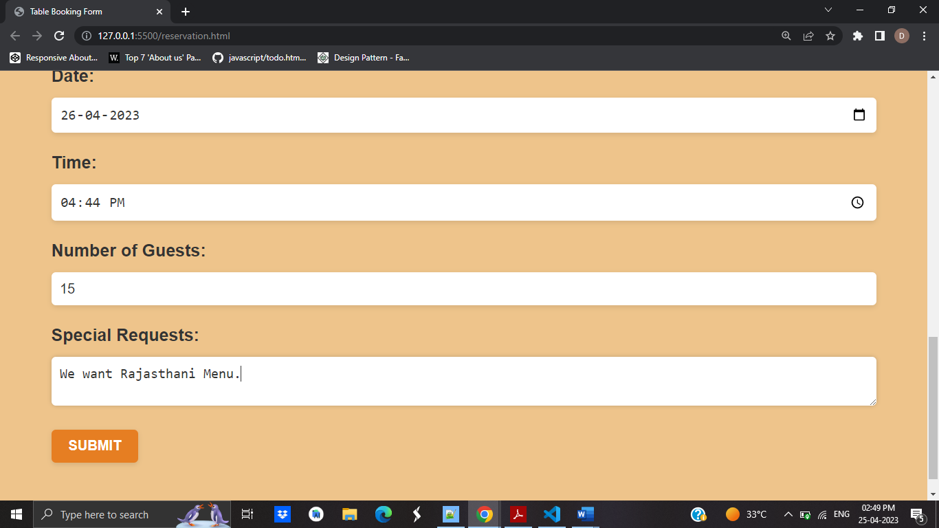

This section is optional, however you can use it to let us know about any unique needs or requirements you may have.

To submit the form, press the "Submit" button.

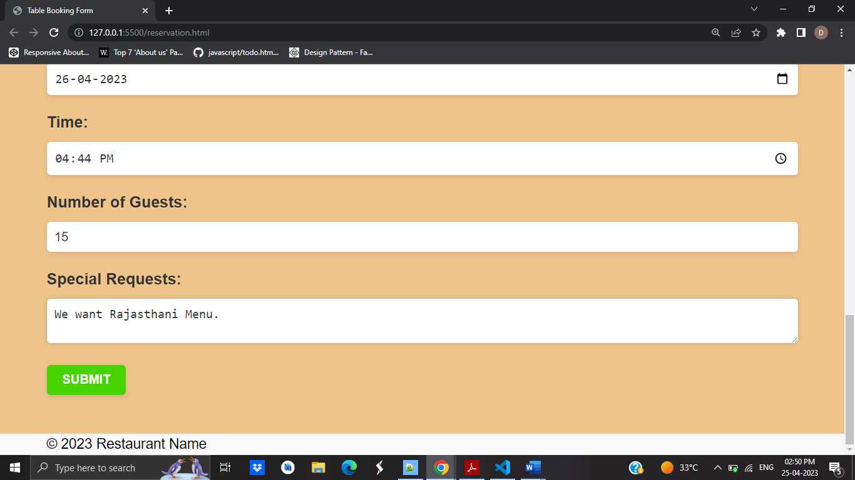

When you submit the form, it will be sent to management team for processing.

If the form is successfully submitted, you should receive a confirmation message.

If there are any problems with your reservation, we will contact you via the email address or phone number you provided.

Here are some more considerations for the restaurant's management team:

1. Users cannot submit the form until all required fields are filled out because it has validation for the required fields.
2. The user cannot enter a number outside of the "Number of Guests" field's range, which is between 1 and 100.
3. There is no payment processing or availability confirmation on the form. It merely enables the user to make a reservation request.
4. The management team will need to build up their own system for accepting and processing reservations since the form has not been integrated with a back-end processing system.

Finally, here is a full screenshot of the form in action:

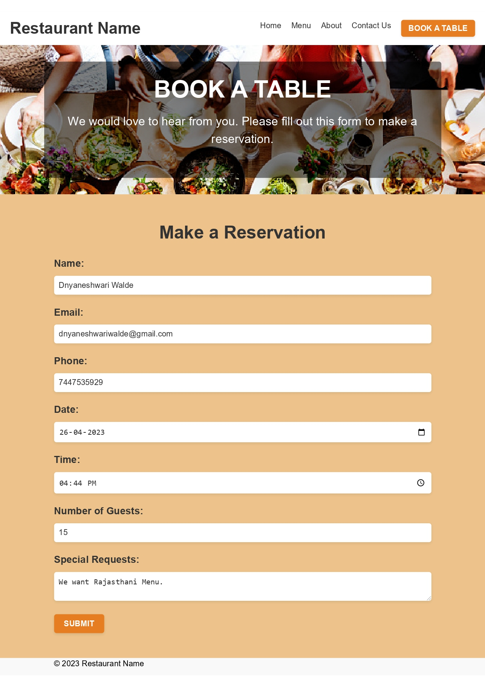

GitHub:https://github.com/DnyaneshwariWalde