**Performing a 32 bit to 64 bit migration using the Transportable Database RMAN feature**

This note describes the procedure used to perform a 32 bit to 64 bit conversion of an 11.2.0.3 database on the Linux platform.

The RMAN CONVERT DATABASE command is used to automate the movement of an entire database from one platform (the source platform) to another (the destination platform).

This is provided that the source and destination platforms are of the same endian format.

For example between Linux X86 32 bit and Linux X86 64 bit.

Note the following:

* Certain types of blocks, such as blocks in undo segments, need to be reformatted to ensure compatibility with the destination platform.
* Redo log files and control files from the source database are not transported. New control files and redo log files are created for the new database during the transport process, and an OPEN RESETLOGS is performed once the new database is created
* BFILEs are not transported. RMAN provides a list of objects using the BFILE datatype in the output for the CONVERT DATABASE command, but users must copy the BFILEs themselves and fix their locations on the destination database.
* Tempfiles belonging to locally managed temporary tablespaces are not transported. The temporary tablespace will be re-created on the target platform when the transport script is run.
* External tables and directories are not transported
* Password files are not transported. If a password file was used with the source database, the output of CONVERT DATABASE includes a list of all usernames and their associated privileges. Create a new password file on the destination database using this information

**Pre-Migration Checks**

**Check if transportable database can be used**

Before attempting a platform migration with TDB, verify the target platform is supported for TDB by your source platform. Query the view V$DB_TRANSPORTABLE_PLATFORM for the target platform name

SQL> select platform_name from v$db_transportable_platform where platform_name like ‘Linux%’;

PLATFORM_NAME

--------------------------------------------------------------------------------

Linux IA (32-bit)

Linux IA (64-bit)

Linux x86 64-bit

**Check for external tables and directories**

SQL> set serveroutput on

SQL> declare x boolean;

begin x := dbms_tdb.check_external; end; 2

3 /

The following directories exist in the database:

SYS.APPS_DATA_FILE_DIR, SYS.ECX_UTL_LOG_DIR_OBJ, SYS.ECX_UTL_XSLT_DIR_OBJ,

SYS.LYCO_AP_REMIT, SYS.DATA_PUMP_DIR, SYS.ORACLE_OCM_CONFIG_DIR

PL/SQL procedure successfully completed.

Directory objects must be created on the target system. Query DBA_DIRECTORIES on the source database to determine the file system locations that must exist on the target system for the directory objects to be usable.

SQL> select directory_name,directory_path from dba_directories;

DIRECTORY_NAME

------------------------------

DIRECTORY_PATH

--------------------------------------------------------------------------------

DATA_PUMP_DIR

/oracle/DEV/admin/DEV/dpdump/

ORACLE_OCM_CONFIG_DIR

/oracle/DEV/devdb/11.2.0.3/ccr/state

LYCO_AP_REMIT

/home/filxfer/PROD/ENG/AP_REM

DIRECTORY_NAME

------------------------------

DIRECTORY_PATH

--------------------------------------------------------------------------------

ECX_UTL_XSLT_DIR_OBJ

/usr/tmp

APPS_DATA_FILE_DIR

/oracle/DEV/devdb/11.2.0.3/appsutil/outbound/DEV_oradevint

ECX_UTL_LOG_DIR_OBJ

/usr/tmp

6 rows selected.

**Ensure that each directory listed in the view DBA_DIRECTORIES points to a valid file system directory, or ASM disk group or directory on the target system.**

Identify external table files that will need to be transferred to the target system when indicated in a later step. To identify external table files, run the following query

SQL> select directory_path||'/'||location External_file_path from dba_directories a, dba_external_locations b where a.directory_name=b.directory_name;

no rows selected

**Check for BFILES**

REM

REM List all directories that contain BFILEs

REM

set serveroutput on format wrap;

set feedback off;

declare

type cur_type is REF CURSOR;

v_cur cur_type;

v_sqlstmt varchar2(100);

v_bfile_loc bfile;

v_bfile_dir_name varchar2(30);

v_bfile_filename varchar2(250);

v_bfile_realpath varchar2(4000);

type array_type is table of number index by varchar2(512);

bfile_dirs array_type;

mydir varchar2(512);

total_bfiles number := 0;

begin

-- loop through all columns that are BFILE type

for bf in

(select owner,table_name,column_name

from dba_tab_cols

where data_type='BFILE')

loop

v_sqlstmt:='select '||bf.column_name||' from '

||bf.owner||'.'||bf.table_name;

open v_cur for v_sqlstmt;

loop

fetch v_cur into v_bfile_loc;

exit when v_cur%notfound;

-- get BFILE directory alias and filename

dbms_lob.filegetname(v_bfile_loc, v_bfile_dir_name,

v_bfile_filename);

if bfile_dirs.exists(v_bfile_dir_name) then

bfile_dirs(v_bfile_dir_name) := bfile_dirs(v_bfile_dir_name) + 1;

else

bfile_dirs(v_bfile_dir_name) := 1;

end if;

end loop;

close v_cur;

end loop;

dbms_output.put_line(' ');

dbms_output.put_line('The following directories contain external files for BFILE columns');

dbms_output.put_line('Copy the files within these directories to the same path on the target system');

dbms_output.put_line(' ');

-- loop through array of all directories

mydir := bfile_dirs.first;

while mydir is not null loop

-- resolve the directory alias to a full path

select directory_path

into v_bfile_realpath

from all_directories

where directory_name = mydir;

dbms_output.put_line(v_bfile_realpath);

total_bfiles := total_bfiles + bfile_dirs(mydir);

mydir := bfile_dirs.next(mydir);

end loop;

dbms_output.put_line(' ');

dbms_output.put_line('There are ' || bfile_dirs.count

|| ' directories, ' || total_bfiles

|| ' total BFILEs');

dbms_output.put_line(' ');

end;

/

The following directories contain external files for BFILE columns

Copy the files within these directories to the same path on the target system

There are 0 directories, 0 total BFILEs

**Export OLAP Analytic Workspaces**

Create a directory to save OLAP analytical workspace migration files.

mkdir /oracle/stage/aw_migrate

**As Sys:**

Create a directory to save OLAP analytical workspace migration files.

SQL> create directory aw_migrate as '/oracle/stage/aw_migrate';

Directory created.

Obtain a list of OLAP analytical workspaces to be migrated.

SQL> col owner format a15

col aw_name format a15

select OWNER, AW_NAME ,PAGESPACES from dba_aws

  where owner != 'SYS' order by 1,2;

SQL>

OWNER           AW_NAME         PAGESPACES

--------------- --------------- ----------

FPA             FPAPJP                 308

ZPB             ZPBANNOT                 7

ZPB             ZPBCODE                292

ZPB             ZPBDATA                  7

For each OLAP analytical workspace from the above query (as per the table below), run the following package procedures to export the workspace.

exec dbms_aw.execute( 'aw attach <owner>.<aw_name> rw' );  
exec dbms_aw.execute( 'allstat' );  
exec dbms_aw.execute( 'export all to eif file ''AW_MIGRATE/<schema>_<aw_name>.eif ''' );  
exec dbms_aw.execute( 'aw detach <owner>.<aw_name>' );

Verify that each export file has been successfully created and copy them all across to the same location on the 64-bit server.

Delete each of the OLAP analytical workspaces.

exec dbms_aw.execute( 'aw delete <owner>.<aw_name>' );

As Sys:

Execute scripts to remove OLAP from the database.

@?/olap/admin/catnoamd.sql  
@?/olap/admin/olapidrp.plb  
@?/olap/admin/catnoaps.sql  
@?/olap/admin/catnoxoq.sql  
@?/rdbms/admin/utlrp.sql

Manually remove additional remaining OLAP database objects.

drop procedure sys.xoq_validate;  
drop view sys.olap_oledb_reg_attrs_pvt;  
drop package body sys.cwm2_olap_installer;

set linesize 120 pagesize 0 feedback off echo off

spool /oracle/stage/aw_migrate/drop_olap_syns.sql

select 'drop public synonym ' || object_name || ';'  
  from dba_objects  
  where owner = 'PUBLIC'  
  and object_type = 'SYNONYM'  
  and status <> 'VALID'  
  and ( object_name like '%OLAP%' or object_name like '%AW' )  
  and object_name not like '%RAW%';

spool off

run script /oracle/stage/aw_migrate/drop_olap_syns.sql

SQL> exec dbms_aw.execute( 'aw attach FPA.FPAPJP rw' );

SQL> exec dbms_aw.execute( 'allstat' );

SQL> exec dbms_aw.execute( 'export all to eif file ''AW_MIGRATE/FPA_FPAPJP.eif ''' );

SQL> exec dbms_aw.execute( 'aw detach FPA.FPAPJP' );

SQL> exec dbms_aw.execute( 'aw attach ZPB.ZPBANNOT rw' );

SQL> exec dbms_aw.execute( 'allstat' );

SQL> exec dbms_aw.execute( 'export all to eif file ''AW_MIGRATE/ZPB_ZPBANNOT.eif ''' );

SQL> exec dbms_aw.execute( 'aw detach ZPB.ZPBANNOT' );

SQL> SQL> BEGIN dbms_aw.execute( 'export all to eif file ''AW_MIGRATE/ZPB_ZPBANNOT.eif ''' ); END;

*

ERROR at line 1:

ORA-33390: There are no objects to export.

ORA-06512: at "SYS.DBMS_AW", line 93

ORA-06512: at "SYS.DBMS_AW", line 122

ORA-06512: at line 1

SQL> exec dbms_aw.execute( 'aw attach ZPB.ZPBCODE rw' );

SQL> exec dbms_aw.execute( 'allstat' );

SQL> exec dbms_aw.execute( 'export all to eif file ''AW_MIGRATE/ZPB_ZPBCODE.eif ''' );

SQL> exec dbms_aw.execute( 'aw detach ZPB.ZPBCODE' );

SQL> exec dbms_aw.execute( 'aw attach ZPB.ZPBDATA rw' );

SQL> exec dbms_aw.execute( 'allstat' );

SQL> exec dbms_aw.execute( 'export all to eif file ''AW_MIGRATE/ZPB_ZPBDATA.eif ''' );

BEGIN dbms_aw.execute( 'export all to eif file ''AW_MIGRATE/ZPB_ZPBDATA.eif ''' ); END;

*

ERROR at line 1:

ORA-33390: There are no objects to export.

ORA-06512: at "SYS.DBMS_AW", line 93

ORA-06512: at "SYS.DBMS_AW", line 122

ORA-06512: at line 1

SQL> exec dbms_aw.execute( 'aw detach ZPB.ZPBDATA' );

SQL>exec dbms_aw.execute( 'aw delete FPA.FPAPJP' );

SQL> exec dbms_aw.execute( 'aw delete ZPB.ZPBCODE' );

SQL> exec dbms_aw.execute( 'aw delete ZPB.ZPBDATA' );

SQL> exec dbms_aw.execute( 'aw delete ZPB.ZPBANNOT' );

Follow MetaLink Note 352306.1

**Prepare the database for Transportable Database**

**Shut Down the Application**

Disconnect users and shutdown all application server processes.  Users cannot use any application served by the database until the migration to the new platform is complete.

Shut down and Start the database in READ ONLY mode

TDB requires that the source database be opened in READ ONLY mode.  The source database will be unavailable from this step forward.

SQL> shutdown immediate;

SQL> startup mount;

SQL> alter database open read only;

**Run the DBMS_TDB.CHECK_DB to Check Database State**

Checks to see if:

* Unrecognized target platform name
* Target platform has a different endian format.
* Database is not open read-only
* There are active or in-doubt transactions in the database.
* Database compatibility version is below 10

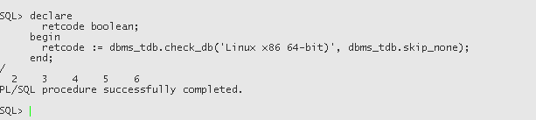

**CONVERT DATABASE**

In this case we are converting the datafiles on the destination source as opposed to converting them on the source host.

The source database (32 bit) data files are stored in a file system while the destination database (64 bit) will be using ASM disk groups instead.

Performing the conversion on the destination system will also avoid any performance overhead on the source system while the conversion process is underway.

We use the **CONVERT DATABASE ON TARGET PLATFORM** RMAN command.

This command will generate a convert script which contains the CONVERT DATAFILE commands to perform the conversion from the source to target format

The transport script contains the actual commands used to recreate the control files on the target database after the data file conversion is completed.

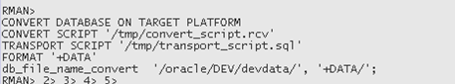

In our case we encountered an error because a number of users had been allocated the SYSTEM tablespace as their default tablespace.

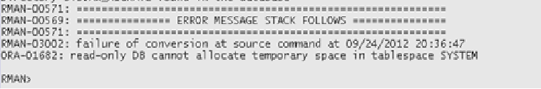

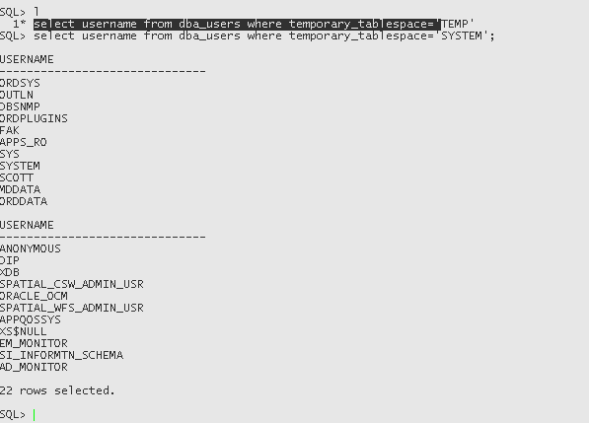

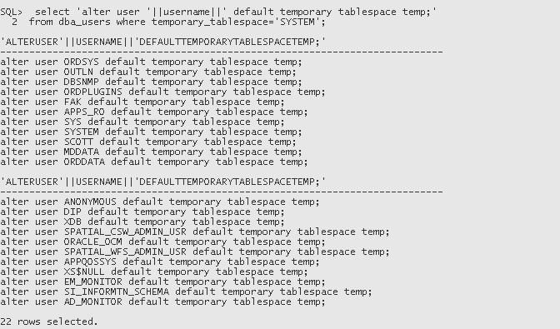

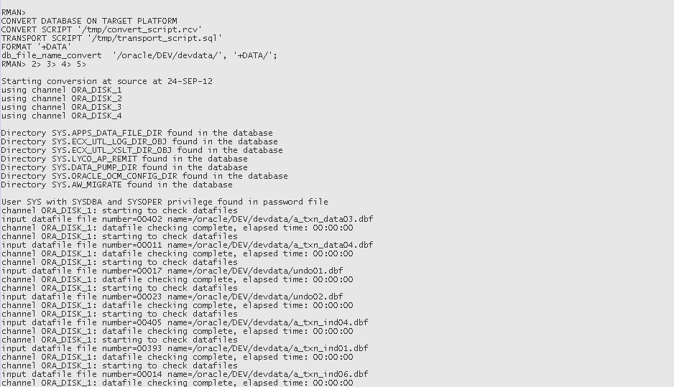

…

…..

………

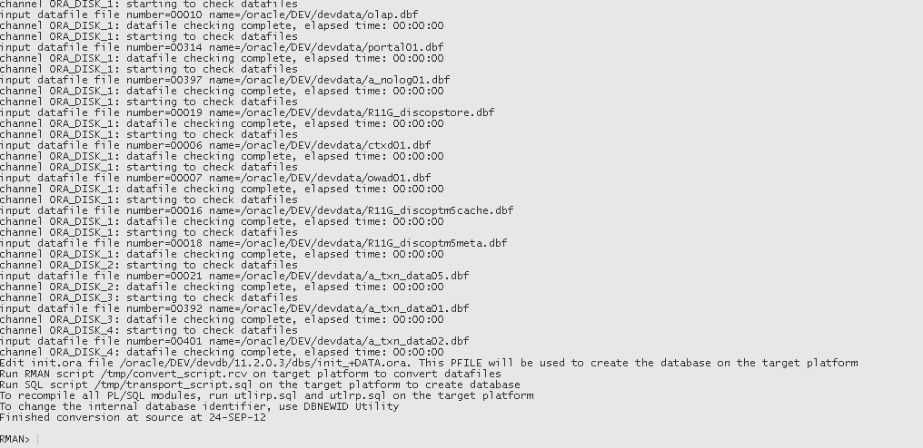

Copy the /tmp/convert_script.rcv and /tmp/transport_script.sql files from source to appropriate destination on target machine.

Copy init.ora parameter file from source to target $ORACLE_HOME/dbs

Make changes to init.ora

Change control_files location to point to ASM disk group

Control_files=’+DATA’,’+DATA’,’+DATA’

Also change location of adump in the init.ora datafile.

**Mount the source (read only) file system on target server**

Add an entry in /etc/exports

$ cat /etc/exports

/oracle oradevdb.mycorp.com.au (ro,sync)

Followed by

/etc/init.d/nfs restart

On target

mount -t nfs 192.168.xxx.xx:/oracle /oracle

**Run the CONVERT script**

convert_script.rcv contents:

RUN {

CONVERT

FROM PLATFORM 'Linux IA (32-bit)'

PARALLELISM 4

DATAFILE '/oracle/DEV/devdata/undo02.dbf' FORMAT '+DATA'

DATAFILE '/oracle/DEV/devdata/undo01.dbf' FORMAT '+DATA'

DATAFILE '/oracle/DEV/devdata/undo04.dbf' FORMAT '+DATA'

DATAFILE '/oracle/DEV/devdata/undo03.dbf' FORMAT '+DATA'

DATAFILE '/oracle/DEV/devdata/system06.dbf' FORMAT '+DATA'

DATAFILE '/oracle/DEV/devdata/system07.dbf' FORMAT '+DATA'

DATAFILE '/oracle/DEV/devdata/system11.dbf' FORMAT '+DATA'

DATAFILE '/oracle/DEV/devdata/system01.dbf' FORMAT '+DATA'

DATAFILE '/oracle/DEV/devdata/system02.dbf' FORMAT '+DATA'

DATAFILE '/oracle/DEV/devdata/system03.dbf' FORMAT '+DATA'

DATAFILE '/oracle/DEV/devdata/system04.dbf' FORMAT '+DATA'

DATAFILE '/oracle/DEV/devdata/system05.dbf' FORMAT '+DATA'

DATAFILE '/oracle/DEV/devdata/system10.dbf' FORMAT '+DATA'

DATAFILE '/oracle/DEV/devdata/system09.dbf' FORMAT '+DATA'

DATAFILE '/oracle/DEV/devdata/system08.dbf' FORMAT '+DATA'

DATAFILE '/oracle/DEV/devdata/a_txn_data03.dbf' FORMAT '+DATA'

DATAFILE '/oracle/DEV/devdata/a_txn_data04.dbf' FORMAT '+DATA'

DATAFILE '/oracle/DEV/devdata/a_txn_ind04.dbf' FORMAT '+DATA'

DATAFILE '/oracle/DEV/devdata/a_txn_ind01.dbf' FORMAT '+DATA'

DATAFILE '/oracle/DEV/devdata/a_txn_ind06.dbf' FORMAT '+DATA'

DATAFILE '/oracle/DEV/devdata/a_txn_ind02.dbf' FORMAT '+DATA'

DATAFILE '/oracle/DEV/devdata/a_txn_ind03.dbf' FORMAT '+DATA'

DATAFILE '/oracle/DEV/devdata/a_txn_ind05.dbf' FORMAT '+DATA'

DATAFILE '/oracle/DEV/devdata/sysaux01.dbf' FORMAT '+DATA'

DATAFILE '/oracle/DEV/devdata/a_archive01.dbf' FORMAT '+DATA'

DATAFILE '/oracle/DEV/devdata/a_media01.dbf' FORMAT '+DATA'

DATAFILE '/oracle/DEV/devdata/a_int01.dbf' FORMAT '+DATA'

DATAFILE '/oracle/DEV/devdata/a_txn_data06.dbf' FORMAT '+DATA'

DATAFILE '/oracle/DEV/devdata/a_ref01.dbf' FORMAT '+DATA'

DATAFILE '/oracle/DEV/devdata/a_summ01.dbf' FORMAT '+DATA'

DATAFILE '/oracle/DEV/devdata/a_ref02.dbf' FORMAT '+DATA'

DATAFILE '/oracle/DEV/devdata/lyco_data01.dbf' FORMAT '+DATA'

DATAFILE '/oracle/DEV/devdata/xxpic01.dbf' FORMAT '+DATA'

DATAFILE '/oracle/DEV/devdata/a_txn_data07.dbf' FORMAT '+DATA'

DATAFILE '/oracle/DEV/devdata/a_queue01.dbf' FORMAT '+DATA'

DATAFILE '/oracle/DEV/devdata/a_queue02.dbf' FORMAT '+DATA'

DATAFILE '/oracle/DEV/devdata/discoverer01.dbf' FORMAT '+DATA'

DATAFILE '/oracle/DEV/devdata/odm.dbf' FORMAT '+DATA'

DATAFILE '/oracle/DEV/devdata/olap.dbf' FORMAT '+DATA'

DATAFILE '/oracle/DEV/devdata/portal01.dbf' FORMAT '+DATA'

DATAFILE '/oracle/DEV/devdata/a_nolog01.dbf' FORMAT '+DATA'

DATAFILE '/oracle/DEV/devdata/R11G_discopstore.dbf' FORMAT '+DATA'

DATAFILE '/oracle/DEV/devdata/ctxd01.dbf' FORMAT '+DATA'

DATAFILE '/oracle/DEV/devdata/owad01.dbf' FORMAT '+DATA'

DATAFILE '/oracle/DEV/devdata/R11G_discoptm5cache.dbf' FORMAT '+DATA'

DATAFILE '/oracle/DEV/devdata/R11G_discoptm5meta.dbf' FORMAT '+DATA'

DATAFILE '/oracle/DEV/devdata/a_txn_data05.dbf' FORMAT '+DATA'

DATAFILE '/oracle/DEV/devdata/a_txn_data01.dbf' FORMAT '+DATA'

DATAFILE '/oracle/DEV/devdata/a_txn_data02.dbf' FORMAT '+DATA'

; }

Next, start the database with NOMOUNT option and run the RMAN script convert_script.rcv

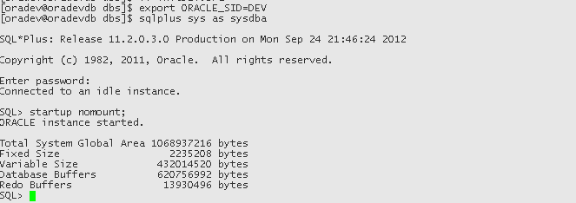

RMAN**>@convert_script.rcv**

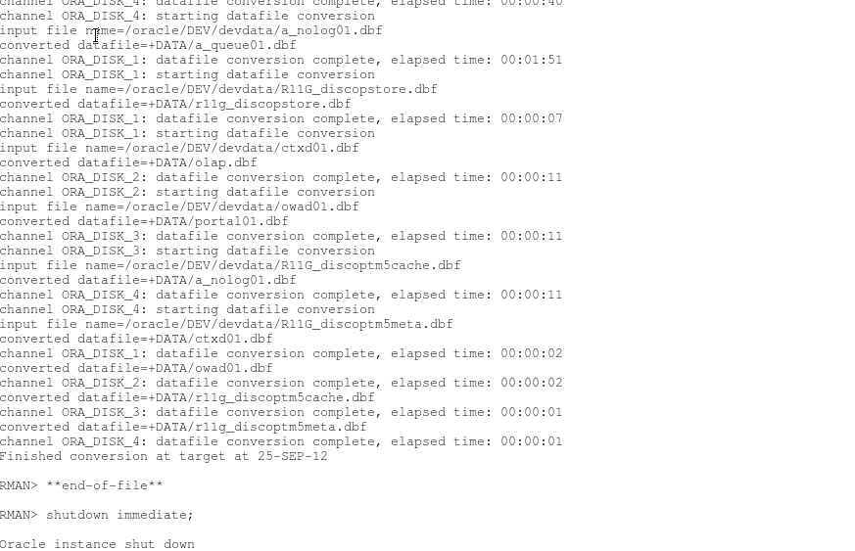

Note – what I found that while it mentions the converted datafile as “+DATA/olap.dbf”, actually the file is created as “+DATA/dev/datafile/olap.277.794979681”

We had to take lines out of transport_script.sql and edit to include the correct ASM OMF file name.

We then created a file called crectl.sql which had the following contents:

crecctl.sql

CREATE CONTROLFILE REUSE SET DATABASE "DEV" RESETLOGS FORCE LOGGING ARCHIVELOG

MAXLOGFILES 32

MAXLOGMEMBERS 5

MAXDATAFILES 512

MAXINSTANCES 8

MAXLOGHISTORY 7260

LOGFILE

GROUP 1 (

'+DATA',

'+DATA'

) SIZE 100M BLOCKSIZE 512,

GROUP 2 (

'+DATA',

'+DATA'

) SIZE 100M BLOCKSIZE 512,

GROUP 3 (

'+DATA',

'+DATA'

) SIZE 100M BLOCKSIZE 512,

GROUP 4 (

'+DATA',

'+DATA'

) SIZE 100M BLOCKSIZE 512,

GROUP 5 (

'+DATA',

'+DATA'

) SIZE 100M BLOCKSIZE 512,

GROUP 6 (

'+DATA',

'+DATA'

) SIZE 100M BLOCKSIZE 512,

GROUP 7 (

'+DATA',

'+DATA'

) SIZE 100M BLOCKSIZE 512,

GROUP 8 (

'+DATA',

'+DATA'

) SIZE 100M BLOCKSIZE 512,

GROUP 9 (

'+DATA',

'+DATA'

) SIZE 100M BLOCKSIZE 512,

GROUP 10 (

'+DATA',

'+DATA'

) SIZE 100M BLOCKSIZE 512

DATAFILE

'+DATA/dev/datafile/apps_ts_tx_data.355.794965469',

'+DATA/dev/datafile/apps_ts_tx_data.361.794965469',

'+DATA/dev/datafile/apps_ts_tx_data.360.794965469',

'+DATA/dev/datafile/apps_ts_tx_data.356.794965469',

'+DATA/dev/datafile/apps_ts_tx_idx.351.794969911',

'+DATA/dev/datafile/apps_undots1.353.794969911',

'+DATA/dev/datafile/apps_undots1.352.794969911',

'+DATA/dev/datafile/apps_ts_tx_data.354.794969895',

'+DATA/dev/datafile/apps_ts_tx_idx.350.794973207',

'+DATA/dev/datafile/apps_ts_tx_idx.348.794973643',

'+DATA/dev/datafile/apps_ts_tx_idx.349.794973643',

'+DATA/dev/datafile/apps_ts_tx_idx.347.794973797',

'+DATA/dev/datafile/sysaux.343.794976769',

'+DATA/dev/datafile/apps_undots1.344.794976663',

'+DATA/dev/datafile/apps_undots1.345.794976619',

'+DATA/dev/datafile/system.342.794977855',

'+DATA/dev/datafile/apps_ts_tx_data.337.794978951',

'+DATA/dev/datafile/apps_ts_seed.336.794979017',

'+DATA/dev/datafile/apps_ts_summary.335.794979051',

'+DATA/dev/datafile/apps_ts_seed.334.794979059',

'+DATA/dev/datafile/lyco.316.794979229',

'+DATA/dev/datafile/system.320.794979215',

'+DATA/dev/datafile/xxpic.315.794979255',

'+DATA/dev/datafile/apps_ts_tx_data.319.794979261',

'+DATA/dev/datafile/system.318.794979377',

'+DATA/dev/datafile/system.317.794979377',

'+DATA/dev/datafile/system.307.794979377',

'+DATA/dev/datafile/system.268.794979377',

'+DATA/dev/datafile/system.271.794979523',

'+DATA/dev/datafile/system.267.794979523',

'+DATA/dev/datafile/system.269.794979523',

'+DATA/dev/datafile/apps_ts_queues.270.794979523',

'+DATA/dev/datafile/odm.276.794979665',

'+DATA/dev/datafile/olap.277.794979681',

'+DATA/dev/datafile/portal.278.794979695',

'+DATA/dev/datafile/discoverer.275.794979665',

'+DATA/dev/datafile/apps_ts_queues.273.794979665',

'+DATA/dev/datafile/r11g_disco_pstore.281.794979715',

'+DATA/dev/datafile/apps_ts_nologging.279.794979711',

'+DATA/dev/datafile/owapub.283.794979731',

'+DATA/dev/datafile/r11g_disco_ptm5_cache.284.794979731',

'+DATA/dev/datafile/ctxd.282.794979729',

'+DATA/dev/datafile/r11g_disco_ptm5_meta.285.794979731',

'+DATA/dev/datafile/system.272.794979657'

CHARACTER SET US7ASCII

;

Now startup nomount the database and run the script crectl.sql which will create the control files in the ASM disk group +DATA

After the control files have been created we open the database with RESETLOGS option.

SQL> ALTER DATABASE OPEN RESETLOGS;

The generated transport_script.sql has the commands to add the tempfiles to the database and then run utlirp.sql.

But we found that when we tried to add the tempfiles, we were getting an error as shown below.

SQL> ALTER TABLESPACE TEMP ADD TEMPFILE '+DATA'

     SIZE 9000M AUTOEXTEND ON NEXT 8192  MAXSIZE 15000M;  2

ALTER TABLESPACE TEMP ADD TEMPFILE '+DATA'

*

ERROR at line 1:

ORA-00604: error occurred at recursive SQL level 1

ORA-06553: PLS-801: internal error [56327]

Next shutdown the database using the IMMEDIATE option.

Change the location for CONTROL_FILES from +DATA to actual OMF file name

*.control_files='+DATA/DEV/CONTROLFILE/current.323.795010677','+DATA/dev/controlfile/current.322.795010679','+DATA/dev/controlfile/current.321.795010679'

Then start the database using the UPGRADE option

SQL> startup upgrade pfile=' /u01/DEV/db/tech_st/11.2.0.3/dbs/initDEV.ora’

Run the utlirp.sql script

@ ?/rdbms/admin/utlirp.sql

Add the tempfiles to the database

ALTER TABLESPACE TEMP ADD TEMPFILE '+DATA'

SIZE 9000M AUTOEXTEND ON NEXT 8192 MAXSIZE 15000M;

ALTER TABLESPACE TEMP ADD TEMPFILE '+DATA'

SIZE 2000M AUTOEXTEND ON NEXT 8192 MAXSIZE 15000M;

ALTER TABLESPACE TEMP ADD TEMPFILE '+DATA'

SIZE 32000M AUTOEXTEND ON NEXT 8192 MAXSIZE 32000M;

ALTER TABLESPACE R11G_IAS_TEMP ADD TEMPFILE '+DATA'

SIZE 104857600 AUTOEXTEND ON NEXT 8192 MAXSIZE 1048576000 ;

Shutdown the database

SQL> shutdown immediate

Next, start the database and run utlrp.sql to recompile all PL/SQL modules

SQL> startup pfile=' /u01/DEV/db/tech_st/11.2.0.3/dbs/initDEV.ora’

SQL>@ ?/rdbms/admin/utlrp.sql

***Note – recompilation took close to 3 hours in this case***

**Add OLAP back into the database.**

@?/olap/admin/olap.sql SYSAUX TEMP

**Import OLAP Analytic Workspaces**

For each OLAP analytical workspace , run the following package procedures to import the workspace.

exec dbms_aw.execute( 'aw create <owner>.<aw_name>' );  
exec dbms_aw.execute( 'import all from eif file ''AW_MIGRATE/<schema>_<aw_name>.eif'' data dfns' );  
exec dbms_aw.execute( 'update' );  
commit;  
exec dbms_aw.execute( 'aw detach <owner>.<aw_name>' );

|  |  |  |  |
| --- | --- | --- | --- |
|  |  |  |  |
|  |  |  |  |

Drop the directory used to import the OLAP analytical workspace migration files.

SQL> drop directory aw_migrate;

Recompile invalid objects.

SQL> @?/rdbms/admin/utlrp.sql

SQL> select OWNER, AW_NAME ,PAGESPACES from dba_aws

where owner != 'SYS' order by 1,2;

OWNER AW_NAME PAGESPACES

------------------------------ ------------------------------ ----------

FPA FPAPJP 532

ZPB ZPBANNOT 8

ZPB ZPBCODE 480

ZPB ZPBDATA 8

Note – further details can be found in MetaLink Note 352306.1