10g Automatic Segment Space Management

Contributor: Gavin Soorma

We will first create a tablespace of 10MB in size – load data in the tablespace so that the Tablespace threshold for space alerts is exceeded and then check if the Alert is notified via Enterprise Manager.

SQL> create tablespace MYSEGMENT
- datafile '/hqlinux04db01/ORACLE/riwl/mytest01.dbf' size 10m;

SQL> execute dbms_server_alert.set_threshold(-
> dbms_server_alert.tablespace_pct_full ,-
> dbms_server_alert.operator_ge,80,-
> dbms_server_alert.operator_ge,95,1,1,NULL,-
> dbms_server_alert.object_type_tablespace,'MYTEST');

PL/SQL procedure successfully completed.

SQL> begin
for i in 1 .. 10 loop
insert into myobjects
select * from all_objects;
commit;
end loop;
end;
/ 2 3 4 5 6 7 8
begin
*
ERROR at line 1:
ORA-01653: unable to extend table SCOTT.MYOBJECTS by 128 in tablespace MYTEST
ORA-06512: at line 3

DBA_OUTSTANDING_ALERTS now has a row related to this alert that was just generated

SQL> select reason,suggested_action from dba_outstanding_alerts;

REASON
--------------------------------------------------------------------------------
SUGGESTED_ACTION
--------------------------------------------------------------------------------
Tablespace [MYTEST] is [90 percent] full
Add space to the tablespace

The same alert is also visible via Enterprise Manager

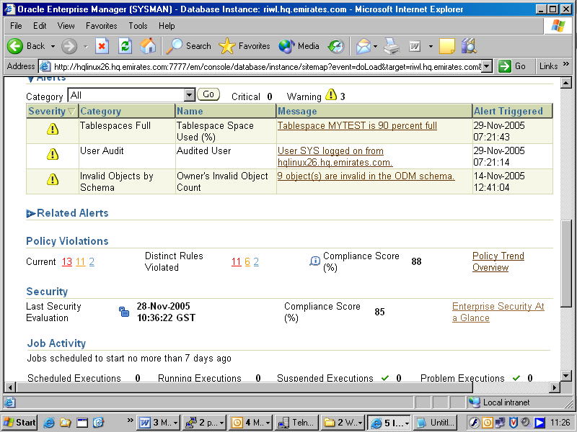

SQL> alter database datafile '/hqlinux04db01/ORACLE/riwl/mytest01.dbf' resize 50m;

Database altered.

Now we will perform some inserts and deletes on the table so that the tablespace becomes fragmented and there is a lot of wasted space in the table above the high water mark

We will use both the API’s as well as the GUI Segment Advisor in this example.

The Segment Advisor can help you determine which objects have space available for reclamation.

The Segment Advisor relies for its analysis on data collected in the Automatic Workload Repository (AWR).

SQL> delete myobjects;

431676 rows deleted.

SQL> commit;

Commit complete.

SQL> begin
for i in 1 .. 10 loop
insert into myobjects
select * from all_objects;
commit;
end loop;
end;
/ 2 3 4 5 6 7 8

SQL> delete myobjects;

431676 rows deleted.

Create an Advisor Task using the DBMS_ADVISOR package

SQL> variable id number;
SQL> begin
2 declare
3 name varchar2(100);
4 descr varchar2(500);
5 obj_id number;
6 begin
7 name:='';
8 descr:='Segment Advisor Task';
9 dbms_advisor.create_task('Segment Advisor', :id, name, descr, NULL);
10 dbms_advisor.create_object
11 (name, 'TABLE', 'SCOTT', 'MYOBJECTS', NULL, NULL, obj_id);
12 dbms_advisor.set_task_parameter(name, 'RECOMMEND_ALL', 'TRUE');
13 dbms_advisor.execute_task(name);
14 end;
15 end;
16 /
Advisor generated: alter table "SCOTT"."MYOBJECTS" shrink space CHECK

PL/SQL procedure successfully completed.

SQL> print id

ID
----------
1175

SQL> select benefit_type from dba_advisor_recommendations where task_id = :id;

BENEFIT_TYPE
--------------------------------------------------------------------------------
Perform shrink, estimated savings is 36370940 bytes.

Go to the Advisor Central page and click on Segment Advisor

Note the task we ran earlier is showing as completed ( TASK_1175)
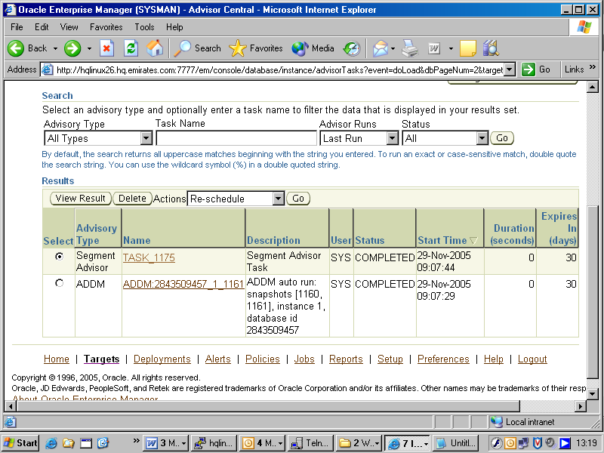

View TASK_1175 and click on “Recommendation Details”

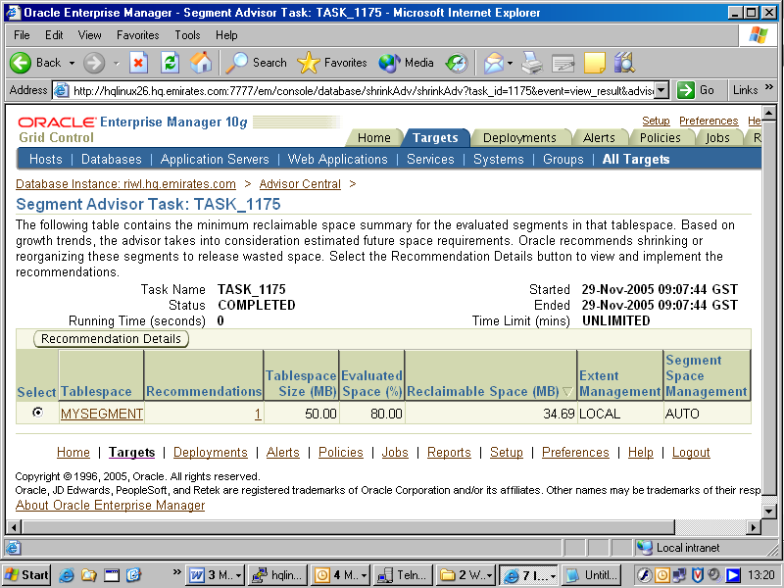

Note the space wasted by the segment MYOBJECTS - 40 MB has been allocated but only 5.26 MB is actually used

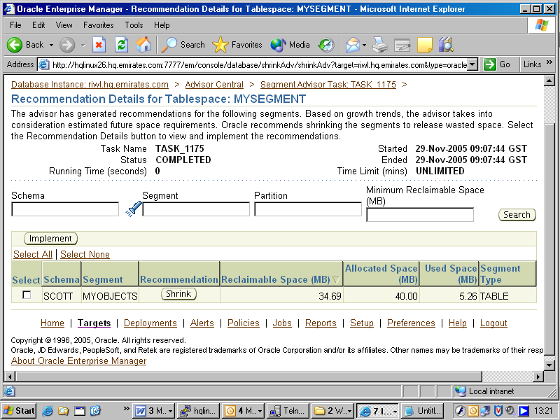

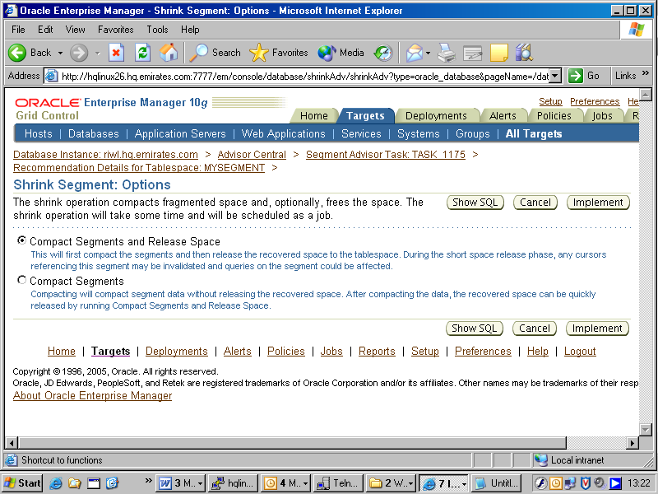
If we click the “Show SQL” button this is the SQL being actually executed:

alter table "SCOTT"."MYOBJECTS" shrink space

Enterprise Manager will call a job to run this SQL command
as shown below

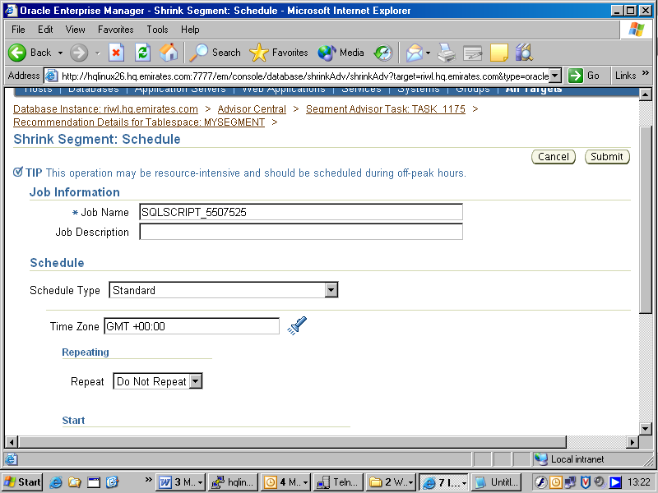

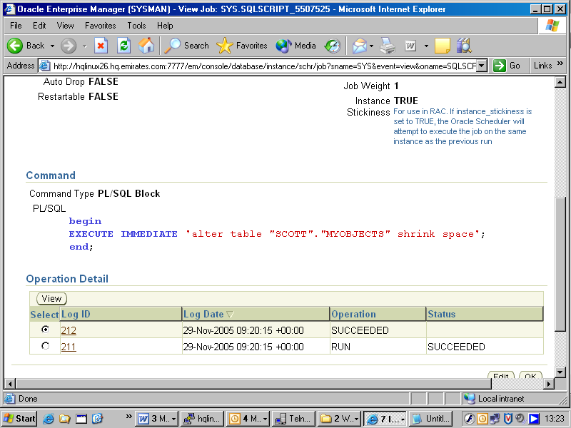

After the Job has been executed to Shrink space , now note the Free Space in the tablespace MYSEGMENT

