Upgrade from 10g to 11g Release 2 using the Database Upgrade Assistant (DBUA)
This note describes the procedure of upgrading a 10.2.0.3 database running on a Windows 2003 Server platform to 11.2.0.1 (11g Release 2).
This note also takes into account the procedure for upgrading a database to 11g with a Data Guard Physical Standby Database also running.
Pre Upgrade Steps
Take an offline backup of the database by first making all the application data and index tablespaces read only and then copying only the datafiles of the other tablespaces left in read-write mode like SYSTEM, SYSAUX,USERS, TOOLS etc. Also copy the control files and online redo log files to the backup location.
This SQL statement will generate a script to make the required tablespaces read only.
SQL> select 'alter tablespace '|| tablespace_name||' read only;'
from dba_tablespaces
Where tablespace_name NOT IN
(‘SYSTEM’,’SYSAUX’,’UNDOTBS1’,’IMOTEMP’,’PERFSTAT_TEMP’,’TEMP’);

Now Shutdown IMMEDIATE the database.

TAKE BACKUP BY COPYING FILES TO G:\PREUPGRADE_BACKUP

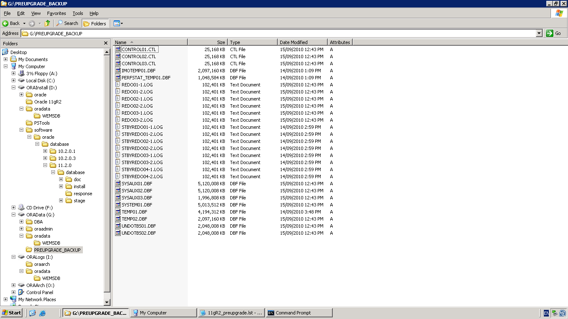

Change the log_archive_format
SQL> connect sys as sysdba
Enter password:
Connected.
SQL> show parameter log_archive_format
NAME TYPE VALUE
------------------------------------ ----------- ------------------------------
log_archive_format string WEMSDB_%S_%R_%T.ARC
SQL> alter system set log_archive_format='WEMSDB_%s_%r_%t.ARC' scope=spfile;
System altered.

TRUNCATE the SYS.AUD$ Table
SQL> conn sys as sysdba
Enter password:
Connected.

SQL> create table aud$_backup
2 as select * from sys.aud$;
Table created.
SQL> truncate table sys.aud$;
Table truncated

Purge the Recycle Bin
SQL> PURGE DBA_RECYCLEBIN ;
DBA Recyclebin purged.

Make a note of the Count of INVALID Objects
SQL> Select owner,object_name,object_type from dba_objects
Where status=’INVALID’;

Gather Dictionary Statistics
To decrease the amount of downtime incurred when collecting statistics, you can collect statistics prior to performing the actual database upgrade
SQL> EXEC DBMS_STATS.GATHER_DICTIONARY_STATS;
PL/SQL procedure successfully completed.

Check log shipping status

SQL> select destination,status from v$archive_dest_status where dest_id <3;
DESTINATION
--------------------------------------------------------------------------------
STATUS
---------
I:\oraarch\WEMSDB
VALID
WEMSDB_WEMDDBA3
VALID

SET PAGESIZE 124
COL DB_NAME FORMAT A8
COL HOSTNAME FORMAT A12
COL LOG_ARCHIVED FORMAT 999999
COL LOG_APPLIED FORMAT 999999
COL LOG_GAP FORMAT 9999
COL APPLIED_TIME FORMAT A12
SELECT DB_NAME, HOSTNAME, LOG_ARCHIVED, LOG_APPLIED,APPLIED_TIME,
LOG_ARCHIVED-LOG_APPLIED LOG_GAP
FROM
(
SELECT NAME DB_NAME
FROM V$DATABASE
),
(
SELECT UPPER(SUBSTR(HOST_NAME,1,(DECODE(INSTR(HOST_NAME,’.'),0,LENGTH(HOST_NAME),
(INSTR(HOST_NAME,’.')-1))))) HOSTNAME
FROM V$INSTANCE
),
(
SELECT MAX(SEQUENCE#) LOG_ARCHIVED
FROM V$ARCHIVED_LOG WHERE DEST_ID=1 AND ARCHIVED=’YES’
and
resetlogs_id in
( select max(resetlogs_id) from v$archived_log)
),
(
SELECT MAX(SEQUENCE#) LOG_APPLIED
FROM V$ARCHIVED_LOG WHERE DEST_ID=2 AND APPLIED=’YES’
and
resetlogs_id in
( select max(resetlogs_id) from v$archived_log)
),
(
SELECT TO_CHAR(MAX(COMPLETION_TIME),’DD-MON/HH24:MI’) APPLIED_TIME
FROM V$ARCHIVED_LOG WHERE DEST_ID=2 AND APPLIED=’YES’
and
resetlogs_id in
( select max(resetlogs_id) from v$archived_log)
);

This output shows that both the Primary database and Standby database are in sync

DB_NAME HOSTNAME LOG_ARCHIVED LOG_APPLIED APPLIED_TIME LOG_GAP
-------- ------------ ------------ ----------- ------------ -------
WEMSDB WEMDDBA2 25 25 30-NOV/13:48 0

Disable Log Shipping on the Primary Database
SQL> alter system set log_archive_dest_state_2='DEFER';
System altered.

On the Standby machine create a pfile if one does not exist
SQL> create pfile from spfile;
File Created
Now Shutdown the 10g Standby Database
SQL> shutdown immediate;
ORA-01109: database not open
Database dismounted.
ORACLE instance shut down.

If the 10g listener is running then stop it
D:\oracle\product\10.2.0\db\BIN>lsnrctl stop
LSNRCTL for 64-bit Windows: Version 10.2.0.3.0 - Production on 30-NOV-2010 15:18:13
Copyright (c) 1991, 2006, Oracle. All rights reserved.
Connecting to (DESCRIPTION=(ADDRESS=(PROTOCOL=TCP)(HOST=wemddba3)(PORT=1528)))
The command completed successfully

Now create the 11g Listener on the Standby machine

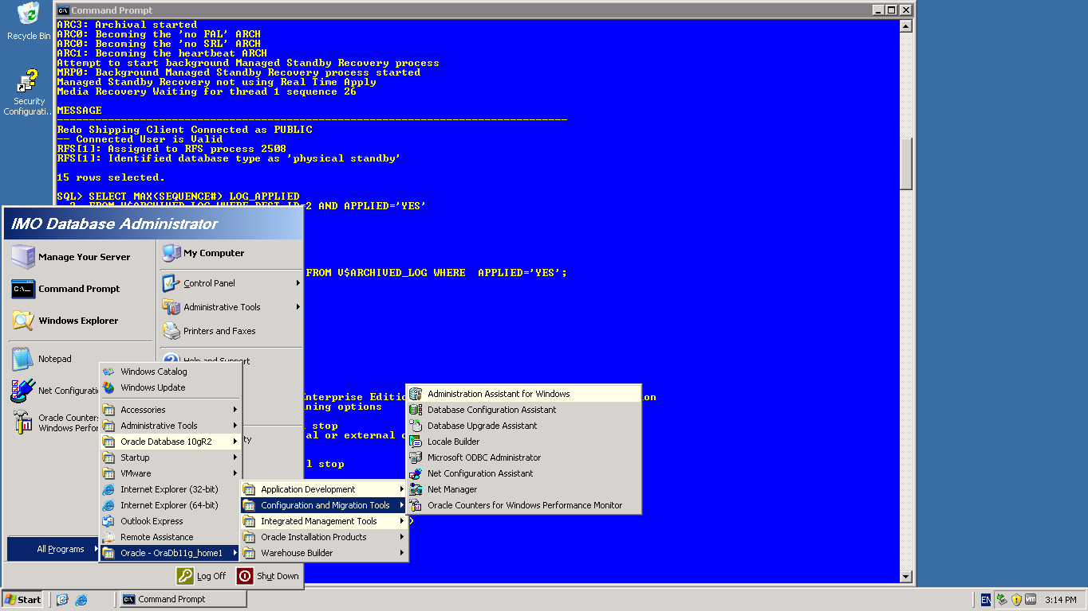

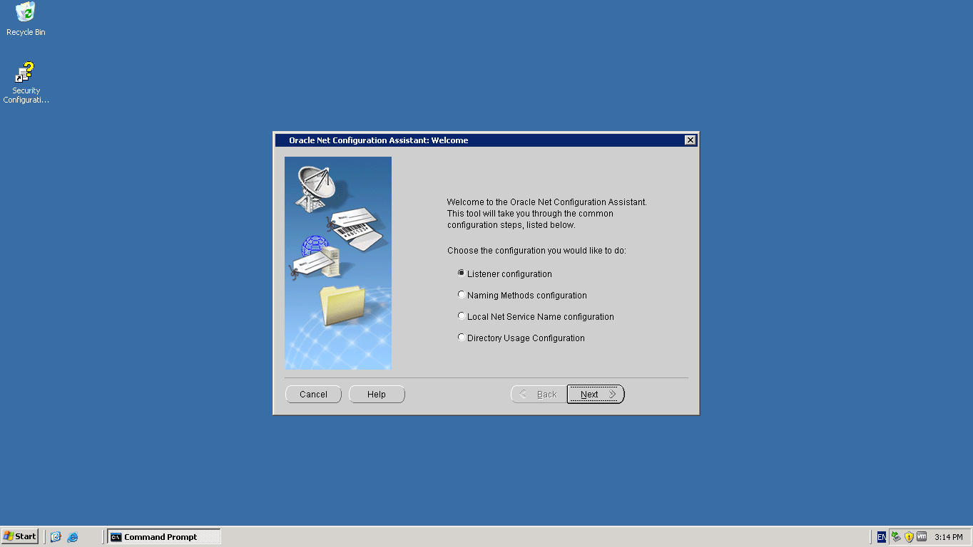

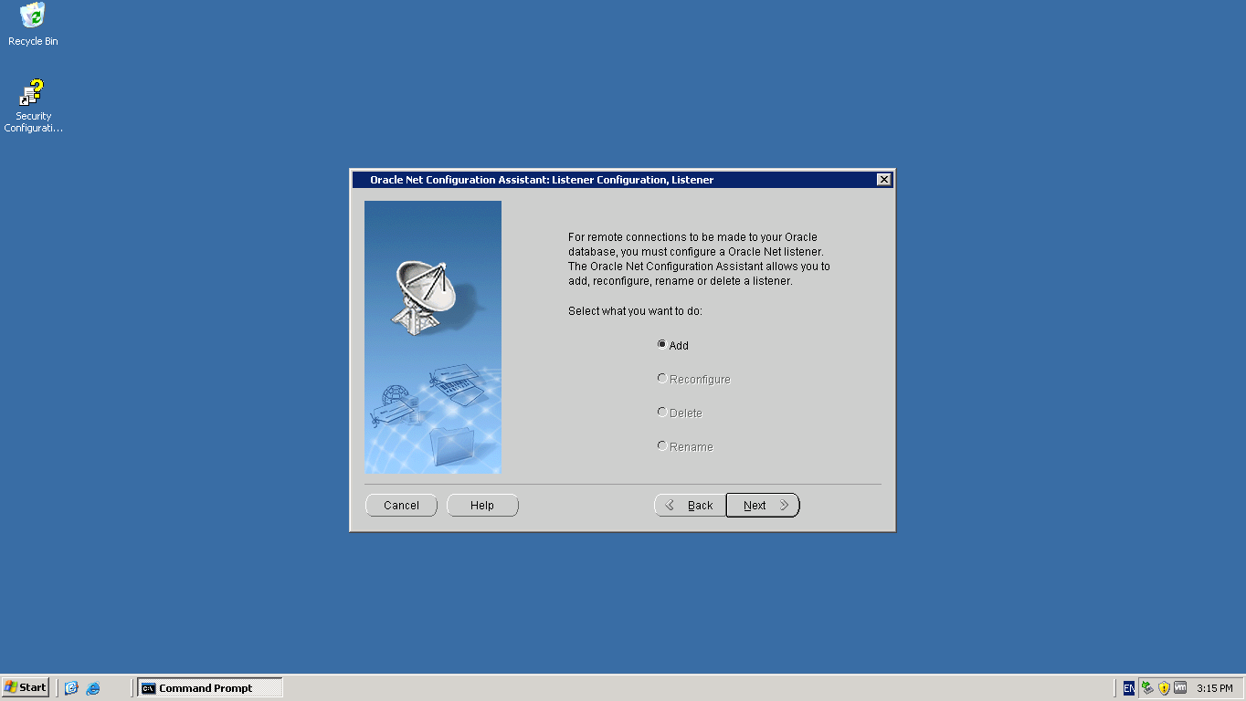

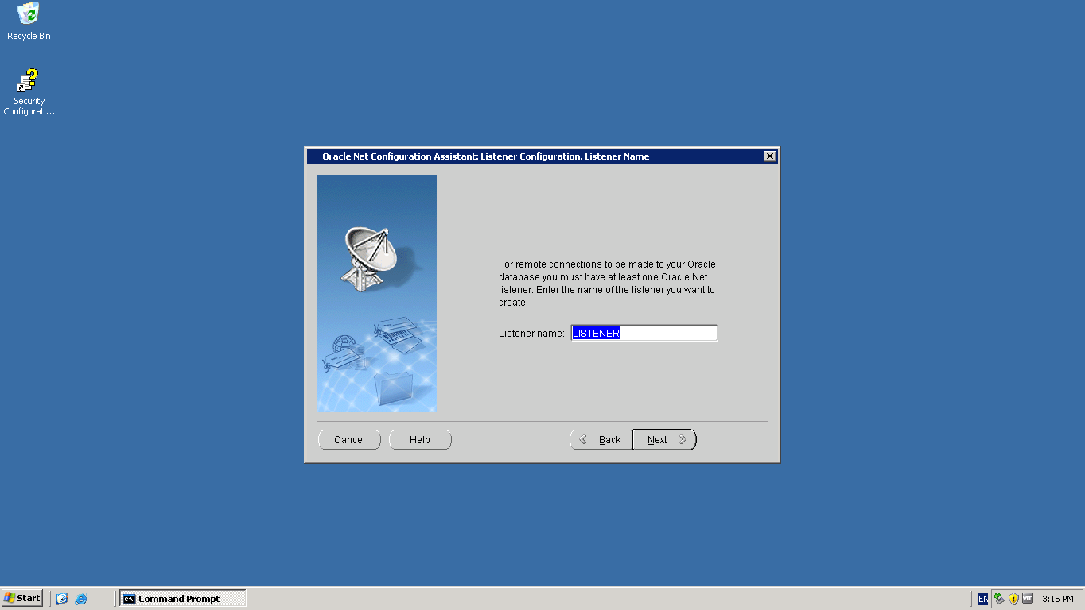

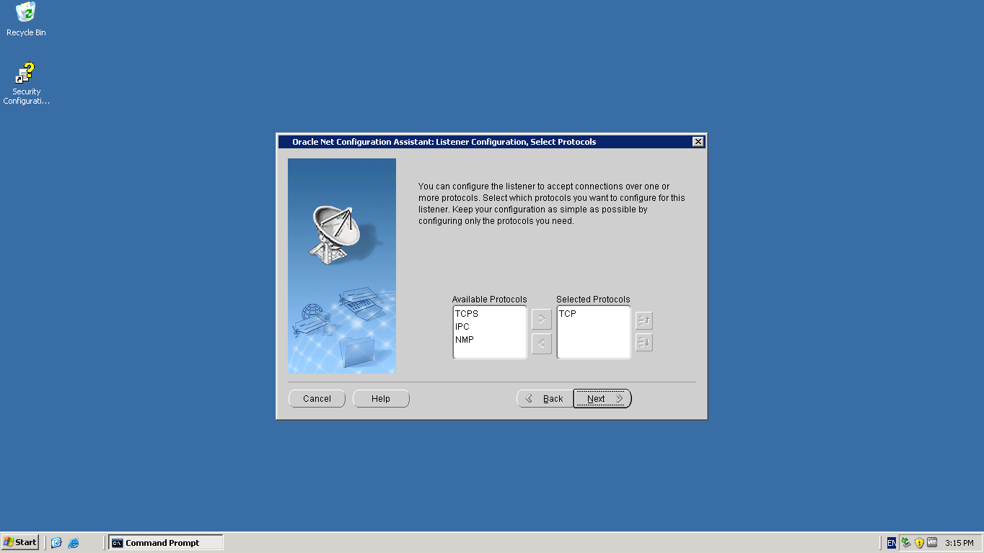

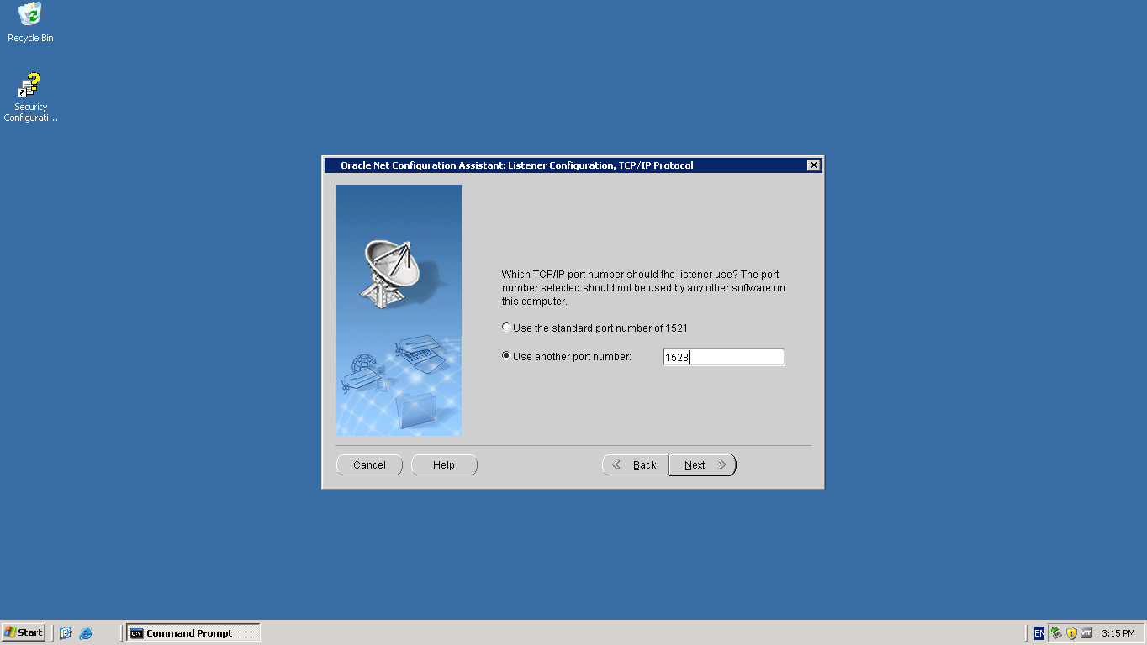

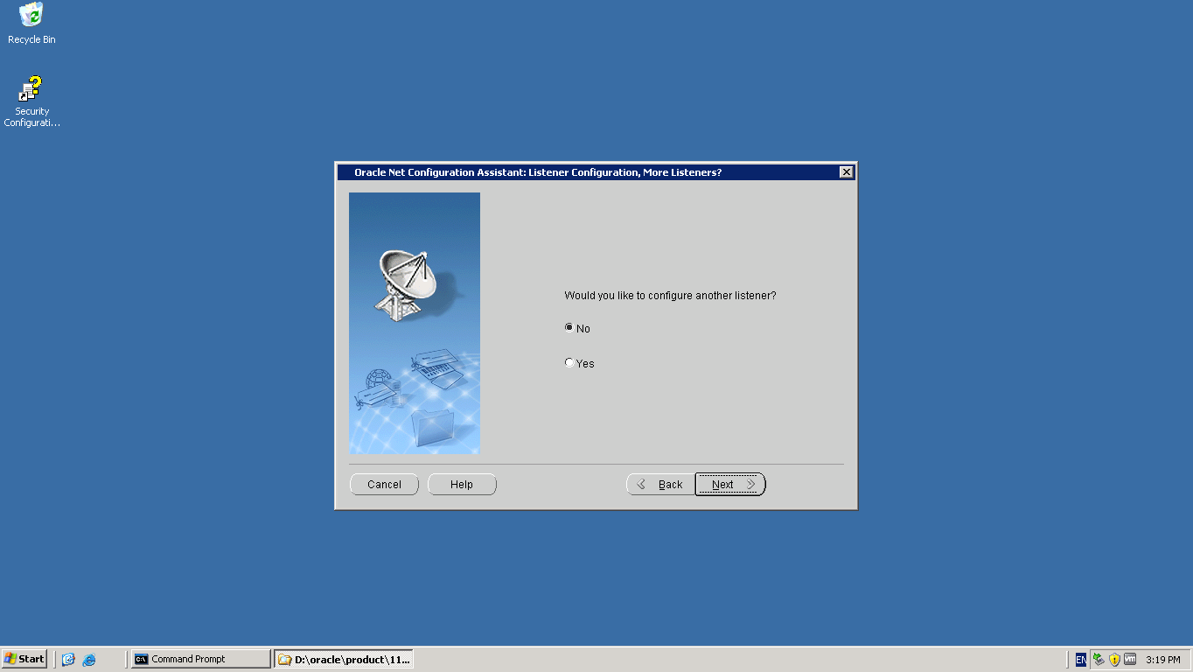

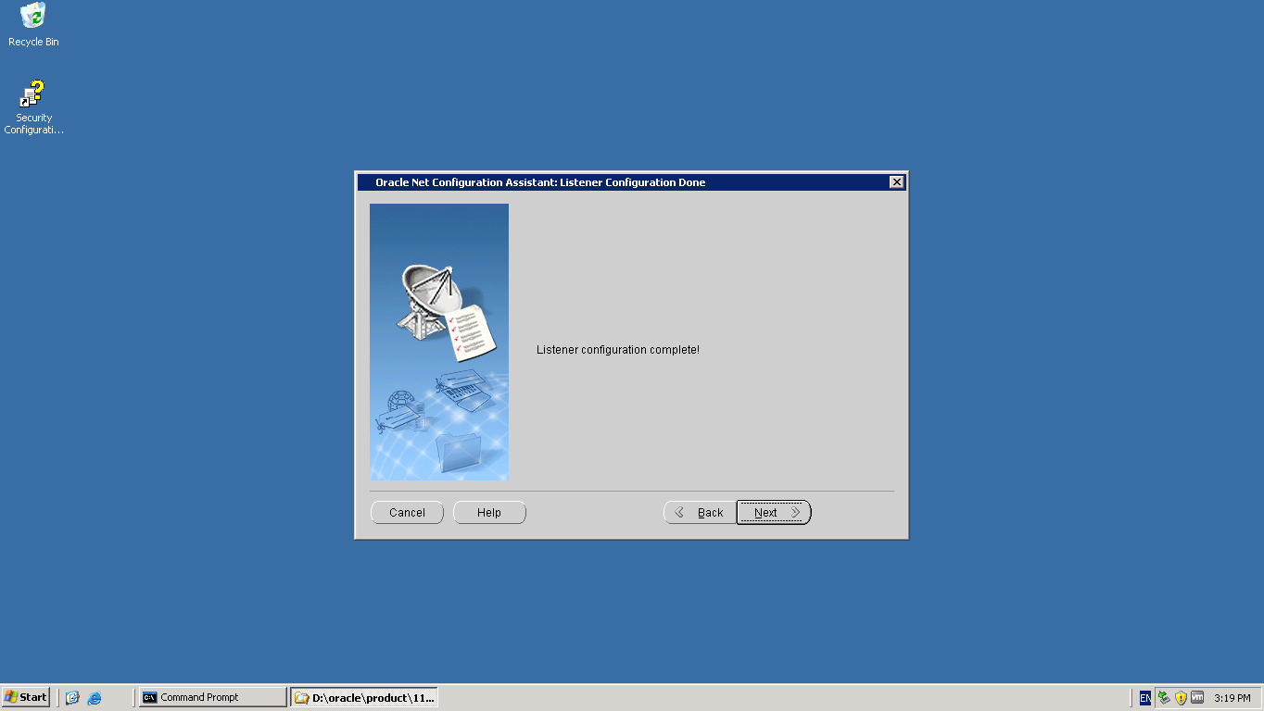

Create new 11g service On the Standby Machine via ORADIM. First delete the 10g Service.

D:\oracle\product\10.2.0\db\BIN>oradim -delete -sid WEMSDB
Instance deleted.

Note- Change to the 11g Release Home to create the 11g Service
D:\oracle\product\11.2.0\db\BIN>oradim -new -sid WEMSDB -startmode AUTO
Instance created.

Copy the password file and init.ora file/spfile from the 10g Oracle Home\Database location to 11g Oracle Home\Database location

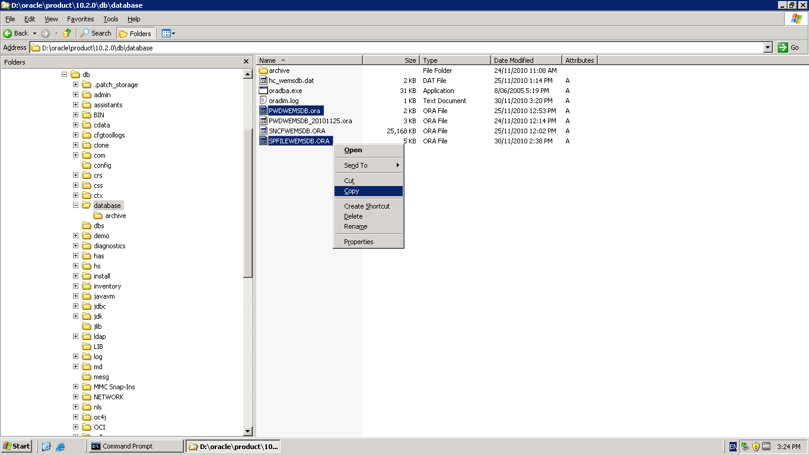

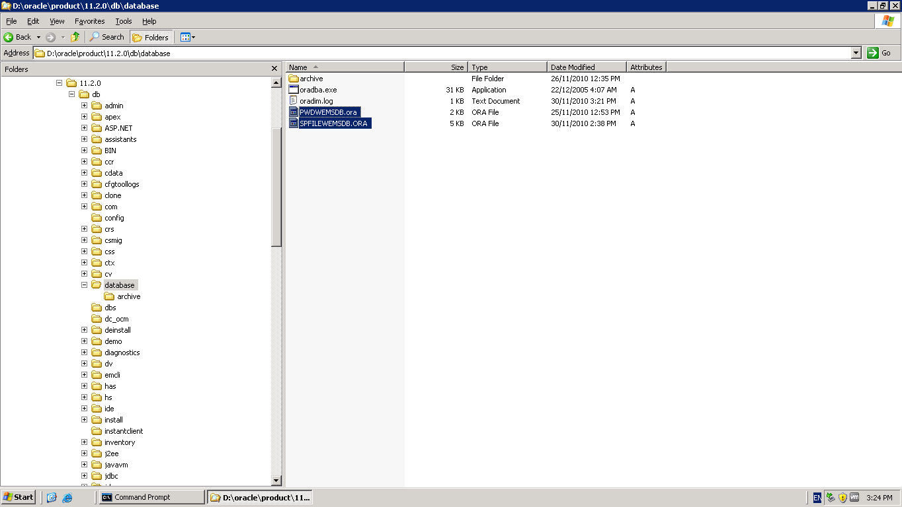

Make changes to init.ora on standby
Note – the parameters background_dump_dest, core_dump_dest and user_dump_dest are deprecated in 11g and have been replaced by the diagnostic_dest parameter in 11g.
*.diagnostic_dest:'D:\oracle'

Note – also remove the parameter standby_archive_dest as it has been deprecated in 11g

Start the 11g standby instance
SQL> create spfile from pfile;
File created.
SQL> startup nomount;
ORACLE instance started.

Total System Global Area 1043886080 bytes
Fixed Size 2182344 bytes
Variable Size 847250232 bytes
Database Buffers 176160768 bytes
Redo Buffers 18292736 bytes
SQL> alter database mount;
Database altered.

Start the managed recovery on the 11g Standby database
SQL> recover managed standby database disconnect from session;
Media recovery complete.

Start log shipping again on Primary
SQL> alter system set log_archive_dest_state_2='ENABLE';
System altered.

Note-
Stop the 10g listener and create a new 11g listener on the same port – the DBUA will also configure Enterprise Manager which requires the 11g listener to be running

Launch DBUA from Start Programs > 11g Oracle Home > Configuration and Migration Tools
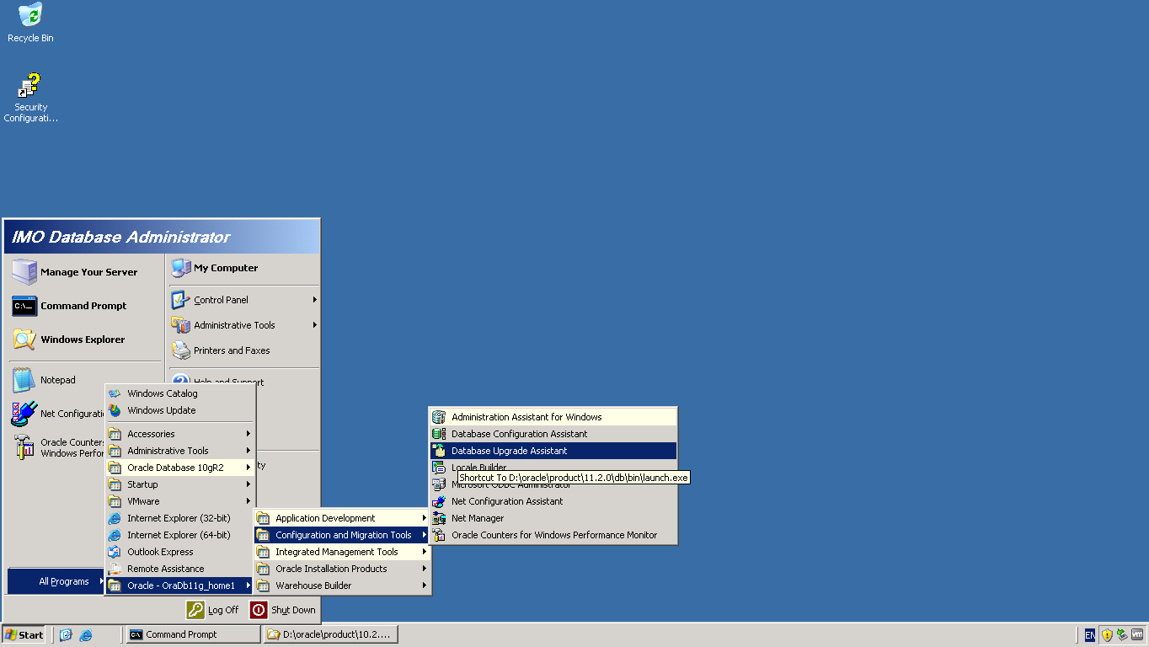

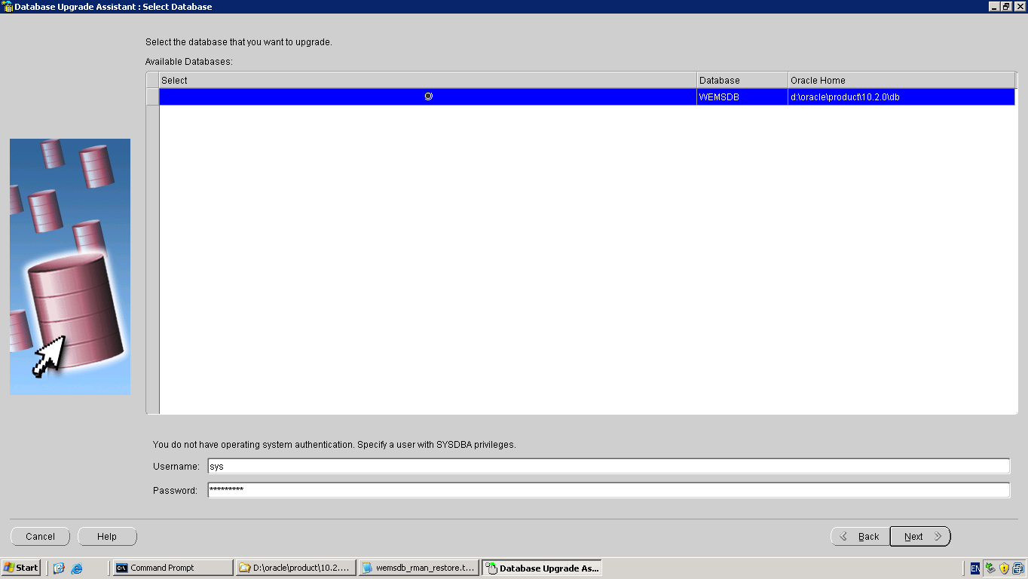

Enter the SYS password and click Next

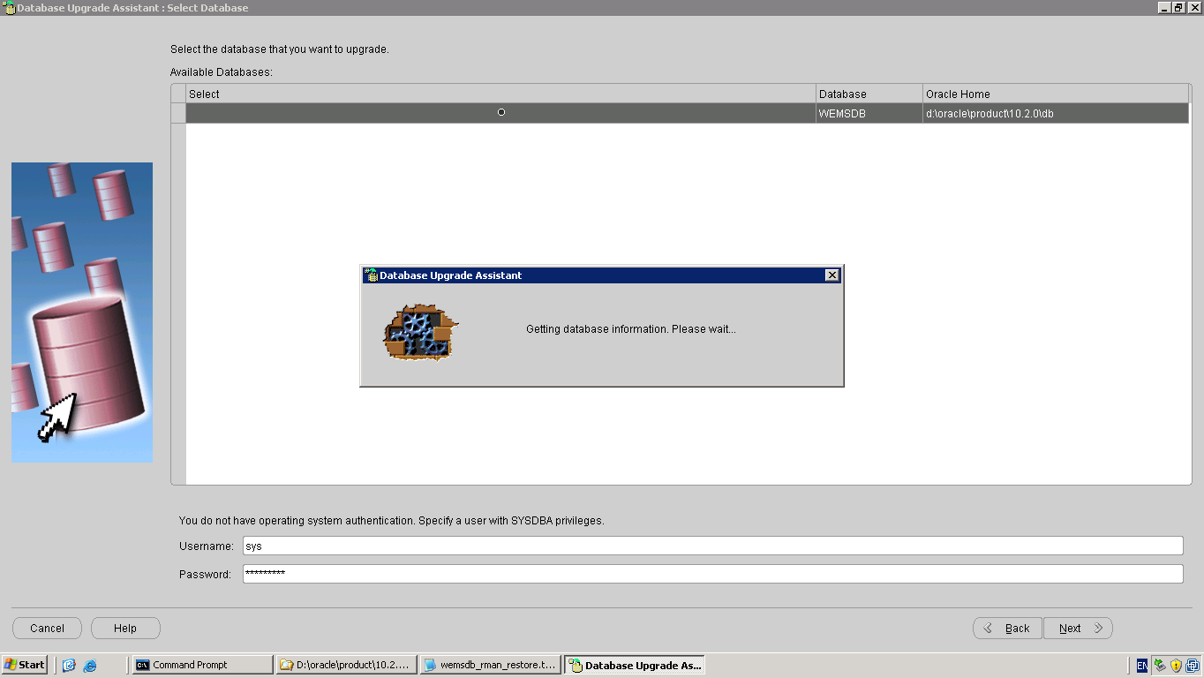

Note – the DBUA is behind the scenes running the 11g Pre-Upgrade Information script utlu112i.sql at this stage.

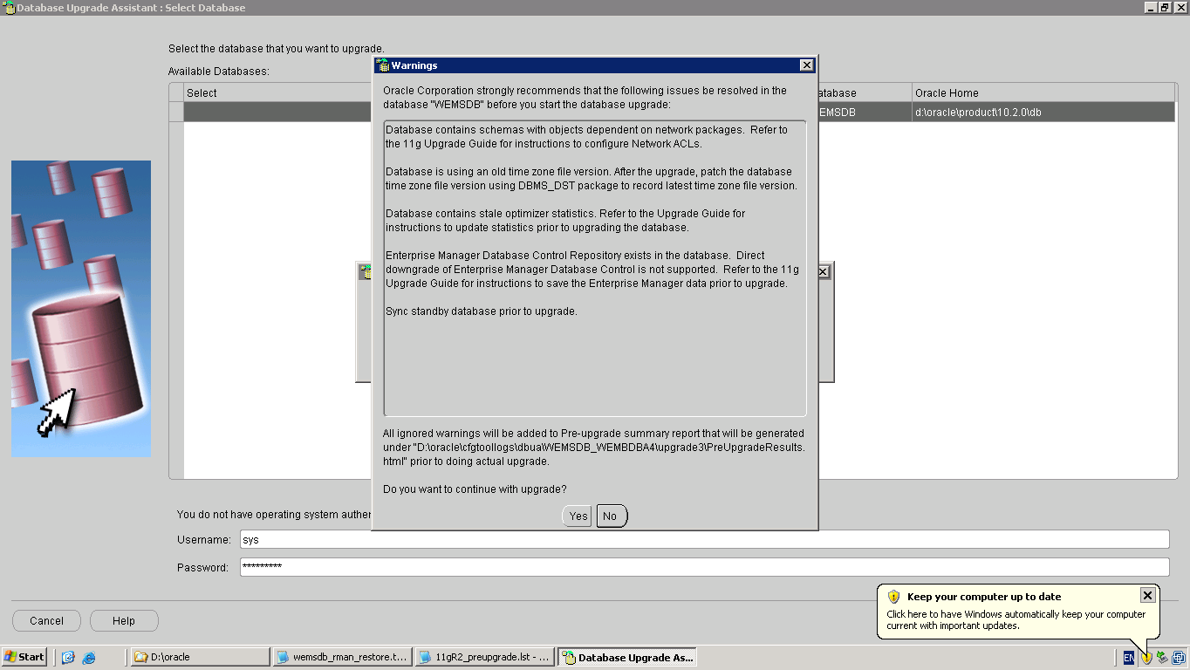

We can make a note of the Warning messages displayed, but ignore the same.
Click Yes
Note – DO NOT turn off Archiving during the upgrade process as the redo needs to be shipped to the standby site.

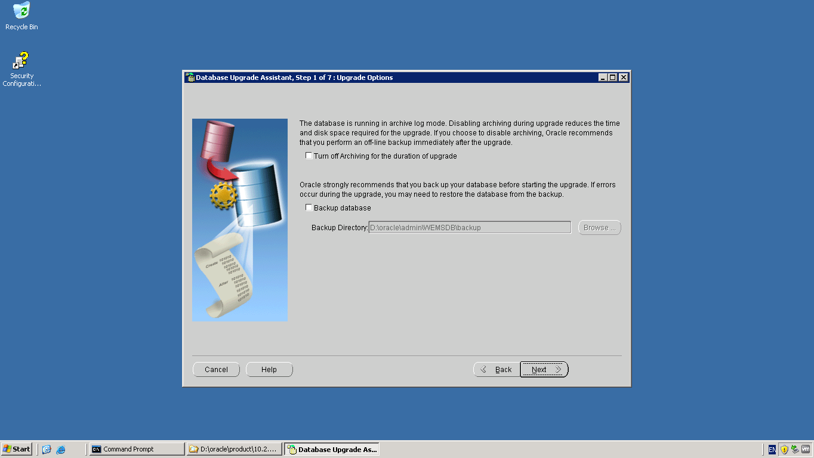

Click Next

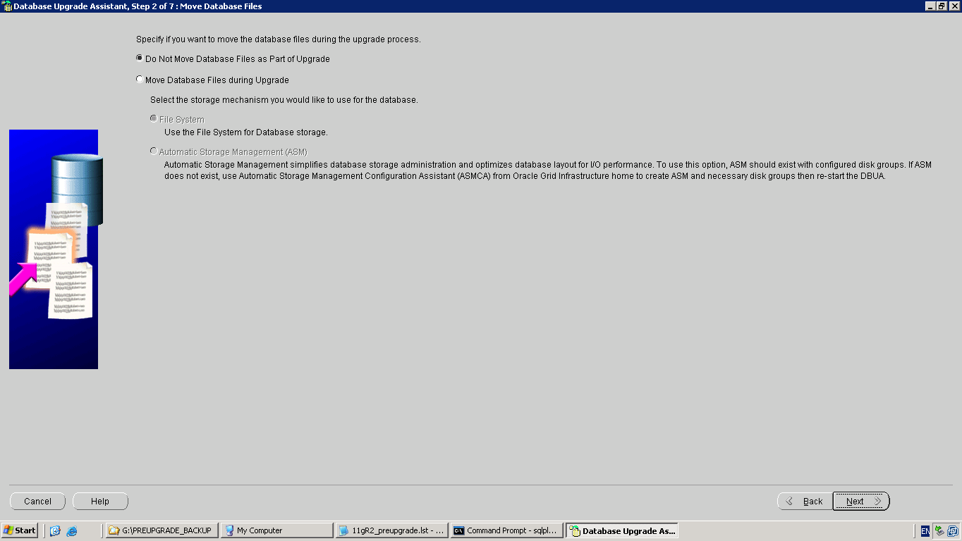

Select “Do Not Move Database Files as part of the Upgrade”.
Click Next
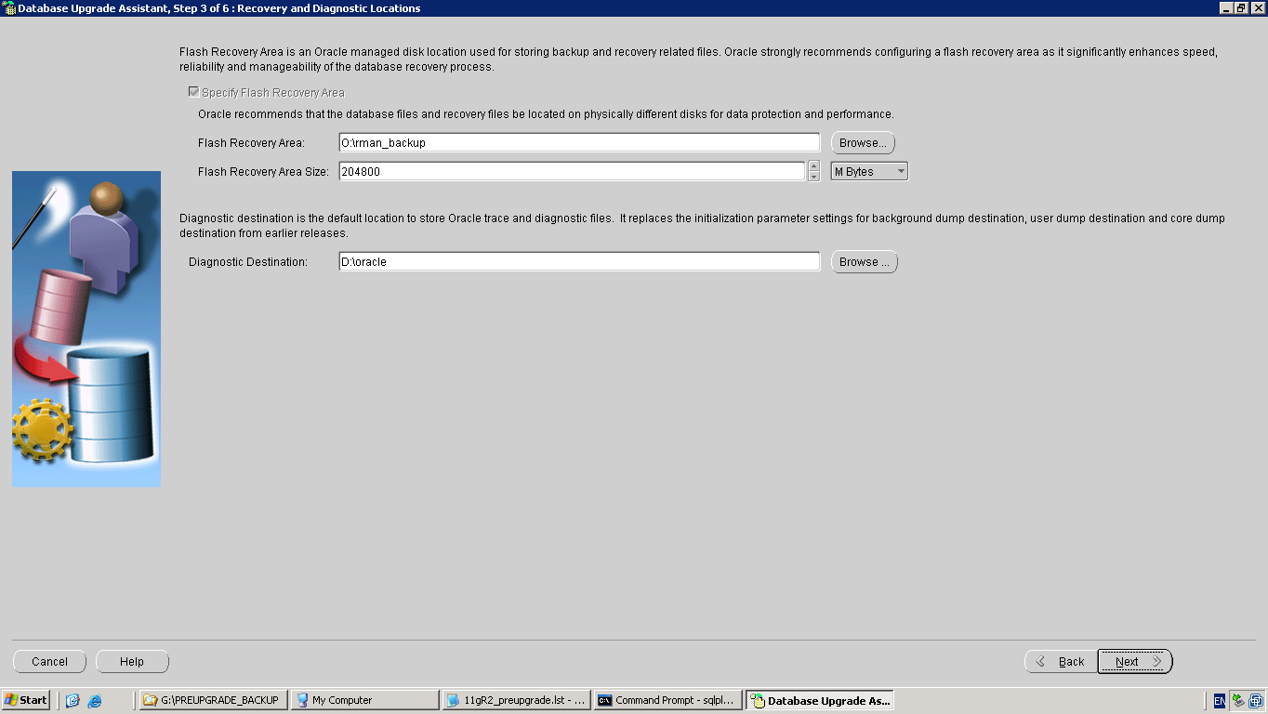

Since we are not using Flashback Database we can ignore the option to specify a Flash Recovery Area.
In 11g the background_dest,core_dump_dest and user_dump_dest parameters have been deprecated and have been replaced by the parameter diagnostic_dest.
We specify the diagnostic destination to be ‘D:\oracle’.
Click Next
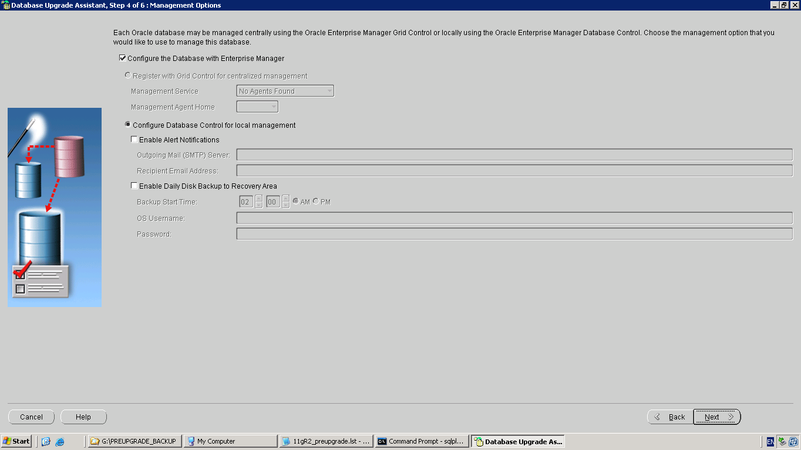

Select the option to configure the database with Enterprise Manager
Click Next
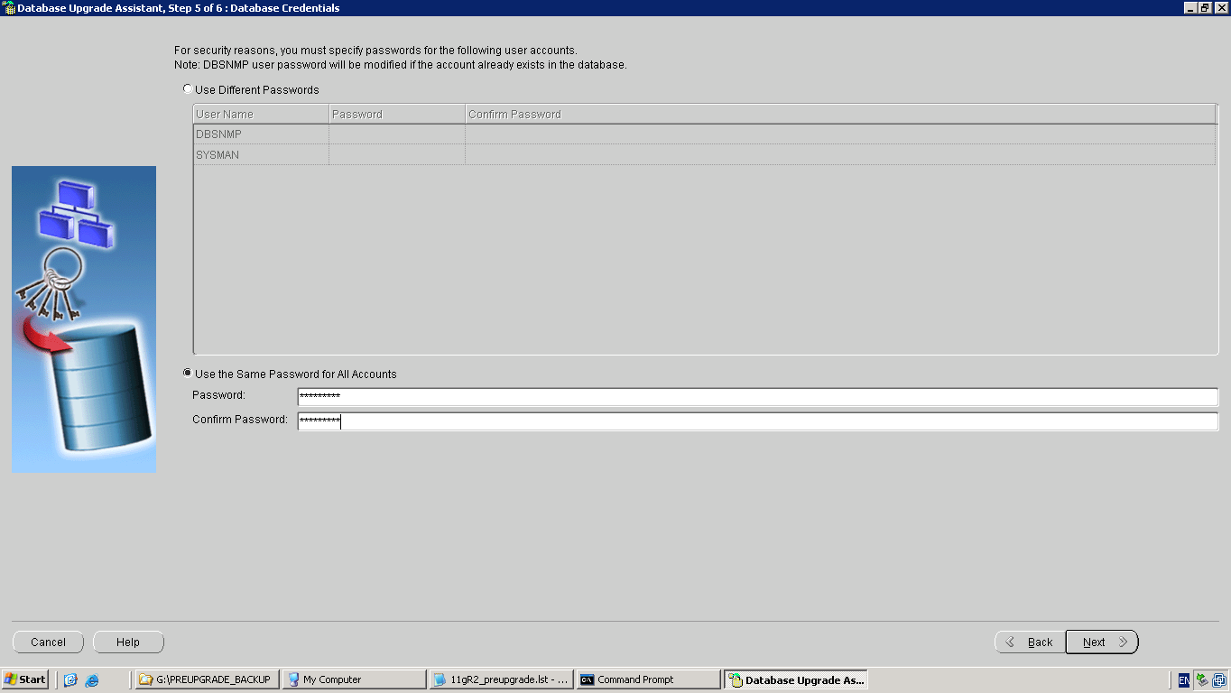

Enter the password for the DBSNMP and SYSMAN users
Click Next

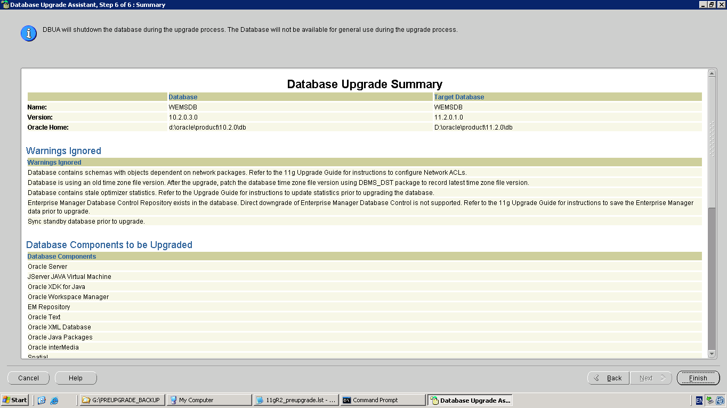

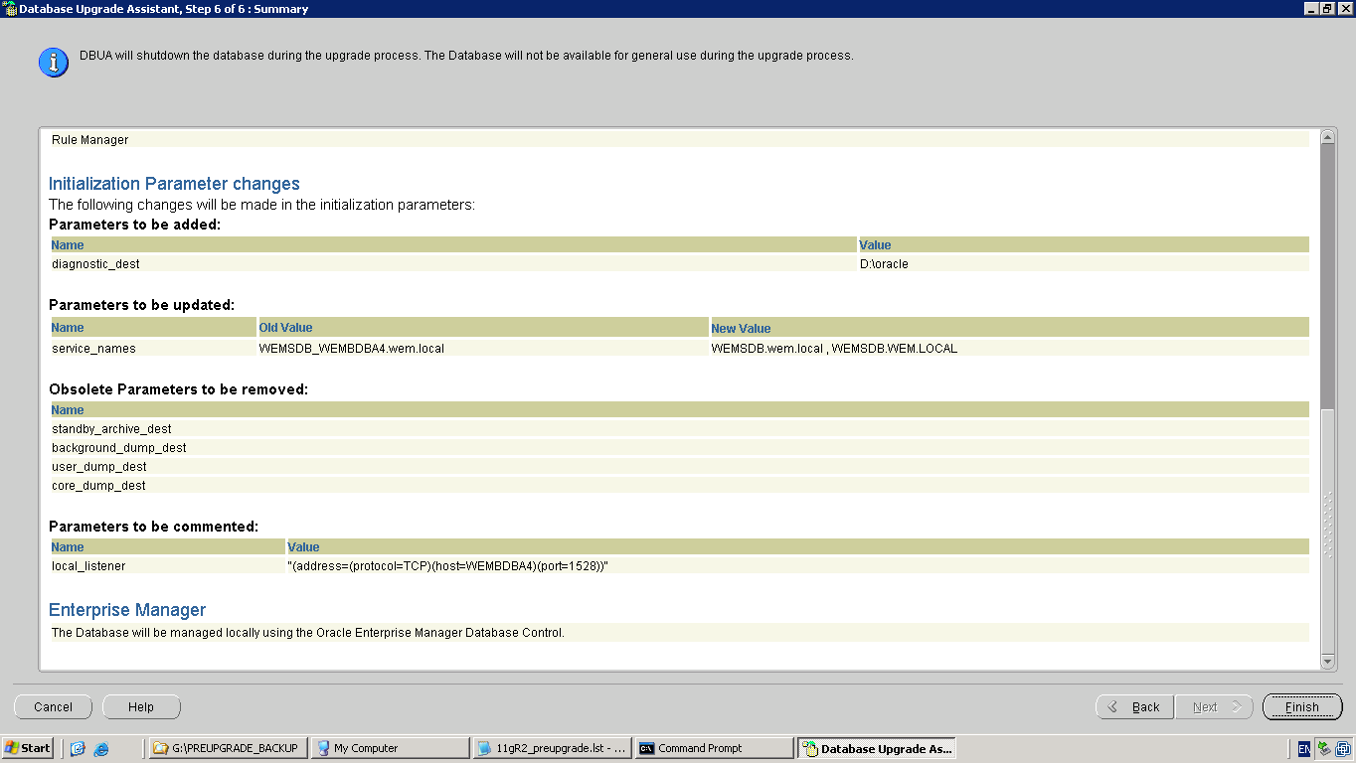

Review the Database Upgrade Summary page
Click Finish

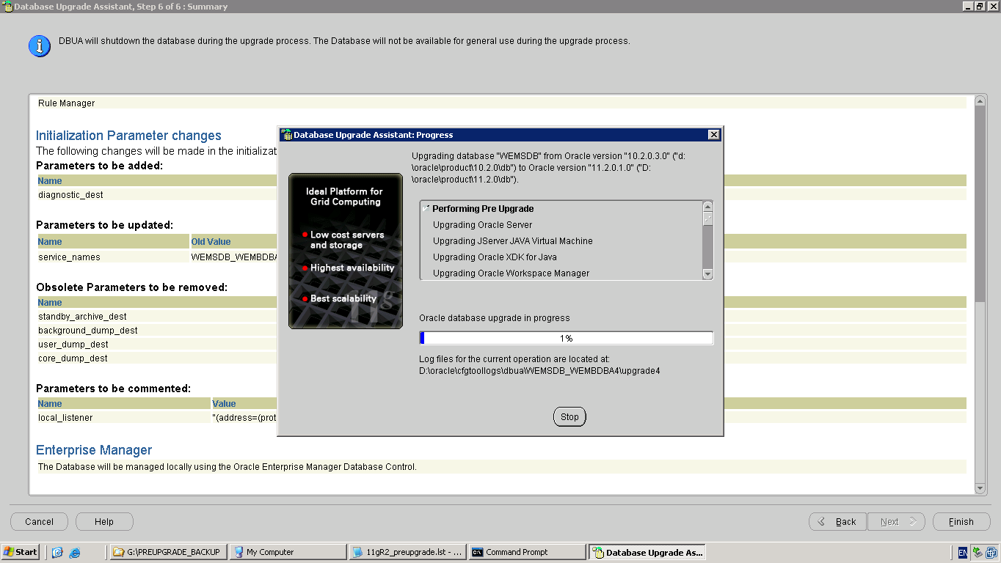

While the upgrade is in progress, we can check the redo apply activity as it is being recorded in the alert log of both the Primary as well as Standby database.

Alert Log File on the Primary Database
Thread 1 advanced to log sequence 83 (LGWR switch)
Current log# 2 seq# 83 mem# 0: G:\ORADATA\WEMSDB\REDO02-1.LOG
Current log# 2 seq# 83 mem# 1: I:\ORADATA\WEMSDB\REDO02-2.LOG
Tue Nov 30 17:41:46 2010
LNS: Standby redo logfile selected for thread 1 sequence 83 for destination LOG_ARCHIVE_DEST_2
Tue Nov 30 17:41:52 2010
Archived Log entry 27569 added for thread 1 sequence 82 ID 0xb70f3f6c dest 1:
Tue Nov 30 17:42:51 2010

Alert Log File on the Standby database
Media Recovery Waiting for thread 1 sequence 82 (in transit)
Tue Nov 30 17:41:55 2010
RFS[8]: Selected log 5 for thread 1 sequence 83 dbid -1385662071 branch 735920934
Tue Nov 30 17:41:59 2010
Archived Log entry 77 added for thread 1 sequence 82 ID 0xb70f3f6c dest 1:
Tue Nov 30 17:42:01 2010
Media Recovery Log I:\ORAARCH\WEMSDB\WEMSDB_0000000082_0735920934_0001.ARC

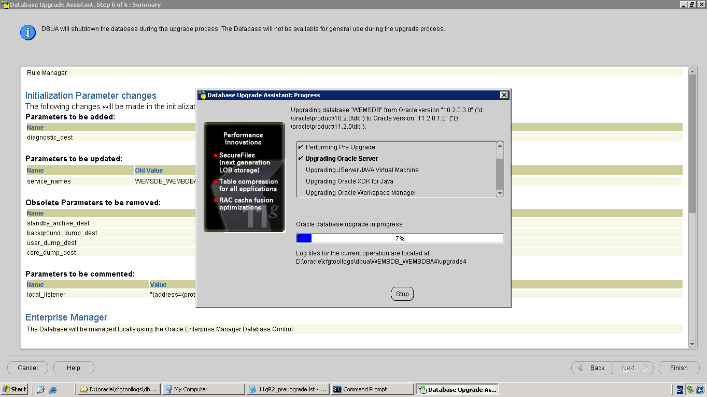

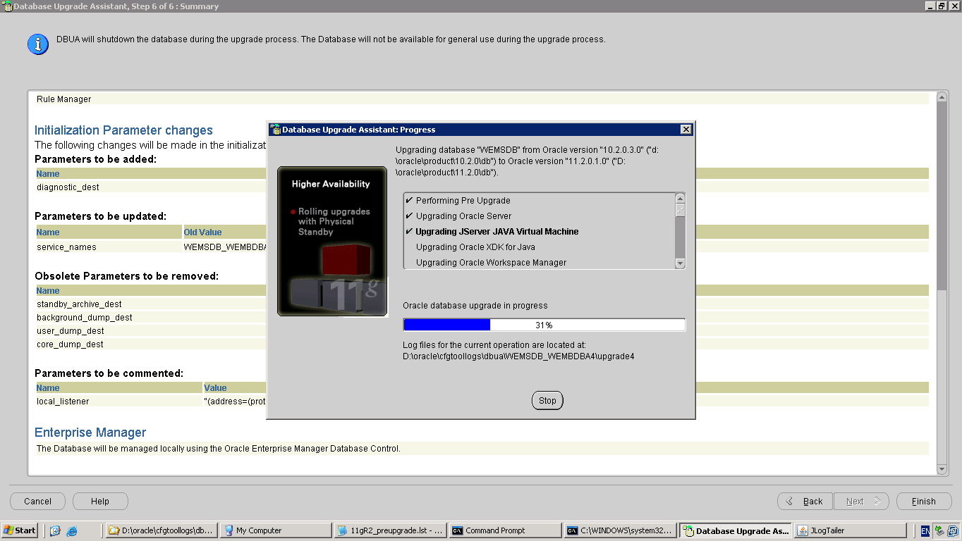
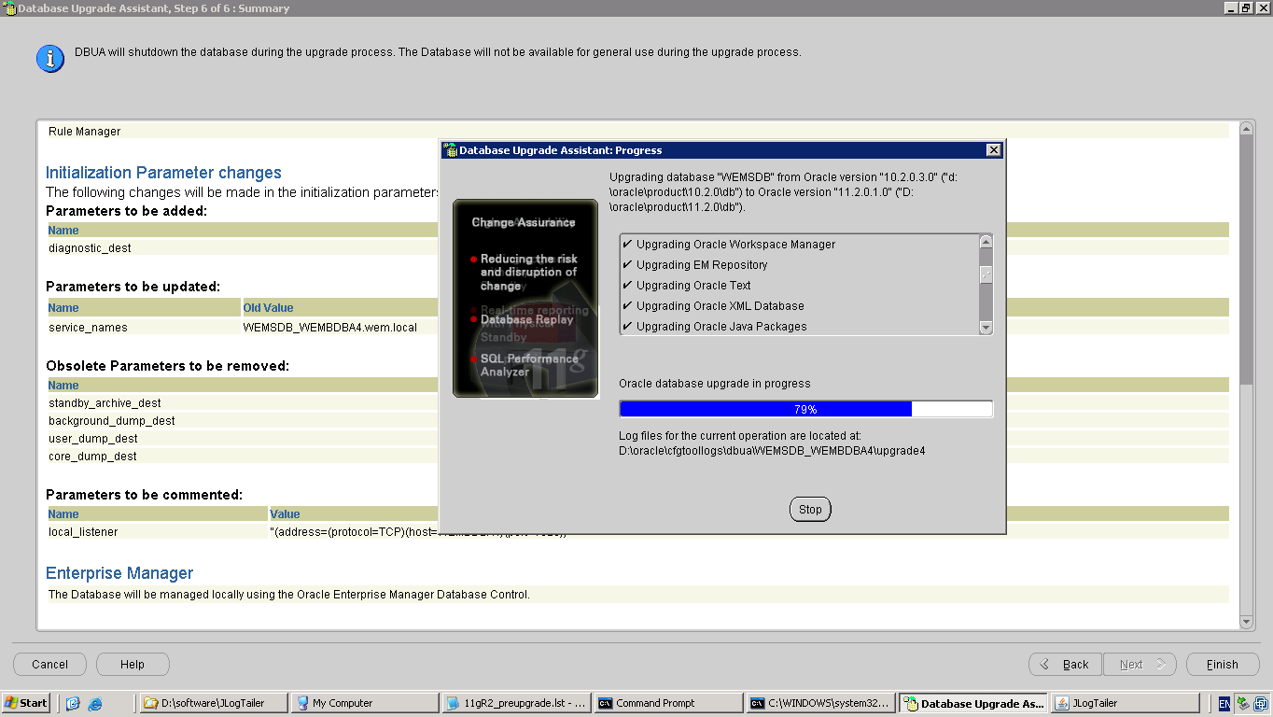

Note – the DBUA displays an error message regarding the Oracle Workspace Manager – we can ignore this error and click the Ignore button.
ORA-00942: table or view does not exist ORA-06512: "WMSYS.OWM_MIG_PKG"
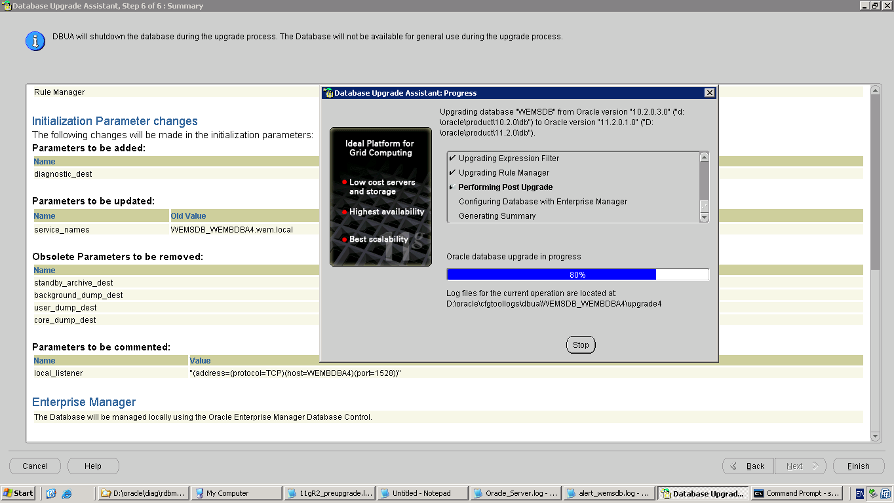

Note – in some cases, we have seen that the running of the utlrp.sql script which is done at the Post Upgrade script will cause the Ora-03113 error and crash the instance.
Follow the procedure outlined in Appendix A to complete the remaining steps of the upgrade manually.
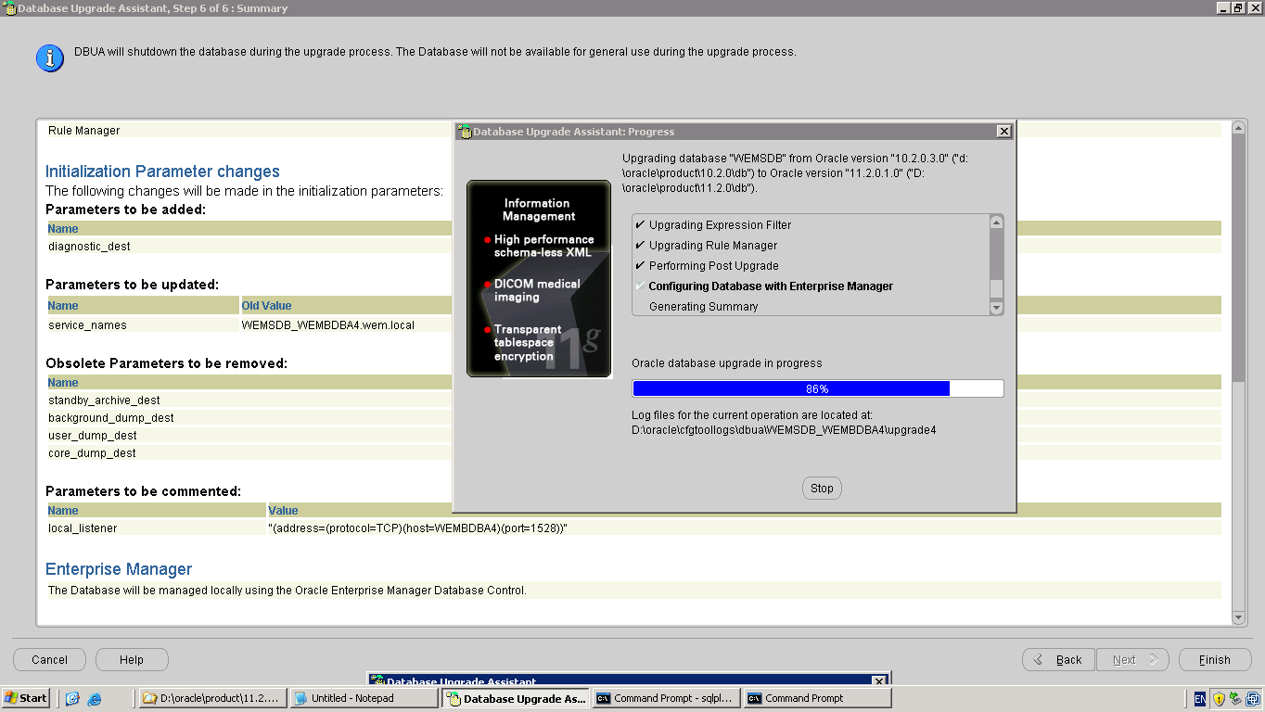
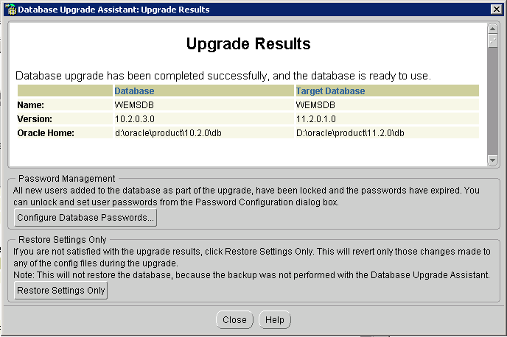
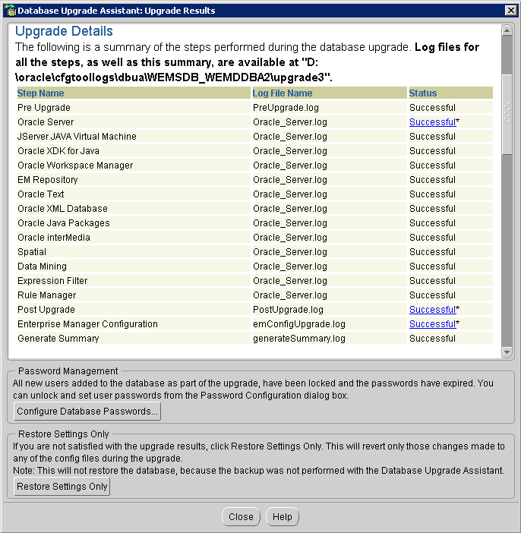

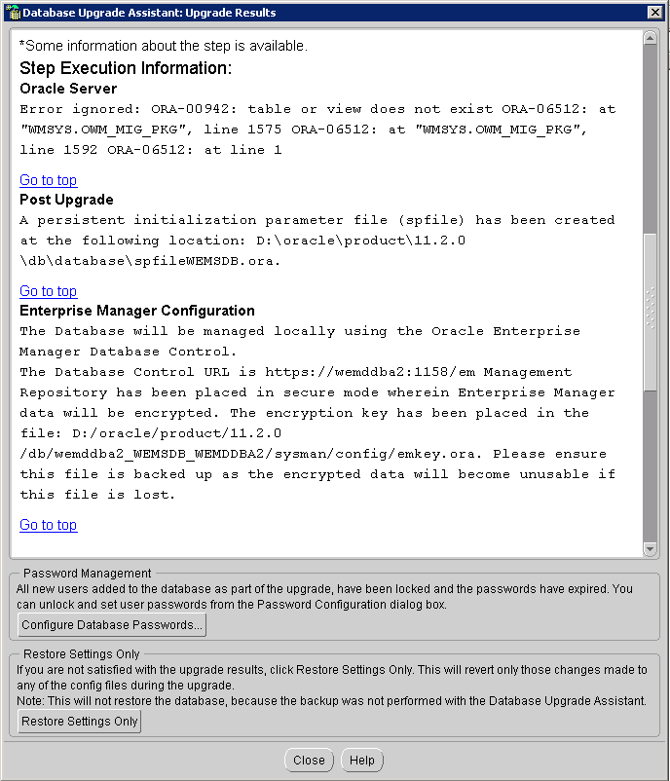

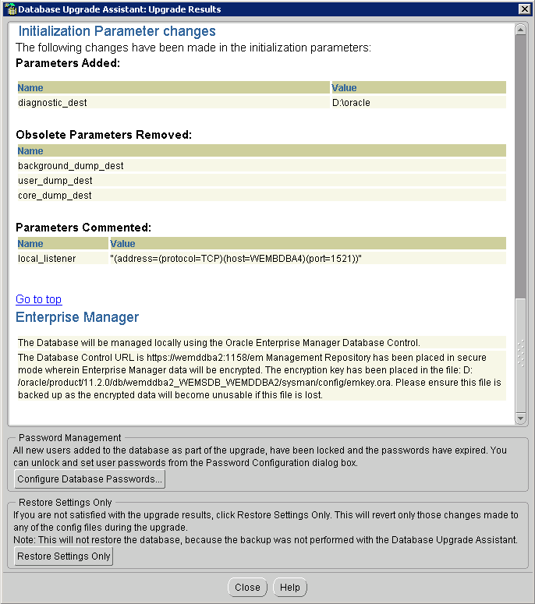

Post Upgrade Tasks

Insert rows back into the SYS.AUD$ table
SQL> insert into SYS.AUD$
2 select * from SYS.AUD$_BACKUP;
insert into SYS.AUD$
*
ERROR at line 1:
ORA-00947: not enough values.

SQL> alter table aud$_backup add OBJ$EDITION varchar2(30);
Table altered.
SQL> insert into SYS.AUD$
2 select * from SYS.AUD$_BACKUP;
7216070 rows created.
SQL> commit;

Check the status of the Standby Database and that all the archived logs generated while the 11g upgrade was in progress have been applied on the standby site.

SET PAGESIZE 124
COL DB_NAME FORMAT A8
COL HOSTNAME FORMAT A12
COL LOG_ARCHIVED FORMAT 999999
COL LOG_APPLIED FORMAT 999999
COL LOG_GAP FORMAT 9999
COL APPLIED_TIME FORMAT A12
SELECT DB_NAME, HOSTNAME, LOG_ARCHIVED, LOG_APPLIED,APPLIED_TIME,
LOG_ARCHIVED-LOG_APPLIED LOG_GAP
FROM
(
SELECT NAME DB_NAME
FROM V$DATABASE
),
(
SELECT UPPER(SUBSTR(HOST_NAME,1,(DECODE(INSTR(HOST_NAME,’.'),0,LENGTH(HOST_NAME),
(INSTR(HOST_NAME,’.')-1))))) HOSTNAME
FROM V$INSTANCE
),
(
SELECT MAX(SEQUENCE#) LOG_ARCHIVED
FROM V$ARCHIVED_LOG WHERE DEST_ID=1 AND ARCHIVED=’YES’
and
resetlogs_id in
( select max(resetlogs_id) from v$archived_log)
),
(
SELECT MAX(SEQUENCE#) LOG_APPLIED
FROM V$ARCHIVED_LOG WHERE DEST_ID=2 AND APPLIED=’YES’
and
resetlogs_id in
( select max(resetlogs_id) from v$archived_log)
),
(
SELECT TO_CHAR(MAX(COMPLETION_TIME),’DD-MON/HH24:MI’) APPLIED_TIME
FROM V$ARCHIVED_LOG WHERE DEST_ID=2 AND APPLIED=’YES’
and
resetlogs_id in
( select max(resetlogs_id) from v$archived_log)
);

Note – both Primary and Standby database are in sync ...
DB_NAME HOSTNAME LOG_ARCHIVED LOG_APPLIED APPLIED_TIME LOG_GAP
-------- ------------ ------------ ----------- ------------ -------
WEMSDB WEMDDBA2 128 128 01-DEC/13:01 0

Make the Standby database READ ONLY
SQL> recover managed standby database cancel;
Media recovery complete.
SQL> alter database open read only;
Database altered.

Check the DBA_REGISTRY view to confirm that the data dictionary has been upgraded

SQL> col comp_name format a50
SQL> set linesize 120
SQL> select comp_name,version,status from dba_registry

COMP_NAME VERSION STATUS
-------------------------------------------------- ------------------------------ ---------------------------------
Oracle Enterprise Manager 11.2.0.1.0 VALID
Spatial 11.2.0.1.0 VALID
Oracle Multimedia 11.2.0.1.0 VALID
Oracle XML Database 11.2.0.1.0 VALID
Oracle Text 11.2.0.1.0 VALID
Oracle Data Mining 11.2.0.1.0 VALID
Oracle Expression Filter 11.2.0.1.0 VALID
Oracle Rule Manager 11.2.0.1.0 VALID
Oracle Workspace Manager 11.2.0.1.0 VALID
Oracle Database Catalog Views 11.2.0.1.0 VALID
Oracle Database Packages and Types 11.2.0.1.0 VALID
JServer JAVA Virtual Machine 11.2.0.1.0 VALID
Oracle XDK 11.2.0.1.0 VALID
Oracle Database Java Packages 11.2.0.1.0 VALID
OLAP Analytic Workspace 10.2.0.3.0 REMOVED
Oracle OLAP API 10.2.0.3.0 REMOVED

Start the Managed recovery again on the Standby Database
SQL> recover managed standby database disconnect from session;
Media recovery complete.

Change the COMPATIBLE Parameter
After we have tested the application is working fine and all pre-11g upgrade functionality is available and tested, we can change the COMPATIBLE parameter to ’11.2.0’.
Note – if we change the COMPATIBLE parameter, we cannot downgrade the database in case any problem is encountered after the upgrade.

APPENDIX A
Manually continuing a failed DBUA upgrade – fails at the Post Upgrade stage
At about 80% completed status, while DBUA runs the utlrp command to recompile invalid objects, it will cause an ORA-03113 error.
Do the following:
Terminate the GUI DBUA session
Start the service again as this would have stopped
From SQL*PLUS execute a shutdown and startup of the database
As SYSDBA run the same from SQL*PLUS

SET SERVEROUTPUT ON SIZE 1000000
BEGIN
FOR cur_rec IN (SELECT owner,
object_name,
object_type,
DECODE(object_type, 'PACKAGE', 1,
'PACKAGE BODY', 2, 2) AS recompile_order
FROM dba_objects
WHERE object_type IN ('PACKAGE', 'PACKAGE BODY')
AND status != 'VALID'
ORDER BY 4)
LOOP
BEGIN
IF cur_rec.object_type = 'PACKAGE' THEN
EXECUTE IMMEDIATE 'ALTER ' || cur_rec.object_type ||
' "' || cur_rec.owner || '"."' || cur_rec.object_name || '" COMPILE';
ElSE
EXECUTE IMMEDIATE 'ALTER PACKAGE "' || cur_rec.owner ||
'"."' || cur_rec.object_name || '" COMPILE BODY';
END IF;
EXCEPTION
WHEN OTHERS THEN
DBMS_OUTPUT.put_line(cur_rec.object_type || ' : ' || cur_rec.owner ||
' : ' || cur_rec.object_name);
END;
END LOOP;
END;
/

SET SERVEROUTPUT ON SIZE 1000000
BEGIN
FOR cur_rec IN (SELECT owner,
object_name,
object_type
FROM dba_objects
WHERE
status != 'VALID' and object_type not in ('PACKAGE','PACKAGE BODY')
ORDER BY 1)
LOOP
BEGIN
EXECUTE IMMEDIATE 'ALTER ' || cur_rec.object_type ||
' "' || cur_rec.owner || '"."' || cur_rec.object_name || '" COMPILE';
EXCEPTION
WHEN OTHERS THEN
DBMS_OUTPUT.put_line(cur_rec.object_type || ' : ' || cur_rec.owner ||
' : ' || cur_rec.object_name);
END;
END LOOP;
END;
/

Now check the count of INVALID objects and ensure no new objects have got invalidated by the database upgrade to 11g
SQL> select owner,object_name,object_type from
2* dba_objects where status='INVALID'

Run the Post Upgrade Status Tool

SQL> @?/rdbms/admin/utlu112s.sql
.
Oracle Database 11.2 Post-Upgrade Status Tool 12-01-2010 12:38:31
.
Component Status Version HH:MM:SS
.
Oracle Server
. VALID 11.2.0.1.0 01:10:38
JServer JAVA Virtual Machine
. VALID 11.2.0.1.0 00:10:02
Oracle Workspace Manager
. ORA-00942: table or view does not exist
. ORA-06512: at "WMSYS.OWM_MIG_PKG", line 1575
. ORA-06512: at "WMSYS.OWM_MIG_PKG", line 1592
. ORA-06512: at line 1
. VALID 11.2.0.1.0 00:01:14
Oracle Enterprise Manager
. VALID 11.2.0.1.0 00:12:29
Oracle XDK
. VALID 11.2.0.1.0 00:02:21
Oracle Text
. VALID 11.2.0.1.0 00:00:56
Oracle XML Database
. VALID 11.2.0.1.0 00:12:39
Oracle Database Java Packages
. VALID 11.2.0.1.0 00:00:31
Oracle Multimedia
. VALID 11.2.0.1.0 00:04:40
Spatial
. VALID 11.2.0.1.0 00:05:54
Oracle Expression Filter
. VALID 11.2.0.1.0 00:00:14
Oracle Rule Manager
. VALID 11.2.0.1.0 00:00:13
Gathering Statistics
. 00:09:10
Total Upgrade Time: 20:03:12

PL/SQL procedure successfully completed.

Note - refer My Oracle Support note ...
“Post-Upgrade Status Script utlu112s.sql Fails with ORA-942 [ID 1051991.1”

Recreate the EM Database Control Manually for 11g

C:\Documents and Settings\IMODBA>emca -config dbcontrol db -repos recreate

STARTED EMCA at Dec 1, 2010 12:49:26 PM
EM Configuration Assistant, Version 11.2.0.0.2 Production
Copyright (c) 2003, 2005, Oracle. All rights reserved.

Enter the following information:
Database SID: WEMSDB
Listener port number: 1528
Listener ORACLE_HOME [ D:\oracle\product\11.2.0\db ]:
Password for SYS user:
Password for DBSNMP user:
Password for SYSMAN user:
Password for SYSMAN user: Email address for notifications (optional):
Outgoing Mail (SMTP) server for notifications (optional):
-----------------------------------------------------------------

You have specified the following settings

Database ORACLE_HOME ................ D:\oracle\product\11.2.0\db

Local hostname ................ wemddba2
Listener ORACLE_HOME ................ D:\oracle\product\11.2.0\db
Listener port number ................ 1528
Database SID ................ WEMSDB
Email address for notifications ...............
Outgoing Mail (SMTP) server for notifications ...............

-----------------------------------------------------------------
Do you wish to continue? [yes(Y)/no(N)]: y
Dec 1, 2010 12:49:56 PM oracle.sysman.emcp.EMConfig perform
INFO: This operation is being logged at D:\oracle\cfgtoollogs\emca\WEMSDB_WEMDDBA2\emca_2010_12_01_12_49_26.log.
Dec 1, 2010 12:49:57 PM oracle.sysman.emcp.EMReposConfig invoke
INFO: Dropping the EM repository (this may take a while) ...
Dec 1, 2010 12:53:10 PM oracle.sysman.emcp.EMReposConfig invoke
INFO: Repository successfully dropped
Dec 1, 2010 12:53:11 PM oracle.sysman.emcp.EMReposConfig createRepository
INFO: Creating the EM repository (this may take a while) ...
Dec 1, 2010 1:00:15 PM oracle.sysman.emcp.EMReposConfig invoke
INFO: Repository successfully created
Dec 1, 2010 1:00:20 PM oracle.sysman.emcp.EMReposConfig uploadConfigDataToRepository
INFO: Uploading configuration data to EM repository (this may take a while) ...
Dec 1, 2010 1:01:07 PM oracle.sysman.emcp.EMReposConfig invoke
INFO: Uploaded configuration data successfully
Dec 1, 2010 1:01:12 PM oracle.sysman.emcp.util.DBControlUtil configureSoftwareLib
INFO: Software library configured successfully.
Dec 1, 2010 1:01:12 PM oracle.sysman.emcp.EMDBPostConfig configureSoftwareLibrary
INFO: Deploying Provisioning archives ...
Dec 1, 2010 1:01:41 PM oracle.sysman.emcp.EMDBPostConfig configureSoftwareLibrary
INFO: Provisioning archives deployed successfully.
Dec 1, 2010 1:01:41 PM oracle.sysman.emcp.util.DBControlUtil secureDBConsole
INFO: Securing Database Control (this may take a while) ...
Dec 1, 2010 1:01:50 PM oracle.sysman.emcp.util.DBControlUtil secureDBConsole
INFO: Database Control secured successfully.
Dec 1, 2010 1:01:50 PM oracle.sysman.emcp.util.DBControlUtil startOMS
INFO: Starting Database Control (this may take a while) ...
Dec 1, 2010 1:02:36 PM oracle.sysman.emcp.EMDBPostConfig performConfiguration
INFO: Database Control started successfully
Dec 1, 2010 1:02:36 PM oracle.sysman.emcp.EMDBPostConfig performConfiguration
INFO: >>>>>>>>>>> The Database Control URL is https://wemddba2:1158/em <<<<<<<<<<<
Dec 1, 2010 1:02:38 PM oracle.sysman.emcp.EMDBPostConfig invoke
WARNING:
************************ WARNING ************************

