Oracle 11g Grid Control Installation Notes

- For installation on 64 bit platforms, WebLogic Server (WLS) 10.3.2 is supplied as a generic .jar file: wls1032_generic.jar.
For example: java -d64 -jar wls1032_generic.jar
- The java from jdk 1.6 must be used to install WLS, but this java is not embedded in the WLS stage on the 64bit platforms and must be downloaded and installed separately. We need to use JDK 1.6 update 18 for Linux-64 and Solaris SPARC 64-bit platforms.
- Ensure that we will be using this version of java before we start the installation by updating the PATH environment variable.
hurricane:/u01/app/oracle/product/10.2.0/bin $ which java
/u01/app/oracle/product/java16/jdk1.6.0_18/bin/java
Check the java version:
hurricane:/u01/app/oracle/product/10.2.0/bin $ java -version
java version "1.6.0_18"
Java(TM) SE Runtime Environment (build 1.6.0_18-b07)
- The installation program uses a temporary directory into which it extracts the files necessary to install the software on the target system. The files in the temporary directory require approximately 2.5 times the space that is ultimately required for the installation.
Since we did not have enough space on /tmp – we had to use the tmpdir option
java -d64 -Djava.io.tmpdir=/u01/oracle/stage -jar wls1032_generic.jar

- Ensure that patch ID WDJ7 is applied on the Oracle WebLogic Server using the Oracle Smart Update utility. This patch fixes bugs 8990616, 9100465, and 9221722.
If connection to the internet from the host is not possible, then read this Metalink note which describes how to do an offline download of the WLS patches
How to Apply WebLogic Server (WLS) Patches to an Offline System [ID 876004.1]
- Needs pre existing database for the EM Repository. Ensure SYSMAN schema does not exist in the database where we are creating the repository.
If the SYSMAN schema exists, it can be dropped using the following command
emca -deconfig dbcontrol db -repos drop -SYS_PWD <SYS password> -SYSMAN_PWD <SYSMAN password>
- Any of the following database versions may be used for the Grid Control 11.1.0.1.0 repository:
10.2.0.4.0
11.1.0.7.0
11.2.0.1.0
- The following prerequisites need to be kept in mind for the repository database:
Undo tablespace must be at least 200M in size.
log_buffer needs to be minimum 10485760
session_cached_cursors should be 200 or higher
processes should be 500 or higher
open_cursors should be 300 or higher

- Oracle home locations
OMS Home
/u01/app/oracle/product/Middleware/oms11g
Agent Home on OMS server
/u01/app/oracle/product/Middleware/agent11g
Web Tier home
/u01/app/oracle/product/Middleware/Oracle_WT

Grid Control Instance Home
/u01/app/oracle/product/gc_inst

- OMS Log files
$OMS_INSTANCE_HOME/em/<oms_name>/sysman/log
For example: /u01/app/oracle/product/gc_inst/em/EMGC_OMS1/sysman/log
Can also use this command to find out log file locations:
<OMS_HOME>/bin/emctl list properties
- Web Tier Log Files
<GC INSTANCE HOME>/WebTierIH1/diagnostics/logs/OPMN/opmn/
<GC INSTANCE HOME>/WebTierIH1/diagnostics/logs/OHS/ohs1/

- Weblogic Admin Server and Node Manager Log Files:
<GC INSTANCE HOME>/user_projects/domains/<domain_name>/servers/<OMS_NAME>/logs
For example:
/u01/app/oracle/product/gc_inst/user_projects/domains/GCDomain/servers/EMGC_OMS1/logs
<GCINSTANCEHOME>/user_projects/domains/<domain_name>/servers/<EMGC_ADMINSERVER>/logs
For example:
/u01/app/gc/gc_inst/user_projects/domains/GCDomain/servers/EMGC_ADMINSERVER/logs
$MW_HOME/wlserver_10.3/common/emnodemanager/nodemanager.log

- Stopping and starting Grid Control
opmnctl is no longer used in 11g Grid Control.
To stop and start we now use the following commands
$OMS_HOME/bin>./emctl start oms
Which will start the OMS and also the WebLogic processes required for Grid Control
opmnctl commands in 11g can be used only to check the status or start the HTTP_Server component
$ export ORACLE_INSTANCE=/u01/app/oracle/product/gc_inst/WebTierIH1
$ cd /u01/app/oracle/product/Middleware/oms11g/opmn/bin
$ ./opmnctl status

Processes in Instance: instance1
---------------------------------+--------------------+---------+---------
ias-component | process-type | pid | status
---------------------------------+--------------------+---------+---------
ohs1 | OHS | 9939 | Alive
Stopping Grid Control
<OMS_ORACLE_HOME>/bin/emctl stop oms -all

Issues Encountered and Fixed
10.2.0.4 listener is showing status Down in EM Grid Control even though it is actually running and status confirmed via lsnrctl status command.
The error message seen in Grid Control console is:
“The listener is down: Failed to tnsping mhost.com.au”
This is documented on Metalink as :
Bug 10070623: STATUS DOWN FOR LISTENER 10.2 MANAGED BY AGENT 11G
The fix for this was to edit the emctl executable which is located in the AGENT_HOME/bin directory.
Stop the agent via the emctl stop agent command
Take a backup of the emctl file and remove the following lines
if [ "$LD_LIBRARY_PATH_64" = "" ] ; then
LD_LIBRARY_PATH_64=$ORACLE_HOME/lib:$ORACLE_HOME/perl/lib:$OUILOC/lib/solaris
else LD_LIBRARY_PATH_64=$ORACLE_HOME/lib:$ORACLE_HOME/perl/lib:$OUILOC/lib/solaris:$LD_LIBRARY_PATH_64
fi
Start the agent.
Check the status of the Oracle 10.2.0.4 listener. It should now show as up!

ORA-7445 errors messages in 9.2.0.6 database alert log and core dumps after starting the 11g Agent on a machine which has an Oracle 9.2.0.6 database Oracle Home

The alert log will show an error message like this
Error : ORA-7445 [00000001001F5B04] [SIGBUS] [Invalid address alignment]
On the Grid Console when trying to configure the 9.2.0.6 database, we will see an error message like this
“Exception in computing dynamic properties”
Apparently this was an issue with the 10.2.0.5 agent and a patch was issued for it.
Bug.8501576 9I DATABASES COREDUMPS IF 10.2.05. AGENT MONITORING
This is what is mentioned on Metalink….
If you cannot upgrade your target database to 9.2.0.8, there is also a fix on the Agent side:
- Apply Agent PSU2 Patch 9162498 (Unix) / Patch 9223116 (Windows) on top of the 10.2.0.5 Agent. Please check Note 986539.1 for more details about PSU2.
- To activate the fix, add the parameter AvoidOCIPing=1 in $AGENT_HOME/sysman/config/emd.properties and restart the Agent. This parameter is not there by default: it is a toggle to activate the bug fix for this particular issue. The default value is 0, which means that the fix is not activated

The workaround for this is to go to the AGENT_HOME/sysman/config directory and edit the emd.properties file.
Change these lines
#
# Flag to Determine if OCIPing can be used. Older versions of databases such
# as 9206 do not support this.
#
#@description=Flag to Determine if OCIPing can be used.
#@default=0
#AvoidOCIPing=0
To
AvoidOCIPing=1

WebLogic 10.3.2.0 Installation

$ java -d64 -Djava.io.tmpdir=/u01/oracle/stage -jar wls1032_generic.jar

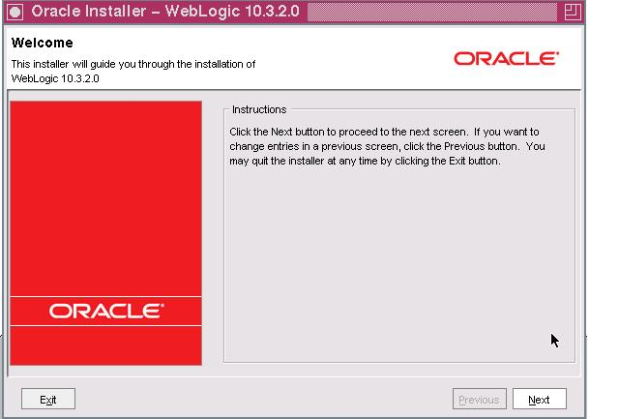

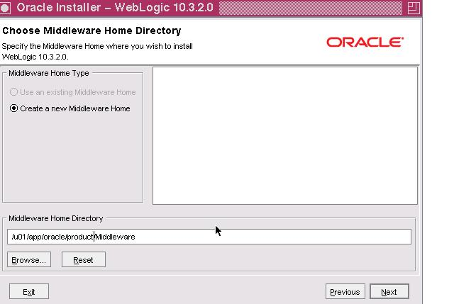
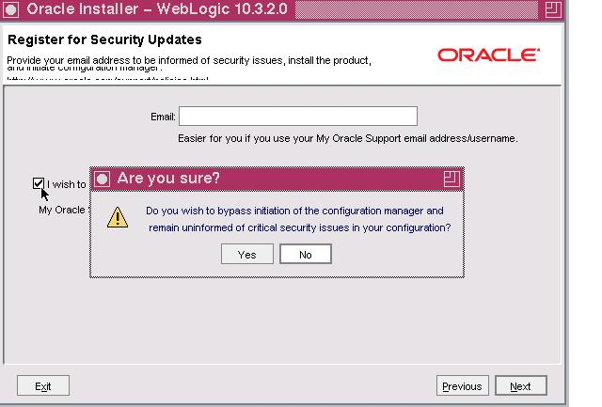

It may take some time at this stage ….
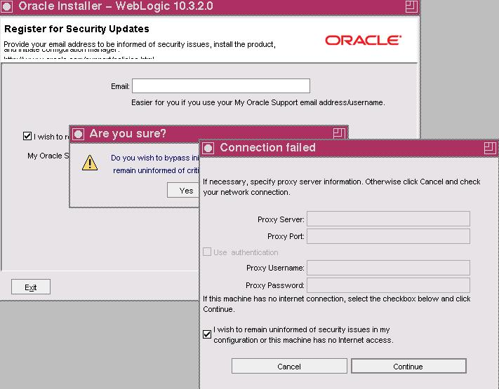

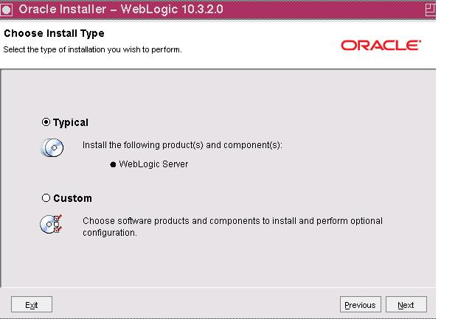

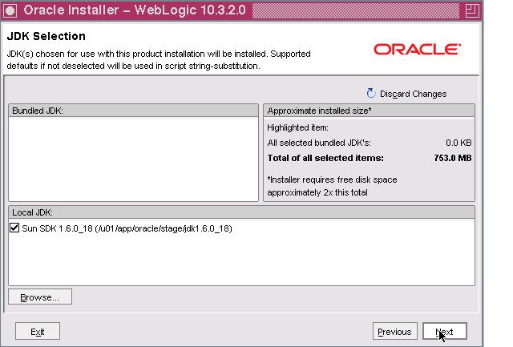
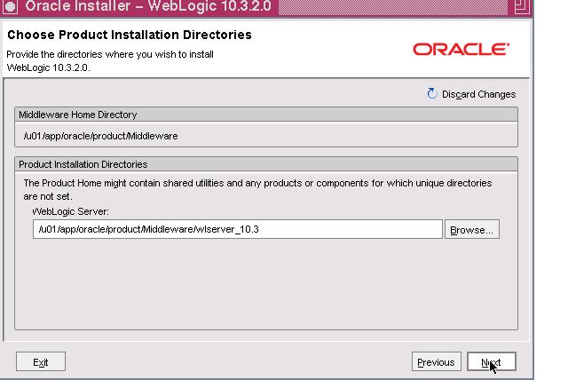
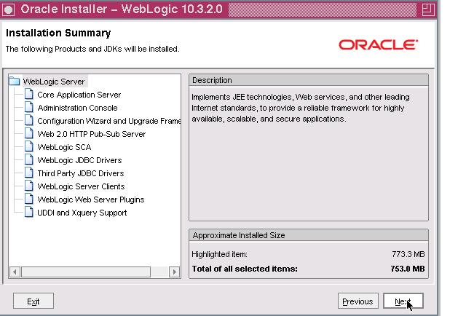
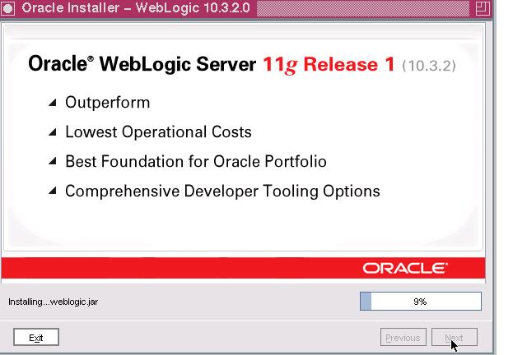
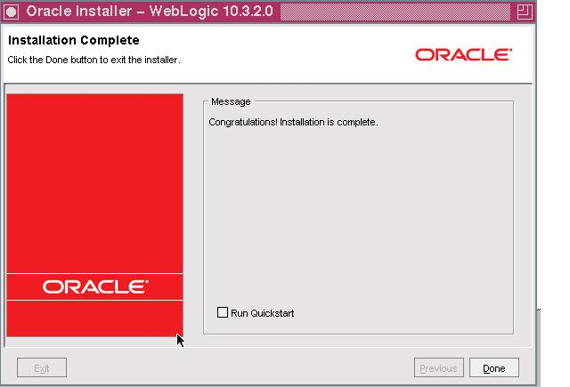

11g Grid Control Installation

