11g Management Agent Deployment via Grid Control using the ‘Push’ Method

The 11g management agent cannot be directly installed using the Oracle Universal Installer GUI as in the 10g version of the product. We can use any of the following methods to deploy the agent on target nodes.
- Agent Pull method
- Agent Push method
- Agent clone.
This note shows us how to deploy the agent from the EM Grid Control interface.
From the Deployment tab in the EM Grid Console, click on Install Agent (under Agent Installation) and then Fresh Install.
Enter the following details :
- The host where we want to deploy the agent
- The OS user account and password on the target machine
- The top level path of the directory under which the ‘agent11g’ sub-directory will be created.
- Management Server registration password
Since the user account we are using does not have the privilege to do a sudo, uncheck the run root.sh box. Remember we will need to run the root.sh from the agent home on the target after the installation.
Since our OMS is secured, enter the Management Server rergistration password for the agent to connect to repository in the secure mode. This password will be the one we supplied at the time of the 11g EM Grid Control installation.

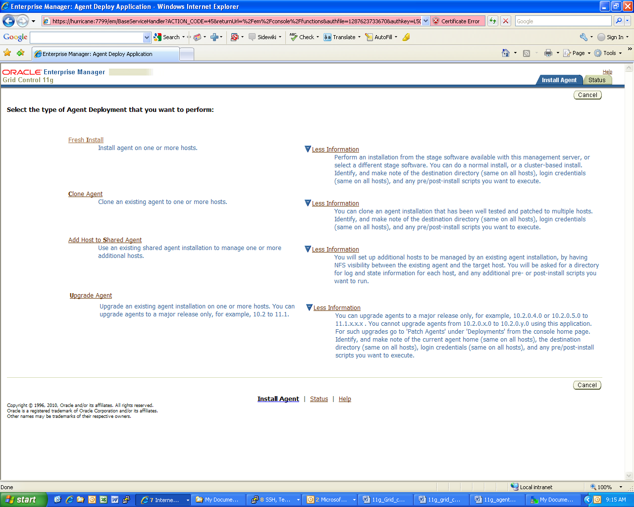
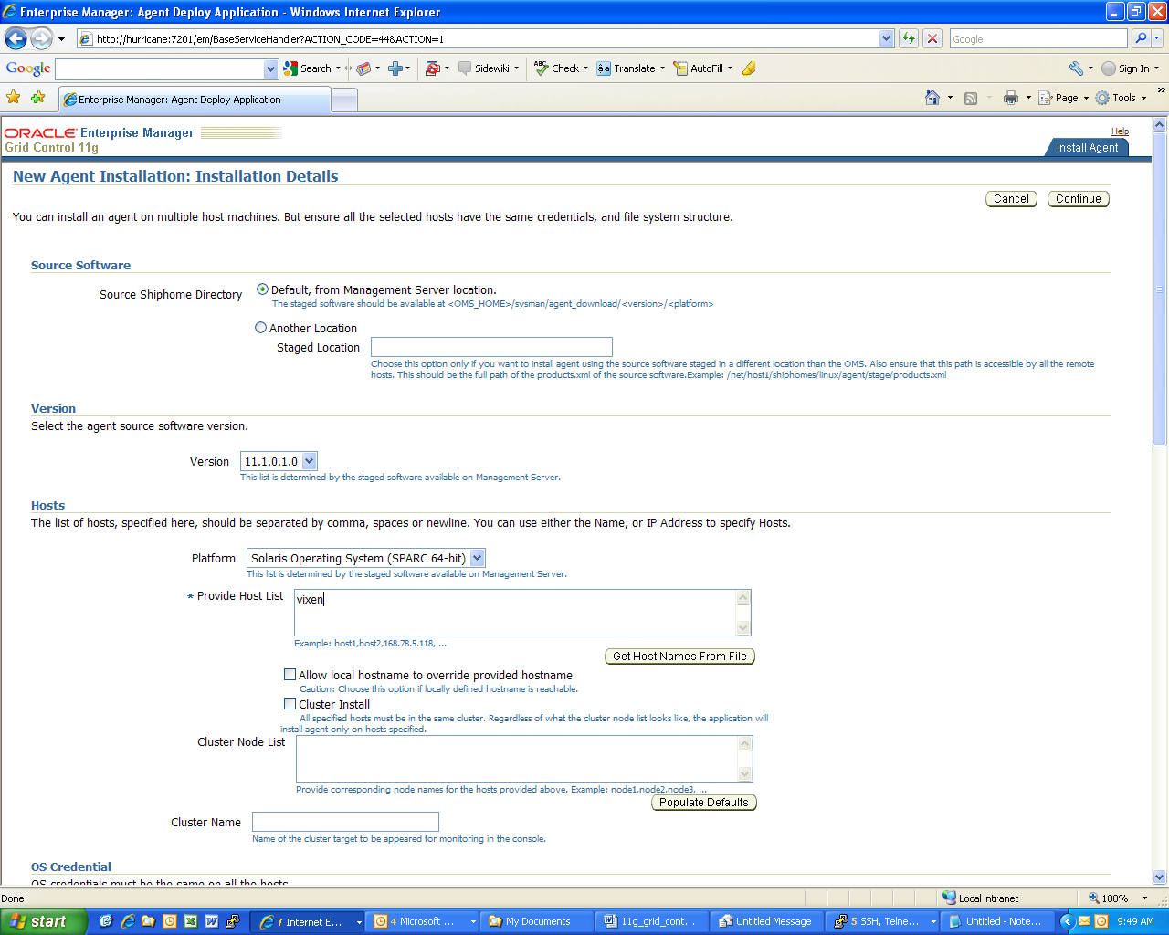
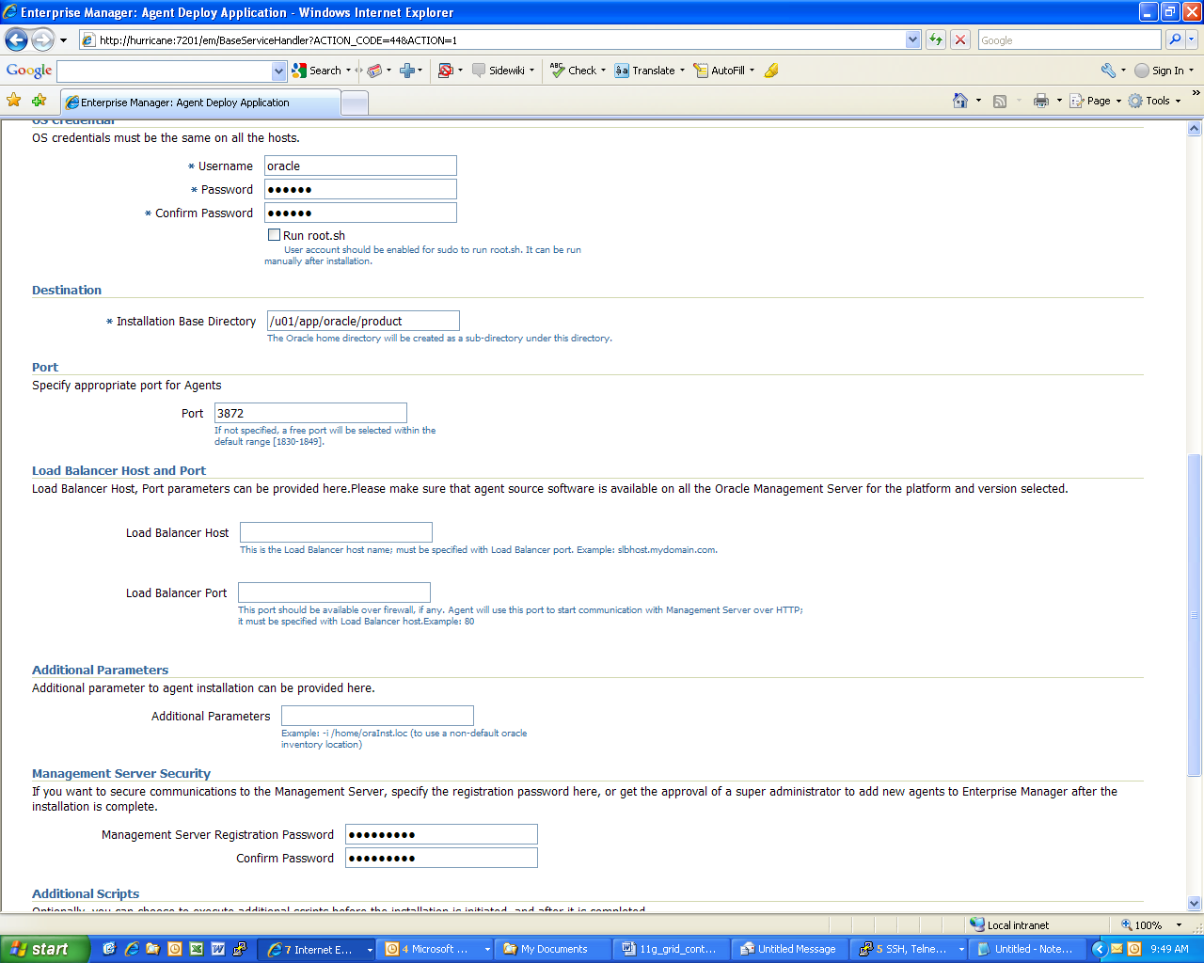
Note:
Since the machine where we are installing the agent does not have a connection to the internet, we will not provide the user account details required to connect to the My Oracle Support site.
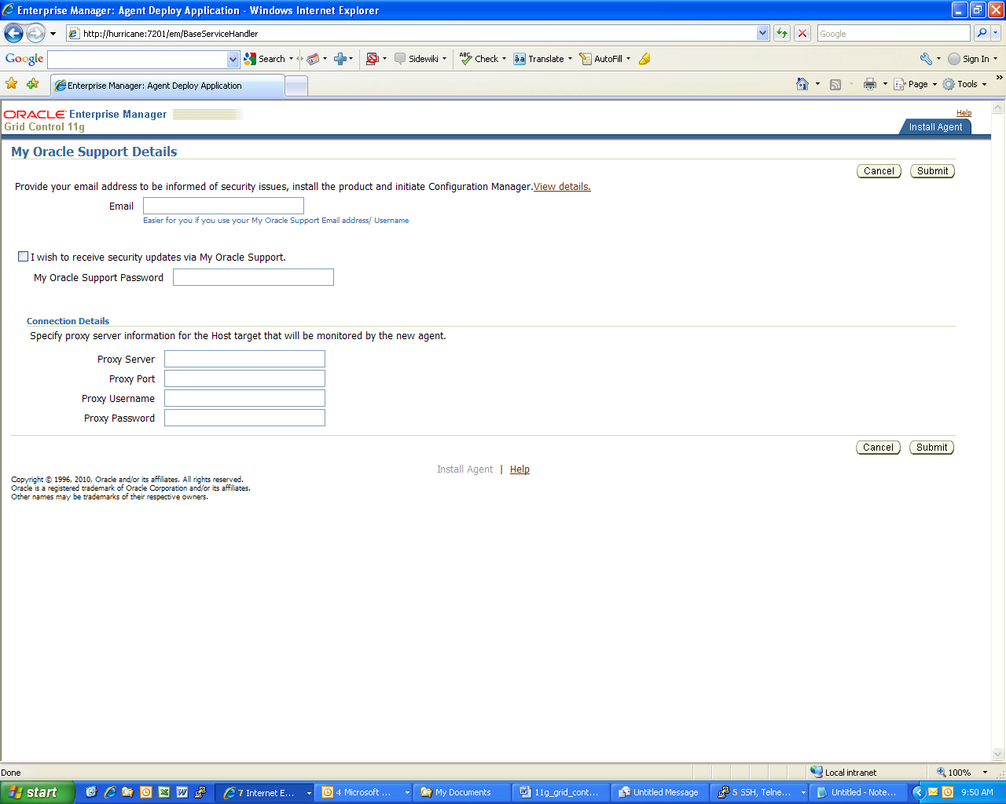
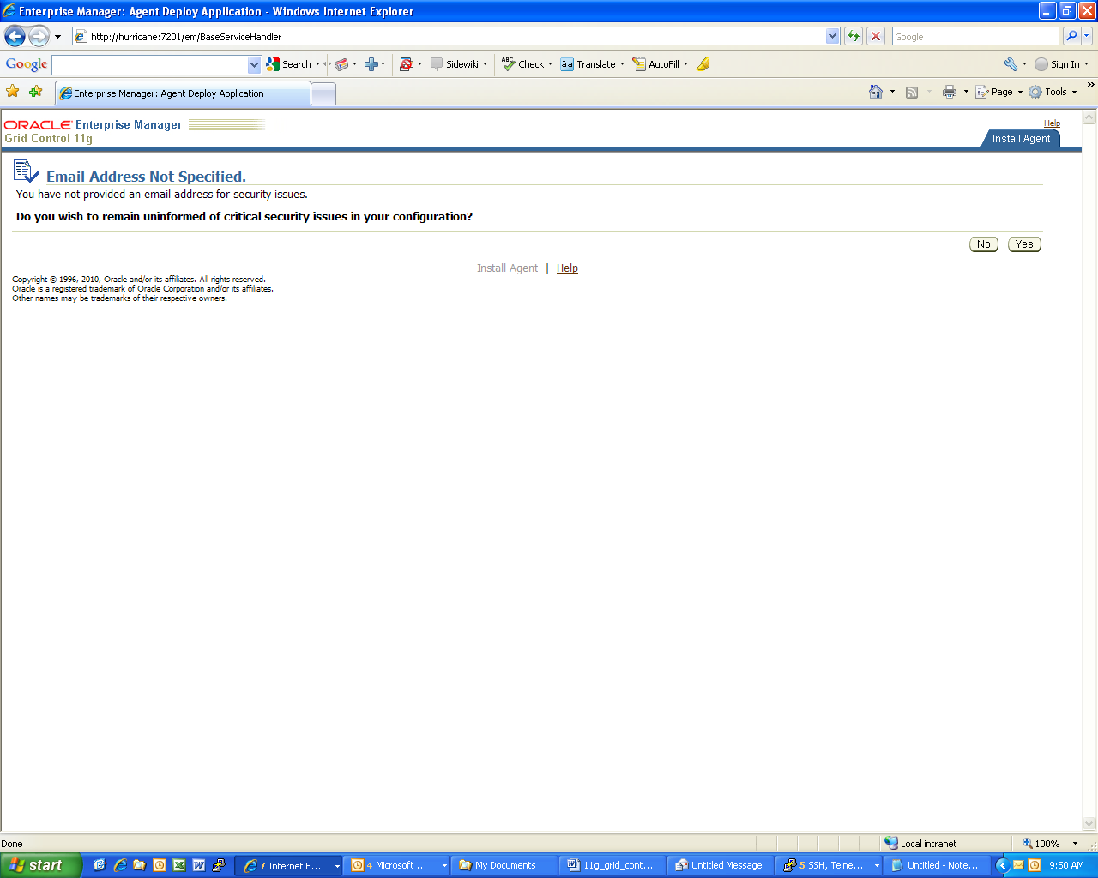

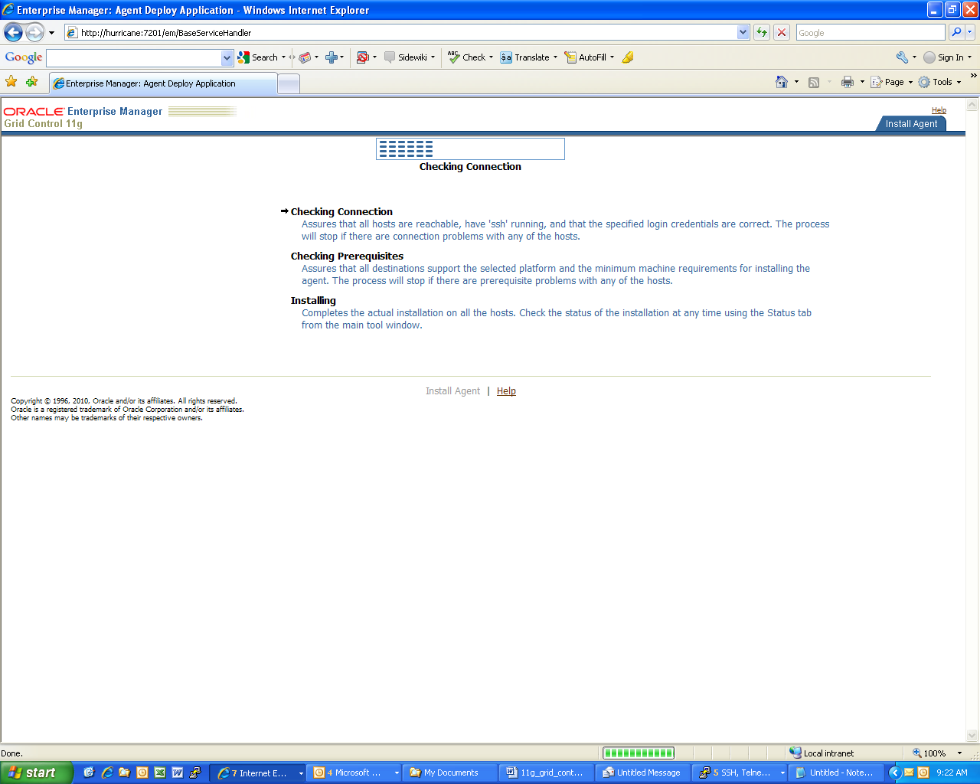

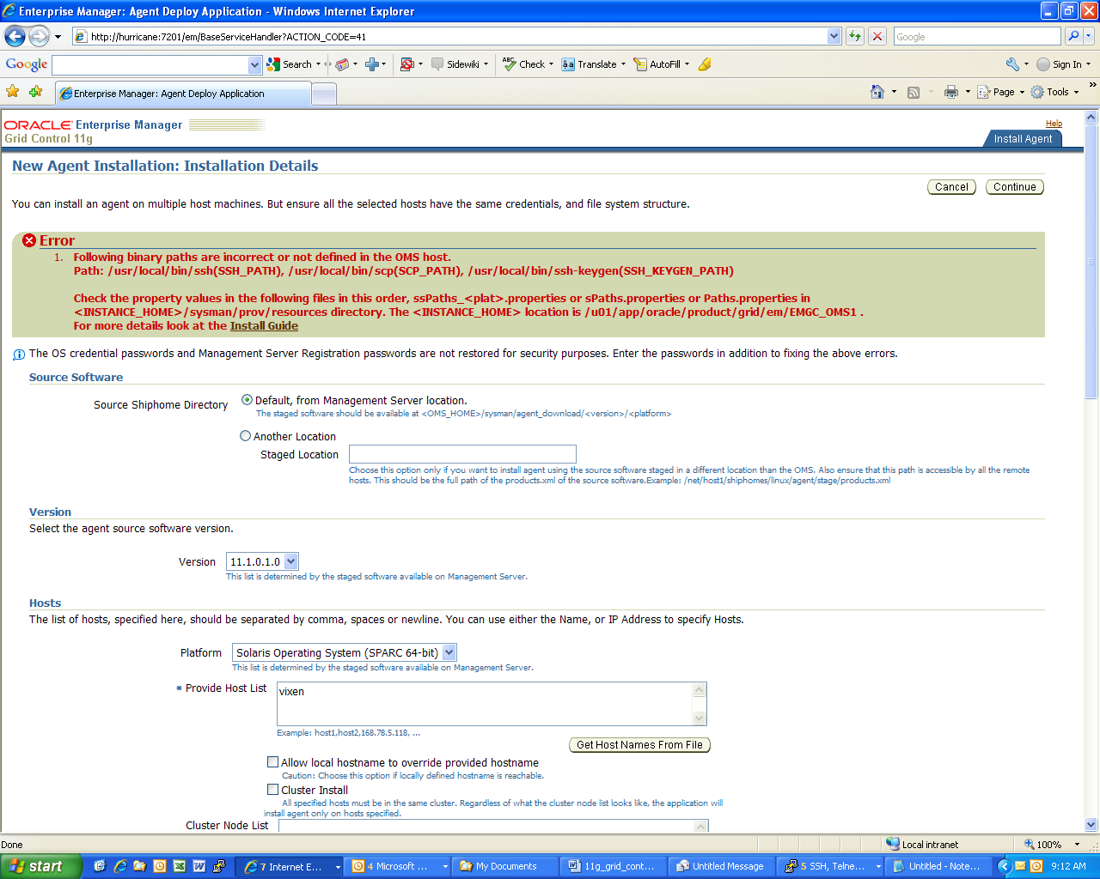

Note:
We need to provide the correct path to the executables like ‘scp’,’ssh’,’ssh-keygen’. In our case these are not located under /usr/local/bin but under /usr/bin.
On the server which hosts the OMS, we go to the Domain directory (gc_inst) that we created at the time of the 11g Grid Control installation.
Edit the file ssPaths_sol.properties and make the following changes
$: cd /u01/app/oracle/product/gc_inst/em/EMGC_OMS1/sysman/prov/resources
$: vi ssPaths_sol.properties
#SSH_PATH=/usr/local/bin/ssh
SSH_PATH=/usr//bin/ssh
#SCP_PATH=/usr/local/bin/scp
SCP_PATH=/usr/bin/scp
#SSH_KEYGEN_PATH=/usr/local/bin/ssh-keygen
SSH_KEYGEN_PATH=/usr/bin/ssh-keygen
SSH_HOST_KEY_LOC=/etc/ssh

After establishing that secure connections to the target host can be made and the host is reachable, the installer will perform a number of prerequisite checks. See Appendix 2 for a list of checks which are performed.
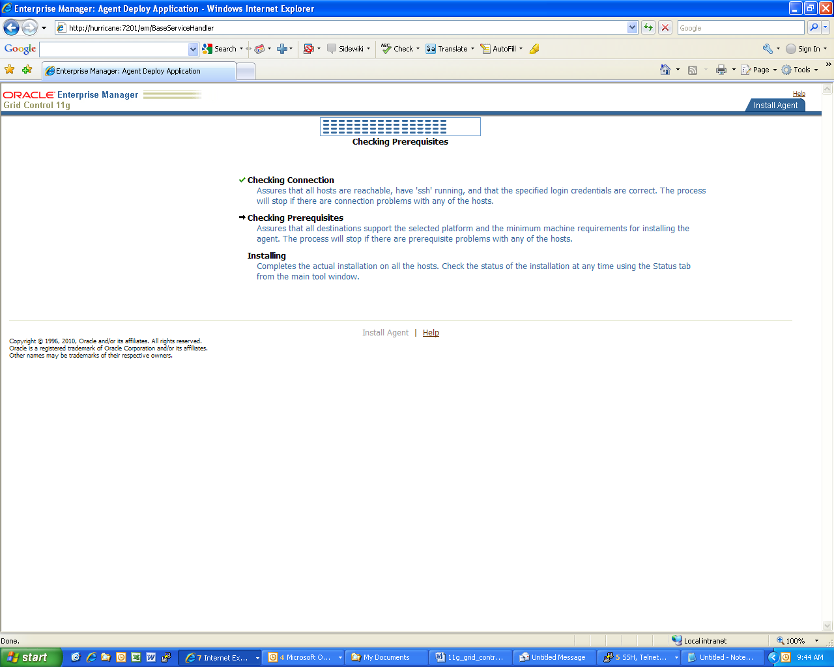

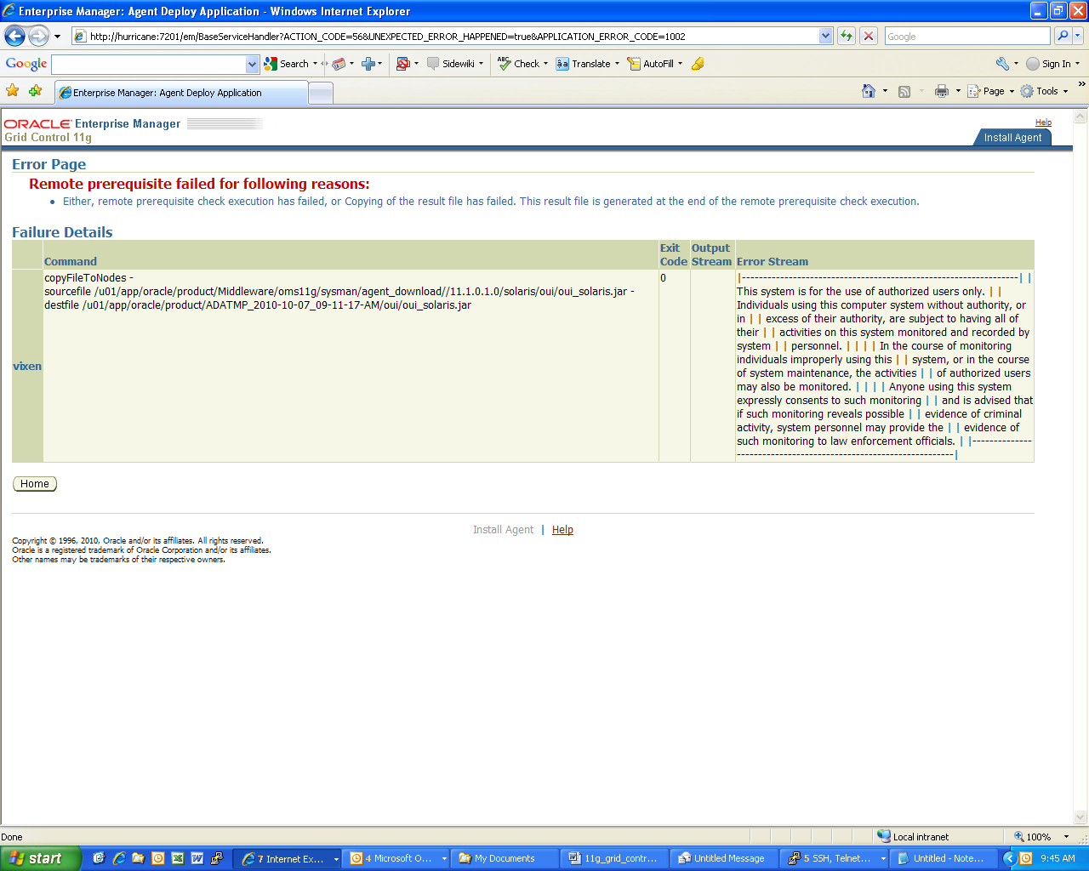

Click on home takes you back to the deployment page
We need to edit the ignoreMessages.txt file under the same location - /gc_inst/em/EMGC_OMS1/sysman/prov/resources
And add the following lines – this is the banner text which is output when a user logs in to the host ….

|-----------------------------------------------------------------|
| This system is for the use of authorized users only. |
| Individuals using this computer system without authority, or in |
| excess of their authority, are subject to having all of their |
| activities on this system monitored and recorded by system |
| personnel. |
| |
| In the course of monitoring individuals improperly using this |
| system, or in the course of system maintenance, the activities |
| of authorized users may also be monitored. |
| |
| Anyone using this system expressly consents to such monitoring |
| and is advised that if such monitoring reveals possible |
| evidence of criminal activity, system personnel may provide the |
| evidence of such monitoring to law enforcement officials. |
|-----------------------------------------------------------------|

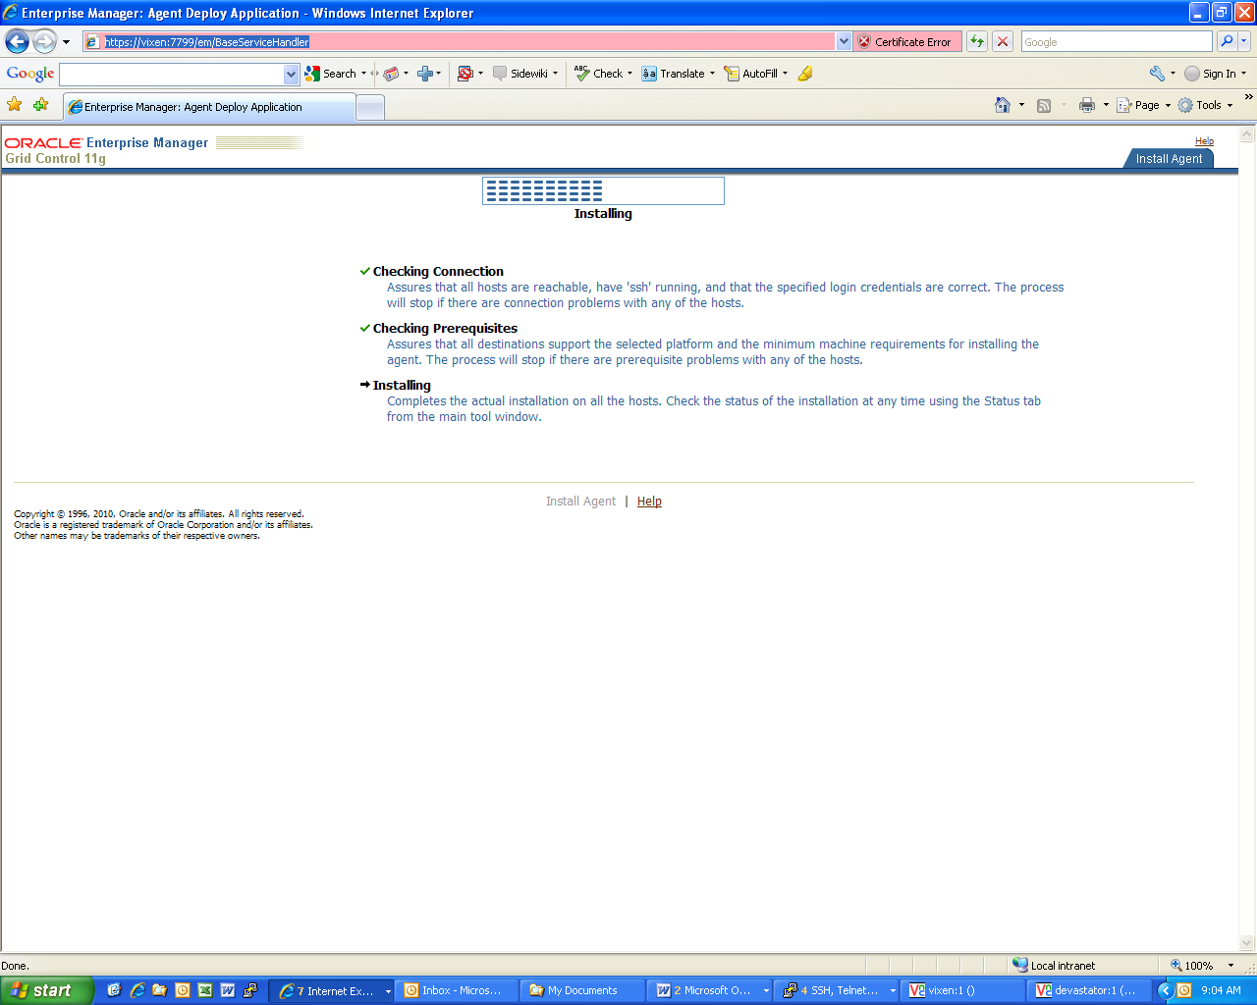

While the installation is in progress, the installer will create a temporary directory on the target server with the prefix ‘ADATMP*’
For example : ADATMP_2010-10-14_10-09-06-AM
This directory is removed automatically after a successful agent installation.
There will be a file called install.log in the same directory location and we can do a tail –f of that file while the agent installation is in progress .
Appendix 1 has excerpts from the file which show the various stages in the agent installation which happen in the background.
After the installation is completed, we can see the screen Agent Installation Session Details which will provide details of the entire agent deployment procedure.

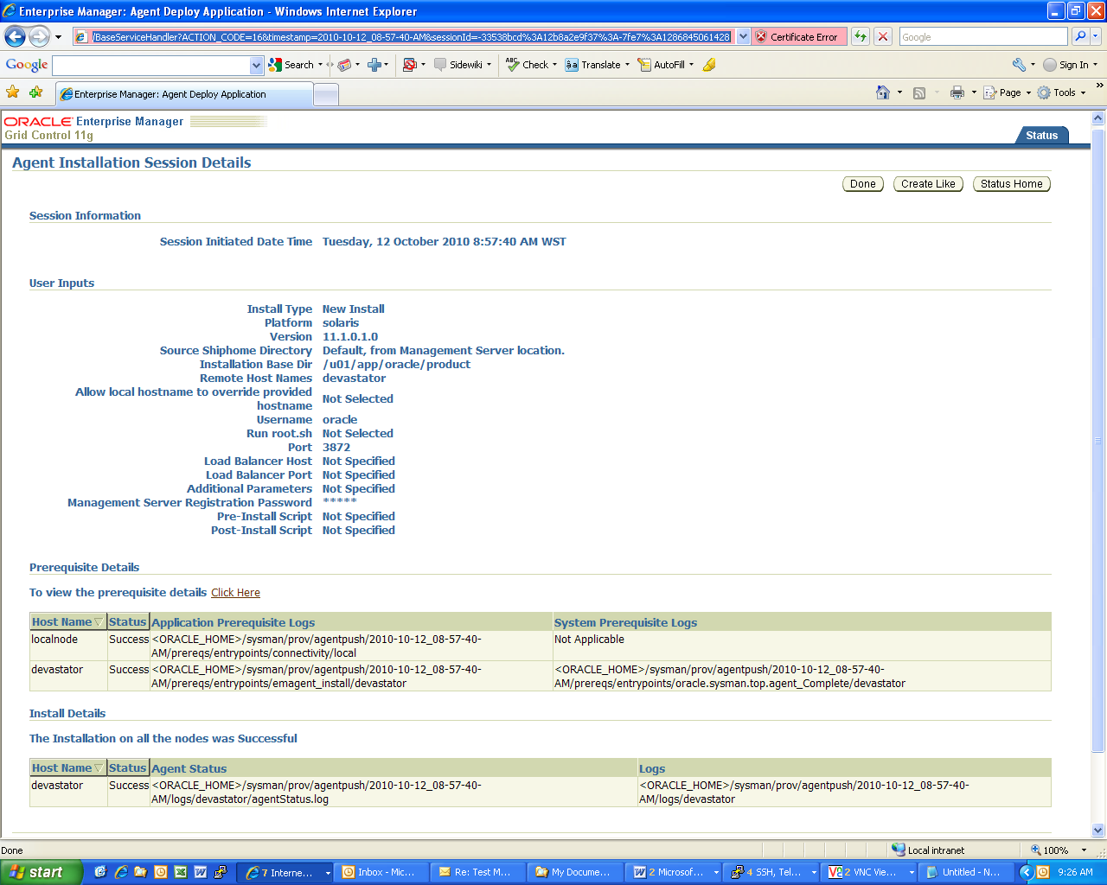

Appendix 1

devastator:/u01/app/oracle/product/ADATMP_2010-10-12_08-57-40-AM $ tail -f install.log

Unjarring Oracle Installer ...
…………….
Adding execute permissions to unzip ...
Launching Oracle Installer ...
Executing /u01/app/oracle/product/ADATMP_2010-10-12_08-57-40-AM//Disk1/runInstaller -waitforcompletion -force -responseFile /u01/app/oracle/product/ADATMP_2010-10-12_08-57-40-AM//agent_download.rsp -silent -invPtrLoc /var/opt/oracle//oraInst.loc b_doDiscovery=TRUE b_startAgent=TRUE -sourceLoc /u01/app/oracle/product/ADATMP_2010-10-12_08-57-40-AM//Disk1/stage/products.xml FROM_LOCATION=http://vixen.dpi.wa.gov.au:4889/agent_download/11.1.0.1.0/solaris/agent/stage/products.xml ORACLE_AGENT_HOME_LOCATION=/u01/app/oracle/product/ -local -staticPortsIniFile /u01/app/oracle/product/ADATMP_2010-10-12_08-57-40-AM/staticports.ini OMS_HOST="vixen.dpi.wa.gov.au" OMS_PORT="4889" -scratchPath /u01/app/oracle/product/ADATMP_2010-10-12_08-57-40-AM/ouitmp
Starting Oracle Universal Installer...

Checking Temp space: must be greater than 150 MB. Actual 13110 MB Passed
Checking swap space: must be greater than 150 MB. Actual 17247 MB Passed
Preparing to launch Oracle Universal Installer from /tmp/OraInstall2010-10-12_09-04-29AM. Please wait ...*** Check for updates ***
*** Select Installation Type ***
*** Check Prerequisites ***
/u01/app/oracle/product/ADATMP_2010-10-12_08-57-40-AM/Disk1/stage/shiphomeproperties.xml (No such file or directory)
*** Specify Oracle Management Service Location ***
*** Customize Ports ***
*** Review ***

-----------------------------------------------------------------------------
Summary
Global Settings
Source: http://vixen.dpi.wa.gov.au:4889/agent_download/11.1.0.1.0/solaris/agent/stage/products.xml
Oracle Home: /u01/app/oracle/product/agent11g (agent11g1)
Installation Type: Complete
Product Languages
English
Space Requirements
/u01/ Required 1.41GB (includes 57MB temporary) : Available 28.10GB
New Installations (58 products)
Oracle Management Agent 11.1.0.1.0
Agent Virtualization 11.1.0.1.0
Enterprise Manager Agent 11.1.0.1.0
Enterprise Manager Agent Core Files 11.1.0.1.0
Secure Socket Layer 11.1.0.7.0
Oracle Recovery Manager 11.1.0.7.0
Enterprise Manager Common Files 11.1.0.1.0
Enterprise Manager Common Core Files 11.1.0.1.0
Required Support Files 11.1.0.7.0
Oracle RAC Required Support Files-HAS 11.1.0.7.0
Oracle JDBC/THIN Interfaces 11.1.0.7.0
Oracle JDBC/OCI Instant Client 11.1.0.7.0
Oracle Globalization Support 11.1.0.7.0
Oracle Net Required Support Files 11.1.0.7.0
SSL Required Support Files for InstantClient 11.1.0.7.0
LDAP Required Support Files 11.1.0.7.0
Oracle Globalization Support 11.1.0.7.0
Perl Interpreter 5.10.0.0.1
Perl Modules 5.10.0.0.1
Expat libraries 2.0.1.0.1
XML Parser for Java 11.1.0.7.0
Precompiler Required Support Files 11.1.0.7.0
RDBMS Required Support Files 11.1.0.7.0
RDBMS Required Support Files for Instant Client 11.1.0.7.0
Parser Generator Required Support Files 11.1.0.7.0
Platform Required Support Files 11.1.0.7.0a
Patch for Oracle Process Management Notification 10.1.3.4.0
Oracle Process Management Notification 10.1.3.0.0
Agent Required Support Files 10.2.0.4.1
XDK Required Support Files 11.1.0.7.0
SQL*Plus Required Support Files 11.1.0.7.0
Secure Socket Layer 11.1.0.7.0
Oracle Core Required Support Files 11.1.0.7.0
Enterprise Manager Agent for Grid Control 11.1.0.1.0
Installation Common Files 11.1.0.7.0
Oracle Configuration Manager 10.3.2.1.0
Oracle Bali Share 11.1.1.2.0
Enterprise Manager Application Server Integrator Plugin -- Agent Support 11.1.0.2.0
Oracle Dynamic Monitoring Service Patch 10.1.2.3.0
Oracle Dynamic Monitoring Service 10.1.2.1.0
Enterprise Manager Application Server Plugin -- Agent Support 11.1.0.1.0
Enterprise Manager Application Server Plugin -- Common Support 11.1.0.1.0
Enterprise Manager Database Plugin -- Agent Support 11.1.0.1.0
Enterprise Manager Siebel Plugin -- Agent Support 11.1.0.1.0
Provisioning Advisor Framework Common Files For Agent and OMS 11.1.0.1.0
Common component for Virtualization 11.1.0.1.0
Oracle Notification Service (eONS) 11.2.0.1.0
Enterprise Manager Collaboration Suite Plugin -- Agent Support 11.1.0.1.0
Oracle Notification Service 10.1.3.0.0
Oracle Required Support Files 32 bit 11.1.0.7.0
OracleAS HTTP Client 11.1.1.2.0
OracleAS J2EE BULKOPS 11.0.0.0.0
Oracle Wallet Manager 11.1.0.7.0
Oracle Security Developer Tools 11.1.0.7.0
Oracle Universal Installer 11.1.0.8.0
Oracle One-Off Patch Installer 11.1.0.8.0
Installer SDK Component 11.1.0.8.0
Sun JDK 1.6.0.14.0
-----------------------------------------------------------------------------
Installation in progress
................................................................................

/u01/app/oracle/product/ADATMP_2010-10-12_08-57-40-AM

Applying opatch for the oneoff 9544525 ...
/u01/app/oracle/product/agent11g/OPatch/opatch napply -invPtrLoc /u01/app/oracle/product/agent11g/oraInst.loc -silent -local -oh /u01/app/oracle/product/agent11g /u01/app/oracle/product/agent11g/install/oneoffs/111010/9544525

Invoking OPatch 11.1.0.8.0

Oracle Interim Patch Installer version 11.1.0.8.0
Copyright (c) 2009, Oracle Corporation. All rights reserved.

UTIL session

Oracle Home : /u01/app/oracle/product/agent11g
Central Inventory : /u01/app/oracle/oraInventory
from : /u01/app/oracle/product/agent11g/oraInst.loc
OPatch version : 11.1.0.8.0
OUI version : 11.1.0.8.0
OUI location : /u01/app/oracle/product/agent11g/oui
Log file location : /u01/app/oracle/product/agent11g/cfgtoollogs/opatch/opatch2010-10-12_09-18-40AM.log

Patch history file: /u01/app/oracle/product/agent11g/cfgtoollogs/opatch/opatch_history.txt

Invoking utility "napply"

Checking conflict among patches...

Checking if Oracle Home has components required by patches...
Checking conflicts against Oracle Home...

OPatch continues with these patches: 9470694 9487118 9544525

Do you want to proceed? [y|n]

Y (auto-answered by -silent)
User Responded with: Y

Running prerequisite checks...

You selected -local option, hence OPatch will patch the local system only.

Please shutdown Oracle instances running out of this ORACLE_HOME on the local system.
(Oracle Home = '/u01/app/oracle/product/agent11g')

Is the local system ready for patching? [y|n]

Y (auto-answered by -silent)
User Responded with: Y

Backing up files affected by the patch 'NApply' for restore. This might take a while...

Applying patch 9470694...

ApplySession applying interim patch '9470694' to OH '/u01/app/oracle/product/agent11g'

Backing up files affected by the patch '9470694' for rollback. This might take a while...

Patching component oracle.sysman.top.agent, 11.1.0.1.0...
Copying file to "/u01/app/oracle/product/agent11g/sysman/admin/scripts/ias.10g/oid/getOIDGenDetail.pl"
Copying file to "/u01/app/oracle/product/agent11g/sysman/admin/scripts/ias.10g/oid/getOIDLogDetail.pl"
Copying file to "/u01/app/oracle/product/agent11g/sysman/admin/scripts/ias.10g/oid/getOIDPerfDetail.pl"
Copying file to "/u01/app/oracle/product/agent11g/sysman/admin/scripts/ias.10g/oid/getOIDSaslDetail.pl"
Copying file to "/u01/app/oracle/product/agent11g/sysman/admin/scripts/ias.10g/oid/getOIDStatsDetail.pl"
ApplySession adding interim patch '9470694' to inventory

Verifying the update...

Inventory check OK: Patch ID 9470694 is registered in Oracle Home inventory with proper meta-data.
Files check OK: Files from Patch ID 9470694 are present in Oracle Home.

Applying patch 9487118...

ApplySession applying interim patch '9487118' to OH '/u01/app/oracle/product/agent11g'

Backing up files affected by the patch '9487118' for rollback. This might take a while...

Patching component oracle.sysman.top.agent, 11.1.0.1.0...
Copying file to "/u01/app/oracle/product/agent11g/sysman/admin/scripts/iam/getCSFPassword.pl"
Copying file to "/u01/app/oracle/product/agent11g/sysman/admin/scripts/iam/getCSFPassword_oim.pl"
Copying file to "/u01/app/oracle/product/agent11g/sysman/admin/scripts/iam/oidtasks.pl"
Copying file to "/u01/app/oracle/product/agent11g/sysman/admin/scripts/iam/weblogicResUsage.pl"
ApplySession adding interim patch '9487118' to inventory

Verifying the update...
Inventory check OK: Patch ID 9487118 is registered in Oracle Home inventory with proper meta-data.
Files check OK: Files from Patch ID 9487118 are present in Oracle Home.

Applying patch 9544525...

ApplySession applying interim patch '9544525' to OH '/u01/app/oracle/product/agent11g'

Backing up files affected by the patch '9544525' for rollback. This might take a while...

Patching component oracle.sysman.top.agent, 11.1.0.1.0...
Copying file to "/u01/app/oracle/product/agent11g/sysman/admin/rollback_9544525.lst"
ApplySession adding interim patch '9544525' to inventory

Verifying the update...

Inventory check OK: Patch ID 9544525 is registered in Oracle Home inventory with proper meta-data.
Files check OK: Files from Patch ID 9544525 are present in Oracle Home.

The local system has been patched and can be restarted.

UtilSession: N-Apply done.

OPatch succeeded.

Unjarring the oneoff 9676134.zip ...
/u01/app/oracle/product/agent11g/jdk/bin/jar xvf /u01/app/oracle/product/agent11g/install/oneoffs/111010/9676134.zip

created: 9676134/
created: 9676134/files/
created: 9676134/files/sysman/
created: 9676134/files/sysman/admin/
created: 9676134/files/sysman/admin/default_collection/
inflated: 9676134/files/sysman/admin/default_collection/database.xmlp
created: 9676134/files/sysman/admin/metadata/

inflated: 9676134/files/sysman/admin/metadata/oracle_database.xml
inflated: 9676134/files/sysman/admin/metadata/rac_database.xml
inflated: 9676134/README.txt
created: 9676134/etc/
created: 9676134/etc/xml/
inflated: 9676134/etc/xml/ShiphomeDirectoryStructure.xml
inflated: 9676134/etc/xml/GenericActions.xml
created: 9676134/etc/config/
inflated: 9676134/etc/config/actions.xml
inflated: 9676134/etc/config/inventory.xml
inflated: 9676134/etc/config/deploy.xml

Applying opatch for the oneoff 9676134 ...
/u01/app/oracle/product/agent11g/OPatch/opatch napply -invPtrLoc /u01/app/oracle/product/agent11g/oraInst.loc -silent -local -oh /u01/app/oracle/product/agent11g /u01/app/oracle/product/agent11g/install/oneoffs/111010/9676134

Invoking OPatch 11.1.0.8.0

Oracle Interim Patch Installer version 11.1.0.8.0
Copyright (c) 2009, Oracle Corporation. All rights reserved.

UTIL session

Oracle Home : /u01/app/oracle/product/agent11g
Central Inventory : /u01/app/oracle/oraInventory
from : /u01/app/oracle/product/agent11g/oraInst.loc
OPatch version : 11.1.0.8.0
OUI version : 11.1.0.8.0
OUI location : /u01/app/oracle/product/agent11g/oui
Log file location : /u01/app/oracle/product/agent11g/cfgtoollogs/opatch/opatch2010-10-12_09-19-06AM.log

Patch history file: /u01/app/oracle/product/agent11g/cfgtoollogs/opatch/opatch_history.txt

Invoking utility "napply"

Checking conflict among patches...

Checking if Oracle Home has components required by patches...
Checking conflicts against Oracle Home...

OPatch continues with these patches: 9676134

Do you want to proceed? [y|n]

Y (auto-answered by -silent)
User Responded with: Y

Running prerequisite checks...

You selected -local option, hence OPatch will patch the local system only.

Backing up files affected by the patch 'NApply' for restore. This might take a while...

Applying patch 9676134...

ApplySession applying interim patch '9676134' to OH '/u01/app/oracle/product/agent11g'

Backing up files affected by the patch '9676134' for rollback. This might take a while...

Patching component oracle.sysman.top.agent, 11.1.0.1.0...
Copying file to "/u01/app/oracle/product/agent11g/sysman/admin/default_collection/database.xmlp"
Copying file to "/u01/app/oracle/product/agent11g/sysman/admin/metadata/oracle_database.xml"
Copying file to "/u01/app/oracle/product/agent11g/sysman/admin/metadata/rac_database.xml"
ApplySession adding interim patch '9676134' to inventory

Verifying the update...
Inventory check OK: Patch ID 9676134 is registered in Oracle Home inventory with proper meta-data.
Files check OK: Files from Patch ID 9676134 are present in Oracle Home.

The local system has been patched and can be restarted.

UtilSession: N-Apply done.

OPatch succeeded.

Finished one-offs apply...

Deleting the files...

Finished deleting the above files...

Configuration assistant "Agent Oneoff Patch Application" Succeeded

Running Configuration assistant "Agent Configuration Assistant"

Performing free port detection on host=devastator.dpi.wa.gov.au

Securing the agent

Performing targets discovery and agent configuration

Starting the agent

Configuration assistant "Agent Configuration Assistant" Succeeded

AgentPlugIn:agent configuration finished with status = true

Running Configuration assistant "Agent Add-on Plug-in"

Configuration assistant "Agent Add-on Plug-in" Succeeded

Querying Agent status: Agent is running
Removing the copied stuff.....
Removed:/u01/app/oracle/product/ADATMP_2010-10-12_08-57-40-AM//Disk1
Log name of installation can be found at: "/u01/app/oracle/product//agentDownload.solaris101210090428.log"
/u01/app/oracle/product//agent11g/root.sh needs to be executed by root to complete this installation.
agent home base name : agent11g
Succeeded message:
Succeeded message 11g: *** The Installation was Successful. ***
Agent installation successfull on node with default shiphome
Check logs if root.sh is to be run
^Cdevastator:/u01/app/oracle/product/ADATMP_2010-10-12_08-57-40-AM $ ls -lrt
total 0

Oracle Enterprise Manager 11g Release 1 Grid Control 11.1.0.1.0
Copyright (c) 1996, 2010 Oracle Corporation. All rights reserved.
---------------------------------------------------------------
Agent Version : 11.1.0.1.0
OMS Version : 11.1.0.1.0
Protocol Version : 11.1.0.0.0
Agent Home : /u01/app/oracle/product/agent11g
Agent binaries : /u01/app/oracle/product/agent11g
Agent Process ID : 237
Parent Process ID : 227
Agent URL : https://devastator.dpi.wa.gov.au:3872/emd/main/
Repository URL : https://vixen.dpi.wa.gov.au:1159/em/upload
Started at : 2010-10-12 09:22:03
Started by user : oracle
Last Reload : 2010-10-12 09:22:03
Last successful upload : (none)
Last attempted upload : (none)
Total Megabytes of XML files uploaded so far : 0.00
Number of XML files pending upload : 16
Size of XML files pending upload(MB) : 16.21
Available disk space on upload filesystem : 54.47%
Last successful heartbeat to OMS : 2010-10-12 09:22:23
---------------------------------------------------------------
Agent is Running and Ready
~

Appendix 2

