A practical guide to 10g RAC installation and configuration
- Its REAL easy!
Gavin Soorma, Emirates Airline

Case Study Environment
- Operating System: LINUX X86_64 RHEL 3AS
- Hardware: HP BL25P Blade Servers with 2 CPU’s (AMD 64 bit processors) and 4 GB of RAM
- Oracle Software: Oracle Database 10g Enterprise Edition Release 10.2.0.1.0 - 64bit
- Two Node Cluster: ITLINUXBL53.hq.emirates.com, ITLINUXBL54.hq.emirates.com
- Shared Storage: OCFS for Cluster Registry and Voting Disks. ASM for all other database related files
- Database Name: racdb
- Instance Names: racdb1, racdb2
Overview of the steps involved
- The planning stage - choosing the right shared storage options.
- Obtain the shared storage volume names from the System Administrator
- Ensuring the operating and software requirements are met
- Setting up user equivalence for the ‘oracle’ user account
- Configuring the network for RAC – obtaining Virtual IP’s
- Configuring OCFS
- Configuring ASM
- Installing the 10g Release 2 Oracle Clusterware
- Installing the 10g Release 2 Oracle Software
- Creating the RAC database using DBCA
- Enabling archiving for the RAC database
- Configuring Services and TAF (Transparent Application Failover)
10g RAC ORACLE HOMEs
The Oracle Database 10g Real Application Clusters installation is a two-phase installation. In phase one, use the Oracle Universal Installer (OUI) to install CRS (Cluster Ready Services).

Note that the Oracle home that you use in phase one is a home for the CRS software which must be different from the Oracle home that you use in phase two for the installation of the Oracle database software with RAC components. The CRS pre-installation starts the CRS processes in preparation for installing Oracle Database 10g with RAC

Choose a Storage Option for Oracle CRS, Database and Recovery Files
All instances in RAC environments share the control file, server parameter file, redo log files, and all datafiles. These files reside on a shared cluster file system or on shared disks. Either of these types of file configurations are accessed by all the cluster database instances. Each instance also has its own set of redo log files. During failures, shared access to redo log files enables surviving instances to perform recovery.
The following table shows the storage options supported for storing Oracle Cluster Ready Services (CRS) files, Oracle database files, and Oracle database recovery files. Oracle database files include datafiles, control files, redo log files, the server parameter file, and the password file. Oracle CRS files include the Oracle Cluster Registry (OCR) and the CRS voting disk.

Storage Option | File Types Supported
Storage Option | CRS | Database | Recovery
Automatic Storage Management | No | Yes | Yes
Cluster file system (OCFS) | Yes | Yes | Yes
Shared raw partitions | Yes | Yes | No
NFS file system | Yes | Yes | Yes

Network Hardware Requirements
Each node in the cluster must meet the following requirements:
- Each node must have at least two network adapters; one for the public network interface and one for the private network interface (the interconnect).
- For the private network, the interconnect must preferably be a Gigabit Ethernet switch that supports TCP/IP. This is used for Cache Fusion inter-node connection

Host Name | Type | IP Address | Registered In
itlinuxbl54.hq.emirates.com | Public | 57.12.70.59 | DNS
itlinuxbl53.hq.emirates.com | Public | 57.12.70.58 | DNS
itlinuxbl54-vip.hq.emirates.com | Virtual | 57.12.70.80 | DNS
itlinuxbl53-vip.hq.emirates.com | Virtual | 57.12.70.79 | DNS
itlinuxbl54-pvt.hq.emirates.com | Private | 10.20.176.74 | /etc/hosts
itlinuxbl53-pvt.hq.emirates.com | Private | 10.20.176.73 | /etc/hosts

Virtual IP’s (VIP)

In 10g RAC, we now require virtual IP addresses for 10g RAC. These addresses are used for failover and are automatically managed by CRS (Cluster Ready Services). The VIPCA (Virtual IP Configuration Assistant) that is called from the root.sh script of a RAC install, configures the virtual IP addresses for each node. Prior to running VIPCA, you just need to make sure that you have unused public IP addresses available for each node and that they are configured in the /etc/hosts file.

VIPs are used in order to facilitate faster failover in the event of a node failure. Each node not only has its own statically assigned IP address as well as also a virtual IP address that is assigned to the node. The listener on each node will be listening on the Virtual IP and client connections will also come via this Virtual IP.

When a node fails, the Virtual IP will actually fail over and come online on another node in the cluster. Even though the IP has failed over and is actually responding from the other node, the client will immediately get an error response indicating a logon failure because even though the IP is active, there is no instance available on that address. The client will immediately retry the connection to the next available address in the address list. It will successfully connect to the VIP that has been actually assigned to one of the existing and functioning nodes in the cluster.

Without using VIPs, clients connected to a node that died will often wait a 10 minute TCP timeout period before getting an error

IP Address Requirements

Before starting the installation, you must identify or obtain the following IP addresses for each node:
- An IP address and an associated host name registered in the domain name service (DNS) for each public network interface
- One unused virtual IP address and an associated virtual host name registered in DNS that you will configure for the primary public network interface
- The virtual IP address must be in the same subnet as the associated public interface. After installation, you can configure clients to use the virtual host name or IP address. If a node fails, its virtual IP address fails over to another node.
- A private IP address and optional host name for each private interface

Check the Network Interfaces (NICs)
- In this case our public interface is eth3 and the private interface is eth1

- Note the IP address 57.12.70.58 belongs to hostname itlinuxbl53.hq.emirates.com

- Note the IP address 10.20.176.73 belongs to the private hostname defined in the /etc/hosts for itlinuxbl53-pvt.hq.emirates.com

# /sbin/ifconfig
eth1 Link encap:Ethernet HWaddr 00:09:6B:E6:59:0D
inet 10.20.176.73 Bcast:10.20.176.255 Mask:255.255.255.0
eth3 Link encap:Ethernet HWaddr 00:09:6B:16:59:0D
inet addr:57.12.70.58 Bcast:57.12.70.255 Mask:255.255.255.0

racdb1:/opt/oracle>cat /etc/hosts
# Do not remove the following line, or various programs
# that require network functionality will fail.
#127.0.0.1 itlinuxbl53.hq.emirates.com itlinuxbl53 localhost.localdomain localhost
57.12.70.59 itlinuxbl54.hq.emirates.com itlinuxbl54
57.12.70.58 itlinuxbl53.hq.emirates.com itlinuxbl53
10.20.176.74 itlinuxbl54-pvt.hq.emirates.com itlinuxbl54-pvt
10.20.176.73 itlinuxbl53-pvt.hq.emirates.com itlinuxbl53-pvt
57.12.70.80 itlinuxbl54-vip.hq.emirates.com itlinuxbl54-vip
57.12.70.79 itlinuxbl53-vip.hq.emirates.com itlinuxbl53-vip

Setup User equivalence using SSH
When we run the Oracle Installer on a RAC mode, it will use ssh to copy the files to other nodes in the RAC cluster. The ‘oracle’ user on the node where the installer is launched must be able to login to other nodes in the cluster without having to provide a password or a passphrase. We use the ssh-keygen utility to create an authentication key for the oracle user.

:/opt/oracle>ssh-keygen -t dsa
Generating public/private dsa key pair.
Enter file in which to save the key (/opt/oracle/.ssh/id_dsa):
Enter passphrase (empty for no passphrase):
Enter same passphrase again:
Your identification has been saved in /opt/oracle/.ssh/id_dsa.
Your public key has been saved in /opt/oracle/.ssh/id_dsa.pub.
The key fingerprint is:
6d:21:6b:a1:4d:b0:1b:8d:56:bf:e1:94:f8:87:11:83 oracle@itlinuxbl53.hq.emirates.com

:/opt/oracle>cd .ssh

:/opt/oracle/.ssh>ls -lrt
total 8
-rw-r--r-- 1 oracle dba 624 Jan 29 14:12 id_dsa.pub
-rw------- 1 oracle dba 672 Jan 29 14:12 id_dsa

- Copy the contents of the id_dsa.pub file to the authorized_keys file

#/opt/oracle/.ssh>cat id_dsa.pub > authorized_keys

- Transfer this file to the other node

#/opt/oracle/.ssh>scp authorized_keys itlinuxbl54:/opt/oracle

#/opt/oracle>ssh-keygen -t dsa
Generating public/private dsa key pair.
Enter file in which to save the key (/opt/oracle/.ssh/id_dsa):
Created directory '/opt/oracle/.ssh'.
Enter passphrase (empty for no passphrase):
Enter same passphrase again:
Your identification has been saved in /opt/oracle/.ssh/id_dsa.
Your public key has been saved in /opt/oracle/.ssh/id_dsa.pub.
The key fingerprint is:
2e:c2:b8:28:98:72:4f:b8:82:a6:4a:4b:40:d3:d5:b1 oracle@itlinuxbl54.hq.emirates.com

#/opt/oracle>cd .ssh

#/opt/oracle/.ssh>ls

id_dsa id_dsa.pub

#/opt/oracle/.ssh>cp $HOME/authorized_keys .

#/opt/oracle/.ssh>ls -lrt
total 12
-rw-r--r-- 1 oracle dba 624 Jan 29 14:20 id_dsa.pub
-rw------- 1 oracle dba 668 Jan 29 14:20 id_dsa
-rw-r--r-- 1 oracle dba 624 Jan 29 14:21 authorized_keys

:/opt/oracle/.ssh>cat id_dsa.pub >> authorized_keys

:/opt/oracle/.ssh>ls -lrt
total 12
-rw-r--r-- 1 oracle dba 624 Jan 29 14:20 id_dsa.pub
-rw------- 1 oracle dba 668 Jan 29 14:20 id_dsa
-rw-r--r-- 1 oracle dba 1248 Jan 29 14:21 authorized_keys

- Copy this file back to the first host itlinuxbl53.hq.emirates.com and overwrite existing authorized keys on that server with the contents of the authorized_keys file that was generated on the host itlinuxbl54.hq.emirates.com

#/opt/oracle/.ssh>scp authorized_keys itlinuxbl53:/opt/oracle/.ssh

- Verify that the User Equivalency has been properly set up on itlinuxbl53.hq.emirates.com

#/opt/oracle/.ssh>ssh itlinuxbl54 hostname
itlinuxbl54.hq.emirates.com

- Verify the same on the other host itlinuxbl54.hq.emirates.com

#/opt/oracle/.ssh>ssh itlinuxbl53 hostname
itlinuxbl53.hq.emirates.com

Configure the hang check timer

[root@itlinuxbl53 rootpre]# /sbin/insmod hangcheck-timer hangcheck_tick=30 hangcheck_margin=180
Using /lib/modules/2.4.21-37.ELsmp/kernel/drivers/char/hangcheck-timer.o

- Confirm that the hang check timer has been loaded

[root@itlinuxbl53 rootpre]# lsmod | grep hang
hangcheck-timer 2672 0 (unused)

Installation and Configuring Oracle Cluster File Systems (OCFS)
- To find out which OCFS drivers we need for our system run:

[root@hqlinux05 root]# uname –a
Linux itlinuxbl54.hq.emirates.com 2.4.21-37.ELsmp #1 SMP Wed Sep 7 13:32:18 EDT 2005 x86_64 x86_64 x86_64 GNU/Linux

- Download the appropriate OCFS RPM’s from :

http://oss.oracle.com/projects/ocfs/files/RedHat/RHEL3/x86_64/1.0.14-1/

- Install the OCFS RPMs for SMP kernels ON ALL NODES TO BE PART OF THE CLUSTER:

[root@itlinuxbl54 recyclebin]# rpm -ivh ocfs-support-1.1.5-1.x86_64.rpm
Preparing... ########################################### [100%]
1:ocfs-support ########################################### [100%]

[root@itlinuxbl54 recyclebin]# rpm -ivh ocfs-tools-1.0.10-1.x86_64.rpm
Preparing... ########################################### [100%]
1:ocfs-tools ########################################### [100%]

[root@itlinuxbl54 recyclebin]# rpm -ivh ocfs-2.4.21-EL-smp-1.0.14-1.x86_64.rpm
Preparing... ########################################### [100%]
1:ocfs-2.4.21-EL-smp ########################################### [100%]

- To configure, format and mount the Oracle Cluster File System we will use the GUI tool ‘ocfstool’ which needs to be launched from a X-term ON BOTH NODES

[root@itlinuxbl53 root]# whereis ocfstool
ocfstool: /usr/sbin/ocfstool /usr/share/man/man8/ocfstool.8.gz

- We first generate the configuration file /etc/ocfs.conf by selecting the “Generate Config” option from the “Tasks” menu. We then select the private interface eth1 using the default port of 7000. Enter the name of the private node as shown below:

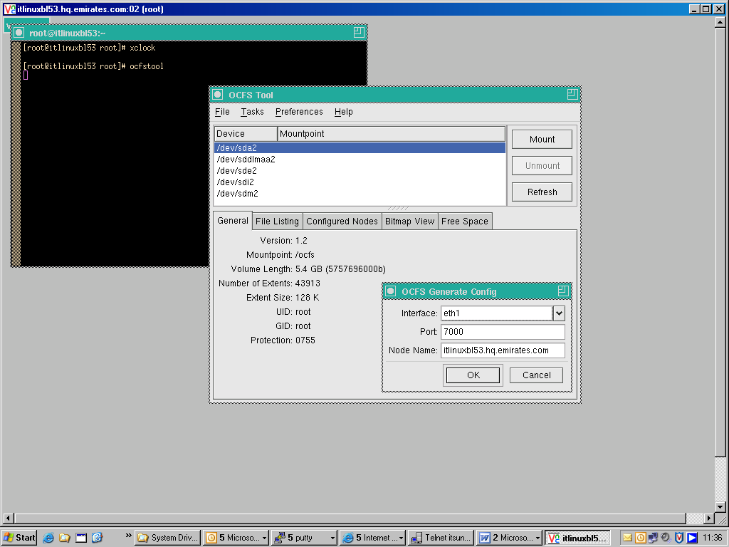

- Note the contents of the /etc/ocfs.conf file:

[root@itlinuxbl53 etc]# cat /etc/ocfs.conf

#
# ocfs config
# Ensure this file exists in /etc
#

node_name = itlinuxbl53.hq.emirates.com
ip_address = 10.20.176.73
ip_port = 7000
comm_voting = 1
guid = 5D9FF90D969078C471310016353C6B23

NOTE: Generate the configuration file on ALL NODES in the cluster

- To load the ocfs.o kernel module, execute:

[root@itlinuxbl53 /]# /sbin/load_ocfs
/sbin/modprobe ocfs node_name=itlinuxbl53.hq.emirates.com ip_address=10.20.176.73 cs=1783 guid=5D9FF90D969078C471310016353C6B23 ip_port=7000 comm_voting=1

[root@itlinuxbl53 /]# /sbin/lsmod |grep ocfs
ocfs 325280 3

Create the mount points and directories for the OCR and Voting disk
[root@itlinuxbl53 root]# mkdir /ocfs/ocr
[root@ itlinuxbl53 root]# mkdir /ocfs/vote
[root@ itlinuxbl53 root]# mkdir /ocfs/oradata
[root@ itlinuxbl53 root]# chown oracle:dba /ocfs/*

- Note: these should be done on both the nodes in the cluster.

Formatting and Mounting the OCFS File System

- Format the OCFS file system only on ONE NODE in the cluster using the ocfstool via the “Tasks” -> “Format” menu as shown below. Ensure that you choose the correct partition on the shared drive for creating the OCFS file system.

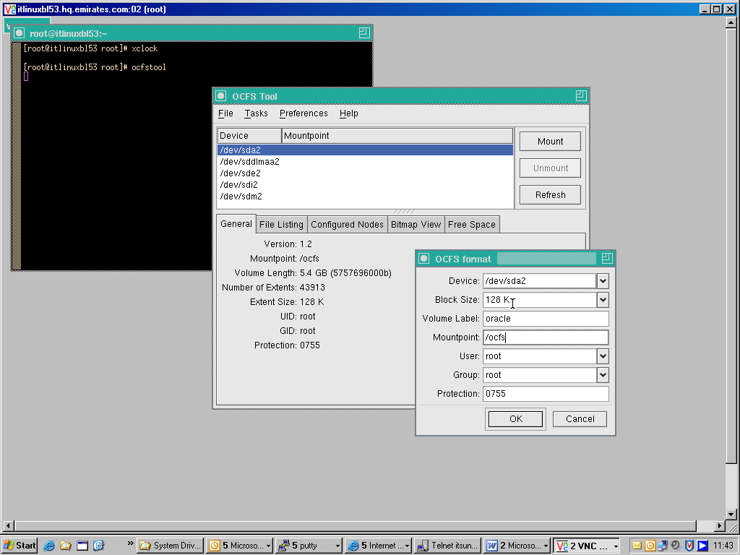

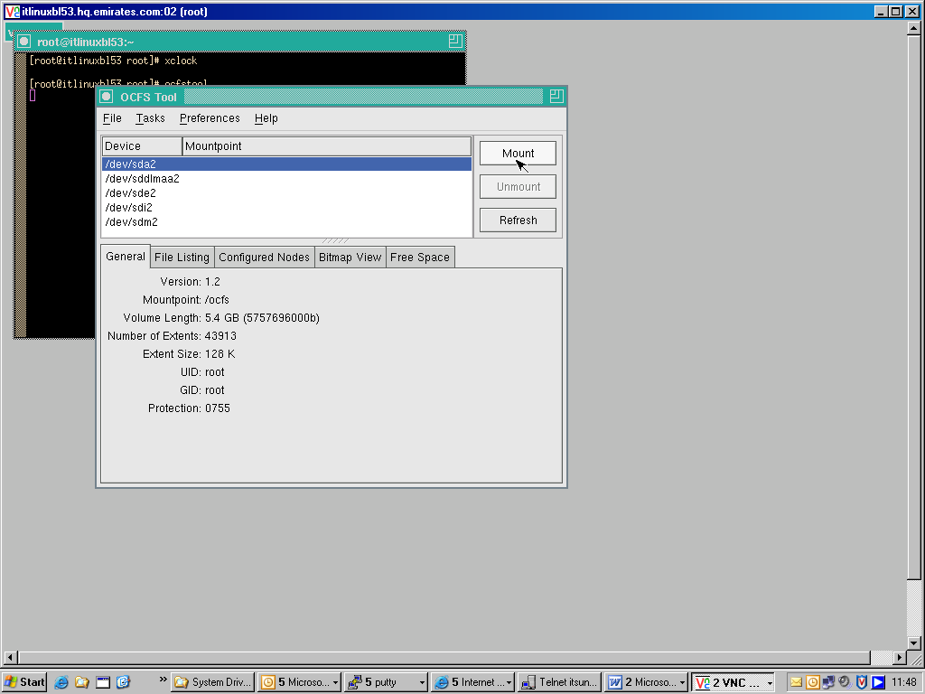

- After formatting the OCFS shared storage, we will now mount the cluster file system. This can be done either from the command line or by using the same GUI ocfstool.

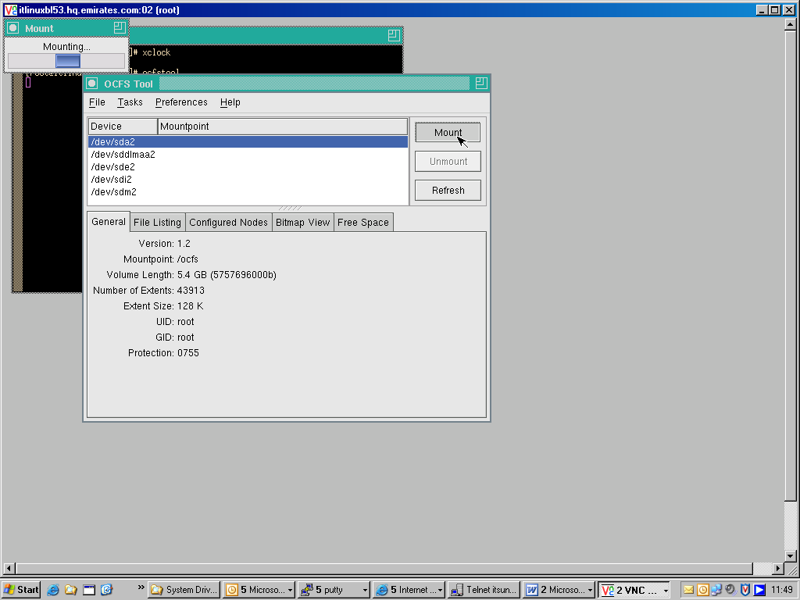

Mount the OCFS file systems on other nodes in the cluster:

- In this case we will mount the OCFS filer system on the second node in the cluster from the command line.

[root@itlinuxbl54 root]# mount -t ocfs /dev/sda2 /ocfs

#/opt/oracle>df –k |grep ocfs

/dev/sda2 5620832 64864 5555968 2% /ocfs

Installing and Configuring Automatic Storage Management (ASM) Disks using the ASMLIB’s
- Download ands install the latest Oracle ASM RPMs from http://otn.oracle.com/tech/linux/asmlib/index.html.
Note: Make sure that you download the right ASM driver for your kernel.

root@itlinuxbl53 recyclebin]# rpm -ivh oracleasm-support-2.0.1-1.x86_64.rpm
Preparing... ########################################### [100%]
1:oracleasm-support ########################################### [100%]

[root@itlinuxbl53 recyclebin]# rpm -ivh oracleasm-2.4.21-37.ELsmp-1.0.4-1.x86_64.rpm
Preparing... ########################################### [100%]
1:oracleasm-2.4.21-37.ELs########################################### [100%]

[root@itlinuxbl53 recyclebin]# rpm -ivh oracleasmlib-2.0.1-1.x86_64.rpm
Preparing... ########################################### [100%]
1:oracleasmlib ########################################### [100%]

[root@itlinuxbl53 recyclebin]# rpm -qa |grep asm
oracleasm-2.4.21-37.ELsmp-1.0.4-1
hpasm-7.5.1-8.rhel3
oracleasm-support-2.0.1-1
oracleasmlib-2.0.1-1

Configuring and Loading ASM
[root@hqlinux05 root]# /etc/init.d/oracleasm configure

Configuring the Oracle ASM library driver.

This will configure the on-boot properties of the Oracle ASM library
driver. The following questions will determine whether the driver is
loaded on boot and what permissions it will have. The current values
will be shown in brackets ('[]'). Hitting <ENTER> without typing an
answer will keep that current value. Ctrl-C will abort.

Default user to own the driver interface [oracle]:
Default group to own the driver interface [dba]:
Start Oracle ASM library driver on boot (y/n) [y]:
Fix permissions of Oracle ASM disks on boot (y/n) [y]:
Writing Oracle ASM library driver configuration [ OK ]
Scanning system for ASM disks [ OK ]

Creating the ASM Disks
- We need to create the ASM disks by executing the following commands ONLY ON ONE NODE in the cluster – also ensure that the correct device name is chosen.

[root@itlinuxbl53 init.d]# ./oracleasm createdisk VOL1 /dev/sddlmab1
Marking disk "/dev/sddlmab1" as an ASM disk: [ OK ]

[root@itlinuxbl53 init.d]# ./oracleasm createdisk VOL2 /dev/sddlmac1
Marking disk "/dev/sddlmac1" as an ASM disk: [ OK ]

[root@itlinuxbl53 init.d]# ./oracleasm createdisk VOL3 /dev/sddlmaf1
Marking disk "/dev/sddlmaf1" as an ASM disk: [ OK ]

[root@itlinuxbl53 init.d]# ./oracleasm listdisks
VOL1
VOL2
VOL3

[root@itlinuxbl53 init.d]# ./oracleasm querydisk VOL1
Disk "VOL1" is a valid ASM disk on device [253, 17]

- On other RAC nodes we need to ensure that the same ASM disks are also visible to the system:

[root@itlinuxbl54 init.d]# ./oracleasm scandisks

Scanning system for ASM disks: [ OK ]

[root@itlinuxbl54 init.d]# ./oracleasm listdisks
VOL1
VOL2
VOL3

Cluster Ready Services Installation

- CRS is the clusterware layer provided by Oracle to enable RAC to function by clustering together nodes on a supported operating system.

- CRS consists of the major components which run as daemons on Unix or services on Windows:

- ocssd is the cluster synchronization service daemon (CSS) which in single-instance environment handles the interaction between ASM instances and regular instances. In a RAC environment, it maintains information on nodes and instances that are part of the cluster at any given time as well as maintaining the heartbeat between the nodes in the cluster.

- crsd daemon is primarily responsible for starting and stopping services and relocating them to other nodes in the event of a node failure. It is also responsible for backing up the Oracle Cluster Registry (OCR)

- evmd is the event manager daemon

- CRS needs to be installed before the Oracle RDBMS is installed and needs to be installed into its own home. As part of the installation, we need to provide a separate location for the OCR and the voting disk used by the CRS. These files need to be installed on a shared storage as all nodes in the cluster need to have access to these files. The OCR and CRS Voting Disk cannot be installed on ASM disks – they need to be installed on raw devices or OCFS. In our case we will use the Oracle Cluster File System for the same.

- The OCR contains metadata about the cluster – for example, information about databases that are part of the cluster as well as instances part of the database.

- The voting disk is used to resolve ‘split-brain’ scenarios - it contains information to resolve conflicts that may arise if nodes in the cluster lose network connections via the interconnect with other nodes in the cluster.

Using the Cluster Verify Utility (cluvfy)
- The Cluster Verify Utility enables us to check our configuration at various different stages of the RAC installation. We can run the cluster verify utility at different stages and it will do a verification check for us as well as point out any errors that have occurred at that particular stage in the configuration.

- The RPM’s for cluvfy need to be installed from the Oracle 10g Release 2 Clusterware software media as shown below
[root@itlinuxbl53 root]# cd /opt/oracle/cluster_cd/clusterware/rpm
[root@itlinuxbl53 rpm]# ls
cvuqdisk-1.0.1-1.rpm
[root@itlinuxbl53 rpm]# export CVUQDISK_GRP=dba
[root@itlinuxbl53 rpm]# rpm -ivh cvuqdisk-1.0.1-1.rpm
Preparing... ########################################### [100%]
1:cvuqdisk ########################################### [100%]

- For example, we can run the cluster verify utility just before we start the installation of the Oracle 10g Release Clusterware to confirm that we have fulfilled all the requirements at the hardware and operating system level.
./runcluvfy.sh stage -post hwos -n itlinuxbl53 -verbose
Performing post-checks for hardware and operating system setup
Checking node reachability...
Check: Node reachability from node "itlinuxbl53"
Destination Node Reachable?
------------------------------------ ------------------------
itlinuxbl53 yes
Result: Node reachability check passed from node "itlinuxbl53".
Checking user equivalence...
Check: User equivalence for user "oracle"
Node Name Comment
------------------------------------ ------------------------
itlinuxbl53 passed
Result: User equivalence check passed for user "oracle".
Checking node connectivity...
Interface information for node "itlinuxbl53"
Interface Name IP Address Subnet
------------------------------ ------------------------------ ----------------
eth1 10.20.176.73 10.20.176.0
eth3 57.12.70.58 57.12.70.0
Check: Node connectivity of subnet "10.20.176.0"
Result: Node connectivity check passed for subnet "10.20.176.0" with node(s) itlinuxbl53.
Check: Node connectivity of subnet "57.12.70.0"
Result: Node connectivity check passed for subnet "57.12.70.0" with node(s) itlinuxbl53.
Suitable interfaces for VIP on subnet "57.12.70.0":
itlinuxbl53 eth3:57.12.70.58
Suitable interfaces for the private interconnect on subnet "10.20.176.0":
itlinuxbl53 eth1:10.20.176.73
Result: Node connectivity check passed.
Checking shared storage accessibility...
Disk Sharing Nodes (1 in count)
------------------------------------ ------------------------
/dev/sddlmaa itlinuxbl53
/dev/sddlmab itlinuxbl53
/dev/sddlmac itlinuxbl53
/dev/sddlmaf itlinuxbl53
Shared storage check was successful on nodes "itlinuxbl53".
Post-check for hardware and operating system setup was successful.

Installing Oracle 10g CRS software

- In order for the OUI to install the software remotely on other nodes in the cluster, the oracle user account needs to be able to ssh to all other RAC nodes without being asked for a password or passphrase. On the terminal where you are going to launch the installer run the following commands:

[oracle@itlinuxbl53 oracle]$ssh-x oracle
[oracle@itlinuxbl53 oracle]$ssh-agent $SHELL
[oracle@itlinuxbl53 oracle]$ssh –add

- Before launching the installer, a good practice would be to check if user equivalence has been configured correctly by running some commands on the remote host.

- On the “Specify Cluster Configuration” screen, we will need to specify the name we are going to use for our cluster as well as the public, private and virtual names that have been assigned to the nodes that are going to make up our 10g RAC cluster.

- We need to ensure that the name hostnames that are present in the /etc/hosts file are specified.

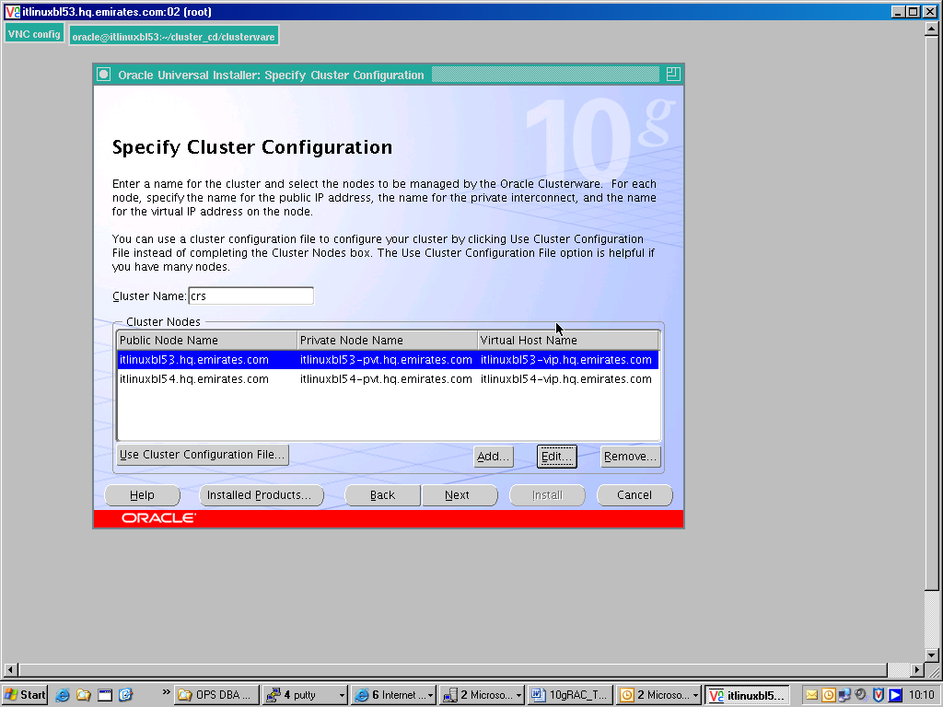

- In the “Specify Network Interface Usage” screen we will specify which network interface card we will use for the interconnect traffic between the cluster nodes as well as for “public” network traffic.

- We will select ‘Public’ for the interface eth3 and ‘Private’ for the interface eth1.

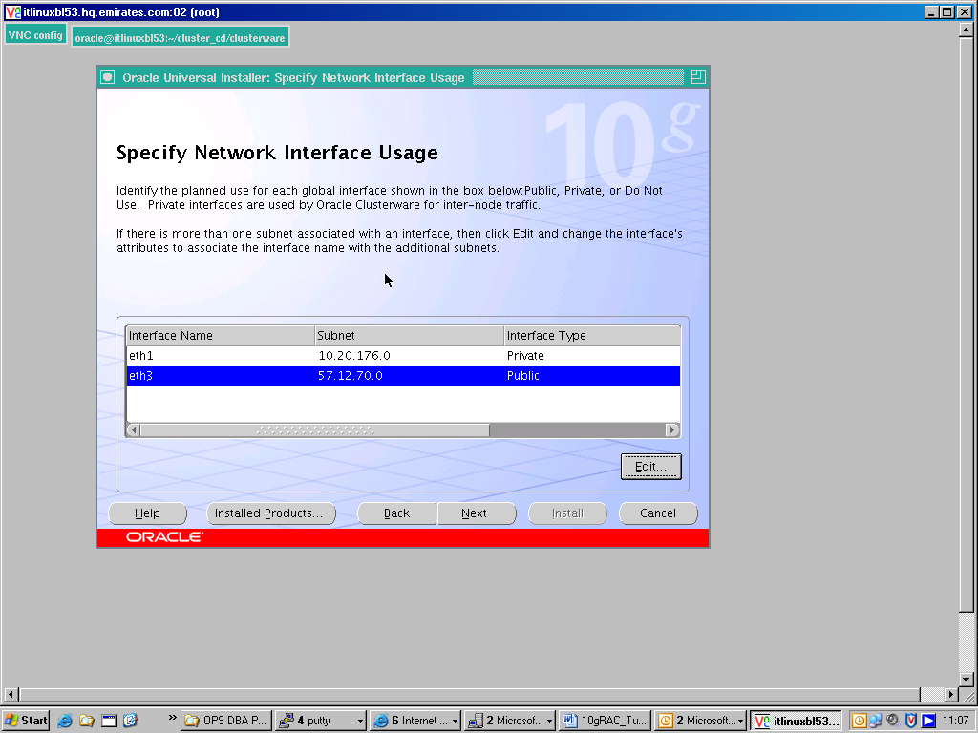

- We need to specify the location of the Oracle Cluster Registry files (OCR). These files need to be stored on shared storage and contain important information or the metadata about the RAC database instance as well as nodes that make up the cluster. We need about 100MB for the OCR files and in our case we will be using the OCFS file system to store the OCR files.

- In Oracle 10g Release 2, we can provide an additional mirrored location for the OCR file which will provide us redundancy and avoid a single point of failure.

- In this example, we are using external redundancy option which means the OCR file is not mirrored and we should use our own mechanisms to backup the OCR file.

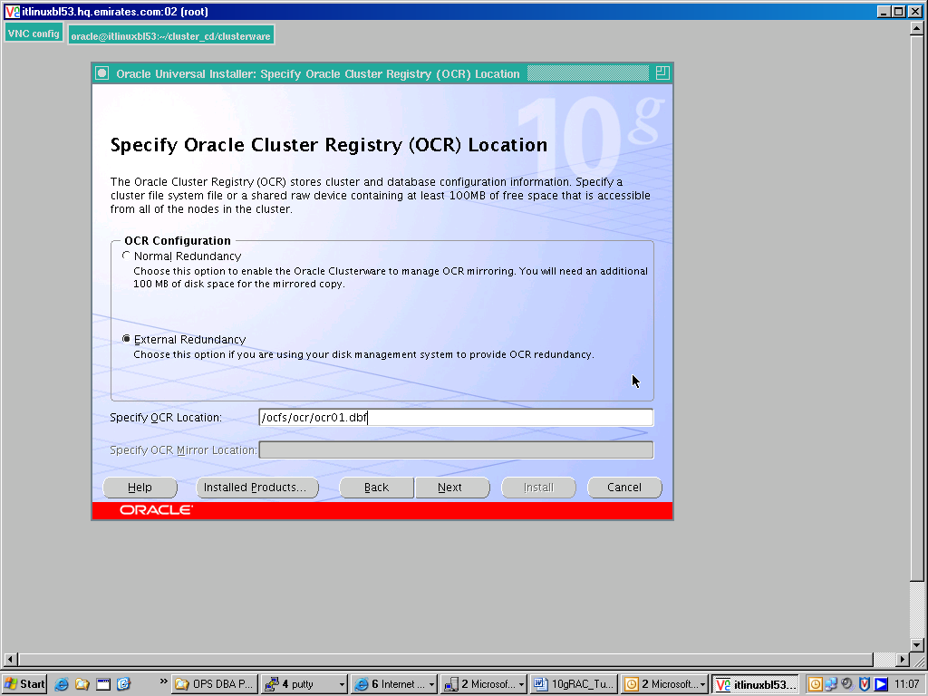

- The Voting Disk is another important file that contains important information about cluster membership and is used by the CRS to avoid ‘spilt-brain’ scenarios should any node in the cluster lose network contact via the interconnect with other nodes in the cluster.

- The Voting Disk also needs to be located on shared storage as all nodes in the cluster needs to have access to the Voting disk files. In our example, we will be using the OCFS file system that we earlier had created.

- The Voting disk files are typically about 20MB and in Oracle 10g Release 2, we are able to specify two additional locations for the Voting Disk file to provide redundancy.

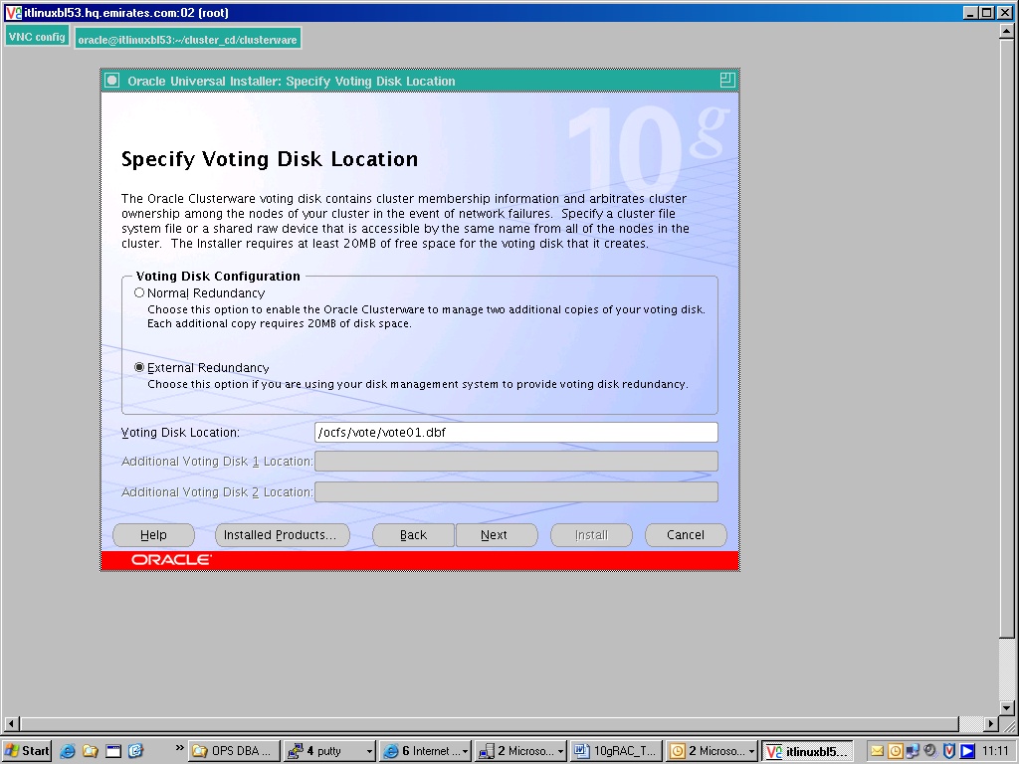

- After completing the installation of the Oracle 10g Clusterware on the local node, the OUI will also copy the Oracle home to other ‘remotes’ nodes in the cluster

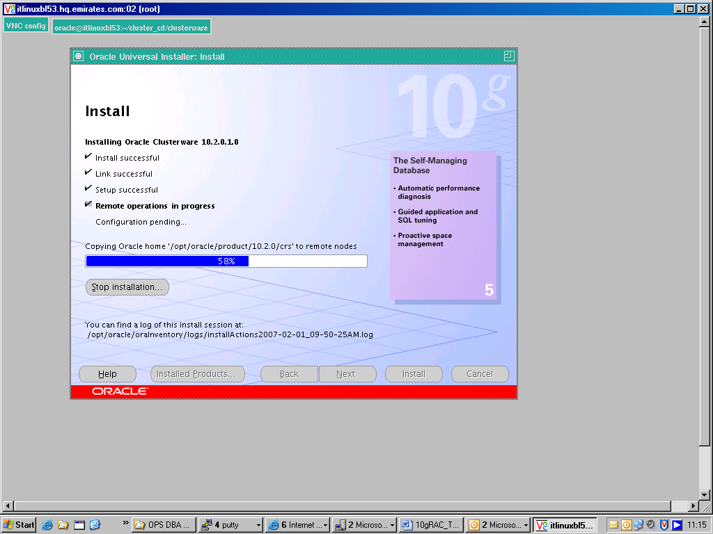

- At the end of the CRS Installation, we will be prompted to run the root.sh from the ORA_CRS_HOME/bin directory. This must be done on each node, one node at a time.

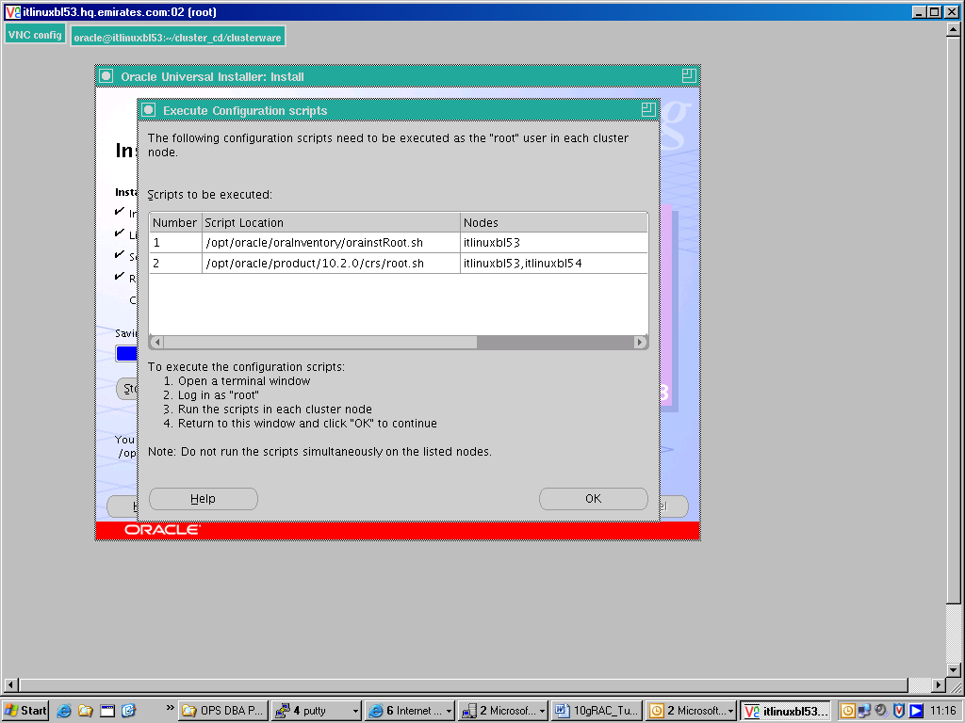

[root@itlinuxbl53 crs]# ./root.sh
WARNING: directory '/opt/oracle/product/10.2.0' is not owned by root
WARNING: directory '/opt/oracle/product' is not owned by root
WARNING: directory '/opt/oracle' is not owned by root
WARNING: directory '/opt' is not owned by root
Checking to see if Oracle CRS stack is already configured

Setting the permissions on OCR backup directory
Setting up NS directories
Oracle Cluster Registry configuration upgraded successfully
WARNING: directory '/opt/oracle/product/10.2.0' is not owned by root
WARNING: directory '/opt/oracle/product' is not owned by root
WARNING: directory '/opt/oracle' is not owned by root
WARNING: directory '/opt' is not owned by root
Successfully accumulated necessary OCR keys.
Using ports: CSS=49895 CRS=49896 EVMC=49898 and EVMR=49897.
node <nodenumber>: <nodename> <private interconnect name> <hostname>
node 1: itlinuxbl53 itlinuxbl53-pvt itlinuxbl53
node 2: itlinuxbl54 itlinuxbl54-pvt itlinuxbl54
Creating OCR keys for user 'root', privgrp 'root'..
Operation successful.
Now formatting voting device: /ocfs/vote/vote01.dbf
Format of 1 voting devices complete.
Startup will be queued to init within 90 seconds.
Adding daemons to inittab
Expecting the CRS daemons to be up within 600 seconds.
CSS is active on these nodes.
itlinuxbl53
CSS is inactive on these nodes.
itlinuxbl54
Local node checking complete.
Run root.sh on remaining nodes to start CRS daemons.

- We will now run the root.sh on the other node in the cluster, ITLINUXBL54. Note, the output of the root.sh is different that the other node.

- The VIPCA (Virtual IP Configuration Assistant) is launched ‘silently’ when the root.sh script is run on this node.

- In the earlier 10g release, the VIPCA used to be launched as part of the Oracle Software installation process

[root@itlinuxbl54 crs]# ./root.sh
WARNING: directory '/opt/oracle/product/10.2.0' is not owned by root
WARNING: directory '/opt/oracle/product' is not owned by root
WARNING: directory '/opt/oracle' is not owned by root
WARNING: directory '/opt' is not owned by root
Checking to see if Oracle CRS stack is already configured

Setting the permissions on OCR backup directory
Setting up NS directories
Oracle Cluster Registry configuration upgraded successfully
WARNING: directory '/opt/oracle/product/10.2.0' is not owned by root
WARNING: directory '/opt/oracle/product' is not owned by root
WARNING: directory '/opt/oracle' is not owned by root
WARNING: directory '/opt' is not owned by root
clscfg: EXISTING configuration version 3 detected.
clscfg: version 3 is 10G Release 2.
Successfully accumulated necessary OCR keys.
Using ports: CSS=49895 CRS=49896 EVMC=49898 and EVMR=49897.
node <nodenumber>: <nodename> <private interconnect name> <hostname>
node 1: itlinuxbl53 itlinuxbl53-pvt itlinuxbl53
node 2: itlinuxbl54 itlinuxbl54-pvt itlinuxbl54
clscfg: Arguments check out successfully.

NO KEYS WERE WRITTEN. Supply -force parameter to override.
-force is destructive and will destroy any previous cluster
configuration.
Oracle Cluster Registry for cluster has already been initialized
Startup will be queued to init within 90 seconds.
Adding daemons to inittab
Expecting the CRS daemons to be up within 600 seconds.
CSS is active on these nodes.
itlinuxbl53
itlinuxbl54
CSS is active on all nodes.
Waiting for the Oracle CRSD and EVMD to start
Oracle CRS stack installed and running under init(1M)
Running vipca(silent) for configuring nodeapps

Creating VIP application resource on (2) nodes...
Creating GSD application resource on (2) nodes...
Creating ONS application resource on (2) nodes...
Starting VIP application resource on (2) nodes...
Starting GSD application resource on (2) nodes...
Starting ONS application resource on (2) nodes...

Done.

Confirm the CRS configuration

- Before we start the RDBMS Software installation, we must ensure that the CRS stack is running on all nodes in the cluster.

- We can run the olsnodes command from the CRS_HOME/bin directory. This should return the names of all nodes that are part of the cluster as well as their internally assigned node number

[oracle@itlinuxbl53 crs]$ cd bin
[oracle@itlinuxbl53 bin]$ ./olsnodes -n
itlinuxbl53 1
itlinuxbl54 2

- We should also confirm if the CRS related processes like the Event Manager Daemon (EMD), Oracle Notification Services (ONS) and Cluster synchronization service daemon (CSS) are running

[root@itlinuxbl53 crs]# ps -ef |grep crs
/opt/oracle/product/10.2.0/crs/log/itlinuxbl53/evmd; exec /opt/oracle/product/10.2.0/crs/bin/evmd '
root 28972 1 0 11:54 ? 00:00:00 /opt/oracle/product/10.2.0/crs/bin/crsd.bin reboot
oracle 29261 28960 0 11:55 ? 00:00:00 /opt/oracle/product/10.2.0/crs/bin/evmd.bin
root 29362 29297 0 11:55 ? 00:00:00 /bin/su -l oracle -c /bin/sh -c 'ulimit -c unlimited; cd /opt/oracle/product/10.2.0/crs/log/itlinuxbl53/cssd; /opt/oracle/product/10.2.0/crs/bin/ocssd || exit $?'
oracle 29363 29362 0 11:55 ? 00:00:00 /bin/sh -c ulimit -c unlimited; cd /opt/oracle/product/10.2.0/crs/log/itlinuxbl53/cssd; /opt/oracle/product/10.2.0/crs/bin/ocssd || exit $?
oracle 29398 29363 0 11:55 ? 00:00:00 /opt/oracle/product/10.2.0/crs/bin/ocssd.bin
oracle 15416 29261 0 12:08 ? 00:00:00 /opt/oracle/product/10.2.0/crs/bin/evmlogger.bin -o /opt/oracle/product/10.2.0/crs/evm/log/evmlogger.info -l /opt/oracle/product/10.2.0/crs/evm/log/evmlogger.log
oracle 16178 1 0 12:08 ? 00:00:00 /opt/oracle/product/10.2.0/crs/opmn/bin/ons -d
oracle 16179 16178 0 12:08 ? 00:00:00 /opt/oracle/product/10.2.0/crs/opmn/bin/ons –d

- We can also use the crsctl command to check the health and availability of the CRS stack.
racdb1:/opt/oracle/product/10.2.0/crs/bin>./crsctl check crs
CSS appears healthy
CRS appears healthy
EVM appears healthy
- We can also check the location of the voting disk using the crsctl command
racdb1:/opt/oracle/product/10.2.0/crs/bin>./crsctl query css votedisk
0. 0 /ocfs/vote/vote01.dbf
located 1 votedisk(s).

- The ocrcheck command can also be used to check the integrity of the Cluster Registry

[root@itlinuxdevblade08 bin]# ./ocrcheck
Status of Oracle Cluster Registry is as follows :
Version : 2
Total space (kbytes) : 262144
Used space (kbytes) : 4352
Available space (kbytes) : 257792
ID : 375460566
Device/File Name : /ocfs/ocr/rac_ocr01.dbf
Device/File integrity check succeeded

- This command will display the Oracle Clusterware version
racdb1:/opt/oracle/product/10.2.0/crs/bin>./crsctl query crs activeversion
CRS active version on the cluster is [10.2.0.1.0]
Installation of Oracle 10g software with Real Application Clusters

- Launch the Oracle Universal Installer only on ONE node

- Use the same terminal that was prepared earlier for ssh and the CRS installation and choose the “Custom” option

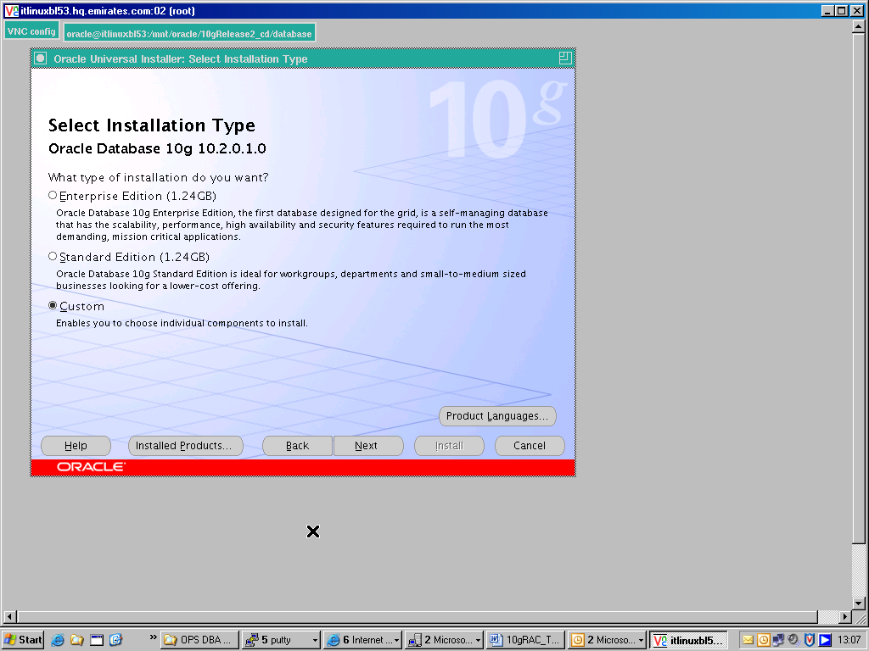

- The OUI will now detect that the node is ‘cluster aware’ because the CRS stack is now active. Ensure that all the nodes in the cluster are listed and since we are not doing a local install but a cluster install, ensure that both the nodes listed have been checked off.

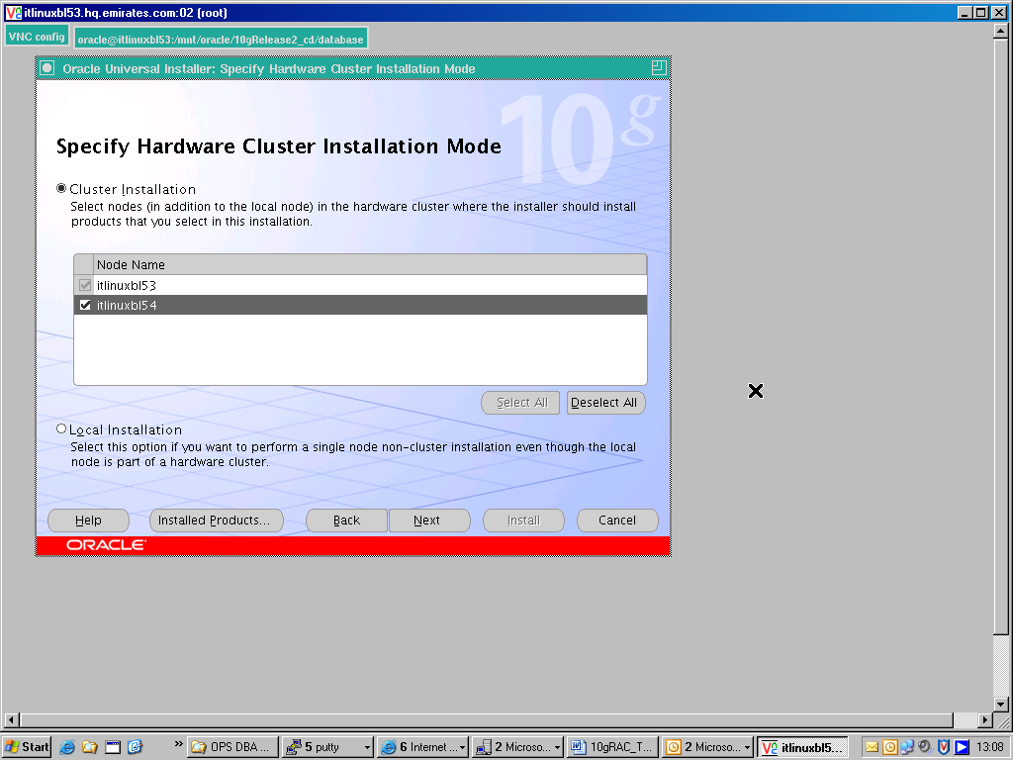

- In this case study, we will be creating the database at a later stage after the software has been installed, that is why we have chosen the “Custom” option
- We will only be installing the RDBMS Software at this stage on all nodes in the cluster.

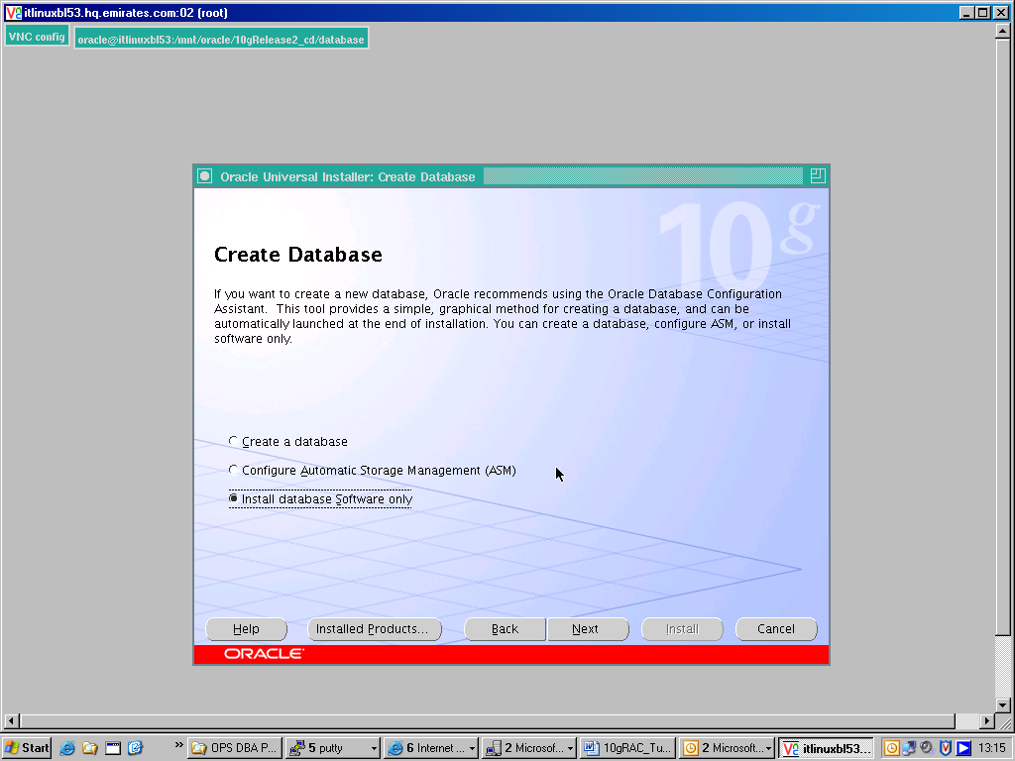

- Similar to the CRS Installation in the earlier stage, once the OUI completes the installation on the local node, it will copy the Oracle Home to other remote nodes in the cluster.

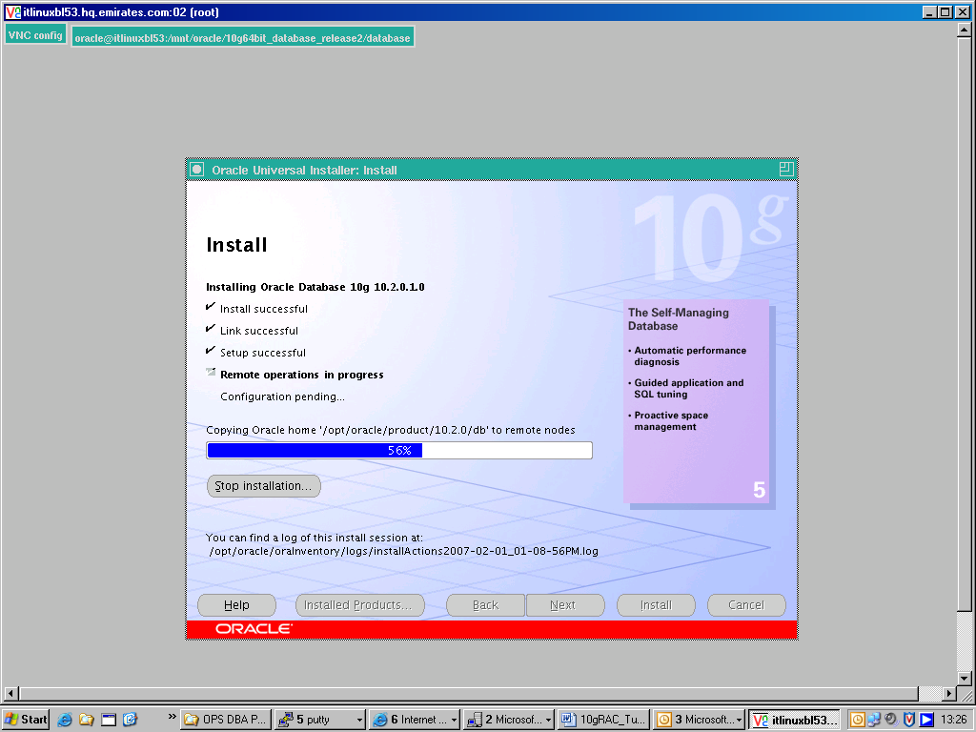

- At the end of the Oracle Software installation, we are prompted to run the root.sh on each node in the cluster. Again, like as in the CRS installation, we need to run the root.sh on each node in the cluster one at a time.

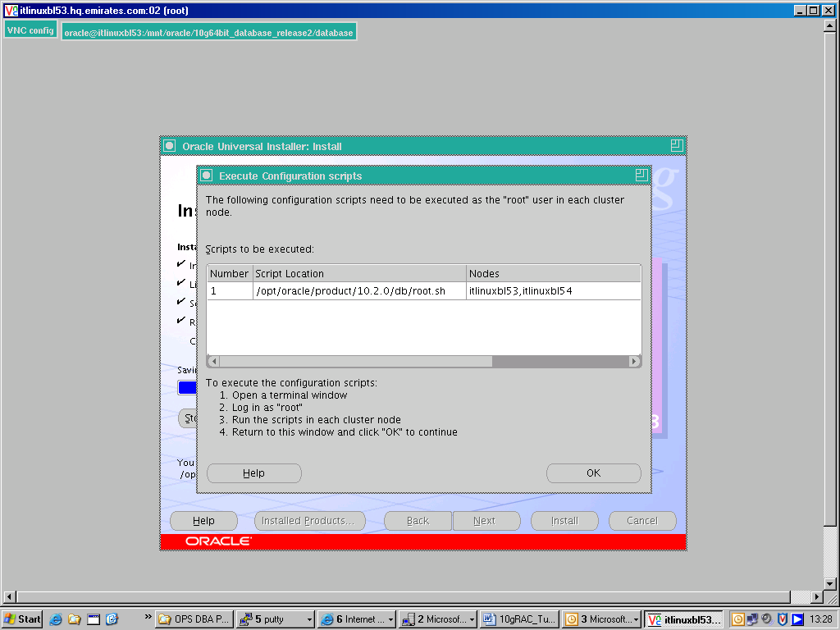

10g RAC DATABASE CREATION USING DBCA

- We will be creating the RAC database using the Database Configuration Assistant (dbca).
- Note: Since the CRS processes are active on this node, the DBCA gives us another option which is to create a Oracle Real Application Clusters Database.

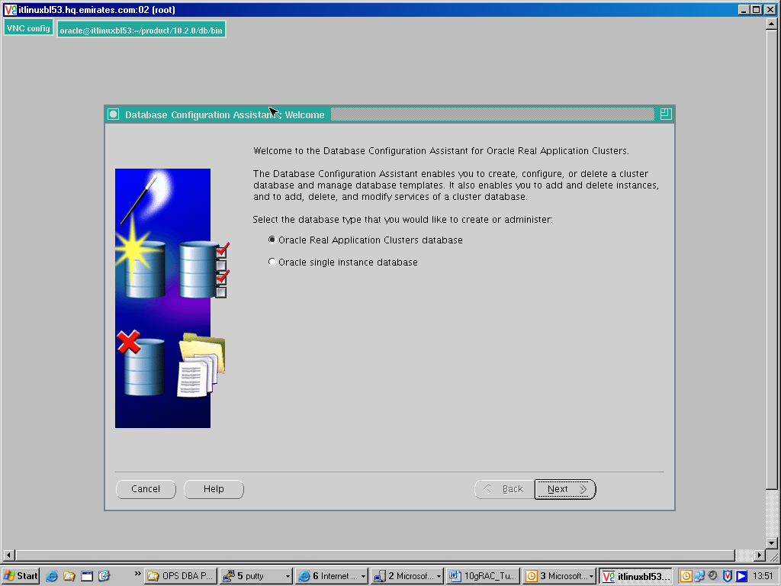

CONFIGURING AUTOMATIC STORAGE MANAGEMENT
- Before creating the database, we will first be configuring Automatic Storage Management (ASM).
- We will now start the ASM instance and create the ASM disk groups as the database files will be located on the shared storage represented by the ASM disks.
- We will launch DBCA and choose the option “Configure Automatic Storage Management”

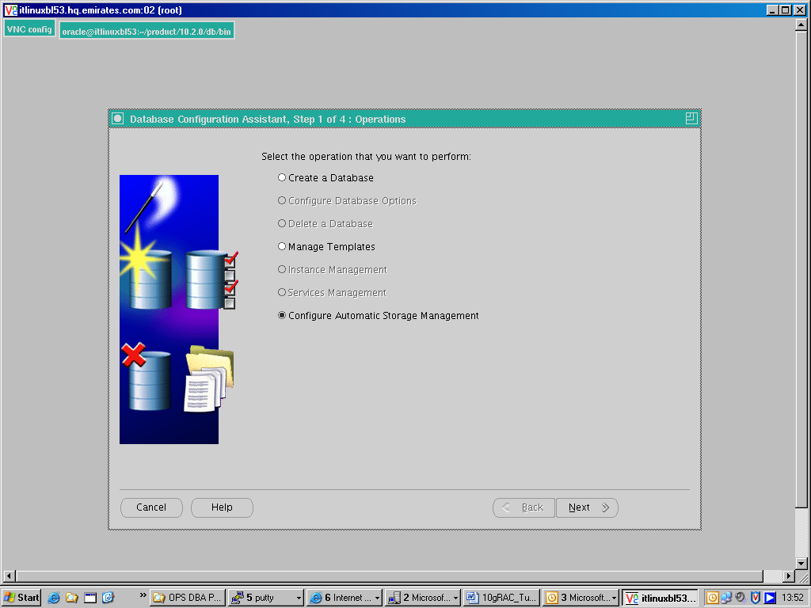

- DBCA will create two ASM instances – one on each node in the cluster.
- In our case it will create ASM instance with SID +ASM1 on ITLINUXBL53 and ASM instance +ASM2 on ITLINUIXBL54.
- The spfile will be exist on the shared storage – in our case the OCFS file system.

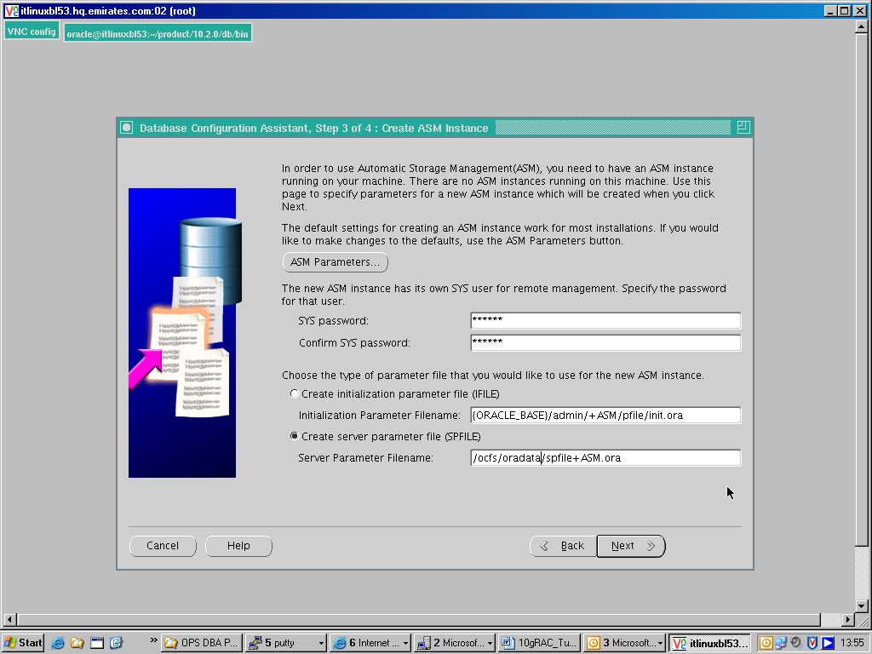

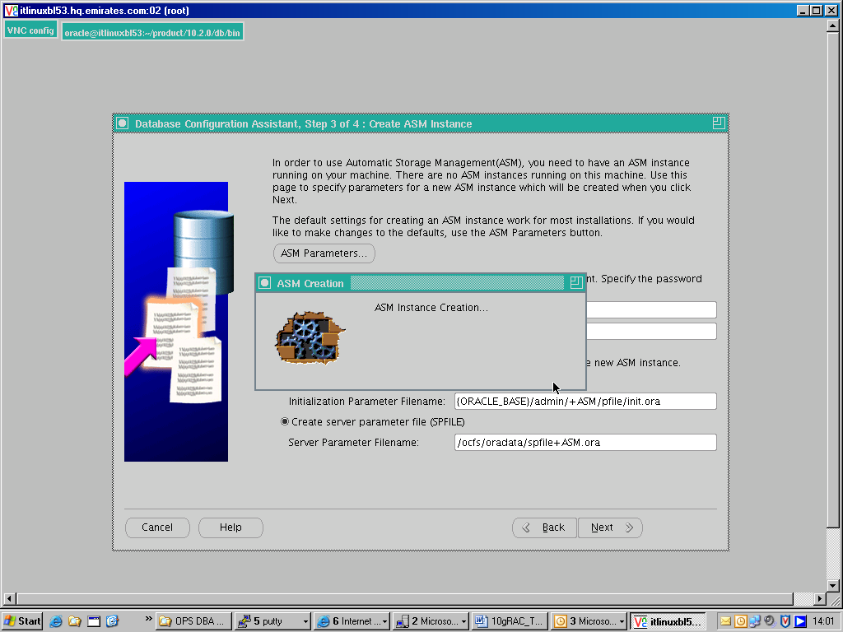

- After the ASM instance has started, we now need to create the ASM disk groups using the ASM volumes we had earlier defined – VOL1, VOL2 and VOL3.
- We can either create new disk groups or add disks to an existing disk group.
- In our case we will be creating an ASM disk group DG1 using the ASM volume VOL1
- At this stage we will not be using the other two volumes VOL2 and VOL3

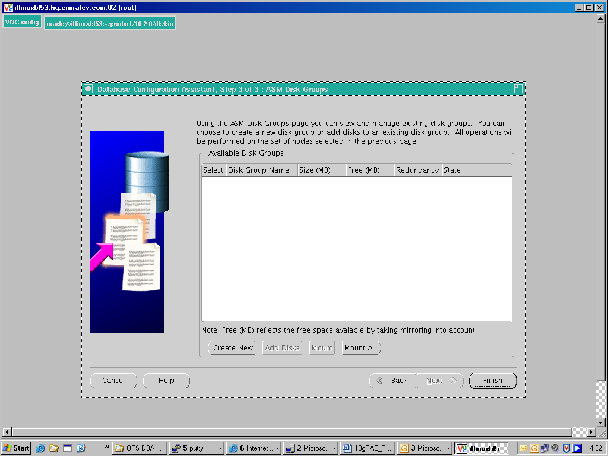

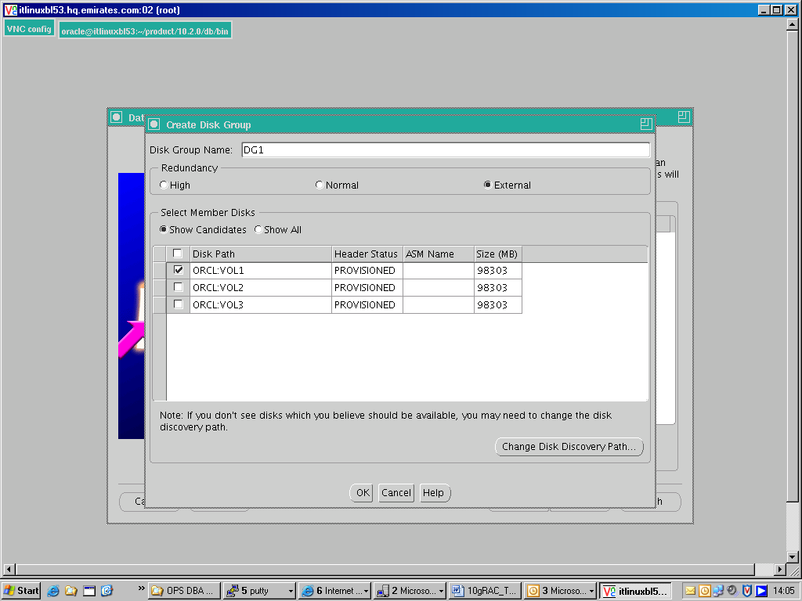
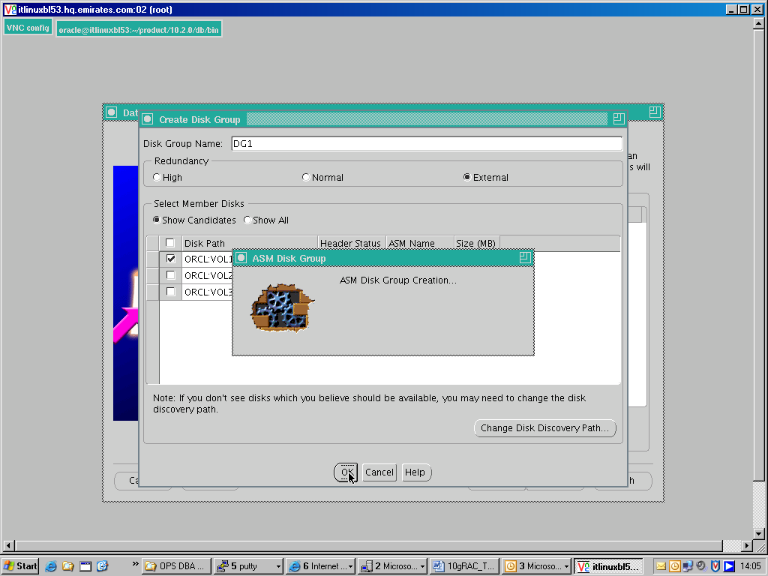

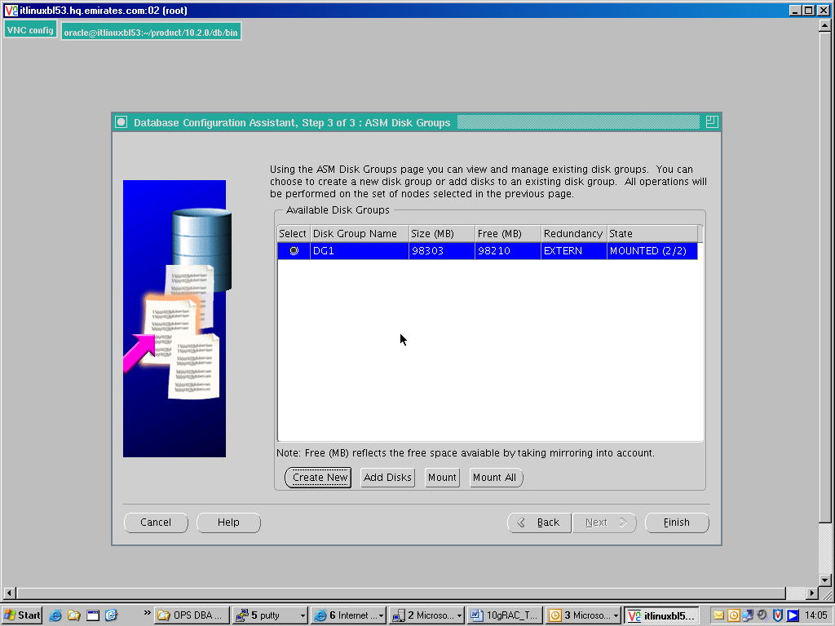

- After the ASM instance has been created and the disk groups allocated, we will now create the RAC database using the DBCA

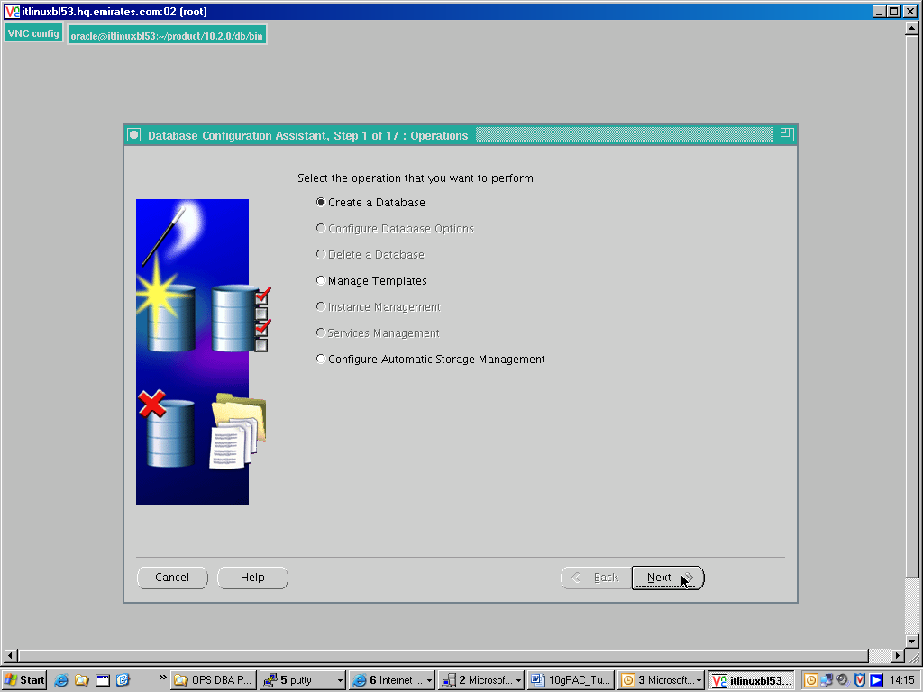

- The DBCA will create two instances – one on each node in the cluster.

- We need to ensure that all the nodes that are part of the cluster are selected.

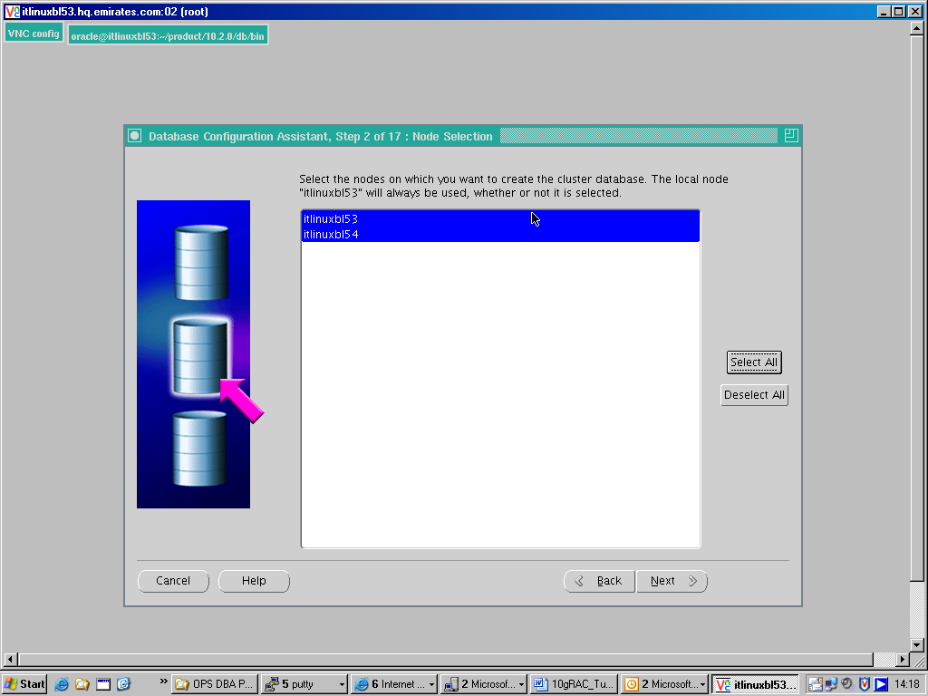

- Note; what we are specifying is not the SID of the RAC database, but the SID prefix which in this case is ‘racdb’.

- DBCA will create two instances, one on each node in the cluster with the SID’s ‘racdb1’ and ‘racdb2’

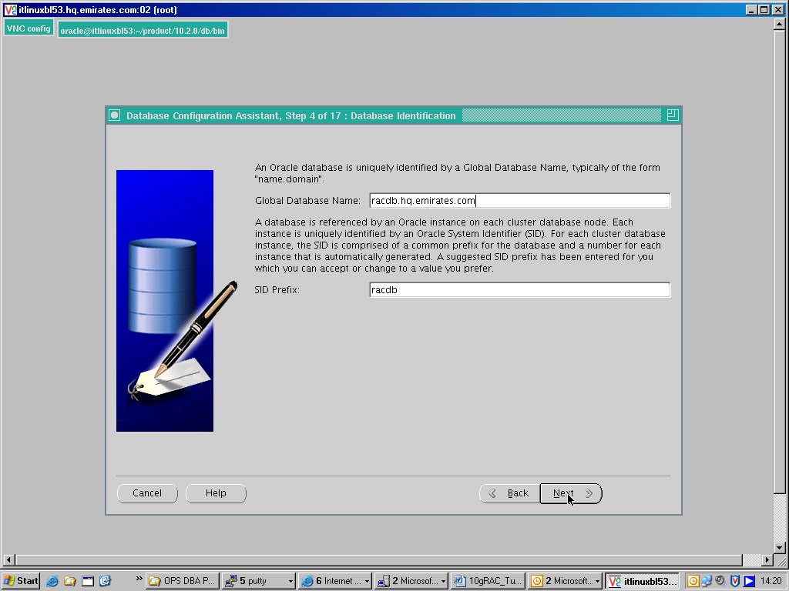

- While choosing the storage options for the Database files, DBCA gives us three options – the raw devices, a cluster file system which in our case is OCFS or ASM.

- We will choose the Automatic Storage Management option as the common shared location for all database files and will use the ASM Disk Group DG1 that was earlier created.

- Note:ASM disk groups are denoted with a ‘+’ sign before the Disk Group name

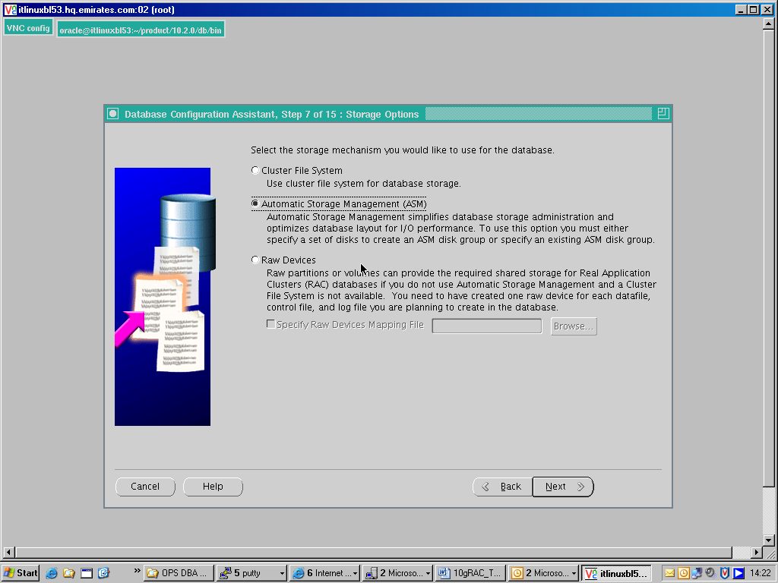

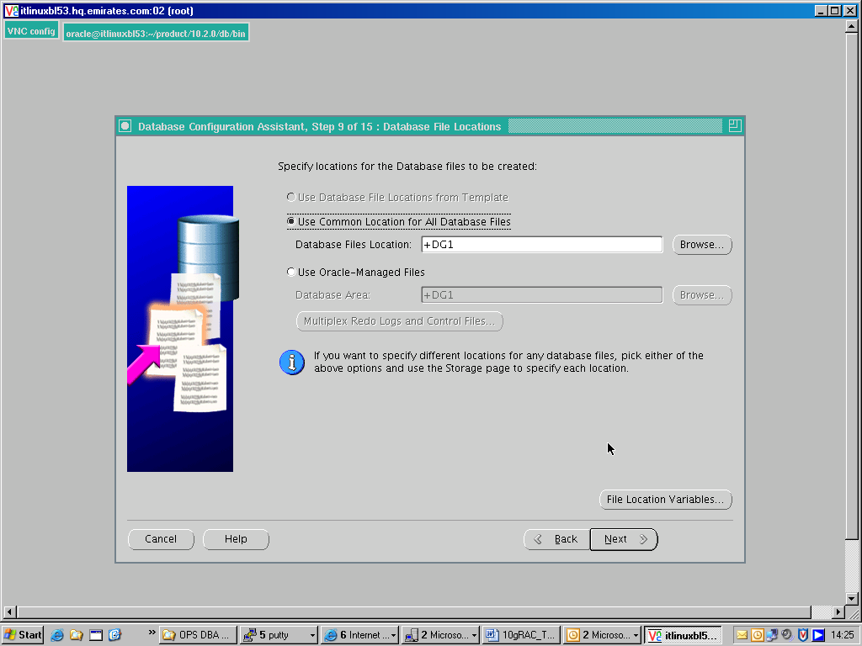

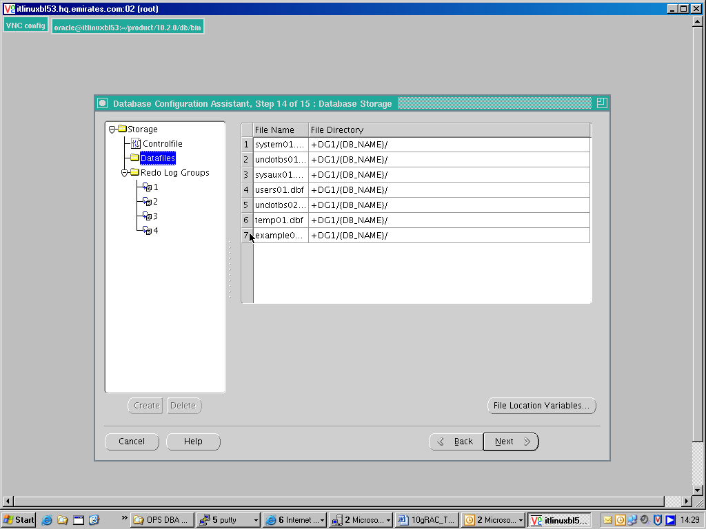

- The DBCA will call the catclust.sql script located at $ORACLE_HOME/rdbms/admin

- The catclust.sql will create the cluster specific data dictionary views

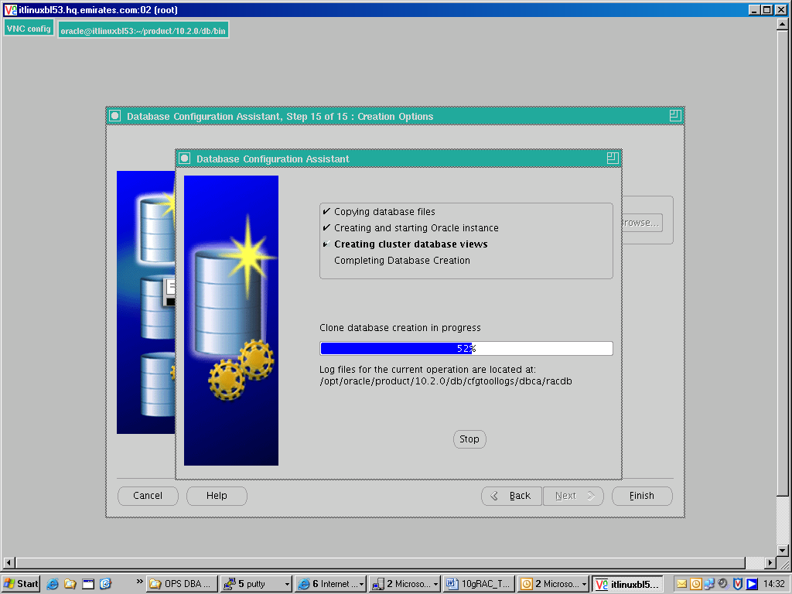

- The spfile for the racdb database is located on the ASM disk +DG1

- The spfile will have init.ora parameters that are common to both RAC instances racdb1 and racdb2 as well as some parameters that are specific to each database instance.

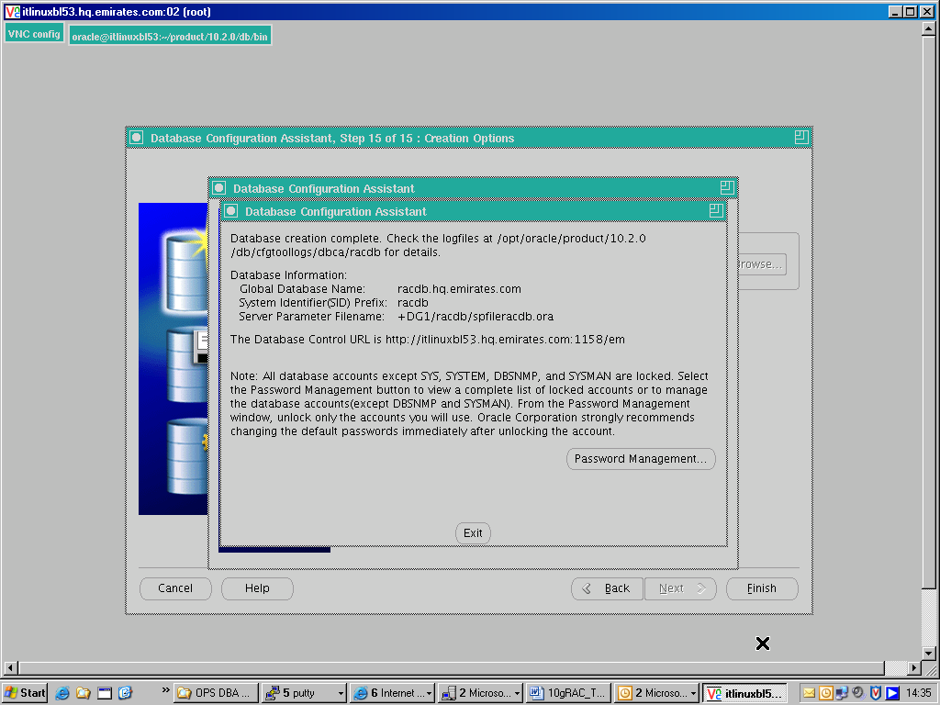

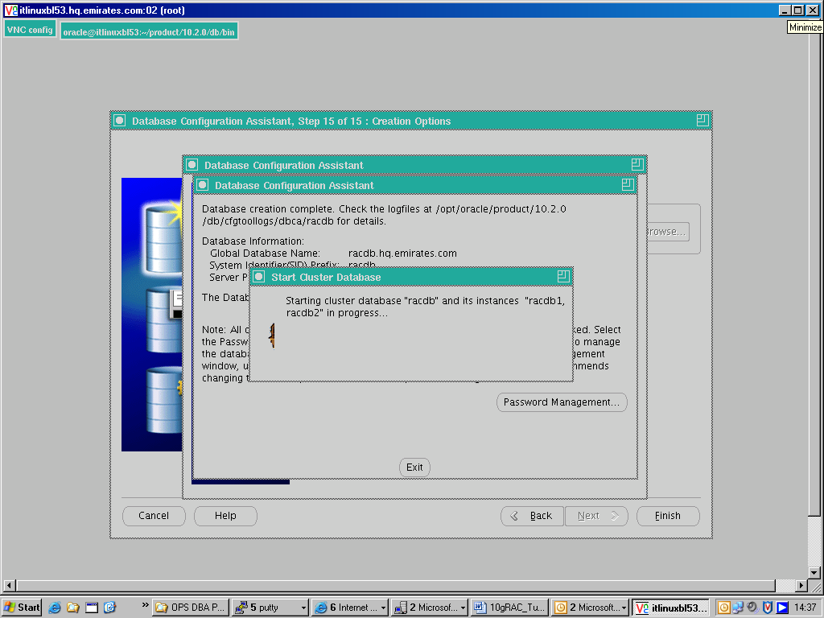

Defining SERVICES and Transparent Application Failover (TAF)

- A Service is associated with an application on the front end that connects to the database on the back end. Users of the application need not care which instance of the RAC cluster or node they are connecting to – for the end user it is totally transparent.

- Services can be used to make logical groups of consumers who share common attributes like workload, a database schema or some common application functionality. For example we can have two services like Finance and HR accessing the same 11i Applications database. Using services, the DBA has the ability to isolate workloads and manage them independently. Using services, the DBA can determine which node or nodes in the cluster the application runs on and also prioritize resources among services.

- We can set the service to run on a node as well as disable it from running on a particular node. We can set it to “Preferred” meaning that the service will primarily run only on that instance or we can set it to “Available” meaning that the service will only run on the instance if the Preferred instance fails.

- We can also configure the TAF policy to either “Basic” or “Pre-Connect”. Basic will establish the connection only at failover time whereas Pre-Connect will establish one connection to the preferred instance and another one to the instance that we have defined as “Available”

- In this example, we will be creating a service called racdb_itlinuxbl53.

- This service will be configured with the preferred node as ITLINUXBL53 and the available node as ITLINUXBL54
- 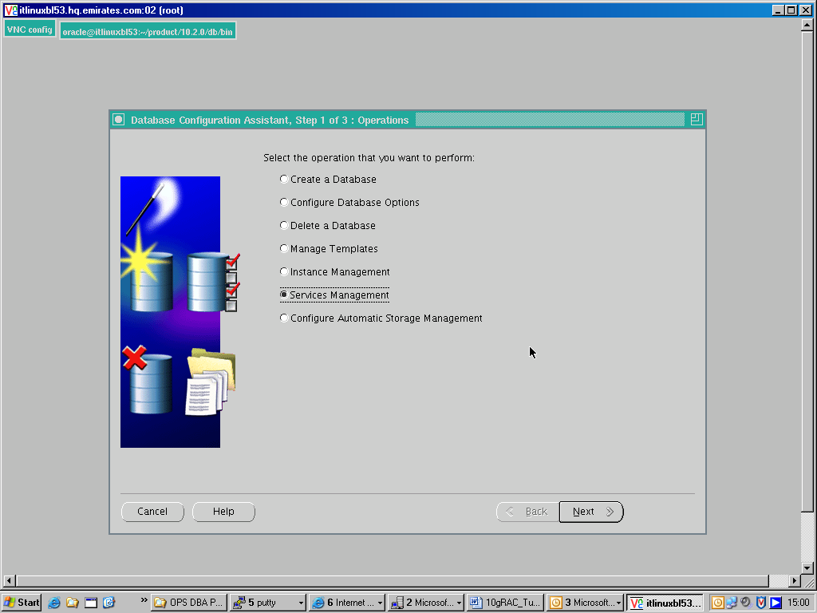

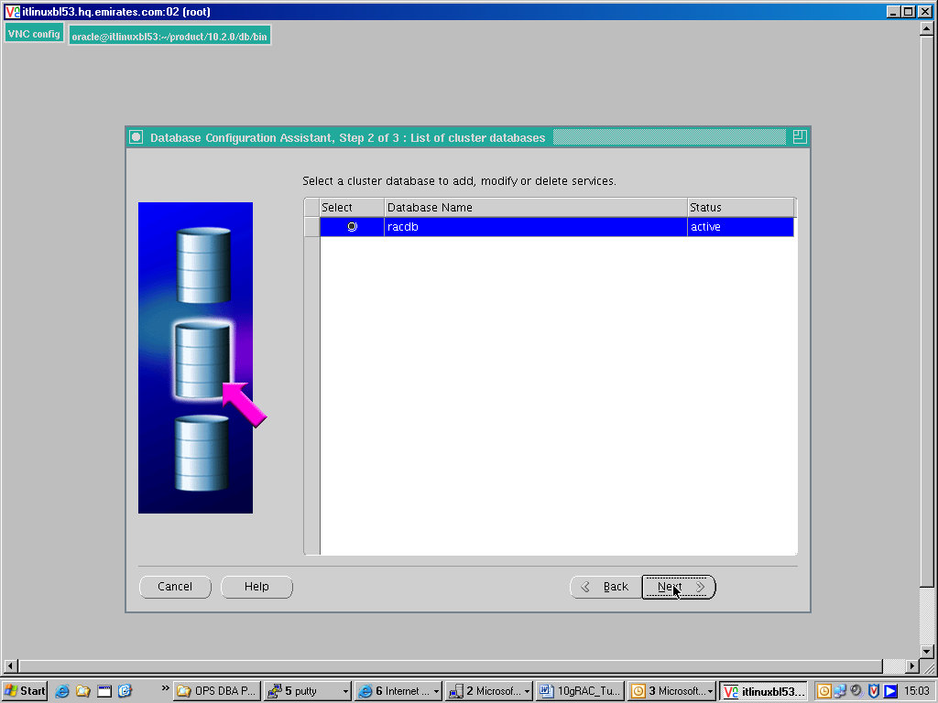

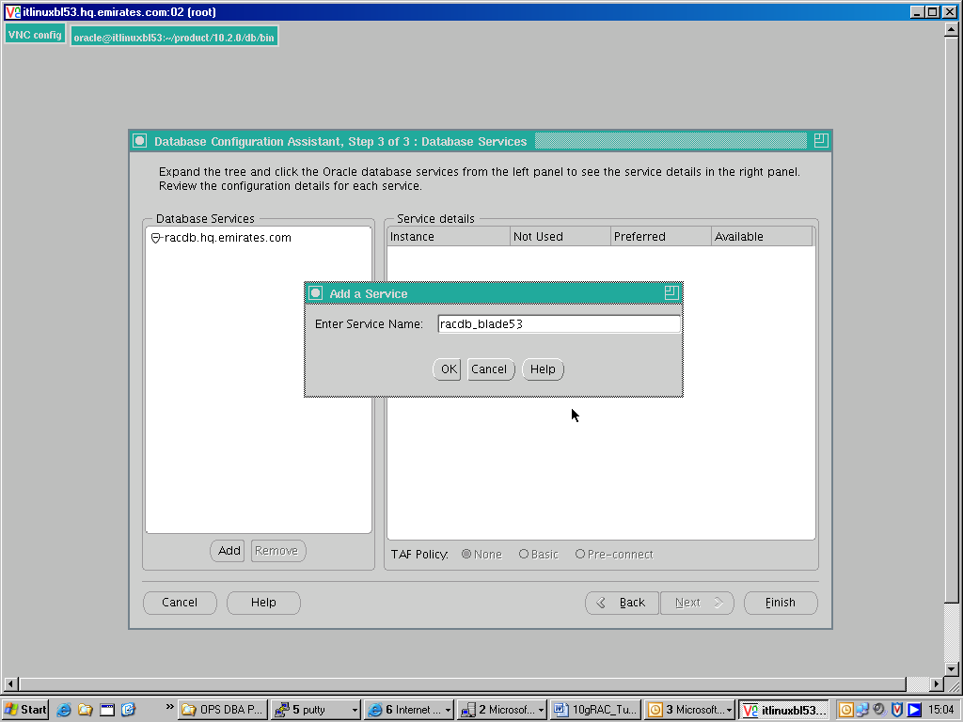
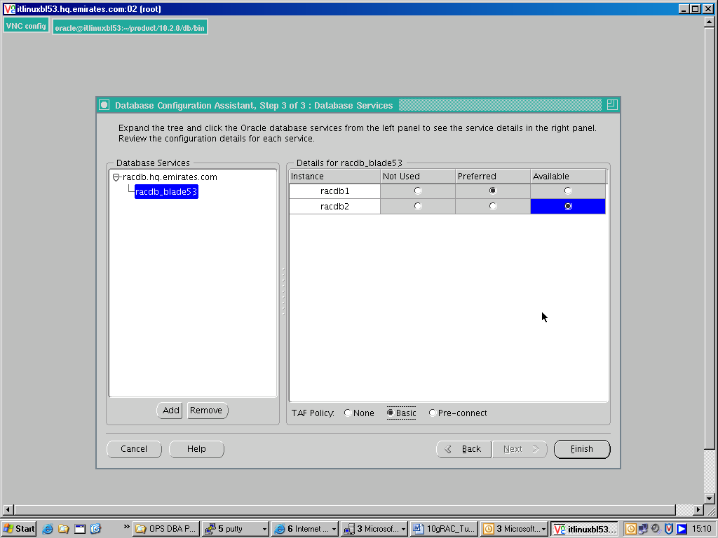
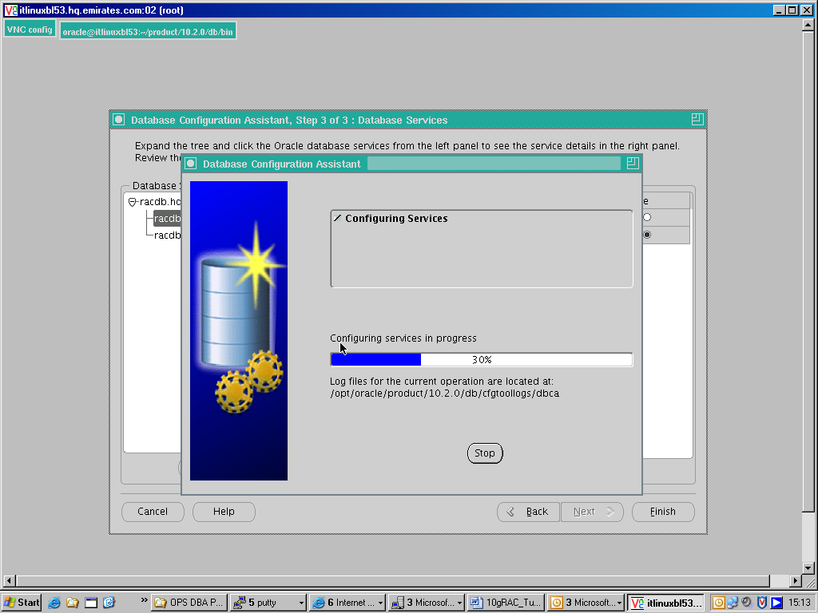

MANAGING SERVICES WITH SRVCTL

racdb2:/opt/oracle/product/10.2.0/db/bin>srvctl status asm -n itlinuxbl53
ASM instance +ASM1 is running on node itlinuxbl53.

racdb2:/opt/oracle/product/10.2.0/db/bin>srvctl status asm -n itlinuxbl54
ASM instance +ASM2 is running on node itlinuxbl54.

racdb2:/opt/oracle/product/10.2.0/db/bin>srvctl config database -d racdb
itlinuxbl53 racdb1 /opt/oracle/product/10.2.0/db
itlinuxbl54 racdb2 /opt/oracle/product/10.2.0/db

racdb2:/opt/oracle/product/10.2.0/db/bin>srvctl status database -d racdb
Instance racdb1 is not running on node itlinuxbl53
Instance racdb2 is not running on node itlinuxbl54

racdb2:/var/opt/oracle>srvctl start database -d racdb
racdb2:/var/opt/oracle>srvctl status database -d racdb
Instance racdb1 is running on node itlinuxbl53
Instance racdb2 is running on node itlinuxbl54

racdb2:/var/opt/oracle>srvctl config service -d racdb
racdb_blade53 PREF: racdb1 AVAIL: racdb2
racdb_blade54 PREF: racdb2 AVAIL: racdb1

racdb2:/var/opt/oracle>srvctl status service -d racdb -s racdb_blade53
Service racdb_blade53 is running on instance(s) racdb1

ENABLING FLASHBACK AND ARCHIVE LOGGING FOR A RAC DATABASE

- We need to first determine the location of the flashback logs as well as the size of the flashback area.

- In our case we will be using the ASM disk group +DG1 as the location for the flashback logs and we are allocating a size of 2GB for the Flash Recovery Area.

- When we are defining init.ora parameters that affect all the cluster instances as in this case, we can use the expression scope=both sid=’*’

- We will execute the following commands while connected to RAC instance racdb1

SQL> alter system set db_recovery_file_dest_size=2G scope=both sid='*';
System altered.
SQL> alter system set db_recovery_file_dest='+DG1' scope=both sid='*';
System altered.
SQL> alter system set log_archive_dest_1='location=USE_DB_RECOVERY_FILE_DEST' scope=both sid='*';
System altered.
SQL> shutdown immediate;
Database closed.
Database dismounted.
ORACLE instance shut down.
Note: At this stage the other RAC instance on ITLINUXBL54, racdb2 is also shut down
SQL> startup mount;
ORACLE instance started.

Total System Global Area 419430400 bytes
Fixed Size 2021216 bytes
Variable Size 247466144 bytes
Database Buffers 163577856 bytes
Redo Buffers 6365184 bytes
Database mounted.

SQL> alter database archivelog;

Database altered.

SQL> alter database open;

Database altered.

After the RAC instance racdb1 has been started on ITLINUXBL53, we now connect to the RAC instance racdb2
SQL> startup mount;

ORACLE instance started.

Total System Global Area 419430400 bytes
Fixed Size 2021216 bytes
Variable Size 226494624 bytes
Database Buffers 184549376 bytes
Redo Buffers 6365184 bytes
Database mounted.

SQL> alter database open;

Database altered.

SQL> archive log list
Database log mode Archive Mode
Automatic archival Enabled
Archive destination USE_DB_RECOVERY_FILE_DEST
Oldest online log sequence 15
Next log sequence to archive 16
Current log sequence 16

- Each RAC instance has its own thread of online redo log files and when we connect to the other RAC instance, racdb1, note that the current log sequence number differs from that of RAC instance racdb2.

- While the archive log files of each RAC instance can be stored in a location local to the specific node, we are storing the archive log files that are generated from both RAC instances in a common shared location (the ASM Disk Group +DG1).

- Since we have already designated the Flash Recovery Area to reside on the ASM disk group +DG1, we will specify the location for the parameter log_archive_dest_1 as USE_DB_RECOVERY_FILE_DEST

- In performing a recovery, Oracle will need access to the archive log files generated by each individual RAC instance that is part of the cluster.

We are now connected to the RAC instance racdb1 – note that the current log sequence here is 18 while in RAC instance racdb2, the current log sequence is 16.

SQL> archive log list
Database log mode Archive Mode
Automatic archival Enabled
Archive destination USE_DB_RECOVERY_FILE_DEST
Oldest online log sequence 17
Next log sequence to archive 18
Current log sequence 18

SQL> select * from v$log;

GROUP# THREAD# SEQUENCE# STATUS
---------- ---------- ---------- ----------------
1 1 18 CURRENT
2 1 17 INACTIVE
3 2 15 INACTIVE
4 2 16 CURRENT

TRANSPARENT APPLICATION FAILOVER (TAF)

- We have defined a service called racdb_blade53 which we will be using to demonstrate the TAF capability of RAC.

- This service has been defined with the Preferred node ITLINUXBL53 and the Available node IT:INUXBL54.

- We will initially connect to RAC instance racdb1 as this is the preferred node for the service.

- We will then simulate a failure by crashing the instance racdb1 and observing how the client connection gets seamlessly transferred to the other available node that has been defined for the service which is in this case ITLINUXBL54.

- Note the tnsnames.ora entry for the service racdb_blade53 and the fact that the hostnames by been defined by the Virtual IP’s and not the actual hostnames

RACDB_BLADE53 =
(DESCRIPTION =
(ADDRESS = (PROTOCOL = TCP)(HOST = itlinuxbl53-vip)(PORT = 1521))
(ADDRESS = (PROTOCOL = TCP)(HOST = itlinuxbl54-vip)(PORT = 1521))
(LOAD_BALANCE = yes)
(CONNECT_DATA =
(SERVER = DEDICATED)
(SERVICE_NAME = racdb_blade53.hq.emirates.com)
(FAILOVER_MODE =
(TYPE = SELECT)
(METHOD = BASIC)
(RETRIES = 180)
(DELAY = 5)
)
)
)

- Establish a client connection using the service racdb_blade53

- Note: we are connected to instance racdb1 on node ITLINUXBL54

racdb1:/opt/oracle/product/10.2.0/db/network/admin>sqlplus system/oracle@racdb_blade53

SQL*Plus: Release 10.2.0.1.0 - Production on Mon Feb 5 09:56:09 2007

Copyright (c) 1982, 2005, Oracle. All rights reserved.

Connected to:
Oracle Database 10g Enterprise Edition Release 10.2.0.1.0 - 64bit Production
With the Partitioning, Real Application Clusters, OLAP and Data Mining options

SQL> select host_name from v$instance;

HOST_NAME
----------------------------------------------------------------
itlinuxbl53.hq.emirates.com

- From another session we will simulate a failure by crashing the instance

- We will kill both the pmon as well as the smon background processes

#/opt/oracle>ps -ef | egrep "pmon|smon"
oracle 25672 1 0 Feb01 ? 00:00:47 asm_pmon_+ASM1
oracle 25694 1 0 Feb01 ? 00:00:11 asm_smon_+ASM1
oracle 23349 1 0 09:14 ? 00:00:01 ora_pmon_racdb1
oracle 23376 1 0 09:14 ? 00:00:00 ora_smon_racdb1
oracle 27803 26853 0 09:58 pts/4 00:00:00 egrep pmon|smon

#/opt/oracle>kill -9 23349 23376

- We will run the same command that we earlier executed and note that now the service racdb_blade53 has been transferred over to the other node in the cluster which is ITLINUXBL54

SQL> select host_name from v$instance;

HOST_NAME
----------------------------------------------------------------
itlinuxbl54.hq.emirates.com

