Using Oracle Internet Directory (OID) and LDAP instead of client tnsnames.ora

The following example will illustrate how we use the Oracle 10g Application Server Internet Directory LDAP server for storing SQL*Net information. Clients will then connect using information stored in OID and not use the local network configuration file tnsnames.ora.

Oracle Internet Directory Server – NBRBWAS11
Client – UATU009

Steps:

Launch the GUI tool Network Manager on the server where the OID resides

iasdbdev-INFRA-nbrbwas11>export DISPLAY=10.254.101.180:0.0

iasdbdev-INFRA-nbrbwas11>netmgr

Click on Directory > Service Naming

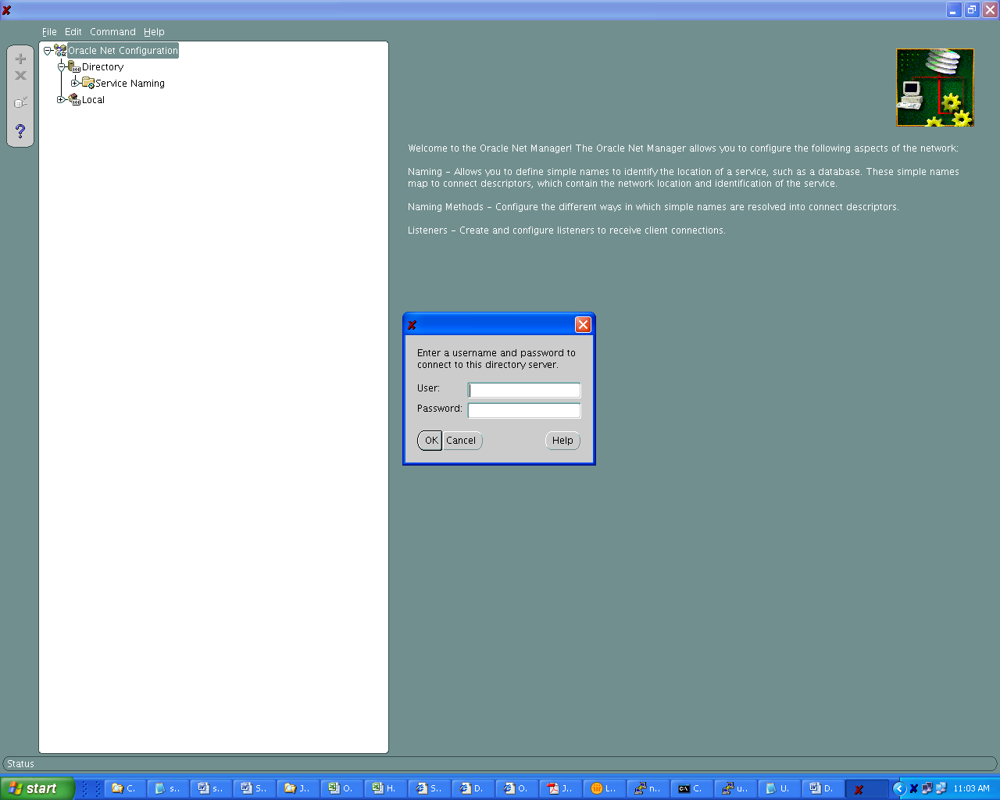

Enter the credentials for the Oracle 10g iAS admin user ‘orcladmin’

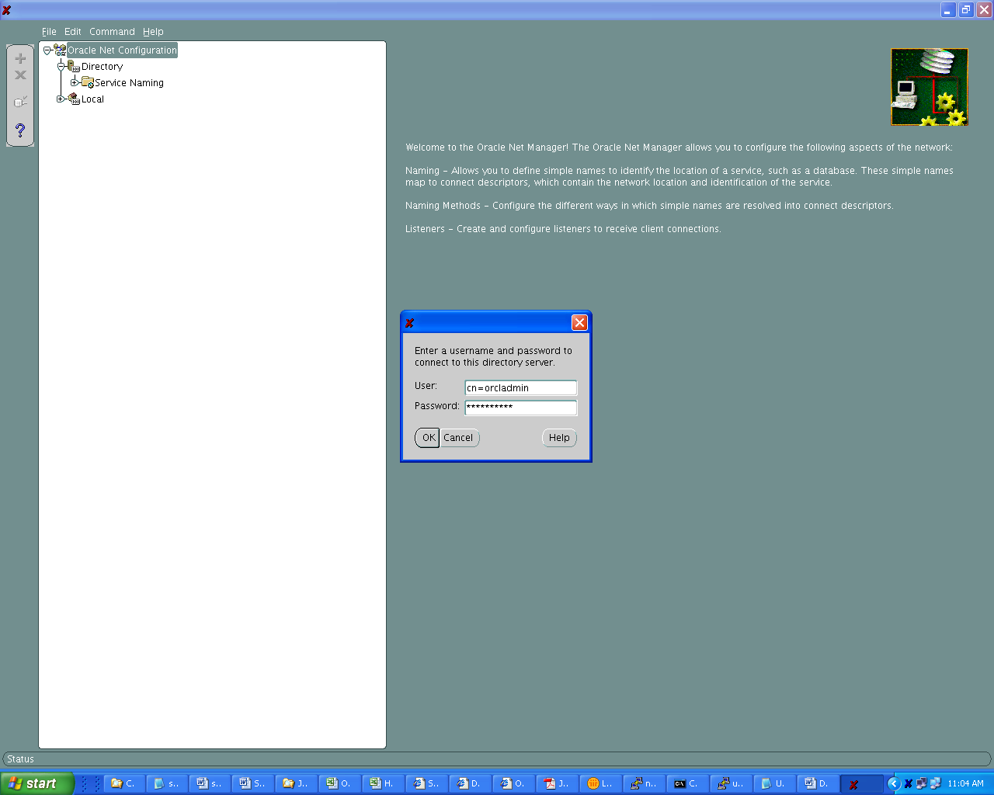

Click on Directory >> Service Naming >> Aliases and create a new alias.

We will call this alias ‘testoid’ – this will connect to the Oracle 10g instance streams on the server uatu009.bankwest.com. The service name of this instance is streams.bankwest.com and the listener port is 1521.

The following screen shots will demonstrate how we create an alias in the OID with the required SQL*Net configuration details.

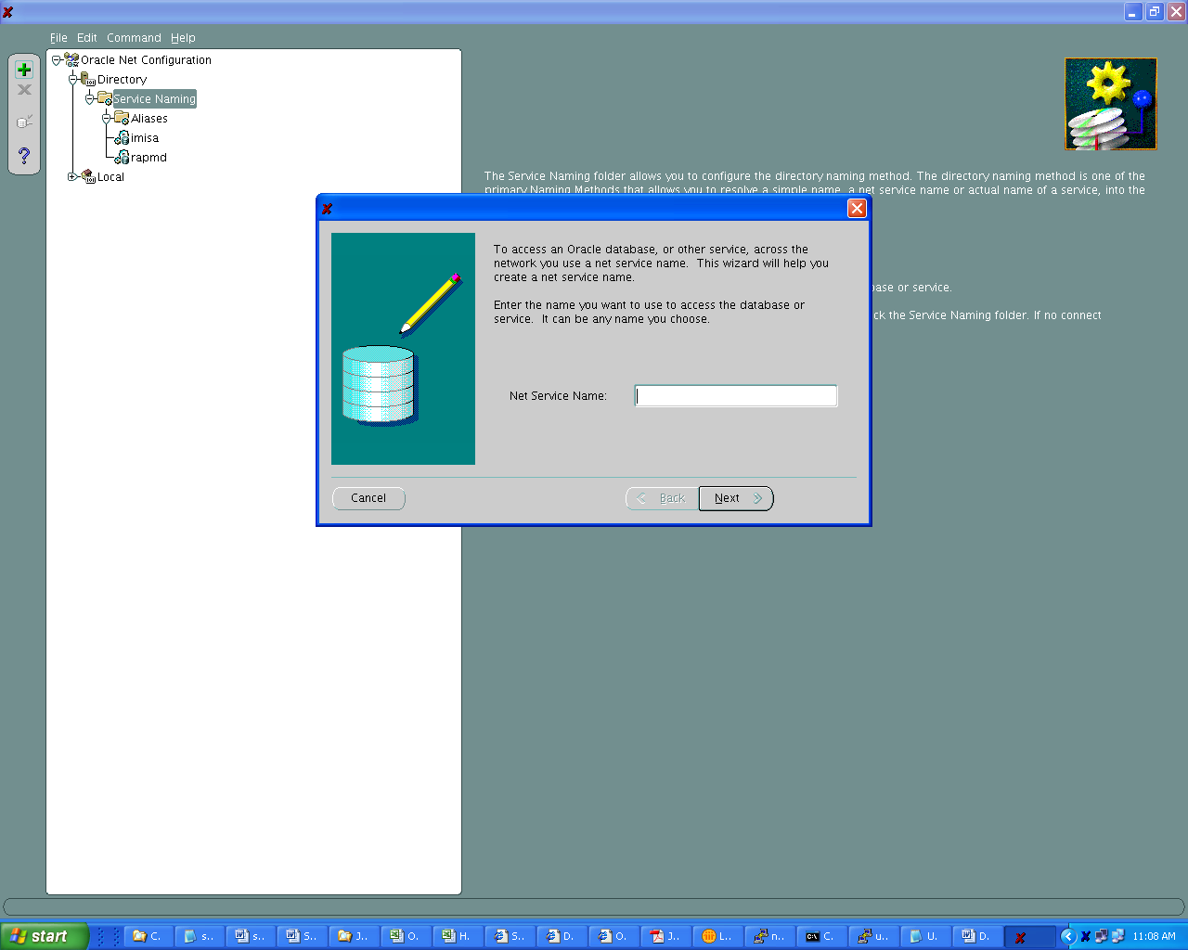

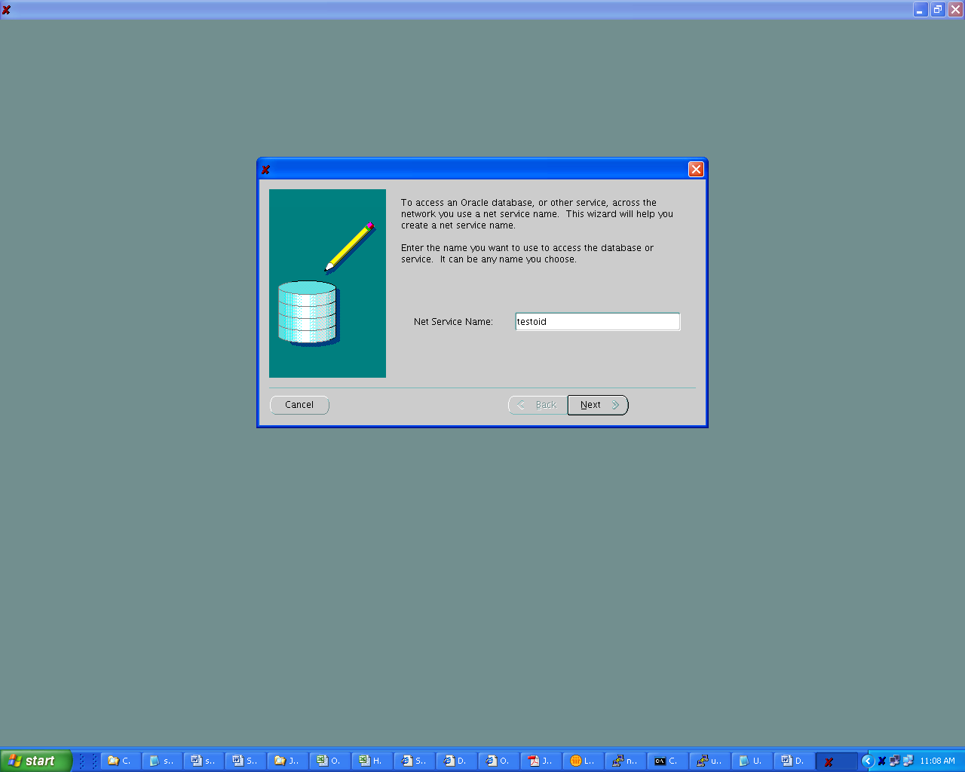

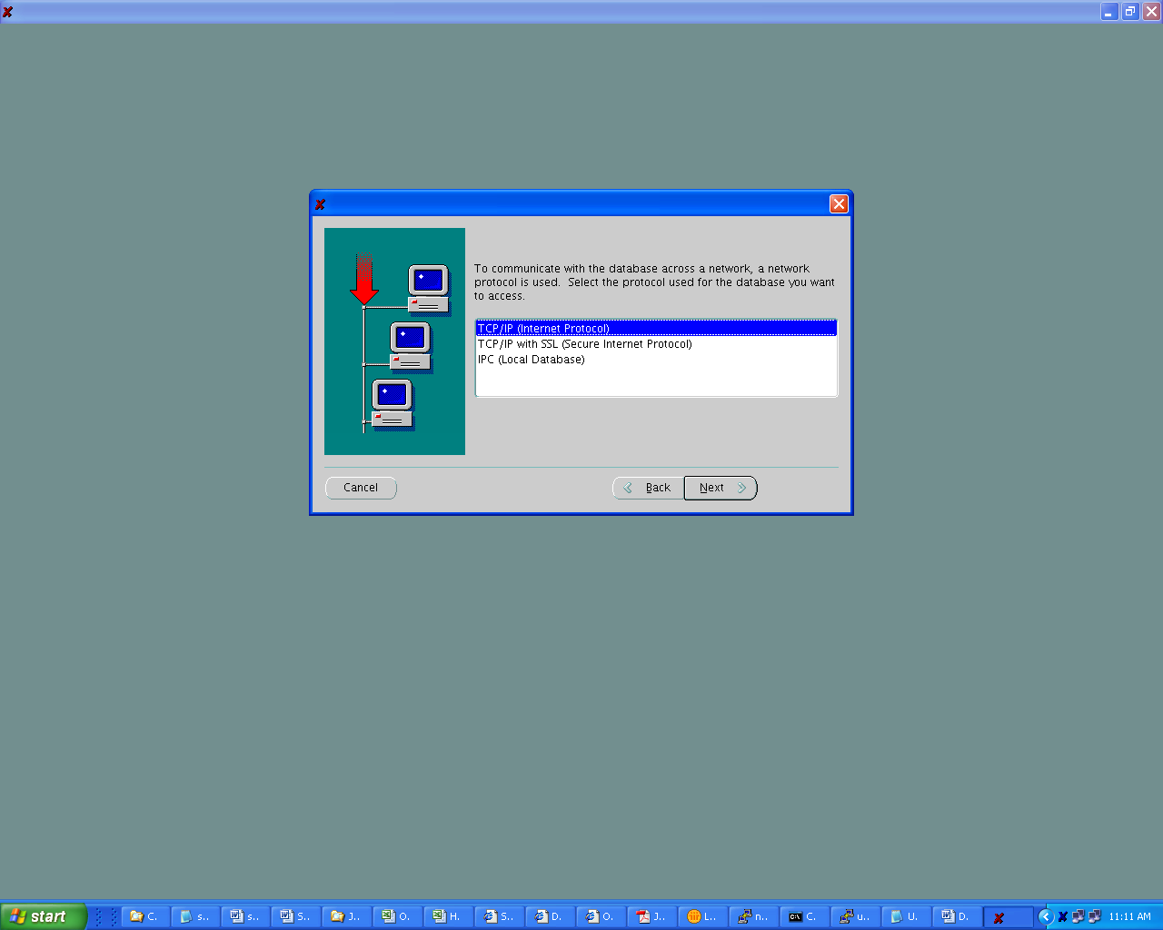

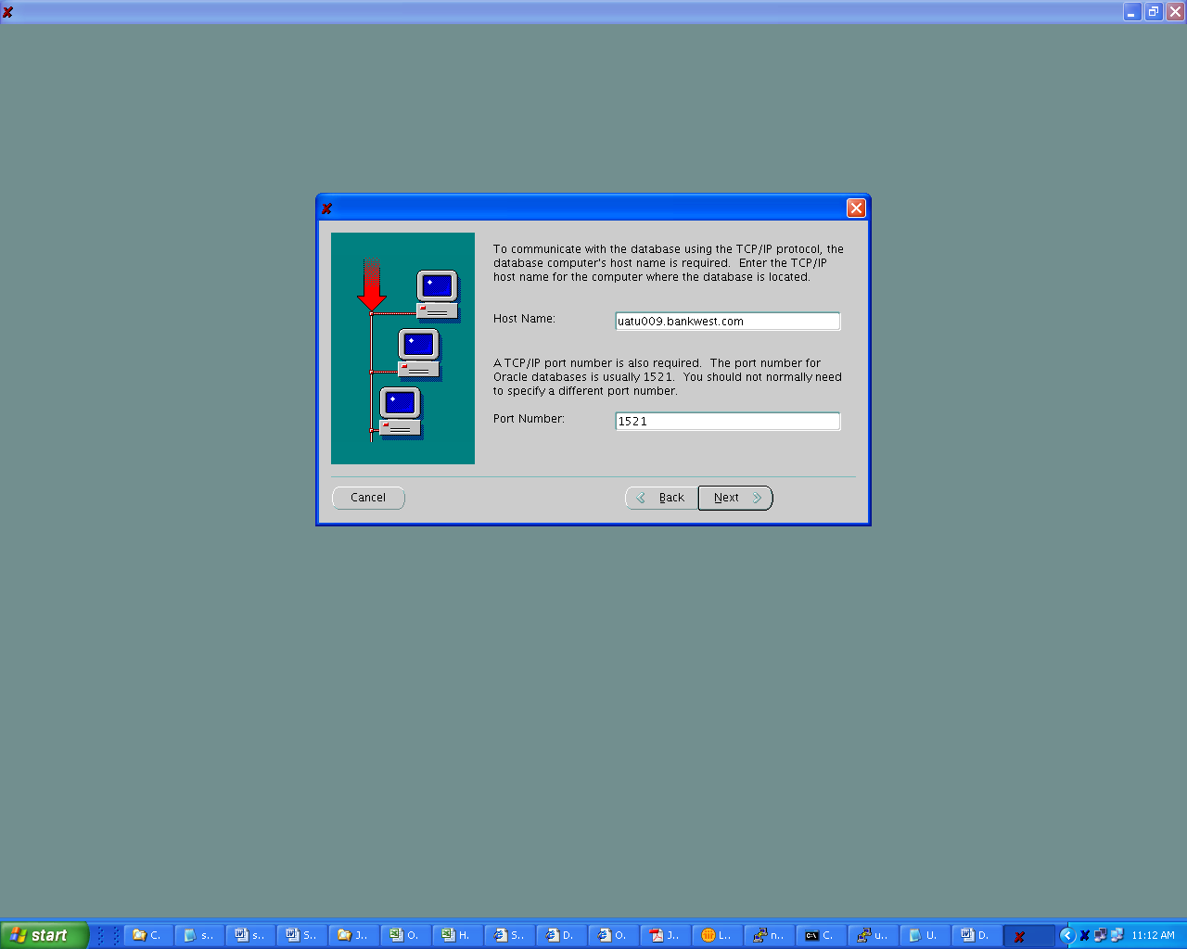

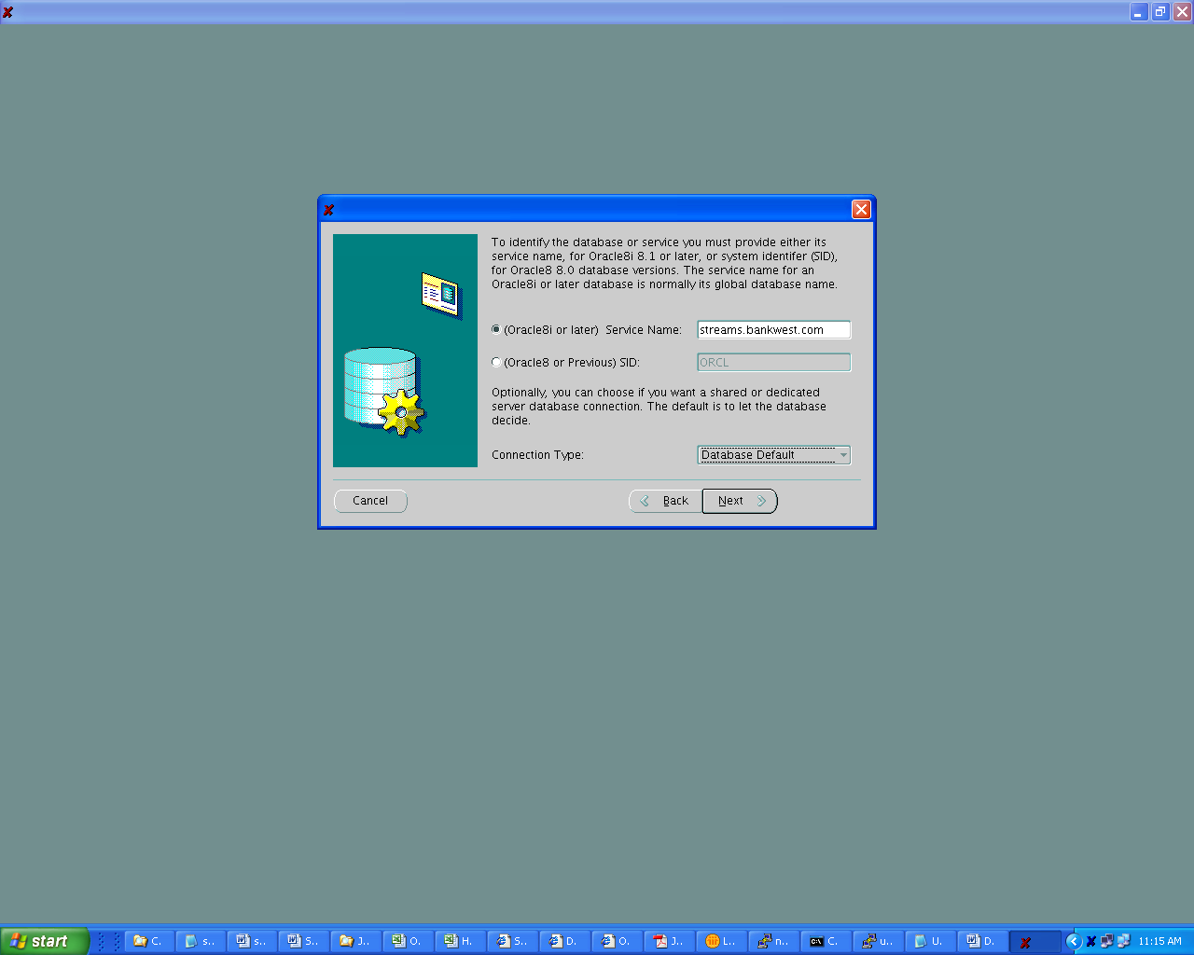

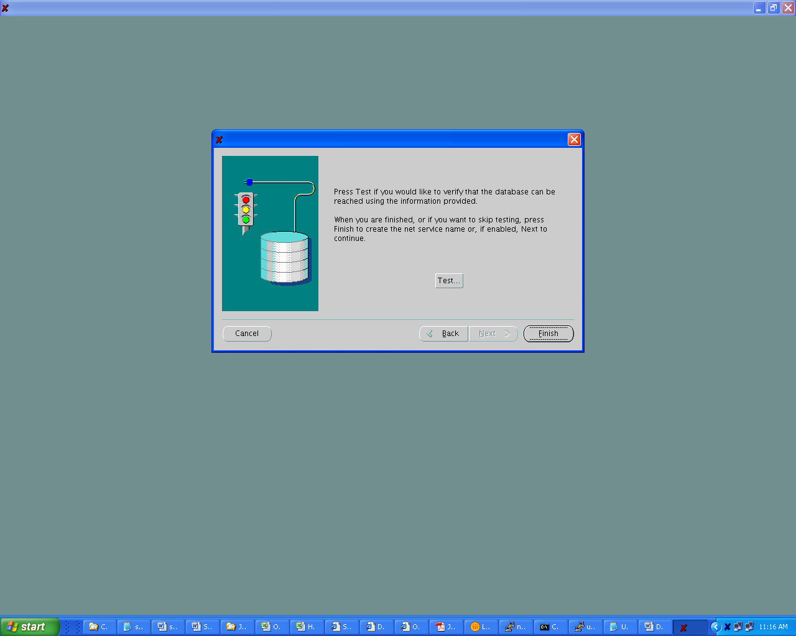
It will try to connect by default using the login credentials “Scott/Tiger” – it will fail as this user does not exist in the target database. We will provide valid login credentials “Strmadmin/Strmadmin” and test the same, which is successful

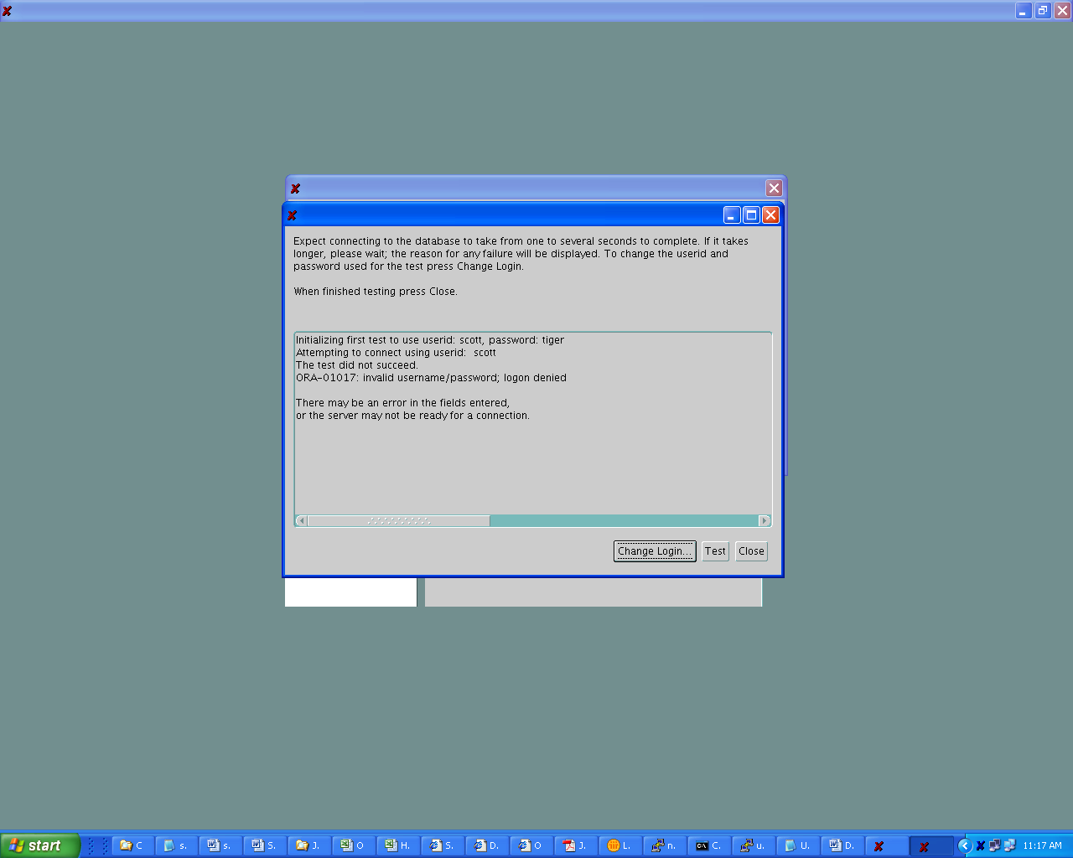

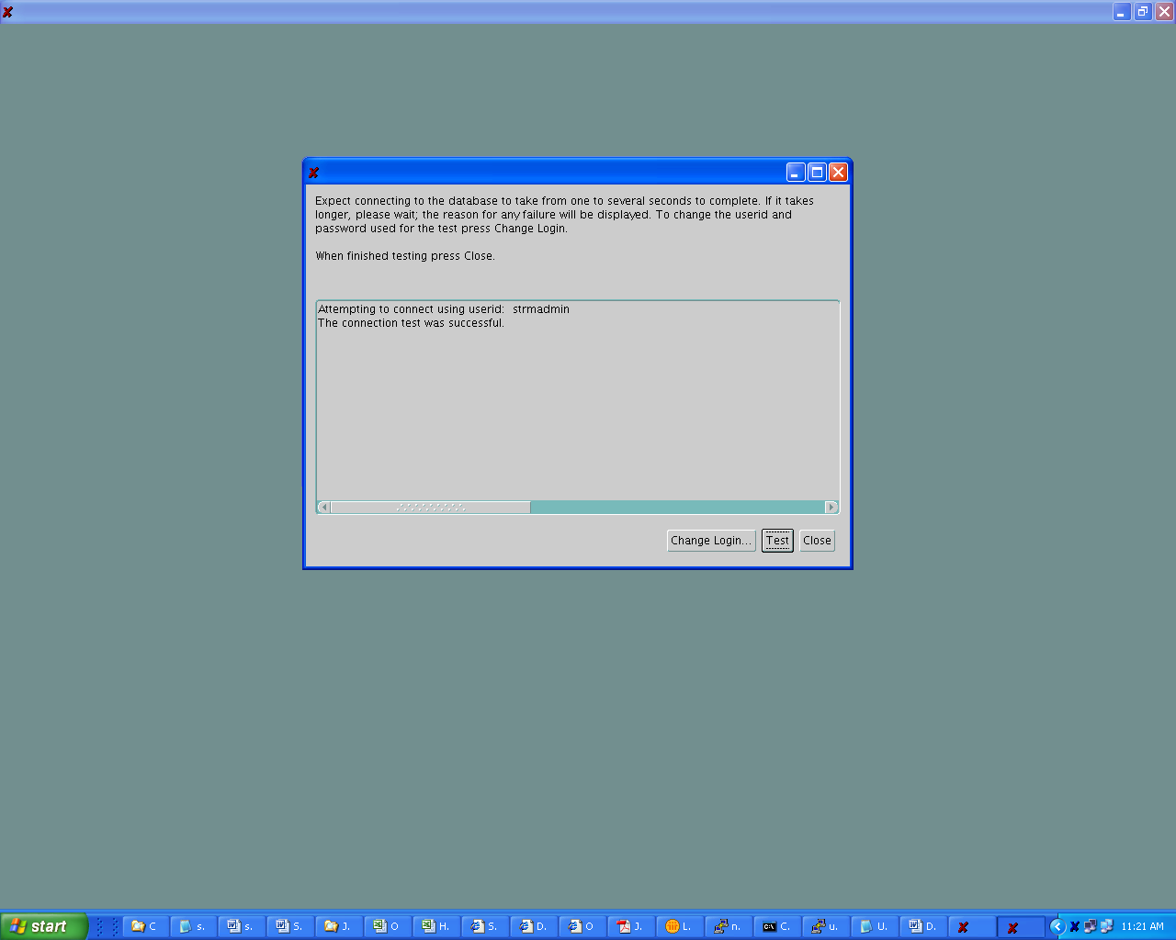

After the alias testoid is created, note that it now been added to the “Aliases” in the OID

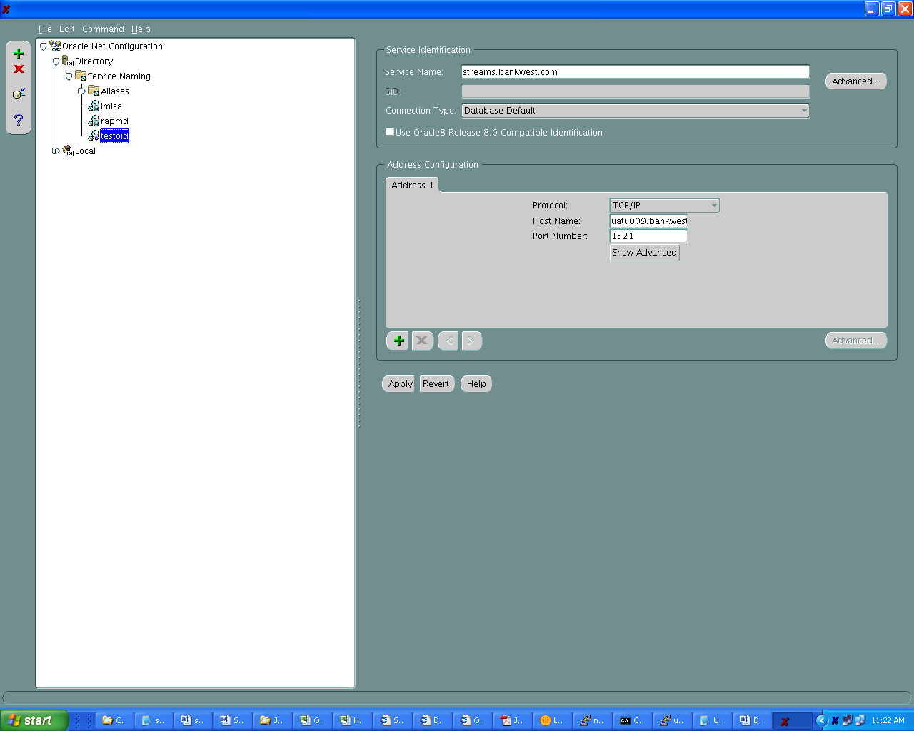

We need to configure two network files – ldap.ora and sqlnet.ora as shown below

On the server uatu009.bankwest.com create the file ldap.ora in the $ORACLE_HOME/network/admin directory location.

This file has information of the server where the LDAP directory resides along with the port numbers for normal and secure connections

DEFAULT_ADMIN_CONTEXT = "dc=bankwest,dc=com"
DIRECTORY_SERVERS = (nbrbwas11.bankwest.com:389:636)
DIRECTORY_SERVER_TYPE = OID

The sqlnet.ora file in the $ORACLE_HOME/network/admin directory location needs to have the following line:

NAMES.DIRECTORY_PATH= (LDAP,TNSNAMES)

This means that all connections will be attempted first by connecting to the LDAP server to obtain SQL*Net information and if no information is available in the OID LDAP directory, it will use the local tnsnames.ora file to resolve SQL*Net connections.

We will now simulate a connection to the alias TESTOID ensuring that the SQL*Net connection details are now obtained from the OID LDAP directory and not using information stored in the local tnsnames.ora file.

Note: the output of the tnsping command shows that the LDAP directory was accessed to resolve the alias

uatu009 $ mv tnsnames.ora tnsnames.ora.bak

uatu009 $ tnsping testoid

TNS Ping Utility for IBM/AIX RISC System/6000: Version 10.2.0.3.0 - Production on 25-JUN-2008 11:30:30

Copyright (c) 1997, 2006, Oracle. All rights reserved.

Used parameter files:
/u01/oracle/product/10.2/db_1/network/admin/sqlnet.ora

Used LDAP adapter to resolve the alias
Attempting to contact (DESCRIPTION=(ADDRESS_LIST=(ADDRESS=(PROTOCOL=TCP)(HOST=uatu009.bankwest.com)(PORT=1521)))(CONNECT_DATA=(SERVICE_NAME=streams.bankwest.com)))
OK (0 msec)

Test a SQL*PLUS connection – note that the alias “testoid” connects to the database “Streams”

uatu009 $ sqlplus strmadmin/strmadmin@testoid

SQL*Plus: Release 10.2.0.3.0 - Production on Wed Jun 25 11:31:02 2008

Copyright (c) 1982, 2006, Oracle. All Rights Reserved.

Connected to:
Oracle Database 10g Enterprise Edition Release 10.2.0.3.0 - 64bit Production
With the Partitioning and Data Mining options

SQL> select name from v$database;

NAME
---------
STREAMS

Now we will perform a test using both the LDAP as well as tnsnames.ora to resolve SQL*Net connections.

We will see that since information for the alias ‘streams.bankwest.com’ is not available in the OID, the tnsnames file is used, while the LDAP directory is used to resolve the alias ‘testoid’

uatu009 $ mv tnsnames.ora.bak tnsnames.ora

uatu009 $ tnsping streams.bankwest.com

TNS Ping Utility for IBM/AIX RISC System/6000: Version 10.2.0.3.0 - Production on 25-JUN-2008 11:32:57

Copyright (c) 1997, 2006, Oracle. All rights reserved.

Used parameter files:
/u01/oracle/product/10.2/db_1/network/admin/sqlnet.ora

Used TNSNAMES adapter to resolve the alias
Attempting to contact (DESCRIPTION = (ADDRESS = (PROTOCOL = TCP)(HOST = uatu009.bankwest.com)(PORT = 1521)) (CONNECT_DATA = (SERVER = DEDICATED) (SERVICE_NAME = streams.bankwest.com)))
OK (0 msec)

uatu009 $ tnsping testoid

TNS Ping Utility for IBM/AIX RISC System/6000: Version 10.2.0.3.0 - Production on 25-JUN-2008 11:33:18

Copyright (c) 1997, 2006, Oracle. All rights reserved.

Used parameter files:
/u01/oracle/product/10.2/db_1/network/admin/sqlnet.ora

Used LDAP adapter to resolve the alias
Attempting to contact (DESCRIPTION=(ADDRESS_LIST=(ADDRESS=(PROTOCOL=TCP)(HOST=uatu009.bankwest.com)(PORT=1521)))(CONNECT_DATA=(SERVICE_NAME=streams.bankwest.com)))
OK (10 msec)

