**Name:** Dnyaneshwari Shivaji Hulage

**Email ID:** hulagednyaneshwari@gmail.com

**Topic Name: Windows Tools for Debugging**

**1. Process Explorer**

* **What it does**: An advanced version of Task Manager; shows detailed info about all running programs and processes.
* **Why it's useful**: Helps you find which program is using a file or using too much memory or CPU.

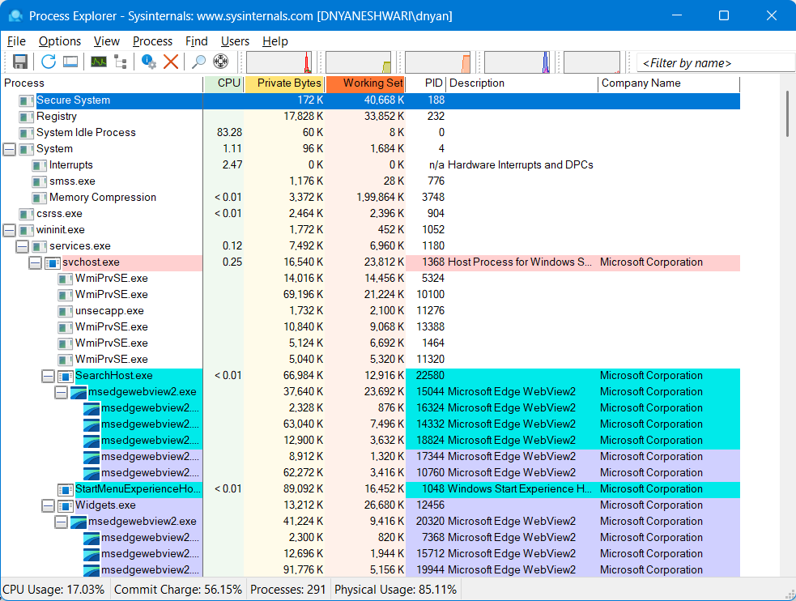  
  
**2. Autologon**

* **What it does**: Automatically logs in a user to Windows without asking for a password.
* **Why it's useful**: Helpful in kiosk setups or testing environments where manual login isn't needed.

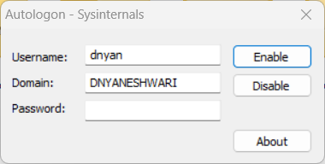 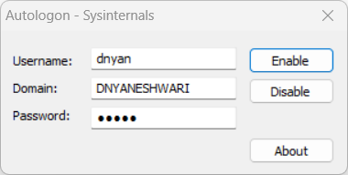

**3. Process Monitor (ProcMon)**

* **What it does:** Monitors and logs real-time file system, registry, and process/thread activity on Windows.
* **Why it's useful:** Helps troubleshoot application errors, detect malware behaviour, and understand which files/registry keys a program accesses.

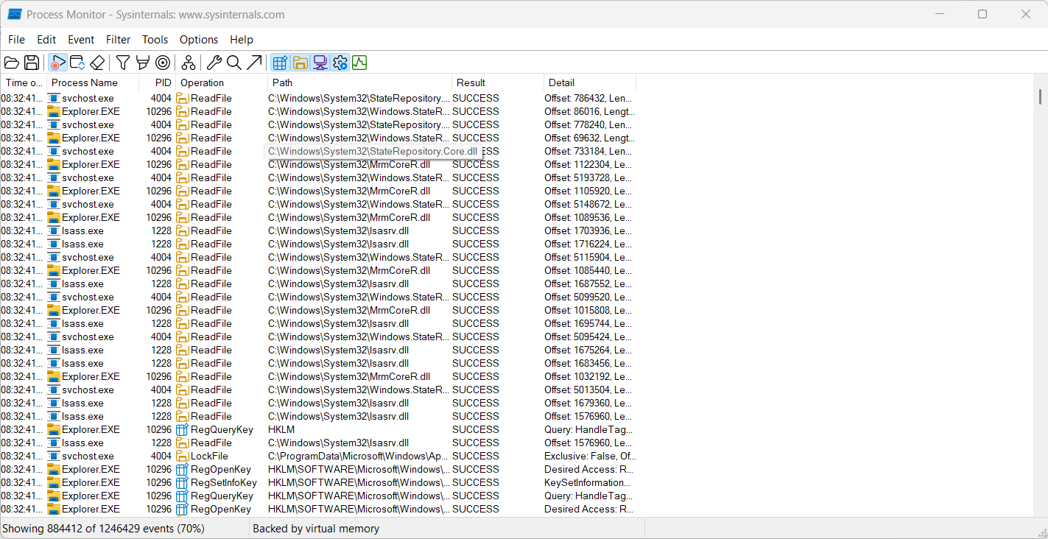

**4. Whois**

* **What it does**: Gives details about who owns a website or IP address.
* **Why it's useful**: Helps track down domain ownership or IP address information for security purposes.

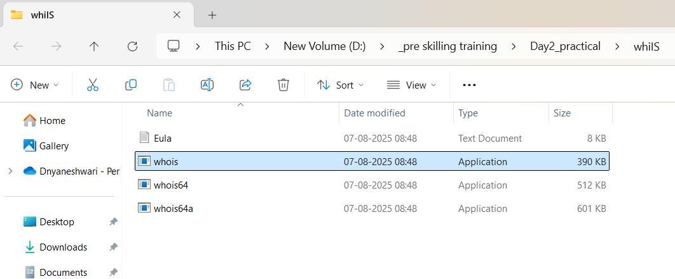

**5. SysMon (System Monitor)**

* **What it does**: Monitors and logs system activity like process creation, network connections, etc.
* **Why it's useful**: Excellent tool for tracking suspicious behavior or malware on a system.

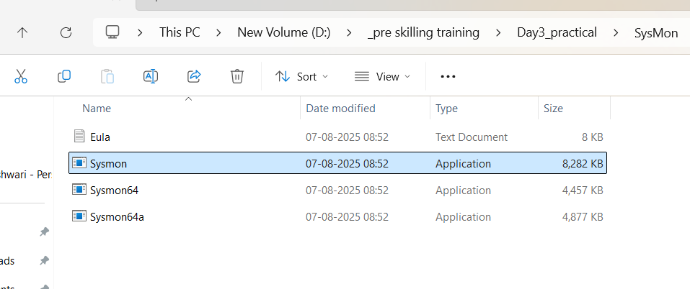

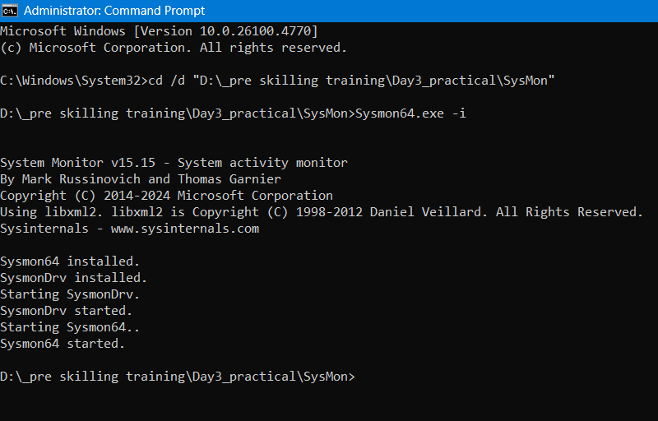

**6. PSTools**

* **What it does**: A collection of command-line tools including PsExec and others to manage systems.
* **Why it's useful**: Helps in performing remote operations like viewing processes, rebooting systems, etc.

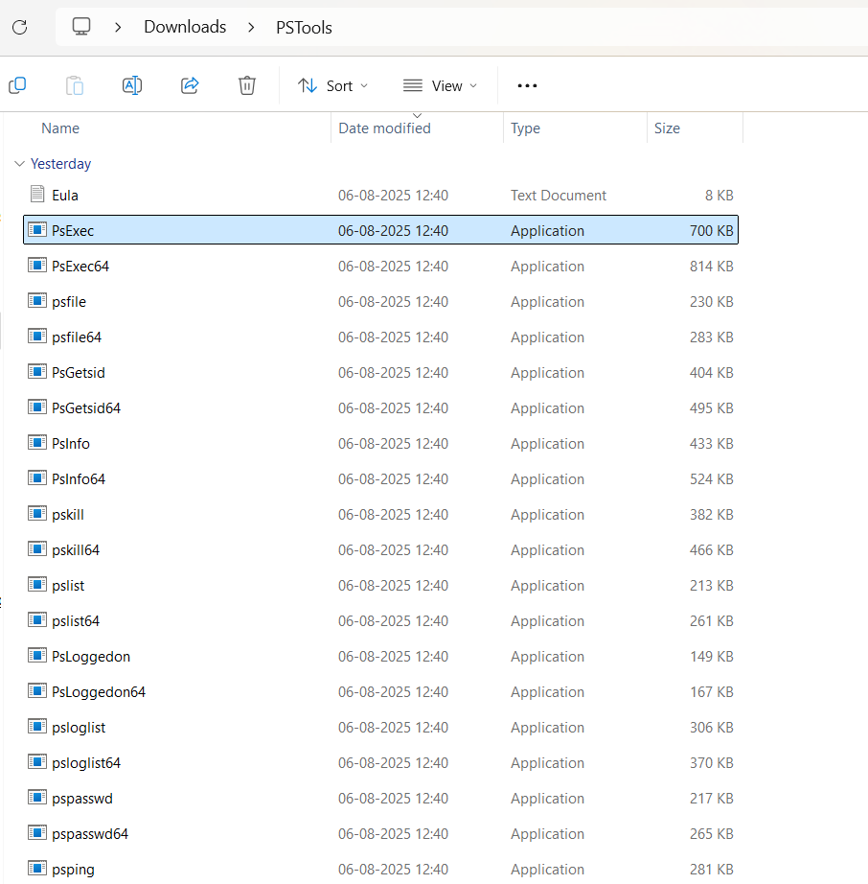

**7. LogonSessions**

* **What it does**: Shows you who is logged into the computer and when.
* **Why it's useful**: Helps track active and past user sessions on a system — useful for security and auditing.

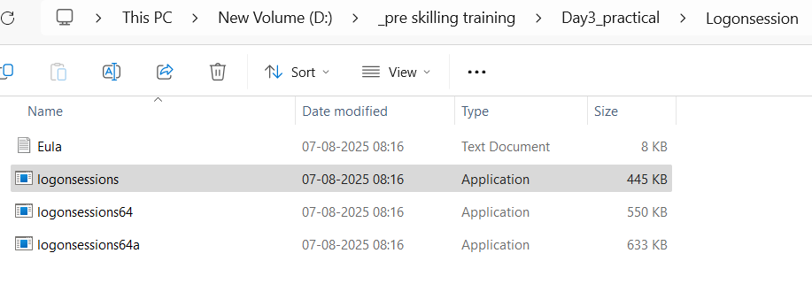

**On remote PC**

