PFP - Labwork 01

Q1 (2.5 marks). Set up the Visual Studio Code environment:
- Install the Visual Studio Code: https://code.visualstudio.com/ (Click Download for Windows).
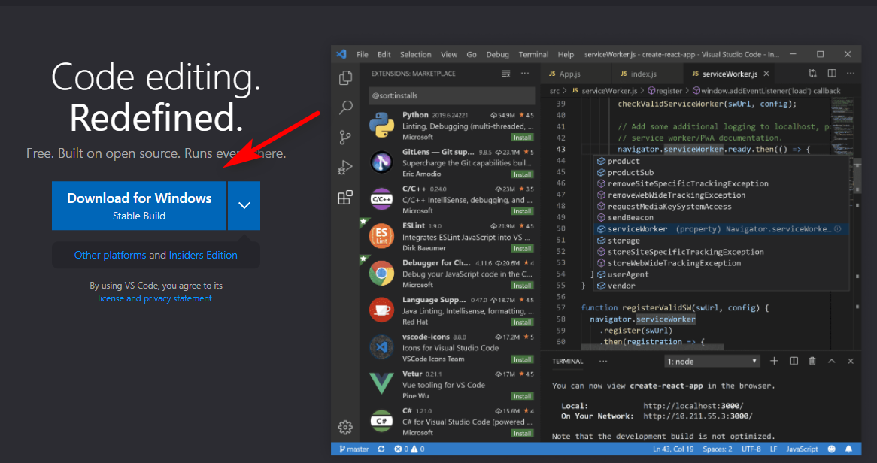
- Install the Python extension for VS Code from the Visual Studio Marketplace. For additional details on installing extensions, see Extension Marketplace. The Python extension is named Python, and Microsoft publishes it. (https://marketplace.visualstudio.com/items?itemName=ms-python.python).
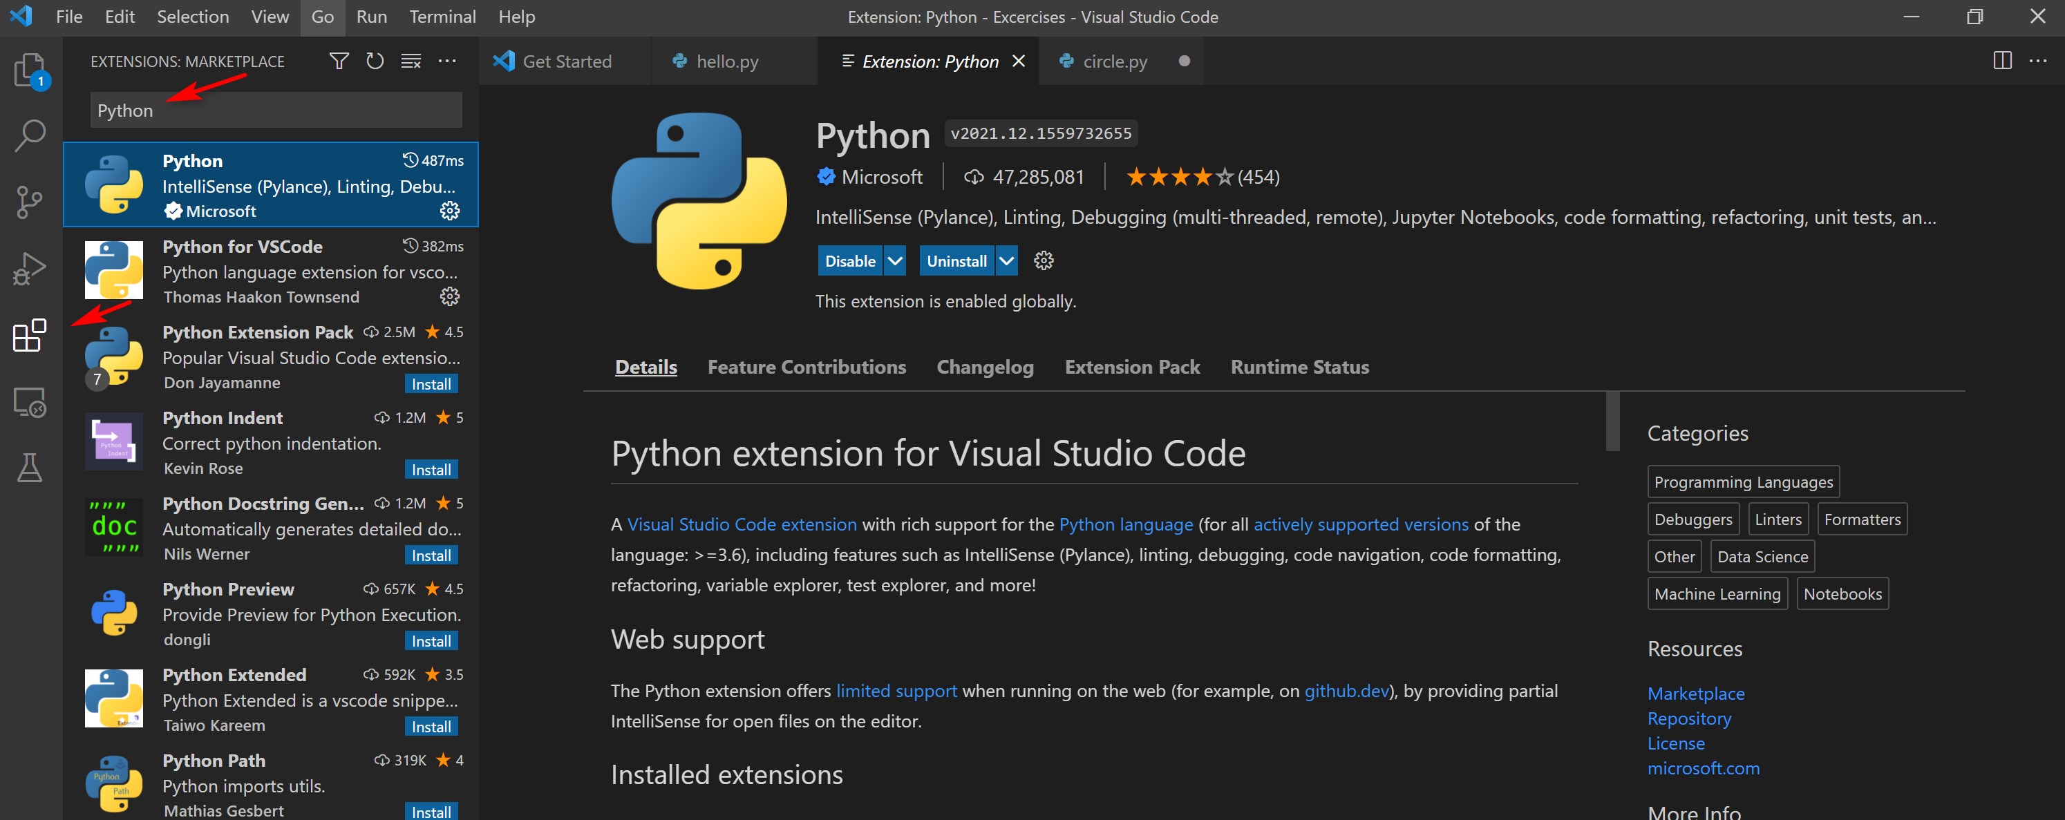
- Install a Python interpreter. (https://www.python.org/downloads/).
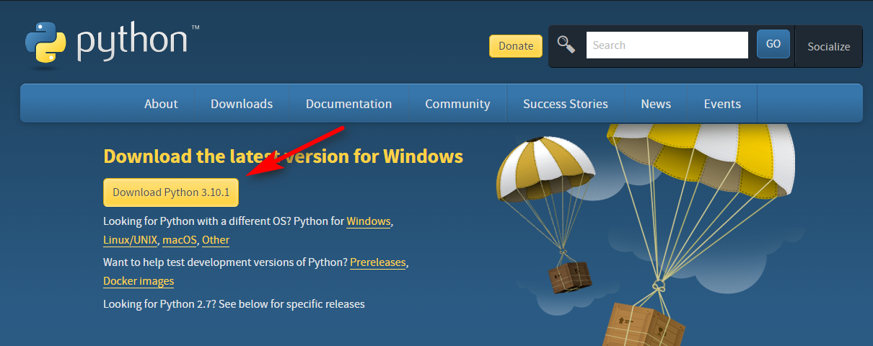
- Verify the Python installation. (py -3 –version)
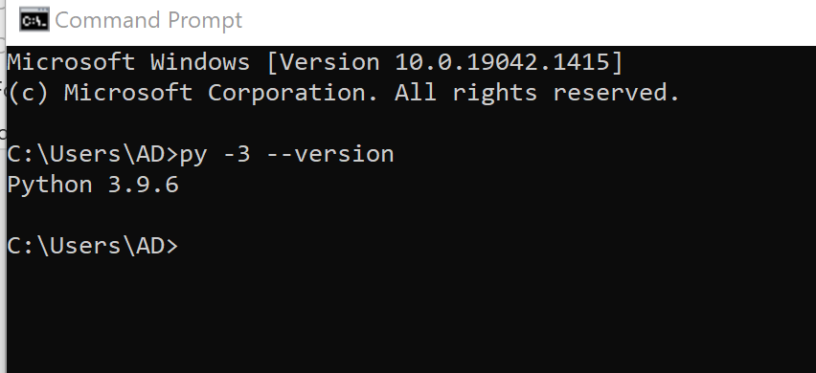
- Start VS Code in a project (workspace) folder.
- Create by Explorer
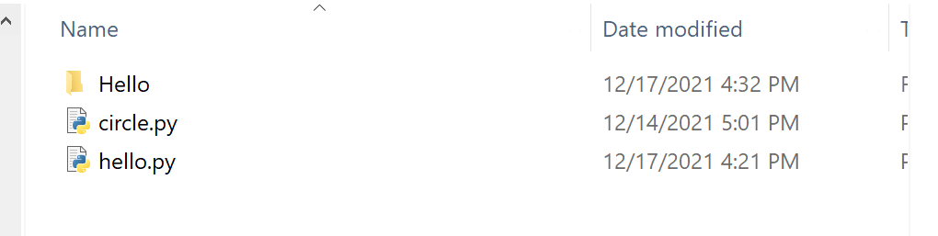
- Create by command line
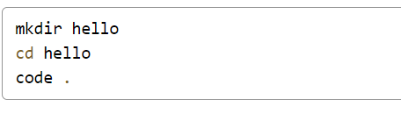
- Select a Python interpreter.
- Click “View” -> “Command Pallete…” or press “Ctrl + Shift + P”
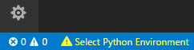
- Type Python: Select Interpreter
- Select command
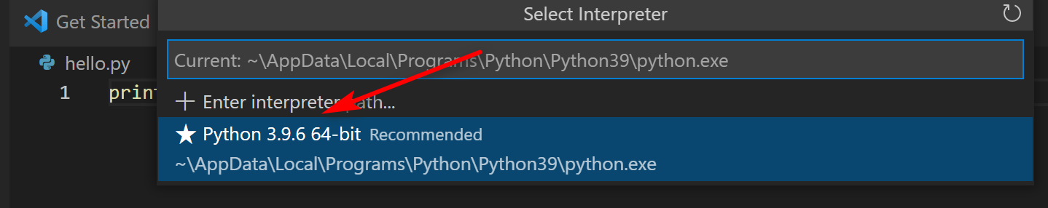

- Create a Python Hello World source code file.
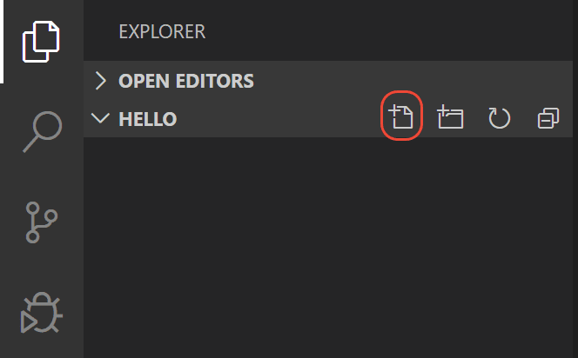

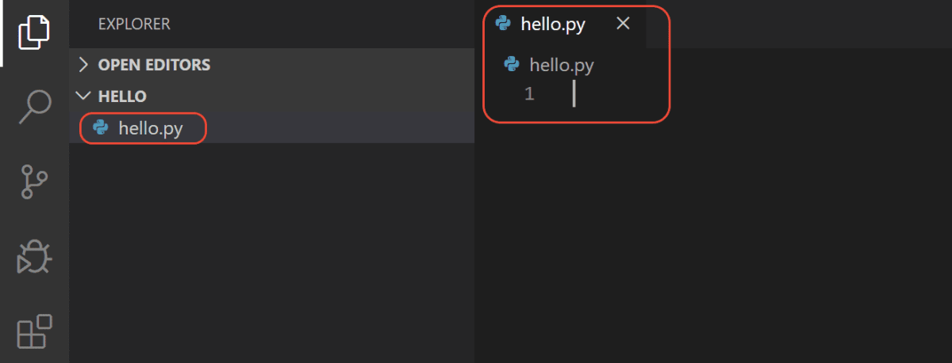
- Run Hello World.
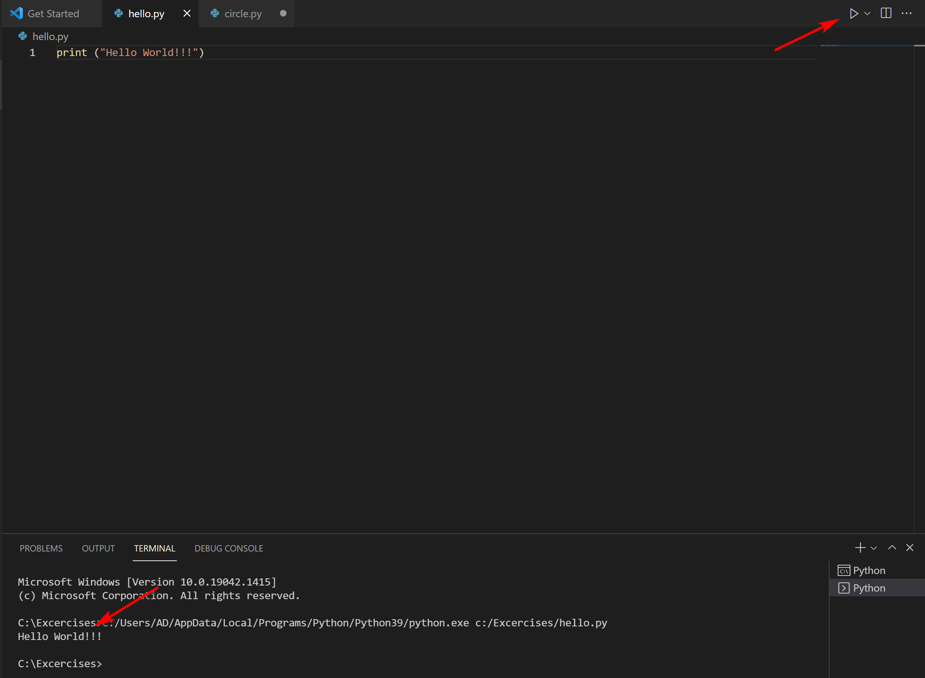
There are three ways to run a python file in VSS:
- Right-click anywhere in the editor window and select Run Python File in Terminal (which saves the file automatically)
- Select one or more lines, then press Shift+Enter or right-click and select Run Selection/Line in Python Terminal. This command is convenient for testing just a part of a file.
- From the Command Palette (Ctrl+Shift+P), select the Python: Start REPL command to open a REPL terminal for the currently selected Python interpreter. In the REPL, you can then enter and run lines of code one at a time.

Reference: https://code.visualstudio.com/docs/python/python-tutorial

Q2 (2.5 marks). Set up the Google Colab:
There are two ways to run a Python program in the Google Colab. The first way you can copy your source codes to the code cell in the colab page and click run.
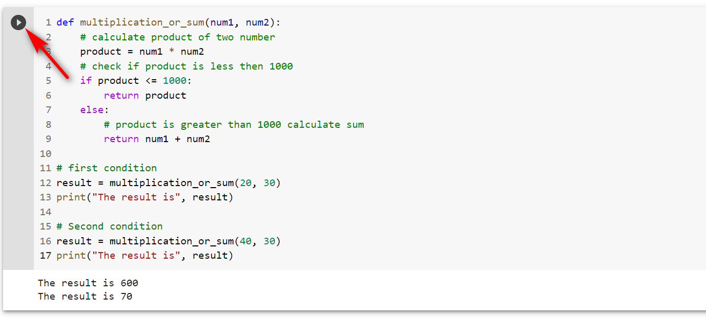
The second way, you can create a .py file in your local disk and then mount your file to the Google Colab following the guideline below:
- Enter the Google Colab: https://colab.research.google.com/notebooks/welcome.ipynb?hl=in

- Mounting drive
- Click “Tool” -> “Command Pallette” or “Ctrl + Shift + P”
- Type “m” and select “Mount Drive”
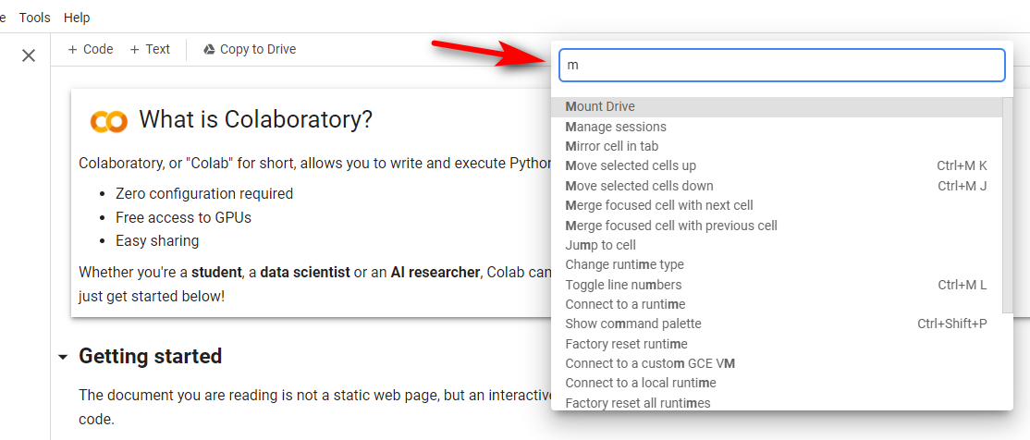
- Click Run cell to mount the drive
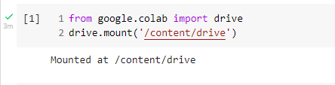
- Listing drive content
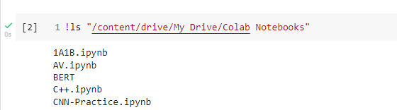
- Create a hello.py file on your local disk.
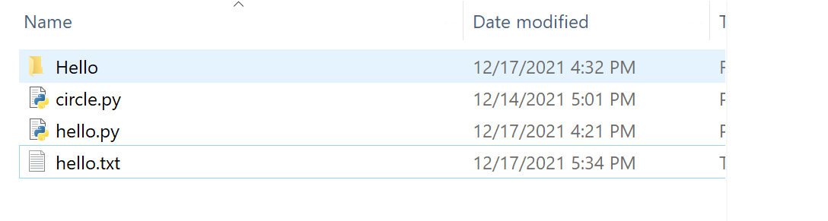
- Upload the file on the drive.
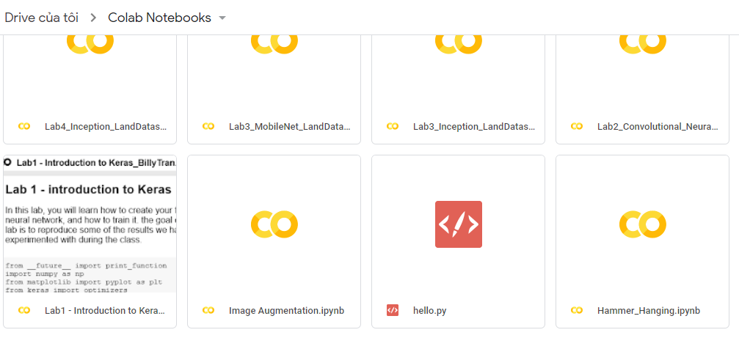
- Run the hello.py file
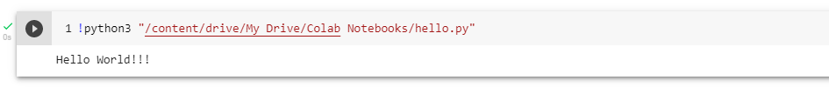

Q3 (2.5 marks). Write a program that performs the following tasks:
- Calculate the multiplication and sum of two numbers
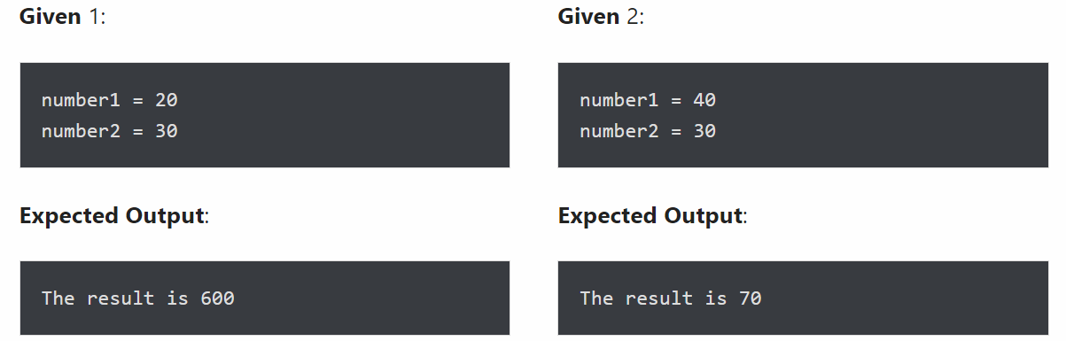
- Print the sum of the current number and the previous number
Write a program to iterate the first 10 numbers and in each iteration, print the sum of the current and previous number.
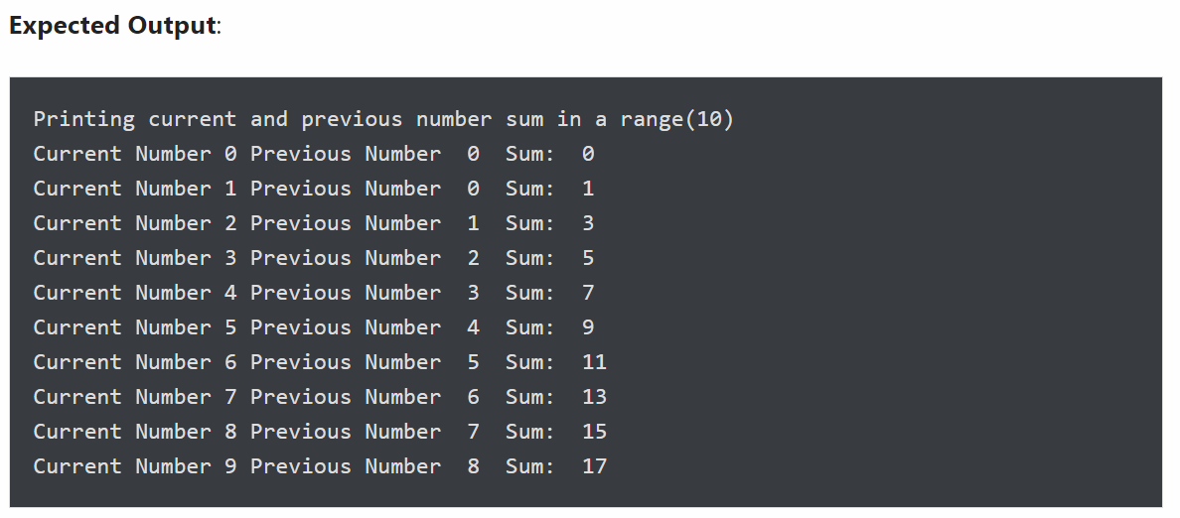
- Display three string “Name”, “Is”, “James” as “Name**Is**James”
Use the print() function to format the given words in the mentioned format. Display the ** separator between each string.
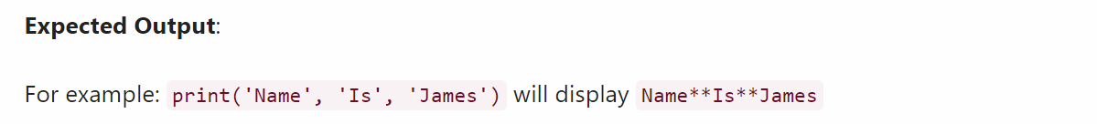

Q4 (2.5 marks). Write a program to accept 3 real numbers a, b, c, then:
- Convert Decimal number to octal using print() output formatting
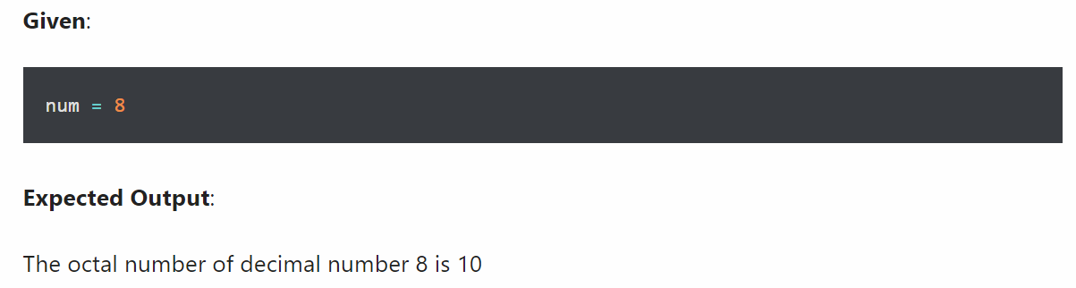

- Display float number with 2 decimal places using print()


