PFP - Labwork 01

Q1 (2.5 marks). Set up the Visual Studio Code environment:
- Install the Visual Studio Code: https://code.visualstudio.com/ (Click Download for Windows).
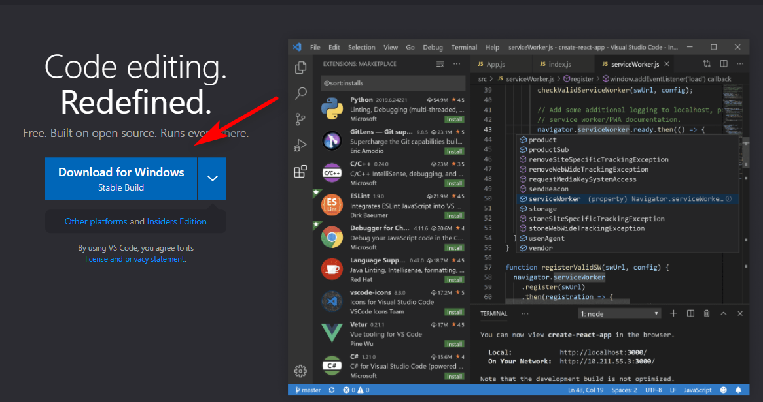
- Install the Python extension for VS Code from the Visual Studio Marketplace. For additional details on installing extensions, see Extension Marketplace. The Python extension is named Python, and Microsoft publishes it. (https://marketplace.visualstudio.com/items?itemName=ms-python.python).
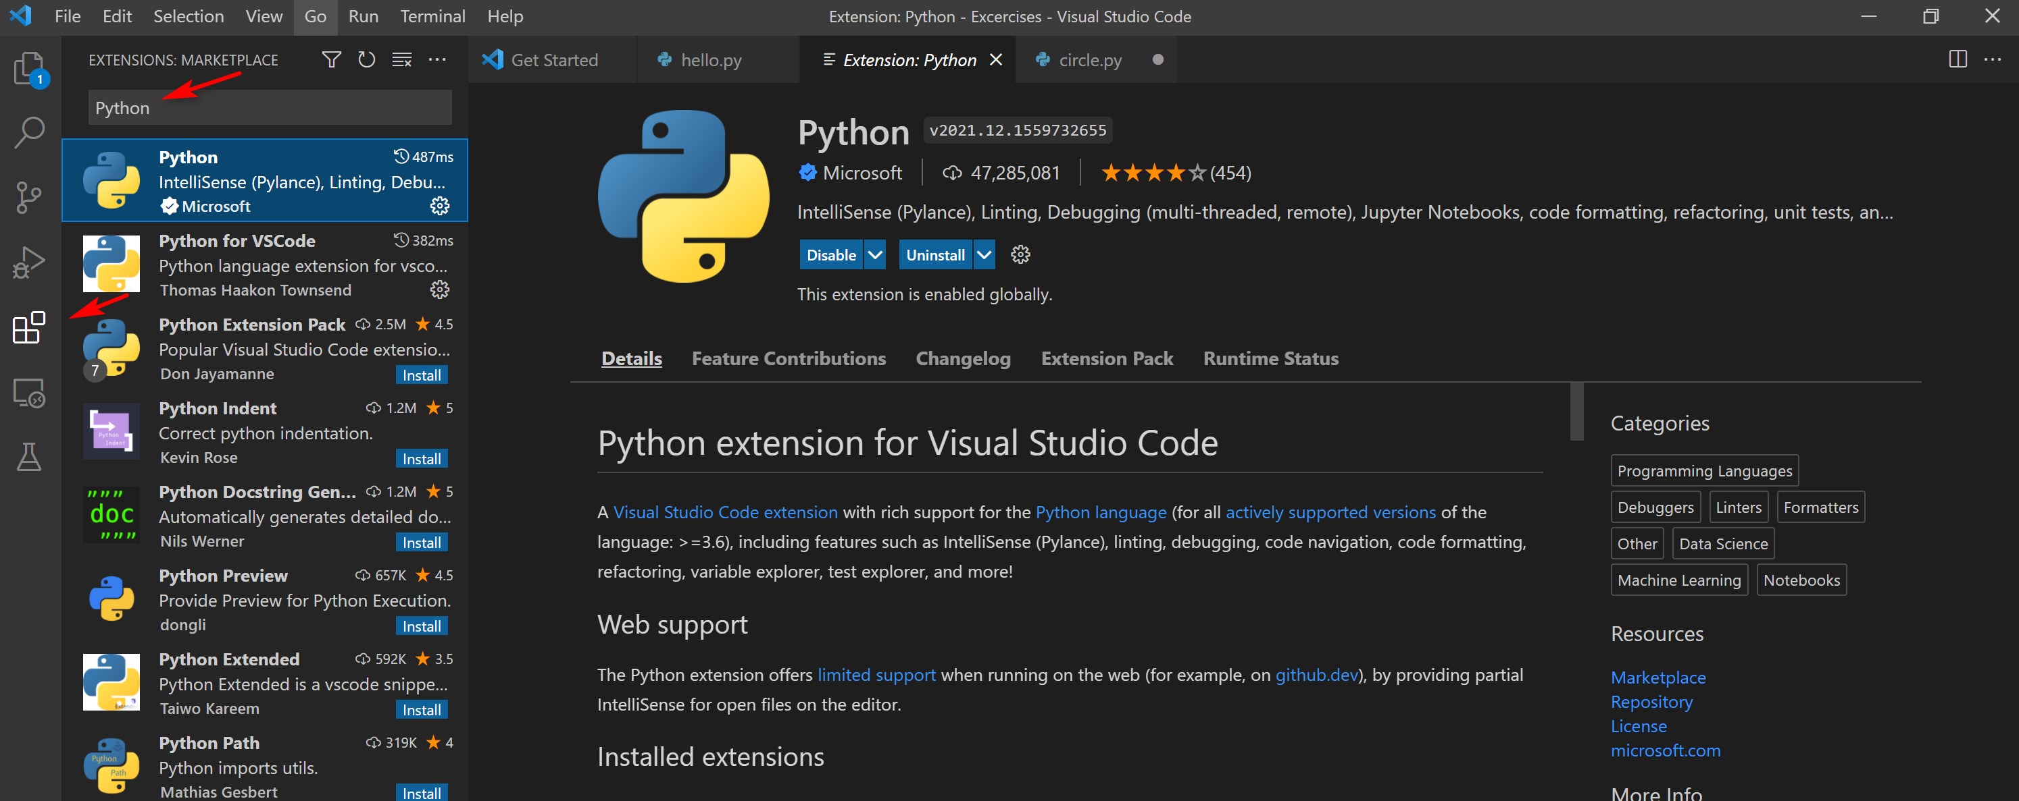
- Install a Python interpreter. (https://www.python.org/downloads/).
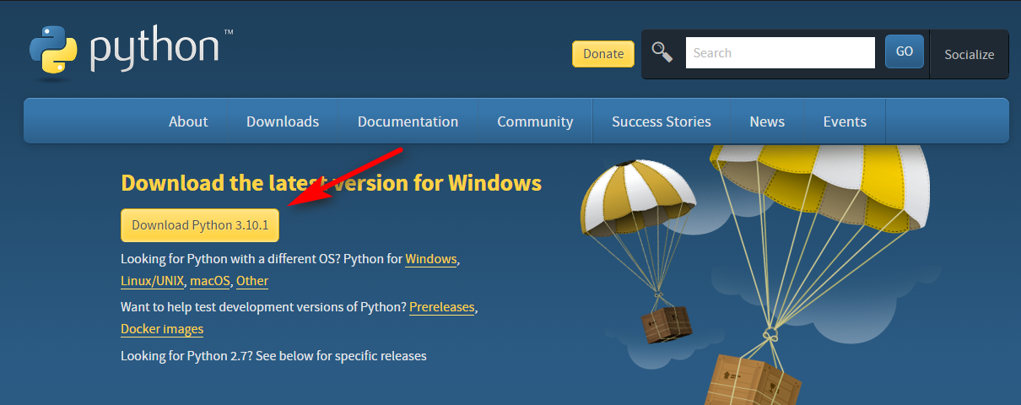
- Verify the Python installation. (py -3 –version)
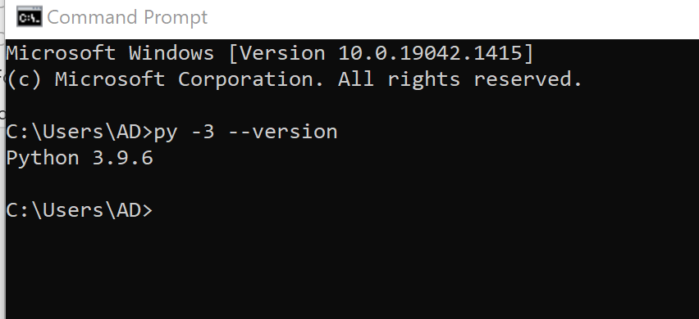
- Start VS Code in a project (workspace) folder.
- Create by Explorer
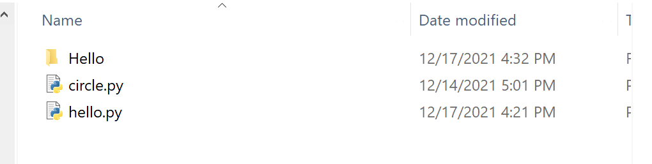
- Create by command line
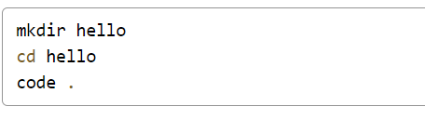
- Select a Python interpreter.
- Click “View” -> “Command Pallete…” or press “Ctrl + Shift + P”
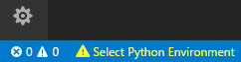
- Type Python: Select Interpreter
- Select command
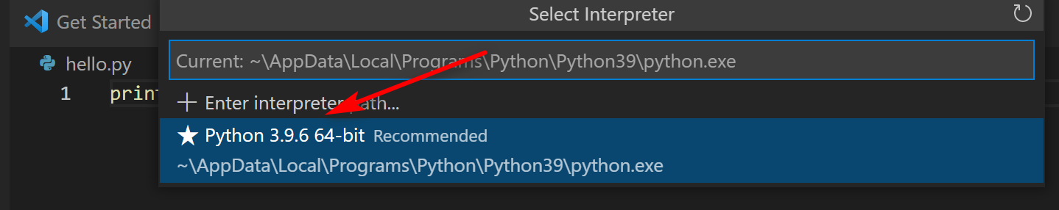

- Create a Python Hello World source code file.
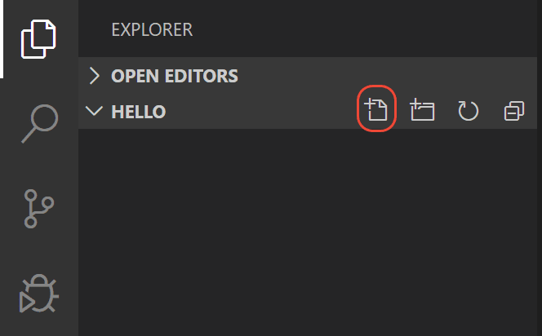

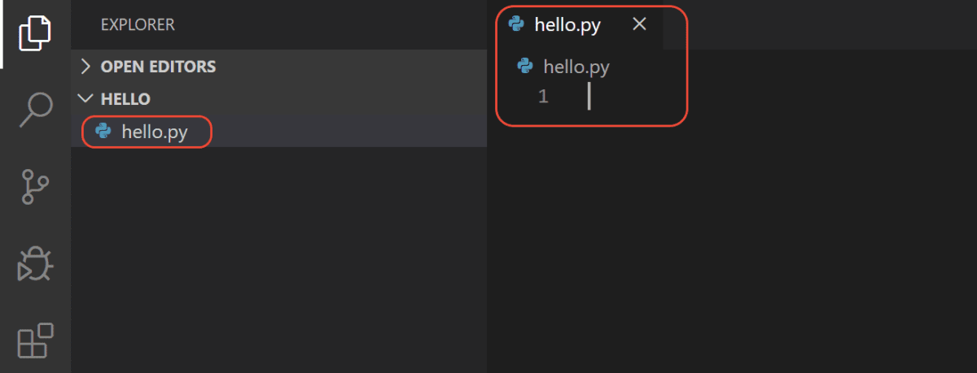
- Run Hello World.
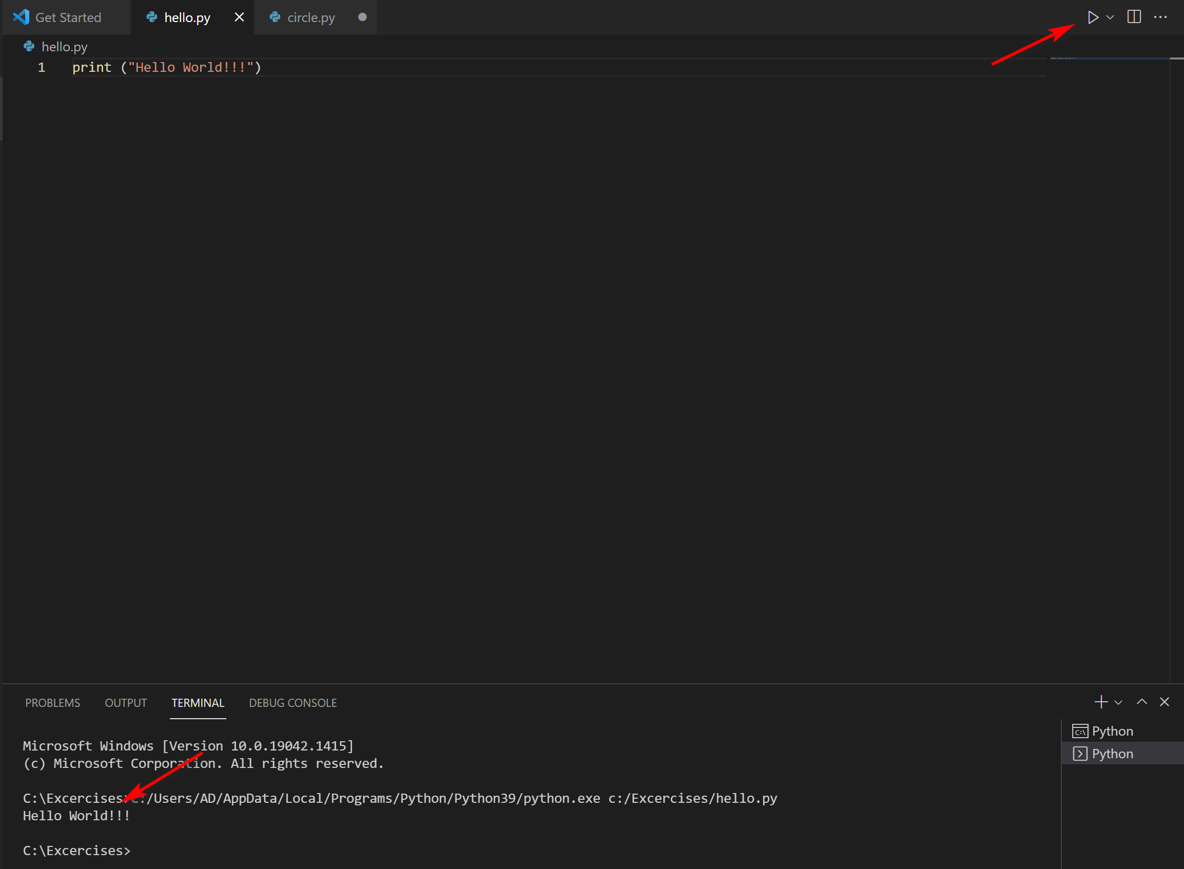
There are three ways to run a python file in VSS:
- Right-click anywhere in the editor window and select Run Python File in Terminal (which saves the file automatically)
- Select one or more lines, then press Shift+Enter or right-click and select Run Selection/Line in Python Terminal. This command is convenient for testing just a part of a file.
- From the Command Palette (Ctrl+Shift+P), select the Python: Start REPL command to open a REPL terminal for the currently selected Python interpreter. In the REPL, you can then enter and run lines of code one at a time.

Reference: https://code.visualstudio.com/docs/python/python-tutorial

Q2 (2.5 marks). Set up the Google Colab:
- Enter the Google Colab: https://colab.research.google.com/notebooks/welcome.ipynb?hl=in

- Mounting drive
- Click “Tool” -> “Command Pallette” or “Ctrl + Shift + P”
- Type “m” and select “Mount Drive”
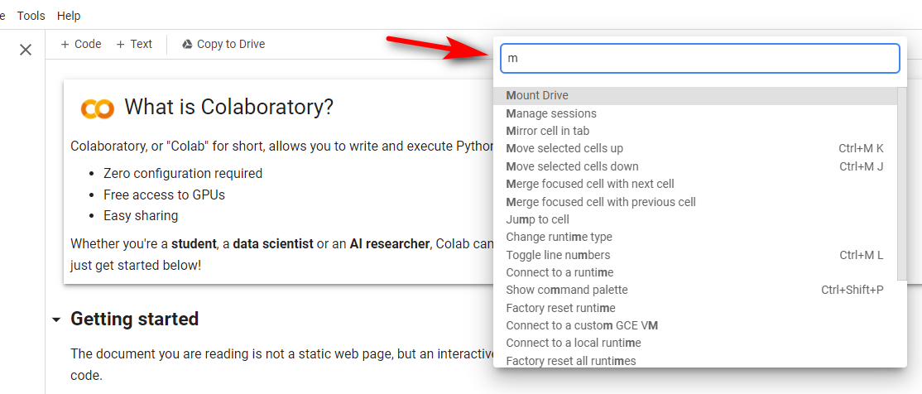
- Click Run cell to mount the drive
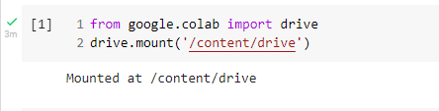
- Listing drive content
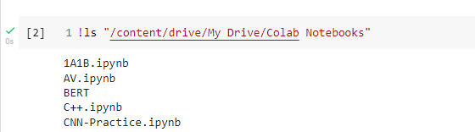
- Create a hello.py file on your local disk.
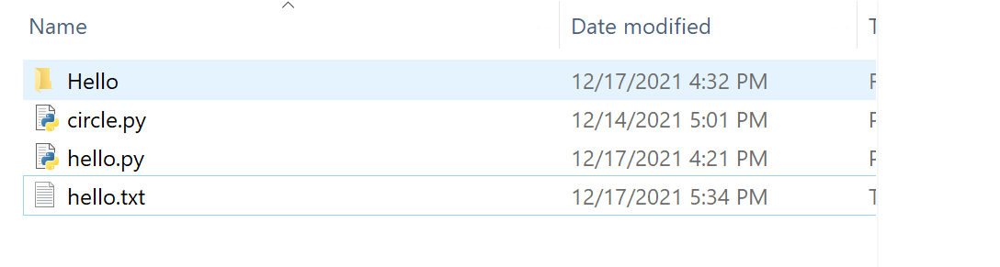
- Upload the file on the drive.
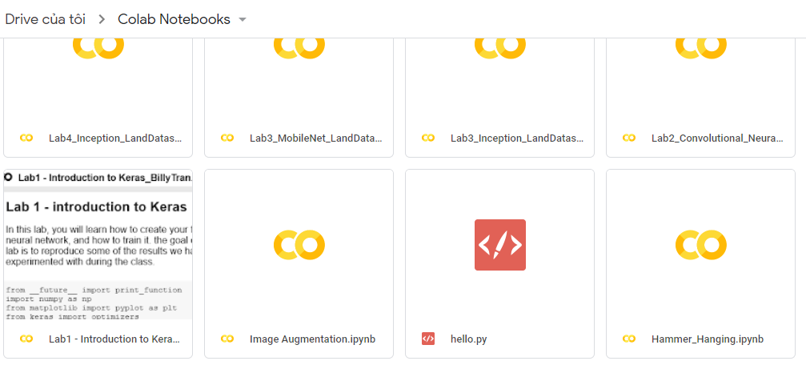
- Run the hello.py file
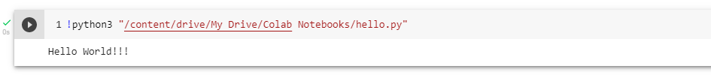

Q3 (2.5 marks). Write a program that performs the following tasks:
- Input 4 real numbers a, b, c and x.
- Calculate S1 = ax² + bx + c.
- Calculate S2 = 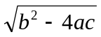 if b² - 4ac > 0, otherwise S2 = 0
- Re-input a, b and c. Check whether a, b and c are sides of a triangle or not.
- If a, b, c are sides of a triangle, then calculate its perimeter and area, otherwise display on the screen a message "a, b, c are not side of a triangle". The area is calculated by the Heron formula below:
S1 = 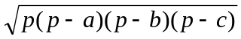, where 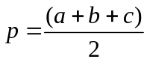

Q4 (2.5 marks). Write a program to accept 3 real numbers a, b, c, then:
- Display the maximum and minimum values among them.
- Arrange them in ascending order, i.e. a ≤ b ≤ c.

