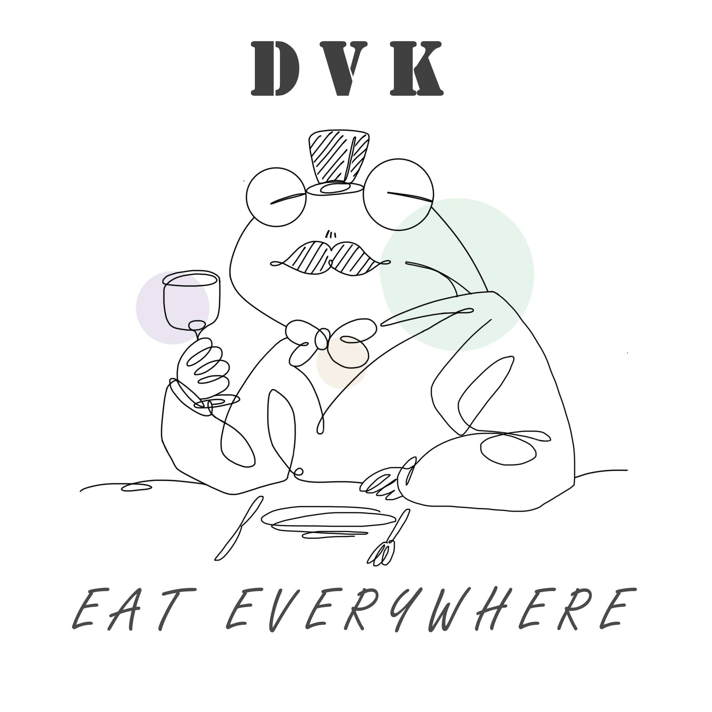

|  |
| --- |
| REPORT  REVIEW FOOD |
|  |

|  |  |  |
| --- | --- | --- |
| Dít Vừa Khít |  |  |
| Email: [ditvuakhit@gmail.com](mailto:ditvuakhit@gmail.com)  Lô E2a-7, Đường D1, Đ. D1, Long Thạnh Mỹ, Thành Phố Thủ Đức, Thành phố Hồ Chí Minh |  |  |

TABLE OF CONTENTS

1. Preliminary Section  
   Title Page…………………………………………………………………………...1  
   Table of Contents………………………………………………………………..2  
   Executive Summary…………………………………………………………....3
2. Body  
   Introduction…………………………………………………………………….....3  
   Procedures……………………………………………………………………........4  
   Findings…………………………………………………………………………......4  
   Analysis…………………………………………………………………………......5  
   Conclusions……………………………………………………………………......6  
   Recommendations……………………………………………………………...7
3. Supplementary Section  
   Appendix…………………………………………..............................................7

## 

In the preliminary section we will summarize the ideas from the previous report. We created the DVK group with the desire to introduce delicious, nutritious, cheap and quality food to people everywhere. Through a long journey, we have enjoyed and shared many dishes with those who have followed the page in the past time. With 15 posts posted, we have also received a lot of attention and love from everyone. From a page without any likes, it has now grown much more than before and received a lot of interaction from all the people who love the content of the page.

**Executive Summary**

This is a project about food review, our team aims to share places, delicious dishes, and reasonable prices to everyone, especially towards FPT students. Helping people have a more objective view, have interesting experiences when enjoying delicious food, and importantly, know more new places and new dishes. The project is conceived, built and implemented by the members. In the early days, team members completed specific goals and plans, then designed a logo, created a fanpage, and shared it with everyone. Next, experience the dishes and record pictures and videos of those dishes. Then, come up with ideas, write articles, post sharing about that experience, in the article will include the name of the dish, the address, opening time, price, rating and feedback about the dish as well. like restaurant service. With this project, our team has had certain successes, gained more knowledge and interesting experiences, so we will have more specific plans on continuing the project in the future.

**Introduction**

Once upon a time, when feeling hungry and wishing to find a restaurant to "fill in the gap", many people often went to food sites and forums to consult people who had eaten before. there. Customers want to find restaurants that suit their tastes and preferences.

Social networking has developed like a storm, leading to many new marketing tools that have been born. If in the past, the advertising methods that restaurants and cafes often apply were handing out flyers, PR, running facebook ads, etc., now the way to review food is the fastest way for customers to find it. services, bringing the brand image quickly in the minds of customers.

The desired dish review gives customers an overview of the products/services of the restaurant or cafe. Among hundreds of restaurants and cafes, customers want an advice from friends or a review from the online community so they can make the right decision. They simply need to know if the food/drink there is delicious, is the service quality good, is the restaurant clean, and ensures food hygiene and safety? Is the price suitable? Unlike any other advertising methods, reviews bring absolute trust to customers.

|  |  |
| --- | --- |
| **Procedures** | |
| 1. Market survey | Admin members will survey directly at the planned location |
| 2. Make an outline of the plan | Development orientation, long-term planning for the project, putting customer interests first |
| 3. Implement the plan | Experience reality and bring true, reliable information,  hit the customer's emotions strongly. Understanding customer psychology, evaluators put themselves in the shoes of customers to meet their needs and desires. |
| 4.Project development | The page operates regularly, actively responds to the requirements given by customers, ready to listen to comments and reviews about the project. |

Findings

All food review groups on Facebook are places for customers to share their reviews and feelings about your restaurant, cafe and competitors. Regularly monitoring the articles on these groups will help you realize what makes customers happy, what makes customers complain so that you can promote the good side to become a special feature of the page and adjust, handle the disadvantages in time.

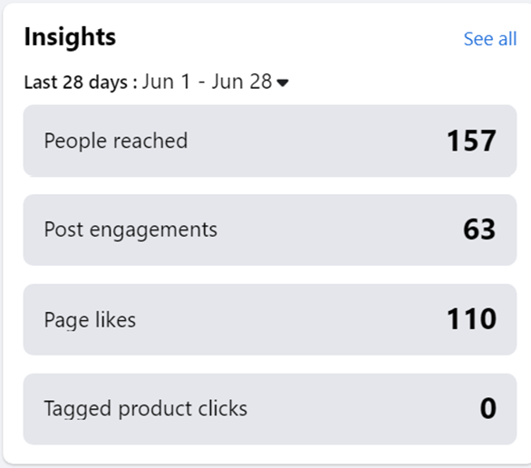 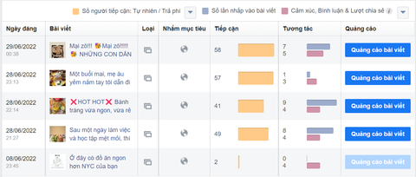

The positives and negatives of food reviews:

Positive: Review articles receive high interaction like, comment, share, use beautiful images, close language to create attraction. Through reviews, your restaurant and cafe services will be known to many people quickly, naturally and authentically. A food review rooted in reality. The description is clear, fair and honest. Give your readers enough information to help them decide based on your assessment.

Opposite:

- Cost a lot for the project

- Receiving malicious comments with no good intentions

- Just one careless action can turn into a mistake and become a troublesome communication crisis.

-Easily leads to cyber violence

Analysis

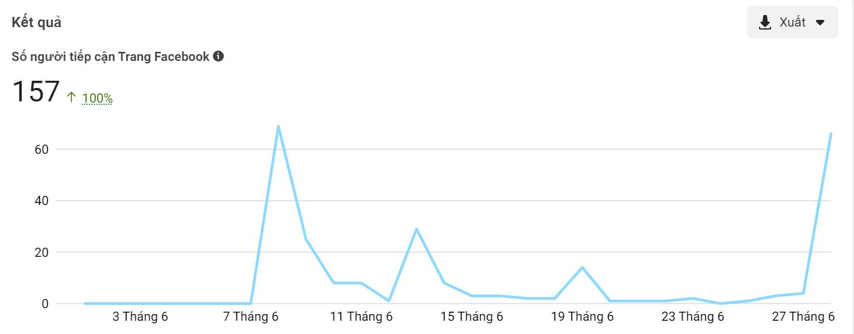

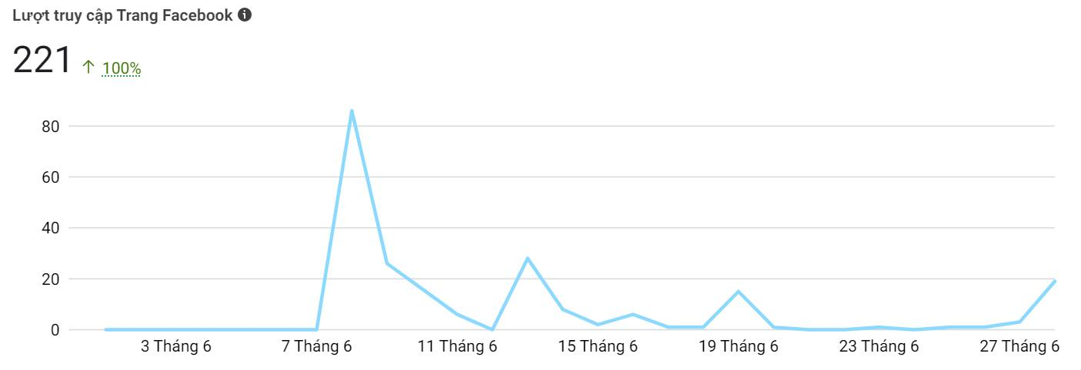

**According to the 2 charts above:**

+ 1: From the date of creation of the page, **the highest number of people** reached on June 8, and June 27 and 28 were the highest number of page visits during the initial period of the page's establishment.

+ 2: The **most visited** was on June 8 .

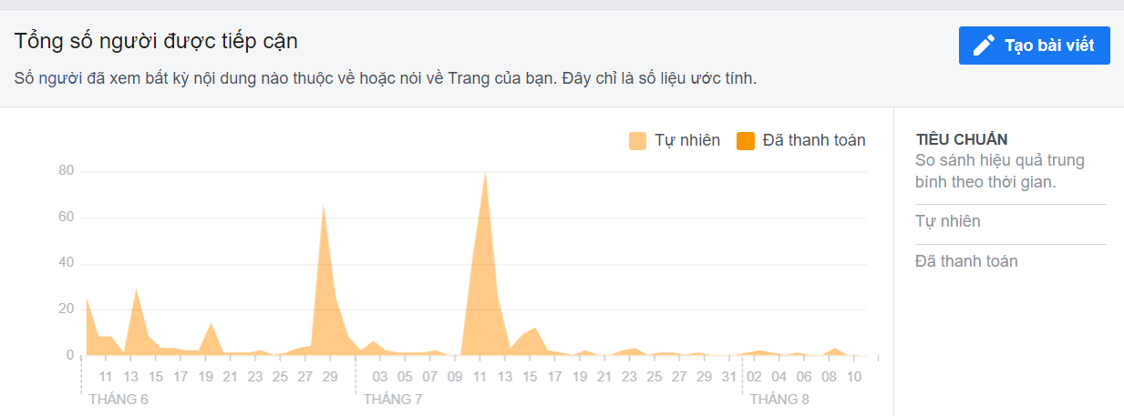

The most viewed estimates of site posts from June to August were on June 28 and 29 and July 11, and after those dates have had very little reach to date.

**Conclusion**

From the time the page was founded until now, the page has spread delicious, cheap, hygienic, affordable food for students and cool refreshments suitable for long days at school. , tired deadline go to the shop together to relax and share learning stories together. But the page has not yet introduced many shops for people to refer to this is a missing part of the page.

**Recommendations:**

The page will fix the shortcomings of the page that have not been completed well, try to review more shops for everyone to refer to, more choices, choose the shop that you want, satisfied with yourself, but affordable my money, the price is right without having to hesitate every time I go out to eat with friends, family or eat alone.

**Appendix**

Appendix A: Preliminary Section

Appendix B: Body

Appendix C: Supplementary Section

|  |
| --- |
|  |