**Câu 1**: **2 marks** Explain the difference between connectionless unacknowledged service and connectionless acknowledged service. How do the protocols that provide these services differ?

**Answer:**

Connection Less:comes with a single free-standing data unit for all transmissions. In there, each unit contains all of the protocols will control information necessary for delivery perspective. However, this contains no provision for sequencing or flow control.

+ Acknowledged:

- Use of ACK and NAK control messages.

- Such protocols are suited for communication over networks: in there, higher layers are sensitive to loss, the underlying network is inherently unreliable with a significant probability of loss or error.

+ Unacknowledge:

- Provide simpler and faster communication for networks with established reliability.

- Besides, it can built-in error control/recovery capabilities or it can withstand information loss.

**Câu 2**. Explain the difference between connection-oriented acknowledged service and  
connectionless acknowledged service. How do the protocols that provide these services  
differ?

**Answer:**

+ Connection-oriented:

- In this service, between sender and receiver will form a setting phase, to establish a context for transferring the information.

- This connection is provided to the sender for all SDUs.

- This service requires a stateful protocol: used to keep track of sequence numbers, and timers.

+ ConnectionLess:

- For this connectionless, there will be no prior context provided for transferring the information between sender and receiver.

- The sender will pass its SDU to an underlying layer without any notice. Therefor, the sender requires an acknowledgment of SDU delivery.

- The protocols are very different in these services.

- This service is not require transmitting protocols to track the acknowledgment of PDU.

- After receiving the PDU, the receiver needs to send acknowledgment, If not received in time, then it will return failure.

**Câu :** Explain the differences between PPP and HDLC.

|  |  |
| --- | --- |
| HDLC | PPP |
| HDLC (High-level Data Link Control ): implement the data encapsulation. | PPP (Point-to-Point Protocol ): use for other device but doesn’t have any changes in data format. |
| HDLC communication: a bit-oriented protocol is used for point-to-point links as well as for multipoint link channels. | PPP communication: PPP uses a byte-oriented protocol for point-to-point links at the time of communication. |
| HDLC does the encapsulation for synchronous media only. | PPP implement the encapsulation for synchronous as well as for asynchronous media. |
| HDLC used only for CISCO devices. | PPP is simple to apply to other devices. |

**Câu 2:** A 1.5 Mbps communications link is to use HDLC to transmit information to the moon. What is the smallest possible frame size that allows continuous transmission? The  
distance between earth and the moon is approximately 375,000 km, and the speed of light  
is 3 x 108 meters/second.

**Answer:**

|  |  |  |
| --- | --- | --- |
|  | Maximum Send Window Size in Default HDLC Frame | Maximum Send Window Size in Extended HDLC Frame |
| Go-Back-N | 7 | 127 |
| Selective Repeat | 4 | 64 |

D (Distance) = 375,000 km = 375 x 106 m

c (Speed of Light) = 3 x 108 m

Then, we can calculate Round Trip Propagation Delay (Trì hoãn do quãng đường) by this formula

2 $t_{prop}$ = $\frac{D}{c}= \frac{2\left(375* {10}^{6} m \right)}{3 * {10}^{8}}=2.50 s$

We know that

$\frac{N×n_{f}}{R}=2t_{prop}⇒n_{f}=\frac{2t_{prop}× R}{N} (*)$

In which, $n_{f}$ is Possible Frame Size (bits), Mbps is the number of Megabyte Per Second.

R = 1,5 Mbps so that R = 1,5 x 106 bps.

Substitute to (*) then we have

Go-Back-N:

If N = 7 : $\frac{7nf}{1.5Mbs}=2.5s→nf=535715 bits$

If N = 127: $\frac{127nf}{1.5Mbs}=2.5s→nf=29528 bits$

Selective Repeat:

If N = 4 : $\frac{4nf}{1.5Mbs}=2.5s→nf= 973500 bits$

If N = 64 : $\frac{64nf}{1.5Mbs}=2.5s→nf= 58594 bits$

Câu 3: Suppose HDLC is used over a **1.5 Mbps** geostationary satellite link. Suppose that  
**250-byte frames** are used in the data link control. What is the maximum rate at which  
information can be transmitted over the link?

**1** Mili giây = **0.001** Giây

R = 1.5 Mbps = 1,5 x 106 bps

nf = 250 bytes = 2000 bits (250 x 8)

We have a distance between earth and satellite: D ≈ 36 000 km = 3,6 x 107m

The propagation delay has been calculated:

$$t_{prop}= \frac{D}{c}=\frac{3,6×{10}^{7}}{3×{10}^{8}}=0,12 s=120 ms$$

The processing rate has been calculated :

$t_{f}=\frac{n_{f}}{R}=\frac{2000}{1,5×{10}^{6}} = 0,00133 s = 1,33 ms$

Use Go-Back-N or Selective Repeat ARQ:

N = 7 is the default window size (with a 3- bit sequence number).

The maximum information rate is achieved with no error, and hence, no retransmission.

$t_{cycle}$ = minimum time to transmit a group of N packets

= $t_{f}$ + 2 $t_{prop}$ = 1.33 + 2 x 120 = 241.33 ms

n = no. of bits transmitted in a cycle = N. $n_{f}$ = 7 x 2000 = 14000 bits

$R_{\max{ }}$ = $\frac{no. of bits sent in a cycle }{minimum cycle time }= \frac{n}{t_{cycle}}$ = 58 kbps

$n$ is number of bits transmitted in a cycle

$R_{max}$ is number of bits sent in a cycle / minimum cycle time

The maximum send window size: N = 2n-1 = 27-1=127 with n = 7.

Then, the maximum information rate have:



$$n=N×n_{f}=127×2000=254000 bits$$

$$R_{max}=\frac{n}{t_{cycle}}=\frac{254000}{241,33}=1052,5 kbps=1,0525 Mbps$$

Câu 4:Suppose that a multiplexer receives constant-length packet from **N = 60 data** sources.  
Each data source has a probability p = 0.1 of having a packet in a given T-second period.  
Suppose that the multiplexer has one line in which it can transmit eight packets every T  
seconds. It also has a second line where it directs any packets that cannot be transmitted  
in the first line in a T-second period. Find the average number of packets that are  
transmitted on the first line and the average number of packets that are transmitted in the  
second line.

**Answer:**

We have: N = 60 data sources and the probability of p = 0.1.

The average number for the arrivals of the packets can be given as Np = 6.

The average number of packets received has been calculated:

X= $\sum_{k=0 }^{8}{k . C_{k}^{60} . {(0,1)}^{k}. {(0,9)}^{60- k}}=4.59$

//Now, the average number of packets received is 4.59 that gets transmitted through the first line. The remaining will get transmitted by the second line. Now, the average number of packets transmitted through the second line per T second can be obtained as below:

The average number of packets transmitted:

Y = Np – X = 6 – 4,59 = 1,41

Therefore, it will transmit 1.41 packets on average per T second from the second line.

**Câu 5:**Consider the transfer of a single real-time telephone voice signal across a packet network.  
Suppose that each voice sample should not be delayed by more than 20 ms.

a. Discuss which of the following adaptation functions are relevant to meeting the  
requirements of this transfer: handling of arbitrary message size; reliability and  
sequencing; pacing and flow control; timing; addressing; and privacy, integrity  
and authentication.  
b. Compare a hop-by-hop approach to an end-to-end approach to meeting the  
requirements of the voice signal.

**Answer:**   
a/Message size is important because in real-time signals of voice it is necessary, to transfer a fixed packet size of that holds no more than 20 ms of the speech signal. As long as the desired voice packet size can be handled, handling arbitrary message sizes is not as crucial.

Sequencing is essential because every packet must arrive in the order in which it was generated.

Reliability is slightly significant when voice transmission can withstand a certain amount of error and loss.

Pacing and flow control are less significant due to the synchronous nature of the voice signal, the end systems will be matched in speed.

Timing, for real-time voice transfer, is important owing to it helps to control the jitter in the delivered signal.

Addressing is only during the connection setup phase when we assume some form of virtual circuit packet switching method.

Privacy, integrity, and authentication have typically been less important than the other problems described above.

b/Determine the reliability of the network. If it is highly reliable, so the end-to-end approach is better due to the probability of error is very low, in order to deliver acceptable performance, processing at the edge is sufficient.

In contrary, low reliable then the hop-by-hop approach may be required. For instance, error recovery at each hop may be required to enable effective communication if the probability of error is very high, as in a wireless channel.

**Câu 6:**Consider the Stop-and-Wait protocol as described. Suppose that the protocol is modified  
so that each time a frame is found in error at either the sender or receiver, the last  
transmitted frame is immediately resent.

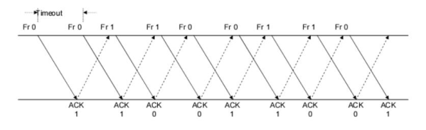

1. Show that the protocol still operates correctly.  
   b. Does the state transition diagram need to be modified to describe the new  
   operation?  
   c. What is the main effect of introducing the immediate-retransmission feature?

**Answer:**

a/In the stop-and-wait protocol , when an acknowledgment is not received in time, the sender resends a frame. The modified protocol acknowledges the retransmitted frame when the sender or receiver encounters an error. When frames are retransmitted earlier, the protocol will function effectively.

b/ No. The diagram of the state transitions won't change.

c/ Thanks to this protocol, the recovery process is fast.

**Câu 7:**  
Suppose that two peer-to-peer processes provide a service that involves the transfer of  
discrete messages. Suppose that the peer processes are allowed to exchange PDUs that  
have a maximum size of M bytes including H bytes of header. Suppose that a PDU is not allowed to carry information from more than one message.  
a. Develop an approach that allows the peer processes to exchange messages of arbitrary size.

To exchange messages of arbitrary size, large messages must be segmented into parts of M-H bytes each in length to be transmitted in multiple PDUS. Small messages must be placed in a single PDU.

b. What essential control information needs to be exchanged between the peer processes?

The peer processes need to communicate information that allows for the reassembly of messages at the receiver. For example, the first PDU may contain the message length. The last PDU may contain and end-of-message marker. Sequence numbers may also be useful to detect loss in connection

oriented networks and to help in reconstruction of the messages in connectionless networks. Lastly, since variable size PDUS are permitted, the size of the PDU must be transmitted in the PDU header.

c. Now suppose that the message transfer service provided by the peer processes is shared by several message source-destination pairs. Is additional control information required, and if so, where should it be placed?

In this case, in addition to all of the header information mentioned in b), each PDU must be labeled with a stream ID, so that the receiver can treat each stream independently when reassembling messages.

**Câu 8:**  
A 1 Mbyte file is to be transmitted over a 1 Mbps communication line that has a bit error rate of p = 10-6.  
a. What is the probability that the entire file is transmitted without errors? Note for n  
large and p very small, (1 - p)n ≈ e-np.  
b. The file is broken up into N equal-sized blocks that are transmitted separately.  
What is the probability that all the blocks arrive correctly without error? Does  
dividing the file into blocks help?  
c. Suppose the propagation delay is negligible, explain how Stop-and-Wait ARQ can  
help deliver the file in error-free form. On the average how long does it take to  
deliver the file if the ARQ transmits the entire file each time?

1. Refer to the following figure for the discussion

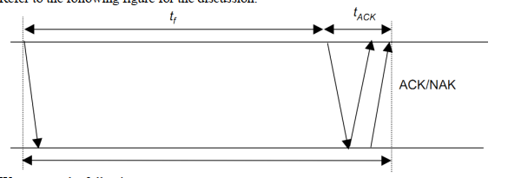

We assume the following:  
• t0= basic time to send a frame and receive the ACK/NAK ≈ ttimeout  
• ttotal = total transmission time until success  
• nf = number of bits/frame  
• na = number of bits per ACK  
• nt = number of transmissions  
• Pf = probability of frame transmission error

**Answer:**

1Mbyte = 106 byte = 8 x ${10}^{6}$ bits because1 byte = 8 bits

The file length n = 8 x 106 bits, the transmission rate R = 1 Mbps = 106 bps and p = 10-6

1. Note : For n lagrge and p very small , ${(1-p)}^{n}≈e^{-np}$

P[no error in the entire file] = ${(1-p)}^{n}≈e^{-np}$ for n >> 1 , p << 1

= $e^{-8}$ = 3.35 x ${10}^{-4}$

We conclude that it is extremely unlikely that the file will arrive error free

1. A subblock of length n/N is received without error with probability :

P[no error in subblock] = ${(1-p)}^{n/N}$

A block has no errors if all subblocks have no errors, so

P[no error in block]= ${P[no error in subblock]}^{N}$ = ${(1-p)}^{{(n/N)}^{N}}$ = ${(1-p )}^{n}$

So it is useless to divide the blocks simply.

c.

Refer to the following figure for the discussion .

We assume the following:

- = basic time to send a frame and receive the ACK/NAK $≈$ ttimeout

- = total transmission time until success

-

- = number of bits per ACK

- = number of transmissions

- = probability of frame transmission error

$t_{0}$ = $t_{f}+ t_{ACK}$ = $\frac{n_{f}}{R}+\frac{n_{a}}{R}$ ($t_{prop ≈0 )}$

$P\left[n_{t}=i \right]=P[one success after i-1 failure]$ = (1 - $p_{f}){p_{f}}^{i-1}$

Given i transmissions : | = i $t_{0}$

*

E[$t_{total}$] = $\sum_{i=1}^{∞}{it_{0}}$ P[$n_{t}=i$] = $t_{0}(1-P_{f})\sum_{i=1}^{∞}{i . P_{f}^{i-1}}$ = $\frac{t_{0}\left(1-P_{f}\right)}{{(1-P_{f})}^{2}}$ = $\frac{t_{0}}{1- p_{f}}$

Here , $n_{f}$ = n >> $n_{a }$ thus $t_{0}$ $≈t_{f}$ = n/R ; and $P_{f} =1-P[no error]$ =

1 $-$ $e^{-np}$

E[total] = n/R(1 - $p_{f})=n/[{Re}^{-np}]$ = 8 / (3.35 x 10-4) = 23847 seconds = 6,62 hours

The file gets through, but only after many retransmissions.

.  
**Câu 9:**

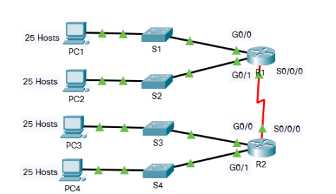

In this activity, you are given the network address of 192.168.11.0/24 to subnet and  
provide the IP addressing for the Packet Tracer network. Each LAN in the network  
requires at least 25 addresses for end devices, the switch and the router. The  
connection between R1 to R2 will require an IP address for each end of the link.

Based on the topology, how many subnets are needed?**5 [0, 1, 2, 3, 4]**  
b. How many bits must be borrowed to support the number of subnets in the topology  
table?**3**

${4×2}^{N }-2≥25$

Then we got N = 3.

(4 because 4 is subnet S1, S2, S3 , S4 not S0/0/0)

**192.168.11.0/24**

**192.168.11.64/24**

**192.168.11.128/24**

**192.168.11.192/24**

**// For every host-bit we borrow we can double the number of subnets we can create**, so by borrowing 2 host bits we can create 4 subnets. Every host bit you “borrow” doubles the amount of subnets you can create. Calculate it from binary to decimal: 128+64 = 192. The new subnet mask will be 255.255.//  
c. How many subnets does this create?23 = 8

000 -> 0

001 -> 1

010 -> 2

011 -> 3

100 -> 4

….

111 -> 7  
d. How many usable hosts does this create per subnet?

**Answer:**

**No of bits for host = 8**

**Bits borrowed for subnet = 3**

**Bits left for host = 8 – 3 = 5 bit**

**Using 5 bit, usable host = 25-2 = 30 hosts**

**Câu 10:**  
Five stations (S1-S5) are connected to an extended LAN through transparent bridges (B1- B2), as shown in the following figure. Initially, the forwarding tables are empty. Suppose the following stations transmit frames: S1 transmits to S5, S3 transmit to S2, S4 transmits to S3, S2 transmits to S1, and S5 transmits to S4. Fill in the forwarding tables with appropriate entries after the frames have been completely transmitted.

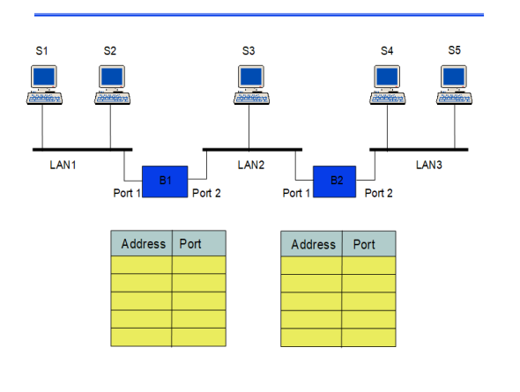

We have 3 types of LAN, and each LAN is arranged follow BUS. In diagram, a device sends data, it will send according to broardcast type (send to any device and internet port).

**B1**

|  |  |  |  |
| --- | --- | --- | --- |
|  |  | Address | Port |
| Step 1 | S1 => S5 | S1 | 1 |
| Step 2 | S3 => S2 | S3 | 2 |
| Step 3 | S4 => S3 | S4 | 2 |
| Step 4 | S2 => S1 | S2 | 1 |
| Step 5 | S5 => S4 |  |  |

B2

|  |  |  |  |
| --- | --- | --- | --- |
|  |  | Address | Port |
| Step 1 | S1 => S5 | S1 | 1 |
| Step 2 | S3 => S2 | S3 | 2 |
| Step 3 | S4 => S3 | S4 | 2 |
| Step 4 | S2 => S1 |  | 1 |
| Step 5 | S5 => S4 | S5 |  |

Câu 12:  
1. Consider the network in Figure.

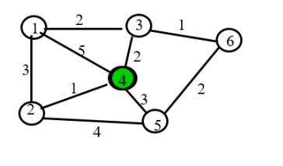

1. Use the Dijkstra algorithm to find the set of shortest paths from node 4 to other  
   nodes.

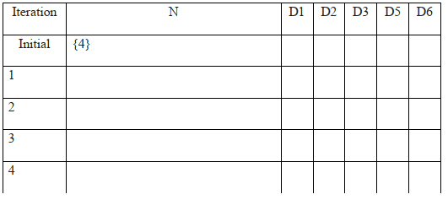

**Answer: a.**

|  |  |  |  |  |  |  |
| --- | --- | --- | --- | --- | --- | --- |
| Iteration | N | D1 | D2 | D3 | D5 | D6 |
| Initial | {4} | $$(-1,∞)$$ | $$-1,∞)$$ | $$(-1,∞)$$ | $$(-1,∞)$$ | $$(-1,∞)$$ |
| 1 | {4,2} | (5,4) | (1, 4) | (2,4) | (3,4) | $$(-1,∞)$$ |
| 2 | {4,2,3} | (4,2) | ______ | (2,4) | (3,4) | $$(-1,∞)$$ |
| 3 | {4,2,3, 5} | (4,2) | ______ | ______ | (3,4) | (3,3) |
| 5 | {4,2,3,5,6} | (4,2) | ______ | ______ | ______ | (3,3) |
| 6 | {4,2,3,5,6,1} | (4,2) | ______ | ______ | ______ | ______ |

The shortest part from D4 to D1 is 4 and the path is D4 -> D2 -> D1

The shortest part from D4 to D2 is 1 and the path is D4 -> D2

The shortest part from D4 to D3 is 2 and the path is D4 -> D3

The shortest part from D4 to D5 is 3 and the path is D4 -> D5

The shortest part from D4 to D6 is 3 and the path is D4 -> D3 -> D6

1. Find the set of associated routing table entries (Destination, Next Hop, Cost)

|  |  |  |
| --- | --- | --- |
| Destination | Cost | Next Hop |
| 1 (chính là D1) | 4 | 2 |
| 2 | 1 | 2 |
| 3 | 2 | 3 |
| 5 | 3 | 5 |
| 6 | 3 | 3 |

**Câu 13:** 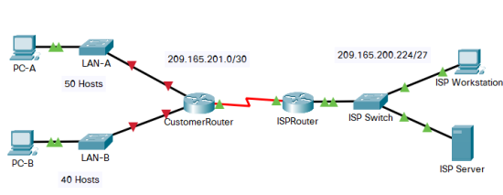

You are a network technician assigned to install a new network for a customer. You must create multiple subnets out of the 192.168.12.0/24 network address space to meet the following requirements:

* + The first subnet is the LAN-A network. You need a minimum of 50 host IP addresses.
  + The second subnet is the LAN-B network. You need a minimum of 40 host IP addresses.
  + You also need at least two additional unused subnets for future network expansion.

**Note**: Variable length subnet masks will not be used. All of the device subnet masks should be the same length.

Answer the following questions to help create a subnetting scheme that meets the stated network requirements:

1. How many host addresses are needed in the largest required subnet?
2. What is the minimum number of subnets required?
3. The network that you are tasked to subnet is 192.168.12.0/24. What is the /24 subnet mask in binary?
4. The subnet mask is made up of two portions, the network portion, and the host portion. This is represented in the binary by the ones and the zeros in the subnet mask.

Questions:

In the network mask, what do the ones and zeros represent?

1. When you have determined which subnet mask meets all of the stated network requirements, derive each of the subnets. List the subnets from first to last in the table. Remember that the first subnet is 192.168.12.0 with the chosen subnet mask.

|  |  |  |
| --- | --- | --- |
| **Subnet Address** | **Prefix** | **Subnet Mask** |

**Answer:**

a. How many host addresses are needed in the largest required subnet?

Soln: 50

b. What is the minimum number of subnets required?

Soln : According to the question , two subnet are required for LAN-A and LAN-B and two subnets are needed to be left for future use. Therefor, the total number of subnets are 4 .

c. The network that you are tasked to subnet is 192.168.12.0/24. What is the /24 subnet mask in binary?

Soln : /24 is prefix length.

In binary, it is 11111111.111111111.111111111.000000000

There are 24 bits 1. It means that the address left 24 first bits for network portion

d. The subnet mask is made up of two portions, the network portion, and the host portion. This is represented in the binary by the ones and the zeros in the subnet mask. In the network mask, what do the ones and zeros represent?

Soln : In the nerwork mask, the ones represent the network portion and the zeroes represent the host portion.

In the network mask, what do the ones represent?

**The ones represent the network portion.**

In the network mask, what do the zeros represent?

**The zeroes represent the host portion.**

e. When you have determined which subnet mask meets all of the stated network requirements, derive each of the subnets. List the subnets from first to last in the table. Remember that the first subnet is 192.168.12.0 with the chosen subnet mask.

|  |  |  |
| --- | --- | --- |
| **Subnet Address** | **Prefix** | **Subnet Mask** |
| **192.168.12.0** | **/26** | **255.255.255.192** |
| **192.168.12.64** | **/26** | **255.255.255.192** |
| **192.168.12.128** | **/26** | **255.255.255.192** |
| **192.168.12.192** | **/26** | **255.255.255.192** |

**Câu 15:**

Suppose that Selective Repeat ARQ is modified so that ACK messages contain a list of the next m frames that it expects to receive.

Solutions follow questions:

a. How does the protocol need to be modified to accommodate this change?

b. What is the effect of the change on protocol performance?

**Answer:**

GIVENTHAT :

a) How does the protocol need to be modified ?

We need to change 2 things:

- To receive the list of frames, the frame header must be changed. Due to, the receiver can specify which frame should be transmitted.

- Secondly, transmitter operation is must change. It is possible to bypass the retransmission of already received frames if the received list includes the m oldest frames that haven't been received yet.

b) What is the effect of change on protocol performance?

If protocol happend error rate or delay together high, the effect performance will high.Specially, single frame can be request a number of frames to be sent again.

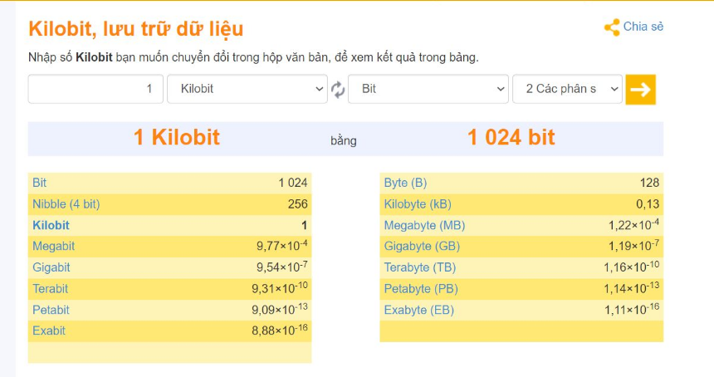

**1** Megabytes = **8388608** Bit = 1024 x 1024 x 8

từ Bytes sang Bit nhân với 2^3 ( =8 ).

**1** Megabits = **1048576** Bit = 1024 x 1024

**Q.1.** (2 marks) Suppose the size of an uncompressed text file is 1 megabyte Note: Explain your answer in details.

a. How long does it take to download the file over a 32 kilobit/second modem?

b. How long does it take to take to download the file over a 1 megabit/second modem?

c. Suppose data compression is applied to the text file. How much do the transmission times in parts (a) and (b) change?

**Answer:**

**Sentence a)**

Convert to bits and bits/second

Size text file = 1 x 1024 x 1024 x 8 (bits)

Speed = 32 x 1000 (bits/second)

=> T (32k) = (1 x 1024 x 1024 x 8 bits / (32 x 1000)) = 262,144 (seconds)

**Sentence b)**

Convert to bits and bits/second

Size text file = 1 x 1024 x 1024 x 8 (bits)

Speed = 1 x 1000 x 1000 (bits/second)

=> T (1M) = (1 x 1024 x 1024 x 8 bits / (1 x 1000 x 1000)) = 8.38 (seconds)

**Sentence c)**

//The question calls for 1:6, then just multiply by 6 for the speed, if the school issues 1:10, then multiply by 10)//

=> T (32k) = (1 x 1024 x 1024 x 8 / (32 x 1000 x 6) = 43.69 (seconds)

=> T (1M) = (1 x 1024 x 1024 x 8 / (1 x 1000 x 1000 x 6) = 1.4 (seconds)

**Q2.** (2 marks) Let g(x)=x3+x+1. Consider the information sequence 1001. Find the codeword corresponding to the preceding information sequence. Using polynomial arithmetic we obtain Note: Explain your answer in details.

1010

1011 1001000

1011

01000

1011

0110

Codeword = 1001110

1011 1001000

1011

01000

1011

0110

Codeword = 1001110

1011 1001000

1011

01000

1011

0110

Codeword = 1001110

The information sequence add 3 bits of 0s, we have 1001000.

1001000 divided by 1011 and remainder is 110

=> Coderword: 1001 combination remainder 110. result is 1001110.

Q.4. (2 marks) A router has the following CIDR entries in its routing table:

Address/mask Next hop

135.46.56.0/22 Interface 0

135.46.60.0/22 Interface 1

192.53.40.0/23 Router 1

default Router 2

1. What does the router do if a packet with an IP address 135.46.63.10 arrives?

135.46.63.10

|  |  |
| --- | --- |
| 135.46.63.10 | 10000111 00101110 00111111 00001010 |
| 255.255.252.0 **AND** | 11111111 11111111 11111100 00000000 AND |
| 135.46.60.0 | 10000111 00101110 00111100 00000000 |

* It matches entry with 135.46.60.0/22, and no other interface found, so it’s in there Interface 1.

(b) What does the router do if a packet with an IP address 135.46.57.14 arrives?

135.46.57.14

|  |  |
| --- | --- |
| 135.46.57.14 | 10000111 00101110 00111001 00001110 |
| 255.255.252.0 **AND** | 11111111 11111111 11111100 00000000 AND |
| 135.46.56.0 | 10000111 00101110 00111000 00000000 |

It matches entry with 135.46.56.0/22, and no other interface found, so it’s in there: Interface 0

**Câu 15**: A Large number of consecutive IP address are available starting at 198.16.0.0. Suppose four organizations, A, B, C, D request 4000, 2000, 4000, and 8000 addresses, respectively. For each of these organizations, give: 1. the first IP address assigned 2. the last IP address assigned 3. the mask in the w.x.y.z/s notation

**Answer:**

IP addresses will be allocated in blocks of power of 2. So the four organization will be allocated IPs as A-4096, B-2048, C-4096, D-8192. Remaining unused Ips are wasted. Ips will be allocated to the organizations contiguosly

A has 212 hosts. So lower order 12 bits will denote host ID and higher order 32 – 12 = 20 bits denotes network ID

A’s first IP = 198.16.0.0(Hosts IP part contatins all 0s)

A’s last IP = 11000110.00010000.00001111.11111111(Host ID part contains all 1s) = 198.16.15.255

A’s Mask = 198.16.15.255

B has 211 hosts. So . So lower order 11 bits will denote host ID and higher order 32 – 11 = 21 bits denotes network ID

B’s first IP = 198.16.16.0

B’s last IP = 11000110.00010000.00010111.11111111 = 198.16.23.255

B’s Mask = 198.16.16.0/21

C has 212 hosts. So lower order 12 bits will denote host ID and higher order 32 – 12 = 20 bits denotes network ID

C’s first IP = 198.16.24.0

C’s last IP = 11000110.00010000.00011111.11111111 = 198.16.31.255

C’s Mask = 198.16.24.0/20

D has 213 hosts. So lower order 13 bits will denote host ID and higher order 32 – 13 = 19 bits denotes network ID.

D’s firt IP = 198.16.32.0

D’s last IP = 11000110.00010000.00111111.11111111 = 198.16.63.255

D’s Mask = 198.16.32.0/19