Bảng ước lương khoảng

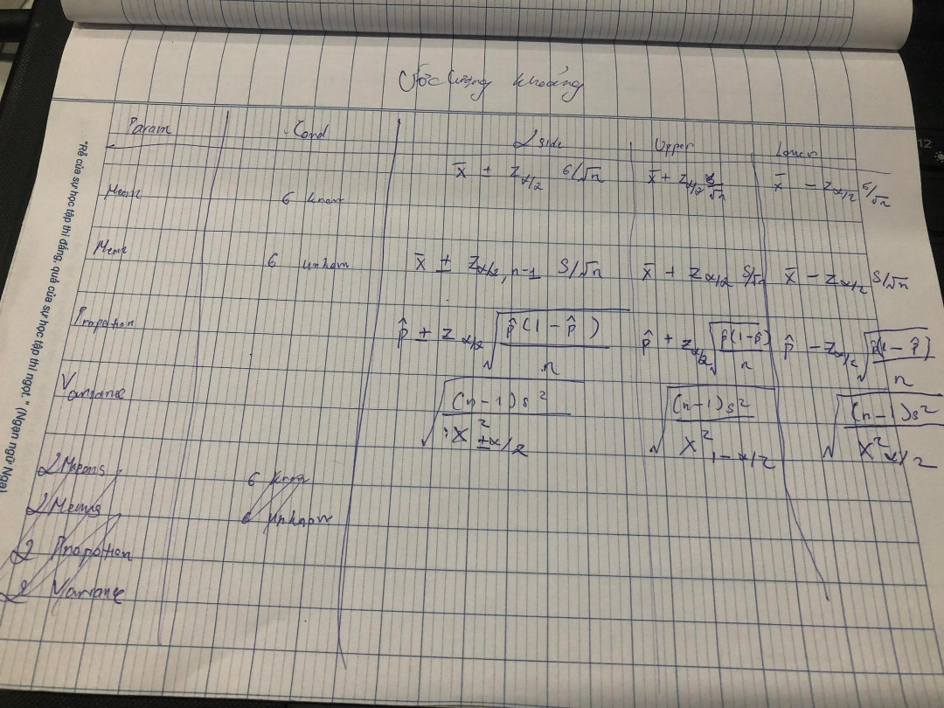

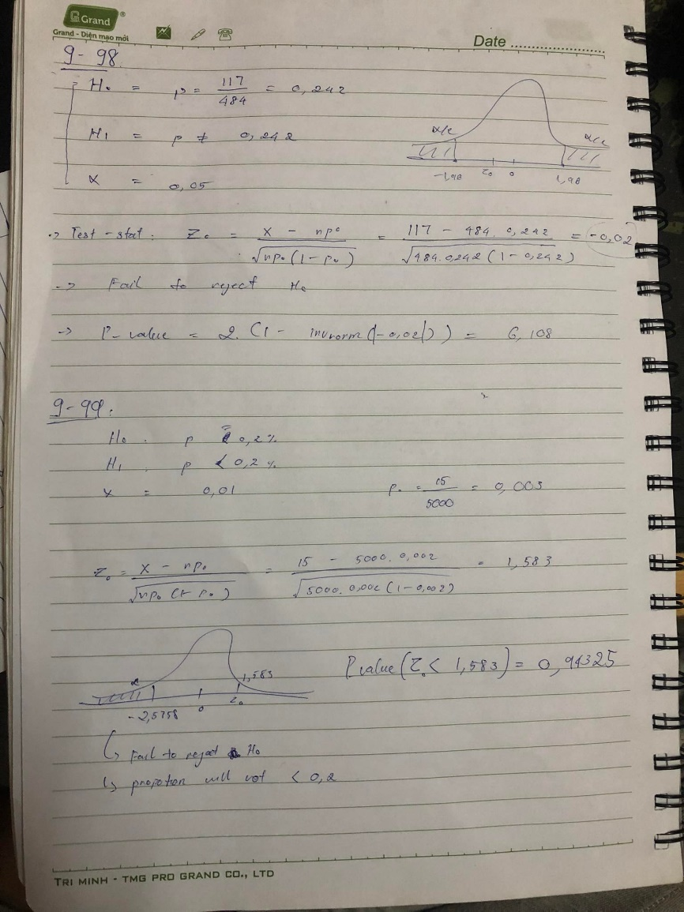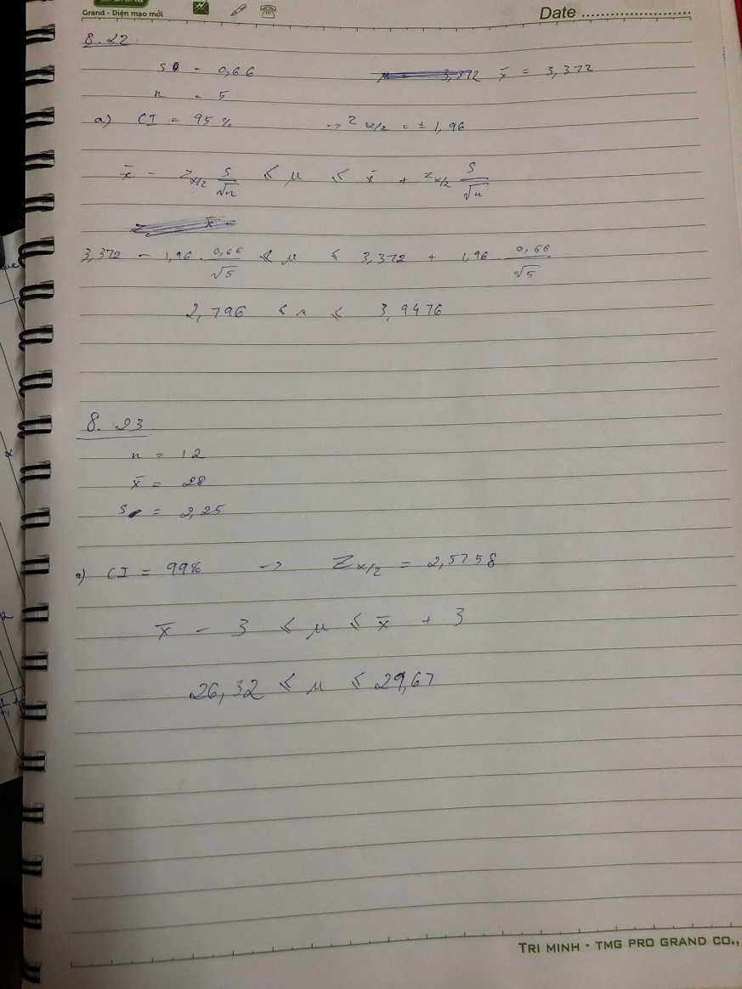

Bảng về kiểm định.

|  |  |  |  |  |  |
| --- | --- | --- | --- | --- | --- |
| Parameter | Conditions  (if any) | TEST STATISTIC | Critical values | | |
| 2 tail | Right tail | Left tail |
| Mean |  | ~N(0;1) |  |  | - |
| Mean |  | ~t(n-1) |  |  |  |
| Propotion | n large enough | =~N(0;1) |  |  | - |
| Variance |  |  |  |  |  |
| 2 MEANS |  |  |  |  | - |
| 2 MEANS |  |  |  |  |  |
| 2 PROPOTION |  |  |  |  | - |
| 2 VARIANCE |  | T =  ~ t( |  |  |  |

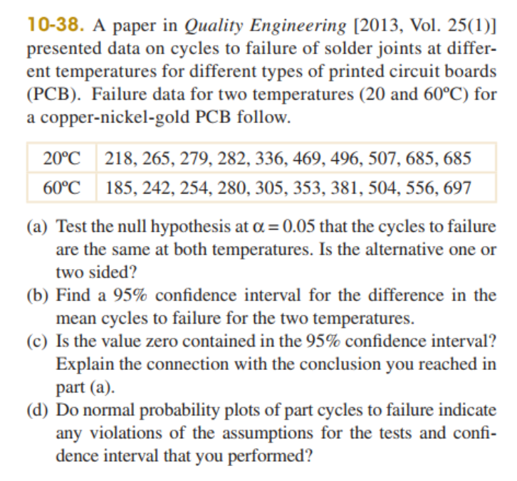

1. Ho :

H1:

Test statictics

= 422.2

= 375.7

Spooled = 27939.65

= = 0.62205

P – value = 0.5417

=0.05

* P – value >
* We do not reject Ho

1. Confidence Interval = .spooled.

⬄ (422.2 -375.7)2.101. .

⬄ 46.5

=> (-110.555 , 203.555)

1. The value zero contained in 95% beacause Confidence Interval

Bảng về REG.

