Heart beats classification method using a multi-signal ECG spectrogram and convolutional neural network with residual blocks

Dominik Siekierski
Faculty of Electrical Engineering
Warsaw University of Technology
Warsaw, Poland
01101513@pw.edu.pl

Abstract— The created solution allows to analyze electrocardiographic signal. The paper describes process of formulating a classifier on the basis information contained by MIT-BIH arrhythmia database. This data source contains electrocardiographic signals from two sensors. Both were used, which is not a common phenomenon. In the learning process, the classifier uses only information with high certainty. Data is based on expert endorsements and the errors found have been corrected over the years. Types of heartbeats were divided into special groups according to the standard "Association for the Advancement of Medical Instrumentation" (AAMI). It recommends splitting the types into five individual groups according to physiological origin. Rare types of heartbeats have a low number of occurrences. For one group, modifying methods were used which allowed to increase the amount of data in training sets. This had a positive impact on the results. The solution includes feature extraction. The main module of the classifier is a deep neural network. Good result was obtained with tools supporting automatic hyperparameter selection. In ECG signal diagnostics, the most important task is to separate the group of supraventricular and ventricular beats. The study managed to obtain this error at a very low level.
Keywords — heartbeat classification, arrhythmia, ECG signal, deep learning, spectrogram

Introduction
Cardiovascular disease is still one of the most common causes of death. In many diseases, including cardiological ones, the decision about life-saving and therapeutic methods depends on quick and correct diagnosis of the disease [4]. Many of the symptoms cover a whole range of diseases. Making a diagnosis with a high probability is not an easy task. Over time, doctors will make greater use of tools that help them make decisions in real time. Medicine already has many different solutions, mostly based on artificial intelligence methods. Algorithms often use artificial neural networks, Bayesian networks, genetic algorithms, decision trees and fuzzy logic [4]. When a short electrocardiographic record (ECG) analysis is needed, an experienced specialist will have no problem with this. The ECG examination can take up to several days. The correct heart rate can be between 60 and even 90 beats at rest. These figures give an unimaginably large collection to analyse throughout the day. Therefore automatic classification methods are needed. As a result of the analysis, the doctor receives selected fragments of the signal and proposed types of pathologies [5]. Continuous recording of medical signals is an important part of diagnostics. Monitoring and supervision of the patient's current condition allows to provide a range of information. The signal created from the sensors during a diagnostic procedure is used in medicine to diagnose heart diseases. ECG measurement is the recording of the electrical activity of the heart muscle from the surface of the chest in the form of potential difference (voltage) between the electrodes. The main objective was to create a solution that would allow the analysis of electrocardiographic signal with a high classification accuracy. The individual processing steps finally lead to the prediction of each heartbeat. The task of the algorithm is to indicate the type of heartbeat with a high level of certainty about the prediction.Initially the signal will be decoded and saved in a form more suitable for further processing. The phase also includes steps to discard information less relevant for further processing. The next step is to extract the features. Specifying the properties that differ from certain types will significantly affect the results. The most important step is to build a classifier. This tool is based on a neural network with a large number of hidden layers. An evaluation was carried out by analysing the results and comparing them with the results from work on similar subjects.
It is worth saying a little more about the database used. The long period of time it existed and its availability meant that it was often used by researchers. It was recorded using the MIT format. It contains 48 half-hour fragments of two-channel ambulatory ECG records. These were obtained from 47 people tested in the Beth Israel Hospital Arrhythmia Laboratory. Twenty-three records were selected at random from a set of four thousand available ECG records. The remaining twenty-five records were selected using the same set, but taking into account less frequent and clinically significant arrhythmia that would not be well represented using random methods. These 25 records also include cases of complex ventricular, supraventricular arrhythmias and conduction disorders. Such records will be of significant difficulty for arrhythmia detectors due to rhythm characteristics, variations in QRS morphology or signal quality. The database has been improved over the years. It contains records of ECG examination of patients with heart arrhythmia.

Methodology
The data has been pre-processed to obtain better results. Activities to enhance the differences in the processed information are called feature extraction. In order to correctly classify the types of heartbeats, several stages of analysis are necessary. A signal recording with interference can go through a filtering process to get rid of noise and artifacts. The next step is the detection of QRS unit in ECG signal. This complex is the most dominant in the time course. Unfortunately, there are types of beats which are not characterized by such a structure. Components coming from the measuring apparatus or pacemaker of the examined patient may also occur. This significantly affects the results when quite simple algorithms are used. Determining a good QRS refraction position is very important when separating time intervals. There are many libraries with a small error when it comes to finding the right parts in the ECG signal. Only the types described in the MIT-BIH database were used to train the created model. This approach was also used in [13], [20], [21] and [22]. and allows for good evaluation of the neural network model.
Size of the set of heartbeat types processed is very large. Although the information contained therein is selected to take into account certain specific and rare conditions, the number of occurrences of several types is small. A grouping method has been chosen to achieve good results and to divide the heartbeat types using reasonable relationships. Table I lists all heartbeat types and the number of heartbeats after pre-processing. The number may vary slightly due to the exclusion of ranges that occurred at the beginning or the end of the signal and did not have appropriate length for further processing. The table also contains acronyms used in medical literature.
- List of arrhythmia classes and their number.
Heartbeat Type | Acronym | Annotation | Total
Normal Beat | NORMAL | N | 74984
Left bundle branch block beat | LBBB | L | 8069
Right bundle branch block beat | RBBB | R | 7250
Atrial escape beat | AESC | e | 16
Nodal (junctional) escape beat | NESC | j | 229
Atrial premature beat | APC | A | 2544
Aberrated atrial premature beat | ABERR | a | 150
Nodal (junctional) premature beat | NPC | J | 83
Supraventricular premature beat | SVPCs/SVE | S | 2
Premature ventricular contraction | PVC | V | 7128
Ventricular escape beat | VESC | E | 106
Ventricular flutter wave | FLWAV | ! | (472)
Fusuion of ventricular and normal beat | FUSION | F | 802
Paced beat | PACE | / | 7020
Fusion of paced and normal beat | PFUS | f | 982
Unclassifiable beat | UNKNOWN | Q | 33

It is worth mentioning a certain irregularity, the descriptions on the official website [23] from which the MIT-BIH database comes from do not match the markings existing in the waveform files. The numbers, signatures and appearance of the different types have been analysed to select and change the designations accordingly. The names cited are consistent with those presented in the files and will be used in this work. The type with the designation "!" has not been included at all, mainly due to uncertainty about where it should belong. In the works [24], [16], [10] and [18], it is not included. The works [6] and [13] grouped it into a ventricular ectopic beat group. Attention should be paid to the high prevalence of normal heartbeats. Next are bundle branch blocks beat, premature ventricular contraction and paced beat. Although this is reflected in the probability of occurrence, such a distribution may affect the final results of the classifier.
The standard created by the "Association for the Advancement of Medical Instrumentation" was used in this work. The AAMI standard "EC38:2007" describes the testing and reporting of heart rate results and algorithms for measuring rhythm and impact events. It recommends grouping the types into five specific groups. According to the standard, the total MIT-BIH database should be divided according to their physiological origin. It is worth mentioning that a lot of work, is not fully compliant with the AAMI standard, because NESC and AESC classes are assigned to the group "N" instead of "S" [24]. This approach has emerged in: [13], [10] and [18]. Incorrect labelling affects 245 strokes in the database, which is 8% of all supraventricular ectopic beat. The exact grouping can be seen in Table II.
- Grouping of heartbeat types according to AAMI standard.
AAMI Classes | Symbol | MIT-BIH heart beat types | Total
Normal beat | N | NORMAL, LBBB, RBBB | 90303
Supraventricular  ectopic beat | S | APC, NPC, ABERR, SVPCs/SVE, NESC, AESC | 3024
Ventricular ectopic  beat | V | PVC, VESC | 7234
Fusion beat | F | FUSION | 802
Unknown beat | Q | PACE, PFUS, UNKNOWN | 8035

The normal heartbeat group is the largest. This is a very big disproportion, especially as these are not the types of heartbeat that a specialist should focus on when analysing the results.

Data analysis
Due ---------- availability.
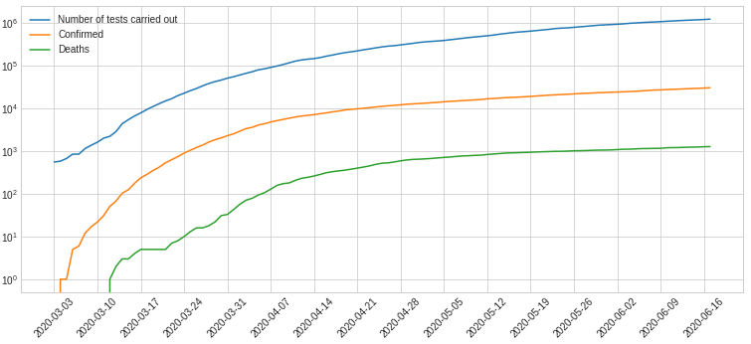
Figure 1. Logarithmic charts of selected data from the first source.

In --------- Figure 2.
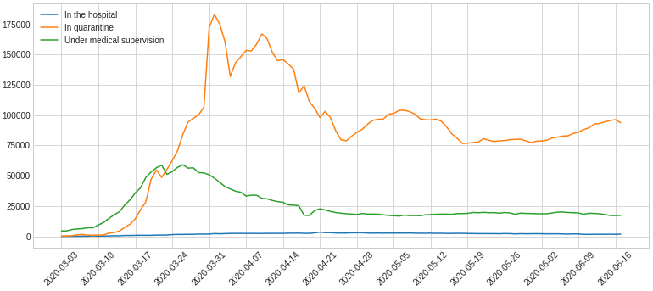
Figure 2. Line charts of selected data from the first source.

The -------------Figure 3 below.
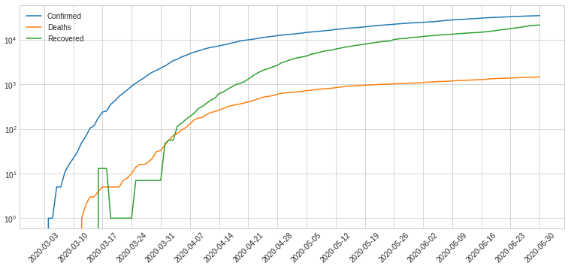
Figure 3. Logarithmic charts of selected data from the second source.

Some ----------symptoms.

Algorithms description
The --------------------- data.

Performance metrics
The -------- correct.

Results
The ----------------- small.

Performance
Two -------------- source.
- Model results by measuring the coefficient of determination. Based on testing data.
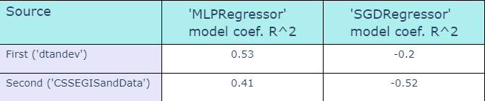
The ---------- assumptions.
- Model results by measuring MAE, MSE and RMSE. Based on testing data.
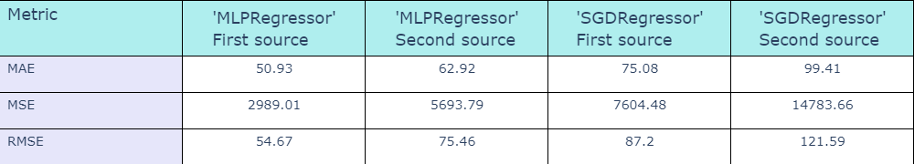
The ------------- source.
- Model results by measuring Execution Time. Based on testing data.
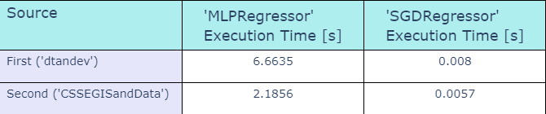
First --------------- algorithm.

Summary
The -------------possible.

Bibliography
[1] | Scikit-learn developers, “MLPRegressor,” 2007. [Online]. Available: https://scikit-learn.org/stable/modules/generated/sklearn.neural_network.MLPRegressor.html. [Accessed 29 June 2020].
[2] | Scikit-learn developers, “SGDRegressor,” 2007. [Online]. Available: https://scikit-learn.org/stable/modules/generated/sklearn.linear_model.SGDRegressor.html. [Accessed 29 June 2020].
[3] | D. Tanajewski, “2020 Poland coronavirus data (COVID-19 / 2019-nCoV),” 2020. [Online]. Available: https://github.com/dtandev/coronavirus. [Accessed 29 June 2020].
[4] | CSSE at Johns Hopkins University, „Novel Coronavirus (COVID-19) Cases, provided by JHU CSSE,” 2020. [Online]. Available: https://github.com/CSSEGISandData/COVID-19. [Data uzyskania dostępu: 29 June 2020].
[5] | Taylor & Francis, “Multiple linear regression, multi-layer perceptron,” Hydrological Sciences Journal, vol. 61, no. 6, pp. 1001-1009, 2016.
[6] | A. B. Nassif, D. Ho and L. F. Capretz, “Towards an early software estimation using log-linear regression and a multilayer perceptron model,” The Journal of Systems and Software, no. 86, pp. 144-160, 2013.
[7] | B. Carpenter, Lazy Sparse Stochastic Gradient Descent for Regularized Mutlinomial Logistic Regression, 2018.
[8] | Scikit-learn developers, “Standard Scaler,” 2007. [Online]. Available: https://scikit-learn.org/stable/modules/generated/sklearn.preprocessing.StandardScaler.html. [Accessed 29 June 2020].
[9] | Medium, “MAE and RMSE — Which Metric is Better,” 2016. [Online]. Available: https://medium.com/human-in-a-machine-world/mae-and-rmse-which-metric-is-better-e60ac3bde13d. [Accessed 29 June 2020].

