Doc how to use Bootstrap – SIO Website

Bootstrap is a Framework which enables us to build a website rapidly and ensures a good and responsive rendering.

I – Bootstrap’s grid

Bootstrap has a grid of 12 columns and as many rows as it is desired that can be used to place the elements. ( see below )

The lines are called with a block with the class “row”.

The columns are called with blocks with the class “col-lg-x col-md-x col-sm-x col-xs-x”. ( x corresponds to the number of columns, lg : large screen, md: medium screen, sm : tablets, xs : smartphones )

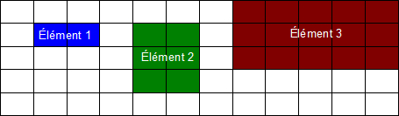

So the design will always be responsive because the grid change itself depending on the screen size.

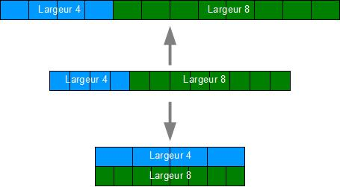

II – Website Creation

First, the menu was created using the “navbar” bootstrap. To add more buttons, simply add items to the list with the class : “navbar-nav”.

Each page runs on the same model, we alternate between a “section” and “section-colored”. Each section has a container block to define the content of the website. Then simply includes rows and columns to divide graphics architecture.

The footer works with bootstrap’s lists.