Flow Designer Components

# Trigger

## Identify trigger type

When configuring a trigger, the first step is to identify the **Trigger Type**. The Trigger drop-down menu provides a list of available options:

* **Record-based** flows run **after** a record is created or updated. The flow can use the triggering record as input for actions.
* **Schedule-based** flows run a flow at a specified time of day, week, or month. The flow can use the execution time as input for actions.
* **Application-based** flows have a **MetricBase** choice and a **Service Catalog**choice. They are available as selections when the associated application is activated *(e.g. the MetricBase trigger is present when the MetricBase application is active)*.

For more information, see [ServiceNow documentation](https://docs.servicenow.com/bundle/quebec-servicenow-platform/page/administer/flow-designer/reference/flow-triggers.html).

## Select table

NOTE: The ITSM application is required to access the Task table.

## Build conditions

Then, select the **Add filters** icon to open the Condition Builder. It can be used to construct a condition statement that identifies a particular field value in the identified table that must **also evaluate to true**.

Conditions are optional and do **NOT** need to be included if they are not required.

## Run Trigger

When you configure the trigger for a flow to run when a record is **Updated**, or **Created or Updated**, you must select a Run Trigger option.

Select the information icon to review the definition for each strategy.

**IMPORTANT**: *Flows that have a record trigger that runs****For each unique change****can produce recursions when run in a non-interactive session. When these flows make a change to the trigger record, the change meets the flow trigger conditions and causes a recursion.*

## Advanced Options

Lastly, you can also identify any User Session requirements needed to start the flow with advanced options. Select the **Advanced Options**button to display their menus.

### Interractive session option

* **Only Run for Non-Interactive Sessions** - flows that have a record trigger that runs 'For each unique change' can produce recursions when run in a non-interactive session.
* **Only Run for User Interactive Session** - only trigged in interactive sessions.
* **Run for Both Interactive and Non-Interactive Sessions** - flow is triggered in all sessions. Flows that have a record trigger that runs 'For each unique change' can produce recursions when run in a non-interactive session.  *(Default setting)*

### User Options

* **Do not run if triggered by the following users** - flow does NOT trigger for the selected list of users.
* **Only run if triggered by the following users** - flow only triggers for the selected list of users.
* **Run for any user** - flow runs for all users. *(Default setting)*

### Table Options

* **Run only on current table -**Flow that is only triggered for the selected table.
* **Run on current and extended tables** - Flow that is triggered for the selected table and any extended tables.

### Where to run the Flow

* **Run flow in background** - Flow that runs asynchronously in the background.
* **Run flow in foreground** - Flow that runs synchronously. May block the current session thread and prevent user input until the flow finishes.

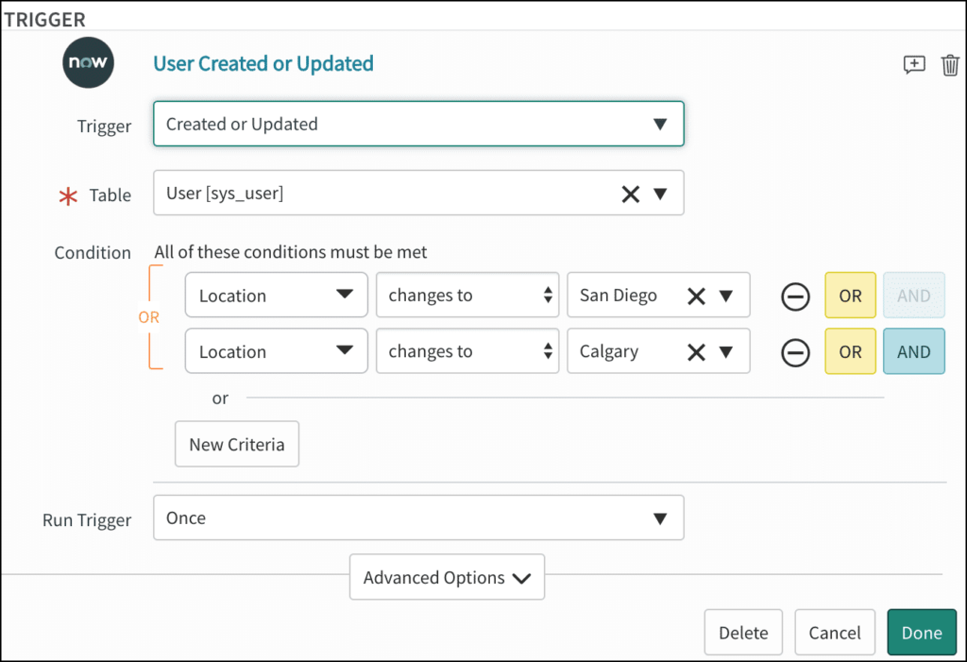*Example of configurated Trigger*