Flow Designer Introduction

# What's?

A flow

* Automates business logic for an application or process.
* Is an **automated sequence** of actions that runs**each time a condition is met**.
* Is **repeatable**.
* Performs the same**predefined process** every time it executes.

# **Flow Designer vs. Workflow**

If you are creating something new, always begin with Flow Designer. However there are a few circumstances when you should still use [Workflow](https://docs.servicenow.com/bundle/newyork-servicenow-platform/page/administer/workflow/concept/c_WorkflowOverview.html).

* Instance is running on an earlier release than Kingston.
* If the process requires very complex/scripted flow logic, it can be written in Workflow and called from a flow.
* Changing logic already developed using Workflow.
* Steps required do not exist yet in Flow Designer and require unsupported protocols.  There is only a handful of situations were this true.
* You are on an instance before Orlando and SLA Timer is required.

# Manage access

* By assigning Flow Designer **delegated development**permission.
* Or by granting one or more Flow Designer **Role(s)**.

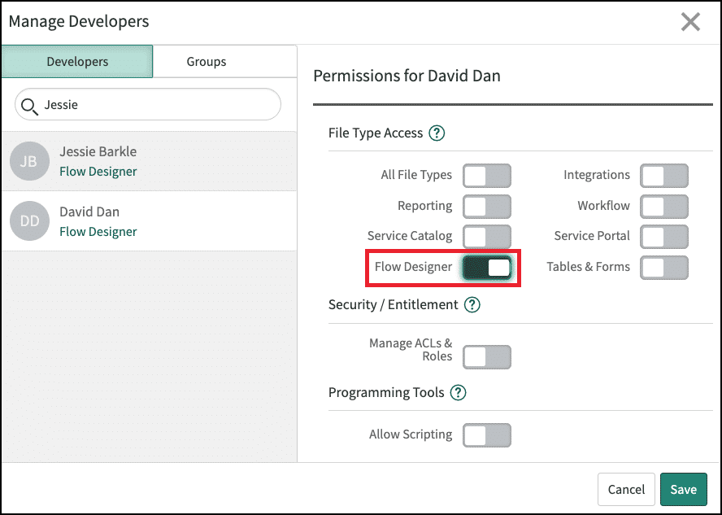

* Navigate to**System Applications > Studio** on the Application Navigator.
  + Select the application of interest.
  + Navigate to **File > Manage Developers**.
  + Select a user's name using the **Developer Name**filter.
  + Turn on **Flow Designer**.
  + Select **Save**.

# Access roles

## flow_designer

Enables a user to launch the Flow Designer design environment to create and edit flows and subflows.

## flow_operator

Enables a user to view flow execution details, dashboards, and logs. Grant this role to users so they can view flow results but not create, change, or test them.

## action_designer

Enables a user to launch the Action Designer design environment to create and edit actions.

**CAUTION!**

Granting the **flow_designer** role is the equivalent of granting the **admin** role.

Flow Designer can run flows as the System user, which has access to all tables and all database operations.

# Prepare the Flow

First step in creating a flow is to understand what you are building.

* Document every step of the process to be automated.
* Ensure the design is thought through before you develop anything!

# Understand Flow processing

1. The scheduler **creates an entry in the event queue** to start the flow.
2. The **system** **processes the event and starts the flow** in the background.
3. The **system** **builds a process plan**from the flow.
4. Using the record that triggered the flow, the **system** **runs the process plan**.
5. The **system** **stores the execution details** in a context record.