**[BEP AN TOAN]**

**Team 1**



**Automation Test Plan**

**Created by: Hoan Tran**

**Version: 1.0**

**December, 13st , 2024**

**Table of Contents**

**1.** **INTRODUCTION 3**

**2.** **TEST OBJECTIVES 3**

**3.** **TEST STRATEGY 3**

***3.1.*** ***Scope of Testing* 3**

*3.1.1.* *In scope testing 3*

*3.1.2.* *Out of scope testing 3*

***3.2.*** ***Test Levels and Test Types* 4**

***3.2.1.*** ***Test levels* 4**

***3.2.2.*** ***Test types* 4**

***3.3.*** ***Risks* 5**

**4.** **TEST CRITERIA 5**

***4.1.*** ***Entry Criteria* 5**

***4.2.*** ***Suspension Criteria* 6**

***4.3.*** ***Exit Criteria* 6**

**5.** **RESOURCE PLANNING 6**

***5.1.*** ***System resource* 6**

***5.2.*** ***Test Resource* 7**

**6.** **SCHEDULE AND ESTIMATION 7**

**7.** **TEST DELIVERABLE 7**

**8.** **AUTOMATION TESTING TOOL AND STRATEGY 9**

***8.1.*** ***Testing process* 9**

***8.2.*** ***Automation strategy* 9**

***8.3.*** ***Automation testing framework* 9**

**9.** **LIFECYCLE OF BUG AND RISK 10**

1. **INTRODUCTION**

The purpose of the project is to build the system that *[BEPANTOAN*:Introduce to customers information about the machine (cotton brand, origin, price, etc. so that consumers can easily choose the model that suits them)*]*. The Test Plan determine the scopes, objectives and risk of testing. Defining the overall test approach, the overall framework, enviroment that will support test activities, resolution for risk and contingency, test criteria, timeline and resource planning.

Build automation test scripts which using for regression test phase.

1. **TEST OBJECTIVES**

* Ensure the sorting function works as expected without any critical errors.
* Ensure the response time for sorting meets expectations.
* Testing Sorting When Data is Paginated.

1. **TEST STRATEGY**
   1. *Scope of Testing* 
      1. *In scope testing*

In scope items will be system testing as usability of below features.

The following is the list features to be tested in this project:

| No. | UserStory/Function | Degree of complex |
| --- | --- | --- |
| 1 | Bếp từ - lọc theo hãng | 2 |
| 2 | Bếp từ - lọc theo mức giá | 2 |
| 3 | Bếp từ - lọc theo xuất xứ | 2 |
| 4 | Bếp từ - lọc theo số bếp | 2 |
| 5 | Bếp từ - lọc theo phân loại | 2 |
| 6 | Bếp từ - lọc theo danh mục | 2 |
| 7 | Máy rửa chén bát - lọc theo hãng | 2 |
| 8 | Máy rửa chén bát - lọc theo mức giá | 2 |
| 9 | Máy rửa chén bát - lọc theo xuất xứ | 2 |
| 10 | Máy rửa chén bát - lọc theo số bộ | 2 |
| 11 | Máy rửa chén bát - lọc theo kích thước | 2 |
| 12 | Máy hút mùi - lọc theo hãng | 2 |
| 13 | Máy hút mùi - lọc theo mức giá | 2 |
| 14 | Máy hút mùi - lọc theo xuất xứ | 2 |
| 15 | Máy hút mùi - lọc theo công xuất | 2 |
| 16 | Máy hút mùi- lọc theo kích thước | 2 |
| 17 | Máy hút mùi- lọc theo danh mục | 2 |

Degree: 1 – Complex, 2 – Medium, 3 – Low

* + 1. *Out of scope testing*

There are some out of scope items:

* Database test
* Mobile test
* Performance test
* Security test
* API test
  1. *Test Levels and Test Types*
     1. *Test levels*

| **No.** | **Test level** | **Method** | **People in charge** | **Note** |
| --- | --- | --- | --- | --- |
| 1 | Integration test | Manual/Automation | Tester | * Testing the integration of systems and packages; testing interfaces to external organizations * Test to find defects in the interfaces and in the interactions between integrated components or systems |
| 2 | System test | Manual/Automation | Tester | Verify that the whole system meets with requirements |
| 3 | User acceptance test | Manual/Automation | Client | Client test the system to make sure that the system is met the requirement. To make sure the useablitiy, maintanceability, reliablity. |

* + 1. *Test types*

| **No.** | **Test type** | **Method** | **People in charge** | **Notes** |
| --- | --- | --- | --- | --- |
| 1 | Review requirement (static testing) | Manual | Tester | To verify the correction and level of detail of User Story |
| 2 | Review code | Automated/Manual | Dev team | Self-review, Peer Review |
| 3 | Functional testing (dynamic testing) | Manual | Tester/Dev team | Verify that the system meets functional requirement |
| 4 | Non-functional testing | Manual | Tester | Performance test, API test, Security test |
| 5 | Re-testing | Manual | Tester/Dev team | Testing after fixing bug to confirm the bug is removed |

* 1. *Risks*

| **No.** | **Risk** | **Mitigation** |
| --- | --- | --- |
| 1 | Requirement contains a lot of technical related to encryption and module communication, not to mention a huge amount of distributed actor, leads tester to difficult to design test cases | * Testers need to review user story/requirement before writing test cases (usually the first 2 days of each Sprint) * Improve communication in the team * Peer review testcase |
| 2 | Project schedule is tight and short, it may be hard to complete testing on time | * Set priority for test activities: focus testing on the features that contains many critical bugs * Writing test checklist instead of test cases step by step if not enough time |
| 3 | System is complex so deployment may be has potential issue | In sprint planning, team need to clarify deployment schedule |

1. **TEST CRITERIA**
   1. *Entry Criteria*

The entry criteria refer to the conditions in order to start testing activities (test design, test execution):

1. The specification of a feature is approved and available on Jira before starting test design
2. Development completed (status must be Ready for test)
3. Features under test are already on QC environment
4. Test cases, test data are peer-review before test execution

*4.2 Suspension Criteria*

The suspension criteria refer to the conditions that test activities will be suspended if suspension criteria are met during testing:

1. Any main flows are not covered
2. Main feature does not meet acceptance criteria

*4.3 Exit Criteria*

The exit criteria are the targeted results of the test that need to be met to complete a test phase:

1. 100% of Test cases executed
2. No Critical, high, medium bug remaining
3. 5 % leakage (total bugs found by client / total bugs) : lọt lỗi sang khách hàng: khách hàng tìm được 5 bugs / 100 bugs team dự án tìm
4. **RESOURCE PLANNING**
   1. *System resource*

| No. | Resources | Description |
| --- | --- | --- |
| 1 | Server | * Not defined |
| 2 | Test tool | * Selenium: Automated testing tool for web applications, supporting multiple browsers. - * TestNG: Testing framework for Selenium. * Google Sheets: Manage and track test cases, easily share and update in real time. |
| 3 | Computer | * The PCs with hardware, software required |
| 4 | **Mobile device** | * *Not defined* |
| 5 | **Web browser** | * *Chrome 131.0.6778.205* |

* 1. *Test Resource*

| **Name** | **Role** | **Start date** | **End date** |
| --- | --- | --- | --- |
| Đỗ Đức Thinh | Tester work 100% | 13-Dec, 2024 | 23-Dec, 2024 |
| Hoàng Đức Trí | Tester work 100% | 13-Dec, 2024 | 23-Dec, 2024 |
| Đặng Thị Thanh Huệ | Tester work 100% | 13-Dec, 2024 | 23-Dec, 2024 |

1. **SCHEDULE AND ESTIMATION**

| **No.** | **Task** | **Member** | **Estimation Effort**  **(Man-day)** |
| --- | --- | --- | --- |
| 1 | Create test plan | Team | 1 |
| 2 | Study & review requirements | Team | 2 |
| 3 | Create test design, test cases | Team | 4 |
| 4 | Test execution | Team | 5 |
| 5 | Test report & Quality Control | Team | 2 |

1. **TEST DELIVERABLE**

| **Phase** | **Deliverable Name** | **How to access** |
| --- | --- | --- |
| **Before testing** | Test Plan | Test plan will be uploaded on Confluence  <https://conf.codestar.com/display/CDIS/Test+plan> |
| Test cases documents | All test cases will be uploaded on Confluence and Zephyr which is an Jira’s Add-On.  Link Confluence:  <https://conf.codestar.com/display/CDIS/Test+cases>  - Jira filter:  Open Advanced Search, then enter below JQL:  *project = CDIS AND issue type = Test* |
| **During testing** | Test cycles | Each Sprint will have at least 1 test cycle for executing sets of test cases.  Please follow this example to filter the test cycle: |
| **After testing** | Test reports | Test reports will be created after each sprint and published on Confluence: [https://conf. codestar.com/display/CDIS/Test+reports](https://conf.gemvietnam.com/display/CDIS/Test+reports) |
| Bugs | All bugs logged on Jira   * Sprint bugs are sub-tasks of the corresponding User story * Bugs/Improvement are linked to User stories, not add into current sprint |

1. **AUTOMATION TESTING TOOL AND STRATEGY**
   1. *Testing process*

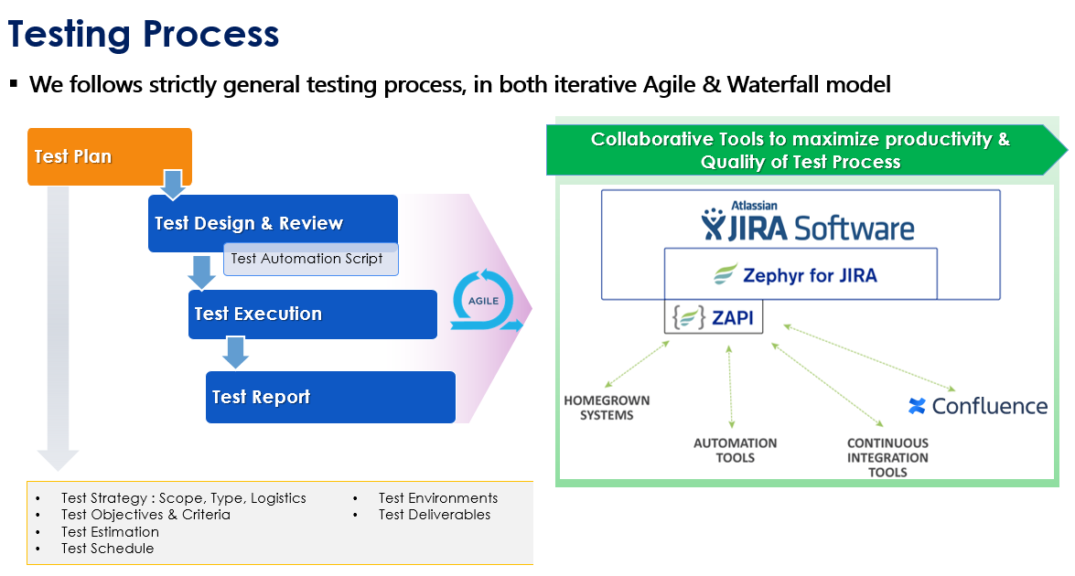

* 1. *Automation strategy*

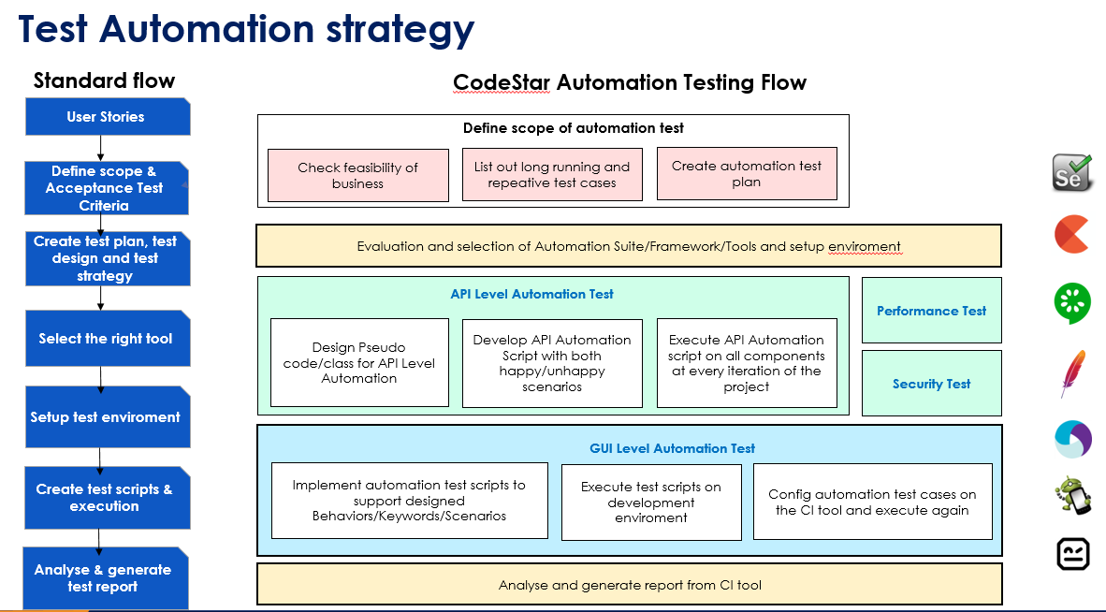

* 1. *Automation testing framework*

**Framework library/ tools:**

* Maven
* TestNG
* Github
* Selenium

**Language**:

* Java
* Python
* C#
* Javascript

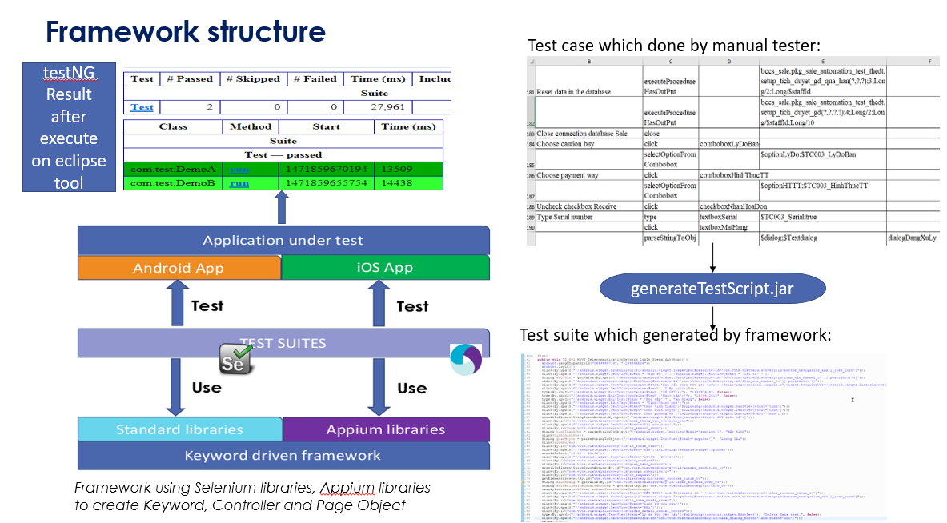

1. **LIFECYCLE OF BUG AND RISK**

BUG LIFECYCLE

