- docker –version
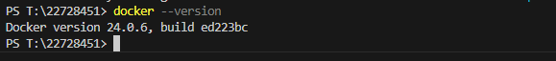
- docker run hello-world

- docker pull nginx
