Sandy Noble original polargraph

<http://www.polargraph.co.uk> – lots of stuff

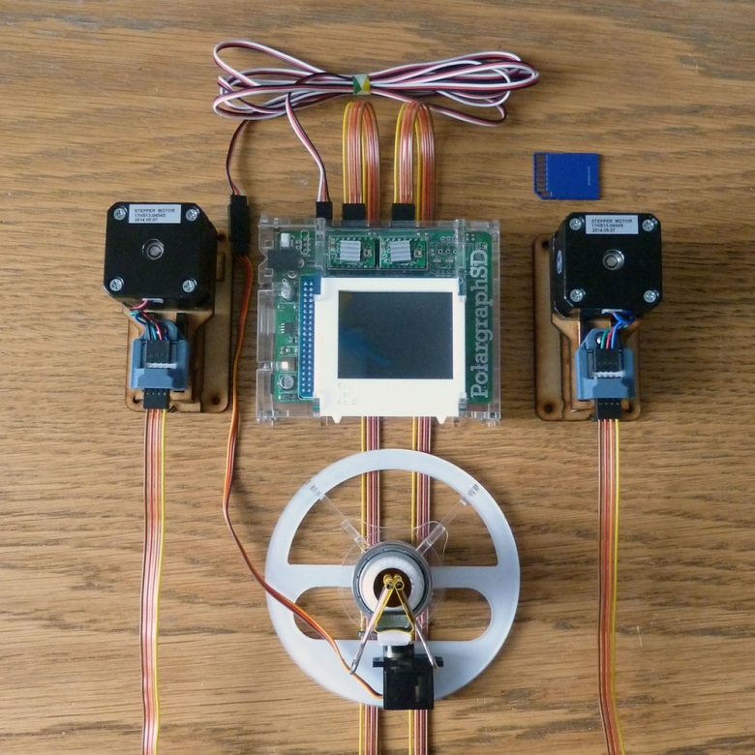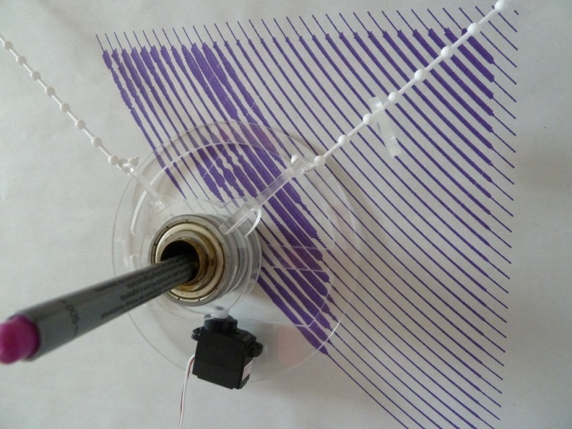

<http://www.instructables.com/id/Polargraph-Drawing-Machine/>

<https://github.com/euphy/polargraphcontroller/releases/tag/2016-03-29-10-23>

Makelangelo

<http://www.makelangelo.com/> Buy from <https://www.marginallyclever.com/product/makelangelo-2-5-2/>

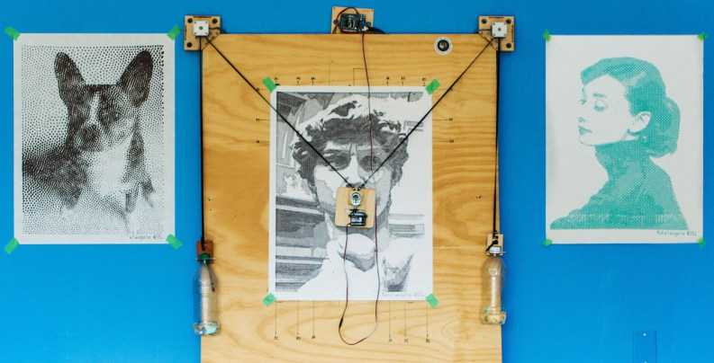

https://www.marginallyclever.com/product/makelangelo-software/

Mark Benson - Make Bournemouth

<https://www.makebournemouth.com/?tag=polargraph>

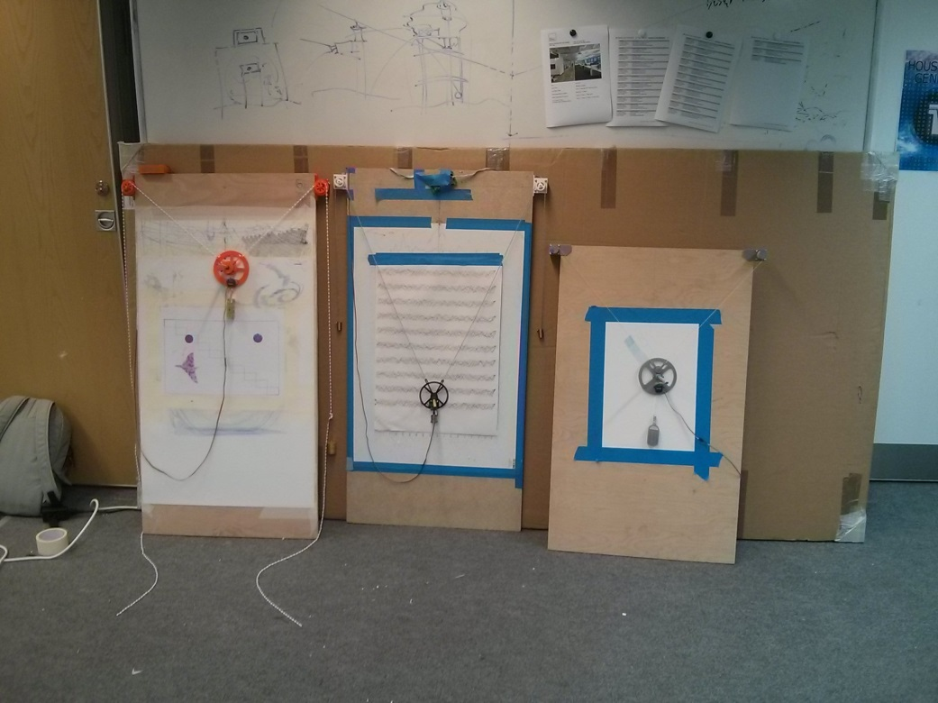

*“The one on the left is running the*[*Gocupi*](https://github.com/brandonagr/gocupi)*firmware and is being run with [Pycupi](https://github.com/brianinnes/pycupi" \t "_blank) a Python port/rewrite of the Gocupi ‘*[*Go*](https://golang.org/)*‘ control software.*

*The other two are running the*[*Polargraph.co.uk*](http://www.polargraph.co.uk/)[*a1\_server firmware variant modified to run on our*](https://github.com/MarkJB/polargraph_server_a1)[*electronics*](https://github.com/MarkJB/Eggbot-Spherebot-Polargraph-Controller)*.*

*The one in the middle is running with [Pylargraph](https://github.com/MarkJB/pylargraph" \t "_blank) which is a Python script to control the original firmware with the intention of plotting or graphing the result of a regular twitter search.*

*The other is running with the*[*Polargraph.co.uk control software*](http://polargraph.co.uk/)*.*

*The various 3d printed parts are our own designs or modified versions of existing designs.*

*My own designs are available on [github](https://github.com/MarkJB/Polargraph-printed-parts" \t "_blank) and [thingiverse](http://www.thingiverse.com/MarkBenson/collections/polargraph" \t "_blank) but not everything is finished.”*

<https://github.com/MarkJB/Polargraph-printed-parts>

<http://www.thingiverse.com/MarkBenson/collections/v-plotter-polargraph-stuff>

We’ve had a go at the gondola , which appears small and fragile – we think that the disc touching the drawing surface improved stability

Experimented with another disc further from the drawing surface to move the centre of gravity back

<https://www.makebournemouth.com/?p=831> Pycupi v-plotter control software

Alex Weber – Der Kritzler– Designed for writing on windows!

<https://tinkerlog.com/2011/09/02/der-kritzler/>

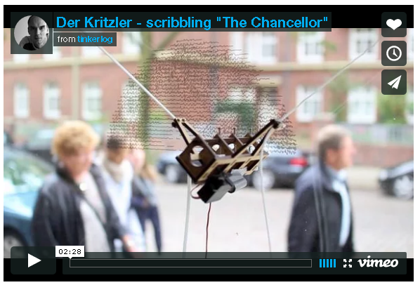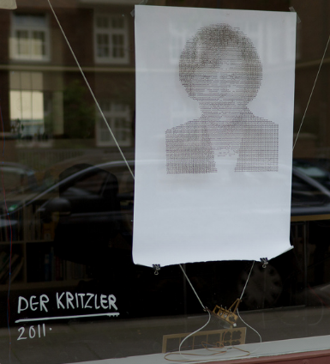

<https://github.com/tinkerlog/Kritzler>

Jacob Gertsch – LinuxCNC Bipod Plotter

<https://www.youtube.com/user/ArduinoBeam>

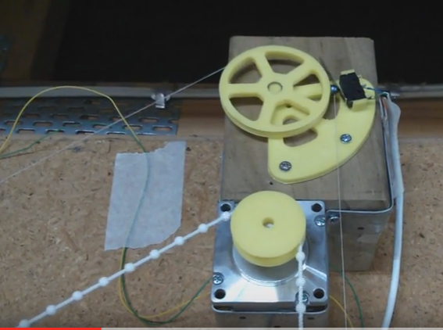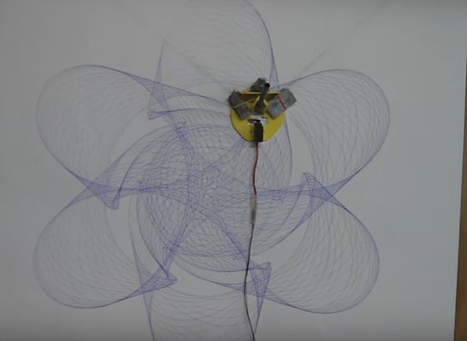

<https://github.com/Chojins/LinuxCNC-Polargraph> (mainly using Solidworks)

<https://github.com/Chojins/Guilloche-Designer> (spirograph-type designs)

Jakob Flierl - Koppi’s Toy (uses a toothed belt)

<http://wiki.linuxcnc.org/cgi-bin/wiki.pl?Koppi%27s_Toy>

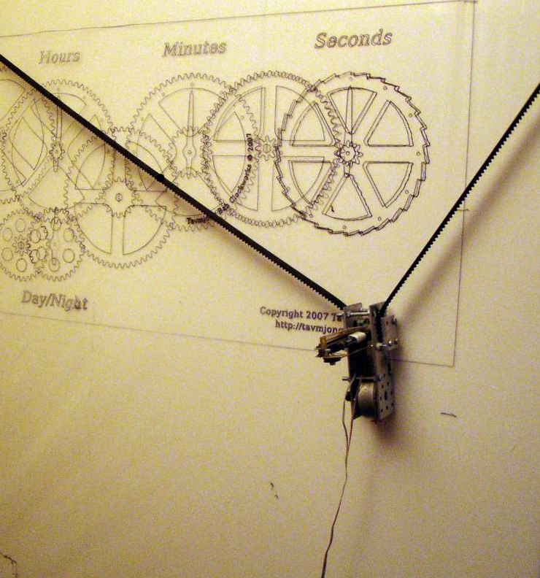

Matt Venn

<http://www.mattvenn.net/2011/09/19/polargraph-energy-monitoring/>

<http://www.mattvenn.net/2015/12/19/megadrawbz/>

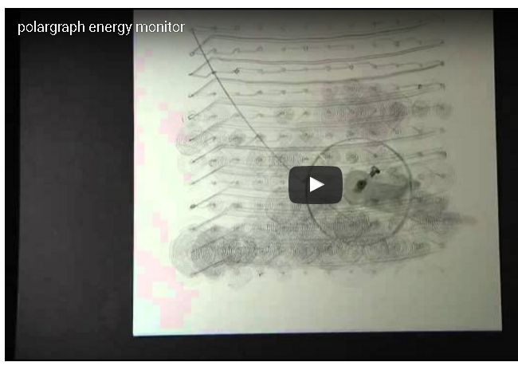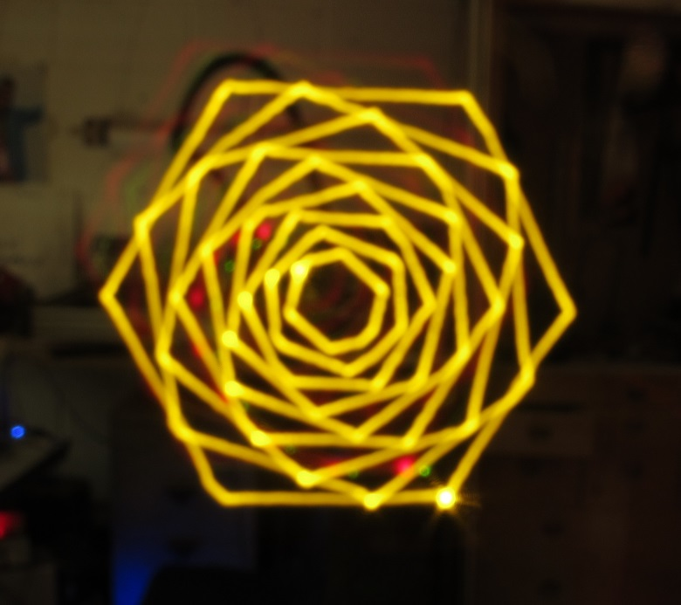

Brandon Dunson / Brandon Green - Gocupi Raspberry pi polargraph

https://github.com/brandonagr/gocupi

<https://www.kickstarter.com/projects/1412673920/gocupi-turns-your-raspberry-pi-into-a-portable-pol>

<http://www.geeky-gadgets.com/transform-your-raspberry-pi-into-a-portable-polargraph-with-gocupi-05-08-2014/>

https://blog.adafruit.com/2012/11/23/gocupi-go-raspberry-pi-polargraph-piday-raspberrypi-raspberry\_pi/

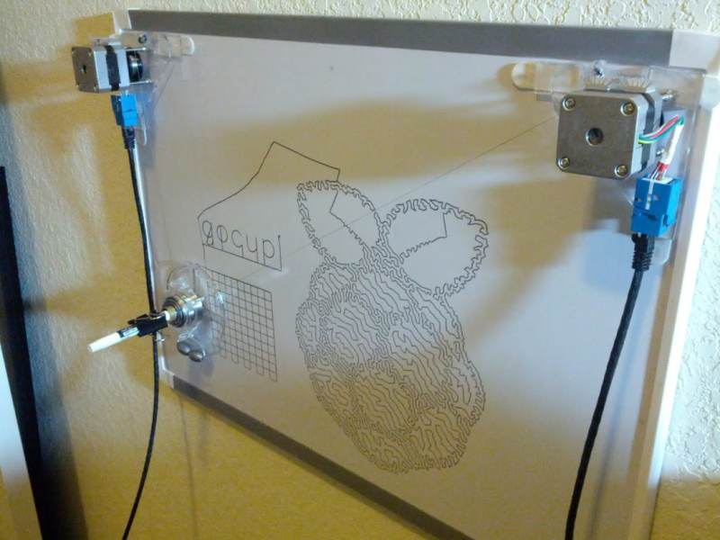

*“This project is different from most other Polargraphs in that there is no step generation code on the arduino, everything is calculated in Go and then the arduino just receives a stream of step deltas that it stores in a memory buffer and then executes. Since all logic is written in Go running on the Pi it allows using more advanced interpolation models for smooth drawing, not needing to use fixed point or single precision floats for calculations, not needing to reflash the arduino often when making code changes, etc.”*