Link download Github: <https://desktop.github.com/>

**UPDATE**

1. In the **Help** menu, click **About GitHub Desktop**.

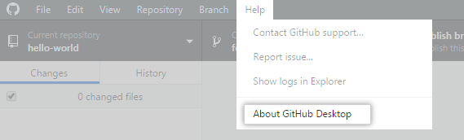

1. Click **Check for Updates**.

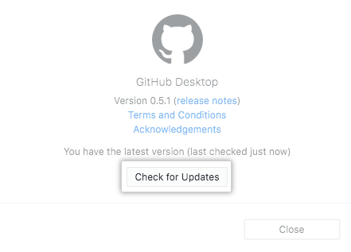

1. If an update is available, quit and relaunch GitHub Desktop to install the update.

**COMMIT**