

**<<Project name>>**

**Software Design Document**

– HCM, September2022–

**Table of Contents**

I. Overview 3

1. Code Packages 3

2. Database Schema 3

II. Code Designs 4

1. <Feature/Function Name1> 4

a. Class Diagram 4

b. Class Specifications 4

c. Sequence Diagram(s) 4

d. Database queries 5

2. <Feature/Function Name2> 5

III. Database Tables 5

1. <Table name 1> 5

2. <Table name 2…> 5

# I. Overview

## 1. Code Packages/Namespaces

***Package descriptions & package class naming conventions***

|  |  |  |
| --- | --- | --- |
| **No** | **Package** | **Description** |
| *01* | *View* | *Web view for admin, host, user, guess* |
| *02* | *Controller* | *Controller of admin, host, user, website* |
| *03* | *DAO* | *List house* |
| *04* | *Filter* | *Sort for admin, host, user* |
| *05* | *Ultils* | *Database sql* |
| *06* | *Model* | *Information of Address, Bill, house, district,….* |

## 2. Database Schema

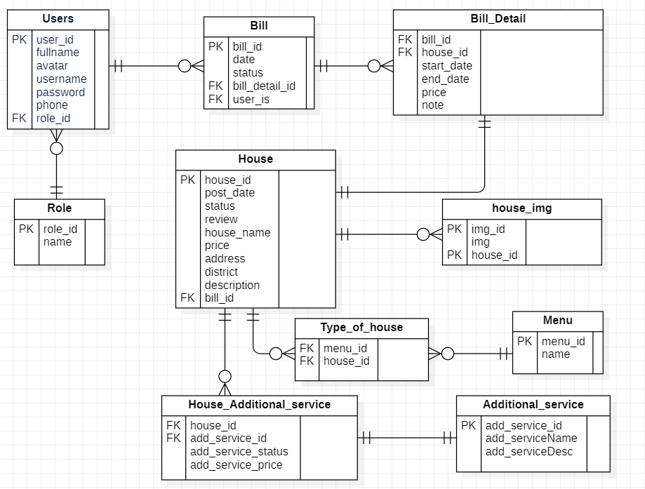

***Table descriptions & package class naming conventions are as below***

|  |  |  |
| --- | --- | --- |
| **No** | **Table** | **Description** |
| 01 | Users | Information of admin, host, custommer.  - Primary keys: user_id  - Foreign keys: role_id |
| 02 | Bill | Information of bill: status of bill, signing date, name’s customer, name’s host  - Primary keys: bill_id  - Foreign keys: (user_id, bill_detail_id) |
| 03 | Bill_detail | Contain detail of bill: rental start date, retal end date, price, note, detail of house  - Primary keys: non  - Foreign keys: (house _id,bill_id) |
| 04 | House | Contain house information: post date, status: rented or not, old customer’s review  - Primary keys: house_id  - Foreign keys: bill_id |
| 05 | House_img | Contain image of house  - Primary keys: img_id  - Foreign keys: house_id |
| 06 | role | Position of user: admin, host, customer  - Primary keys: role_id  - Foreign keys: non |
| 07 | Type_of_house | connection between houses and menu to determine types of houses  - Primary keys: img_id  - Foreign keys: house_id |
| 08 | Menu | Type of house: single-storey house, villa,……..  - Primary keys: menu_id  - Foreign keys: name |
| 09 | Additional_service | Detail of house’s service: name, description  - Primary keys: add_service_id  - Foreign keys: non |
| 10 | House_Additional_service | connection between houses and service have status and price of service  - Primary keys: non  - Foreign keys: (house_id, add_service_id) |

# II. Code Designs

## 1. <Feature/Function Name1>

*[Provide the detailed design for the function <Feature/Function Name1>. It include Class Diagram, Class Specifications, and Sequence Diagram(s)]*

### a. Class Diagram

*[This part presents the class diagram for the relevant feature]*

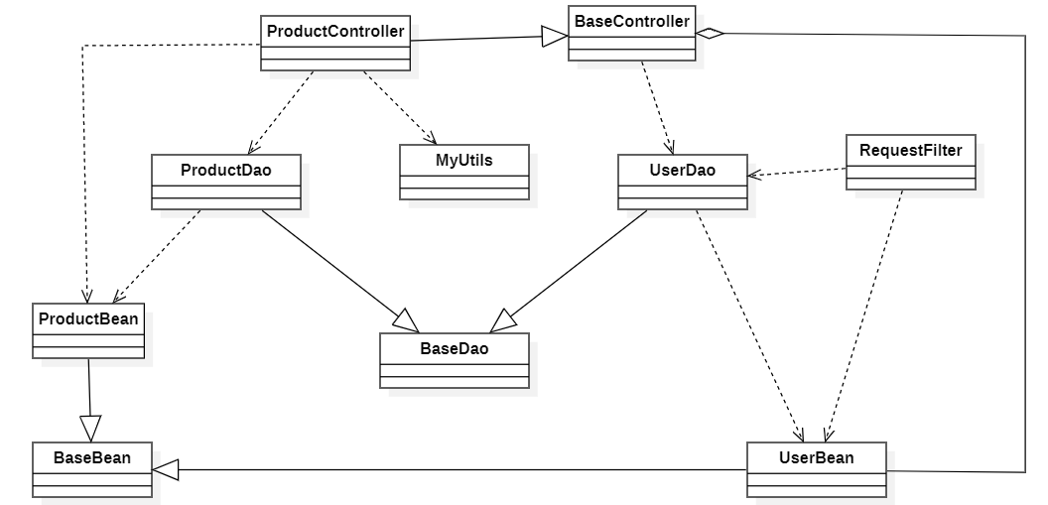

### b. Class Specifications

*[Provide the description for each class and the methods in each class, following the table format as below]*

#### XYZ Class

*[Provide the detailed description for the class methods]*

|  |  |  |
| --- | --- | --- |
| **No** | **Method** | **Description** |
| *01* | *<method name>* | *<Description of the method, including the inputs, outputs & internal method processing>* |
|  |  |  |

#### ABC Class

***Class Methods***

*[Provide the detailed description for the class methods]*

|  |  |  |
| --- | --- | --- |
| **No** | **Method** | **Description** |
| *01* | *<method name>* | *<Description of the method, including the inputs, outputs & internal method processing>* |
|  |  |  |

### c. Sequence Diagram(s)

*[Provide the sequence diagram(s) for the feature, see the sample below]*

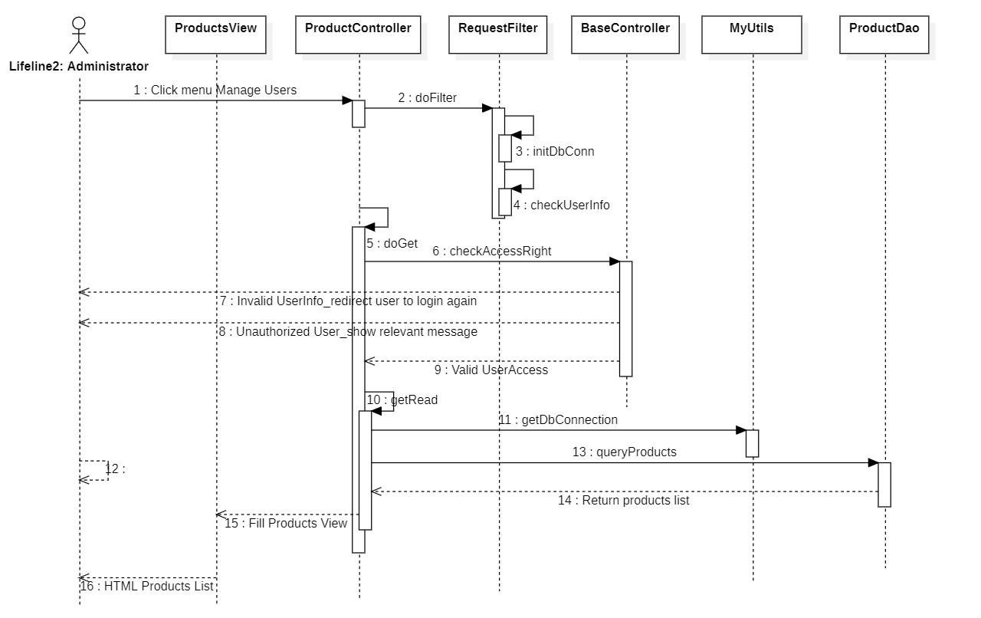

### d. Database queries

*[Provide the detailed SQL (select, insert, update...) which are used in implementing the function/screen]*

## 2. <Feature/Function Name2>

…

# III. Database Tables

## 1. <Table name 1>

*[Give some lines about the table here>>*

*[Table fields, in the form of table format as below]*

|  |  |  |  |  |  |  |  |
| --- | --- | --- | --- | --- | --- | --- | --- |
| **#** | **Field name** | **Type** | **Size** | **Unique** | **Not Null** | **PK/FK** | **Notes** |
| 1 | Field name1 |  |  |  |  |  |  |
| 2 | Field name2 |  |  |  |  |  |  |

## 2. <Table name 2…>