RIZKY MAULANA SAPUTRA  Full Stack Web Developer | Backend & Frontend Developer | System Analyst | IT Support  Bekasi, Indonesia | +62 856-9799-2400 | rizkyms123@gmail.com  LinkedIn: www.linkedin.com/in/rizkymaulanasaputra14 | GitHub: https://github.com/DoICare | 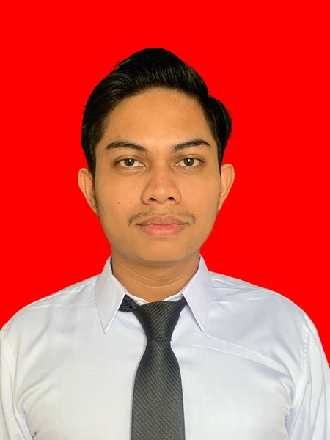
PROFESSIONAL SUMMARY
Informatics Bachelor's graduate from Universitas Gunadarma (GPA 3.68/4.00) and certified Junior Web Programmer (LSP/BNSP). Possesses strong hands-on expertise in Full Stack Web Development (Frontend & Backend), System Analysis, Relational Database Management (MySQL, Oracle, SQL Server), and IT Network/Technical Support. Proven track record in leading cross-functional software teams as a Project Manager while actively contributing to end-to-end development using PHP (Laravel), JavaScript (React.js, Next.js), Go (Golang), and MySQL. Adept at translating stakeholder requirements into scalable, user-centric web applications and delivering reliable technical solutions.
EDUCATION
Universitas Gunadarma — Bekasi, Indonesia — 2022 – 2026
Bachelor of Informatics (S.Kom.) | Fresh Graduate | GPA: 3.68 / 4.00
- Relevant Coursework: Software Project Management (PPPL), Web Programming, Software Engineering, Database Management Systems (DBMS), System Analysis & Design, Computer Networks, and Artificial Intelligence.
PROJECT EXPERIENCE
Public Service & Announcement Information System – Manggarai Selatan Sub-District — October 2025 – December 2025
Project Manager & Full Stack Web Developer | Community Service Project (PKM) – Software Project Management Course | South Jakarta
- Stakeholder Initiation & System Analysis: Initiated direct consultations with Manggarai Selatan Sub-District officials to gather requirements, analyze administrative workflows, and define system specifications for public service and announcement management.
- Project Management & Leadership: Led the project lifecycle from timeline planning and task allocation to weekly progress tracking, and spearheaded the final presentation and live system demonstration before sub-district officials.
- End-to-End Full Stack Development: Actively developed responsive frontend interfaces (HTML5, CSS3, JavaScript), engineered backend application logic (PHP), and designed the relational database schema (MySQL).
- Testing & Quality Assurance: Conducted comprehensive functional testing and end-to-end debugging across all modules to ensure zero critical defects and seamless deployment in alignment with stakeholder expectations.
BusOnline – Intercity Bus Ticket Aggregator Platform across Java — 2024 – 2026
Full Stack Web Developer | Scientific Research Project (2024–2025) & Undergraduate Thesis Expansion (2025–2026) | Bekasi
- Multi-Operator Architecture & Database Design: Architected a relational MySQL database and aggregator platform workflow accommodating multiple intercity bus operators (AKAP/AKDP) across Java, managing routes, departure schedules, seat availability, and passenger transactions.
- Customer Booking Features: Built dynamic route and schedule search modules, interactive seat selection, online ticket reservation workflows, and digital booking confirmation using PHP, Laravel, HTML5, CSS3, and JavaScript.
- Admin Dashboard & Thesis Enhancement: Engineered a centralized administrative dashboard for schedule management, payment verification, and transaction reporting, completing the advanced Undergraduate Thesis development phase intensively within one month.
TECHNICAL & INTERPERSONAL SKILLS
Programming & Web Technologies: PHP, JavaScript (ES6+), Go (Golang), HTML5, CSS3, SQL, PL/SQL.
Frameworks & Libraries: Laravel, React.js, Next.js, Bootstrap, Tailwind CSS.
Database & Server Environment: MySQL, Oracle Database, SQL Server, phpMyAdmin, XAMPP, Perancangan ERD & Normalisasi Database.
Tools & Desain: Git, GitHub, Postman (API Testing), Visual Studio Code, Figma, Canva, Google AI Studio.
Core Competencies & Networking: System Analysis, SDLC, UML Modeling, Wireless LAN & TCP/IP Configuration, Debugging & Troubleshooting, IT Support.
Soft Skills: Project Management, Team Leadership, Stakeholder Communication & Presentation, Problem Solving, Adaptability.
CERTIFICATIONS, TECHNICAL TRAINING & ACHIEVEMENTS
- Junior Web Programmer Competency Certification (Status: Kompetent) — Professional Certification Institute (LSP) Universitas Gunadarma (June 2026). Certified across 8 national competency units: Data Structures Implementation, User Interface Implementation, Programming Tools Installation, Coding Guidelines & Best Practices, Structured Programming, Pre-Existing Library/Component Utilization, Program Code Documentation, and Debugging.
- Web & Software Engineering Technical Training (Certificate of Training) — Universitas Gunadarma: Basic Web Application Development (June 2026), Basic Web Application Design (September 2025), Go-Lang for Intermediate (August 2025), Go-Lang for Beginner (August 2024), and Fundamental Web Programming (August 2023).
- Database Management Technical Training (Certificate of Training) — Universitas Gunadarma: Oracle for Intermediate (February 2025), Oracle for Beginner (February 2024), and Fundamental DBMS (MySQL, SQL Server, Oracle) (February 2023).
- Networking Workshop, Community Service & Academic Assessment — Universitas Gunadarma: Introduction to Wireless LAN Installation & TCP/IP Workshop (May 2024), Community Service (PKM) Project Completion – Manggarai Selatan Sub-District (December 2025), and Official University Aptitude Test (July 2026).
LANGUAGES
Indonesian: Native Proficiency | English: Intermediate (Professional Working & Technical Documentation)

