

Newsletter
Office Supply is your one-stop resource for office supplies, paper, and equipment.

Locations
- Springfield - 120 W Jefferson St
- Chicago
  - Downtown - 100 W Randolph St
  - Lakeview - 1060 W Addison St

Featured Products
We have your favorite products in stock:

Post-its
Assorted Colors
$3.59 and up
Markers
Dry-Erase
$6.49
Staplers
Red Swingline
$21.99

Sales Update
We had a great first quarter. Here are our latest sales figures:
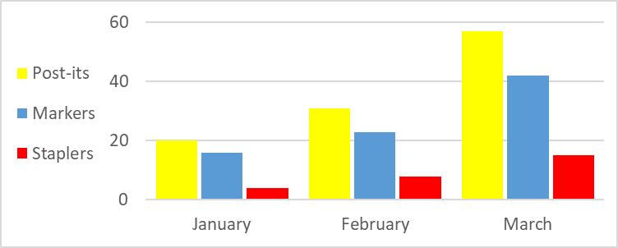
Product | January | February | March
Post-its | 20 | 31 | 57
Markers | 16 | 23 | 42
Staplers | 4 | 8 | 15

