
Newsletter
Office Supply is your one-stop resource for office supplies, paper, and equipment.
Locations
● Springfield - 120 W Jefferson St
● Chicago
o Downtown - 100 W Randolph St
o Lakeview - 1060 W Addison St
Featured Products
We have your favorite products in stock:

Post-its Markers Staplers
Assorted Colors Dry-Erase Red Swingline
$3.59 and up $6.49 $21.99

Sales Update
We had a great first quarter. Here are our latest sales figures:
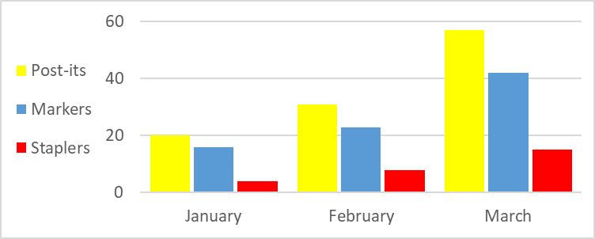
Sales Update
Product | January | February | March
Post-its | 20 | 31 | 57
Markers | 16 | 23 | 42
Staplers | 4 | 8 | 15

