Midterm Portion II. Cis43 Summer 2011
Please scan over the whole Midterm before you get started. Remember to write pseudo code for the ones that are more involved.

- (5pts) Write a Java class (FindGreatest) to find the greatest of three numbers. Read the numbers from the keyboard into an array. Print out in any format the number which is greater. Your class must include a method to do the addition. Make your code modular, and add lots of comments.

2. (5pts) Write a Java Class (AddTwo) to add two numbers. Read in the numbers from the keyboard, add them and display the results. Make your code modular and add lots of comments.
3. (5pts). Show the output of running the class Test in the following code lines:

interface A {
void print();
}

class C {}

class B extends C implements A {
public void print() { }
}

class Test {
public static void main(String[] args) {
B b = new B();
if (b instanceof A)
System.out.println("b is an instance of A");
if (b instanceof C)
System.out.println("b is an instance of C");
}
}

a. Nothing.
b. b is an instance of A.
c. b is an instance of C.
d. b is an instance of A followed by b is an instance of C.
answer: C

a. (15) (Geometry: The MyRectangle2D class) Define the MyRectangle2D class that contains:
- Two double data fields named x and y that specify the center of the rectangle with get and set methods. (Assume that the rectangle sides are parallel to x- or y- axes.)
- The double data fields width and height with get and set methods.
- A no-arg constructor that creates a default rectangle with (0, 0) for (x, y) and 1 for both width and height.
- A constructor that creates a rectangle with the specified x, y, width, and height.
- A method getArea() that returns the area of the rectangle.
- A method getPerimeter() that returns the perimeter of the rectangle.
- A method contains(double x, double y) that returns true if the specified point (x, y) is inside this rectangle. See Figure 1(a).
- A method contains(MyRectangle2D r) that returns true if the specified rectangle is inside this rectangle. See Figure 1(b).
- A method overlaps(MyRectangle2D r) that returns true if the specified rectangle overlaps with this rectangle. See Figure 1(c).

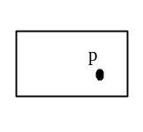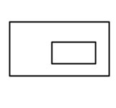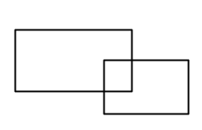

(a) (b) (c)

Figure 1
(a) A point is inside the rectangle. (b) A rectangle is inside another rectangle. (c) A rectangle overlaps another rectangle.

Draw the UML diagram for the class.

Implement the method getArea(), getPerimeter(), contains(double x, double y), contains(MyRectangle2D r), and overlaps(MyRectangle2D r).

5. (15pts) Design any Program you want to design about something that interests you. The first step will be to draw the UML diagram for your program to show the relationship amongst the classes. Your program could be a game, or a show, an experiment…etc. Design the class, create the instance variables, use methods to get and set values. Extend the class. Create other classes that inherit from it. Implement other non-related classes. Include all of the features of OOP into your program to show that you understand how it works. This program is open to interpretation, and can be simple or complicated. However, you must show the OOP principles, and comment your code. This is open to interpretation, so just have fun.

