**Instruction on how to use Personal Task Management:**

**How to login to the program:**

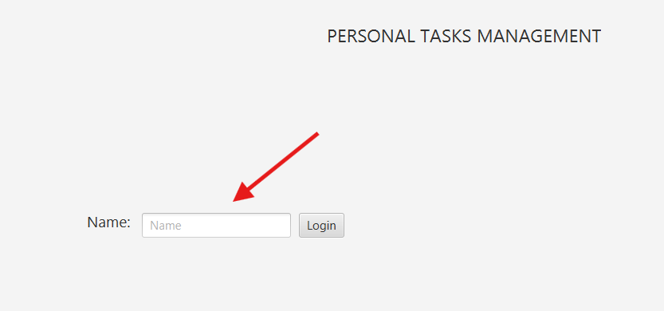

Step 1: Enter your name to login

in User Information Page

Step 2: After entering a proper name, all the tabs will be opened

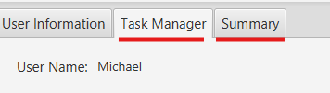

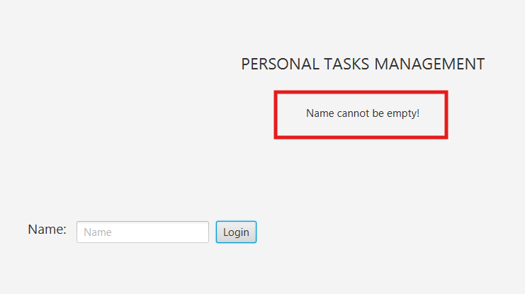P/s: The small line below PERSONAL TASKS MANAGEMENT

shows you how to use the program properly

**How to use Task Manager:**

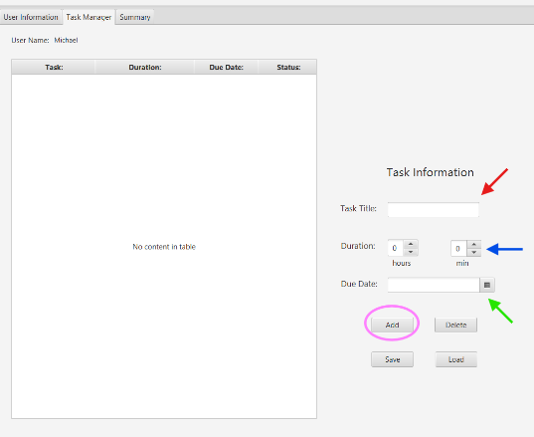

* **Add a task:**

1. Enter your task title (red)
2. Pick your duration, how long you

would like to do the task (blue)

1. Choose your due date (green)
2. Press Add to add to the table

* **Delete a task:**

1. Select a task you want to delete on the table (red)
2. 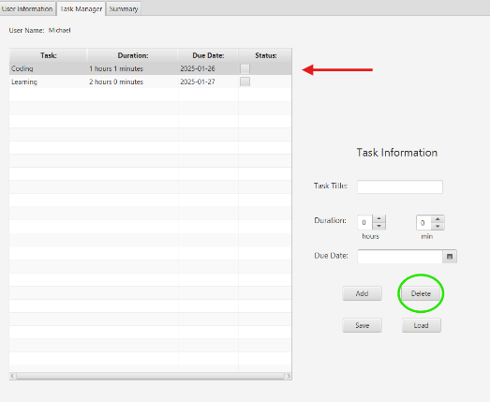Press Delete to delete (green)

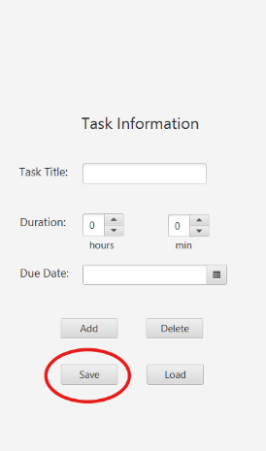

* **Save your tasks**

1. Click Save (red)
2. Name your file (blue) and press save (yellow)

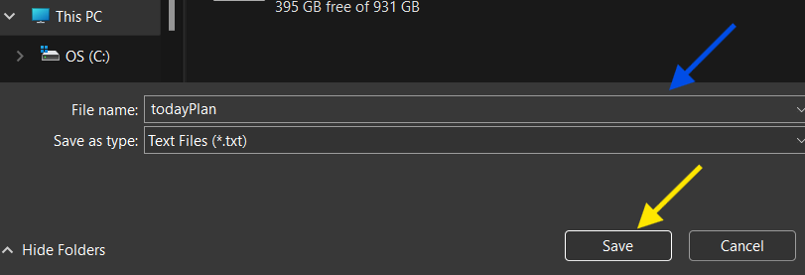

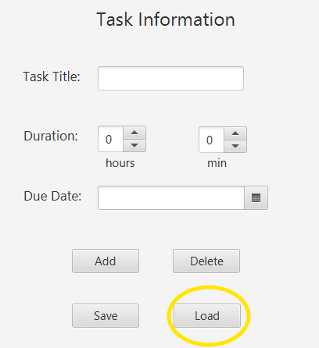

* **Load your tasks**

1. Click Load (yellow)
2. Select a .txt file you want to load (blue)

and click Open (green)

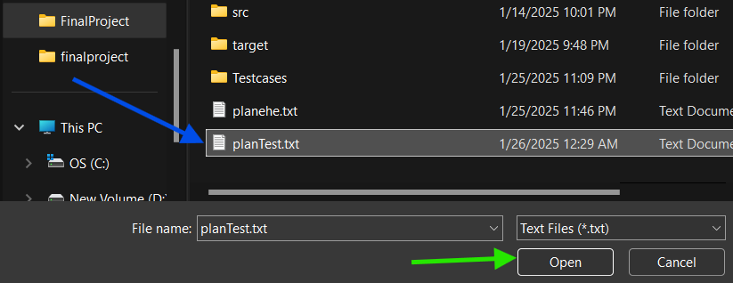

**Other features:**

1. 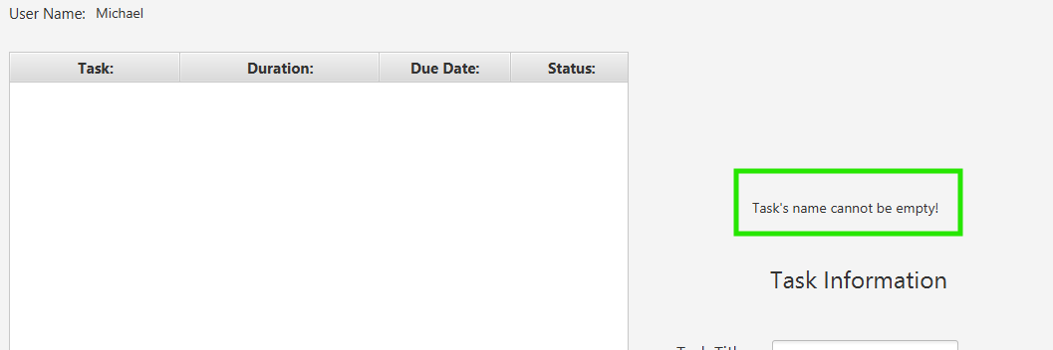A small line above “Task Information” to notify you to use the program properly
2. Tick the status check box to change your task’s status

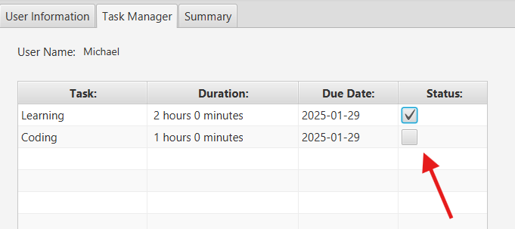

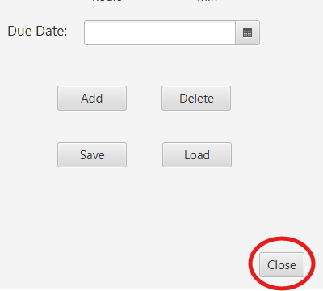

1. Click Close to terminate the program

**How to use the Summary tab**

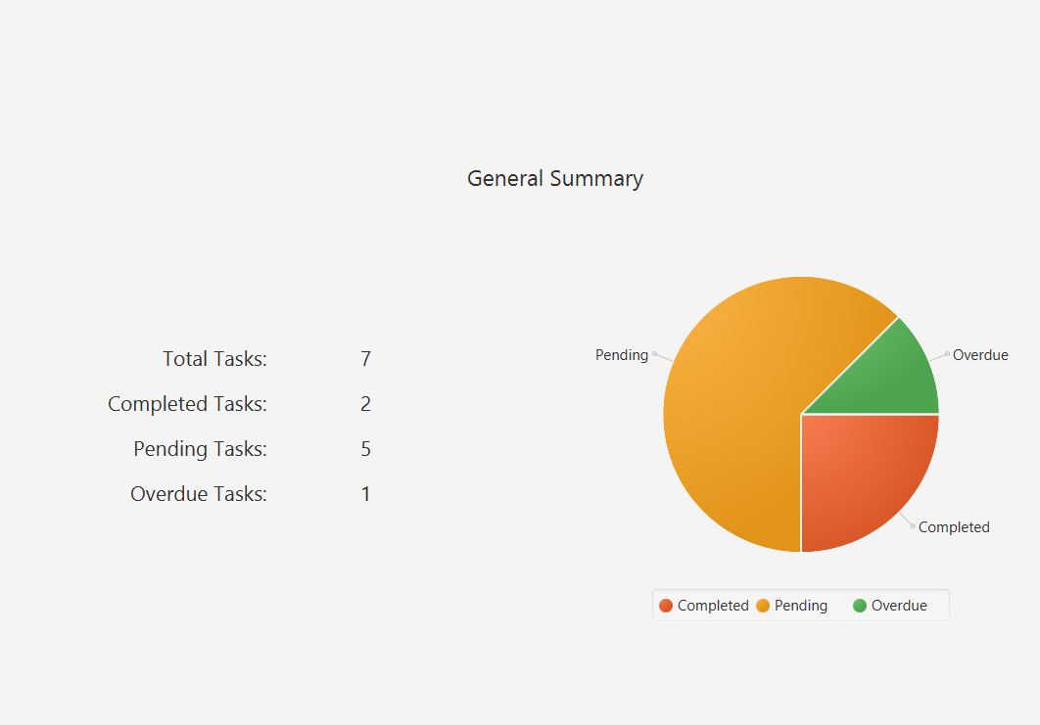

The summary tab summarizes all the necessary information including:

* The total tasks you have
* The total tasks you completed
* The total tasks are still pending
* The total tasks were overdue
* Pie chart with clearer visual

Notes from the developer:

* You cannot add duplicate tasks, so don’t try!
* Don’t try to break the program, use it in the common way you believe it should
* Now it is time to enjoy, I hope you will get your deadlines on time by using my program😊