**BÀI TẬP MẢNG**

1. Are PHP keys case-sensitive? What will the output of this script be?

<?php

$arr1 = ["A" => "apple", "B" => "banana"];

$arr2 = ["a" => "aardvark", "b" => "baboon"];

echo count($arr1 + $arr2);

A. This produces an error

B. 2

C. 4

D. None of the above

2. What will this script output?

<?php

$arr = [

'a' => 'apple',

'b' => 'banana',

'c' => 'cherry'

];

$keys = array_keys($arr);

*if* (in_array($keys, 'a')) { // truyền sai tham số

echo "Found";

}

A. Found

B. Nothing

C. Warning: in_array() expects parameter 2 to be array

D. None of the above

3. What will this script output?

<?php

$birds = ['duck', 'chicken', 'goose'];

$net = ['dog', 'cat', 'chicken', 'goose', 'hamster'];

echo count(array_intersect_assoc($net, $birds));

A. 0

B. 1

C. 2

D. 3

E. None of the above

4. What will this script output?

<?php

$a = array('one','two');

$b = array('three','four','five');

echo count($a + $b);

A. This produces an error

B. 2

C. 3

D. 5

5. What will this script output?

<?php

$a = array('three','four','five');

$b = array('one','two');

echo count($a - $b);

A. This produces an error

B. 3

C. 2

D. 1

6. What will this code output?

<?php

$keys = range(1, 6, 2);

$arr = array_fill_keys($keys, 'PHP');

krsort($arr); // krsort theo khóa

$arr = array_flip($arr);

echo $arr['PHP'];

A. There is an error in calling krsort()

B. There is an error in calling array_flip()

C. You cannot reference the key 'PHP' because there is more than one of them in the array

D. 1

E. 5

F. 6

7. What will this code output?

<?php

$array = [

[1, 2],

[3, 4],

];

*foreach* ($array as list($a, $b)) {

echo "A: $a; B: $b" . PHP_EOL;

}

A. A: 1; B: 2

A: 3; B: 4

B. Notice: Undefined offset: 1  
C. Undefined variable $a

D. None of the above

8. What will this code output?

<?php

$arr = [1,2,3,4,5];

$spliced = array_splice($arr, 2, 1);

$number = array_shift($arr);

echo $number;

A. This produces an error

B. 1

C. 3

D. 5

9. You run the following PHP script:

<?php

$array1 = array ('a' => 20, 30, 35);

$array2 = array ('b' => 20, 35, 30);

$array = array_intersect_assoc ($array1, $array2);

var_dump ($array);

?>

What will be output?

A. array(1) { ["'a'"]=> int(20)}

B. array(3) { ["'a'"]=> int(20) [0]=> int(30) [1]=> int(35) }

C. array(0) { }

D. The script will throw an error message.

10. Consider the following PHP script:

<?php

$a = [

1 => 'php',

'Hypertext',

'Preprocessor',

'widely used' => [

'general' => 'purpose',

'scripting' => 'language',

'that' => 'was',

'originally' => [

5 => 'designed',

9 => 'for',

'Web development', // key được gán là key = key +1

4 => 'purpose',

]

]

];

*//write code here*

?>

What should you write here to print the value 'Web development'?

A. print $a[widely used][originally][3];

B. print $a[2][3][3];

C. print $a['widely used']['originally'][0];

D. print $a['widely used']['originally'][10];

11. What will be the out put of the PHP script given below?

<?php

$array1 = array("orange", "banana", "apple", "raspberry");

$array2 = array(0 => "pineapple", 4 => "cherry");

$array3 = array(0 => "grape");

$array4 = array_replace($array1, $array2, $array3);

print_r($array4);

?>

A. Array (

[0] => orange  
 [1] => banana  
 [2] => apple  
 [3] => raspberry  
 [4] => cherry  
 (

B. Array (

[0] => orange  
 [1] => banana  
 [2] => apple  
 [3] => raspberry  
 [4] => grape

)

C. Array (

[0] => banana  
 [1] => cherry  
 [2] => grape

)

D. Array (

[0] => grape  
 [1] => banana  
 [2] => apple  
 [3] => raspberry  
 [4] => cherry

)

12. Consider the following PHP script:

<?php

$base_array = array("red", "green", "yellow", "white");

$replacements_array = array(0 => "orange", 4 => "blue");

$result = array_replace($base_array, $replacements_array);

print_r($result);

?>

A. Script will throw an error message.

B. Array(

[0] => orange  
 [1] => green  
 [2] => yellow  
 [3] => white  
 [4] => blue

)

C. Array (  
 [0] => blue  
 [1] => white  
 [2] => yellow  
 [3] => green  
 [4] => orange  
 )

D. Array (  
 [0] => yellow  
 [1] => white  
 [2] => blue  
 [3] => green  
 [4] => orange  
 )

13. Consider the following code:

<?php

$array = array("a1"=>'x',"a2"=>'e',"a3"=>'z');

asort( $array );

*foreach* ( $array as $keys => $values )

{

print "$keys = $values";

}

?>

What will be the output?

A. a2 = e a1 = x a3 = z

B. a1 = e a2 = x a3 = z

C. 0 = e 1 =x 2 = z

D. The script will throw an error message.

14. What will be the output of the following PHP code?

<?php

array_combine(array(1,2,3,6),array(4,5,6));

A. Warning message

B. array(

1=>2,

3=>4,

5=>6

)

C. array(

1=>4,

2=>5,

3=>6

)

D. array(1,2,3,4,5,6)

15. Which of the following functions is used to insert a new element in the beginning of an array?

A. array_unique()

B. array_unique()

C. array_pop()

D. array_push()

// Không có đáp án ?

16.

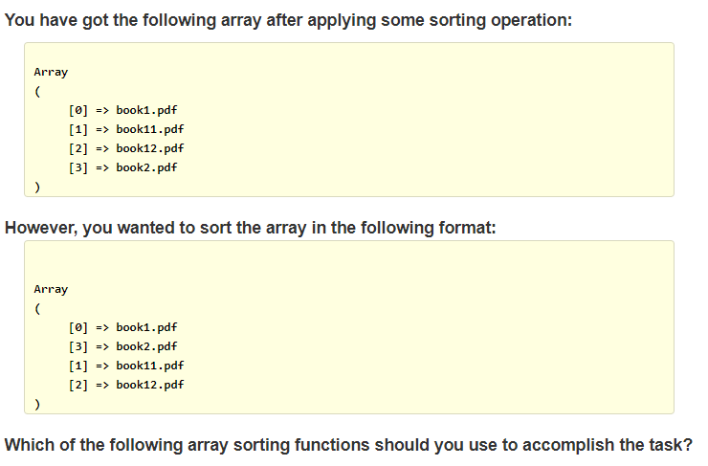

A. natsort()

B. ksort()

C. sort()

D. asort()

17. You run the following code:

<?php

$array = array("a1"=>x,"a2"=>e,"a3"=>z);

ksort( $array );

*foreach* ( $array as $keys => $values ) {

print "$keys = $values ";

}

?>

What will be the output?

A. a1 = x a2 = e a3 = z

B. a1 = e a2 = x a3 = z

C. 0 = e 1 = x 2 = z

D. The script will throw an error message.

18. You run the following PHP script:

<?php

$array1 = array ("a", "b", "c", "d", "e", "f");

$array2 = array_slice($array1, -3);// đếm ngược từ cuối về đầu

*foreach* ( $array2 as $val ) {

print "$val ";

}

?>

What will be the output?

A. b c d

B. a b c

C. d e f

D. c d e

19. What will be the output of the following code snippet?

<?php

$my_array = array(1 => 'a', 2 => 'b');

echo $my_array;

A. bool (true)

B. Array (

[1] => a

[2] => b

)

C. It will show an error message.

D. Array

20. What will be the output of the following PHP code snippet?

<?php

$array = array (1.1 => '1', 1.2 => '1');

echo count ($array);

?>

A. 1

B. The script will throw an error message.

C. 0

D. 2

21. Which of the following functions will you use to merge one or more arrays?

A. array_pad()

B. array_pop()

C. array_product()

D. array_merge()

22. Which of the following methods compares array1 against array2 and returns the difference by checking array keys in addition?

A. array_diff_uassoc

B. array_diff_ukey

C. array_diff_assoc()

D. array_diff_key()

23. Which of the following functions returns an array with all keys from input lowercased or uppercased?

A. array_count_values

B. array_ combine()

C. array_ chunk()

D. array_change_key_case()

24. Which of the following functions can be used to check whether a particular element exists in a given array or not?

A. array_value

B. array_keys

C. in_array

D. array_key_exists

25. What will be the output of the following code snippet?

<?php

$input = array(4, "4", "3", 4, 3, "3", 3, 3, 3, 3, 3, 5, 5, 5, 5, 7, 7, 7, 7);

echo count(array_unique($input)); // so sánh cả kiểu dữ liệu

?>

A. 4

B. The script will throw an error message

C. 19

D. 6

26. What will be the output?

<?php

$queue = array(1, 2);

array_unshift($queue, 0, 4); // truyền giá trị về phía trước của mảng

print_r($queue);

?>

A. Array  
 (  
 [0] => 1  
 [1] => 2  
 )

B. Array  
 (  
 [0] => 0  
 [1] => 4  
 [2] => 1  
 [3] => 2  
 )

C. Array  
 (  
 [0] => 0  
 [1] => 1  
 [2] => 2  
 [3] => 4  
 )

D. Array  
 (  
 [0] => 4  
 [1] => 2  
 [2] => 1  
 [3] => 0  
 )

27. What will be the output?

<?php

$a = array('a', 'b');

array_push($a, array(1,2));

print_r($a);

?>

A. array(array(1, 2), 'a', 'b')

B. array('a', 'b', array(1, 2))

C. array('a', 'b', 1, 2)

D. array(1, 2, 'a', 'b')

28 .What will be the output?

<?php

$array = array ('1', '2', '3');

*foreach* ($array as $key => $value) {

$value = 4;

}

print_r($array);

?>

A. The script will throw an error message.

B. Array ( [0] => 1 [1] => 2 [2] => 3 )

C. Array ( [0] => 4 [1] => 8 [2] => 12 )

D. Array ( [0] => 1 [4] => 2 [8] => 3 )

29. You passed an associative array to the sort() function. What will happen?

A. The elements of the array will be sorted and keys will not be preserved.

B. The elements of the array will be sorted and the keys will not be sorted, however, they will be preserved.

C. The key of the array will be sorted and the elements will not be sorted, however, they will be preserved.

D. The keys will be sorted, however, elements will not be preserved.

30. What will be the output of the script?

<?php

$var1 = array("foo", "bar", "hello", "world", "PHP", "nice");

$var2 = array("foo", "bar", "hello", "PHP", "nice", "language");

echo count( array_merge(array_diff($var1,$var2),array_diff($var2,$var1)));

// array_diff($var1,$var2) => [1] => world

// array_diff($var2,$var1) => [5] => language

Output => 2

?>

A. 4

B. 3

C. 2

D. 1