**Final Day Assignments**

**Assignment 1 – Create a simple User validation through Login from Postman.**

* **Before Authentication (Integration with Angular)**

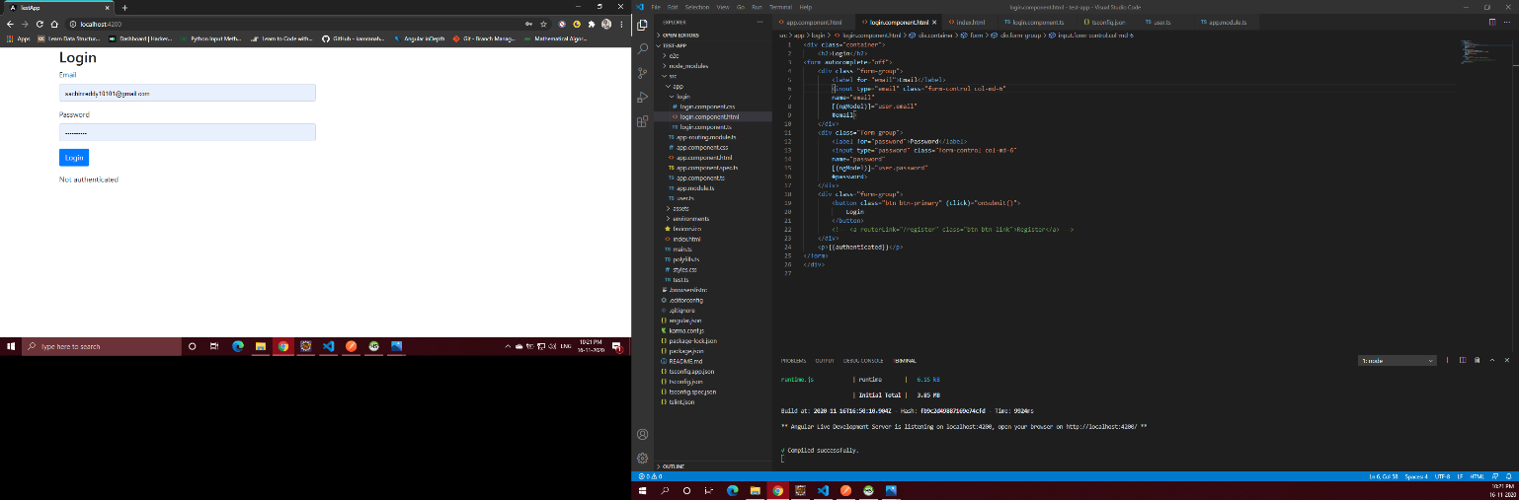

* **After Authentication (Angular Form and Postman)**

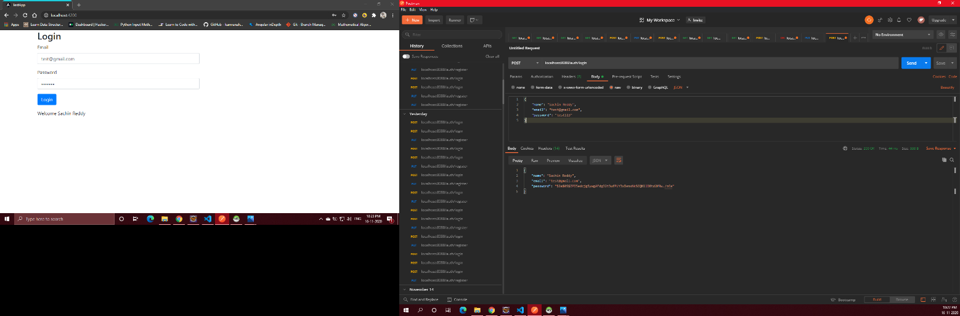

**Assignment 2 – CRUD operations(Insert, Delete, Update) using Spring Boot and JPA.**

* **Display All records**

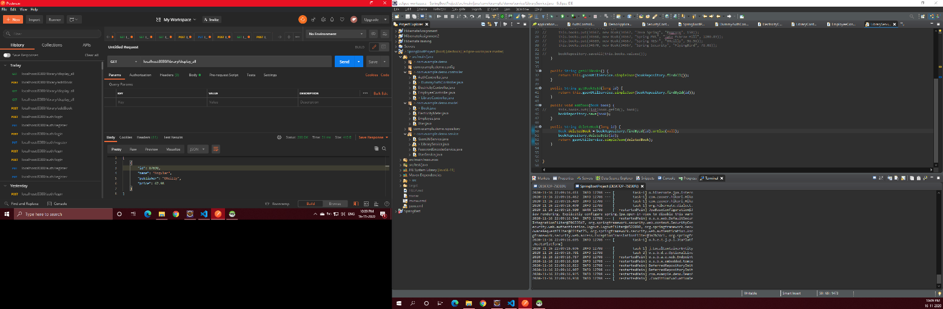

* **Display by Id**

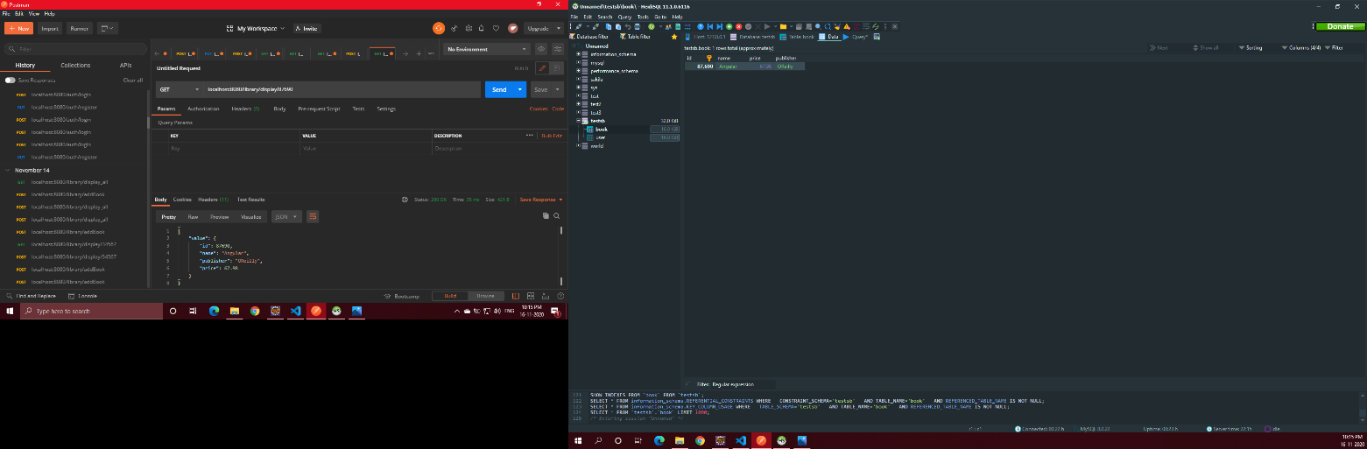

* **Add record**

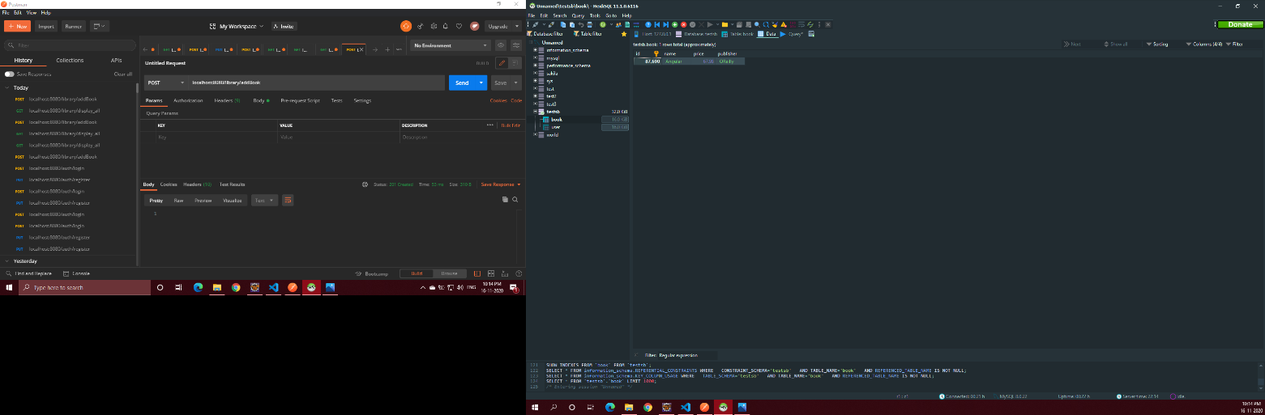

* **Delete Record**

