Customer management





**Sequence Diagram demonstrating operation “Add new customer”**



**Sequence Diagram demonstrating operation “Delete customer”**



**Sequence Diagram demonstrating operation “Update customer information”**



**Sequence Diagram demonstrating operation “Create customer report”**



**Model-View-Controller (MVC) Model “Add new customer”**

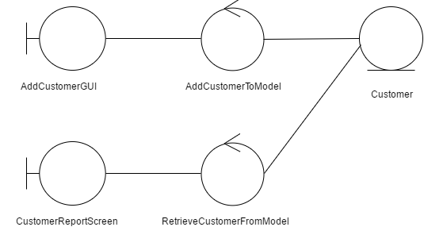

**Model-View-Controller (MVC) Model “Delete customer”**

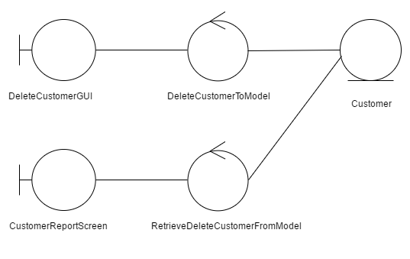

**Model-View-Controller (MVC) Model “Update customer information”**



**Model-View-Controller (MVC) Model “Create customer report”**

