Plot

Michael Way

29 June 2016

# Main Title

You can write blocks of text. You can write blocks of text. You can write blocks of text. You can write blocks of text. You can write blocks of text. You can write blocks of text. You can write blocks of text.You can write blocks of text. You can write blocks of text.You can write blocks of text.You can write blocks of text. You can write blocks of text. You can write blocks of text.

You can insert hyperlinks <http://rmarkdown.rstudio.com>

1. Item 1
   * Item 1a
   * Item 2b

Use 2 stars to make text **BOLD** or 1 star to make *ITALIC*

## Plotting data

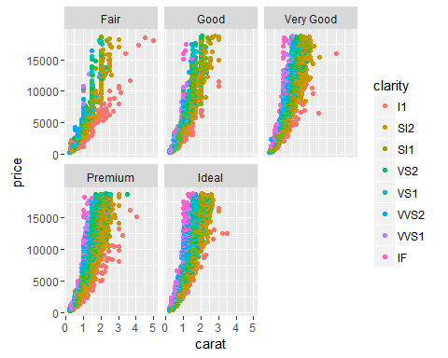

## Summarising Data

Number of datapoints: 53940

Number of variable: 10

head(diamonds)

## carat cut color clarity depth table price x y z  
## 1 0.23 Ideal E SI2 61.5 55 326 3.95 3.98 2.43  
## 2 0.21 Premium E SI1 59.8 61 326 3.89 3.84 2.31  
## 3 0.23 Good E VS1 56.9 65 327 4.05 4.07 2.31  
## 4 0.29 Premium I VS2 62.4 58 334 4.20 4.23 2.63  
## 5 0.31 Good J SI2 63.3 58 335 4.34 4.35 2.75  
## 6 0.24 Very Good J VVS2 62.8 57 336 3.94 3.96 2.48