## **서울대학교 빅데이터 핀테크 전문가 과정**

## **파이썬 프로그래밍 HW1**

### Q1

For the following expressions, what value will the expression give? Verify your answers by typing the expressions into Python.

9/2

하나를 선택하세요.

1. 4

2. "9/2"

3. 5

4. 0.222222

5. 4.5

### Q2

Choose an assignment statement that do the following:

**"Convert the value in temp from Celsius to Fahrenheit by multiplying by 1.8 and adding 32; make temp refer to the resulting value."**

하나를 선택하세요.

1. temp + 1.8 * temp + 32

2. temp = 1.8 * temp * 32

3. temp = 1.8 * temp + 32

4. temp = temp + 32

5. temp = 1.8 + temp + 32

### Q3

For the following expression, in which order are the subexpressions evaluated?

5 - 2 * 3 ** 4

하나를 선택하세요.

1. '-' -> '*' -> '**'

2. '-' -> '**' -> '*'

3. '*' -> '**' -> '-'

4. '**' -> '-' -> '*'

5. '**' -> '*' -> '-'

### 

### Q4

Which of the following expressions results in Syntax Errors? **(Choose 2 answers)**

하나 이상을 선택하세요.

1. 4 += 7 / 2

2. (-(-(-(-5))))

3. ((((4 ** 3))))

4. 8 = people

5. 6 * -----------8

### Q5

For the following function call, which subexpression is evaluated **first**?

abs(min(4, 6, max(2, 8)))

하나를 선택하세요.

1. min

2. max

3. abs

### Q6

Considering the following code, fill in the second column of the table by choosing **square, num, square(3), and 3**.

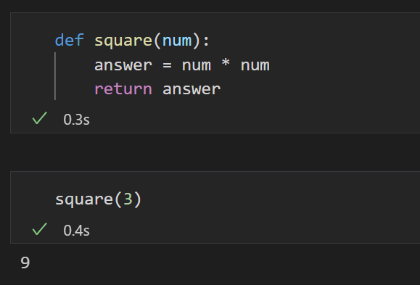

# 

|  |  |
| --- | --- |
| Function name |  |
| Function call |  |
| Parameter |  |
| Argument |  |

### 

### Q7

Considering the following definition and example result, choose a right expression to define the **average_grade** function.

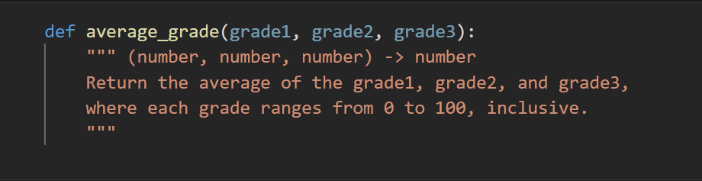

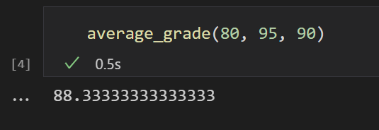

하나를 선택하세요.

1. return (grade1 * grade2 * grade3) / 3

2. return grade1 + grade2 + grade3

3. return (grade1 + grade2 + grade3) * 3

4. return (grade1 + grade2 + grade3) / 3

5. return (grade2 + grade3) / 2

# 

### Q8

What value does the following expression evaluate to? (Don’t miss the quotation mark!)



### Q9

Given variables x and y, which refer to values 3 and 12.5, respectively, choose the function that prints the following message. (**variables x and y should be used.)**

12.5 * 3 is 37.5.

하나를 선택하세요.

1. print('The rabbit is', x, 'years old.')

2. print(y, 'is average.')

3. print('The rabbit is ' + str(x) + '.')

4. print(str(y) + ' * ' + str(x) + ' is ' + str(y * x) + '.')

5. print(y, '*', x)

### Q10

Consider the following code. What is printed by this code?

